6E:221
Professor N. E. Savin

Problem Set on Matrix Algebra

1. Consider the following Matrix and Vectors

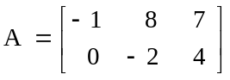, 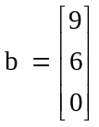, 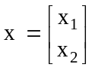.

Calculate:

a. Ab
b. AIb
c. 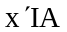
d. 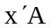
e. Does the insertion of I in b change the result in a?
f. Does the deletion of I in d change the result in c?

2. Let A, B, C, D, E, F, G and H be Square Matrices, where E and F are nonsingular.

Expand the matrix product

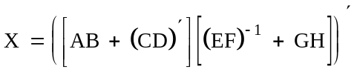

3. Consider the following system of equations

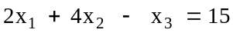

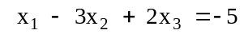

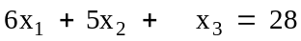

Solve by

a. Matrix Inversion
b. Cramer’s rule

4. Let 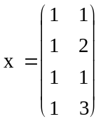

a. Compute 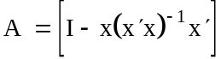
b. Show that A is idempotent and determine its rank.

5. Let 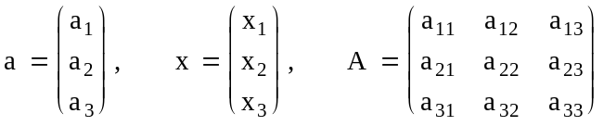

Define 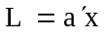 and 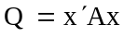, where L is called a linear form in x and Q is
called a quadratic form in x. Follow the definitions of matrix derivatives given in Greene’s textbooks of econometrics

Find the following derivatives:

a. 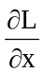

b. Assume A is a symmetric matrix. Find

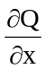 and 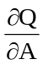

c. Let y = Ax . Find

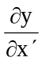 and 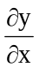

6. Let 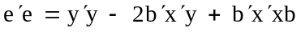, where e and y are n 1 vectors, b is a p 1 vector, and x is a n p matrix. Find 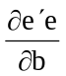

7. Let 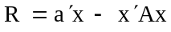

where 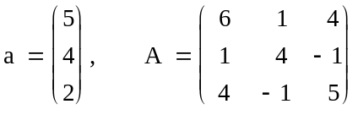

a. Maximize R with respect to x.
b. Verify that the second order condition is satisfied.

