University for Applied Sciences Informatics Department Applied Informatics

LionsApp-Documentation

|  |  |
| --- | --- |
| Clients: | Prof. Dr. Stephan Kurpjuweit,  Jens Kohler |
| Professors: | Herbert Thielen,  Werner König |
| Semester: | Summer Semester 2023 |
| Due Date: | 30. March 2023 |

Inhalt

Team Introduction: 3

1. Introduction and Goals: 4

1.1: Requirements Overview: 4

1.2: Stakeholders: 6

1.3: Use Cases: 7

1.4: User Stories: 7

2. App Planning 8

3. App Development 12

Glossary: 13

# Team Introduction:

|  |  |  |  |
| --- | --- | --- | --- |
| Name | Rolle | Email | Matrikelnummer |
| Saadet Ibrahimova | Product Owner | inf3530@hs-worms.de |  |
| Ayoub El-Mrabet | Scrum Master | inf3822@hs-worms.de | 677623 |
| Philipp Muders | Developer | [inf3455@hs-worms.de](mailto:inf3455@hs-worms.de) | 675908 |
| Kristiyan Ivanov | Developer | inf3563@hs-worms.de | 676281 |
| Omer Guimdo-Achoungo | Developer | [inf3249@hs-worms.de](mailto:inf3249@hs-worms.de) | 674699 |
| Marc Wieland | Developer | [inf3457@hs-worms.de](mailto:inf3457@hs-worms.de) | 675904 |
| Mikulas Willaschek | Developer | [inf3825@hs-worms.de](mailto:inf3825@hs-worms.de) | 677636 |
| Nico Hofmann | Developer | inf3207@hs-worms.de | 674656 |
| Tom Brauns | Developer | [inf3621@hs-worms.de](mailto:inf3621@hs-worms.de) | 676672 |

# 1. Introduction and Goals:

The Focus of this application is to develop an application working as both an Application aswell as an Web-App. It’s supposed to enable a simplistic donation process for Guests and should have the option for Users to sign up and therefore have access to more functions and benefits on the application. The App in itself includes an calendar, a project-catalogue, aswell as Events, an donation screen and a chat.

## 1.1: Requirements Overview:

#### Functions include but are not limited to:

* Scanning a QR-Code
* The Login-Function
* The register-function
* The Change-User-Data-function
* Donate
* Continue as Guest
* Select Paymethode
* Share Donation
* Get a Donation-Receipt
* Display Events
* Display specific Event
* Create Event
* Edit Event
* Delete Event
* Display Catalogue
* Display specific project
* Create project
* Edit project
* Delete project

#### A summarization of the functional requirements would look as follows:

|  |  |  |  |
| --- | --- | --- | --- |
| ID | Requirement | Description | Reasoning |
| F-1 | Scanning a QR-Code | A User at an Event can scan a QR-Code portrayed on a Flyer | The QR-Code handles the Navigation to a specific Screen and therefore is essential |
| F-2 | A User can register | Users can register on the Application to save their data and have more functions on the Application | In order to avoid having to enter required data repeatedly, it is necessary that the User can register. |
| F-3 | A User can login | Users can choose to log in in the Application if their Account is already existing. | As an Account was already created, logging into that account saves the effort to have to enter important data repeatedly. |
| F-4 | Logged in Users can change their Data | A Logged in User can change the given Data. | Contact info might change considering the address or the Email, or the user wants to change the password. All these functions need to be provided. |
| F-5 | Donate | Users can donate |  |
| F-6 | Continue as Guest | A User can donate without being required to sign up. | Just because a User doesn’t want to sign up doesn’t mean he should be hindered from donating to a good cause. |
| F-7 |  |  |  |
| F-8 |  |  |  |
| F-9 |  |  |  |
| F-10 |  |  |  |

#### This graphic depicts the functions in accordance with the User-types. The further you move to the right, the more functions that User has access to.

## 1.2: Stakeholders:

#### As Stakeholders we consider all the people benefitting from the direct implementation and release of the application

|  |  |  |
| --- | --- | --- |
| Stakeholders | Type of Stakeholder | Reasoning |
| Donators | Primary | As we aim to make the donation process as easy as possible, we always have to think of the donators. |
| Sponsors | Primary | As with all projects, keeping an application running as well as running actual events that we use the application for requires funding. Those can be companies supporting the events, as well as organizations using it. |
| Lions | Primary | While the App isn’t directly in development for the Lions-Club, we still have to consider them or main audience group. |
| Lions Members | Secondary | As |
| Organizations | Secondary | If available, those are the organizations that handle contributing the funds to the actual problem. |
| State | Tertiary | Considering that donating involves money transactions, the state has to at least be considered for legal reasoning |
| Donation Receivers | Secondary | As they are the ones who actually benefit from the gathering of money, we should keep them in mind. |

## 1.3: Use Cases:

#### Considering the in 1.1 defined functional requirements the user is left with (but not exclusively) the following use cases:

|  |  |  |
| --- | --- | --- |
| ID | Use Case | Description |
|  |  |  |
|  |  |  |
|  |  |  |
|  |  |  |
|  |  |  |
|  |  |  |
|  |  |  |
|  |  |  |
|  |  |  |
|  |  |  |
|  |  |  |
|  |  |  |
|  |  |  |
|  |  |  |
|  |  |  |

## 1.4: User Stories:

#### The core of each app is to focus on the main functionality at first, so that an application, having the core features implemented, can be used already. To best fulfill this approach, we’ll focus on the most important Use-Cases and User-Stories.

|  |  |  |  |
| --- | --- | --- | --- |
| ID | User-Story | Function | Reference |
|  |  |  |  |
|  |  |  |  |
|  |  |  |  |
|  |  |  |  |
|  |  |  |  |
|  |  |  |  |
|  |  |  |  |
|  |  |  |  |
|  |  |  |  |
|  |  |  |  |

# 2. App Planning

Before we could get to work, we had to do some planning. So we started off by taking another look at the presented project we had presented to us and the Requirements that our customer had defined:

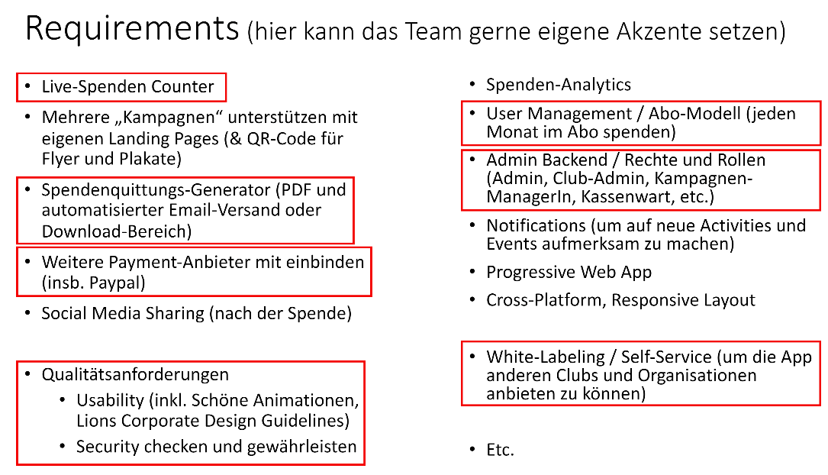

#### This is a Screenshot from the presentation in: [Spendenapp.pdf · main · TOP / 23s / TOP 23 project proposals and teams · GitLab (rlp.net)](https://gitlab.rlp.net/top/23s/top-23-project-proposals/-/blob/main/Spendenapp.pdf)

This helped us get a general idea, but wasn’t enough to fully understand what the final version would have to look like, so we continued our Research and started Brainstorming once again. For this we used the previously designed Brainstorming board that all of the groups created before:

[Insert initial Brainstorming board]

Now that we had a bunch of input combined with the original ideas from our Customer, we started working on our understanding of the application and how it should work. In doing so we made a board ourselves, gathering our Ideas that we thought would be necessary in defining a united understanding of the product we were about to develop.

[Insert our Brainstorming-Whiteboard]

We then used those Ideas and compared them to the ones that were previously gathered by all the groups, adding a few of those ideas to our final realization, before starting to think about functionalities we wanted in that app.

In doing so, we realized quickly, that we would need a Database to store all of the Data (be it user-related or for the events itself). Luckily we had a bunch of dedicated Network-Security majors that volunteered to start the learning process regarding those Databases and decided on the Firebase.

We still wanted some sort of visualization. Afterall we were working with an Application, so Mockups would be helpful for all of us to best understand which Screens we would need and what each of the Screens would require. We turned to <https://miro.com/> for this, as we could all work on it together and have a lot of features customizing it.

But where does one start when it comes to thinking about an application. We referred to something our customer defined previously. The focus of the application should be, that a guest could SCAN A QR-Code and donate to an Event (or Activity), without jumping through too many hoops. Considering that this was one of the core things our Customer wanted, we started off thinking about how that would look like and created an “Epic” just for that occasion. The customer would scan a QR-Code, open the App, donate to the cause, would then have an option to log in/ register, OR just continue as a guest, select a payment methode, for legal reasons input the required data for a donation certificate, before finally being presented with the Notification of the successful donation done.

The created an happy path of that process in miro that looked something like this:

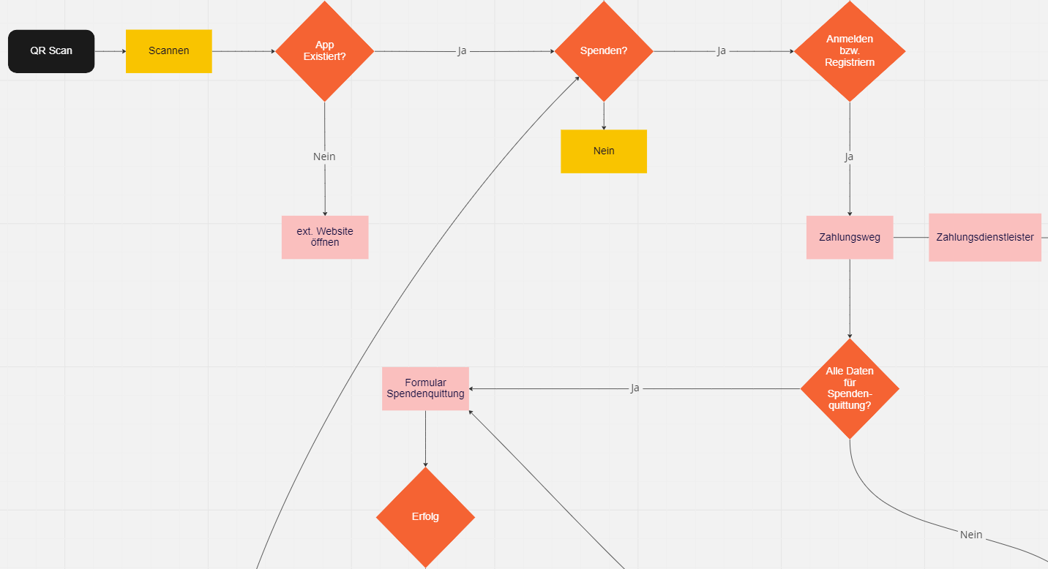

This implied, that a guest wouldn’t be required to input too much data, or even create an account in order to be able to donate, so we wanted to visually display the simplicity of the process.

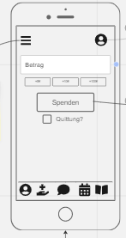Now that we had a general process portrayed, we started thinking about how each of those pages would generally look like. In doing so, we created simple wireframes for each of the required Screens.

In doing so, we quickly realized, that this would require a bunch of pages and therefore some sort of Navigation to make it useable. So we started working with an Burger menu. In addition of that we thought it to be a nice feature to add a Bottom Navigation Bar for the core Screens that you would want to access. By thinking about it in detail, we started realizing, that this wouldn’t apply to the guest that would just want to donate without a lot of distractions. This started a discussion on which roles there actually are, so we agreed upon a guest, a member and some sort of admin initially.

We continued to create wireframes for each of the required Screens in the process, including Buttons, Textfields and first Icons that would require functions behind it in the respective screens lateron.

In defining and using our Burgermenu we required an united understanding of what the application would have as Screens. So, we started thinking about what we would want in that.

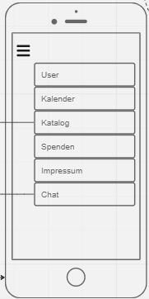After some discussing, we ended up on the 6 most important Screens, or rather Categories at this point , as each of these screens would have a bunch of screens following in the process. Those screens are the User tab, to customize data, change settings and administrate subscriptions etc, the calendar to portray events, the Catalogue to show the projects that the Lions Club does their events (activities) for, the donation tab, which would be our starting page, and the impressum for legal reasons. We also noted that there would be some sort of an chat, even though we weren’t quite clear on how that would look in realization.

We created Wireframes for all of the screens we thought necessary in those categories aswell as further categories (such as the events, the contact form, the login page etc) and created the flutter repository.

A few days later we got the chance to have a first chat with our customer, presenting him our general understanding and presenting him our Miro-board and the epic that we created for the general donation process. In this conversation, there were a bunch of right assumptions, but also a lot of newly presented topics, such as the difference between a member and a friend.

This lead to a lot of discussions about the roles in specific, which we then pinpointed to avoid further confusion and to ensure a likeminded understanding of it:

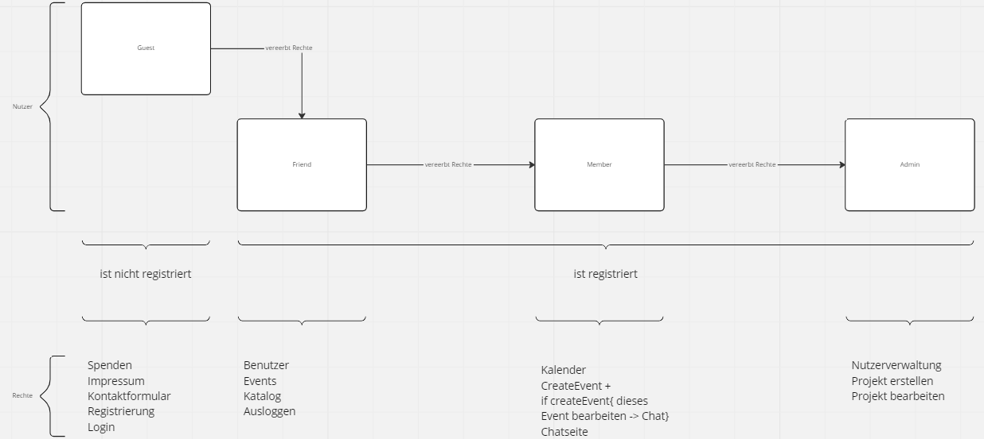

While we have 4 different Users of the application, only 3 of these are registered. Each of the roles has more rights and Screens available to them, ranking from the friend (registered guest) to the member (someone who received additional rights by an Admin), to an Admin (someone with the capabilities to create catalogue entries (projects), and give other friends the member role). We went ahead and defined each of the functions and screens available to each of the roles to understand them individually.

Having the screens available to us, we started working out our user stories and issues specific to the roles.

Now that we had the core screens thought of and wireframes created, we were able to start with the development process. We created a git repository, created a flutter project and started learning about flutter, as it was some time for each of us since we worked with the dart wireframe or flutter in general.

# 3. App Development

# Glossary:

Application: The final product that we intend to create.

User: Every type of person having access to the Application and making use of the functions.

Guest: Someone who uses the Application but does not log in / register to the page

Registered User: A registered User is a User that registered on the Application / logged into the Application. This refers to Friends, Member or Admins.

Logged In User: A logged in User is a User that is currently signed into the Application with an Email aswell as an password.

Friend: A Friend is a person that registered on the Application

Member: A Member is someone who has more rights than a Friend. They have been given the role Member by an Admin and are the organizational Users that can create Events and access the Calendar.

Admin: An Admin is a Member in its core functionality, but has further rights, such as creating new Catalogue Entries (Considered as Projects in our Application ) as well as Manage the rights of Users.

Catalogue: The Catalogue has all of the projects available portrayed in it in a List.

Projects: Projects are Categories that summarize an Catastrophy that occurred around the world. In the project, you can read up on the catastrophy, as well as see the measurements that are being taken to help. They are listed in the Catalogue

Events: Events are datebound Activities, that have the purpose of collecting money to donate for one of the Projects. They are being displayed in a List.

Donation Receivers: As Donations are gathered, the Receivers refers to the Organization or the people that benefit from that money.

Customer: This refers to the person that contracted us to develop this Application (in this case Prof. Dr. Kurpjuweit)

Database: Storage medium to store all of the Data , be it Events (Activities) , Catalogue entries (Projects), or User Data ( Email, Password etc.)

Firebase:

Wireframe: Used as a Visual Prototype, without any functions.

Screen: A page that’s being portrayed in the application.