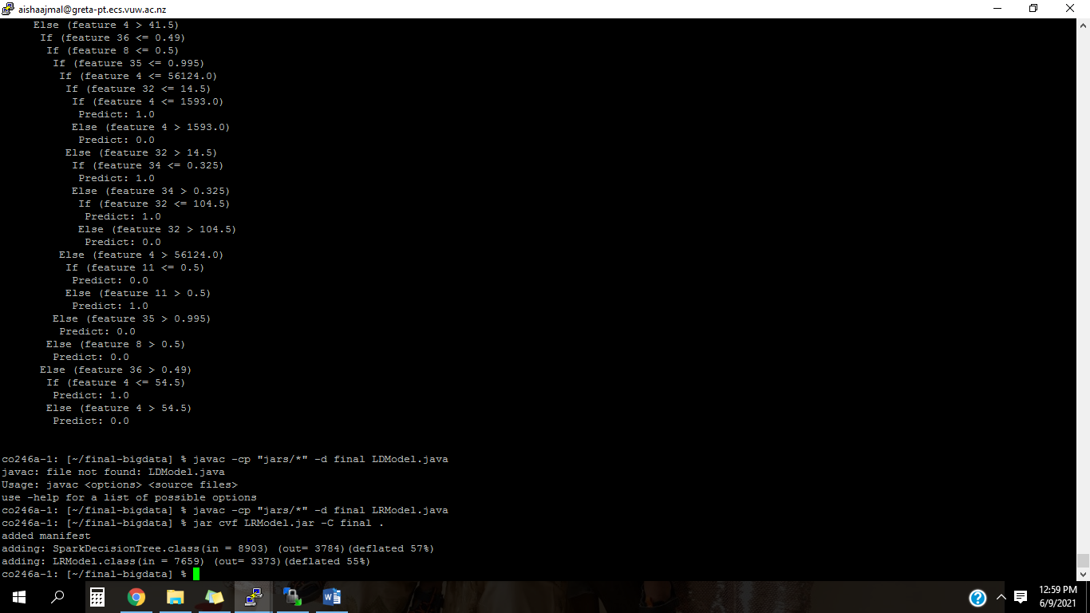

|  |  |
| --- | --- |
|  | Spark’s Decision Tree algorithm |
| Run 1 | Train Accuracy: 0.9958091360833383  Train Error: 0.0041908639166616775  Test Accuracy: 0.9862526168876483  Test Error: 0.01374738311235171  Duration: 22ms |
| Run 2 | Train Accuracy: 0.9960365944512323  Train Error: 0.003963405548767768  Test Accuracy: 0.9860356865787432  Test Error: 0.013964313421256789  Duration: 21ms |
| Run 3 | Train Accuracy: 0.9968334578043316  Train Error: 0.003166542195668409  Test Accuracy: 0.9863964658859827  Test Error: 0.01360353411401725  Duration: 24ms |
| Run 4 | Train Accuracy: 0.995685393258427  Train Error: 0.004314606741573033  Test Accuracy: 0.9857948610820974  Test Error: 0.014205138917902652  Duration: 22ms |
| Run 5 | Train Accuracy: 0.996297522651335  Train Error: 0.003702477348665001  Test Accuracy: 0.9863589390285911  Test Error: 0.013641060971408887  Duration: 22ms |
| Run 6 | Train Accuracy: 0.9964632805302107  Train Error: 0.003536719469789283  Test Accuracy: 0.9864433245794592  Test Error: 0.013556675420540848  Duration: 21ms |
| Run 7 | Train Accuracy: 0.9958177744585511  Train Error: 0.004182225541448843  Test Accuracy: 0.9866769511254471  Test Error: 0.013323048874552977  Duration: 21ms |
| Run 8 | Train Accuracy: 0.9974318392211903  Train Error: 0.002568160778809687  Test Accuracy: 0.9869464523826234  Test Error: 0.013053547617376657  Duration: 22ms |
| Run 9 | Train Accuracy: 0.9959031100478469  Train Error: 0.00409688995215311  Test Accuracy: 0.9871992165640738  Test Error: 0.012800783435926133  Duration: 22ms |
| Run 10 | Train Accuracy: 0.9967978452790663  Train Error: 0.0032021547209337125  Test Accuracy: 0.9863138049018924  Test Error: 0.013686195098107675  Duration: 23ms |

|  |  |
| --- | --- |
|  | Logistic Regression algorithm |
| Run 1 | Train Accuracy: 0.888696534638689  Train Error: 0.11130346536131097  Test Accuracy: 0.8888498559685238  Test Error: 0.11115014403147616  Duration: 19ms |
| Run 2 | Train Accuracy: 0.8879194027165602  Train Error: 0.11208059728343978  Test Accuracy: 0.8914146680570039  Test Error: 0.10858533194299613  Duration: 21ms |
| Run 3 | Train Accuracy: 0.8908443327047978  Train Error: 0.10915566729520221  Test Accuracy: 0.8841884816753927  Test Error: 0.11581151832460734  Duration: 20ms |
| Run 4 | Train Accuracy: 0.8890255610224409  Train Error: 0.1109744389775591  Test Accuracy: 0.8871146903637879  Test Error: 0.11288530963621213  Duration: 21ms |
| Run 5 | Train Accuracy: 0.8871759564150152  Train Error: 0.11282404358498477  Test Accuracy: 0.8893230983949756  Test Error: 0.11067690160502441  Duration: 20ms |
| Run 6 | Train Accuracy: 0.8886305371728372  Train Error: 0.11136946282716276  Test Accuracy: 0.8846370683579986  Test Error: 0.1153629316420014  Duration: 25ms |
| Run 7 | Train Accuracy: 0.8860425353211147  Train Error: 0.11395746467888535  Test Accuracy: 0.889436766442114  Test Error: 0.110563233557886  Duration: 22ms |
| Run 8 | Train Accuracy: 0.8862539349422875  Train Error: 0.11374606505771245  Test Accuracy: 0.887351366386204  Test Error: 0.11264863361379596  Duration: 31ms |
| Run 9 | Train Accuracy: 0.8876163206871869  Train Error: 0.11238367931281312  Test Accuracy: 0.8915399774774775  Test Error: 0.10846002252252251  Duration: 23ms |
| Run 10 | Train Accuracy: 0.8877807726864331  Train Error: 0.11221922731356693  Test Accuracy: 0.8884706538407918  Test Error: 0.11152934615920818  Duration: 23ms |