**Endangered amphibian larvae in high mountain lakes have weak and variable top-down impact on algal resources and invertebrate competitors.**

Thomas C. Smith1,2,3* and Cheryl J. Briggs2.

1. University of California Santa Barbara, Earth Research Institute.

2. University of California Sierra Nevada Aquatic Research Laboratory.

3. University of California Santa Barbara, Department of Ecology Evolution, and Marine Biology.

*tcsmith@ucsb.edu

Abstract

Worldwide declines in amphibian populations and diversity have prompted investigations into the ecological roles of amphibian species and the consequences of their declines and local extinctions. In the Sierra Nevada of California, mountain yellow-legged frogs (*Rana muscosa* and *Rana sierrae*) have declined and have been locally extirpated from most of their historic range in large part due to disease caused by the amphibian chytrid fungus (*Batrachochytrium dendrobatidis*), yet their impacts on other species remain largely unquantified. We performed two experiments to quantify grazing impacts of mountain yellow-legged frog tadpoles and potentially competing mayfly nymphs (*Callibaetis ferrugineus* and *Ameletus edmundsi*) on algal communities. In a field enclosure experiment in two remote high-elevation lakes, algal abundance declined with increasing mayfly abundance, but was unaffected by tadpole abundance. In a factorial-designed mesocosm experiment, in which tadpoles and mayflies were absent or present at high densities, tadpoles reduced algal abundance by half. Mayflies alone did not reduce algal abundance, but reduced algal abundance in the presence of tadpoles. Our results suggest that the decline of mountain yellow-legged frog tadpoles may allow benthic producers to reach higher abundance, and that tadpole declines—such as those following outbreaks of *Batrachochytrium dendrobatidis*—have the potential to alter lake communities. At the whole-lake scale, however, the top-down effect of tadpole grazing on producer abundance is likely obscured by variability driven by bottom-up abiotic processes.

Keywords: *Ameletus spp.,* amphibian declines, *Callibaetis ferrugineus*, *Rana muscosa, Rana sierrae*, Sierra Nevada, alpine lakes, grazers, consequences of extinction

Introduction

Although worldwide amphibian population declines and extinctions (Stuart et al. 2004, Wake and Vredenburg 2008) have been recognized and studied for nearly three decades, the ecological outcomes of these natural species removal experiments have been quantified in few ecosystems (Hocking and Babbitt 2014a, but see examples in Matthews et al. 2002, Ranvestel et al. 2004, Rantala et al. 2015, Smith et al. 2016). While over 40% of the 5700 amphibian species are declining in abundance or shrinking in distribution or both, declines of anurans (frogs and toads) are the best understood and may be the most extensive (Stuart et al. 2004, Tollefson 2019). Many have declined in abundance or have been driven locally extinct by habitat destruction, over-exploitation, disease, or a combination of causes (Stuart et al. 2004). The effects of amphibian declines on freshwater and terrestrial communities will depend in part on the declining species’ impact on resources and on other consumers in its community.

Dramatic declines in species’ abundance and local extinctions can alter communities by reducing or eliminating the top-down limits on resource abundance imposed by species as they consume resources (Hairston et al. 1960, Paine 1966, Carpenter et al. 1985, Chalcraft and Resetarits 2003, Gruner et al. 2008). Species declines can also release other consumers from competitive interactions, due to the subsidy of resources made available following a species’ decline (Holbrook and Schmitt 1995). Ongoing declines and extinctions of amphibians have the potential to change communities, but the extent to which any species shapes its community via resource consumption is likely to vary idiosyncratically (Menge 2003). The degree to which a species affects its community may depend on several factors, including the impact of the specific consumer on its resources (Shurin et al. 2002, Borer et al. 2005, Wollrab et al. 2012) and competition with? other species that share the resources (Murdoch et al. 2003). Therefore, predictions about the ecological effects of declines or extinctions of a species and its ecological importance should be based on quantitative measurements of its interactions with and positive or negative impacts on the abundance of other community members (Kareiva and Levin 2003, Simberloff 2003).

Anurans, and especially their tadpoles, have characteristics that give them potential to influence the abundance of other populations (Alford 1999). Many tadpoles are grazers that reduce the abundance of benthic producers (Kupferberg 1997a, 1997b, Alford 1999, Connelly et al. 2008, 2014), by up to 98% in some cases (Brönmark et al. 1991, Lamberti et al. 1992). This ability to control resources also makes tadpoles strong exploitative competitors, and they can induce declines in abundance, growth, and fecundity of other amphibian, insect, and invertebrate grazers (Brönmark et al. 1991, Kupferberg 1997a, 1997b). Tadpoles can interfere with or facilitate the feeding of aquatic insects and other amphibians (Steinwascher 1978a, Kiffney and Richardson 2001, Ranvestel et al. 2004). As with other consumers, tadpoles can also be negatively affected by these same interspecific competitive processes (Smith-Gill and Gill 1978, Woodward 1982, Morin et al. 1988, Blaustein and Margalit 1996). Lastly, tadpoles can be extremely abundant, seasonally or locally (McDiarmid and Altig 1999, Lannoo 2005), and high abundance can enhance the impact of a species (Power et al. 1996).

Like many tadpoles, those of the mountain yellow-legged frogs (*Rana muscosa* and *R. sierrae*) could be very ecologically important. They graze on benthic algae, and are potential competitors (or facilitators) of mayfly nymphs, caddisfly larvae, diptera larvae, and other benthic macroinvertebrates (Grinnell and Storer 1924, Zweifel 1955, Harper-Smith et al. 2005, Finlay and Vredenburg 2007, Smith et al. 2016). Unlike tadpoles of many anuran species, *R. muscosa* and *R. sierrae* tadpoles generally require 2-3 years to metamorphose, so cohorts overlap. They typically reach high densities (20-30 individuals per meter of lake shoreline; personal observation; Roland A. Knapp, personal communication/unpublished data), and can aggregate into groups of thousands of individuals in a few square meters (Smith 2015).

Mountain yellow-legged frog and tadpole populations of that magnitude are now rare. Historically, mountain yellow-legged frogs were ubiquitous in thousands of lakes, meadows, and streams at all elevations throughout the entire Sierra Nevada range, with disjunct populations in adjacent ranges (Grinnell and Storer 1924, Vredenburg et al. 2007). Currently, large mountain yellow-legged frog populations are limited to a handful of extremely high elevation lakes in Yosemite and Sequoia/Kings Canyon National Parks and the adjacent John Muir Wilderness in the southern Sierra Nevada. In most lakes in the Sierra Nevada, mountain yellow-legged frogs and their tadpoles have gone locally extinct (Briggs et al. 2010, Vredenburg et al. 2010). Populations initially declined due to predation by stocked non-native trout, which generally led to local frog and tadpole extirpation (Knapp and Matthews 2000). Even after trout stocking was curtailed, frog populations continued to decline due to the emergence and spread of the amphibian chytrid fungus, *Batrachochytrium dendrobatidis*, which is generally lethal to post-metamorphic mountain yellow-legged frogs (Briggs et al. 2005, Rachowicz et al. 2006, Voyles et al. 2009). Both species are currently listed as endangered (Federal Register 2014). USFWS 2014

To explore how declines and local extinctions of mountain yellow-legged frogs might affect Sierra Nevada lake communities, we examined the impacts of tadpoles and a potential competitor on their shared resources. Mountain yellow-legged frog tadpoles may reduce algal resources and compete, through exploitative or interference interactions, with co-occurring insect grazers. For example, co-occurring mayfly nymphs are potential competitors, are abundant and ubiquitous in most fishless Sierra Nevada lakes (Bradford et al. 1998, Epanchin et al. 2010), and can suppress algal abundance (Hill and Knight 1987, Morin et al. 1988, Dudley 1992, Bradford et al. 1998, Hertonsson et al. 2007, Epanchin et al. 2010). We predicted that in the presence of tadpoles – as would occur in a pristine, fish-free and disease-free lake community – algal abundance would be lowest. Conversely, we predicted that reducing tadpole abundance or excluding tadpoles – as in a disease-driven decline or local extinction – would increase algal abundance. We also predicted that mayflies would reduce algal abundance, and that when both consumers were present, interactive effects would enhance or reduce the impact of one or both grazers. Having no prior information about the ability of these two consumers to interfere with or facilitate one another, our hypothesis was not directional. To test these predictions, we performed two experiments which manipulated the presence or abundance of tadpoles and mayflies, to examine their effects on algal abundance.

Methods

We performed two experiments: 1) an *in situ* field experiment and 2) a mesocosm experiment. In the field experiment, we examined interactions between two consumers: mountain yellow-legged frog tadpoles (including both *R. muscosa* and *R. sierrae*, “tadpoles” hereafter) and mayfly nymphs (*C. ferrugineus* and *A. edmundsi*, “mayflies” hereafter), and their shared, “algal” food resource. In the subsequent mesocosm experiment, we measured the effects of tadpoles and mayfly nymphs (*R. sierrae* and *C. ferrugineus*) on algal resources, in outdoor arenas with standard environmental conditions.

*Study system*

Our study lakes are remote high elevation lakes in the Kings Canyon National Park backcountry of the Sierra Nevada mountains, which are located….. We selected two lakes inhabited by large, disease-free (at the time of the study) cohorts of mountain yellow-legged frog tadpoles and large mayfly nymph populations, that are seldom visited by backpackers. Both lakes are unnamed, so we refer to them as LeConte (3221 m elevation) and Spur lakes (48 km southeast of LeConte, 3518 m elevation). Exact locations are not reported to protect these endangered frog populations. These small (1.5 ha and 1.4 ha, respectively) alpine lakes sit just west of the Sierra Nevada crest, and are are typical of Sierra Nevada lakes, with low nutrient concentrations and circumneutral pHs (nitrate 0 – 10 μmol L-1, total phosphorus 0 – 1 μmol L-1 (Sickman et al. 2003); median pH ≅ 7 (Bradford et al. 1998)). Both lakes freeze in winter, so tadpoles’ active growing season is usually 3-4 ice-free, summer months. Both lakes are fishless, a condition necessary for occupancy by large populations of mountain yellow-legged frogs and many benthic macroinvertebrates including mayflies (Knapp and Matthews 2000).

Despite similarities, the two study lakes differ conspicuously. LeConte is the largest lake centrally located in a basin, surrounded and fed by small streams, meadows, ponds, and permanent snowfields, bordered by grassy shorelines, sparse white bark pine and willow patches, some talus, and bare bedrock. In contrast, Spur is surrounded by unvegetated talus and bare bedrock, at the top of a basin and with a single ephemeral inlet stream. LeConte is lower in elevation, but due to runoff from permanent snowfields it remains colder than Spur. The frog species in each lake differs. Mountain yellow-legged frogs are a two-species complex (Vredenburg et al. 2007) with the species divide roughly halfway between our study lakes: LeConte is inhabited by the Sierra Nevada yellow-legged frog (*Rana sierrae*) and Spur is inhabited by the Southern mountain yellow-legged frog (*R. muscosa*). These sister species are ecologically similar. The mayfly communities also differ between lakes: only *A. edmundsi* occurs at LeConte, while *C. ferrugineus* and *A. edmundsi* co-occur at Spur in approximately equal proportions. Both can graze on benthic and littoral surfaces (Merritt and Cummins 1996) but they differ in emergence phenologies and behavior. In high elevation Sierra Nevada lakes, *C. ferrugineus* emerges in large cohorts a few weeks after snowmelt, emerging on the water surface throughout the lake; *A. edmundsi* emerges more uniformly throughout the summer, clinging to shoreline substrates as it emerges (TCS, personal observation). In 2009, non-experimental mayfly emergence peaked in late July in Spur lake and in mid-August in LeConte lake; we observed no emergence in September at either site.

The resource putatively shared by tadpoles and mayfly nymphs is the benthic matter in the littoral zones of these high elevation lakes. This assemblage is composed mostly of diatoms with smaller proportions of green algae, cyanobacteria, chrysophytes, detritus, bacteria, and inorganic matter (Smith 2015), hereafter referred to as “algae”, but we concede that it is actually a complex assemblage.

*Field enclosure experiment.*

*Experimental design.—*In the field enclosure experiment, we used a response surface design to characterize the independent and interactive effects of two grazers on their algal resources. Response surface designs can also facilitate analysis of consumer responses to inter- and intraspecific interactions (Inouye 2001). We fully crossed four densities of tadpoles (0, 2, 10, or 20 individuals) with four densities of mayflies (0, 25, 125, or 250 individuals), yielding 16 consumer-density treatments. We replicated this experiment at LaConte and Spur lakes. The remote, wilderness site locations and rugged terrain limited the number of enclosures that we could carry to and install in study sites, so we used three temporally replicated blocks rather than a large number of simultaneous, spatially replicated treatments. These temporal blocks spanned one ice-free season (summer 2009). Within each lake in each time block, we replicated only the no-consumer treatment (0 tadpoles × 0 mayflies), for which we deployed two replicates. Thus, we used 17 enclosures/lake × 2 lakes × 3 temporal block replicates.

We based our selection of the highest abundance treatments (i.e., 20 tadpoles; 250 mayflies) on the highest observed density of these consumers in high elevation Sierra Nevada lakes (Roland A. Knapp personal communication, Smith 2015), with lower densities set at half and 1/10 of these high abundances. Enclosure placements within each lake littoral zone was determined by substrate and benthic topography, so some abiotic variation remained among enclosures. We randomly assigned treatments to enclosures by drawing enclosure numbers? from a hat.

*Enclosures.—*In each lake, we placed the seventeen enclosures along the shoreline in the littoral zone, where mountain yellow-legged frog tadpoles generally feed during the day in lakes at these latitudes and elevations. Each enclosure was 0.5 m wide × 0.5 m tall at the near-shore end and 0.5 m wide × 1.5 m tall at the deep end, and were 2 m long (bottom area = 1 m2, Fig. 1a). To accommodate emerging mayflies and metamorphosing tadpoles, we submerged enclosures only partially so a 25 cm space remained above the water line in the top of each enclosure. To provide metamorphosing froglets with above-water substrate within each enclosure?, we added one rock from outside the lake. Enclosures were supported by light weight steel poles (Sturdy Stake #ST6, www.homedepot.com) and guy-lines, and were constructed from synthetic mesh fabric, with pore size approximately 250 μm (Nitex: e.g. SKU 24-C44, www.wildco.com; and polyester organza, various commercial fabric stores). This mesh size prevented escape of mayflies and tadpoles while preventing immigration by other benthic macroinvertebrates. We observed movement of sediment and small zooplankton (mostly Copepoda) through the mesh. Algae was passively introduced into enclosures by allowing sediment and water to pass through the mesh.

*Tadpoles.-* We captured tadpoles from within each study lake to populate enclosures. After weighing and staging each tadpole (Gosner 1960), we placed individuals between Gosner stages 26 and 39 into enclosures (UCSB IACUC protocol #6-08-762). If a tadpole was stage 39 at the end of each temporal block, we released them into the lake so they did not metamorphose within enclosures during the subsequent block, and we replaced each released tadpole with a younger tadpole. On average, we replaced 1.3 (SE = 0.3) tadpoles per cage per time block (about 12% ± 3 SE of the tadpoles in a cage). Thus, we reused many individual tadpoles in all three time-blocks; we did this to minimize the overall number of individuals that we used in the experiment and our potential impact on these threatened populations.

*Mayflies.-* We captured mayflies in the littoral zone using benthic sweeps with a standard D-net (mesh size 250 μm), then separated mayflies without wingpads from other invertebrates in a sorting pan using featherweight forceps and a turkey baster. When mayflies emerged in enclosures, we removed adults and replaced them with newly captured nymphs; emergence (and subsequent replacement) was 0-40% (mean 11% ± 0.1 SE) of mayflies per enclosure per block.

*Benthic Algae.-* To standardize measurements of algal abundance, we placed artificial substrates (porcelain tiles; sometimes referred to as ‘unglazed ceramic’) in each enclosure. Porcelain tiles, and plastic substrates like the enclosure mesh, permit algal growth sufficiently for many experimental applications (Aloi 1990). We could not pre-condition tiles with algal growth by placing them in the study lakes prior to the experiment, because lakes could not be accessed until mid-July due to snow-cover. To account for potential variation in algal growth due to within-lake variation in local algae community composition, nutrient concentrations, water temperature, or currents, we established a control treatment for each enclosure by placing 12 tiles in a 15 × 30 cm mesh bag supported by a wire arch, placed on littoral substrate on the south side of each enclosure (no-consumer “location-within-lake” controls, Fig. 1b). We recorded natural substrate type below each enclosure and control. Soft versus hard substrates can strongly influence dissolved nutrient concentrations available to the overlying producer communities in lake littoral zones (Vincent and Downes 1981, Potapova and Charles 2005, Smith 2015), which could affect nutrient concentration in and algal immigration into the overlying enclosure. Therefore, we described substrate type as percent of the substrate below each enclosure which was composed of silt (defined as particles < 0.5mm, as in Knapp and Matthews 2000). We measured light intensity within and outside each enclosure (photosynthetic photon flux) at the water surface using a quantum meter (Apogee Instruments, Logan, UT, www.apogee-inst.com). On average, mesh reduced light intensity by 24%, from 1977.1 ± 4.2 to 1505.0 ± 25.0 μmol photons m-2 s-1(ANOVA, F1,66=349.02, p < 0.001).

*Experimental timeline.—*We initiated the experiment in the very early ice-free season (17 July 2009 in LeConte and 21 July 2009 in Spur); our temporal blocks each lasted 16-21 days. At the beginning of each block, we weighed and staged all experimental tadpoles, then placed clean tiles, tadpoles and mayfly nymphs in enclosures at densities corresponding with treatments. At the end of each block, we sampled algal abundance, mayfly nymph and emerged adult abundances, and tadpole abundance, stages and weights.

*Quantifying consumers.—*At the end of each time-block, we counted, weighed, and staged tadpoles. We released any individual which had metamorphosed during the temporal block. At the end of the entire experiment, we weighed, staged, and released all tadpoles. At the end of each time block, we counted mayfly nymphs in each enclosure, and collected and counted emerged adult mayflies. Similarly to tadpoles, many, but not all, of the same individuals were used in the same enclosure in subsequent blocks.

*Quantifying algal abundance.—*We measured algal biomass - ash-free dry mass (AFDM) concentration – in each enclosure as the amount of material on unglazed porcelain tiles placed on the bottom of each enclosure for the duration of each block (24 tiles, each 2.4 cm x 2.4 cm, 140 cm2 total area per enclosure). We collected algal samples from tiles in enclosures and in location-within-lake controls by scrubbing tiles using a soft-bristle toothbrush, suspending organic matter in 60 mL of water, then filtering algal suspensions onto glass fiber filters (1.2 μm pore size). Filters were wrapped in foil and stored in a cool dark place in the field, then transported to and frozen at – XC in the laboratory. We dried filters at 105 °C for 24-48 hours, weighed, combusted at 500 °C for 1 hour, and then weighed again. Ash-free dry mass was calculated as the difference between filter-plus-sample weights before and after combustion (Hauer and Lamberti 2007). The algal biomasses we observed are 1-3 orders of magnitude lower than those found in some other studies of high elevation lake periphyton (Vinebrooke and Leavitt 1996) but they are not significantly different than those we observed on artificial substrates outside of enclosures in both study lakes and in one non-study lake adjacent to LeConte (ANOVA, F2,209 = 0.09, p = 0.9).

*Mesocosm experiment.*

*Experimental design.—*We conducted a mesocosm experiment to further explore the effects of tadpoles and mayflies on algal resources. By using mesocosms, we were able to reduce environmental heterogeneity inherent in field enclosure experiments, and to sample larger proportions of the benthic surface available to grazers. We used a 2 x 2 factorial design, with treatment levels of presence and absence of tadpoles and mayflies, arranged randomly among four blocks. Four mesocosms contained zero consumers, four contained 16 tadpoles, four contained 250 mayflies, and the remaining four contained 16 tadpoles and 250 mayflies (n = 16).

*Mesocosms.-* Mesocosms were located at the University of California Sierra Nevada Aquatic Research Laboratory near Mammoth Lakes, CA (2165 m elevation, 37°36'50.83" N 118°49'57.56" W). We used sixteen cube shaped (1 m3) concrete tanks (Fig. 1d), each with a narrow shelf at the water line on the south facing aspect to allow tadpoles and metamorphs to bask (Fig.1f). The benthic area was equal to that of field experiment enclosures (1 m2). We filled tanks with water from adjacent Convict Creek. Nitrate and phosphate levels in Convict Creek are similar to those observed in most Sierra Nevada lakes, and while Convict Creek pH (pH 7.9 – 8.5)(Leland et al. 1989, Sickman et al. 2003) is high relative to most Sierra Nevada lakes, it is in the range tolerated by the mayflies and MYLF tadpoles inhabiting those lakes (pH 6.5 - 8.5)(Bradford et al. 1998). Each mesocosm contained thirty sets of twelve porcelain tiles (Fig. 1e,f); identical to those used in the field enclosures, each tile was 2.4 cm x 2.4 cm, total area of 12 tiles x 30 sets of tiles: 2074 cm2. As with the field enclosures, tiles provided a standard surface on which we could measure algal abundance; 25 were placed on the bottom of each mesocosm, and five were placed on each shelf (Fig. 1e,f).

*Tadpoles and mayflies.-* We collected 160 *Rana sierrae* tadpoles (Gosner stages 34-39) from a non-study lake in the John Muir Wilderness and transported them in one gallon containers with portable aerators surrounded by blocks of snow. We collected about 3000 mayfly nymphs (*Callibaetis ferrugineus*) from a small pond in Yosemite National Park; we used a D-net with 250 μm mesh size to capture nymphs, and we separated them from benthic material and other benthic macroinvertebrates using 250 μm sieves, pipettes, and turkey basters, and transported them similarly to tadpoles.

*Algae.-* Creek water was the source for algae, and mesocosms were filled in April 2010 to allow algae communities to develop prior to the introduction of consumers. Rocks were removed from the creek, scrubbed into small buckets of creek water, mixed in a large barrel, then aliquoted evenly to each mesocosm, and left undisturbed, covered by screen, until late July (~3 months).

*Experimental timeline.-* We began the experiment in late July 2010, when we added consumers to the mesocosms. The experiment lasted 21 days. We sampled several variables on four occasions: at the start of the experiment on July 26, on two intermediate occasions in August 2010, and at the conclusion of the experiment. On each occasion, we sampled algae on experimental tiles, measured tadpoles, and attempted to count mayflies. We ended the experiment when we could no longer maintain tadpole densities due to metamorphosis and eventual lack of younger, replacement tadpoles. Initially we added younger tadpoles to replace individuals that metamorphosed, which we removed from the mesocosms. We had a limited - and continually developing – cohort of ‘extra’ tadpoles, which was the main limit on duration of the experiment.

*Quantifying consumers.-* On each sampling occasion, we measured tadpole size (tail muscle height and width, body length not including tail, and wet weight) and developmental stage (Gosner stage) of all tadpoles. We sampled each mesocosm for mayflies using the same D-net used to collect them, sampling until 20 consecutive sweeps collected no more mayfly nymphs, then counted individual nymphs.

*Quantifying algal abundance.-* To quantify algal abundance, we exposed pre-conditioned tiles on the bottoms to grazing for one, two, and three weeks. In week 1, we removed 15 tiles from each mesocosm, sampled algae, and replaced them. In week 2, five of the previously sampled tiles were removed, sampled again, and replaced. In week 3, at the conclusion of the experiment, we removed all remaining tiles. To sample algae, we scrubbed algae from each tile with a soft toothbrush, suspended it in 60 mL of water, and filtered the suspension onto a glass fiber filter, using an electric vacuum pump. These samples were frozen immediately. We later measured AFDM of algae on filters as described above.

*Analytical methods*

For both experiments, we performed analyses to relate algal abundance to consumer abundance. We constructed, assessed, and compared linear models using a step-down approach, comparison using AIC, and visual inspection of model residuals as outlined in Zuur et al. (2009). All analyses were performed and graphics were made using R (R Core Team 2015).

*Field experiment analysis. –* For our analysis of field enclosure algal abundance data, our independent variables were tadpole abundance and mayfly abundance, with four categorical levels for each abundance treatment of each consumer. We included categorical covariates for experimental block, with three levels, and for lake, with two levels (LeConte and Spur). The lake covariate accounted for differences in lake elevation, temperature, size, and drainage basin characteristics. Our response variable was algal abundance (algal biomass, AFDM m-2), measured at the conclusion of each block. We used linear mixed effects models (Zuur et al. 2009) to test the response of algal abundance to variation in consumer abundance. Using a step-down model fitting procedure, starting from a model which included all independent variables and covariates, we selected the best-fit model based on Akaike Information Criteria (AIC) and visual inspection of model residuals (Zuur et al. 2009). Our initial models included the response variable algal abundance, the predictor variables tadpole and mayfly abundance, and covariates for enclosure siltiness, light intensity, duration of experimental block, lake, and block number. We included an interaction term between consumers, because of the potential for tadpoles to either facilitate or interfere with mayfly grazing. We also tested models that included interaction between consumers and lake, based on trends we observed in preliminary plots. To meet the assumption of normality of residuals, we log-transformed algal biomass. We compared models that included random intercepts (for block or lake), random slopes for consumer effects in different lakes, and allowed variance to differ among experimental blocks, lakes, and levels of mayfly and tadpole abundance.

To account for within-lake heterogeneity in algal abundance, we calculated a second response variable “location-controlled algal abundance” using a log ratio of the algal abundance in enclosures relative to the algal abundance on control tiles: log(AFDMexperimental /AFDMcontrol). This metric is less than one when algae was less abundant in the enclosures; the log transform helped models meet the assumption of normality of residuals. Using this alternate response variable, we repeated the analyses as described above. This metric is also essentially an effect size metric (Osenberg et al. 1997) applied to each enclosure.

To examine potential effects of intraspecific or interspecific competition on tadpole body size, we compared tadpole weights at the end of the first block relative to the density of tadpoles. We included only tadpoles from the first block because many individuals were reused in later blocks. Preliminary analysis (visual, and with general additive mixed effects models) indicated that neither tadpole density, mayfly density, nor algal biomass in each enclosure had an effect on tadpole weights, so we did not pursue further analysis. Experimental tadpole weights were lighter relative to a sample of similarly staged wild tadpoles (experimental tadpoles were approximately 2 g, or 33%, lighter; ANOVA, F1,70=41, p<0.001), but that difference did not affect our between-treatment comparisons.

We calculated effect sizes for the results of the field enclosure experiments, using the log-response ratio, defined as: $LRR= ln\left({{\overline{x}}_{experimental}}/{{\overline{x}}_{control}}\right)$ with 95% confidence intervals for the LRR = $LRR ±0.975 × \sqrt{\left({σ_{treatment}}/{\left(N_{Treatment}×{\overline{x}}_{treatment}^{2}\right)}\right)+\left({σ_{control}}/{\left(N_{control}×{\overline{x}}_{control}^{2}\right)}\right)}$; for interpretation and comparison, we back-transformed the LRR as $e^{LRR}$ (Hedges et al. 1999).

*Mesocosm experiment analysis. –* In our analyses of mesocosm algal abundance, the independent variables were tadpole abundance and mayfly presence. We were unable to maintain, or count, the number of mayflies during this experiment and our final counts indicated large declines in experimental numbers. Thus we performed an initial analysis based on our experimental design, using mayfly presence as an independent variable, and a second analysis using final mayfly abundance. We included an interaction term between consumers, because of the potential for tadpoles to either facilitate or interfere with mayfly grazing. We included covariates for duration of algal growth (days) and for the initial abundance of algae (log AFDM) on a subset of tiles in each mesocosm; we allowed variance to differ with respect to consumer presence-absence or abundance. We used a similar approach to fitting linear models as outlined above.

We calculated growth rate (units? Qty/day?) of algae in the experiment, using the difference between initial July algal abundance and the measured experimental algal abundance, and duration between sample occasion on a particular tile. Growth rate was analyzed using generalized least squares models and the selection procedure described above.

For the mesocosm experiment, we analyzed the response of tadpole body sizes to mayfly nymph presence and abundance. The tadpole body size metrics of length and wet weight were correlated (e.g. Spearman’s rank correlation, ρbody length-wet weight = 0.6, p < 0.001), so we analyzed body length alone. The mean sizes of tadpoles in each mesocosm were compared between the mayfly presence-absence treatment using analysis of variance (ANOVA). We also analyzed mayfly length as a response to tadpole presence. We tested an ANCOVA model, using tadpole presence as a categorical independent variable and final mayfly abundance as a continuous covariate, and included an interaction between the two independent variables. Due to the declines in mayfly abundance throughout the experiment, we also analyzed the effect of tadpole presence on mayfly abundance using a one-way ANOVA, with tadpole presence as the categorical predictor and mayfly abundance as the continuous response.

Results

*Field enclosure experiment. –* Tadpoles reduced algal abundance by about 7% per additional tadpole. The effect of mayflies differed by lake, with a 0.4% reduction in algal abundance per additional mayfly in LeConte, and a 0.1% increase in algal abundance per mayfly in Spur (Table 1, Fig. 2). The best-fit model (Table 2) of log-transformed algal abundance included tadpole abundance, mayfly abundance, lake, and a mayfly-lake interaction as fixed effects; there was no interaction between consumers. The best-fit model also included a random intercept to allow mean log-transformed algal abundance to differ among blocks, and allowed different variance in the two lakes (Table 1). Variation in log-transformed algal abundance was twice as great in Spur as in LeConte (Table 1).

The impact of tadpoles and mayflies were similar when we used the dependent variable log10(experimental algal abundance/control algal abundance) (Table 3), based on the best-fit model (Table 4). Both tadpoles and mayflies reduced the experimental to control ratio – that is, as consumers increased, the ratio became smaller, indicating a decreasing abundance of algae in the enclosures relative to the controls. Again, an interaction between mayfly abundance and lake meant that the effect of mayflies differed between lakes (Table 3). This model also allowed variance to differ among lakes (higher in Spur), and among experimental blocks (highest in mid-summer, Table 3).

The effect sizes of tadpole and mayfly presence and density varied throughout our field enclosure experiment (Table 5). In LeConte, the presence of tadpoles reduced algal abundance in tadpole containing enclosures relative to no-tadpole enclosures, by 20-40%. In Spur, algal abundance was reduced at medium and high densities of tadpoles by 40-80%, although variability was high and all confidence intervals included zero. The effect of mayfly presence varied and was opposite in the study lakes. In LeConte, mayfly presence led to a 20-70% reduction in algal abundance in enclosures relative to the controls. In Spur, mayflies reduced algal abundance at low and medium densities by 60-70%, and algal abundance was 20% higher in the highest mayfly density enclosures relative to the no-mayfly enclosures; but again, confidence intervals included zero.

*Mesocosm experiment. –* In the 2010 mesocosm experiment, tadpole presence reduced algal abundance by 50% (Table 6, Figure 4). The best-fit model included the response variable log-transformed algal abundance, and included fixed effects for tadpole presence, duration of growth, and the initial abundance of algae, and allowed variances to differ between tadpole presence-absence (Table 6). Mayfly presence had no effect on algal abundance, and was not included as a fixed effect in the best model. We found no difference among growth rates of algae among consumer treatments (Figure 5, ANOVA, F3,28 = 0.0011, p < 1.0).

In the mesocosms, mayfly nymph abundance declined by 48% – 96% during the experiment. Despite a trend towards larger declines in mayfly abundance in the presence of tadpoles, the difference was not significant (ANOVA, F2,6 = 0.338, p = 0.58). Live mayflies collected from mesocosms at the conclusion of the experiment did not have wing pads so were not near metamorphosis, and we did not observe exuvia or emerged adults on the water surfaces of mesocosms, which would be typical during *C. ferrugineus* emergence; thus we assume there was mayfly nymph mortality. Because of this mayfly decline, we repeated our analysis of algal abundance using a continuous variable for mayfly abundance and categorical variable for tadpole presence. The presence of tadpoles affected the outcome: in the absence of tadpoles algal abundance was unaffected by mayfly abundance, but in the presence of tadpoles, algal abundance was negatively affected by mayfly abundance (Fig. 6). The best fit model of algal abundance, with respect to tadpole presence-absence and mayfly abundance, included fixed effects for this tadpole presence-mayfly abundance interaction, duration of algal growth, and initial algal abundance, and allowed the variance of algal abundance to differ with tadpole presence-absence (Table 7). In the mesocosm experiment, we found no effect of mayfly presence on tadpole body length (ANOVA, F1,6 = 0.7, p = 0.4), and no effect of tadpole presence on mayfly body length (ANOVA, F1,6 = 0.5, p = 0.5). The final abundance of mayfly nymphs in the mesocosms was positively related to individual mayfly length; because mayfly length did not differ with respect to tadpole presence, we used a linear regression model with one fixed effect for final mayfly abundance (slope=0.014, R2=0.7, F1,6=15.52, p=0.008).

Discussion

The Anthropocene era is characterized by unprecedented rates of biodiversity loss, and worldwide amphibian declines are a substantial contributor to the phenomenon (Scheele et al. 2019, Tollefson 2019). Declines in amphibian abundance, site occupancy, and richness deprive communities and ecosystems of species that can play critical ecological roles (Hocking and Babbitt 2014, Connelly et al. 2014, Rantala et al. 2015, Barnum et al. 2015). The decline of California’s mountain yellow-legged frogs (*Rana muscosa* and *R. sierrae*) is one of the best documented amphibian declines (Briggs et al. 2005, 2010, Vredenburg et al. 2010, Knapp et al. 2016, Joseph and Knapp 2018), yet we know relatively little about the impacts that those declines have on aquatic communities and ecosystems in the Sierra Nevada region (Smith 2015, Smith et al. 2016). We showed that mountain yellow-legged frog tadpoles, in their role as grazers on algal resources, can reduce algal abundance by 20-80%. Based on this, the loss of these grazers has the potential to drive changes in the whole-lake community.

Our study adds to the body of literature that documents the ability of tadpole grazing to reduce algal resources and influence community composition, though our results also support the general conclusion that the effects of tadpoles as grazers vary by species, habitat, and site (Alford 1999). Many studies that have found tadpole grazing effects have also highlighted factors that can reduce the impact of tadpoles at longer time scales, larger spatial scales, and when considering community composition. In this study, we observed tadpole-driven reductions in algal abundance of up to 80% in enclosures and approximately 50% in mesocosms but saw large between- and within-lake variation in grazing quotients and effect sizes. In northern California ponds, the grazing effects of *Rana aurora* (Northern red-legged frog) tadpoles depend on the seasonal abundance of tadpoles, which reduced filamentous algae up to two orders of magnitude in pond enclosures until the cohort metamorphosed (after several weeks). This release of grazing pressure and subsequent increase in algal abundance and shift in dominant algal taxa mirrored growth and succession occurring simultaneously in the ponds outside the enclosures (Dickman 1968). Because *R. muscosa and R. sierrae* tadpoles overwinter (at least once) and so take more than one season to metamorphose, we do not expect similar phenomenon in Sierra Nevada lakes, or that the long-term presence of these tadpoles could help maintain community structure and delay succession.

Tadpole grazing impacts are likely also limited by spatial scale. Green frogs (*Rana clamitans*) in experimental enclosures at ambient densities reduced algal abundance 30-40% over three weeks (Holomuzki 1998), but the enclosures eliminated natural variation in how tadpoles use littoral space. *Rana clamitans* tadpoles – and many other tadpole species including *R. muscosa* and *R. sierrae* – tend to aggregate where and when water temperature peaks, e.g. in shallow water areas at midday (same citation?). Holomuzki (1998) suggested that the observed grazer effects were likely to be constrained to those patches on shorelines where tadpoles aggregated, and thus unlikely to be observed at the whole lake scale.

Species composition can also influence the community consequences of tadpole grazing. In northern California, foothill yellow-legged frog (*Rana boylii*) tadpoles in river enclosures at densities similar to those we see in Sierra Nevada lake littoral zones reduced epiphytic diatom abundance by 56%, and removal of those diatoms facilitated filamentous algal growth by 72%; these tadpoles also reduced detrital abundance by 85% (Kupferberg 1997a). Those direct and indirect grazing effects may be strong but that strength is partly a result of community composition: edible diatoms grow on filamentous algae and surrounding forests input plentiful detritus. By comparison, mountain yellow-legged frogs have relatively fewer potential pathways to shape the community because filamentous algae (or other vegetation) and allochthonous detritus are rare in the littoral zones of many Sierra Nevada lakes.

Many studies finding effects of tadpoles as grazers have occurred at habitat or site scales (whole ponds or stream reaches), and may be more relevant to interpreting the overall impact of tadpole presence or absence (examples? As cited above? You named only a few). However, the results of these experiments – many of which were grazer exclusions – should be viewed with many of the same caveats about the influence of time, space, and community as we apply to the small scale, short enclosure experiments described above. Over time, tadpoles turn into frogs, and transition from being mostly sub-aquatic grazers to being predators on shorelines and beyond. Therefore, ontogenetic niche-shift and habitat change are likely to reduce the importance of tadpoles at longer time scales. At the scale of whole ponds over two years, an assemblage of tadpoles (midwestern ranids, hylids, bufonids, and salamanders) reduced primary production, but over that period their influence on pond producers fluctuated seasonally as tadpole cohorts metamorphosed and tadpole abundance declined until the next frog breeding season (Seale 1980). In *R. muscosa* and *R. sierrae*, the ontogenetic niche shift occurs, but because their tadpoles generally overwinter once or twice and several cohorts co-occur in a lake, tadpole presence (and often, abundance) at most breeding sites is relatively constant. This slow development is unusual among frogs, and may enhance the importance of *R. muscosa* and *R. sierrae* tadpoles as grazers, relative to other ranids or other amphibians in the Sierra Nevada (e.g. although *Hyliola regilla* or *Anaxyrus canorus* can co-occur, they metamorphose rapidly). As studies scale up spatially to include larger sites or multiple sites, they include more abiotic factors and variation that can obscure or override the effects of tadpoles. In a simultaneous study in which we excluded *R. muscosa* and *R. sierrae* tadpoles from lake substrates, we found a trend towards higher diatom abundance within tadpole-exclusions and a negative correlation between diatom abundance and average tadpole abundance on study patches in lake littoral zones (Smith 2015). However, these trends were non-significant, in part due to high variation among samples that was correlated with within-lake variation in benthic substrates (silt, gravel, bedrock) across centimeters to hundreds of meters, and among lakes. In some Pacific Northwest (USA) streams, algae abundance can be reduced by tailed frog (*Ascaphus truei*) tadpole grazing, but it can also be reduced by riparian shade (Mallory and Richardson 2005), and the between-stream variability can obscure tadpole effects across larger scales (Lamberti et al. 1992). With respect to the consequences of community composition, the exclusion of all tadpoles in a complex multi-species assemblage in Neotropical streams resulted in 111% to 200% increases in benthic algal abundance (Ranvestel et al. 2004, Connelly et al. 2008). In a natural experiment imposed by the emergence of the amphibian chytrid fungus, which extirpated many of the tadpole species in these same streams, algal abundance rapidly increased 2-6 fold in the absence of tadpoles (Connelly et al. 2008, 2014).

Although mountain yellow-legged frog tadpoles can reduce algae experimentally, several factors are likely to determine how resource abundance responds to disease-driven declines in tadpole abundance. Correlations between consumer and resource abundances can be reduced by long consumer generation times, intraspecific competition, or low nutritional value of resources (Power 1992). Mountain yellow-legged frog generations are long, and the time between when an individual is a grazing tadpole and a reproducing adult could be years –individuals may spend 3 years as a tadpole and then not reproduce until years after metamorphosis (Vredenburg 2004). Intraspecific competition among mountain yellow-legged frog tadpoles likely occurs via interference, especially where hundreds to thousands of individuals spend their days densely aggregated into a few square meters of very shallow water (probably due to warm water temperatures). Strong intraspecific competition can reduce the impact of a consumer on its resource and the importance of the consumer for the abundance of the resource (Murdoch et al. 2003). The nutritional quality of the material that tadpoles ingest likely decouples individual growth from available resource abundance. Firstly, large tadpoles like those of mountain yellow legged frogs may assimilate only a small fraction of their ingested food (Altig and McDearman 1975). Secondly, the bulk of littoral producers in our study lakes are diatoms (Smith 2015), many of which can pass through grazers’ guts unharmed (Peterson 1987); feces collected from our mesocosms and from wild caught animals contained intact diatoms. Wild tadpoles’ feces also contained high proportions of undigestible silt and sand. Lastly, tadpoles’ own feces can comprise a large fraction of their diets (Gromko et al. 1973, Steinwascher 1978a, 1978b); this is probably especially true for tadpoles that spend their days in dense aggregations. Summarily, mountain yellow-legged frog tadpoles may ingest a large proportion of previously ingested, partially digested, and even indigestible material. The combination of poor nutrition, potential interference, and the lag between grazing and reproduction likely reduces any long-term, lake scale correlation between resource abundance and declining tadpole abundance.

We found that grazing effects of tadpoles could reduce producer abundance when examined in mesocosms and enclosures, but the larger question of the consequences of mountain yellow-legged frog declines requires focus on the scale of lakes, lake basins, or the entire Sierra Nevada. Patterns in whole-lake algal abundance in tadpole-extant and tadpole-extirpated lakes can be obscured by high within- and between-lake heterogeneity in algal abundance. Large scale consequences of tadpole grazing loss will likely be difficult to detect across the Sierra Nevada. Our experiments occurred in high elevation, low productivity lakes, but mountain yellow-legged frogs can occur in water bodies across a broad elevation range and include warmer, more productive, more diverse habitats (Smith 2015), where tadpoles metamorphose more rapidly. These factors seem likely to decouple consumer-resource relationships between tadpoles and algae, reduce the degree to which tadpole grazing affects lake communities, and thus reduce the overall impact of tadpole decline or loss throughout the Sierra Nevada.

Our mixed results, and our subsequent prediction that loss of tadpole grazing will not reshape Sierra Nevada lake communities, may indicate a capacity for resistance and resilience to the loss of mountain yellow-legged frogs at the scale of primary producers?. If tadpole grazing does not impact communities at the lake scale, that may be good for both lake communities and recovering frog populations. For one, the resistance of lake communities to tadpole loss may help them be resistant or resilient to future stressors. Secondly, current mountain yellow-legged frog recovery strategies focus on frog translocation and reintroduction (Knapp et al. 2011, Joseph and Knapp 2018). Sierra Nevada lake communities and ecosystems that resist change following frog declines and remain intact may be more likely to support, rather than challenge, the frogs that will be released back into these habitats.

Conclusion

We showed that tadpoles can reduce algal resources in experimental settings. Their absence has the potential to alter lake communities based on loss of top-down control or competitive release (Hairston et al. 1960, Paine 1966, Carpenter et al. 1985, Holbrook and Schmitt 1995, Chalcraft and Resetarits 2003, Gruner et al. 2008). However, previous research shows that tadpoles’ absence does not have strong effects on community composition at the lake scale (Smith et al. 2016) and that amphibian declines do not completely restructure aquatic foodwebs (Barnum et al. 2015). This contrast highlights how the ecological consequences of mountain yellow-legged frog declines remain unclear.

The decline of the mountain yellow-legged frogs and the question of their ecological importance is emblematic of the decline of amphibian species and biodiversity loss worldwide, and the uncertain consequences of those species losses. Some declines have been associated with ecosystem changes following loss of functions performed by amphibians (Colón-Gaud et al. 2009, Whiles et al. 2012, Rantala et al. 2015), but the ecological consequences of most amphibian and anuran declines remain undocumented (Hocking and Babbitt 2014). That uncertainty extends to predicting the consequences of world biodiversity loss and species declines and extinctions, given the challenge of predicting which species’ losses precipitate the largest change without specific knowledge of a species’ ecological interactions (Kareiva and Levin 2003). Studies like ours provide evidence of the consequences of losing individual species (Simberloff 2003), and contribute to understanding the consequences of ongoing biodiversity loss.

Acknowledgements

The use of tadpoles in these experiments was approved by the University of California, Santa Barbara Institutional Animal Care and Use Committee. Sequoia-Kings Canyon permitted the field experiment, and we thank Danny Boiano for providing logistical support in the field. We thank the Sierra Nevada Aquatic Research Laboratory for logistical support and use of facilities. This research was supported by National Science Foundation Ecology and Evolution of Infectious Disease program (EF-0723563), by the University of California Natural Reserve System Mildred E. Mathias Grant for Graduate Student Research, the Henry Luce Foundation Environmental Science to Solutions Fellowship, and UCSB Department of Ecology, Evolution, and Marine Biology. and contributed to the research, analysis, and text, and edited the manuscript Stephen DeLisle, Michael McFarlin, Michael Hernandez, Madelynn Johnston, Garrison Loope, and Cord Dorcey, Marina Bozinovic, Yishen Miao, Andrea Jani, Mary Toothman, and Tate Tunstall assisted with field and/or laboratory work. Nikki Gantos, Patricia Monié, and Dominique Monié sewed field enclosures. Roland Knapp, Sally Holbrook, Scott Cooper, and Andrea Adamsprovided valuable comments that enhanced the research and the manuscript.

Literature Cited

Alford, R. A. 1999. Ecology: resource use, competition, and predation. Tadpoles: The Biology of Anuran Larvae:240–278.

Aloi, J. E. 1990. A Critical Review of Recent Freshwater Periphyton Field Methods. Canadian Journal of Fisheries and Aquatic Sciences 47:656–670.

Altig, R., and W. McDearman. 1975. PERCENT ASSIMILATION AND CLEARANCE TIMES OF 5 ANURAN TADPOLES. Herpetologica 31:67–69.

Barnum, T. R., J. M. Drake, C. Colón-Gaud, A. T. Rugenski, T. C. Frauendorf, S. Connelly, S. S. Kilham, M. R. Whiles, K. R. Lips, and C. M. Pringle. 2015. Evidence for the persistence of food web structure after amphibian extirpation in a Neotropical stream. Ecology 96:2106–2116.

Blaustein, L., and J. Margalit. 1996. Priority effects in temporary pools: nature and outcome of mosquito larva-toad tadpole interactions depend on order of entrance. Journal of Animal Ecology 65:77–84.

Borer, E. T., E. W. Seabloom, J. B. Shurin, K. E. Anderson, C. A. Blanchette, B. Broitman, S. D. Cooper, and B. S. Halpern. 2005. What determines the strength of a trophic cascade? Ecology 86:528–537.

Bradford, D. F., S. D. Cooper, T. M. Jenkins Jr, K. Kratz, O. Sarnelle, and A. D. Brown. 1998. Influences of natural acidity and introduced fish on faunal assemblages in California alpine lakes. Canadian Journal of Fisheries and Aquatic Sciences 55:2478–2491.

Briggs, C. J., R. A. Knapp, and V. T. Vredenburg. 2010. Enzootic and epizootic dynamics of the chytrid fungal pathogen of amphibians. Proceedings of the National Academy of Sciences 107:9695–9700.

Briggs, C. J., V. T. Vredenburg, R. A. Knapp, and L. J. Rachowicz. 2005. Investigating the population-level effects of chytridiomycosis: An emerging infectious disease of amphibians. Ecology 86:3149–3159.

Brönmark, C., S. D. Rundle, and A. Erlandsson. 1991. Interactions between freshwater snails and tadpoles: competition and facilitation. Oecologia 87:8–18.

Carpenter, S. R., J. F. Kitchell, and J. R. Hodgson. 1985. Cascading trophic interactions and lake productivity. Bioscience 35:634–639.

Chalcraft, D. R., and W. J. Resetarits. 2003. Predator identity and ecological impacts: functional redundancy or fuctional diversity? Ecology 84:2407–2418.

Colón-Gaud, C., M. R. Whiles, S. S. Kilham, K. R. Lips, C. M. Pringle, S. Connelly, and S. D. Peterson. 2009. Assessing ecological responses to catastrophic amphibian declines: Patterns of macroinvertebrate production and food web structure in upland Panamanian streams. Limnology and Oceanography 54:331–343.

Connelly, S., C. M. Pringle, T. Barnum, M. Hunte-Brown, S. Kilham, M. R. Whiles, K. R. Lips, C. Colón-Gaud, and R. Brenes. 2014. Initial versus longer-term effects of tadpole declines on algae in a Neotropical stream. Freshwater Biology 59:1113–1122.

Connelly, S., C. M. Pringle, R. J. Bixby, R. Brenes, M. R. Whiles, K. R. Lips, S. Kilham, and A. D. Huryn. 2008. Changes in stream primary producer communities resulting from large-scale catastrophic amphibian declines: can small-scale experiments predict effects of tadpole loss? Ecosystems 11:1262–1276.

Dickman, M. 1968. The Effect of Grazing by Tadpoles on the Structure of a Periphyton Community. Ecology 49:1188–1190.

Dudley, T. L. 1992. Beneficial effects of herbivores on stream macroalgae via epiphyte removal. Oikos 65:121–127.

Epanchin, P., R. Knapp, and S. Lawler. 2010. Nonnative trout impact an alpine-nesting bird by altering aquatic insect subsidies. Ecology 91:2406–2415.

Finlay, J. C., and V. T. Vredenburg. 2007. Introduced trout sever trophic connections in watersheds: Consequences for a declining amphibian. Ecology 88:2187–2198.

Gosner, K. L. 1960. A simplified table for staging anuran embryos and larvae with notes on identification. Herpetologica 16:183–190.

Grinnell, J., and T. I. Storer. 1924. Animal life in the Yosemite: an account of the mammals, birds, reptiles, and amphibians in a cross-section of the Sierra Nevada. University of California Press, Berkeley.

Gromko, M. H., F. S. Mason, and S. J. Smith-Gill. 1973. Analysis of the crowding effect inRana pipiens tadpoles. Journal of Experimental Zoology 186:63–71.

Gruner, D. S., J. E. Smith, E. W. Seabloom, S. A. Sandin, J. T. Ngai, H. Hillebrand, W. S. Harpole, J. J. Elser, E. E. Cleland, M. E. S. Bracken, E. T. Borer, and B. M. Bolker. 2008. A cross-system synthesis of consumer and nutrient resource control on producer biomass. Ecology Letters 11:740–755.

Hairston, N. G., F. E. Smith, and L. B. Slobodkin. 1960. Community Structure, Population Control, and Competition. The American Naturalist 94:421.

Harper-Smith, S., E. L. Berlow, R. Knapp, R. J. Williams, and N. Martinez. 2005. Communicating ecology through food webs: visualizing and quantifying the effects of stocking alpine lakes with trout. Pages 407–423 *in* P. C. de Ruiter, V. Wolters, and J. C. Moore, editors. Dynamic Food Webs: Multispecies Assemblages, Ecosystem Development and Environmental Change. Academic Press, San Diego.

Hauer, F. R., and G. A. Lamberti. 2007. Methods in stream ecology. Academic Press.

Hedges, L. V., J. Gurevitch, and P. S. Curtis. 1999. THE META‐ANALYSIS OF RESPONSE RATIOS IN EXPERIMENTAL ECOLOGY. Ecology 80:1150–1156.

Hertonsson, P., K. Åbjörnsson, and C. Brönmark. 2007. Competition and facilitation within and between a snail and a mayfly larva and the effect on the grazing process. Aquatic Ecology 42:669–677.

Hill, W. R., and A. W. Knight. 1987. Experimental analysis of the grazing interaction between a mayfly and stream algae. Ecology 68:1955–1965.

Hocking, D., and K. Babbitt. 2014. Amphibian Contributions to Ecosystem Services. Herpetological Conservation and Biology 9:1–17.

Holbrook, S. J., and R. J. Schmitt. 1995. Compensation in resource use by foragers released from interspecific competition. Journal of Experimental Marine Biology and Ecology 185:219–233.

Holomuzki, J. R. 1998. Grazing Effects by Green Frog Tadpoles (Rana clamitans) in a Woodland Pond. Journal of Freshwater Ecology 13:1–8.

Inouye, B. D. 2001. Response surface experimental designs for investigating interspecific competition. Ecology 82:2696–2706.

Joseph, M. B., and R. A. Knapp. 2018. Disease and climate effects on individuals drive post‐reintroduction population dynamics of an endangered amphibian. Ecosphere 9.

Kareiva, P. M., and S. A. Levin. 2003. The Importance of Species: Perspectives on Expendability and Triage. Princeton University Press.

Kiffney, P. M., and J. S. Richardson. 2001. Interactions among Nutrients, Periphyton, and Invertebrate and Vertebrate (Ascaphus truei) Grazers in Experimental Channels. Copeia 2001:422–429.

Knapp, R. A., C. J. Briggs, T. C. Smith, and J. R. Maurer. 2011. Nowhere to hide: impact of a temperature-sensitive amphibian pathogen along an elevation gradient in the temperate zone.

Knapp, R. A., G. M. Fellers, P. M. Kleeman, D. A. W. Miller, V. T. Vredenburg, E. B. Rosenblum, and C. J. Briggs. 2016. Large-scale recovery of an endangered amphibian despite ongoing exposure to multiple stressors. Proceedings of the National Academy of Sciences 113:11889–11894.

Knapp, R. A., and K. R. Matthews. 2000. Non-native fish introductions and the decline of the mountain yellow-legged frog from within protected areas. Conservation Biology 14:428–438.

Kupferberg, S. 1997a. Facilitation of periphyton production by tadpole grazing: functional differences between species. Freshwater Biology 37:427–439.

Kupferberg, S. J. 1997b. Bullfrog (Rana catesbeiana) invasion of a a California river: the role of larval competition. Ecology 78:1736–1751.

Lamberti, G. A., S. V. Gregory, C. P. Hawkins, R. C. Wildman, L. R. Ashkenas, and D. M. DeNicola. 1992. Plant—herbivore interactions in streams near Mount St Helens. Freshwater Biology 27:237–247.

Lannoo, M. J. 2005. Amphibian Declines: The Conservation Status of United States Species - Google Books. University of California Press, Berkeley, California.

Leland, H. V., S. V. Fend, T. L. Dudley, and J. L. Carter. 1989. Effects of copper on species composition of benthic insects in a Sierra Nevada, California, stream. Freshwater Biology 21:163–179.

Mallory, M. A., and J. S. Richardson. 2005. Complex interactions of light, nutrients and consumer density in a stream periphyton–grazer (tailed frog tadpoles) system. Journal of Animal Ecology 74:1020–1028.

Matthews, K. R., R. A. Knapp, and K. L. Pope. 2002. Garter snake distributions in high-elevation aquatic ecosystems: Is there a link with declining amphibian populations and nonnative trout introductions? Journal of Herpetology 36:16–22.

McDiarmid, R. W., and R. Altig. 1999. Tadpoles: the biology of anuran larvae. University of Chicago Press.

Menge, B. A. 2003. The overriding importance of environmental context in determining the outcome of species-deletion experiments. Pages 16–43 *in* P. M. Kareiva and S. A. Levin, editors. The importance of species: perspectives on expendability and triage. Princeton University Press, Princeton.

Merritt, R. W., and K. W. Cummins. 1996. An introduction to the aquatic insects of North America. Kendall Hunt, Dubuque.

Morin, P. J., S. P. Lawler, and E. A. Johnson. 1988. Competition between aquatic insects and vertebrates: interaction strength and higher order interactions. Ecology 69:1401–1409.

Murdoch, W. W., C. J. Briggs, and R. M. Nisbet. 2003. Consumer-resource Dynamics. Princeton University Press.

Osenberg, C. W., O. Sarnelle, and S. D. Cooper. 1997. Effect Size in Ecological Experiments: The Application of Biological Models in Meta-Analysis. The American Naturalist 150:798–812.

Paine, R. T. 1966. Food web complexity and species diversity. The American Naturalist 100:65.

Peterson, C. G. 1987. Gut passage and insect grazer selectivity of lotic diatoms. Freshwater Biology 18:455–460.

Potapova, M., and D. F. Charles. 2005. Choice of substrate in algae-based water-quality assessment. Journal of the North American Benthological Society 24:415–427.

Power, M. E. 1992. Top-down and bottom-up forces in food webs: do plants have primacy? Ecology:733–746.

Power, M. E., D. Tilman, J. A. Estes, B. A. Menge, W. J. Bond, L. S. Mills, G. Daily, J. C. Castilla, J. Lubchenco, and R. T. Paine. 1996. Challenges in the quest for keystones. BioScience 46:609–620.

R Core Team. 2015. R: A language and environment for statistical computing. R Foundation for Statistical Computing, Vienna, Austria.

Rachowicz, L. J., R. A. Knapp, J. A. T. Morgan, M. J. Stice, V. T. Vredenburg, J. M. Parker, and C. J. Briggs. 2006. Emerging infectious disease as a proximate cause of amphibian mass mortality. Ecology 87:1671–1683.

Rantala, H. M., A. M. Nelson, J. N. Fulgoni, M. R. Whiles, R. O. Hall, W. K. Dodds, P. Verburg, A. D. Huryn, C. M. Pringle, S. S. Kilham, K. R. Lips, C. Colon-Gaud, A. T. Rugenski, S. D. Peterson, K. Fritz, K. E. McLeran, and S. Connelly. 2015. Long-term changes in structure and function of a tropical headwater stream following a disease-driven amphibian decline. Freshwater Biology 60:575–589.

Ranvestel, A. W., K. R. Lips, C. M. Pringle, M. R. Whiles, and R. J. Bixby. 2004. Neotropical tadpoles influence stream benthos: evidence for the ecological consequences of decline in amphibian populations. Freshwater Biology 49:274–285.

Register, F. 2014. Endangered and Threatened Wildlife and Plants; Endangered Species Status for Sierra Nevada Yellow-Legged Frog and Northern Distinct Population Segment of the Mountain Yellow-Legged Frog, and Threatened Species Status for Yosemite Toad; Final Rule. Federal Register 78:24256–24310.

Scheele, B. C., F. Pasmans, L. F. Skerratt, L. Berger, A. Martel, W. Beukema, A. A. Acevedo, P. A. Burrowes, T. Carvalho, A. Catenazzi, I. De la Riva, M. C. Fisher, S. V Flechas, C. N. Foster, P. Frías-Álvarez, T. W. J. Garner, B. Gratwicke, J. M. Guayasamin, M. Hirschfeld, J. E. Kolby, T. A. Kosch, E. La Marca, D. B. Lindenmayer, K. R. Lips, A. V Longo, R. Maneyro, C. A. McDonald, J. Mendelson, P. Palacios-Rodriguez, G. Parra-Olea, C. L. Richards-Zawacki, M.-O. Rödel, S. M. Rovito, C. Soto-Azat, L. F. Toledo, J. Voyles, C. Weldon, S. M. Whitfield, M. Wilkinson, K. R. Zamudio, and S. Canessa. 2019. Amphibian fungal panzootic causes catastrophic and ongoing loss of biodiversity. Science (New York, N.Y.) 363:1459–1463.

Seale, D. B. 1980. Influence of Amphibian Larvae on Primary Production, Nutrient Flux, and Competition in a Pond Ecosystem. Ecology 61:1531–1550.

Shurin, J. B., E. T. Borer, E. W. Seabloom, K. Anderson, C. A. Blanchette, B. Broitman, S. D. Cooper, and B. S. Halpern. 2002. A cross-ecosystem comparison of the strength of trophic cascades. Ecology Letters 5:785–791.

Sickman, J. O., J. M. Melack, and D. W. Clow. 2003. Evidence for nutrient enrichment of high-elevation lakes in the Sierra Nevada, California. Limnology and Oceanography 48:1885–1892.

Simberloff, D. 2003. Community and ecosystem impacts of single-species extinctions. Pages 221–234 *in* P. M. Kareiva and S. A. Levin, editors. The importance of species: perspectives on expendability and triage. Princeton University Press, Princeton.

Smith-Gill, S. J., and D. E. Gill. 1978. Curvilinearities in the competition equations: an experiment with ranid tadpoles. American Naturalist 112:557–570.

Smith, T. C. 2015. Ecological impacts of mountain yellow-legged frog (Rana muscosa and Rana sierrae) declines on Sierra Nevada lake communities. University of California, Santa Barbara.

Smith, T. C., R. A. Knapp, and C. J. Briggs. 2016. Declines and extinctions of mountain yellow-legged frogs have small effects on benthic macroinvertebrate communities. Ecosphere 7:e01327.

Steinwascher, K. 1978a. Interference and exploitation competition among tadpoles of Rana utricularia. Ecology 59:1039–1046.

Steinwascher, K. 1978b. The effect of coprophagy on the growth of Rana catesbeiana tadpoles. Copeia1:130–134.

Stuart, S. N., J. S. Chanson, N. A. Cox, B. E. Young, A. S. L. Rodrigues, D. L. Fischman, and R. W. Waller. 2004. Status and trends of amphibian declines and extinctions worldwide. Science 306.

Tollefson, J. 2019. Humans are driving one million species to extinction. Nature 2019 569:7755.

Vincent, W. F., and M. T. Downes. 1981. Nitrate Accumulation in Aerobic Hypolimnia: Relative Importance of Benthic and Planktonic Nitrifiers in an Oligotrophic Lake. Appl. Envir. Microbiol. 42:565–573.

Vinebrooke, R. D., and P. R. Leavitt. 1996. Effects of ultraviolet radiation on periphyton in an alpine lake. Limnology and Oceanography 41:1035–1040.

Voyles, J., S. Young, L. Berger, C. Campbell, W. F. Voyles, A. Dinudom, D. Cook, R. Webb, R. A. Alford, and L. F. Skerratt. 2009. Pathogenesis of chytridiomycosis, a cause of catastrophic amphibian declines. Science 326:582.

Vredenburg, V. T. 2004. Reversing introduced species effects: Experimental removal of introduced fish leads to rapid recovery of a declining frog. Proceedings of the National Academy of Sciences 101:7646.

Vredenburg, V. T., R. Bingham, R. Knapp, J. A. T. Morgan, C. Moritz, and D. Wake. 2007. Concordant molecular and phenotypic data delineate new taxonomy and conservation priorities for the endangered mountain yellow-legged frog. Journal of Zoology 271:361–374.

Vredenburg, V. T., R. A. Knapp, T. S. Tunstall, and C. J. Briggs. 2010. Dynamics of an emerging disease drive large-scale amphibian population extinctions. Proceedings of the National Academy of Sciences 107:9689–9694.

Wake, D. B., and V. T. Vredenburg. 2008. Are we in the midst of the sixth mass extinction? A view from the world of amphibians. Proceedings of the National Academy of Sciences 105:11466–11473.

Whiles, M. R., R. O. Hall, W. K. Dodds, P. Verburg, A. D. Huryn, C. M. Pringle, K. R. Lips, S. S. Kilham, C. Colón-Gaud, A. T. Rugenski, S. Peterson, and S. Connelly. 2012. Disease-driven amphibian declines alter ecosystem processes in a tropical stream. Ecosystems 16:146–157.

Wollrab, S., S. Diehl, and A. M. De Roos. 2012. Simple rules describe bottom-up and top-down control in food webs with alternative energy pathways. Ecology Letters 15:935–46.

Woodward, B. D. 1982. Tadpole competition in a desert anuran community. Oecologia 54:96–100.

Zuur, A. F., E. N. Ieno, N. J. Walker, A. A. Saveliev, and G. M. Smith. 2009. Mixed effects models and extensions in ecology with R. Springer, New York.

Zweifel, R. G. 1955. Ecology, distribution, and systematics of frogs of the Rana boylei group. University of California Press.

Tables

Table 1. Best-fit model of log-transformed algal abundance in 2009 field enclosure experiment.

|  |  |  |  |  |
| --- | --- | --- | --- | --- |
|  | Coefficient | F1,95 | p | Mixed-effects |
| Lake × Mayfly interaction | 0.006 ± 0.002 | 6.5 | 0.01 |  |
| Lake | LeConte: -1.1 ± 0.16 Spur: -0.59 ± 0.3 | 23 | <0.001 | Variance differs by lake σLeConte = 0.62; σSpur = 1.432 |
| Mayfly abundance | LeConte: -0.004 ± 0.001 Spur: 0.001 ± 0.001 | 18 | <0.001 |  |
| Tadpole abundance | -0.02 ± 0.01 | 3.7 | 0.06 |  |
| Block |  |  |  | Random intercept N(0, 0.122) |

Table 2. Comparison of models of raw algal abundance in 2009 field enclosure experiment, using numerical tadpole and mayfly abundance as the independent variables. We used a model selection procedure based on graphical interpretation of residuals and Akaike information criteria. ∆AIC compares the model to the initial model.

|  |  |  |
| --- | --- | --- |
| Model formula | Random and mixed effects | ∆AIC |
| Tadpole × Mayfly × Lake + Duration + Silt + Radiation + Block |  | 0 |
| Tadpole × Mayfly × Lake + Duration + Silt + Radiation + Block |  | -124 |
| Tadpole × Lake + Mayfly × Lake + Duration + Silt + Radiation + Block |  | -125 |
| Tadpole × Mayfly + Lake + Duration + Silt + Radiation + Block |  | -121 |
| Tadpole × Lake + Mayfly*Lake + Duration + Silt + Radiation | Intercept: block | -124 |
| Tadpole + Mayfly + Silt + Duration + Radiation + Block | Intercept: Lake | -116 |
| Tadpole + Mayfly + Duration + Silt + Radiation | Intercept: block, nested in lake | -115 |
| Tadpole × Lake + Mayfly × Lake + Duration + Silt + Radiation | Intercept: block Variance: Lake | -153 |
| Tadpole × Lake + Mayfly × Lake + Duration + Silt + Radiation | Intercept: block Variance: block | -125 |
| Tadpole × Lake + Mayfly × Lake + Duration + Silt + Radiation | Intercept: block Variance: tadpole | -123 |
| Tadpole × Lake + Mayfly × Lake + Duration + Silt + Radiation | Intercept: block Variance: mayfly | -122 |
| Tadpole × Lake + Mayfly × Lake + Duration + Silt + Radiation | Intercept: block Variance: Lake, block | -153 |
| Tadpole + Mayfly × Lake + Duration + Silt + Radiation | Intercept: block Variance: Lake | -154 |
| Tadpole + Mayfly + Lake + Duration + Silt + Radiation | Intercept: block Variance: Lake | -151 |
| Tadpole + Lake × Mayfly + Duration + Silt | Intercept: block Variance: Lake | -155 |
| Tadpole + Lake × Mayfly + Duration | Intercept: block Variance: Lake | -157 |
| Tadpole + Lake × Mayfly | Intercept: Block Variance: Lake | -158 |

Table 3. Description of best-fit model of log10 ratio of experimental to control algal abundance.

|  |  |  |  |  |
| --- | --- | --- | --- | --- |
|  | Coefficient | F-test | p-value | Variance structure |
| Lake × Mayfly interaction | 0.004 | F1,95=6.5 | 0.01 |  |
| Lake | -0.47 | F1,95=0.4 | 0.6 | σLeConte ~ N(0, 0.752)σSpur ~ N(0, 1.02) |
| Mayfly Abundance | LeConte: -0.004 Spur: -0.0002 | F1,95=14 | <0.001 |  |
| Tadpole Abundance | -0.02 | F1,95=7.3 | 0.01 |  |
| Block |  | F2,95=11.4 | <0.001 | σblock 1 ~ N(0, 0.752) σblock 2 ~ N(0, 0.902) σblock 3 ~ N(0, 0.52) |

Table 4. Comparison of models of log10 ratio of experimental to control algal abundance. ∆AIC compares the model to the best-fit model.

|  |  |  |
| --- | --- | --- |
| Model formula | Random effects and variance structure | ∆AIC |
| Tadpole × Mayfly × Lake + Silt + Radiation + Block + Duration |  | 0 |
| Tadpole × Mayfly × Lake + Silt + Radiation + Duration | Intercept: block | 7.0 |
| Tadpole × Mayfly + Silt + Radiation + Duration + Block | Intercept: lake | -1.3 |
| Tadpole × Mayfly + Silt + Radiation + Duration | Intercept: block nested in lake | 8.7 |
| Tadpole × Mayfly + Silt + Radiation + Duration + Block | Intercept: Lake; Slope: Lake | 2.7 |
| Tadpole × Mayfly + Silt + Radiation + Duration | Intercept: Block; Slope: Lake | 6.1 |
| Tadpole × Mayfly × Lake + Silt + Radiation + Duration + Block | Variance: Lake | -1.3 |
| Tadpole × Mayfly × Lake + Silt + Radiation + Duration + Block | Variance: Block | -3.1 |
| Tadpole × Mayfly × Lake + Silt + Radiation + Duration + Block | Variance: Lake & Block | -5.5 |
| Tadpole × Mayfly × Lake + Silt + Radiation + Duration | Intercept: Block  Variance: Lake & Block | 1.8 |
| Tadpole × Mayfly + Silt + Radiation + Duration | Intercept: Block nested in Lake Variance: Lake & Block | 5.6 |
| Tadpole × Mayfly + Silt + Radiation + Duration + Block | Intercept: Lake  Variance: Lake & Block | -1.1 |
| Tadpole × Mayfly × Lake + Silt + Radiation + Duration | Intercept: Lake; Slope: Lake  Variance: Lake & Block | 1.8 |
| Tadpole × Mayfly × Lake + Silt + Duration + Block | Variance: Lake & Block | -7.5 |
| Tadpole × Lake + Mayfly × Lake + Silt + Duration + Block | Variance: Lake & Block | -10 |
| Tadpole × Lake + Mayfly × Lake + Silt + Block | Variance: Lake & Block | -12 |
| Tadpole + Lake + Mayfly × Lake + Silt + Block | Variance: Lake & Block | -13 |
| **Tadpole + Lake + Mayfly × Lake + Block** | **Variance: Lake & Block** | **-15** |
| Tadpole + Lake + Mayfly × Lake | Variance: Lake & Block | 1.0 |
| Tadpole + Lake + Mayfly × Lake | Intercept: Block  Variance: Lake & Block | -7.2 |

Table 5. Effect sizes (as log response ratios, LRR) with 95% confidence intervals (CI), and back-transformed effect sizes (Ratio, eLRR, Hedges et al. 1999). A negative LRR indicates lower mean algal abundance in experimental treatment relative to control treatment, and thus a negative effect of consumer presence or density on the resource. A back-transformed effect size (Ratio) with a value less than one indicates the same as a negative LRR. Bold print indicates those for which the CI does not inlcude zero.

|  |  |  |  |  |  |  |
| --- | --- | --- | --- | --- | --- | --- |
| Lake | Consumer | Control | Experimental | LRR | 95% CI | Ratio |
| Combined | Tadpole | 0 | 2 | 0.07 | -5.8 – 5.9 | 1.1 |
|  | Tadpole | 0 | 10 | -0.51 | -4.3 – 3.3 | 0.6 |
|  | Tadpole | 0 | 20 | -1.36 | -4.9 – 2.2 | 0.3 |
|  | Mayfly | 0 | 25 | -0.91 | -4.5 – 2.7 | 0.4 |
|  | Mayfly | 0 | 125 | -0.89 | -4.6 – 2.8 | 0.4 |
|  | Mayfly | 0 | 250 | 0.11 | -5.8 – 6.0 | 1.1 |
| **LeConte** | **Tadpole** | **0** | **2** | **-0.48** | **-0.54 – -0.41** | **0.6** |
|  | **Tadpole** | **0** | **10** | **-0.50** | **-0.56 – -0.43** | **0.6** |
|  | **Tadpole** | **0** | **20** | **-0.26** | **-0.34 – -0.19** | **0.8** |
|  | **Mayfly** | **0** | **25** | **-0.19** | **-0.26 – -0.11** | **0.8** |
|  | **Mayfly** | **0** | **125** | **-0.71** | **-0.77 – -0.65** | **0.5** |
|  | **Mayfly** | **0** | **250** | **-1.2** | **-1.2 – -1.1** | **0.3** |
| Spur | Tadpole | 0 | 2 | 0.12 | -14.0 – 14.3 | 1.1 |
|  | Tadpole | 0 | 10 | -0.51 | -9.4 – 8.4 | 0.6 |
|  | Tadpole | 0 | 20 | -1.7 | -10.0 – 6.6 | 0.2 |
|  | Mayfly | 0 | 25 | -1.1 | -9.4 – 7.2 | 0.3 |
|  | Mayfly | 0 | 125 | -0.9 | -9.5 – 7.6 | 0.4 |
|  | Mayfly | 0 | 250 | 0.2 | -14.1 – 14.6 | 1.2 |

Table 6. For mesocosm experiment, table for best fit linear mixed-effects model of log transformed mg AFDM m-2, relative to tadpole and mayfly presence-absence, duration of algal growth, and initial log(algal abundance).

|  |  |  |  |  |
| --- | --- | --- | --- | --- |
|  | Coefficient | t32 | p-value | Variance |
| Tadpole presence | -0.04 ± 0.01 | -2.7 | < 0.01 | σno tadpoles = 0.452  σtadpoles present = 0.772 |
| Duration of algal growth | -0.05 ± 0.02 | 3.4 | 0.002 |  |
| Log(initial algae abundance) | 0.59 ± 0.28 | 2.1 | 0.05 |  |

Table 7. For mesocosm experiment, linear mixed-effects model of log transformed algal abundance (mg log AFDM m-2), as a function of tadpole presence-absence, final mayfly abundance, the interaction between consumers, duration of algal growth, and of initial algal abundance.

|  |  |  |  |  |
| --- | --- | --- | --- | --- |
|  | Coefficient | t26 | p-value | Variance |
| Tadpole presence | -0.02 ± 0.02 | -1.2 | 0.25 | σno tadpoles = 0.442  σtadpoles present = 0.732 |
| Final mayfly abundance | 0.003 ± 0.002 | 1.4 | 0.18 |  |
| Tadpole presence x  final mayfly abundance | 0.05 ± 0.014 | 3.6 | 0.002 |  |
| Duration of algal growth | 0.71 ± 0.28 | 2.5 | 0.02 |  |
| Log(initial algal abundance) | -0.0008 ± 0.0004 | -2.2 | 0.04 |  |

Figures

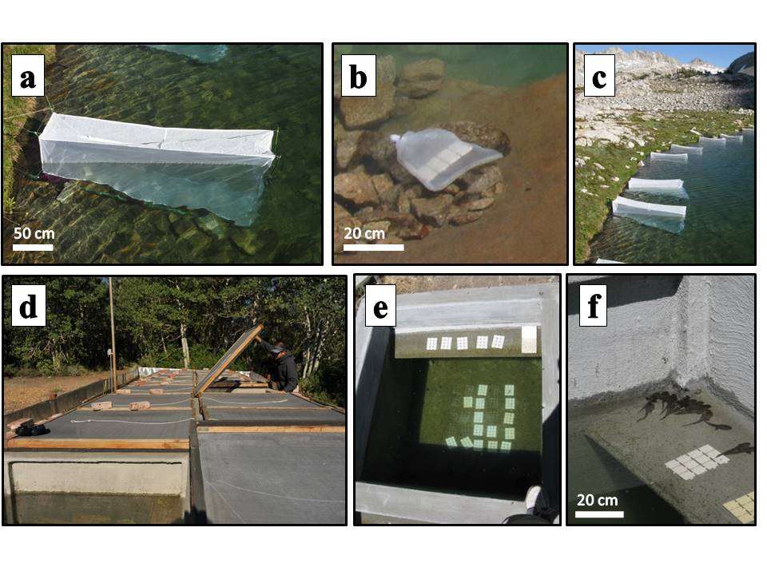

FIG. 1. a) *in situ* experimental mesh enclosure in LeConte lake, b) no consumer location-within-lake control tiles in bag of same mesh as enclosure and placed next to enclosure, c) Field enclosures erected in one of the study lakes in Kings Canyon National Park, CA, USA, d) mesocosms located at Sierra Nevada Aquatic Research Laboratory in Mammoth Lakes, CA, e) view of experimental tiles and algal growth in one mesocosm (some tiles were removed for sampling at the time of the photograph), and f) tadpoles basking on shelf in a mesocosm.

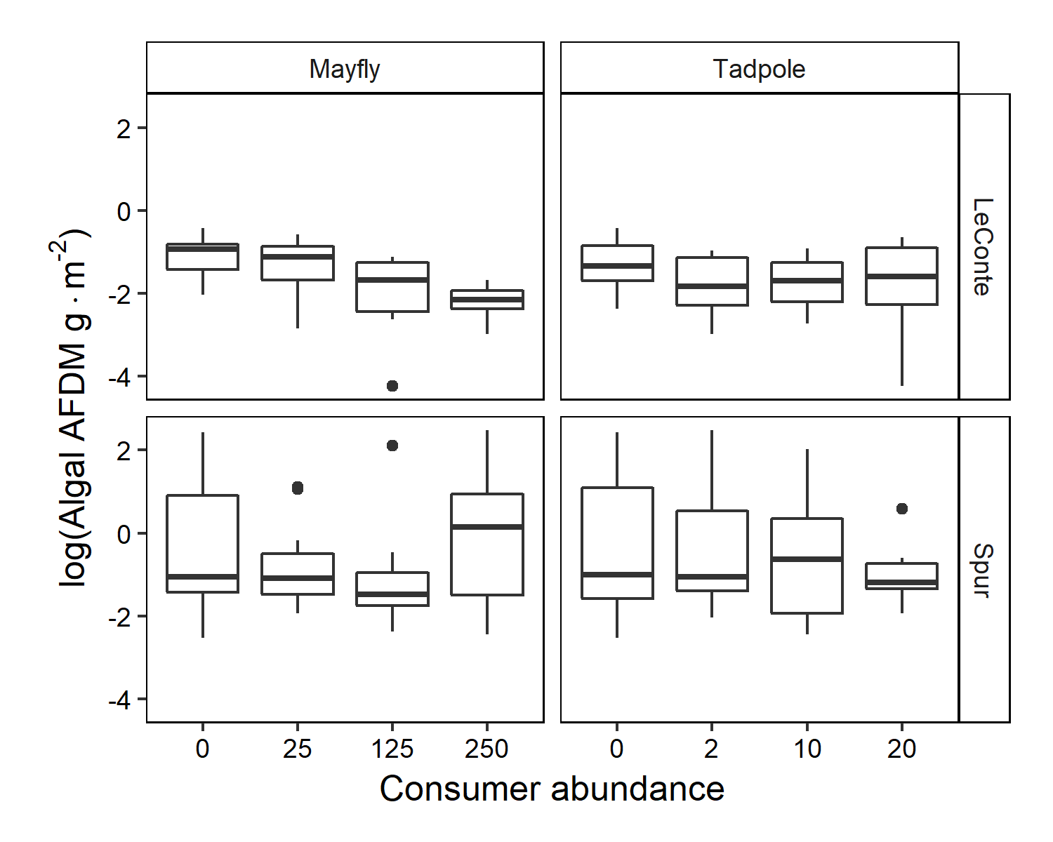

Figure 2. For 2009 field enclosure experiment, algal abundance (log grams of ash free dry mass per square meter), with respect to lake and to each consumer. In all boxplots, the median is indicated by the heavy bar; the first and third quartiles are indicated by the outer edges of the boxes; whiskers include the most extreme values less than 1.5x the distance between first and third quartiles; points beyond whiskers are more extreme than 1.5x the interquartile distance.

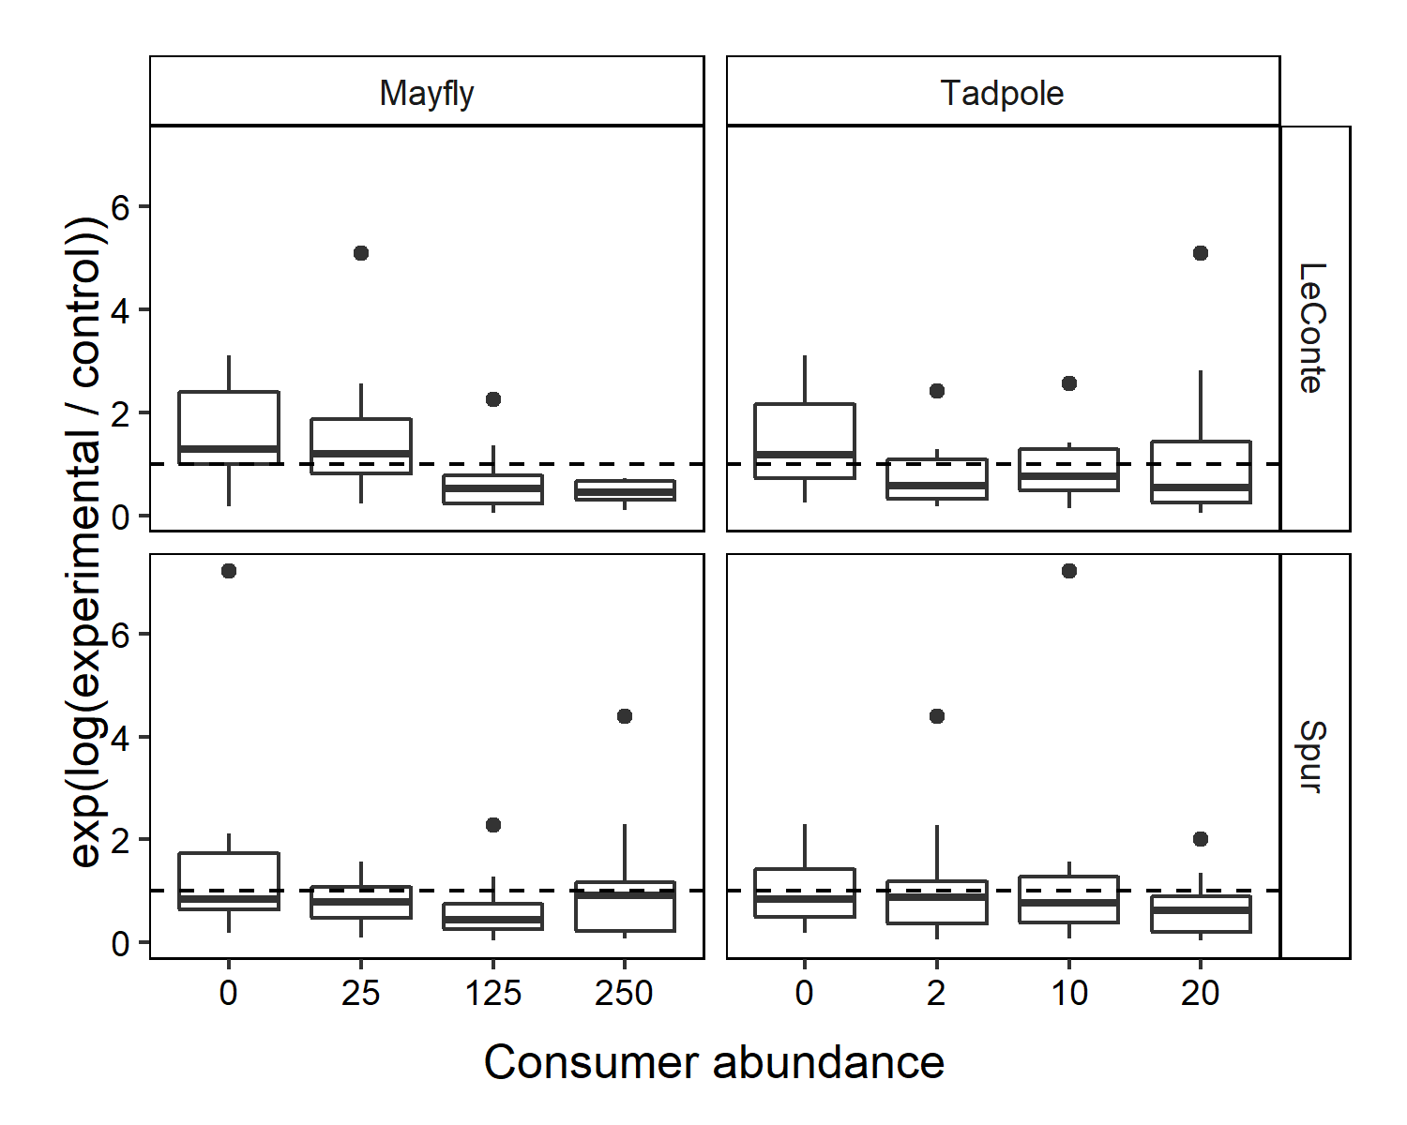

Figure 3. For 2009 field enclosure experiment, back transformed log-ratio of experimental to control algal abundance, with respect to lake and to each consumer. The line at 1 represents the value if experimental and control tiles had equal algal abundance, and data points below the line represent where the abundance of algae on experimental tiles was less than that on control tiles. Boxplots as in Fig. 2.

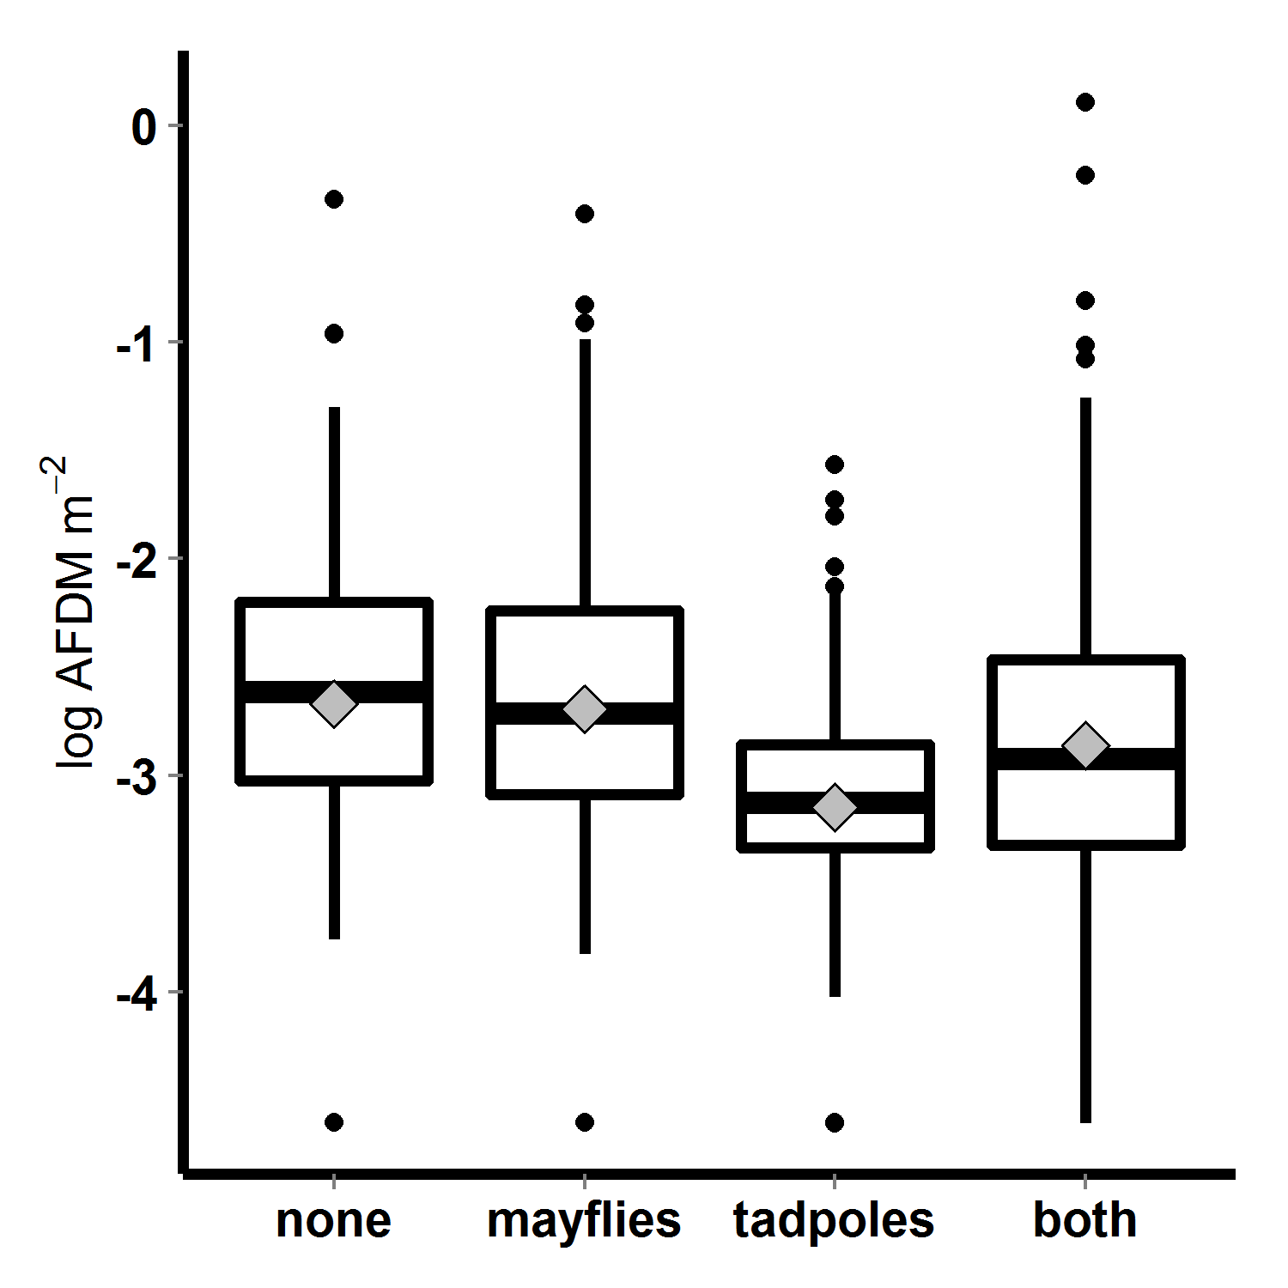

Figure 4. Algal abundance (log transformed mg AFDM m-2) in mesocosm experiment, with respect to tadpole and mayfly treatments;, boxes contain 50% of data, whiskers contain 95% of the data, points are outliers, bars indicate medians and diamonds indicate means.

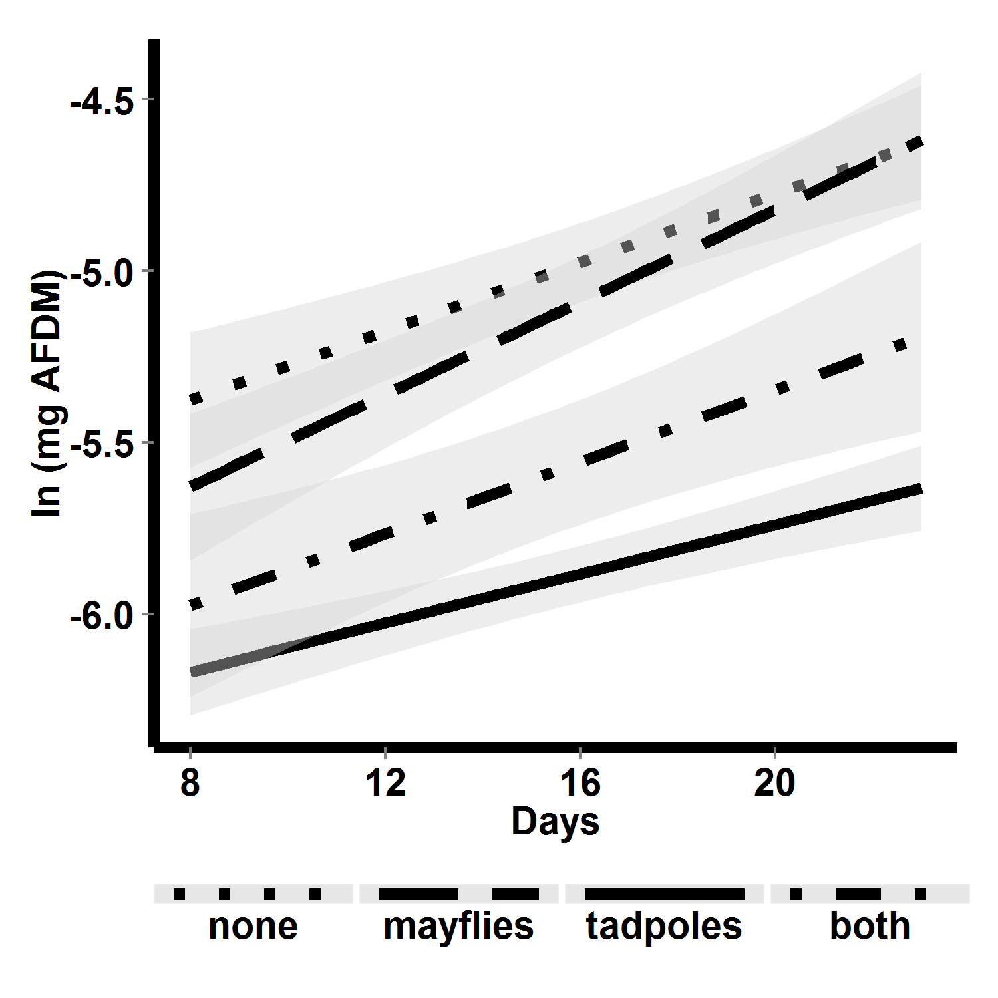

Figure 5. Algal abundance (log transformed mg AFDM m-2) over time in mesocosms, with respect to consumer treatment. Lines are linear fits, and shaded areas are 95% confidence regions for those fits. Algal growth rates did not differ among treatments.

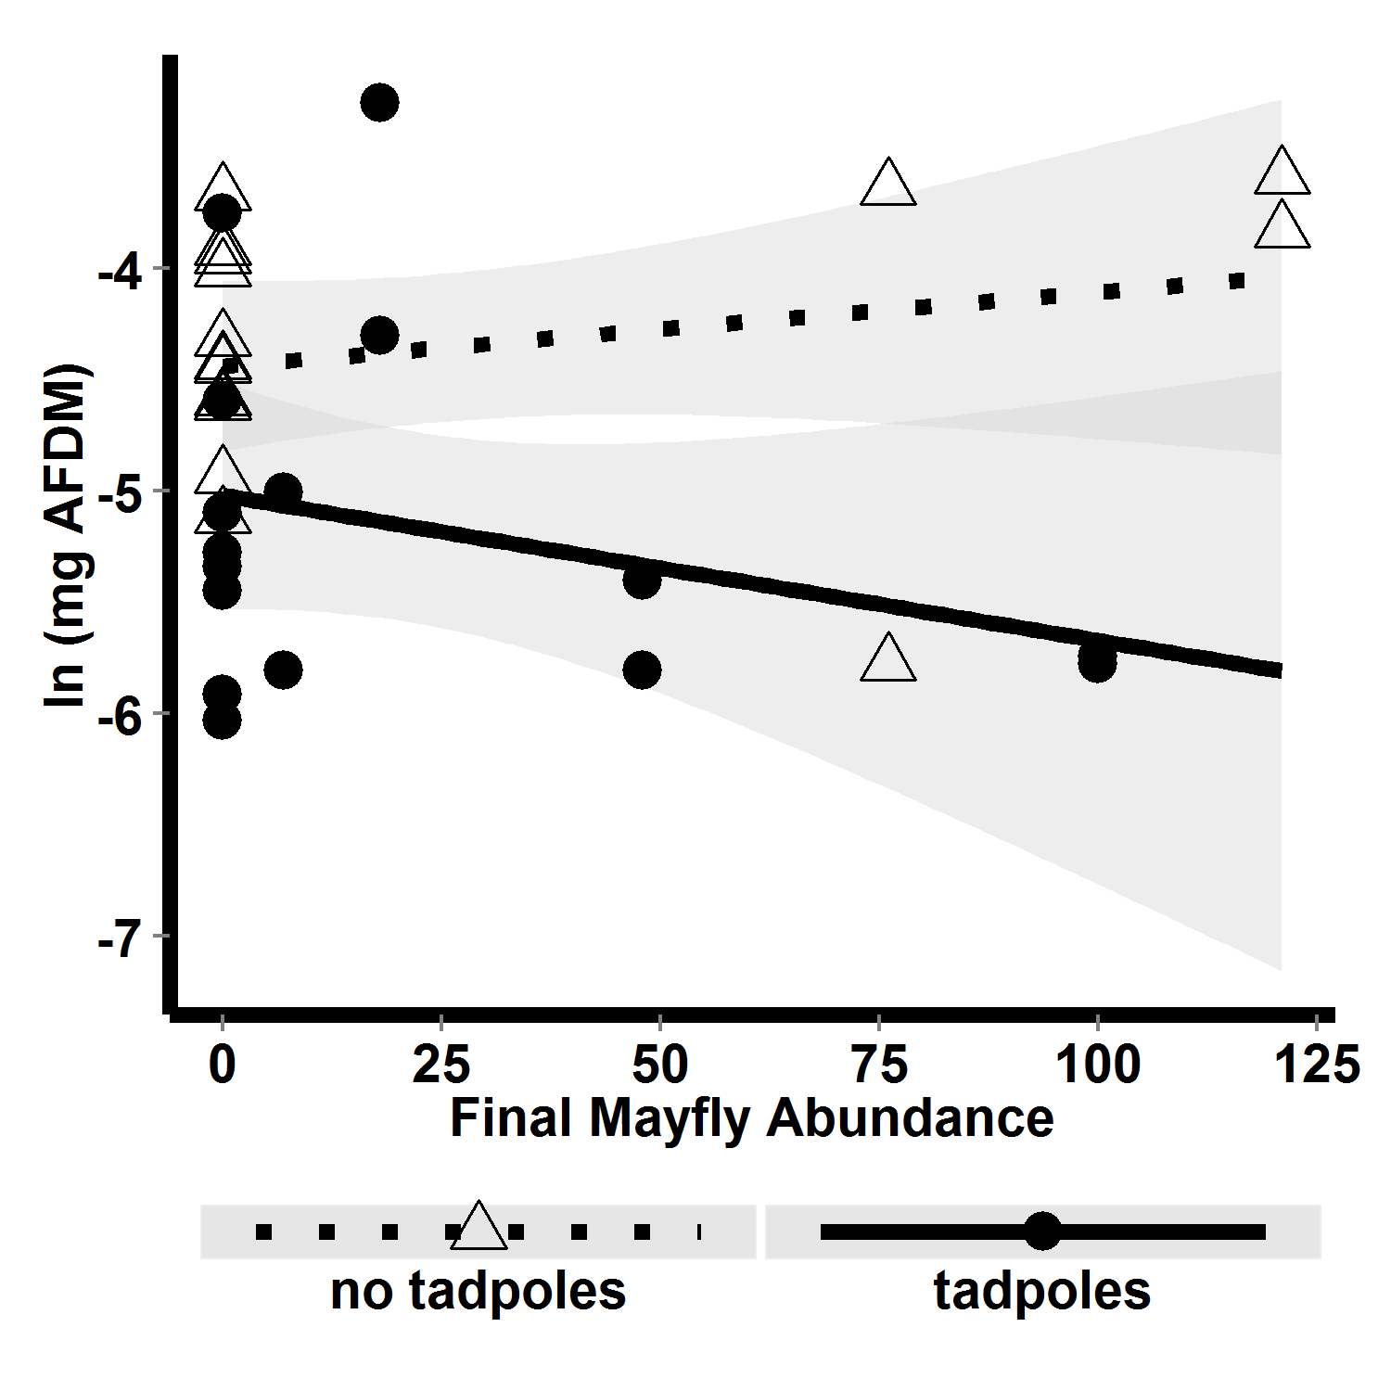

Figure 6. Mesocosm algal abundance (log transformed mg AFDM m-2) with respect to interaction between final mayfly abundance and tadpole presence-absence. Dotted line shows the relationship between algal abundance and mayfly abundance when tadpoles were absent, and solid line shows the relationship between algal abundance and mayfly abundance when tadpoles were present. Mayflies reduced algal abundance only when tadpoles were present.