# Bending Moment Diagram and Shear Force Diagram

## Bending Moment Diagram

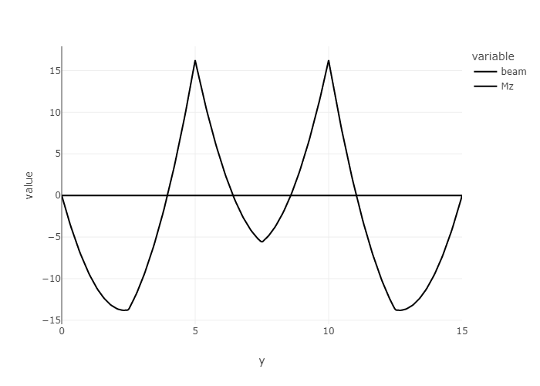

## Shear Force Diagram

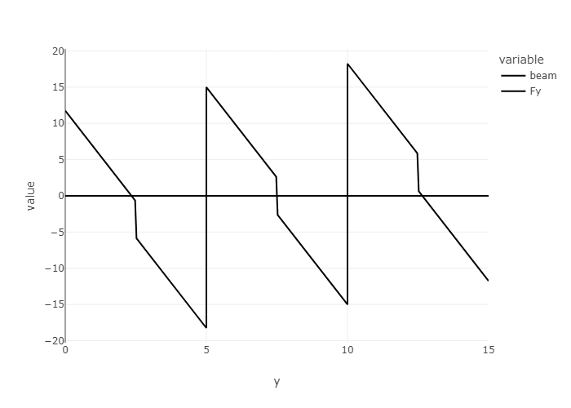

## Deflection Diagram

