Paper Title* (use style: paper title)
*Note: Sub-titles are not captured in Xplore and should not be used

line 1: 1st Given Name Surname
line 2: dept. name of organization (of Affiliation)
line 3: name of organization (of Affiliation)
line 4: City, Country
line 5: email address or ORCID
line 1: 2nd Given Name Surname
line 2: dept. name of organization (of Affiliation)
line 3: name of organization (of Affiliation)
line 4: City, Country
line 5: email address or ORCID
line 1: 3rd Given Name Surname
line 2: dept. name of organization (of Affiliation)
line 3: name of organization (of Affiliation)
line 4: City, Country
line 5: email address or ORCID
line 1: 4th Given Name Surname
line 2: dept. name of organization (of Affiliation)
line 3: name of organization (of Affiliation)
line 4: City, Country
line 5: email address or ORCID

line 1: 5th Given Name Surname
line 2: dept. name of organization (of Affiliation)
line 3: name of organization (of Affiliation)
line 4: City, Country
line 5: email address or ORCID
line 1: 6th Given Name Surname
line 2: dept. name of organization (of Affiliation)
line 3: name of organization (of Affiliation)
line 4: City, Country
line 5: email address or ORCID

Abstract—This electronic document is a “live” template and already defines the components of your paper [title, text, heads, etc.] in its style sheet. *CRITICAL: Do Not Use Symbols, Special Characters, Footnotes, or Math in Paper Title or Abstract. (Abstract)
Keywords—component, formatting, style, styling, insert (key words)

Introduction (Heading 1)
This template, modified in MS Word 2007 and saved as a “Word 97-2003 Document” for the PC, provides authors with most of the formatting specifications needed for preparing electronic versions of their papers. All standard paper components have been specified for three reasons: (1) ease of use when formatting individual papers, (2) automatic compliance to electronic requirements that facilitate the concurrent or later production of electronic products, and (3) conformity of style throughout a conference proceedings. Margins, column widths, line spacing, and type styles are built-in; examples of the type styles are provided throughout this document and are identified in italic type, within parentheses, following the example. Some components, such as multi-leveled equations, graphics, and tables are not prescribed, although the various table text styles are provided. The formatter will need to create these components, incorporating the applicable criteria that follow.

Ease of Use

Selecting a Template (Heading 2)
First, confirm that you have the correct template for your paper size. This template has been tailored for output on the US-letter paper size. If you are using A4-sized paper, please close this file and download the file “MSW_A4_format”.

Maintaining the Integrity of the Specifications
The template is used to format your paper and style the text. All margins, column widths, line spaces, and text fonts are prescribed; please do not alter them. You may note peculiarities. For example, the head margin in this template measures proportionately more than is customary. This measurement and others are deliberate, using specifications that anticipate your paper as one part of the entire proceedings, and not as an independent document. Please do not revise any of the current designations.
Identify applicable funding agency here. If none, delete this text box.

CONTINUOUS WAVELET TRANSFORM
In this section we describe the approach to take advantage of the success of Convolutional Neural Networks (CNN) in processing images for classification. This has been applied across multiple domains (references?). Here we propose to transform the 1-dimensional time series from each detector site into a 2-dimensional image using the Continuous Wavelet transform (CWT). This is accomplished by taking the spectrogram of the CWT.
The CWT is given by transforming a time signal into its frequency (psi) and amplitude (a) components:
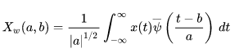
A diagram of the pre-processing is shown below (figure name/number?). A training example where there is a gravitational wave is shown on the upper left (Signal). Similarly, a training example where there is no gravitational wave (just detector noise) is shown in the upper right (Noise). The first row of diagrams shows detector output for each of the 3 sites for 2 seconds (4096 samples). From the naked eye it is hard to tell if these represent time series from a gravitational wave or just noise. Note the scale of the Y-axis is 1e-20. The second row of diagrams shows the result of the first step of pre-processing: normalizing the signals by the z-transform. Again it is difficult to tell the difference between detector output with a gravitational wave and with just noise. The third row of diagrams shows the CWT spectrogram of the normalized signal after applying a bandpass filter to remove frequencies below 15 Hz and above 500 Hz. It was given in the problem statement that typical gravitiational waves are around 350 Hz.

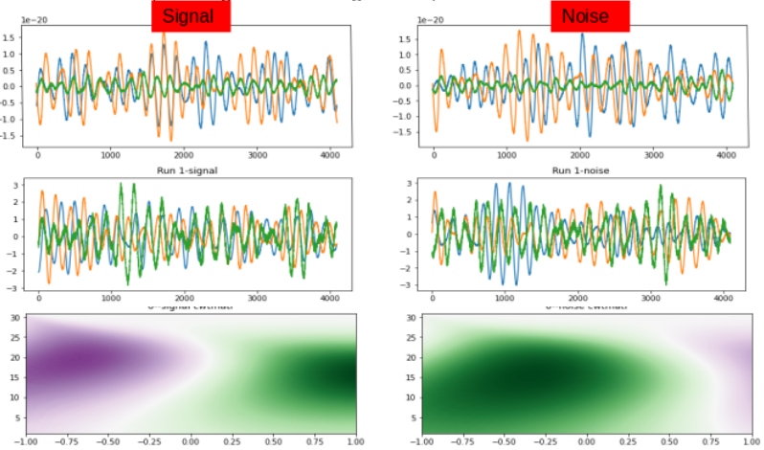
The figure below (name, number?) shows a diagram of the CNN used to process the spectrogram images. Each image is 300x97 pixels. As shown the CNN consists of multiple convolutional and pooling layers for the feature extractor. The output layer classifies the image as 1 for gravitational wave detected or 0 for no detection.

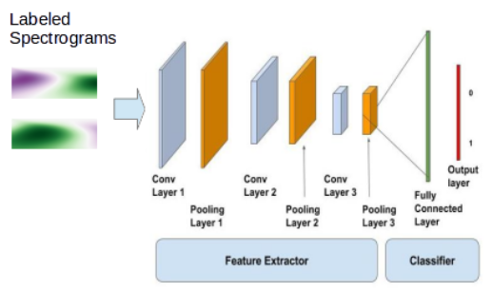
The figure below (name, number?) shows the summary description of the Tensorflow model.
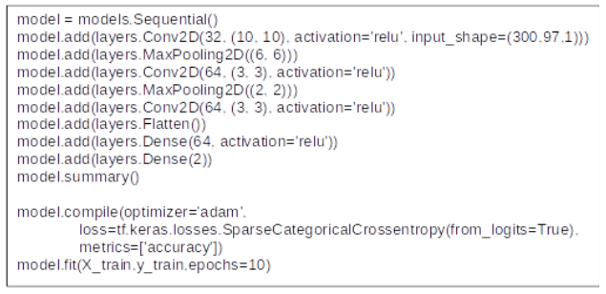
The figure below (name, number?) shows the initial results of running 1000 training examples through the model using a 60/20/20 training/test/validation split. During the training the accuracy increased with each epoch, eventually reaching 0.795 after 30 epochs. The divergence of the accuracy and validation shows that overfitting is happening. Though it appears our model is getting more accurate, running the test data through achieves a score of 0.43. If this were the entirety of the training set we should actually take the opposite of whatever our model predicts! However, the low score is probably due to the small amount of training/test samples used for this analysis.

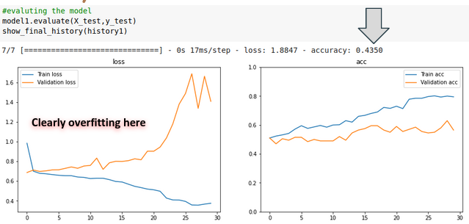
The figure below (name, number?) shows the results of running 10000 training examples through the model using a 60/20/20 training/test/validation split. Here we use regularization in training the model and see that overfitting is not occuring. However, our test accuracy is 0.505 so our model is not much better than flipping a coin. This indicates our pre-processing is not doing much to differentiate detector output with gravitational waves from those with just noise. So more work needs to be done on the pre-processing step. Some ideas include:
1) changing the bandpass filter parameters to allow more or less data through.
2) making larger/smaller images to pass into the CNN
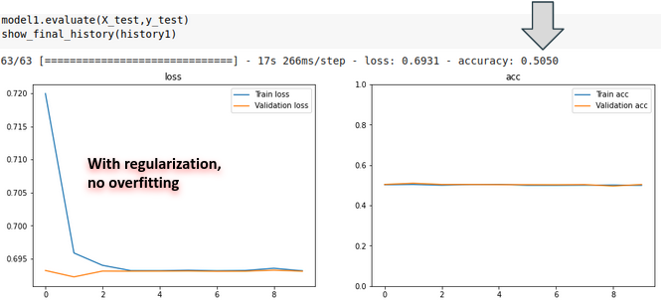

In summary, an approach was developed to perform pre-processing on detector output using the Continuous Wavelet Transform. The data was processed through a Convolutional Neural Network using Tensorflow. Results were inconclusive regarding the ability of the model to detect gravitational waves and ideas for further study were presented.

Abbreviations and Acronyms
Define abbreviations and acronyms the first time they are used in the text, even after they have been defined in the abstract. Abbreviations such as IEEE, SI, MKS, CGS, sc, dc, and rms do not have to be defined. Do not use abbreviations in the title or heads unless they are unavoidable.

Units
- Use either SI (MKS) or CGS as primary units. (SI units are encouraged.) English units may be used as secondary units (in parentheses). An exception would be the use of English units as identifiers in trade, such as “3.5-inch disk drive”.
- Avoid combining SI and CGS units, such as current in amperes and magnetic field in oersteds. This often leads to confusion because equations do not balance dimensionally. If you must use mixed units, clearly state the units for each quantity that you use in an equation.
- Do not mix complete spellings and abbreviations of units: “Wb/m2” or “webers per square meter”, not “webers/m2”. Spell out units when they appear in text: “. . . a few henries”, not “. . . a few H”.
- Use a zero before decimal points: “0.25”, not “.25”. Use “cm3”, not “cc”. (bullet list)

Equations
The equations are an exception to the prescribed specifications of this template. You will need to determine whether or not your equation should be typed using either the Times New Roman or the Symbol font (please no other font). To create multileveled equations, it may be necessary to treat the equation as a graphic and insert it into the text after your paper is styled.
Number equations consecutively. Equation numbers, within parentheses, are to position flush right, as in (1), using a right tab stop. To make your equations more compact, you may use the solidus ( / ), the exp function, or appropriate exponents. Italicize Roman symbols for quantities and variables, but not Greek symbols. Use a long dash rather than a hyphen for a minus sign. Punctuate equations with commas or periods when they are part of a sentence, as in:
a  b    
Note that the equation is centered using a center tab stop. Be sure that the symbols in your equation have been defined before or immediately following the equation. Use “(1)”, not “Eq. (1)” or “equation (1)”, except at the beginning of a sentence: “Equation (1) is . . .”

Some Common Mistakes
- The word “data” is plural, not singular.
- The subscript for the permeability of vacuum μ₀, and other common scientific constants, is zero with subscript formatting, not a lowercase letter “o”.
- In American English, commas, semicolons, periods, question and exclamation marks are located within quotation marks only when a complete thought or name is cited, such as a title or full quotation. When quotation marks are used, instead of a bold or italic typeface, to highlight a word or phrase, punctuation should appear outside of the quotation marks. A parenthetical phrase or statement at the end of a sentence is punctuated outside of the closing parenthesis (like this). (A parenthetical sentence is punctuated within the parentheses.)
- A graph within a graph is an “inset”, not an “insert”. The word alternatively is preferred to the word “alternately” (unless you really mean something that alternates).
- Do not use the word “essentially” to mean “approximately” or “effectively”.
- In your paper title, if the words “that uses” can accurately replace the word “using”, capitalize the “u”; if not, keep using lower-cased.
- Be aware of the different meanings of the homophones “affect” and “effect”, “complement” and “compliment”, “discreet” and “discrete”, “principal” and “principle”.
- Do not confuse “imply” and “infer”.
- The prefix “non” is not a word; it should be joined to the word it modifies, usually without a hyphen.
- There is no period after the “et” in the Latin abbreviation “et al.”.
- The abbreviation “i.e.” means “that is”, and the abbreviation “e.g.” means “for example”.
An excellent style manual for science writers is [7].

Using the Template
After the text edit has been completed, the paper is ready for the template. Duplicate the template file by using the Save As command, and use the naming convention prescribed by your conference for the name of your paper. In this newly created file, highlight all of the contents and import your prepared text file. You are now ready to style your paper; use the scroll down window on the left of the MS Word Formatting toolbar.

Authors and Affiliations
The template is designed for, but not limited to, six authors. A minimum of one author is required for all conference articles. Author names should be listed starting from left to right and then moving down to the next line. This is the author sequence that will be used in future citations and by indexing services. Names should not be listed in columns nor group by affiliation. Please keep your affiliations as succinct as possible (for example, do not differentiate among departments of the same organization).

For papers with more than six authors: Add author names horizontally, moving to a third row if needed for more than 8 authors.

For papers with less than six authors: To change the default, adjust the template as follows.

Selection: Highlight all author and affiliation lines.

Change number of columns: Select the Columns icon from the MS Word Standard toolbar and then select the correct number of columns from the selection palette.

Deletion: Delete the author and affiliation lines for the extra authors.

Identify the Headings
Headings, or heads, are organizational devices that guide the reader through your paper. There are two types: component heads and text heads.
Component heads identify the different components of your paper and are not topically subordinate to each other. Examples include Acknowledgments and References and, for these, the correct style to use is “Heading 5”. Use “figure caption” for your Figure captions, and “table head” for your table title. Run-in heads, such as “Abstract”, will require you to apply a style (in this case, italic) in addition to the style provided by the drop down menu to differentiate the head from the text.
Text heads organize the topics on a relational, hierarchical basis. For example, the paper title is the primary text head because all subsequent material relates and elaborates on this one topic. If there are two or more sub-topics, the next level head (uppercase Roman numerals) should be used and, conversely, if there are not at least two sub-topics, then no subheads should be introduced. Styles named “Heading 1”, “Heading 2”, “Heading 3”, and “Heading 4” are prescribed.

Figures and Tables

Positioning Figures and Tables: Place figures and tables at the top and bottom of columns. Avoid placing them in the middle of columns. Large figures and tables may span across both columns. Figure captions should be below the figures; table heads should appear above the tables. Insert figures and tables after they are cited in the text. Use the abbreviation “Fig. 1”, even at the beginning of a sentence.
- Table Type Styles
Table Head | Table Column Head
Table Head | Table column subhead | Subhead | Subhead
copy | More table copyª
- Sample of a Table footnote. (Table footnote)
- Example of a figure caption. (figure caption)
Figure Labels: Use 8 point Times New Roman for Figure labels. Use words rather than symbols or abbreviations when writing Figure axis labels to avoid confusing the reader. As an example, write the quantity “Magnetization”, or “Magnetization, M”, not just “M”. If including units in the label, present them within parentheses. Do not label axes only with units. In the example, write “Magnetization (A/m)” or “Magnetization {A[m(1)]}”, not just “A/m”. Do not label axes with a ratio of quantities and units. For example, write “Temperature (K)”, not “Temperature/K”.

Acknowledgment (Heading 5)
The preferred spelling of the word “acknowledgment” in America is without an “e” after the “g”. Avoid the stilted expression “one of us (R. B. G.) thanks ...”. Instead, try “R. B. G. thanks...”. Put sponsor acknowledgments in the unnumbered footnote on the first page.

References
The template will number citations consecutively within brackets [1]. The sentence punctuation follows the bracket [2]. Refer simply to the reference number, as in [3]—do not use “Ref. [3]” or “reference [3]” except at the beginning of a sentence: “Reference [3] was the first ...”
Number footnotes separately in superscripts. Place the actual footnote at the bottom of the column in which it was cited. Do not put footnotes in the abstract or reference list. Use letters for table footnotes.
Unless there are six authors or more give all authors’ names; do not use “et al.”. Papers that have not been published, even if they have been submitted for publication, should be cited as “unpublished” [4]. Papers that have been accepted for publication should be cited as “in press” [5]. Capitalize only the first word in a paper title, except for proper nouns and element symbols.
For papers published in translation journals, please give the English citation first, followed by the original foreign-language citation [6].

- G. Eason, B. Noble, and I. N. Sneddon, “On certain integrals of Lipschitz-Hankel type involving products of Bessel functions,” Phil. Trans. Roy. Soc. London, vol. A247, pp. 529–551, April 1955. (references)
- J. Clerk Maxwell, A Treatise on Electricity and Magnetism, 3rd ed., vol. 2. Oxford: Clarendon, 1892, pp.68–73.
- I. S. Jacobs and C. P. Bean, “Fine particles, thin films and exchange anisotropy,” in Magnetism, vol. III, G. T. Rado and H. Suhl, Eds. New York: Academic, 1963, pp. 271–350.
- K. Elissa, “Title of paper if known,” unpublished.
- R. Nicole, “Title of paper with only first word capitalized,” J. Name Stand. Abbrev., in press.
- Y. Yorozu, M. Hirano, K. Oka, and Y. Tagawa, “Electron spectroscopy studies on magneto-optical media and plastic substrate interface,” IEEE Transl. J. Magn. Japan, vol. 2, pp. 740–741, August 1987 [Digests 9th Annual Conf. Magnetics Japan, p. 301, 1982].
- M. Young, The Technical Writer’s Handbook. Mill Valley, CA: University Science, 1989.
IEEE conference templates contain guidance text for composing and formatting conference papers. Please ensure that all template text is removed from your conference paper prior to submission to the conference. Failure to remove template text from your paper may result in your paper not being published.

