Maintaining the Files in the QBSDK
Onscreen Reference (v3.0)
This file updated 12/03/03

Location of Files 1
Filename Abbreviations 1
File-Naming Conventions 1
Notes on the Table 3
Example of #5 (index-QBFC.html) 4
Example of #12 (requests-QBFC.html.xp and requests-QBFC.html) 5
Example of #8 and #15 (after a message has been selected) 5
Exception Text (Explanation of #21 through #26) 6
What to Do When the Spec Changes 7

Location of Files
The master files are in Perforce at //IDN/main/QBSDK/src/OSR/

Filename Abbreviations
QBD = qbXML API for QuickBooks desktop
QBC = qbXML or QBFC API for QuickBooks Canada Edition
QBO = qbXML API for QuickBooks Online Edition
QBFC = QBFC for all QuickBooks

File-Naming Conventions
X means this file includes text that is maintained by hand. (Most of this never has to change.)

# |  | General Files
1 | X | index.html | OSR home page
2 | X | index-QBD.html | Main page for QB Reference (qbXML)
3 | X | index-QBC.html | Main page for QBC Reference (qbXML)
4 | X | index-QBO.html | Main page for QBOE Reference (qbXML)
5 | X | index-QBFC.html | Main page for QBFC Reference
6 | X | ORTExceptions.xml | XML doc that shows which element-, aggregate-, and product-exception files should exist (Note: some are obsolete….)
7 | X | styleguide.css | Style sheet for top, middle, & bottom frames

 |  | Files for the Top & Middle Frames | These files are automatically generated
8 |  | QBD-<operation>Rq.html  QBD-<operation >Rs.html | Files for the middle frame for QB.  E.g., QBD-AccountAddRq.html
9 |  | QBC-<operation >Rq.html  QBC-<operation >Rs.html | Files for the middle frame for QBC
10 |  | QBO-<operation >Rq.html  QBO-<operation >Rs.html | Files for the middle frame for QBOE
11 |  | QBFC-<operation >Rq.html  QBFC- <operation >Rs.html | Files for the middle frame for QBFC
12 |  | requests-<product>.html and  requests-<product>.html.xp | Files for the top frame for all the combinations.  <product> = QBD, QBC, QBO, or QBFC

# |  | Default Files for Bottom Frame |  | Text that appears in the bottom frame when something is clicked in the middle frame--if the tool doesn’t find any exception files
13 | X | <element name>.html |  | E.g., Addr1.html
14 | X | <data type>.html |  | E.g., ENUMTYPE.html
15 | X | <aggregate name>.html  (e.g., EntityFilter.html;  Employee.html) |  | E.g., the text in the Employee.html file appears when EmployeeAdd, EmployeeMod, or EmployeeRet is clicked
16 | X | <attribute>.html |  | E.g., defMacro.html
17 |  | QBFC-I<object>List.html or  QBFC-I <object>List.html |  | Auto-generated text that appears when the user clicks a QBFC “list object” data type. (E.g., in the QBFC ItemQuery response, they click on IDataExtRetList.)
19 | X | QBFC-<xxx>List.html |  | You see these files when you click a QBFC “list object.” (E.g., in the QBFC ItemQuery response, click DataExtRetList. Does not start with “I” like the list object data type described above.)
20 | X | qbXML only:  <enum>.html. xp  <enum>.html |  | Files that combine hand-written text with auto-generated list of enum values.  The files that result after regeneration.
 |  | Exception Files for Bottom Frame |  | Text that appears in the bottom frame when exception text is called for (as shown in the ORTExceptions.xml file)
 |  |  |  | 3 types of element exceptions:
21 | X | <product>-<aggregate>-<element>.html |  | Appears when this element is clicked in the context of this aggregate in this product. Top priority exception.
22 | X | <product>-<element>.html  (applies to any aggregate) |  | Appears when this element is clicked in the context of this product. 2nd priority.
23 | X | special case for QBFC:  <product>-<data type>.html |  | All enum types have QBFC exception files as appropriate, because these files are generated differently from the qbXML enum types. NOTE: These exceptions do not have entries in ORTExceptions.xml.
24 | X | <aggregate>-<element>.html  (applies to any product) |  | Appears when this element is clicked in the context of this aggregate. 3rd priority.
 |  |  |  | 1 type of aggregate exception and 1 type of attribute exception:
25 | X | <product>-<aggregate>.html
26 | X | <product>-<attribute>.html |  | Only product exceptions are possible for attributes. (No aggregate exceptions.)

 |  | Message Set Files for Bottom Frame | Text that appears in the bottom frame when something is selected in the top frame. (Nothing has to be clicked in the middle frame.) Most of these files are blank.
27 | X | <object><operation>.html  e.g., ChargeAdd.html;  ChargeMod.html;  ChargeQuery.html | E.g., the html file appears in the bottom frame when, from qbXML QBD, QBC, or QBOE, the user selects the following in the top frame (without clicking anything):  ChargeAdd Request or Response  ChargeMod Request or Response  ChargeQuery Request or Response
28 | X | QBFC-<operation>.html | These files mirror the files described above, but for QBFC. (You select ChargeMod, and QBFC- ChargeMod.html appears in the bottom frame.)
 |  | Other Files | Misc
29 | X | help1.html  help2.html  help3.html  help4.html | Links to these files appear within OSR-Help-Midframe.html.  Getting started  More info  Other docs  Abbreviations
30 | X | OSR-Help-Midframe.html | Appears in the middle frame before you select a message. Has links to the files in #29 above.
31 |  | blank.html
32 | X | <product>-errorcodes.html  <product>-extras.html | Links to these files appear in the top frame. <product> = QBD, QBC, QBO, or QBFC  The “Errors” link for each API/product combo  The “Help” link for each API/product combo
33 | X | qbXML only:  <product>-attributes.html | Links to these files appear in the top frame. <product>= QBD, QBC, or QBO
34 | X | QBOE only:  QBO-signon.html | Link to this appears in the top frame of index-QBO.html
35 | X | QBFC only:  QBFC-quickref.html | Link to this appears in the top frame of index-QBFC.html

Notes on the Table
- Compare #27 with #15. Important but subtle difference.
- #20: When editing an <enum>.html file like AccountType.html, you must also edit AccountType.html.xp, or else the changes will be lost when the files are regenerated. You should also edit QBFC-AccountType.html. (The QBFC enums don’t have .xp files, because they are presented differently.)

Example of #5 (index-QBFC.html)
Figure 1 What’s actually in index-QBFC.html (#5)
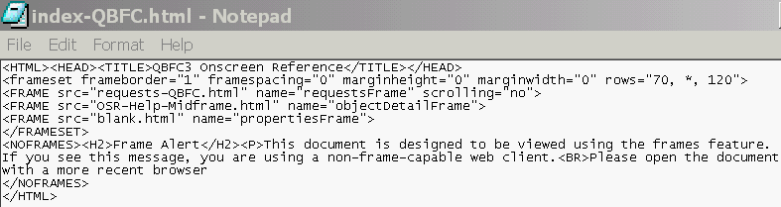
Describes what will be in the top frame

Middle frame

Bottom frame

Figure 2 What index-QBFC.html looks like in a browser window
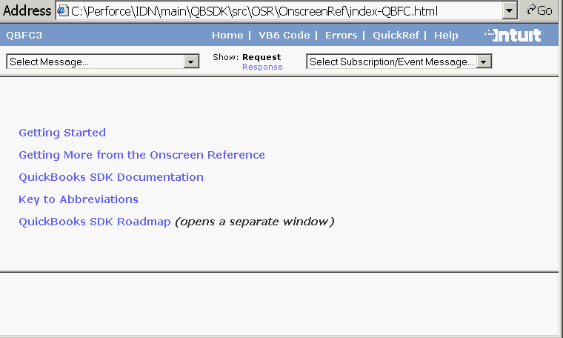
Top frame =
requests-QBFC.html (#12). See example below.
Middle frame always starts as OSR-Help-Midframe.html (#30)
Bottom frame (always starts as blank.html)
When you click one of these links, the text appears in the bottom frame (#29).

Example of #12 (requests-QBFC.html.xp and requests-QBFC.html)

Here’s how requests-QBFC-html appears in a browser. (This is the top frame from the previous graphic.)

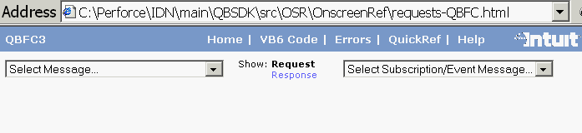
To edit it, you must edit requests-QBFC.html.xp, which contains JavaScript and regular HTML. When you edit these .xp files, be careful not to change any of the JavaScript.

Example of #8 and #15 (after a message has been selected)

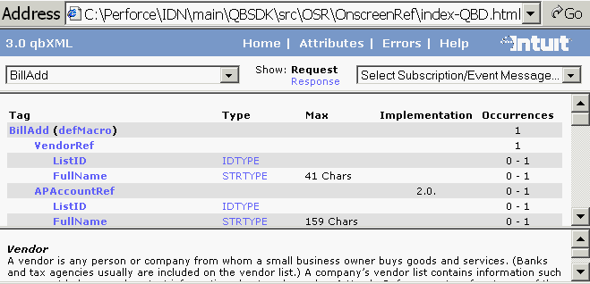
Middle frame =
QBD-BillAddRq.html
(example of #8)
Bottom frame = Vendor.html (The VendorRef aggregate has been clicked—example of #15)

Exception Text (Explanation of #21 through #26)

The acceptable format for the exceptions is shown in ORTExceptions.xml. It’s basically this:
<DocExceptions>
<ElementException> … </ElementException>
<AggregateException> … </AggregateException>
</DocExceptions>
with as many ElementException and AggregateException aggregates as you need.

Element Exceptions (#21, #22, and #24)
Each Element exception can be in one of three forms:
<ElementException>
<Element> … </Element> //El., Ag., & Prod. are case-sensitive
<Aggregate> … </Aggregate>
<Product> … </Product> //Product can be QBD, QBC, or QBO
</ElementException

or
<ElementException>
<Element> … </Element>
<Product> … </Product> //Product can be QBD, QBC, or QB </ElementException>
(equivalent to including a wildcard <Aggregate>ALL</Aggregate>, which is also acceptable)

or
<ElementException>
<Element> … </Element>
<Aggregate> … </Aggregate>
</ElementException>
(equivalent to including a wildcard <Product>ALL</Product>, which is also acceptable)

Aggregate Exceptions (#25)
Each Aggregate exception can be in only one form:
<Aggregate Exception>
<Aggregate> … </Aggregate>
<Product> … </Product>
</ Aggregate Exception

Attribute Exceptions (#26)
Each Attribute exception can be in only one form:
<Attribute Exception>
<Attribute> … </Aggregate>
<Product> … </Product>
</ Aggregate Exception

Treatment of Objects
Instead of including any aggregate ending in –Ref, -Ret, -Mod, -Del, -Add, or –Query, use the object name where you would normally use the aggregate name. (Example: Instead of BillQuery, use Bill.)

Creating Files with Exception Text
Each exception needs a corresponding .html file with text in it. For example, this exception enables you to write text for the Country element within Currency messages, different from what appears for the Country element in other contexts.
<ElementException>
<Element>Country</Element>
<Aggregate>Currency</Aggregate>
<Product>QBC</Product>
</ElementException>
You’d need to create a corresponding file called QBC-Currency-Country.html.

When the OSR is regenerated, docgen checks ORTException.xml file for expected exceptions, then links the exception text to the appropriate places in the –Rq.html and –Rs.html files as appropriate.

What to Do When the Spec Changes

- Update index.html (#1):
- If the font or colors need changing, make those changes in styleguide.css.
- Change what’s within the <title> tag to reflect the new version (4.0 or whatever).
- Change the text within the <body> tag as needed … i.e., the title, the names of the API/product combinations, the copyright year, the links….
- Update index-QBD.html, index-QBC.html, etc. (#2 through #5):
- Change what’s within the <title> tag to reflect the new version (4.0 or whatever).
- Update requests-QBD.html.xp, requests-QBC.html.xp, etc. (#12):
- If the font or colors need changing, make those changes in styleguide.css.
- Change the text within the <body> tag as needed … i.e., the title, the names of the API/product combinations, the copyright year, the links….
- Be careful when editing the html.xp files not to change any of the JavaScript that will be used to create the corresponding .html file.
- Update QBD-errorcodes.html, QBC-errorcodes.html, etc. (#32) if needed.
- Update QBD-extras.html, QBC-extras.html, etc. (#32):
- If the font or colors need changing, make those changes in styleguide.css.
- Change what’s within the <title> tag to reflect the new version (4.0 or whatever).
- Add any new abbreviations (e.g., “4.0”).
- Update the version and copyright information at the bottom.
- NOTE: If you change the “Help” portion of one of these files, be sure to replicate that change in the other -extras.html files and in the Help1.html, Help2.html, Help3.html, or Help4.html files.
- Update QBD-attributes.html, QBC-attributes.html, etc. (# 33) if there are new (high-level) attributes.
- Update QBO-signon.html (#34) if there are changes to the sign-on procedure for QBOE.
- Update QBFC-quickref.html (#35) with any new high-level QBFC objects or any new functions within the high-level objects.
- Have Lois regenerate the OSR.
- Search the OSR folder for files that contain the text “stub page” and add text to them.
- Get a list of new .xp files from Lois or Ha and make sure these files have the text they need.
- Create exception text when/if needed. (See “Exception Text” above.)

Make sure to check all changes into Perforce.

