WEB-BASED DOCUMENT TRACKING AND RECORDS MANAGEMENT SYSTEM
FOR THE BUREAU OF LOCAL GOVERNMENT FINANCE – REGION II
_____________________
A Thesis Presented to
the Faculty of the Graduate School
Cagayan State University – Carig Campus
Tuguegarao City
_____________________
In Partial Fulfillment of the
Academic Requirements for the degree
MASTER OF SCIENCE IN INFORMATION TECHNOLOGY
_____________________
By:
TOM TOM G. CATRAL
JULY 2026

APPROVAL SHEET
This thesis proposal entitled “Web-Based Document Tracking and Records Management System for the Bureau of Local Government Finance – Region II,” prepared and submitted by TOM TOM G. CATRAL in partial fulfillment of the requirements for the degree MASTER OF SCIENCE IN INFORMATION TECHNOLOGY, has been examined and is recommended for proposal defense.
____________________________________
[NAME OF THESIS ADVISER]
Thesis Adviser
Approved by the Thesis Committee:
Panel Member | Signature | Date
[NAME OF CHAIRPERSON] | ________________ | ________________
[NAME OF PANEL MEMBER] | ________________ | ________________
[NAME OF PANEL MEMBER] | ________________ | ________________

ACKNOWLEDGEMENT
The researcher expresses sincere gratitude to the Almighty for the strength and wisdom to undertake this study; to the thesis adviser and panel members for their guidance; to the officials and personnel of the Bureau of Local Government Finance – Region II for sharing their workflow requirements and operational insights; and to family, colleagues, and friends whose encouragement made this work possible.
The researcher also recognizes the value of the open-source community whose technologies made the development of the proposed system feasible. Any remaining errors or limitations are solely the responsibility of the researcher.

DEDICATION
This work is dedicated to my family, mentors, colleagues, and the public servants whose commitment to accountable and efficient records management inspired this study.

TABLE OF CONTENTS
APPROVAL SHEET ii
ACKNOWLEDGEMENT iii
DEDICATION iv
TABLE OF CONTENTS v
LIST OF TABLES viii
LIST OF FIGURES ix
ABSTRACT x
CHAPTER I. THE PROBLEM AND ITS BACKGROUND 11
1.1 Introduction 11
1.2 Conceptual Framework 11
1.3 Research Paradigm 13
1.4 Objectives of the Study 15
1.4.1 General Objective 15
1.4.2 Specific Objectives 16
1.5 Scope and Limitation of the Study 16
1.6 Significance of the Study 17
1.7 Definition of Terms 17
CHAPTER II. REVIEW OF RELATED LITERATURE AND STUDIES 19
2.1 Foreign Literature 19
2.2 Local Literature 19
2.3 Synthesis 20
CHAPTER III. RESEARCH METHODOLOGY 21
3.1 Research Design 21
3.2 System Architecture 21
3.3 Use-Case Diagram 22
3.4 Context Level – Data Flow Diagram 23
3.5 Software and Hardware Requirements 23
3.6 Respondents of the Study 24
3.7 Research Instrument 24
3.8 Locale of the Study 24
3.9 Data Gathering 25
3.10 Data Analysis 25
CHAPTER IV. RESULTS AND DISCUSSIONS 26
4.1 Problems Encountered in the Existing System 26
4.2 The Developed System 26
4.2.1 Hierarchical Input Process Output (HIPO) 27
4.2.2 Input Process Output (IPO) Diagram 29
4.2.3 Entity Relationship Diagram (ERD) 29
4.2.3.1 User’s View 30
4.2.3.2 Data Model 31
4.2.4 Table Design 31
4.3 The Extent of Compliance of the Developed System to ISO 25010 Software Quality Standards 31
CHAPTER V. SUMMARY OF FINDINGS AND RECOMMENDATIONS 33
5.1 Summary of Findings 33
5.2 Conclusions 33
5.3 Recommendations 33
BIBLIOGRAPHY 35
APPENDICES 36
Appendix A. Request Letter for Gathering Data 36
Appendix B. Request for Pilot Testing 37
Appendix C. Users Manual 38
C.1 Accessing the System 38
C.2 Registering a Document 38
C.3 Routing and Acting on a Document 38
C.4 Search, Notifications, QR, and Slips 38
C.5 Administrative Functions 38
C.6 Basic Troubleshooting 39
Appendix D. ISO 25010 Questionnaire 40
D.1 Respondent Profile 40
D.2 Rating Scale 41
D.3 System Quality Evaluation 41
A. FUNCTIONAL SUITABILITY 41
B. PERFORMANCE EFFICIENCY 42
C. COMPATIBILITY 42
D. USABILITY 42
E. RELIABILITY 43
F. SECURITY 43
G. MAINTAINABILITY 43
H. PORTABILITY 44
D.4 Evaluation Summary (For Researcher Use) 44
D.5 Overall Assessment and Comments 44
Appendix E. Source Code 46
CURRICULUM VITAE 47

LIST OF TABLES
Table 1. Functional Scope of the Developed System
Table 2. Software and Hardware Requirements
Table 3. Data Model and Major Entities
Table 4. ISO/IEC 25010 Evaluation Matrix
Table 5. Summary of Findings Template

LIST OF FIGURES
Figure 1. Conceptual Framework
Figure 2. Research Paradigm
Figure 3. System Architecture
Figure 4. Use-Case Diagram
Figure 5. Context-Level Data Flow Diagram
Figure 6. Hierarchical Input Process Output
Figure 7. Input-Process-Output Diagram
Figure 8. Entity Relationship Diagram
Figure 9. BLGF Region II Authentication View
Figure 10. Document Tracking and Management Dashboard
Figure 11. Upload and Log New Document View
Figure 12. Incoming Documents View
Figure 13. Outgoing Documents View
Figure 14. Document Routing Slip View
Figure 15. Office Directory View
Figure 16. QR Code Generator View
Figure 17. Audit Logs View
Figure 18. User and Role-Based Access Control View
Figure 19. Outgoing Envelope Dispatch View
Figure 20. Account Settings View

ABSTRACT
This study presents the design and development of a Web-Based Document Tracking and Records Management System for the Bureau of Local Government Finance – Region II (BLGF Region II). The system responds to operational challenges commonly associated with manual or fragmented document handling, including delayed routing, limited visibility of document status, duplicate route numbers, difficulty locating records, inconsistent accountability, and time-consuming report preparation. The developed application centralizes the registration of incoming and outgoing documents, routing and transfer history, attachments, notifications, employee records, audit logs, outgoing-envelope logs, QR code generation and scanning, document slips, storage configuration, and database export.
The project uses a developmental research approach and an iterative software development process. Its implementation employs React and TypeScript for the client interface, Express and TypeScript for the application programming interface, and MySQL for persistent storage with a JSON fallback mechanism. Role-based access controls regulate the information and functions available to administrators, records personnel, division chiefs, staff, and other authorized users. The proposed evaluation adopts the ISO/IEC 25010 product-quality model, focusing on functional suitability, performance efficiency, compatibility, usability, reliability, security, maintainability, and portability.
Based on functional inspection of the implemented modules, the system provides a traceable document lifecycle from registration through routing, receipt, action, completion, storage, and audit. Actual user-acceptance scores and statistical findings must be entered after pilot testing with authorized BLGF Region II respondents. The study is expected to support faster retrieval, clearer accountability, better records integrity, and more consistent document-processing practices.
Keywords: document tracking, records management, workflow automation, role-based access control, QR code, audit trail, BLGF Region II, ISO/IEC 25010

CHAPTER I. THE PROBLEM AND ITS BACKGROUND

1.1 Introduction
Government offices create and receive a continuous stream of memoranda, endorsements, requests, reports, communications, and supporting records. Each document may pass through several offices and personnel before a final action is completed. When the process depends heavily on handwritten logbooks, isolated spreadsheets, email threads, or verbal follow-ups, personnel may have difficulty determining where a document is located, who currently holds it, what action is required, and whether a deadline has been met.
Records management is not limited to storing files. It includes the controlled creation, receipt, classification, routing, use, retention, retrieval, and disposition of records. A tracking mechanism therefore needs to preserve both the document and its chain of custody. The ability to view a reliable routing history is especially important in public service, where transparency, accountability, and timely action directly affect organizational performance.
The Bureau of Local Government Finance – Region II requires a practical mechanism for managing incoming and outgoing documents across organizational units. The developed Web-Based Document Tracking and Records Management System provides a centralized interface for document registration, status monitoring, routing, attachments, notifications, audit trails, employee records, storage, QR-enabled identification, and report-related functions. The project is designed around the office’s workflow rather than as a generic file repository.
This study documents the analysis, design, development, and proposed evaluation of the system. It examines how an integrated web application may reduce fragmented records, improve document visibility, support faster retrieval, and strengthen responsibility at each routing step.

1.2 Conceptual Framework
Figure 1 presents the detailed conceptual framework of the study using the Input–Process–Output (IPO) model. The framework connects the evidence gathered from the existing BLGF Region II document workflow, the development and evaluation activities performed by the researcher, and the operational and measurable results expected from the Web-Based Document Tracking and Records Management System.
The input component covers both organizational and technical information. Organizational inputs include data gathered from BLGF offices, records personnel, division users, and system administrators; the procedures used to register, route, monitor, retrieve, and store documents; and observed delays, document misplacement, duplicate entries, and limitations in status visibility. Technical inputs include functional and security requirements, organizational roles, document metadata, hardware and software resources, storage requirements, office policies, and the ISO/IEC 25010 quality model.
The process component has two related parts. System development follows an Iterative and Incremental Development Model. The first increments establish authentication, document registration, and basic storage; succeeding increments add routing, multi-routing, transfer, status history, notifications, attachments, QR and printing tools, employee records, logs, configuration, and administration. Each increment is analyzed, designed, implemented, tested, and refined before integration. Research data are gathered through interviews, structured questionnaires, workflow observation, functional testing, and user evaluation. Frequency, percentage, weighted mean, and qualitative thematic grouping support the descriptive analysis.
The output component is an operational system that centralizes incoming and outgoing document records; preserves route and status history; controls access by role; and provides notifications, QR tools, routing slips, attachments, employee records, audit logs, envelope logs, configurable storage, and export functions. Expected organizational outcomes include faster processing and retrieval, fewer duplicate or unlocated records, improved monitoring, stronger accountability, and better information availability. These outcomes are verified through actual task measurements and respondent evaluation rather than assumed from implementation alone.
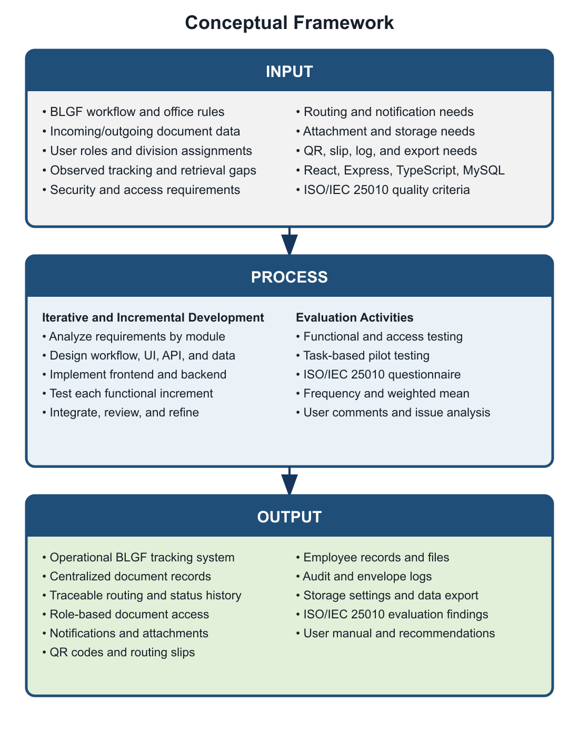
Figure 1. Conceptual Framework

1.3 Research Paradigm
Figure 2 presents the research paradigm that links the study inputs, system-development activities, evaluation procedures, and intended outcomes. Unlike the conceptual framework, which summarizes how resources are transformed into outputs, the research paradigm specifies the evidence, implementation components, and measurements used to answer the study objectives.
Research inputs consist of the existing BLGF Region II document workflow and office rules; incoming and outgoing document forms and metadata; route information, attachments, and logs; authorized user roles and division responsibilities; observed delays, errors, and retrieval problems; functional, access-control, notification, file-storage, and reporting requirements; the selected React, TypeScript, Express, MySQL, and file-storage technologies; and the ISO/IEC 25010 product-quality criteria.
The development component applies an Iterative and Incremental Development Model. Requirements are organized into functional increments; each increment undergoes workflow and interface design, database and API implementation, frontend and backend development, functional testing, integration, and refinement. These activities produce the actual modules verified in the project: authentication and role-based access; incoming and outgoing registration; unique route-number validation; routing, multi-routing, transfer, receipt, and completion; status and route history; notifications; attachments; QR and document-slip tools; employee records; audit and envelope logs; configurable storage; user administration; and database export.
The evaluation component combines functional verification, role and access testing, task-based user testing, the 30-item ISO/IEC 25010 questionnaire, and analysis of user comments and encountered issues. The resulting outcomes are an operational system, centralized and searchable records, verified task results, software-quality ratings, documented user feedback, evidence concerning visibility and accountability, a user manual, and recommendations for controlled improvement. Evaluation results feed back into the next development increment so that identified defects or usability issues can be corrected.
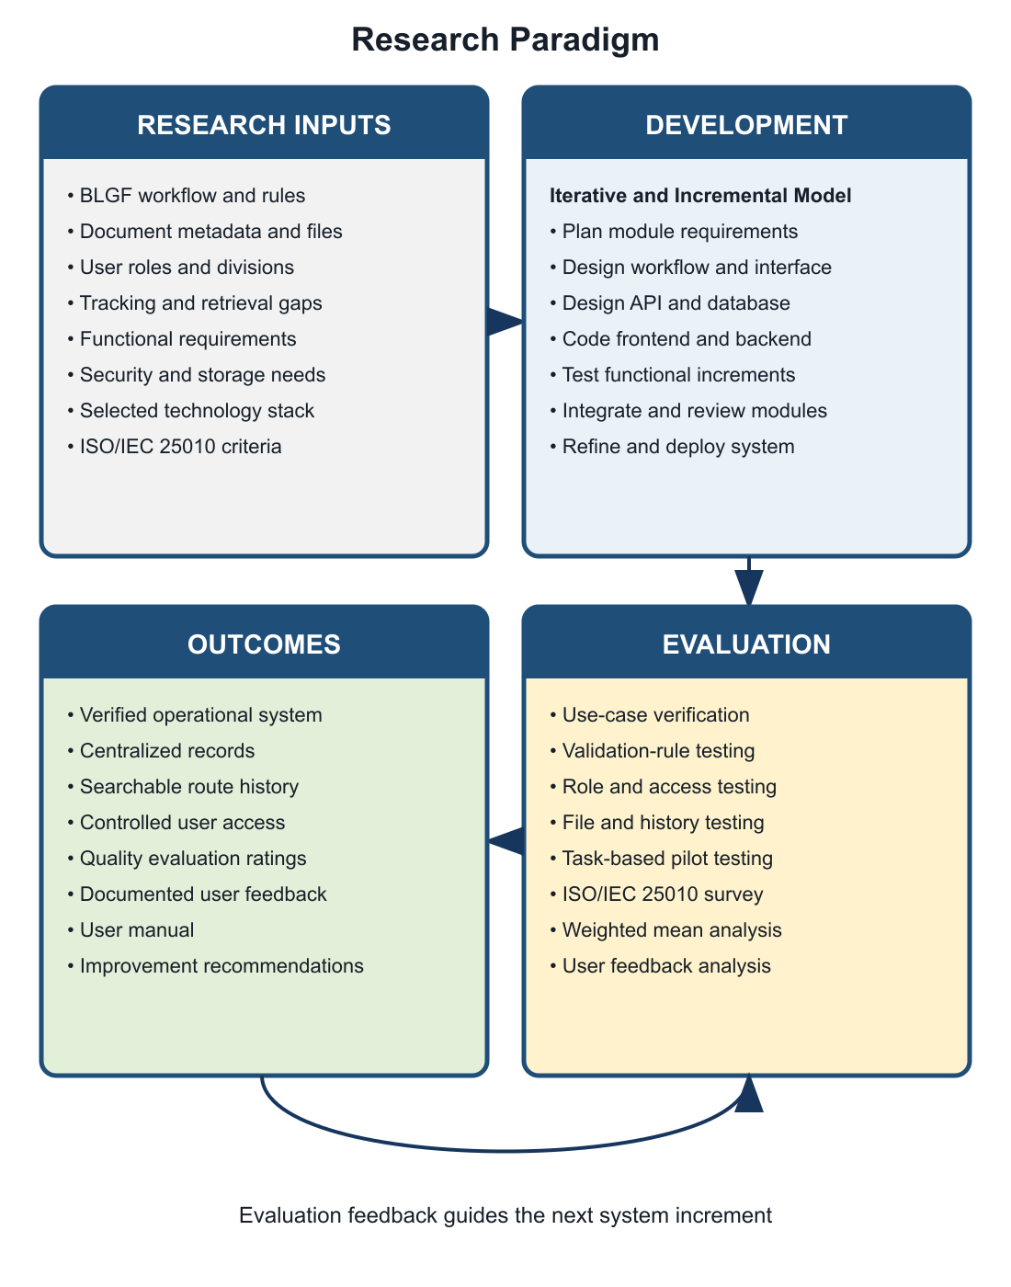
Figure 2. Research Paradigm

1.4 Objectives of the Study

1.4.1 General Objective
To design, develop, and evaluate a web-based document tracking and records management system that supports the secure, timely, and traceable processing of official documents at BLGF Region II.

1.4.2 Specific Objectives
- To document the existing practices and problems in registering, routing, monitoring, retrieving, and storing official documents.
- To identify challenges encountered by users in both the existing workflow and the developed system.
- To develop centralized modules for incoming and outgoing document registration, unique route-number validation, status monitoring, routing, transfer, and completion.
- To provide role-based access, user and employee management, notifications, audit trails, envelope dispatch logs, and attachment management.
- To support QR code generation/scanning, document slips, configurable file storage, search, filtering, dashboard summaries, and database export.
- To evaluate the system using the ISO/IEC 25010 product-quality characteristics.
- To recommend operational and technical improvements based on testing and user feedback.

1.5 Scope and Limitation of the Study
The study covers the document lifecycle supported by the implemented application: user authentication; incoming and outgoing document registration; division and user assignment; routing and multi-routing; transfer and receiving actions; document statuses and priorities; attachments; notifications; searchable lists and dashboards; official routing slips; outgoing-envelope recording; QR generation/scanning; employee profiles and folders; audit logs; configurable storage directories; MySQL export; and administrative user management.
The application is intended for authorized BLGF Region II personnel and is designed for use through a modern web browser on a networked computer. Access is controlled by predefined roles and permissions. The current implementation uses a React/TypeScript client, an Express/TypeScript server, and MySQL persistent storage, with local JSON files available as a fallback in supported deployments.
The study does not claim to replace national records-disposition policies, digital-signature infrastructure, or a full enterprise content-management platform. System effectiveness depends on correct data entry, reliable network and server availability, proper user-account administration, backup procedures, and staff compliance with approved workflows. Actual ISO/IEC 25010 scores cannot be finalized until the prescribed respondents complete pilot testing and the evaluation questionnaire.

1.6 Significance of the Study
- BLGF Region II Management. Consolidated operational information can support oversight, workload monitoring, accountability, and process improvement.
- Records and Administrative Personnel. Centralized registration, storage, search, routing history, and logs can reduce repetitive encoding and manual follow-up.
- Division Chiefs and Staff. Notifications and document-status visibility can clarify assigned actions, deadlines, and responsibility.
- Clients and Partner Offices. More consistent internal processing may improve response time and service delivery.
- System Administrators. Role management, storage configuration, audit trails, and database export provide tools for controlled system operation.
- Future Researchers and Developers. The study provides a reference for workflow-oriented records systems in comparable public-sector environments.

1.7 Definition of Terms
Term | Operational Definition
Audit Trail | A chronological record of system and user activities related to documents and administrative operations.
Document Route Number | A unique identifier used by the system to register, locate, and distinguish an official document.
Document Routing | The controlled forwarding of a document to one or more authorized users or divisions for action.
Incoming Document | A record received by BLGF Region II from an external or internal source.
Outgoing Document | A record released or transmitted by BLGF Region II to an intended recipient.
QR Code | A machine-readable code used to represent or retrieve document-identifying information.
Records Management | The systematic control of records throughout their creation, use, storage, retrieval, and disposition.
Role-Based Access Control | A security approach in which system permissions depend on a user’s assigned organizational role.
Routing History | The ordered record of offices, users, dates, actions, remarks, statuses, and attachments associated with document movement.
ISO/IEC 25010 | A software product-quality model used in this study as the basis for system evaluation.

CHAPTER II. REVIEW OF RELATED LITERATURE AND STUDIES

2.1 Foreign Literature
International records-management literature treats records as evidence of organizational activity and emphasizes their authenticity, reliability, integrity, and usability throughout the records lifecycle. This perspective supports the inclusion of unique identifiers, metadata, controlled access, routing history, audit logs, and systematic storage in an electronic tracking system.
Workflow information systems coordinate tasks, people, and business rules so that work items move through defined stages. In document-intensive organizations, workflow automation can reduce uncertainty by recording assignment, receipt, action, transfer, and completion events. Dashboards and notifications further convert stored transaction data into actionable information.
Role-based access control limits operations according to organizational responsibility. Applied to document tracking, it helps ensure that users see only the records and functions required by their duties, while administrators retain controlled capabilities for account, configuration, and audit management. Logging complements access control by establishing who performed an action and when it occurred.
QR codes provide a compact method for connecting physical documents to digital identifiers. When a printed routing slip or folder bears a QR code, scanning can accelerate lookup and reduce errors associated with manually typing long identifiers. The value of the code nevertheless depends on authoritative records and secure access in the underlying application.
Software-quality evaluation should be multidimensional. ISO/IEC 25010 identifies characteristics such as functional suitability, performance efficiency, compatibility, usability, reliability, security, maintainability, and portability. These characteristics provide a structured basis for evaluating whether the developed system meets both functional and quality expectations.

2.2 Local Literature
Philippine public offices operate within an environment that values accountability, efficient public service, data protection, and proper records custody. The Electronic Commerce Act recognizes electronic data messages and documents in transactions, while the Data Privacy Act establishes responsibilities for the lawful and secure processing of personal information. These principles make controlled access, accurate records, and appropriate safeguards important in government information systems.
The Ease of Doing Business and Efficient Government Service Delivery Act reinforces the need for simplified and timely government procedures. Although document tracking alone cannot resolve every service delay, accurate visibility into pending records, assigned personnel, target dates, and completed actions can help offices identify bottlenecks and establish responsibility.
The National Archives of the Philippines provides the institutional context for government records management. Local digitalization initiatives commonly seek to improve retrieval and reduce dependence on fragmented paper logs. However, successful implementation also requires approved classification, retention, backup, access, and disposition procedures, together with staff training and management support.

2.3 Synthesis
The reviewed concepts converge on five requirements: reliable document identification, explicit workflow states, controlled access, traceable actions, and usable retrieval. Records-management principles explain what must be preserved; workflow systems explain how tasks move; security models govern who may act; QR technology connects physical and digital records; and ISO/IEC 25010 supplies an evaluation structure.
The proposed system integrates these requirements in a single application tailored to BLGF Region II. Its contribution is not the isolated use of a database or web interface, but the combination of registration, role-based routing, status history, attachments, alerts, storage, employee records, dispatch logs, QR-assisted lookup, and audit functions around the office’s operational document lifecycle.

CHAPTER III. RESEARCH METHODOLOGY

3.1 Research Design
The study uses developmental research with descriptive evaluation. Developmental research is appropriate because the main output is an information system created in response to an identified organizational need. The descriptive-evaluative component records workflow observations, encountered challenges, functional-test results, and user perceptions of the completed system using the ISO/IEC 25010 quality characteristics.
System development follows an Iterative and Incremental Development Model. Requirements are divided into manageable functional increments. Each increment passes through analysis, design, implementation, testing, integration, and review. Feedback from a completed increment informs the next one, allowing the system to progress from core authentication and document registration to routing, notifications, attachments, reporting tools, records functions, storage configuration, and administration.

3.2 System Architecture
The system follows a web-based client–server architecture. The browser client renders the React interface and calls REST-style endpoints. The Express server performs validation, workflow processing, authentication, file handling, and data access. MySQL stores structured operational data, while configured directories preserve uploaded files. A JSON fallback supports selected local deployments. Production assets are generated through Vite and esbuild.
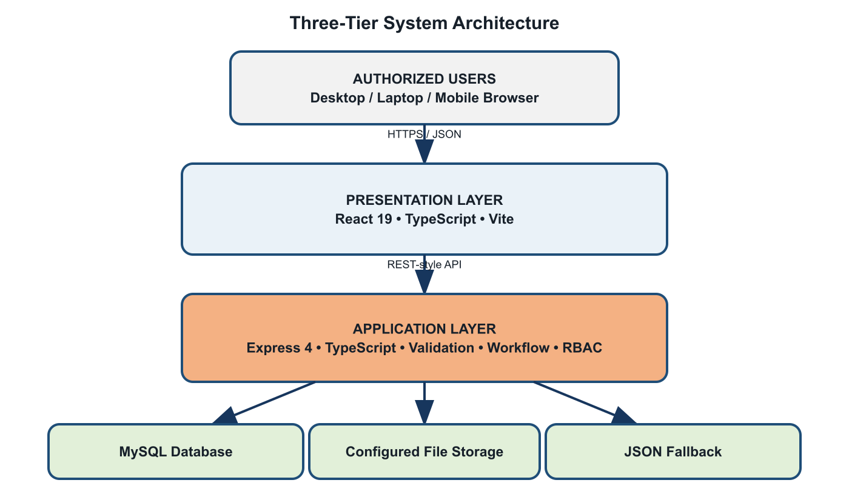
Figure 3. System Architecture

3.3 Use-Case Diagram
The principal actors are Administrator, Records Personnel, Division Chief, Staff/User, and Authorized Viewer. Available functions vary according to role permissions configured in the application.
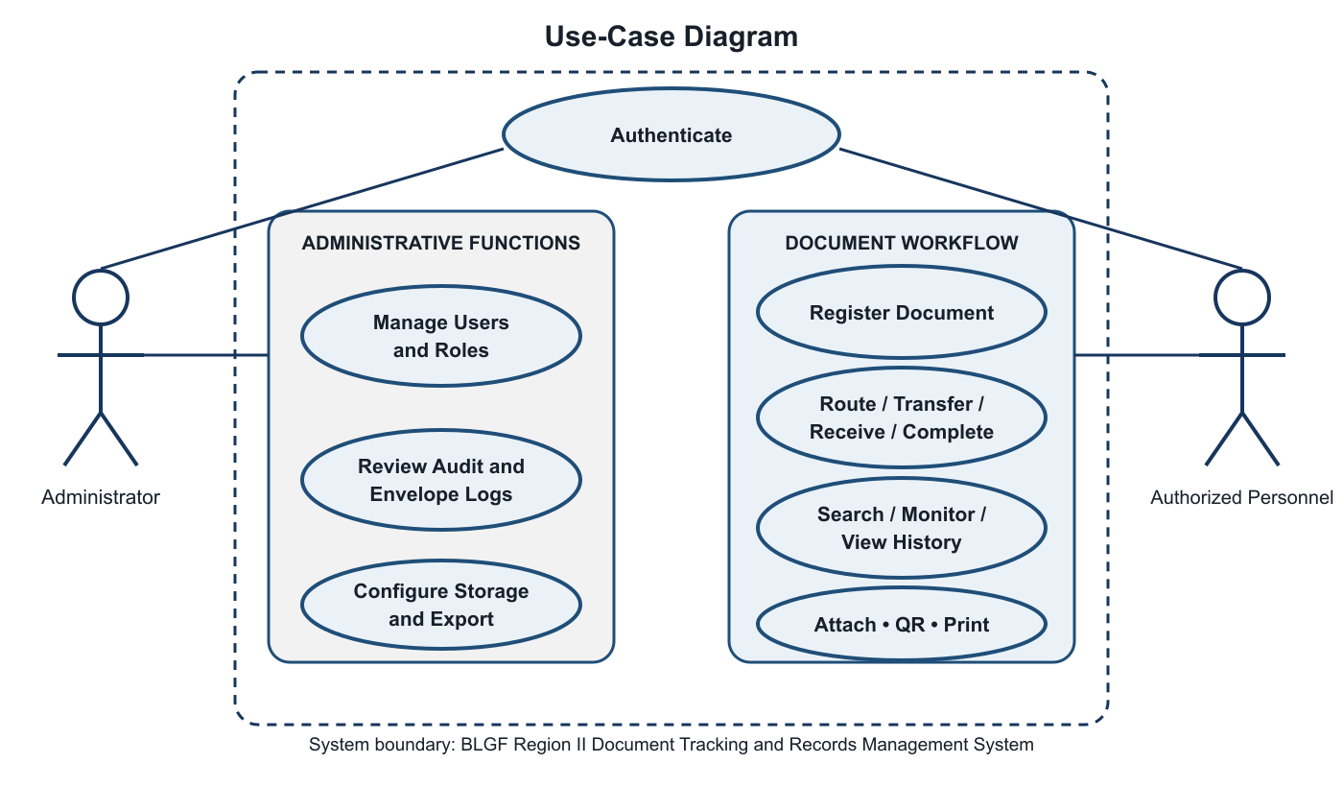
Figure 4. Use-Case Diagram

3.4 Context Level – Data Flow Diagram
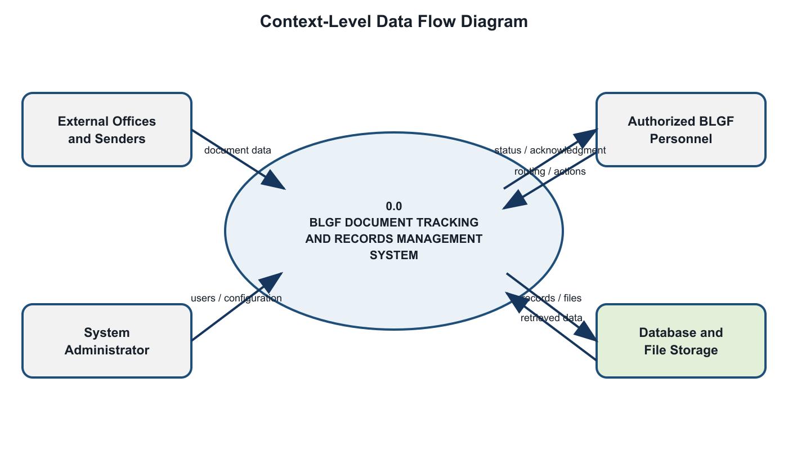
Figure 5. Context-Level Data Flow Diagram

3.5 Software and Hardware Requirements
Category | Minimum / Required | Recommended
Client Hardware | Dual-core CPU, 4 GB RAM, 1366×768 display | Modern multi-core CPU, 8 GB RAM or higher
Server Hardware | 4-core CPU, 8 GB RAM, 20 GB available storage | Scalable server/VM with monitored backups
Client Software | Modern Chromium, Firefox, or Edge browser | Current supported browser with JavaScript enabled
Server Software | Node.js-compatible runtime, npm, MySQL | Current LTS Node.js, managed MySQL/TiDB, TLS
Frontend | React 19, TypeScript, Vite | Production build served over HTTPS
Backend | Express 4, TypeScript, mysql2, Multer | Process manager, logging, health monitoring
Network | Reliable LAN/Internet connectivity | Redundant connection and secure network controls
Backup | Periodic database and attachment copy | Automated encrypted, tested, off-site backup

3.6 Respondents of the Study
The proposed respondents are authorized BLGF Region II personnel who participate in document receipt, registration, routing, action, release, records storage, supervision, or system administration. Purposive sampling is recommended because respondents must have direct knowledge of the workflow being evaluated.
Final respondent profile: [INSERT APPROVED NUMBER OF RESPONDENTS], consisting of [INSERT GROUPS, SUCH AS RECORDS PERSONNEL, DIVISION CHIEFS, STAFF, AND ADMINISTRATORS]. The final manuscript must report the actual distribution and selection criteria after approval by the adviser and participating office.

3.7 Research Instrument
The primary instrument is a structured questionnaire based on the eight ISO/IEC 25010 product-quality characteristics. Respondents rate statements on a five-point Likert scale: 5 – Strongly Agree, 4 – Agree, 3 – Neither Agree nor Disagree, 2 – Disagree, and 1 – Strongly Disagree. The instrument also includes respondent profile items and open-ended questions for observed issues and recommendations. A functional-test checklist records whether required use cases, validation rules, permissions, files, notifications, histories, and administrative functions operate as intended.
Content validation should be performed by the thesis adviser, an information-technology expert, and a records/process representative. A pilot test should verify clarity, completion time, and internal consistency before the main administration.

3.8 Locale of the Study
The study is intended for the Bureau of Local Government Finance – Region II. Data gathering, workflow validation, pilot testing, and user evaluation should be conducted with permission from the authorized regional office and in accordance with its operational and information-security requirements. Insert the approved office address here: [COMPLETE BLGF REGION II OFFICE ADDRESS].

3.9 Data Gathering
- Secure written permission from BLGF Region II and approval of the research instrument.
- Interview or consult process owners to document existing registration, routing, follow-up, storage, and reporting practices.
- Review non-confidential forms, log formats, routing slips, and metadata requirements.
- Configure a controlled test environment using non-sensitive or properly authorized sample data.
- Orient respondents and conduct task-based pilot testing of relevant system modules.
- Administer the ISO/IEC 25010 questionnaire and collect open-ended feedback.
- Encode, verify, analyze, and securely retain the resulting data.
- Revise the system and manuscript based on validated findings.

3.10 Data Analysis
Frequency and percentage will describe respondent groups and recurring workflow issues. The weighted mean will summarize each ISO/IEC 25010 statement and quality characteristic. Where appropriate, standard deviation may describe response dispersion. Open-ended responses will be grouped by recurring theme.

Weighted Mean = Σ(f × w) / N
Weighted Mean Range | Verbal Interpretation
4.21–5.00 | Strongly Agree / Excellent
3.41–4.20 | Agree / Very Good
2.61–3.40 | Neither Agree nor Disagree / Good
1.81–2.60 | Disagree / Fair
1.00–1.80 | Strongly Disagree / Poor

CHAPTER IV. RESULTS AND DISCUSSIONS
This chapter documents the system output already verifiable from the implemented application. Survey-dependent tables remain explicitly marked for completion after formal pilot testing; no respondent score is fabricated in this proposal draft.

4.1 Problems Encountered in the Existing System
The requirements addressed by the system indicate recurring risks in a manual or fragmented workflow: difficulty locating a document after endorsement; dependence on personal follow-up; inconsistent route-number recording; duplicate entries; limited visibility of pending actions and target dates; attachments stored separately from transaction records; incomplete chain-of-custody information; and delayed preparation of logs or reports.
These conditions may result in unnecessary processing time, uncertainty regarding responsibility, weak auditability, and difficulty retrieving historical records. They also make continuity dependent on individual knowledge instead of shared and controlled organizational information.

4.2 The Developed System
The developed application centralizes the complete document lifecycle and presents functions according to the authenticated user's role and explicit menu permissions. Incoming and outgoing records are registered using a unique Document Route Number together with title, classification, subject, sender or recipient, originating office, priority, target date, initial destination, action requested, remarks, and one or more authorized file attachments. The server validates route-number uniqueness before saving a transaction. Subsequent routing, multi-recipient forwarding, transfer, receipt, return, completion, attachment, and status-changing actions are preserved as an ordered history and reflected in notifications and audit logs. The dashboard, filtered document lists, QR tools, routing slip, office directory, outgoing-envelope log, user management, and account settings provide supporting views for daily operation and administration.
Module | Implemented Capability
Authentication and Access | User login, active-account checking, role-based views and action permissions
Dashboard | Operational summaries and access-aware document information
Incoming / Outgoing | Registration, unique route number, metadata, priority, target date, attachments
Routing | Single and multiple recipients, transfer, receipt/action status, remarks, route history
Notifications | Action-required and routing alerts tied to users and documents
Document Slip | Selection and printing of official routing information
QR Tools | QR generation and camera-based scanning support
Envelope Dispatch | Outgoing recipient/releasing details and separate envelope logs
Employee Records | Employee profiles, folders, and supporting files
Audit | Chronological user/system activity records
Storage | Configurable document directories and controlled file access
Administration | Users, divisions, settings, deletion rights, database export

4.2.1 Hierarchical Input Process Output (HIPO)
Figure 6 presents the Hierarchical Input Process Output (HIPO) model of the developed system. At Level 0, the complete BLGF Region II Document Tracking and Records Management System acts as the parent function. Level 1 decomposes the system into six major modules that correspond to the active functions implemented in the frontend and backend: authentication and role authorization; document registration; routing and status tracking; file and employee-record storage; search, notification, QR, and printing; and administration, audit, and export.
The lower portion of the figure provides an IPO summary for every Level 1 module. Each row identifies the data accepted by a module, the principal validation or transformation performed by the application, and the resulting record, view, history entry, notification, file, or administrative output. This structure shows both the functional hierarchy and the flow of information without treating unsupported legacy schema tables as active system modules.
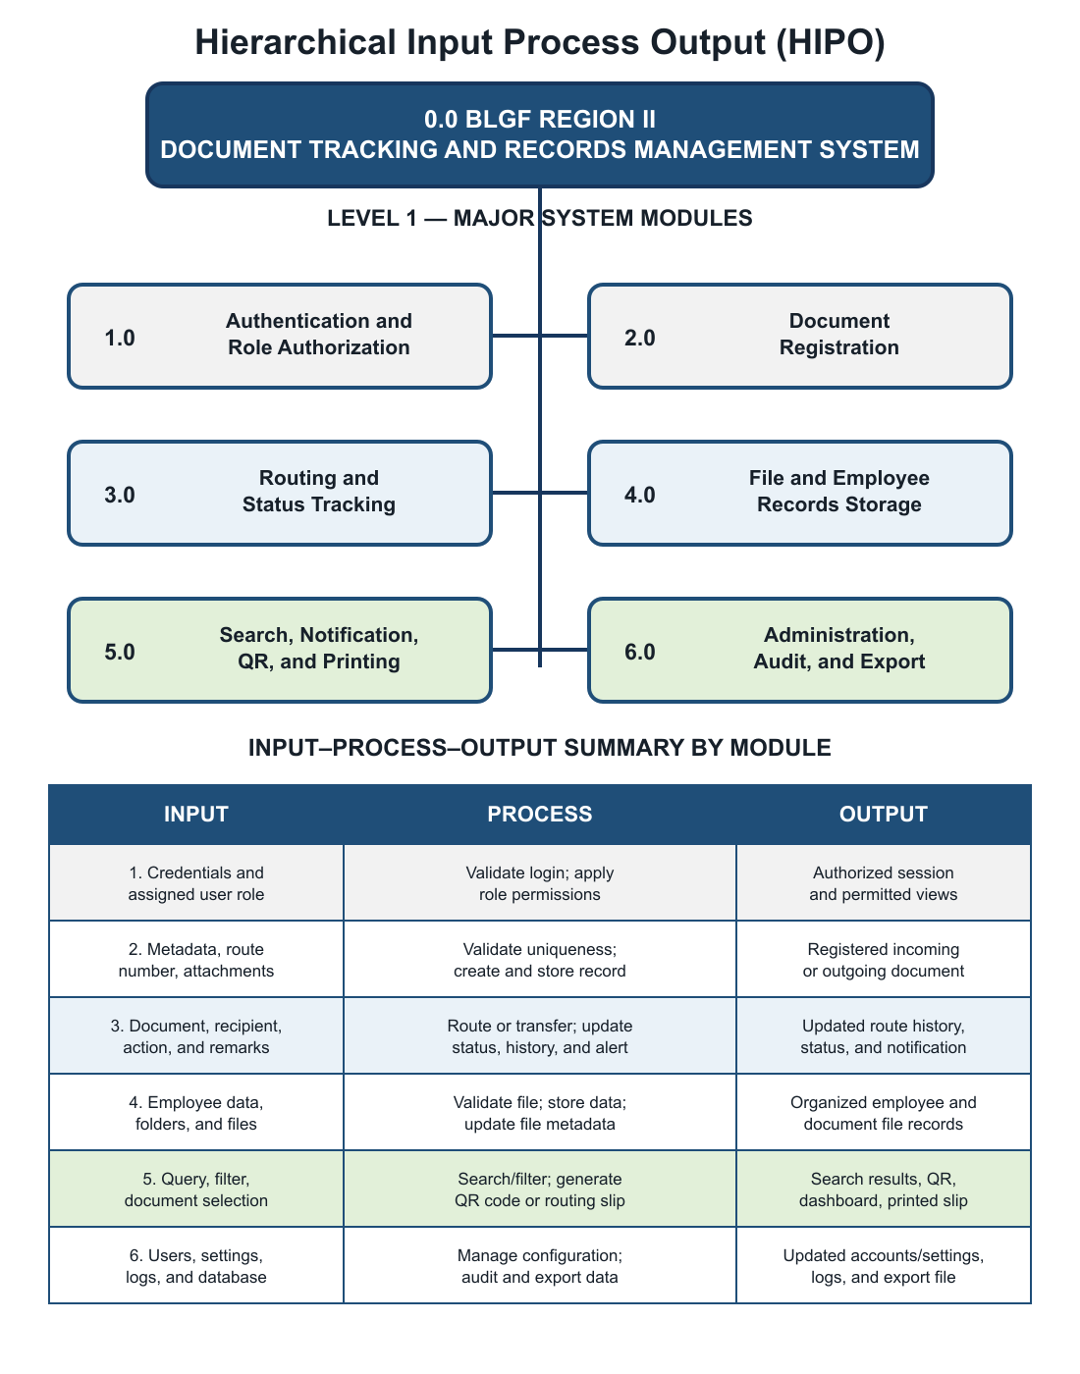
Figure 6. Hierarchical Input Process Output

4.2.2 Input Process Output (IPO) Diagram
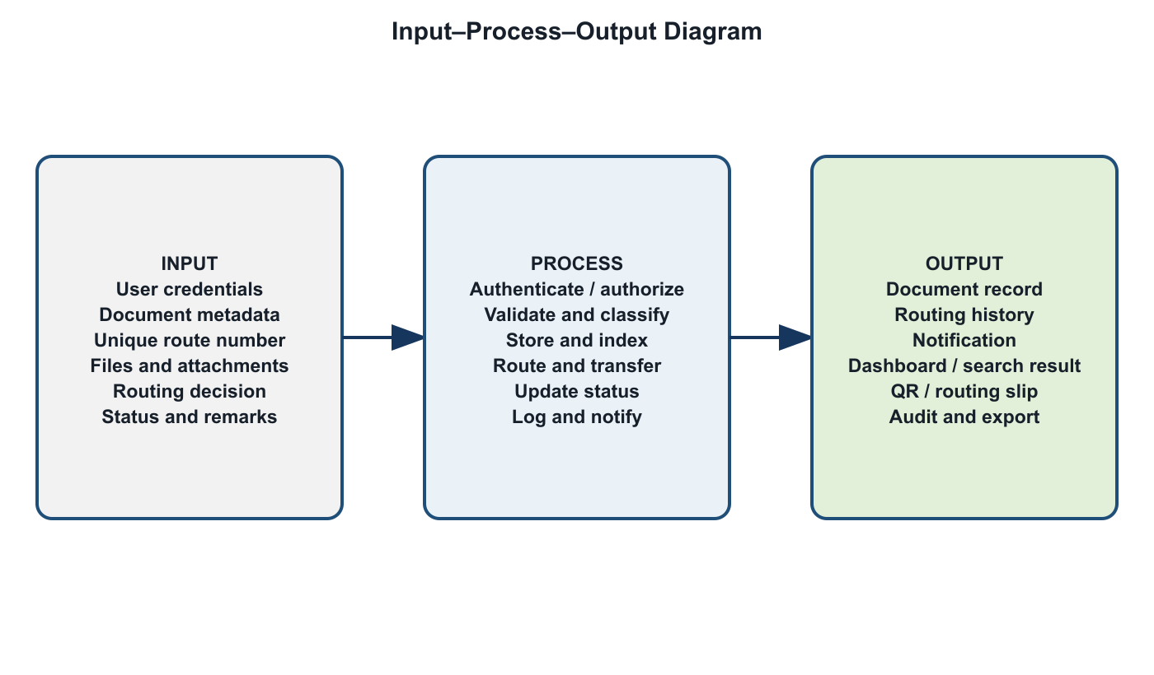
Figure 7. Input-Process-Output Diagram

4.2.3 Entity Relationship Diagram (ERD)
Figure 8 presents the active data relationships used by the developed system. The core workflow centers on the documents entity, which stores the unique tracking number, direction, subject and classification data, current status, current division, assignment, and relevant dates. A document may have many routing steps and attachments. Notifications may refer to a document and are assigned to a user. Users are grouped by division and their significant actions are recorded in audit logs.
Employee records form a related but distinct branch: one employee profile may contain many folders, and one folder may contain many files. Solid relationship lines identify foreign keys explicitly enforced in the current MySQL schema. Dashed lines identify application-level logical references such as division_code, user_id, and notification document_id, which are used by the application but are not declared as foreign-key constraints in the schema. This distinction prevents the diagram from claiming database constraints that do not exist.
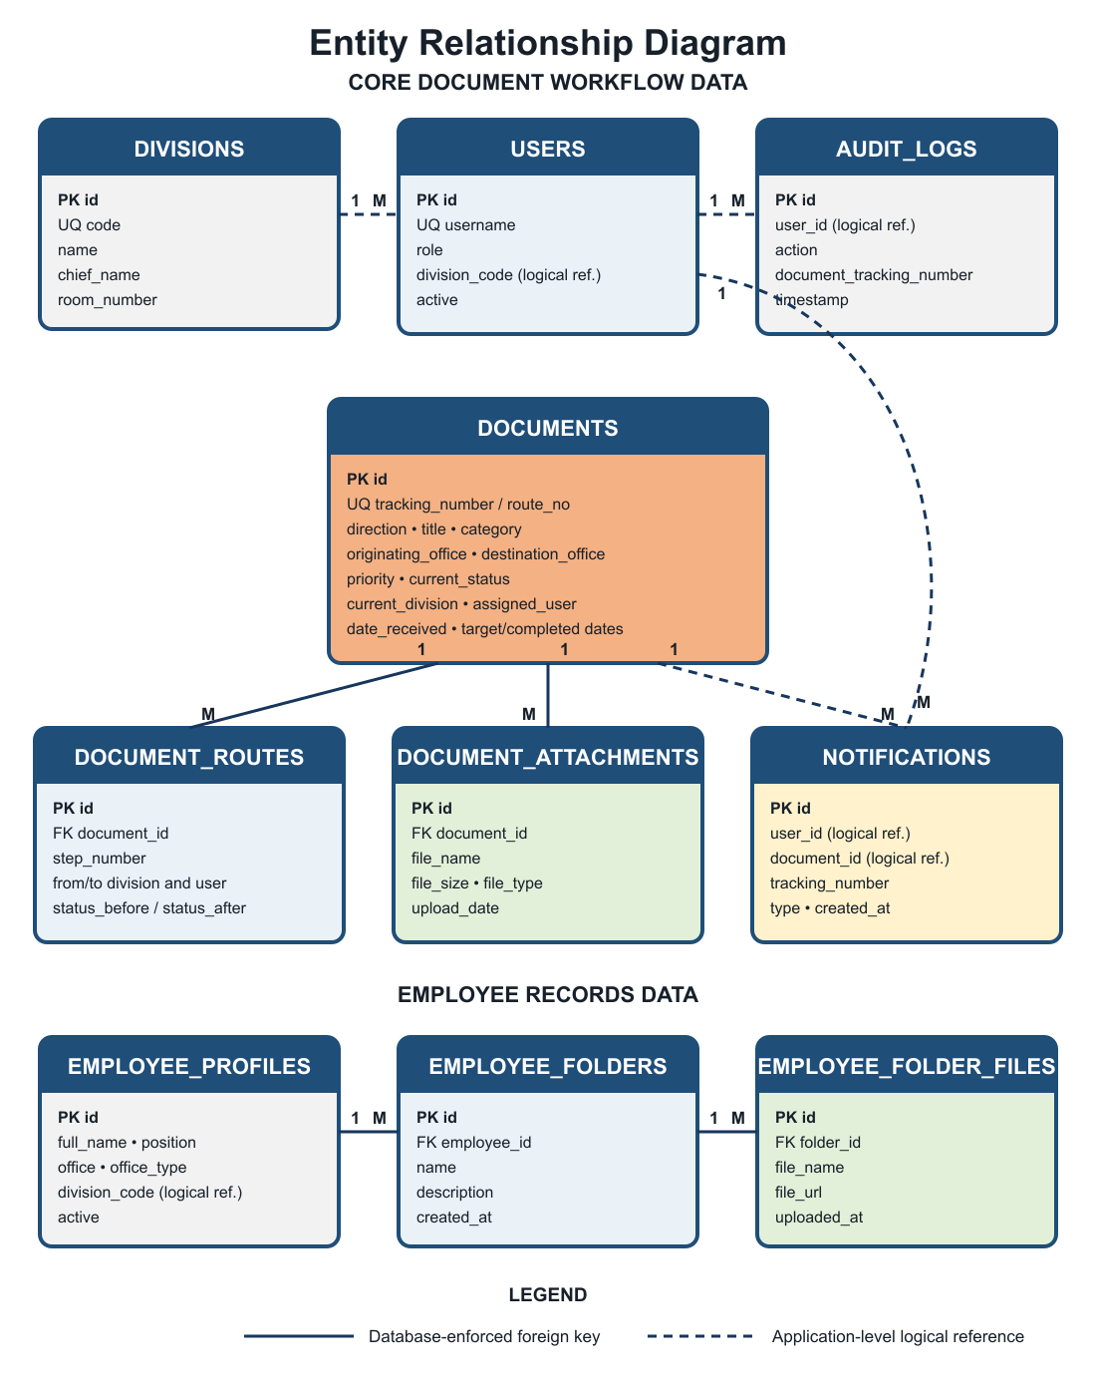
Figure 8. Entity Relationship Diagram

4.2.3.1 User’s View
Figures 9 to 20 present the principal user and administrator interfaces of the implemented BLGF Region II system. After authentication, each account receives only the navigation items, records, and actions authorized for its role. Records personnel can encode and route transactions; assigned division users can review and act on documents routed to them; and system administrators can supervise users, permissions, logs, storage-related settings, and organization-wide records. The sequence below follows the normal operational flow from sign-in and registration to retrieval, routing support, monitoring, and administration.

4.2.3.1.1 Authentication View
The authentication dialog requires an active account and validates the username and password before the application workspace is displayed. It prevents unauthenticated access to operational menus and provides a controlled administrator password-recovery entry point.
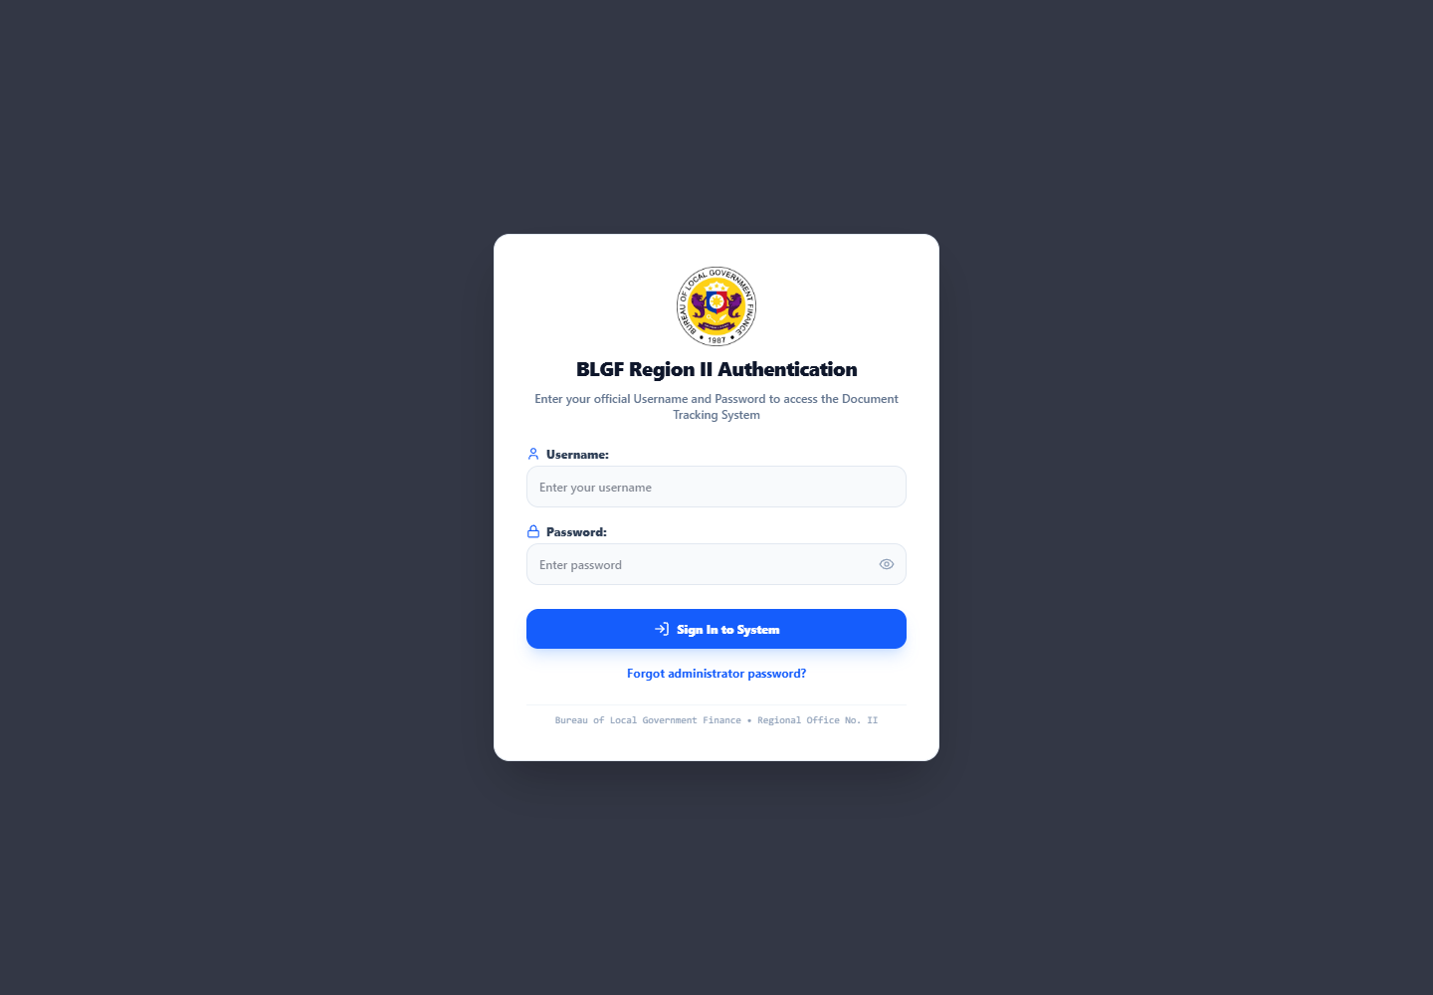
Figure 9. BLGF Region II Authentication View

4.2.3.1.2 Dashboard View
The dashboard summarizes incoming and outgoing volume, pending and in-progress work, completed and returned documents, urgent items, division workload, and recent transactions. Its search, QR scanner, notification control, and quick-action buttons reduce the number of steps needed to locate or create a record.
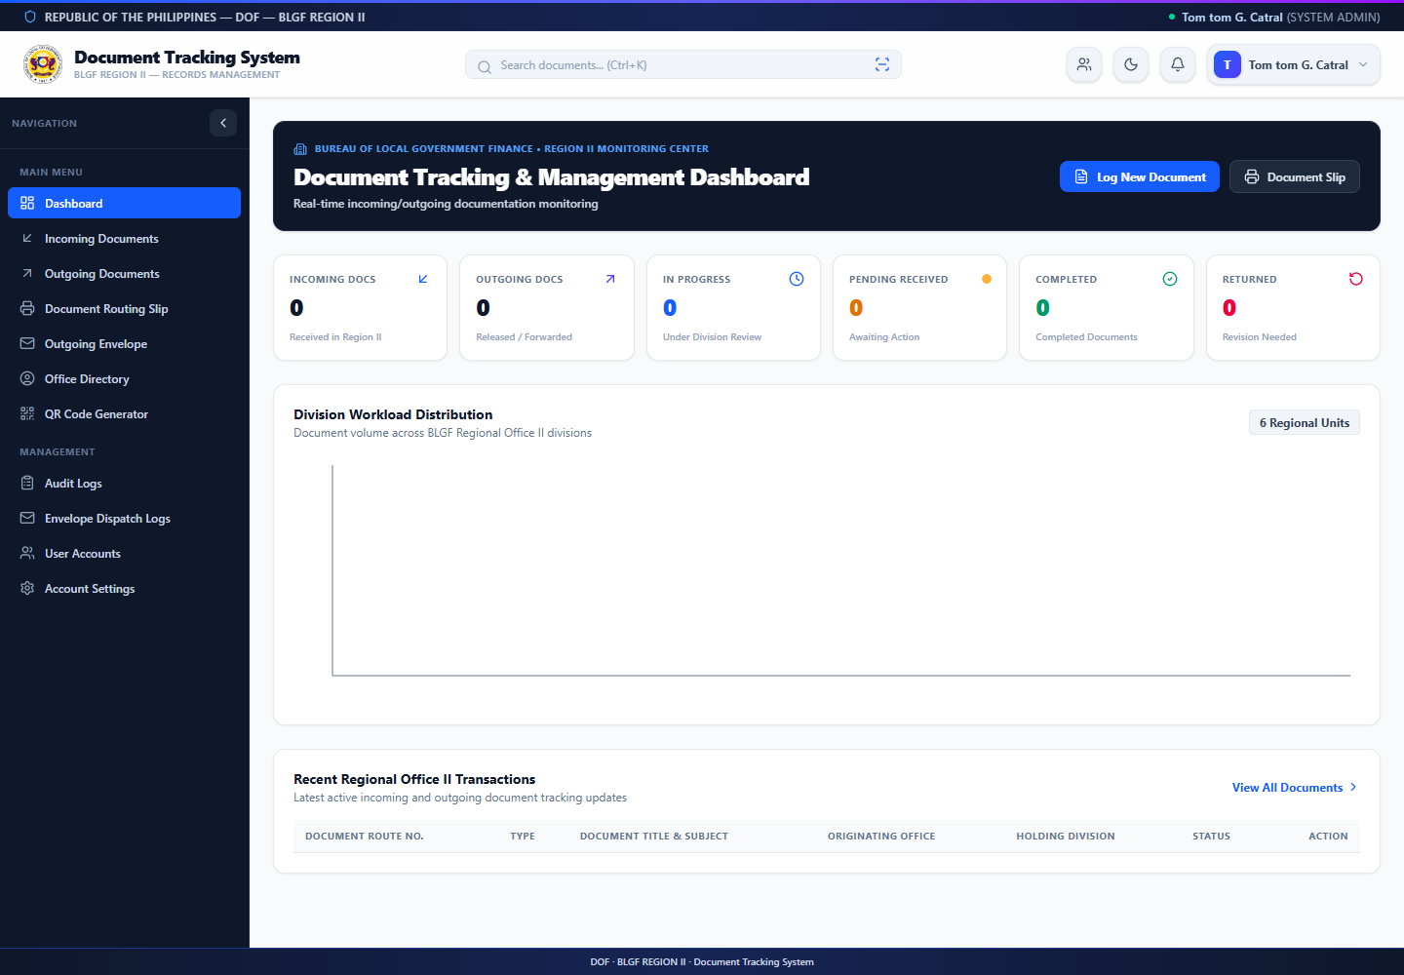
Figure 10. Document Tracking and Management Dashboard

4.2.3.1.3 Upload and Document Registration View
The Log New Document form is the primary upload interface. The user selects the transaction direction, enters the required route number and metadata, chooses an authorized destination and action, sets the priority and target date, and uses Choose Files to attach supporting documents. Register Only stores the record for later routing, while Register & Route saves it and immediately creates the initial routing transaction. The user must review filenames and remove sensitive or incorrect files before submission.
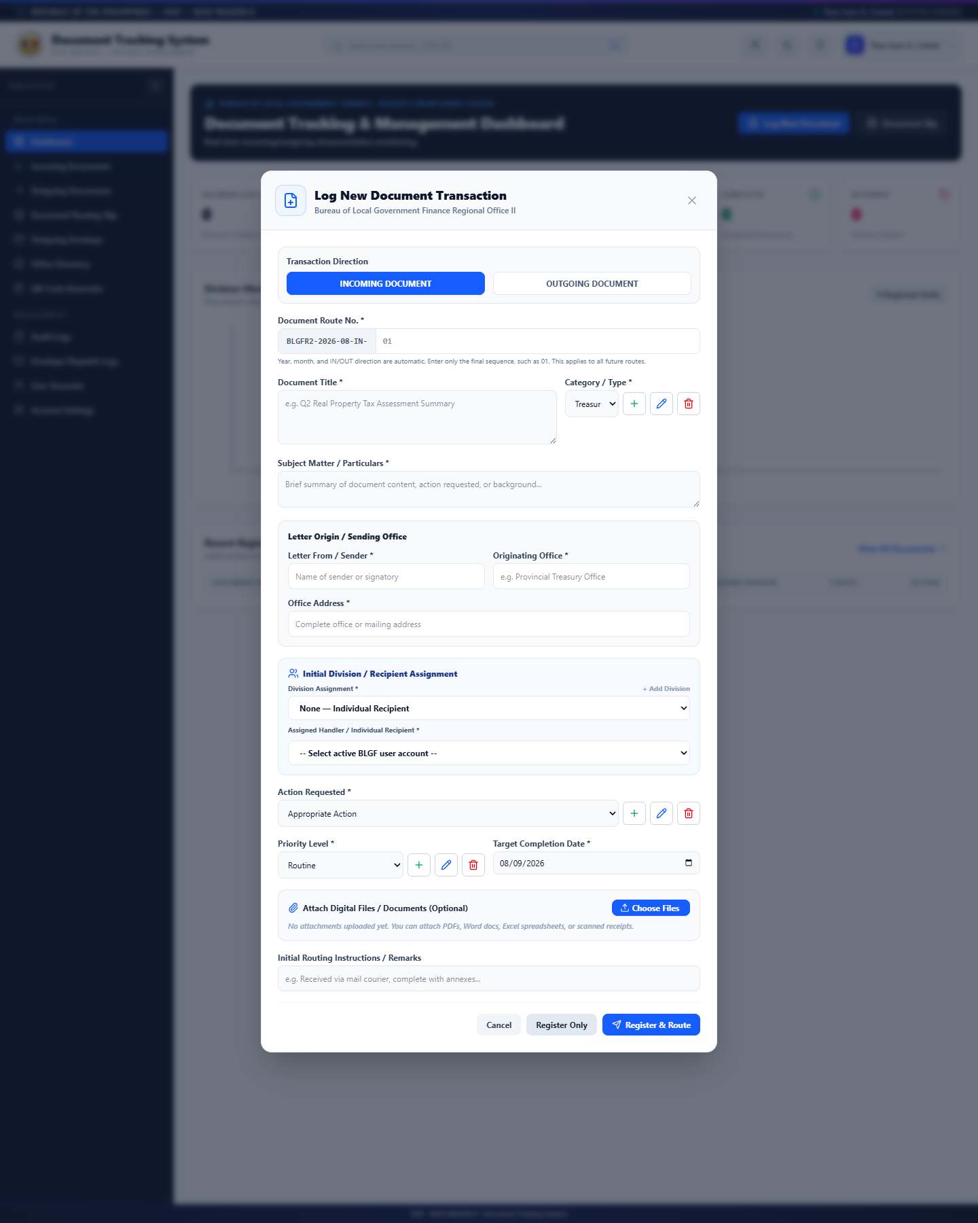
Figure 11. Upload and Log New Document View

4.2.3.1.4 Incoming Documents View
The Incoming Documents module lists records received by the regional office. Search and filters support retrieval by route number, subject, sender, status, division, or priority. Opening a row provides the metadata, attachment list, present holder, and chronological route history available to the signed-in user.
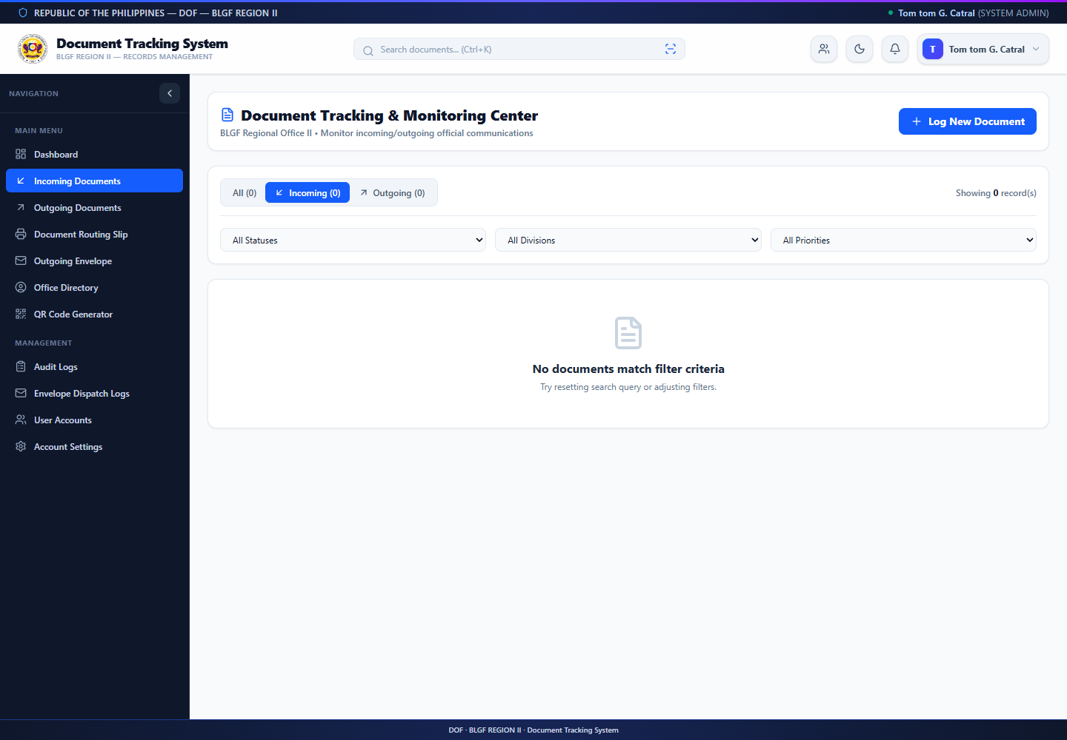
Figure 12. Incoming Documents View

4.2.3.1.5 Outgoing Documents View
The Outgoing Documents module separates communications released or forwarded by BLGF Region II. It supports the same controlled search, filtering, detail, routing, and status-handling functions while preserving recipient and dispatch information appropriate to outgoing records.
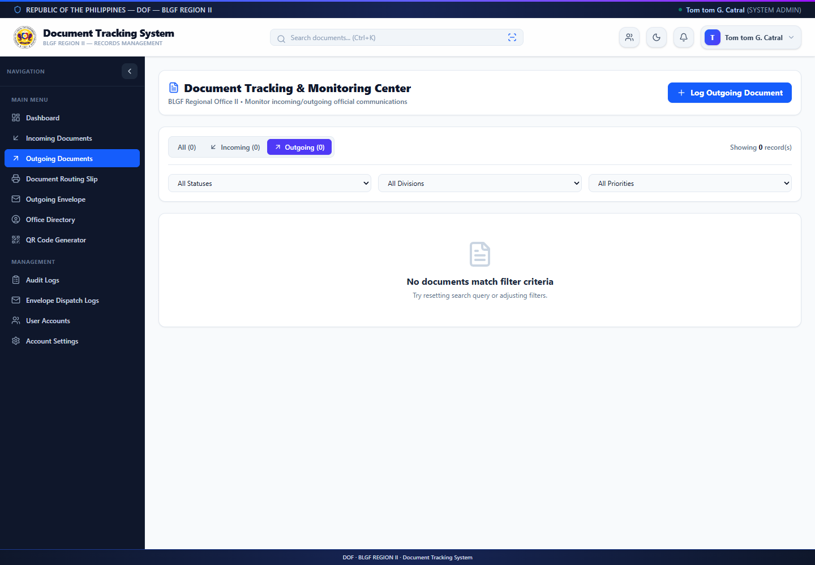
Figure 13. Outgoing Documents View

4.2.3.1.6 Document Routing Slip View
The routing-slip view converts a selected digital record and its route history into a print-oriented form. Before printing, the user verifies the route number, document particulars, origin, destination, requested action, dates, and recorded sequence so the physical copy remains linked to the correct electronic record.
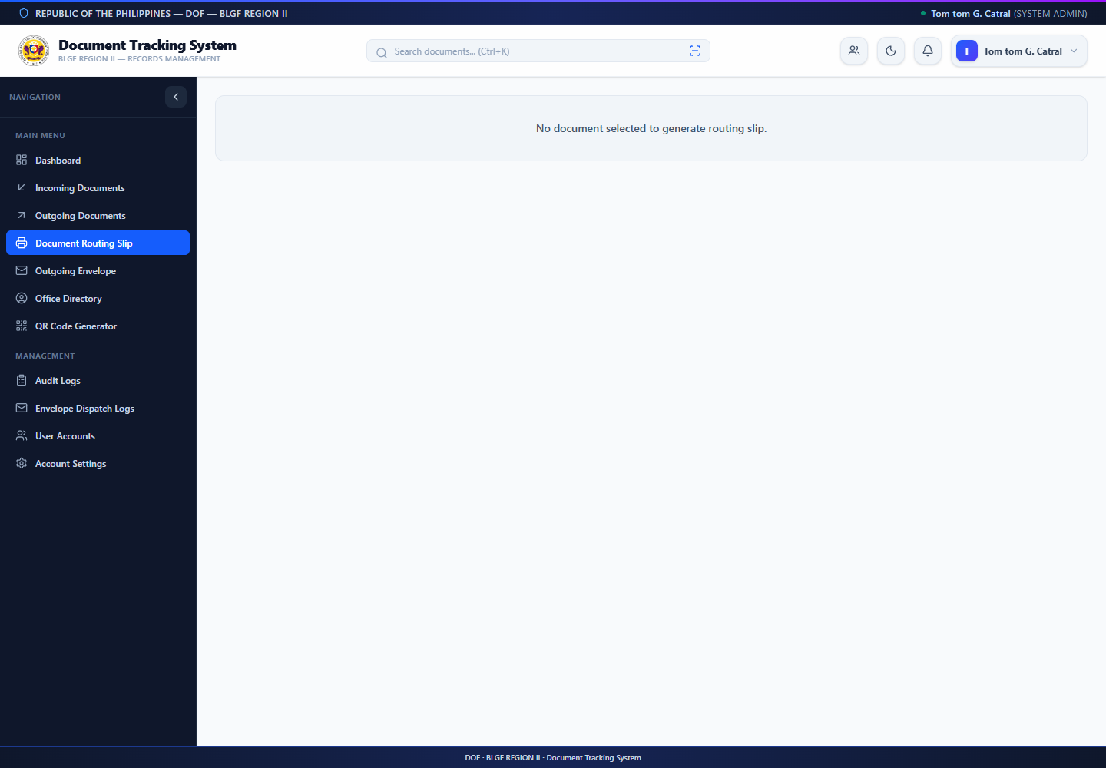
Figure 14. Document Routing Slip View

4.2.3.1.7 Office Directory View
The Office Directory displays active personnel profiles used for organizational reference and document assignment. Maintaining accurate division, designation, email, and contact information helps users select the correct recipient and reduces misrouting.
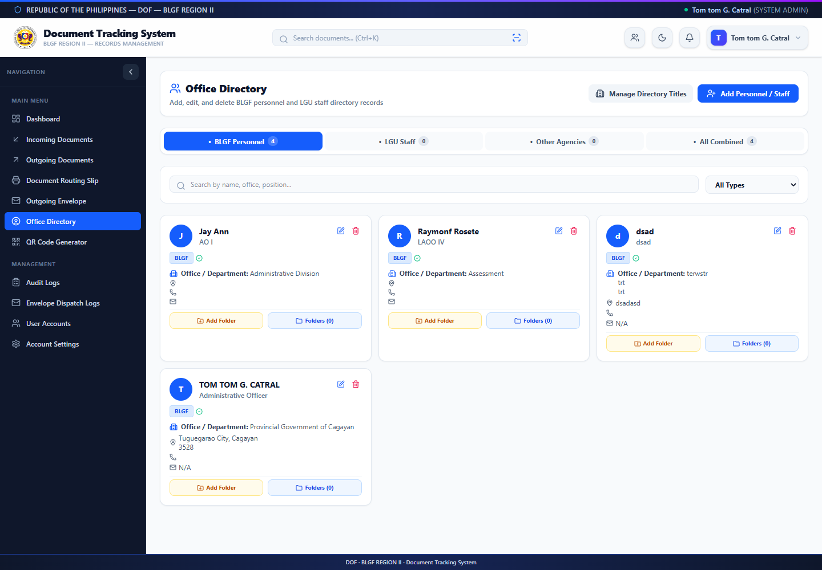
Figure 15. Office Directory View

4.2.3.1.8 QR Code Generator View
The QR Code Generator produces a machine-readable representation of document-identifying information. The generated code may be placed on an authorized routing slip or folder to speed up lookup and reduce manual transcription of route numbers; the encoded value must still be checked before printing or distribution.
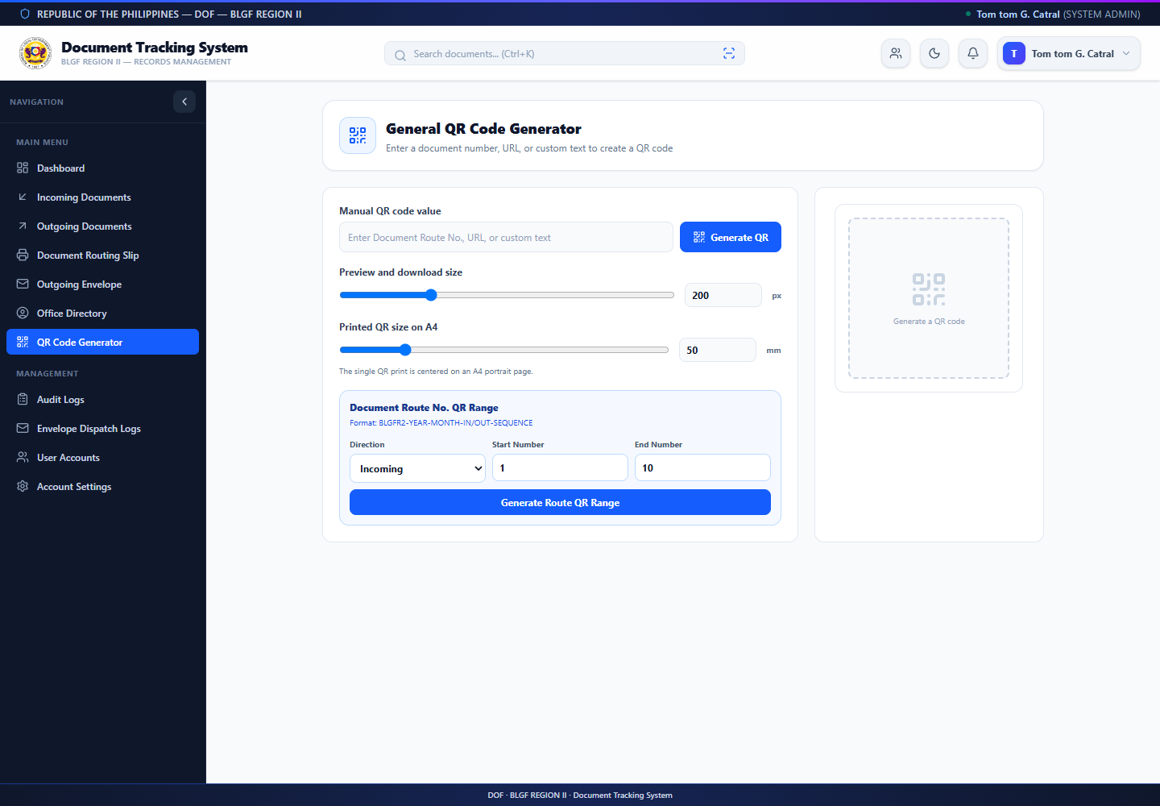
Figure 16. QR Code Generator View

4.2.3.1.9 Audit Logs View
The audit-log view records significant user and system actions with the responsible account, role, time, affected document, and transaction details. Access is restricted to authorized administrators because the entries support accountability, incident review, and reconstruction of changes.
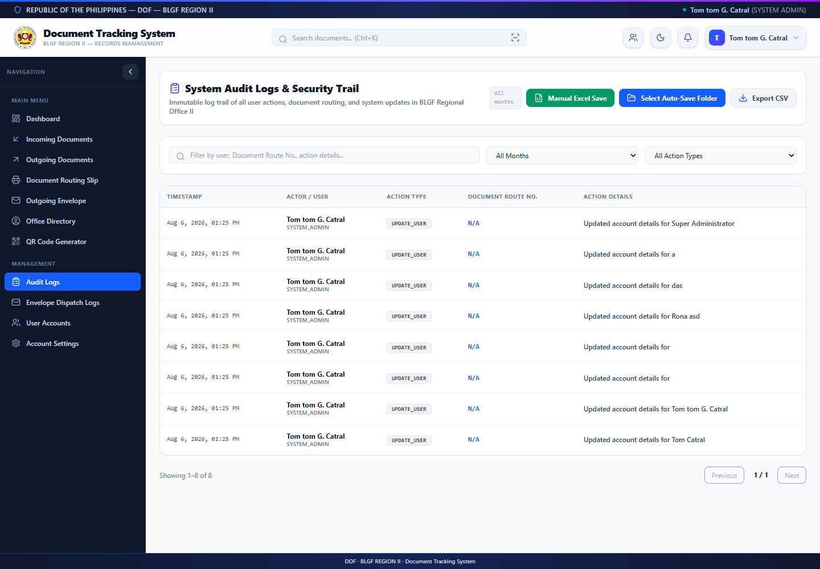
Figure 17. Audit Logs View

4.2.3.1.10 User and Role Management View
Authorized system administrators create, edit, activate, deactivate, or delete accounts and configure role-based menu and management permissions. Access should follow least privilege: users receive only the functions necessary for their assigned BLGF responsibilities, and role changes are reviewed and recorded.
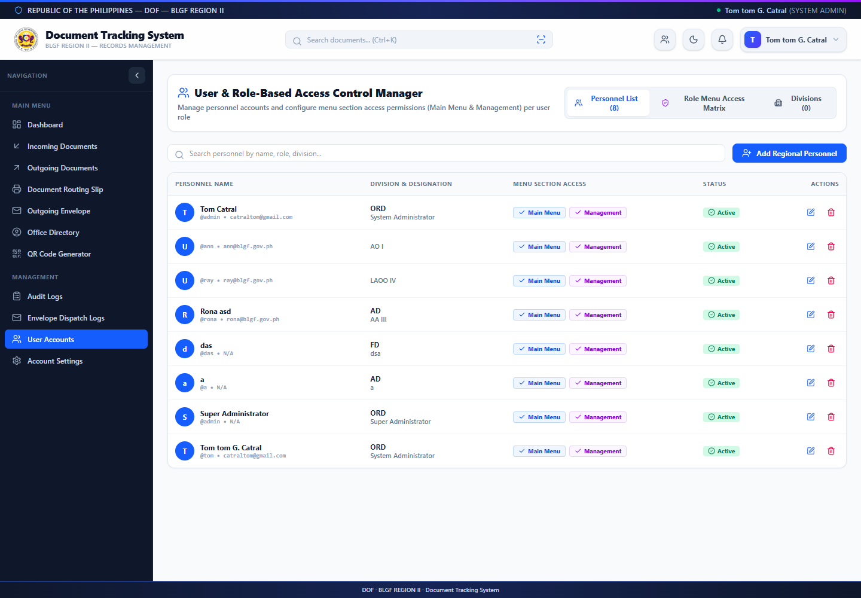
Figure 18. User and Role-Based Access Control View

4.2.3.1.11 Outgoing Envelope View
The Outgoing Envelope module records physical dispatch information that complements the outgoing document record. It supports accountability for envelope preparation and release while preserving a searchable dispatch log for follow-up.
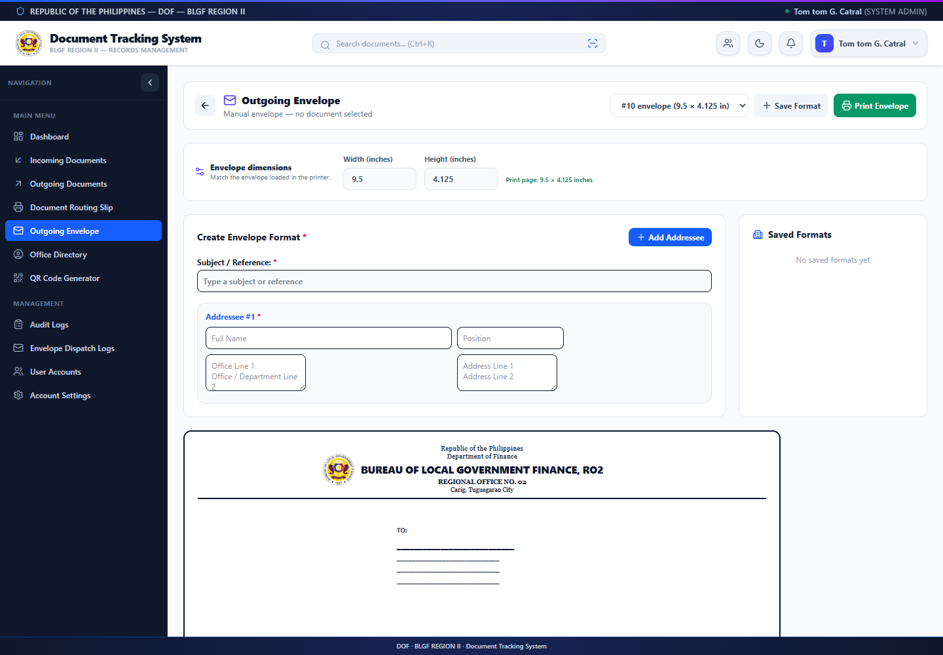
Figure 19. Outgoing Envelope Dispatch View

4.2.3.1.12 Account Settings View
Account Settings allows an authenticated user to review and update permitted profile and credential information. Password changes should use a strong, unique value and must not be shared or written in the document record or remarks fields.
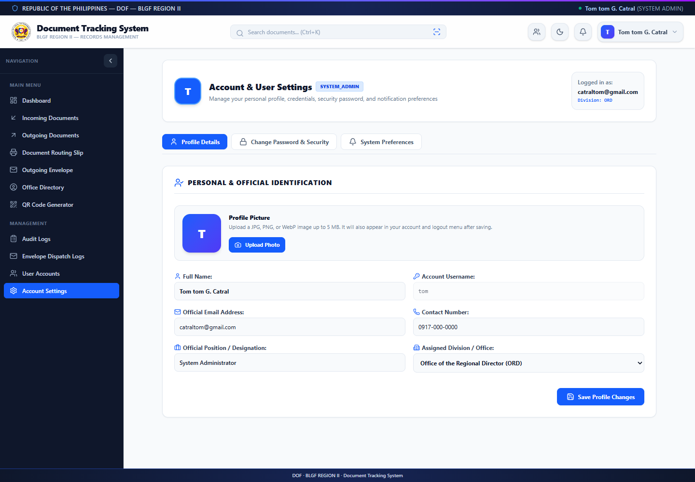
Figure 20. Account Settings View

4.2.3.2 Data Model
Entity | Purpose / Key Data
divisions | Organizational units and codes
users | Credentials, role, division, active state, profile details
documents | Route number, direction, subject, dates, sender/recipient, priority, status
document_routes | Origin, destination, action, status transition, remarks, timestamps
document_attachments | File metadata and relationship to a document or route
notifications | User-specific document alerts and read/action state
audit_logs | Actor, action, description, timestamp, contextual data
employee_profiles | Employee identity, appointment, division, and profile metadata
employee_folders/files | Organized employee supporting records

4.2.4 Table Design
The relational design uses primary keys to uniquely identify records and foreign-key relationships to connect documents, routes, users, divisions, attachments, and notifications. Route numbers require uniqueness at the application level and should also be protected by a database constraint in production. Timestamps support chronological reconstruction. Enumerated status, direction, priority, role, and document-type values promote consistency.
File contents are stored in configured directories while structured file metadata and relationships remain in the application data model. This separation keeps operational queries manageable while allowing controlled retrieval. Database export and backup procedures should always include both structured data and referenced file storage so that restored records remain complete.

4.3 The Extent of Compliance of the Developed System to ISO 25010 Software Quality Standards
Complete this section after pilot testing. The table below is intentionally prepared as an encoding template. Replace each blank with the computed weighted mean and verbal interpretation from actual respondents.
Quality Characteristic | Indicators | Weighted Mean | Interpretation
Functional Suitability | Completeness, correctness, appropriateness | [ ] | [ ]
Performance Efficiency | Response time, resource use, capacity | [ ] | [ ]
Compatibility | Co-existence and interoperability | [ ] | [ ]
Usability | Learnability, operability, accessibility, error protection | [ ] | [ ]
Reliability | Availability, fault tolerance, recoverability | [ ] | [ ]
Security | Confidentiality, integrity, accountability, authenticity | [ ] | [ ]
Maintainability | Modularity, analyzability, modifiability, testability | [ ] | [ ]
Portability | Adaptability, installability, replaceability | [ ] | [ ]
Overall | Grand weighted mean | [ ] | [ ]

CHAPTER V. SUMMARY OF FINDINGS AND RECOMMENDATIONS

5.1 Summary of Findings
The requirements analysis identified a need for centralized registration, unique document identification, transparent routing, timely notifications, attachment management, retrieval, and auditability. Functional inspection confirms that the developed system implements the major modules required to address these needs. It captures incoming and outgoing documents, route histories, status transitions, assignments, attachments, dispatch information, employee records, and logs in an integrated interface.
Final user-evaluation findings must be added after approved pilot testing. Report the number and profile of respondents, weighted mean for each ISO/IEC 25010 characteristic, overall mean, strongest and weakest indicators, observed task issues, and recurring qualitative feedback.

5.2 Conclusions
The developed system demonstrates that BLGF Region II’s document workflow can be represented in a centralized web application with explicit roles, statuses, routing events, attachments, and audit information. The implementation is technically capable of supporting traceability and organized retrieval. Its organizational effectiveness, however, must be confirmed through controlled deployment, user evaluation, reliable infrastructure, and approved operating procedures.
A defensible final conclusion regarding ISO/IEC 25010 compliance should be written only after actual evaluation data have been collected and analyzed. The present manuscript therefore treats compliance as an evaluation objective rather than an unsupported claim.

5.3 Recommendations
- Conduct formal pilot testing with approved representatives from each relevant user group.
- Enforce HTTPS, strong password practices, least-privilege accounts, session controls, and periodic access reviews.
- Automate encrypted backups of both database records and attachment directories, and test restoration regularly.
- Establish written rules for route-number issuance, metadata quality, status updates, retention, and disposition.
- Provide user orientation, a designated support contact, and periodic refresher training.
- Add automated tests, structured error monitoring, and deployment health checks before wider rollout.
- Consider future integration with official email, digital signatures, retention schedules, and enterprise identity services subject to policy and budget.
- Repeat ISO/IEC 25010 evaluation after major revisions and compare results over time.

BIBLIOGRAPHY
International Organization for Standardization. (2015). ISO 15489-1:2016 Information and documentation—Records management—Part 1: Concepts and principles.
International Organization for Standardization. (2011). ISO/IEC 25010:2011 Systems and software engineering—Systems and software Quality Requirements and Evaluation (SQuaRE)—System and software quality models.
National Archives of the Philippines. (n.d.). Government records management policies, standards, and guidance.
Republic Act No. 8792. (2000). Electronic Commerce Act of 2000. Republic of the Philippines.
Republic Act No. 10173. (2012). Data Privacy Act of 2012. Republic of the Philippines.
Republic Act No. 11032. (2018). Ease of Doing Business and Efficient Government Service Delivery Act of 2018. Republic of the Philippines.
Sommerville, I. (2016). Software Engineering (10th ed.). Pearson.
Pressman, R. S., & Maxim, B. R. (2020). Software Engineering: A Practitioner’s Approach (9th ed.). McGraw-Hill.
React Team. (n.d.). React documentation. https://react.dev/
OpenJS Foundation. (n.d.). Node.js documentation. https://nodejs.org/
Express.js. (n.d.). Express web framework documentation. https://expressjs.com/
Oracle Corporation. (n.d.). MySQL reference manual. https://dev.mysql.com/doc/

APPENDICES

Appendix A. Request Letter for Gathering Data
[DATE]
[NAME OF REGIONAL DIRECTOR / AUTHORIZED OFFICIAL] [POSITION] Bureau of Local Government Finance – Region II [OFFICE ADDRESS]
Dear Sir/Madam:
I am TOM TOM G. CATRAL, a student of [PROGRAM] at [SCHOOL]. I am conducting a study entitled “Web-Based Document Tracking and Records Management System for the Bureau of Local Government Finance – Region II.” In this connection, I respectfully request permission to gather non-confidential workflow requirements, consult authorized personnel, and conduct system testing and evaluation at your office.
All information will be used solely for academic purposes and handled in accordance with applicable privacy, security, and office policies. No confidential document content will be reproduced in the manuscript without written authorization.
Respectfully yours,
TOM TOM G. CATRAL
Researcher

Appendix B. Request for Pilot Testing
[DATE]
May I respectfully request permission to conduct pilot testing of the Web-Based Document Tracking and Records Management System with selected authorized personnel. The activity will involve task-based use of a controlled test environment and completion of an ISO/IEC 25010 questionnaire. Testing will use non-sensitive or expressly authorized sample data. Participation will be voluntary, and responses will be summarized without unnecessary personal identifiers.
Proposed schedule: [DATE / TIME] Venue or access method: [LOCATION / URL] Estimated duration: [MINUTES]
Respectfully yours, TOM TOM G. CATRAL Researcher

Appendix C. Users Manual
This manual follows the implemented interface shown in Figures 9 to 20. Menu availability depends on the account's role and permissions; therefore, a user should contact the system administrator when an expected function is not visible.

C.1 Accessing the System
- Open the authorized system address in a supported web browser.
- Enter the assigned username and password.
- Select Login. Contact the administrator if the account is inactive or credentials are unavailable.

C.2 Registering a Document
- Open Incoming Documents or Outgoing Documents.
- Select the command to add/register a document.
- Enter the unique Document Route Number and required metadata.
- Choose priority, status, dates, sender/recipient, and initial assignment as applicable.
- Attach only authorized files, review the entries, and submit.
Select Choose Files and locate the authorized attachment on the user's device. Multiple supporting files may be selected when the record requires them.
Confirm that every selected filename belongs to the transaction and contains no unrelated personal, confidential, or test information.
Use Register Only when the record should be saved without an immediate destination. Use Register & Route when the recipient, action requested, and initial routing details are already confirmed.
After submission, search the assigned Document Route Number and verify the saved metadata, attachment entry, current holder, status, and first route-history event.

C.3 Routing and Acting on a Document
- Open the document details and verify its current status and history.
- Select Route, Transfer, Receive, or the permitted action.
- Choose the destination user/division, action required, remarks, and target date.
- Confirm the transaction and verify that the new route appears in history.
For multi-routing, select only the active user accounts or divisions that require the same action and verify all recipients before confirmation.
If the document was sent to the wrong recipient, use the authorized Transfer or Reassign function and state a clear reason; do not create a duplicate record.
When attaching a reply during routing, upload only the final authorized PDF, verify its filename, and confirm that the attachment appears under the correct route number.
Mark a document Completed only after the requested action and supporting record have been verified. Returned or rejected items should include a clear remark explaining the required correction.

C.4 Search, Notifications, QR, and Slips
- Use list filters or search to locate a route number, subject, sender, recipient, or related metadata.
- Open the notification bell to review documents requiring attention.
- Use the QR module to generate or scan document-identifying information.
- Open Document Slip, select the record, review the routing details, and print using the browser dialog.

C.5 Administrative Functions
- Manage user accounts and roles only when authorized.
- Review audit and outgoing-envelope logs for accountability.
- Configure storage directories carefully and test file retrieval.
- Export and back up the database according to the approved schedule.
Review account permissions periodically and immediately deactivate access that is no longer authorized.
Preserve audit and envelope-dispatch logs; do not alter or remove entries merely to conceal an error. Corrections should be performed through an authorized, traceable transaction.
Keep the application behind HTTPS, apply security updates, restrict storage-directory access, and test restoration of both database records and uploaded files.

C.6 Basic Troubleshooting
- Refresh the page and confirm network connectivity if information does not load.
- Verify route-number uniqueness when registration is rejected.
- Check role permissions if a menu or action is unavailable.
- Do not repeatedly submit the same transaction after an error; verify document history first.
- Report persistent errors with the route number, time, action attempted, and a screenshot that contains no unnecessary sensitive data.

Appendix D. ISO 25010 Questionnaire
SYSTEM QUALITY EVALUATION QUESTIONNAIRE
Research Title: Web-Based Document Tracking and Records Management System for the Bureau of Local Government Finance – Region II
Purpose and Confidentiality. This questionnaire evaluates the developed system using the ISO/IEC 25010 software product-quality model. Participation is voluntary. Responses will be summarized for academic purposes and will not be used to identify individual respondents unnecessarily. Do not write passwords or confidential document contents on this form.
Instructions. Complete the assigned pilot-testing tasks before answering. Read every statement and place exactly one check mark (✓) under 5, 4, 3, 2, or 1. Base each answer only on the system functions you actually used or verified. If clarification is needed, ask the researcher without disclosing passwords or confidential document contents.

D.1 Respondent Profile
Privacy reminder: Do not write your name, username, password, personal contact details, or confidential document information. The researcher will assign the respondent code.
Information | Response
Respondent Code | ____________________________ Date: ____________________________
Position / Designation | ____________________________________________________________
Division / Unit | ☐ ORD ☐ AD ☐ LTOD ☐ LAOD ☐ FD ☐ LU ☐ Other: __________
Primary System Role | ☐ Administrator ☐ Records Officer ☐ Division Chief ☐ Action Officer ☐ Staff / Authorized User ☐ Other: __________
Length of Service | ☐ Less than 1 year ☐ 1–5 years ☐ 6–10 years ☐ More than 10 years
Document-Handling Frequency | ☐ Daily ☐ Several times weekly ☐ Weekly ☐ Occasionally
System-Use Experience | ☐ First-time/pilot user ☐ Less than 1 month ☐ 1–6 months ☐ More than 6 months
Pilot Modules Used | ☐ Login/dashboard ☐ Registration ☐ Routing/tracking ☐ Search/QR/slip ☐ Records/files ☐ Administration/logs
Consent to participate: ☐ I voluntarily agree to participate in this system evaluation and understand that my responses will be reported in summarized form.

D.2 Rating Scale
Rating | Response | Meaning
5 | Strongly Agree | The quality requirement is fully evident.
4 | Agree | The quality requirement is generally evident.
3 | Neither Agree nor Disagree | The respondent is uncertain or the result is mixed.
2 | Disagree | The quality requirement is generally not evident.
1 | Strongly Disagree | The quality requirement is not evident.

D.3 System Quality Evaluation
Response columns: 5 – Strongly Agree; 4 – Agree; 3 – Neither Agree nor Disagree; 2 – Disagree; 1 – Strongly Disagree. Check one response per statement.

A. FUNCTIONAL SUITABILITY
Measures whether the system provides correct, complete, and appropriate functions for the intended document workflow.
No. | Evaluation Statement | 5 | 4 | 3 | 2 | 1
1 | The system provides the functions needed to register incoming and outgoing documents. | ☐ | ☐ | ☐ | ☐ | ☐
2 | The system correctly records document status, routing history, assignments, dates, remarks, and attachments. | ☐ | ☐ | ☐ | ☐ | ☐
3 | Search, filtering, notifications, QR tools, routing slips, and logs support the intended office tasks. | ☐ | ☐ | ☐ | ☐ | ☐
4 | The available functions are appropriate for the responsibilities of my assigned user role. | ☐ | ☐ | ☐ | ☐ | ☐

B. PERFORMANCE EFFICIENCY
Measures responsiveness and efficient operation during normal document-processing activities.
No. | Evaluation Statement | 5 | 4 | 3 | 2 | 1
5 | The login, dashboard, document lists, and detail pages load within an acceptable time. | ☐ | ☐ | ☐ | ☐ | ☐
6 | Saving, routing, transferring, receiving, and completing a document respond within an acceptable time. | ☐ | ☐ | ☐ | ☐ | ☐
7 | Search and filtering return results promptly during normal use. | ☐ | ☐ | ☐ | ☐ | ☐
8 | The system remains responsive while processing the expected number of records and users. | ☐ | ☐ | ☐ | ☐ | ☐

C. COMPATIBILITY
Measures operation with the approved browser, device, file formats, and office environment.
No. | Evaluation Statement | 5 | 4 | 3 | 2 | 1
9 | The system works correctly with the web browser and computer approved for office use. | ☐ | ☐ | ☐ | ☐ | ☐
10 | The system can upload, retrieve, display, or download supported document attachments correctly. | ☐ | ☐ | ☐ | ☐ | ☐
11 | Database export and stored records can be used with the approved office environment. | ☐ | ☐ | ☐ | ☐ | ☐

D. USABILITY
Measures clarity, learnability, ease of operation, error prevention, and interface readability.
No. | Evaluation Statement | 5 | 4 | 3 | 2 | 1
12 | The labels, icons, menus, forms, and status indicators are clear and understandable. | ☐ | ☐ | ☐ | ☐ | ☐
13 | I can learn the tasks relevant to my role with reasonable orientation. | ☐ | ☐ | ☐ | ☐ | ☐
14 | The steps for registering, routing, locating, and reviewing a document are easy to follow. | ☐ | ☐ | ☐ | ☐ | ☐
15 | Validation messages and confirmations help prevent or correct user errors. | ☐ | ☐ | ☐ | ☐ | ☐
16 | Text, controls, tables, and dialogs remain readable on the devices approved for office use. | ☐ | ☐ | ☐ | ☐ | ☐

E. RELIABILITY
Measures consistent operation, preservation of confirmed transactions, and useful error feedback.
No. | Evaluation Statement | 5 | 4 | 3 | 2 | 1
17 | The system is available and operates consistently during the evaluation period. | ☐ | ☐ | ☐ | ☐ | ☐
18 | Confirmed document transactions remain saved after refresh, logout, or subsequent login. | ☐ | ☐ | ☐ | ☐ | ☐
19 | The displayed status and routing history remain consistent with completed user actions. | ☐ | ☐ | ☐ | ☐ | ☐
20 | The system provides understandable feedback when an operation cannot be completed. | ☐ | ☐ | ☐ | ☐ | ☐

F. SECURITY
Measures authentication, role-based access, accountability, and protection of records and files.
No. | Evaluation Statement | 5 | 4 | 3 | 2 | 1
21 | The system requires valid user credentials before protected information can be accessed. | ☐ | ☐ | ☐ | ☐ | ☐
22 | Users can view only the documents and functions permitted by their assigned roles. | ☐ | ☐ | ☐ | ☐ | ☐
23 | Routing history and audit logs identify accountable users and actions. | ☐ | ☐ | ☐ | ☐ | ☐
24 | The system handles document attachments and personal information with appropriate access controls. | ☐ | ☐ | ☐ | ☐ | ☐

G. MAINTAINABILITY
Measures how readily authorized technical personnel can analyze, modify, and retest the system.
No. | Evaluation Statement | 5 | 4 | 3 | 2 | 1
25 | The system modules and error information allow technical personnel to identify affected functions. | ☐ | ☐ | ☐ | ☐ | ☐
26 | A change in one module can be introduced without unnecessary impact on unrelated functions. | ☐ | ☐ | ☐ | ☐ | ☐
27 | The system can be retested after corrections, configuration changes, or enhancements. | ☐ | ☐ | ☐ | ☐ | ☐

H. PORTABILITY
Measures adaptability and operation within approved server, storage, and browser environments.
No. | Evaluation Statement | 5 | 4 | 3 | 2 | 1
28 | The system can be installed and configured in the approved server environment. | ☐ | ☐ | ☐ | ☐ | ☐
29 | The application operates on current supported web browsers without requiring specialized client software. | ☐ | ☐ | ☐ | ☐ | ☐
30 | Database and file-storage settings can be adapted to an approved deployment environment. | ☐ | ☐ | ☐ | ☐ | ☐

D.4 Evaluation Summary (For Researcher Use)
ISO/IEC 25010 Characteristic | Item Numbers | No. of Items | Total Score | Mean | Interpretation
Functional Suitability | 1–4 | 4
Performance Efficiency | 5–8 | 4
Compatibility | 9–11 | 3
Usability | 12–16 | 5
Reliability | 17–20 | 4
Security | 21–24 | 4
Maintainability | 25–27 | 3
Portability | 28–30 | 3
Overall System Quality | 1–30 | 30
Computation: Mean per characteristic = total score for the characteristic ÷ number of answered items. Overall mean = total score for Items 1–30 ÷ 30. Do not compute a mean when an item is unanswered; return the form for completion whenever practical.

D.5 Overall Assessment and Comments
Overall, I am satisfied with the developed system. ☐ 5 ☐ 4 ☐ 3 ☐ 2 ☐ 1
Most useful feature(s): ____________________________________________________________________ ____________________________________________________________________
Problem(s) encountered: ____________________________________________________________________ ____________________________________________________________________
Suggested improvement(s): ____________________________________________________________________ ____________________________________________________________________
Respondent Signature (optional): _________________________

Appendix E. Source Code
The complete source code is maintained in the project repository. For printed submission, include only representative excerpts required by the institution; attach the full source electronically or provide repository access according to adviser and office approval.
Path | Contents
frontend/src/ | React/TypeScript user interface, components, types, services, and utilities
backend/server.ts | Express API, workflow logic, storage, authentication, and data operations
backend/schema.sql | MySQL relational schema
backend/utils/ | Database export and supporting utilities
package.json | Dependencies and build, development, lint, and start commands
README.md | Project structure and operating instructions
Repository: https://github.com/TomCatral/blgfr2-doctract

CURRICULUM VITAE
Field | Information
Name | TOM TOM G. CATRAL
Address | [COMPLETE ADDRESS]
Email / Contact | [EMAIL ADDRESS / CONTACT NUMBER]
Program | [DEGREE / PROGRAM]
School | [NAME OF SCHOOL / UNIVERSITY]
Educational Background | [DEGREE, SCHOOL, YEAR]
Employment / Experience | [POSITION, ORGANIZATION, YEARS]
Training / Certifications | [RELEVANT TRAINING OR CERTIFICATIONS]
Technical Skills | Web application development, document workflow analysis, database and records-system implementation

