WEB-BASED DOCUMENT TRACKING AND RECORDS MANAGEMENT SYSTEM
FOR THE BUREAU OF LOCAL GOVERNMENT FINANCE – REGION II
_____________________
A Thesis Presented to
the Faculty of the Graduate School
Cagayan State University – Carig Campus
Tuguegarao City
_____________________
In Partial Fulfillment of the
Academic Requirements for the degree
MASTER OF SCIENCE IN INFORMATION TECHNOLOGY
_____________________
By:
TOM TOM G. CATRAL
2026

APPROVAL SHEET

This thesis proposal entitled “Web-Based Document Tracking and Records Management System for the Bureau of Local Government Finance – Region II,” prepared and submitted by TOM TOM G. CATRAL in partial fulfillment of the requirements for the degree MASTER OF SCIENCE IN INFORMATION TECHNOLOGY, has been examined and is recommended for proposal defense.

EDIZON D. BRAVO
Thesis Adviser
Panel Member | Signature | Date

ACKNOWLEDGEMENT

The researcher expresses sincere gratitude to the Almighty for the strength and wisdom to undertake this study; to the thesis adviser and panel members for their guidance; to the officials and personnel of the Bureau of Local Government Finance – Region II for sharing their workflow requirements and operational insights; and to family, colleagues, and friends whose encouragement made this work possible.
The researcher also recognizes the value of the open-source community whose technologies made the development of the proposed system feasible. Any remaining errors or limitations are solely the responsibility of the researcher.

DEDICATION

This work is dedicated to my family, mentors, colleagues, and the public servants whose commitment to accountable and efficient records management inspired this study.

TABLE OF CONTENTS
APPROVAL SHEET ii
ACKNOWLEDGEMENT iii
DEDICATION iv
TABLE OF CONTENTS v
LIST OF TABLES ix
LIST OF FIGURES x
ABSTRACT xii
CHAPTER I. THE PROBLEM AND ITS BACKGROUND 1
1.1 Introduction 1
1.2 Conceptual Framework 1
1.3 Research Paradigm 3
1.4 Objectives of the Study 5
1.4.1 General Objective 5
1.4.2 Specific Objectives 6
1.5 Scope and Limitation of the Study 6
1.6 Significance of the Study 7
1.7 Definition of Terms 7
CHAPTER II. REVIEW OF RELATED LITERATURE AND STUDIES 9
2.1 Foreign Literature 9
2.2 Local Literature 9
2.3 Synthesis 10
CHAPTER III. RESEARCH METHODOLOGY 11
3.1 Research Design 11
3.2 System Architecture 11
3.3 Use-Case Diagram 12
3.4 Context Level – Data Flow Diagram 13
3.5 Software and Hardware Requirements 13
3.6 Respondents of the Study 14
3.7 Research Instrument 14
3.8 Locale of the Study 14
3.9 Data Gathering 15
3.10 Data Analysis 15
CHAPTER IV. RESULTS AND DISCUSSIONS 16
4.1 Problems Encountered in the Existing System 16
4.2 The Developed System 16
4.2.1 Hierarchical Input Process Output (HIPO) 17
4.2.2 Input Process Output (IPO) Diagram 19
4.2.3 Entity Relationship Diagram (ERD) 19
4.2.3.1 User’s View 20
4.2.3.2 Data Model 52
4.2.4 Table Design 57
4.3 The Extent of Compliance of the Developed System to ISO 25010 Software Quality Standards 57
CHAPTER V. SUMMARY OF FINDINGS AND RECOMMENDATIONS 59
5.1 Summary of Findings 59
5.2 Conclusions 59
5.3 Recommendations 59
BIBLIOGRAPHY 60
APPENDICES 61
Appendix A. Request Letter for Gathering Data 61
Appendix B. Request for Pilot Testing 62
Appendix C. Users Manual 63
C.1 Accessing the System 63
C.2 Registering a Document 63
C.3 Routing and Acting on a Document 63
C.4 Search, Notifications, QR, and Slips 63
C.5 System Administrator Procedures 63
C.6 Regular User Procedures 64
C.7 Basic Troubleshooting 64
Appendix D. ISO 25010 Questionnaire 65
D.1 Respondent Profile 65
D.2 Rating Scale 66
D.3 System Quality Evaluation 66
A. FUNCTIONAL SUITABILITY 66
B. PERFORMANCE EFFICIENCY 67
C. COMPATIBILITY 67
D. USABILITY 67
E. RELIABILITY 68
F. SECURITY 68
G. MAINTAINABILITY 69
H. PORTABILITY 69
D.4 Evaluation Summary (For Researcher Use) 70
D.5 Overall Assessment and Comments 70
Appendix E. Source Code 71
E.1 Project Source Structure 71
E.2 User-ID Foreign-Key Schema 71
E.3 Server-Side Document Access Control 72
E.4 Secure Document Registration and Ownership 72
E.5 ID-Based Routing to a Recipient 73
E.6 Account and Credential Synchronization 73
E.7 Frontend Identity-Based Visibility 74
E.8 API Identity Header and Transfer Contract 74
CURRICULUM VITAE 76

LIST OF TABLES

Table 1. Functional Scope of the Developed System
Table 2. Software and Hardware Requirements
Table 3. Data Model and Major Entities
Table 4. ISO/IEC 25010 Evaluation Matrix
Table 5. Summary of Findings Template
Table 4.6. Implemented Data Environment and Integrity Rules

LIST OF FIGURES

Figure 1. Conceptual Framework
Figure 2. Research Paradigm
Figure 3. System Architecture
Figure 4. Use-Case Diagram
Figure 5. Context-Level Data Flow Diagram
Figure 6. Hierarchical Input Process Output
Figure 7. Input-Process-Output Diagram
Figure 8. Entity Relationship Diagram
Figure 9. Close-Up Authentication Form
Figure 10. System Administrator Dashboard
Figure 11. Administrator Log New Document and Upload Form
Figure 12. Administrator Document Monitoring Center
Figure 13. Administrator Document Details and History
Figure 14. Administrator Route/Forward Form
Figure 15. Administrator Routing Slip Feature
Figure 16. Administrator Outgoing Envelope Feature
Figure 17. Administrator Office Directory
Figure 18. Administrator QR Code Generator
Figure 19. System Audit Logs
Figure 20. Envelope Dispatch Logs
Figure 21. Personnel Account Management
Figure 22. Role and Menu Access Matrix
Figure 23. Create New Regional Personnel Account Form
Figure 24. Division Management
Figure 25. Administrator Account Settings
Figure 26. Regular User Dashboard
Figure 27. Regular User Notification Drawer
Figure 28. Regular User Assigned Document List
Figure 29. Regular User Document Details
Figure 30. Regular User Route and Action Form
Figure 31. Regular User Registration and File Upload Form
Figure 32. Regular User Account Settings
Figure 4.22. Employee Profiles and Positions Data Environment
Figure 4.23. Users Data Environment
Figure 4.24. Divisions Data Environment
Figure 4.25. Documents Data Environment
Figure 4.26. Document Routes Data Environment
Figure 4.27. Document Attachments Data Environment
Figure 4.28. Audit Logs Data Environment
Figure 4.29. Envelope Dispatch Logs Data Environment

ABSTRACT

This study presents the design and development of a Web-Based Document Tracking and Records Management System for the Bureau of Local Government Finance – Region II (BLGF Region II). The system responds to operational challenges commonly associated with manual or fragmented document handling, including delayed routing, limited visibility of document status, duplicate route numbers, difficulty locating records, inconsistent accountability, and time-consuming report preparation. The developed application centralizes the registration of incoming and outgoing documents, routing and transfer history, attachments, notifications, employee records, audit logs, outgoing-envelope logs, QR code generation and scanning, document slips, storage configuration, and database export.
The project uses a developmental research approach and an iterative software development process. Its implementation employs React and TypeScript for the client interface, Express and TypeScript for the application programming interface, and MySQL for persistent storage with a JSON fallback mechanism. Role-based access controls regulate the information and functions available to administrators, records personnel, division chiefs, staff, and other authorized users. The proposed evaluation adopts the ISO/IEC 25010 product-quality model, focusing on functional suitability, performance efficiency, compatibility, usability, reliability, security, maintainability, and portability (International Organization for Standardization [ISO], 2011).
Based on functional inspection of the implemented modules, the system provides a traceable document lifecycle from registration through routing, receipt, action, completion, storage, and audit. Actual user-acceptance scores and statistical findings must be entered after pilot testing with authorized BLGF Region II respondents. The study is expected to support faster retrieval, clearer accountability, better records integrity, and more consistent document-processing practices.
Keywords: document tracking, records management, workflow automation, role-based access control, QR code, audit trail, BLGF Region II, ISO/IEC 25010

CHAPTER I. THE PROBLEM AND ITS BACKGROUND

1.1 Introduction
Government offices create and receive a continuous stream of memoranda, endorsements, requests, reports, communications, and supporting records. Each document may pass through several offices and personnel before a final action is completed. When the process depends heavily on handwritten logbooks, isolated spreadsheets, email threads, or verbal follow-ups, personnel may have difficulty determining where a document is located, who currently holds it, what action is required, and whether a deadline has been met.
Records management is not limited to storing files. It includes the controlled creation, receipt, classification, routing, use, retention, retrieval, and disposition of records. A tracking mechanism therefore needs to preserve both the document and its chain of custody. The ability to view a reliable routing history is especially important in public service, where transparency, accountability, and timely action directly affect organizational performance (International Organization for Standardization [ISO], 2016).
The Bureau of Local Government Finance – Region II requires a practical mechanism for managing incoming and outgoing documents across organizational units. The developed Web-Based Document Tracking and Records Management System provides a centralized interface for document registration, status monitoring, routing, attachments, notifications, audit trails, employee records, storage, QR-enabled identification, and report-related functions. The project is designed around the office’s workflow rather than as a generic file repository.
This study documents the analysis, design, development, and proposed evaluation of the system. It examines how an integrated web application may reduce fragmented records, improve document visibility, support faster retrieval, and strengthen responsibility at each routing step.

1.2 Conceptual Framework
Figure 1 presents the detailed conceptual framework of the study using the Input–Process–Output (IPO) model. The framework connects the evidence gathered from the existing BLGF Region II document workflow, the development and evaluation activities performed by the researcher, and the operational and measurable results expected from the Web-Based Document Tracking and Records Management System.
The input component covers both organizational and technical information. Organizational inputs include data gathered from BLGF offices, records personnel, division users, and system administrators; the procedures used to register, route, monitor, retrieve, and store documents; and observed delays, document misplacement, duplicate entries, and limitations in status visibility. Technical inputs include functional and security requirements, organizational roles, document metadata, hardware and software resources, storage requirements, office policies, and the ISO/IEC 25010 quality model.
The process component has two related parts. System development follows an Iterative and Incremental Development Model. The first increments establish authentication, document registration, and basic storage; succeeding increments add routing, multi-routing, transfer, status history, notifications, attachments, QR and printing tools, employee records, logs, configuration, and administration. Each increment is analyzed, designed, implemented, tested, and refined before integration. Research data are gathered through interviews, structured questionnaires, workflow observation, functional testing, and user evaluation. Frequency, percentage, weighted mean, and qualitative thematic grouping support the descriptive analysis.
The output component is an operational system that centralizes incoming and outgoing document records; preserves route and status history; controls access by role; and provides notifications, QR tools, routing slips, attachments, employee records, audit logs, envelope logs, configurable storage, and export functions. Expected organizational outcomes include faster processing and retrieval, fewer duplicate or unlocated records, improved monitoring, stronger accountability, and better information availability. These outcomes are verified through actual task measurements and respondent evaluation rather than assumed from implementation alone.
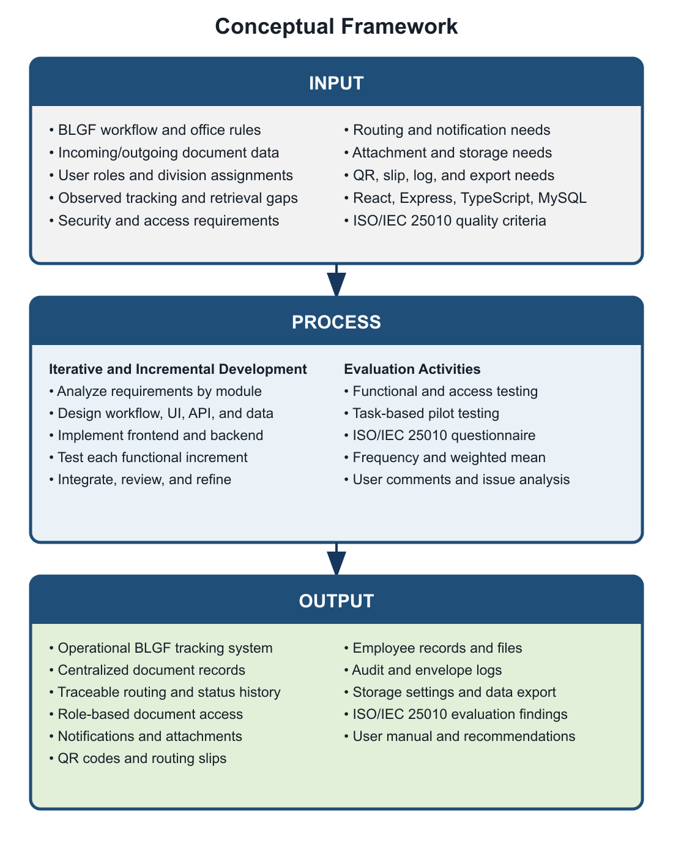
Figure 1. Conceptual Framework

1.3 Research Paradigm
Figure 2 presents the research paradigm that links the study inputs, system-development activities, evaluation procedures, and intended outcomes. Unlike the conceptual framework, which summarizes how resources are transformed into outputs, the research paradigm specifies the evidence, implementation components, and measurements used to answer the study objectives.
Research inputs consist of the existing BLGF Region II document workflow and office rules; incoming and outgoing document forms and metadata; route information, attachments, and logs; authorized user roles and division responsibilities; observed delays, errors, and retrieval problems; functional, access-control, notification, file-storage, and reporting requirements; the selected React, TypeScript, Express, MySQL, and file-storage technologies; and the ISO/IEC 25010 product-quality criteria.
The development component applies an Iterative and Incremental Development Model. Requirements are organized into functional increments; each increment undergoes workflow and interface design, database and API implementation, frontend and backend development, functional testing, integration, and refinement. These activities produce the actual modules verified in the project: authentication and role-based access; incoming and outgoing registration; unique route-number validation; routing, multi-routing, transfer, receipt, and completion; status and route history; notifications; attachments; QR and document-slip tools; employee records; audit and envelope logs; configurable storage; user administration; and database export.
The evaluation component combines functional verification, role and access testing, task-based user testing, the 30-item ISO/IEC 25010 questionnaire, and analysis of user comments and encountered issues. The resulting outcomes are an operational system, centralized and searchable records, verified task results, software-quality ratings, documented user feedback, evidence concerning visibility and accountability, a user manual, and recommendations for controlled improvement. Evaluation results feed back into the next development increment so that identified defects or usability issues can be corrected.
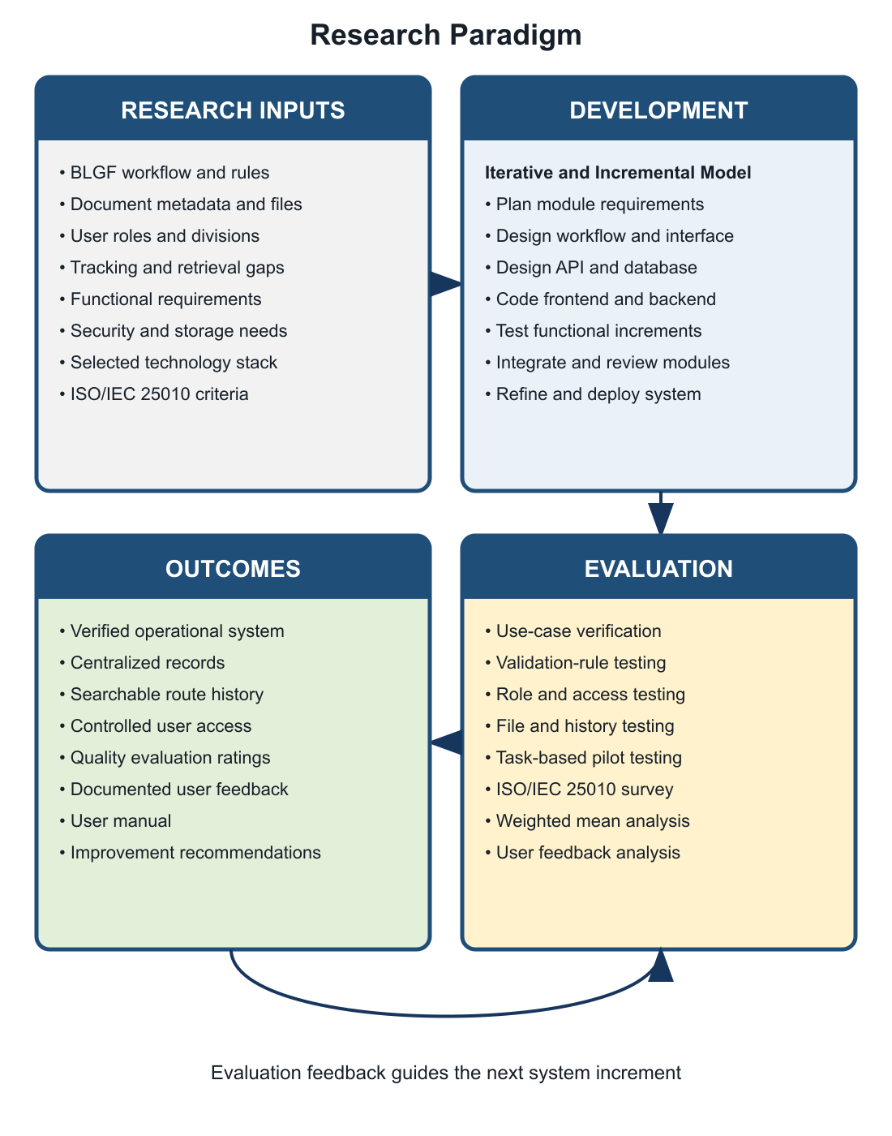
Figure 2. Research Paradigm

1.4 Objectives of the Study

1.4.1 General Objective
To design, develop, and evaluate a web-based document tracking and records management system that supports the secure, timely, and traceable processing of official documents at BLGF Region II.

1.4.2 Specific Objectives
- To document the existing practices and problems in registering, routing, monitoring, retrieving, and storing official documents.
- To identify challenges encountered by users in both the existing workflow and the developed system.
- To develop centralized modules for incoming and outgoing document registration, unique route-number validation, status monitoring, routing, transfer, and completion.
- To provide role-based access, user and employee management, notifications, audit trails, envelope dispatch logs, and attachment management.
- To support QR code generation/scanning, document slips, configurable file storage, search, filtering, dashboard summaries, and database export.
- To evaluate the system using the ISO/IEC 25010 product-quality characteristics.
- To recommend operational and technical improvements based on testing and user feedback.

1.5 Scope and Limitation of the Study
The study covers the document lifecycle supported by the implemented application: user authentication; incoming and outgoing document registration; division and user assignment; routing and multi-routing; transfer and receiving actions; document statuses and priorities; attachments; notifications; searchable lists and dashboards; official routing slips; outgoing-envelope recording; QR generation/scanning; employee profiles and folders; audit logs; configurable storage directories; MySQL export; and administrative user management.
The application is intended for authorized BLGF Region II personnel and is designed for use through a modern web browser on a networked computer. Access is controlled by predefined roles and permissions. The current implementation uses a React/TypeScript client, an Express/TypeScript server, and MySQL persistent storage, with local JSON files available as a fallback in supported deployments.
The study does not claim to replace national records-disposition policies, digital-signature infrastructure, or a full enterprise content-management platform. System effectiveness depends on correct data entry, reliable network and server availability, proper user-account administration, backup procedures, and staff compliance with approved workflows. Actual ISO/IEC 25010 scores cannot be finalized until the prescribed respondents complete pilot testing and the evaluation questionnaire.

1.6 Significance of the Study
- BLGF Region II Management. Consolidated operational information can support oversight, workload monitoring, accountability, and process improvement.
- Records and Administrative Personnel. Centralized registration, storage, search, routing history, and logs can reduce repetitive encoding and manual follow-up.
- Division Chiefs and Staff. Notifications and document-status visibility can clarify assigned actions, deadlines, and responsibility.
- Clients and Partner Offices. More consistent internal processing may improve response time and service delivery.
- System Administrators. Role management, storage configuration, audit trails, and database export provide tools for controlled system operation.
- Future Researchers and Developers. The study provides a reference for workflow-oriented records systems in comparable public-sector environments.

1.7 Definition of Terms
Term | Operational Definition
Audit Trail | A chronological record of system and user activities related to documents and administrative operations.
Document Route Number | A unique identifier used by the system to register, locate, and distinguish an official document.
Document Routing | The controlled forwarding of a document to one or more authorized users or divisions for action.
Incoming Document | A record received by BLGF Region II from an external or internal source.
Outgoing Document | A record released or transmitted by BLGF Region II to an intended recipient.
QR Code | A machine-readable code used to represent or retrieve document-identifying information.
Records Management | The systematic control of records throughout their creation, use, storage, retrieval, and disposition.
Role-Based Access Control | A security approach in which system permissions depend on a user’s assigned organizational role.
Routing History | The ordered record of offices, users, dates, actions, remarks, statuses, and attachments associated with document movement.
ISO/IEC 25010 | A software product-quality model used in this study as the basis for system evaluation.

CHAPTER II. REVIEW OF RELATED LITERATURE AND STUDIES

2.1 Foreign Literature
International records-management literature treats records as evidence of organizational activity and emphasizes their authenticity, reliability, integrity, and usability throughout the records lifecycle. This perspective supports the inclusion of unique identifiers, metadata, controlled access, routing history, audit logs, and systematic storage in an electronic tracking system (ISO, 2016).
Workflow information systems coordinate tasks, people, and business rules so that work items move through defined stages. In document-intensive organizations, workflow automation can reduce uncertainty by recording assignment, receipt, action, transfer, and completion events. Dashboards and notifications further convert stored transaction data into actionable information.
Role-based access control limits operations according to organizational responsibility. Applied to document tracking, it helps ensure that users see only the records and functions required by their duties, while administrators retain controlled capabilities for account, configuration, and audit management. Logging complements access control by establishing who performed an action and when it occurred.
QR codes provide a compact method for connecting physical documents to digital identifiers. When a printed routing slip or folder bears a QR code, scanning can accelerate lookup and reduce errors associated with manually typing long identifiers. The value of the code nevertheless depends on authoritative records and secure access in the underlying application.
Software-quality evaluation should be multidimensional. ISO/IEC 25010 identifies characteristics such as functional suitability, performance efficiency, compatibility, usability, reliability, security, maintainability, and portability. These characteristics provide a structured basis for evaluating whether the developed system meets both functional and quality expectations (ISO, 2011).

2.2 Local Literature
Philippine public offices operate within an environment that values accountability, efficient public service, data protection, and proper records custody. The Electronic Commerce Act recognizes electronic data messages and documents in transactions, while the Data Privacy Act establishes responsibilities for the lawful and secure processing of personal information. These principles make controlled access, accurate records, and appropriate safeguards important in government information systems (Republic Act No. 8792, 2000; Republic Act No. 10173, 2012).
The Ease of Doing Business and Efficient Government Service Delivery Act reinforces the need for simplified and timely government procedures. Although document tracking alone cannot resolve every service delay, accurate visibility into pending records, assigned personnel, target dates, and completed actions can help offices identify bottlenecks and establish responsibility (Republic Act No. 11032, 2018).
The National Archives of the Philippines provides the institutional context for government records management. Local digitalization initiatives commonly seek to improve retrieval and reduce dependence on fragmented paper logs. However, successful implementation also requires approved classification, retention, backup, access, and disposition procedures, together with staff training and management support (National Archives of the Philippines, n.d.).

2.3 Synthesis
The reviewed concepts converge on five requirements: reliable document identification, explicit workflow states, controlled access, traceable actions, and usable retrieval. Records-management principles explain what must be preserved; workflow systems explain how tasks move; security models govern who may act; QR technology connects physical and digital records; and ISO/IEC 25010 supplies an evaluation structure.
The proposed system integrates these requirements in a single application tailored to BLGF Region II. Its contribution is not the isolated use of a database or web interface, but the combination of registration, role-based routing, status history, attachments, alerts, storage, employee records, dispatch logs, QR-assisted lookup, and audit functions around the office’s operational document lifecycle.

CHAPTER III. RESEARCH METHODOLOGY

3.1 Research Design
The study uses developmental research with descriptive evaluation. Developmental research is appropriate because the main output is an information system created in response to an identified organizational need. The descriptive-evaluative component records workflow observations, encountered challenges, functional-test results, and user perceptions of the completed system using the ISO/IEC 25010 quality characteristics.
System development follows an Iterative and Incremental Development Model. Requirements are divided into manageable functional increments. Each increment passes through analysis, design, implementation, testing, integration, and review. Feedback from a completed increment informs the next one, allowing the system to progress from core authentication and document registration to routing, notifications, attachments, reporting tools, records functions, storage configuration, and administration (Pressman & Maxim, 2020; Sommerville, 2016).

3.2 System Architecture
The system follows a web-based client–server architecture. The browser client renders the React interface and calls REST-style endpoints. The Express server performs validation, workflow processing, authentication, file handling, and data access. MySQL stores structured operational data, while configured directories preserve uploaded files. A JSON fallback supports selected local deployments. Production assets are generated through Vite and esbuild (Express.js, n.d.; OpenJS Foundation, n.d.; Oracle Corporation, n.d.; React Team, n.d.).
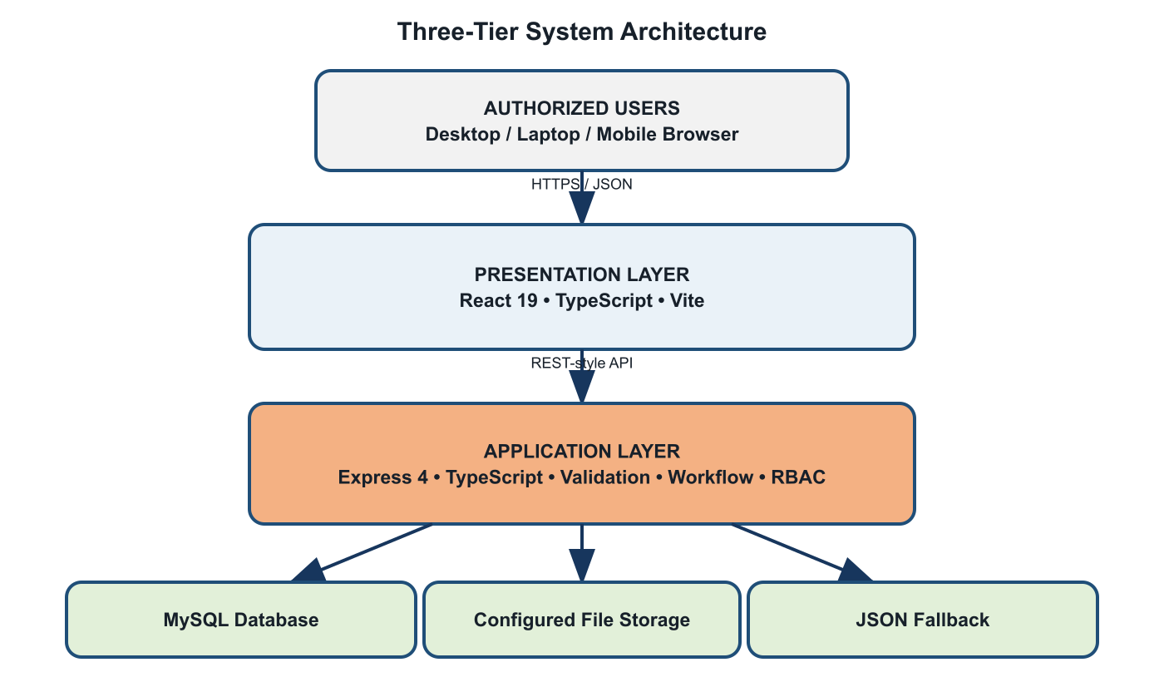
Figure 3. System Architecture

3.3 Use-Case Diagram
The principal actors are Administrator, Records Personnel, Division Chief, Staff/User, and Authorized Viewer. Available functions vary according to role permissions configured in the application.
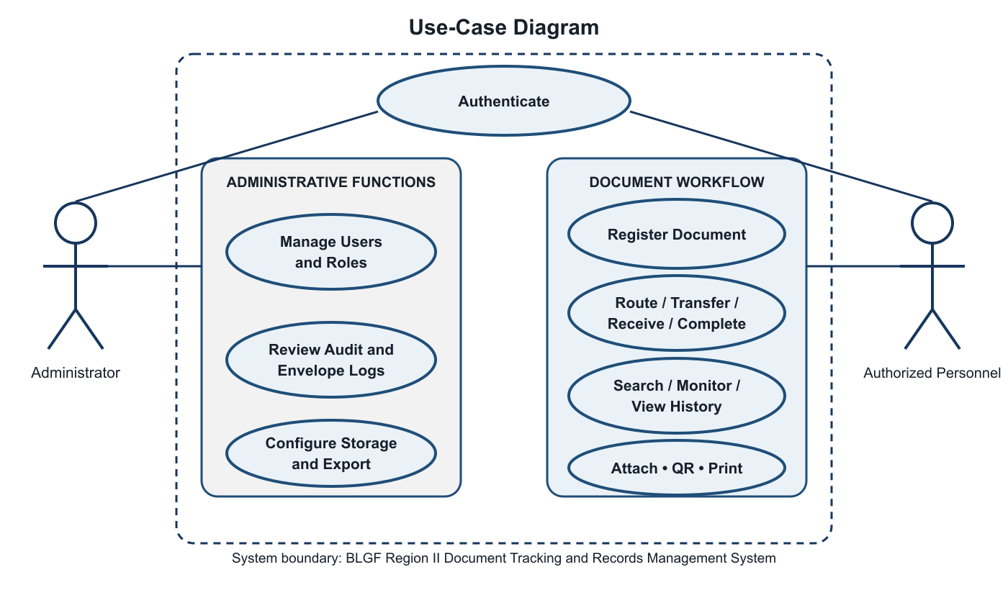
Figure 4. Use-Case Diagram

3.4 Context Level – Data Flow Diagram
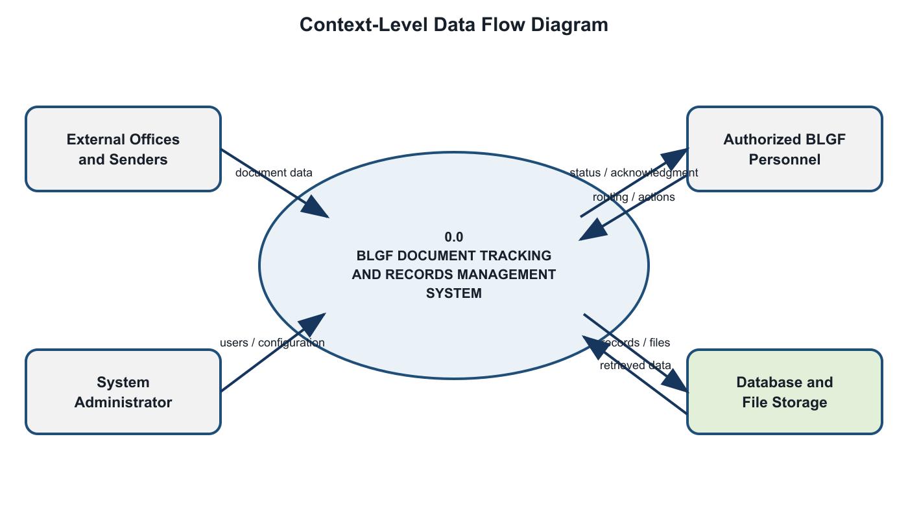
Figure 5. Context-Level Data Flow Diagram

3.5 Software and Hardware Requirements
Category | Minimum / Required | Recommended
Client Hardware | Dual-core CPU, 4 GB RAM, 1366×768 display | Modern multi-core CPU, 8 GB RAM or higher
Server Hardware | 4-core CPU, 8 GB RAM, 20 GB available storage | Scalable server/VM with monitored backups
Client Software | Modern Chromium, Firefox, or Edge browser | Current supported browser with JavaScript enabled
Server Software | Node.js-compatible runtime, npm, MySQL | Current LTS Node.js, managed MySQL/TiDB, TLS
Frontend | React 19, TypeScript, Vite | Production build served over HTTPS
Backend | Express 4, TypeScript, mysql2, Multer | Process manager, logging, health monitoring
Network | Reliable LAN/Internet connectivity | Redundant connection and secure network controls
Backup | Periodic database and attachment copy | Automated encrypted, tested, off-site backup

3.6 Respondents of the Study
The proposed respondents are authorized BLGF Region II personnel who participate in document receipt, registration, routing, action, release, records storage, supervision, or system administration. Purposive sampling is recommended because respondents must have direct knowledge of the workflow being evaluated.
Final respondent profile: 20, for the Administrative Division, Legal Division, Financial Division, Local Treasury Operations Division, Local Assessment Operations Division, Office of the Regional Director. The final manuscript must report the actual distribution and selection criteria after approval by the adviser and participating office.

3.7 Research Instrument
The primary instrument is a structured questionnaire based on the eight ISO/IEC 25010 product-quality characteristics. Respondents rate statements on a five-point Likert scale: 5 – Strongly Agree, 4 – Agree, 3 – Neither Agree nor Disagree, 2 – Disagree, and 1 – Strongly Disagree. The instrument also includes respondent profile items and open-ended questions for observed issues and recommendations. A functional-test checklist records whether required use cases, validation rules, permissions, files, notifications, histories, and administrative functions operate as intended (ISO, 2011).
Content validation should be performed by the thesis adviser, an information-technology expert, and a records/process representative. A pilot test should verify clarity, completion time, and internal consistency before the main administration.

3.8 Locale of the Study
The study is intended for the Bureau of Local Government Finance – Region II, Regional Government Center, Tuguegarao City, Cagayan. Data gathering, workflow validation, pilot testing, and user evaluation should be conducted with permission from the authorized regional office and in accordance with its operational and information-security requirements.

3.9 Data Gathering
- Secure written permission from BLGF Region II and approval of the research instrument.
- Interview or consult process owners to document existing registration, routing, follow-up, storage, and reporting practices.
- Review non-confidential forms, log formats, routing slips, and metadata requirements.
- Configure a controlled test environment using non-sensitive or properly authorized sample data.
- Orient respondents and conduct task-based pilot testing of relevant system modules.
- Administer the ISO/IEC 25010 questionnaire and collect open-ended feedback.
- Encode, verify, analyze, and securely retain the resulting data.
- Revise the system and manuscript based on validated findings.

3.10 Data Analysis
Frequency and percentage will describe respondent groups and recurring workflow issues. The weighted mean will summarize each ISO/IEC 25010 statement and quality characteristic. Where appropriate, standard deviation may describe response dispersion. Open-ended responses will be grouped by recurring theme.

Weighted Mean = Σ(f × w) / N
Weighted Mean Range | Verbal Interpretation
4.21–5.00 | Strongly Agree / Excellent
3.41–4.20 | Agree / Very Good
2.61–3.40 | Neither Agree nor Disagree / Good
1.81–2.60 | Disagree / Fair
1.00–1.80 | Strongly Disagree / Poor

CHAPTER IV. RESULTS AND DISCUSSIONS

This chapter documents the system output already verifiable from the implemented application. Survey-dependent tables remain explicitly marked for completion after formal pilot testing; no respondent score is fabricated in this proposal draft.

4.1 Problems Encountered in the Existing System
The requirements addressed by the system indicate recurring risks in a manual or fragmented workflow: difficulty locating a document after endorsement; dependence on personal follow-up; inconsistent route-number recording; duplicate entries; limited visibility of pending actions and target dates; attachments stored separately from transaction records; incomplete chain-of-custody information; and delayed preparation of logs or reports.
These conditions may result in unnecessary processing time, uncertainty regarding responsibility, weak auditability, and difficulty retrieving historical records. They also make continuity dependent on individual knowledge instead of shared and controlled organizational information.

4.2 The Developed System
The developed application centralizes registration, file upload, routing, monitoring, receipt, transfer, return, completion, retrieval, and administrative control in one role-aware workspace. The implemented interface includes authentication, dashboard summaries, incoming and outgoing document lists, unique route-number validation, document details and lifecycle progress, additional attachments, single- and multi-recipient routing, reply-PDF upload, routing slips, outgoing-envelope preparation, QR generation and scanning, notifications, office-directory records, audit and envelope-dispatch logs, user accounts, divisions, role-permission matrices, and account settings. Functions are displayed according to the authenticated account's role and saved permissions, while each significant transaction is associated with a user and time-stamped history.

Module | Implemented Capability
Authentication and Access | User login, active-account checking, role-based views and action permissions
Dashboard | Operational summaries and access-aware document information
Incoming / Outgoing | Registration, unique route number, metadata, priority, target date, attachments
Routing | Single and multiple recipients, transfer, receipt/action status, remarks, route history
Notifications | Action-required and routing alerts tied to users and documents
Document Slip | Selection and printing of official routing information
QR Tools | QR generation and camera-based scanning support
Envelope Dispatch | Outgoing recipient/releasing details and separate envelope logs
Employee Records | Employee profiles, folders, and supporting files
Audit | Chronological user/system activity records
Storage | Configurable document directories and controlled file access
Administration | Users, divisions, settings, deletion rights, database export

4.2.1 Hierarchical Input Process Output (HIPO)
Figure 6 presents the Hierarchical Input Process Output (HIPO) model of the developed system. At Level 0, the complete BLGF Region II Document Tracking and Records Management System acts as the parent function. Level 1 decomposes the system into six major modules that correspond to the active functions implemented in the frontend and backend: authentication and role authorization; document registration; routing and status tracking; file and employee-record storage; search, notification, QR, and printing; and administration, audit, and export.
The lower portion of the figure provides an IPO summary for every Level 1 module. Each row identifies the data accepted by a module, the principal validation or transformation performed by the application, and the resulting record, view, history entry, notification, file, or administrative output. This structure shows both the functional hierarchy and the flow of information without treating unsupported legacy schema tables as active system modules.
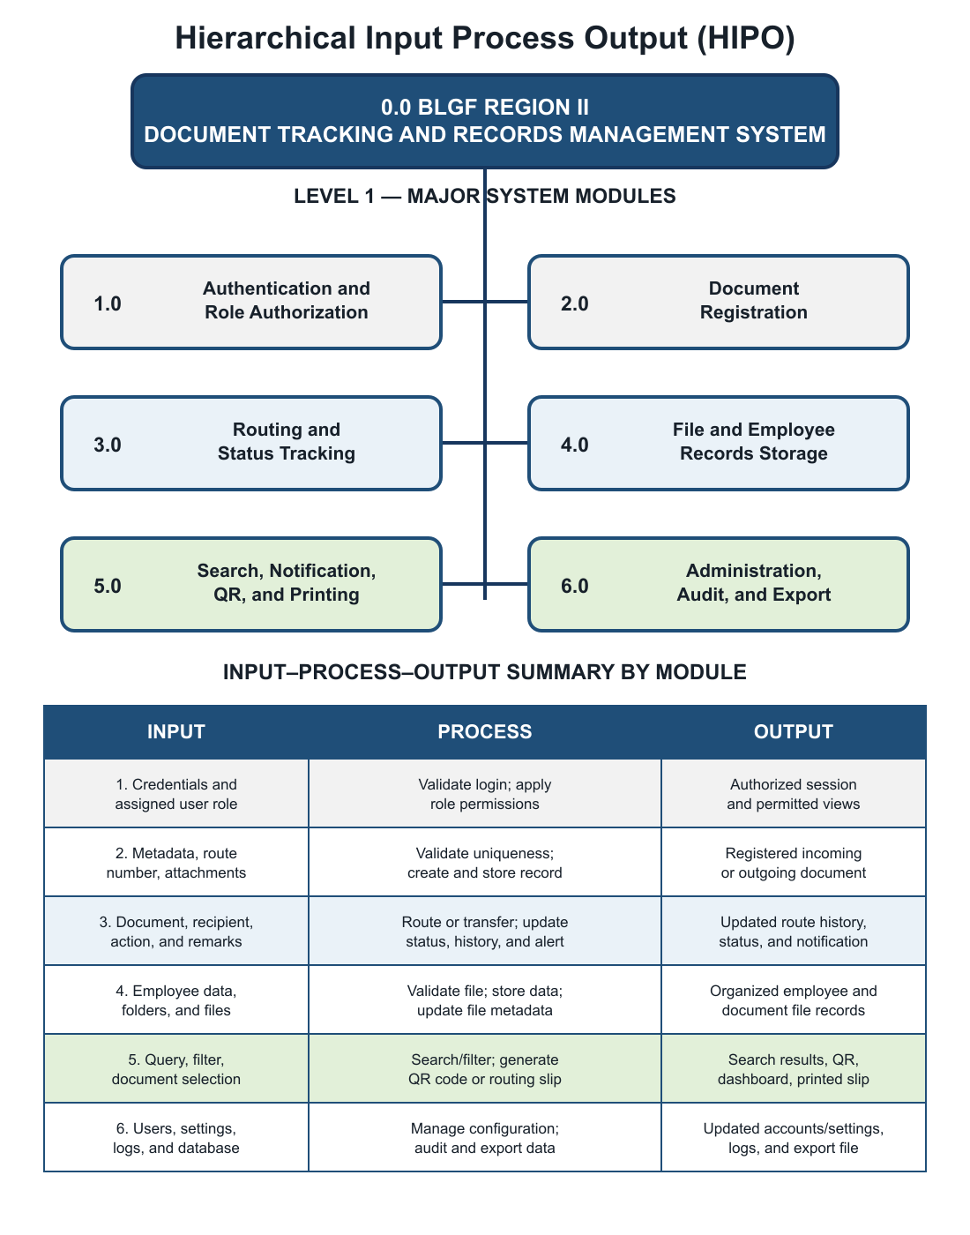
Figure 6. Hierarchical Input Process Output

4.2.2 Input Process Output (IPO) Diagram
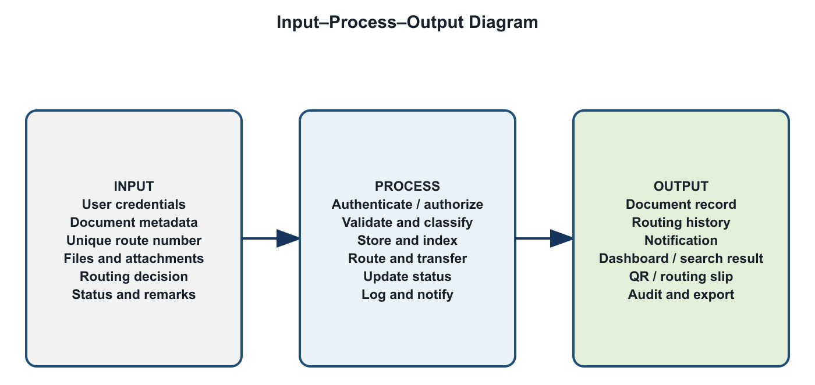
Figure 7. Input-Process-Output Diagram

4.2.3 Entity Relationship Diagram (ERD)
Figure 8 presents the active data relationships used by the developed system. The core workflow centers on the documents entity, which stores the unique tracking number, direction, subject and classification data, current status, current division, assignment, and relevant dates. A document may have many routing steps and attachments. Notifications may refer to a document and are assigned to a user. Users are grouped by division and their significant actions are recorded in audit logs.
Employee records form a related but distinct branch: one employee profile may contain many folders, and one folder may contain many files. Solid relationship lines identify foreign keys explicitly enforced in the current MySQL schema. Dashed lines identify application-level logical references such as division_code, user_id, and notification document_id, which are used by the application but are not declared as foreign-key constraints in the schema. This distinction prevents the diagram from claiming database constraints that do not exist.
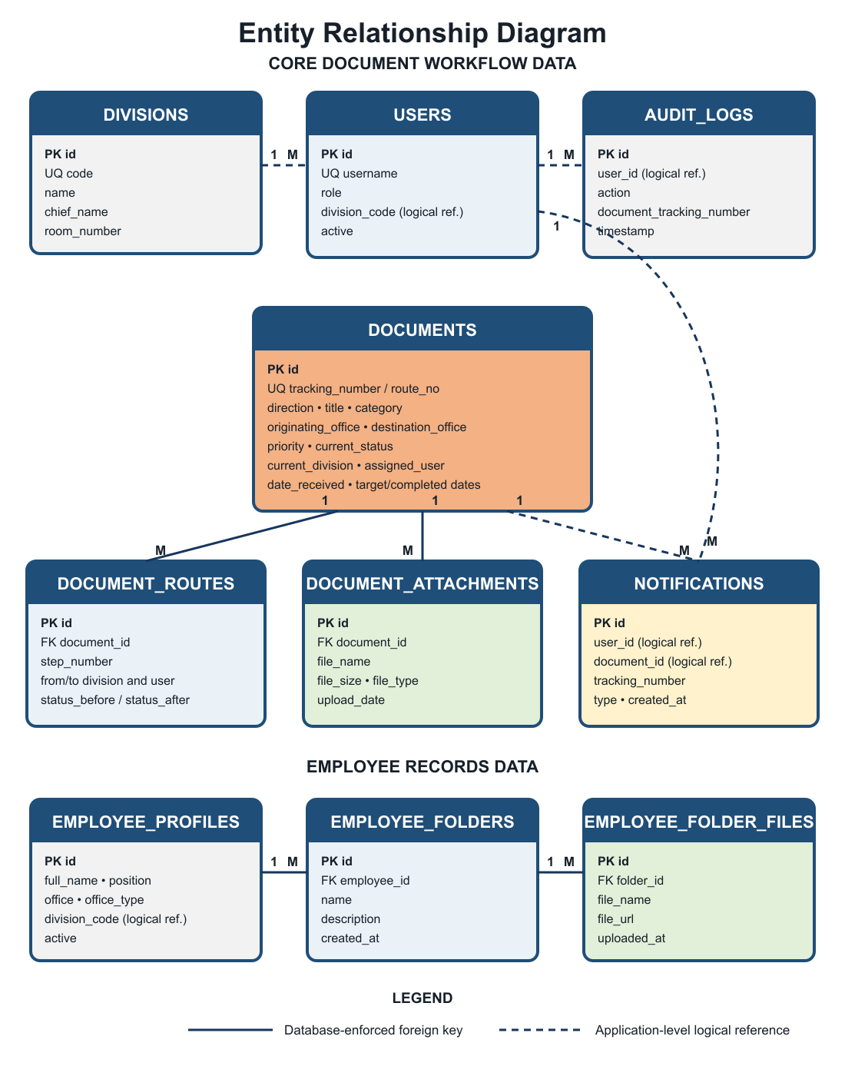
Figure 8. Entity Relationship Diagram

4.2.3.1 User’s View
Figures 9 to 32 document the actual implemented interface. The presentation is divided into shared access, System Administrator features, and regular-user features so that responsibilities and access boundaries are explicit. Each figure is followed by its purpose, important controls, correct operating sequence, and expected result, following the feature-by-feature approach used in the Web-Based Document Tracking and Records Management System for the Bureau of Local Government Finance – Region II documentation.

4.2.3.1.1 Role and Feature Access Summary
The System Administrator supervises organization-wide configuration and accountability controls. A regular user performs document work permitted for the account and normally sees only records connected to that user or division. The permission matrix remains authoritative when a specific role has been customized.

4.2.3.1.2 Shared Authentication View
The authentication form is the common entry point for both administrator and user accounts. The system validates an active username and password before loading role permissions. Failed credentials do not reveal protected records.
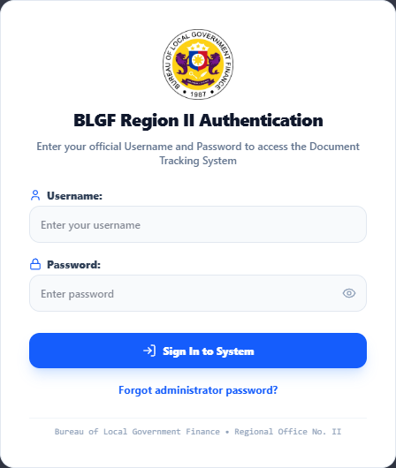
Figure 9. Close-Up Authentication Form

Username — enter the exact account name assigned by the System Administrator.
Password — enter the private credential; the eye control may temporarily show or hide the value.
Sign In to System — submits the credentials and opens only the menus allowed for the account.
Forgot administrator password — starts the controlled recovery process for an administrator account; ordinary users should contact the administrator.
Expected result — a successful login displays the account name, role, permitted sidebar menus, and current notifications.

4.2.3.1.3 System Administrator View
The System Administrator view provides the widest operational and configuration scope. It is used to supervise documents, personnel accounts, role permissions, divisions, logs, and system-wide settings. Administrative access must be limited to designated personnel and reviewed periodically.

A. Administrator Dashboard
The dashboard presents organization-wide totals, document statuses, workload distribution, recent transactions, global search, QR scanning, notifications, and quick commands.

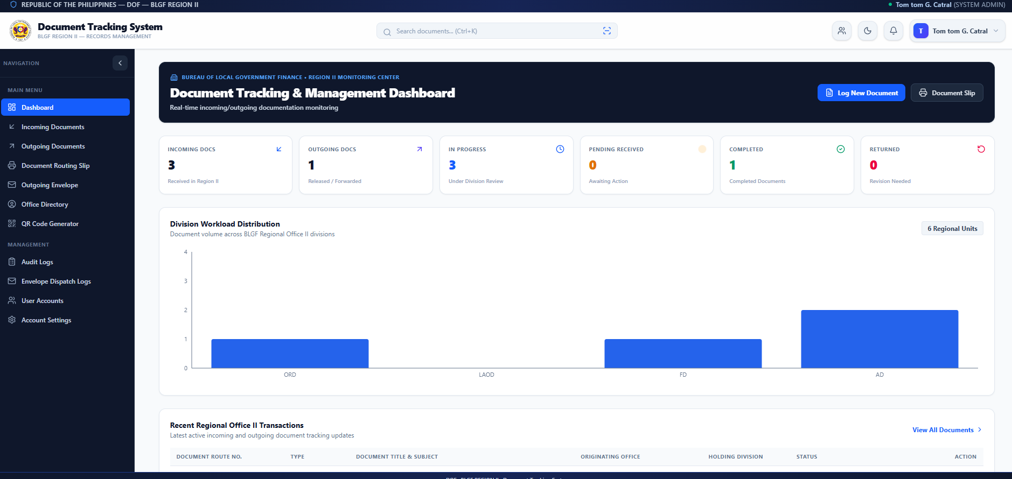
Figure 10. System Administrator Dashboard

Summary cards — open filtered sets for incoming, outgoing, pending, in-progress, completed, returned, or urgent records.
Log New Document — opens the registration and upload form.
Document Slip — opens the printable routing-slip workspace.
Search and QR scan — locate a document by metadata or encoded route number.

B. Log New Document and File Upload Form
This form creates an incoming or outgoing transaction and optionally routes it immediately. Required fields are marked with an asterisk; the record should not be submitted until the source document and destination have been verified.
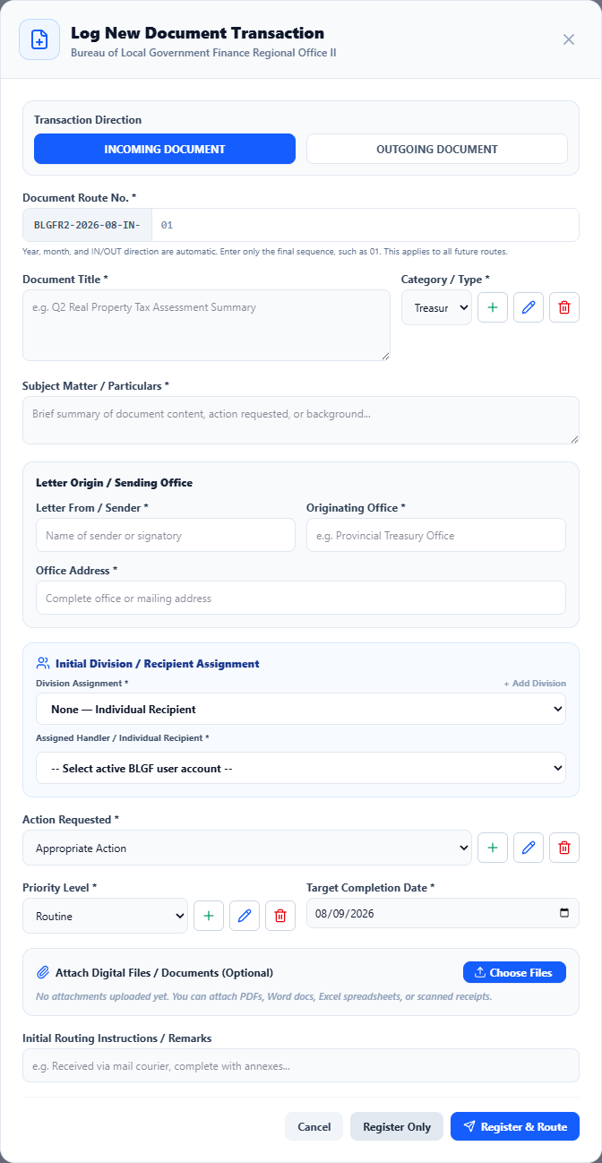
Figure 11. Administrator Log New Document and Upload Form
Transaction Direction — select INCOMING when received by BLGF Region II and OUTGOING when released or transmitted by the office.
Document Route No. — enter only the manual sequence; the year, month, and IN/OUT prefix are generated by the interface. A duplicate route number is rejected.
Document Title — enter the official title exactly as shown on the source record.
Category/Type — classify the record; authorized administrators may add, edit, or remove managed options.
Subject Matter/Particulars — summarize the request, action, or principal content for searching.
Letter From/Sender, Originating Office, and Office Address — identify document provenance.
Division Assignment and Assigned Handler — choose the correct division and one or more active user accounts; use All Divisions only when the same action is legitimately required by all.
Action Requested — state what the recipient must do, such as approval, verification, endorsement, or filing.
Priority and Target Completion Date — indicate urgency and the expected action date.
Choose Files — upload only authorized files belonging to this route number; review each filename before submission.
Initial Routing Instructions/Remarks — record concise operational instructions, not passwords or unnecessary sensitive data.
Register Only — saves the record without dispatch. Register & Route — saves the record and opens the routing workflow. Expected result: the new route number appears in the correct list with its attachment and first history event.

C. Incoming and Outgoing Monitoring
The monitoring center provides All, Incoming, and Outgoing tabs plus status, division, and priority filters. It shows route number, title, lifecycle progress, current status, holding division, dates, and permitted actions.
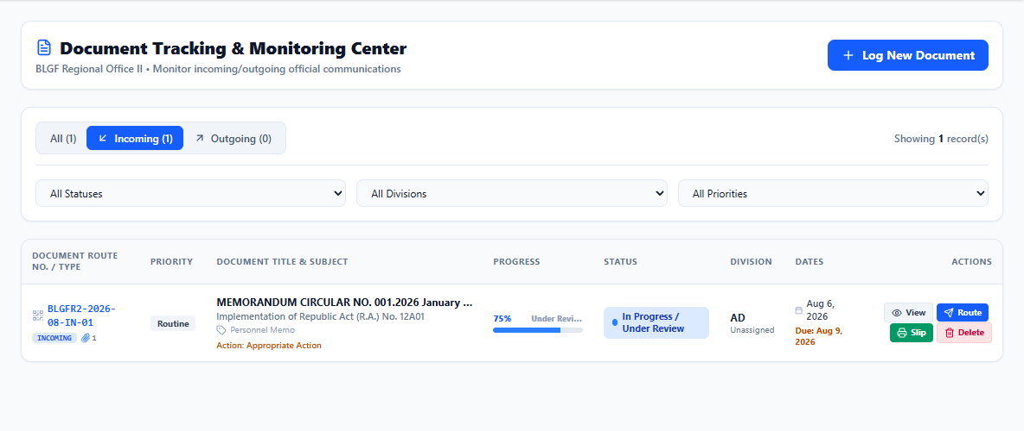
Figure 12. Administrator Document Monitoring Center

View — opens complete metadata, attachments, and routing history.
Route — opens the recipient/action form.
Slip — prepares the routing slip.
Delete — administrator-only destructive action; use only under approved correction rules and never to conceal a transaction.

D. Document Details, Attachments, and History
The details window is the authoritative transaction view. It combines lifecycle progress, document summary, attached files, and the chronological routing and audit trail.
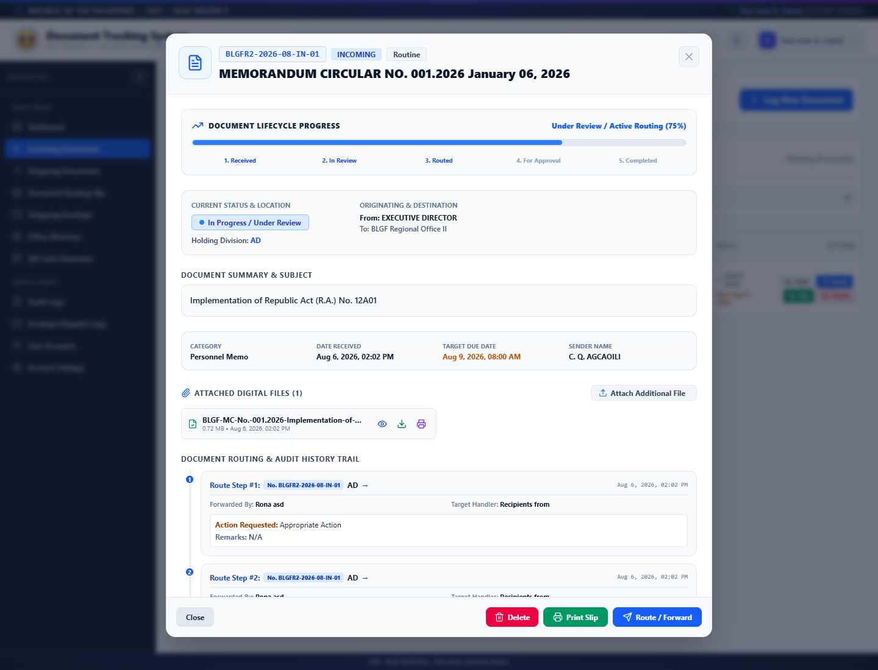
Figure 13. Administrator Document Details and History

Lifecycle progress — shows receipt, processing, routing, and completion stage.
Attach Additional File — adds an authorized supporting file after registration.
View, Download, and Print PDF — provide controlled handling of stored attachments.
Routing history — identifies sender, recipient, division, action, remarks, status change, and time for every visible step.
Print Slip and Route/Forward — continue the workflow from the verified record.

E. Route/Forward and Reply Upload Form
This form assigns the next responsible users or divisions, records the action requested, changes lifecycle status, captures remarks, and optionally attaches a reply PDF.
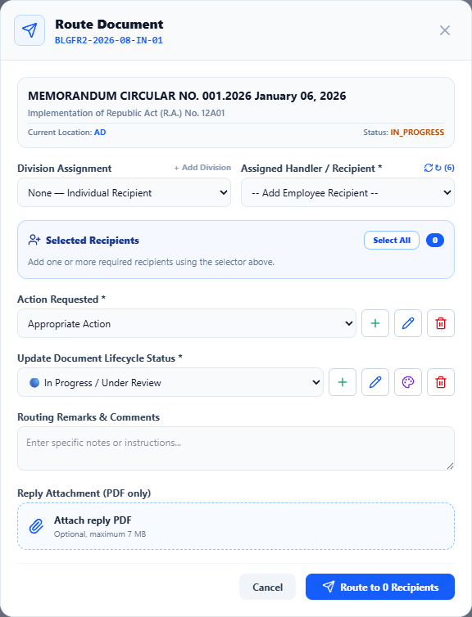
Figure 14. Administrator Route/Forward Form

Destination Division — narrows or expands recipients; Add Division supports legitimate multi-routing.
Assigned Handler/Recipient — select active accounts sourced from User Management; verify all selected names before routing.
Action Requested — choose the exact expected action; administrators with permission can manage reusable options.
Lifecycle Status — choose Pending, In Progress, For Signature, Completed, Returned, or On Hold according to the real condition.
Remarks — explain instructions, transfer reasons, return/rejection reasons, or completion context.
Reply Attachment — accepts the authorized reply PDF within the displayed size limit.
Route button — remains ineffective until required recipients and action information are complete. Expected result: a new route-history step and recipient notification are created.

F. Document Routing Slip
The routing-slip workspace selects a registered document and converts its identifying data and routing sequence into a print-ready record linked to the electronic transaction.
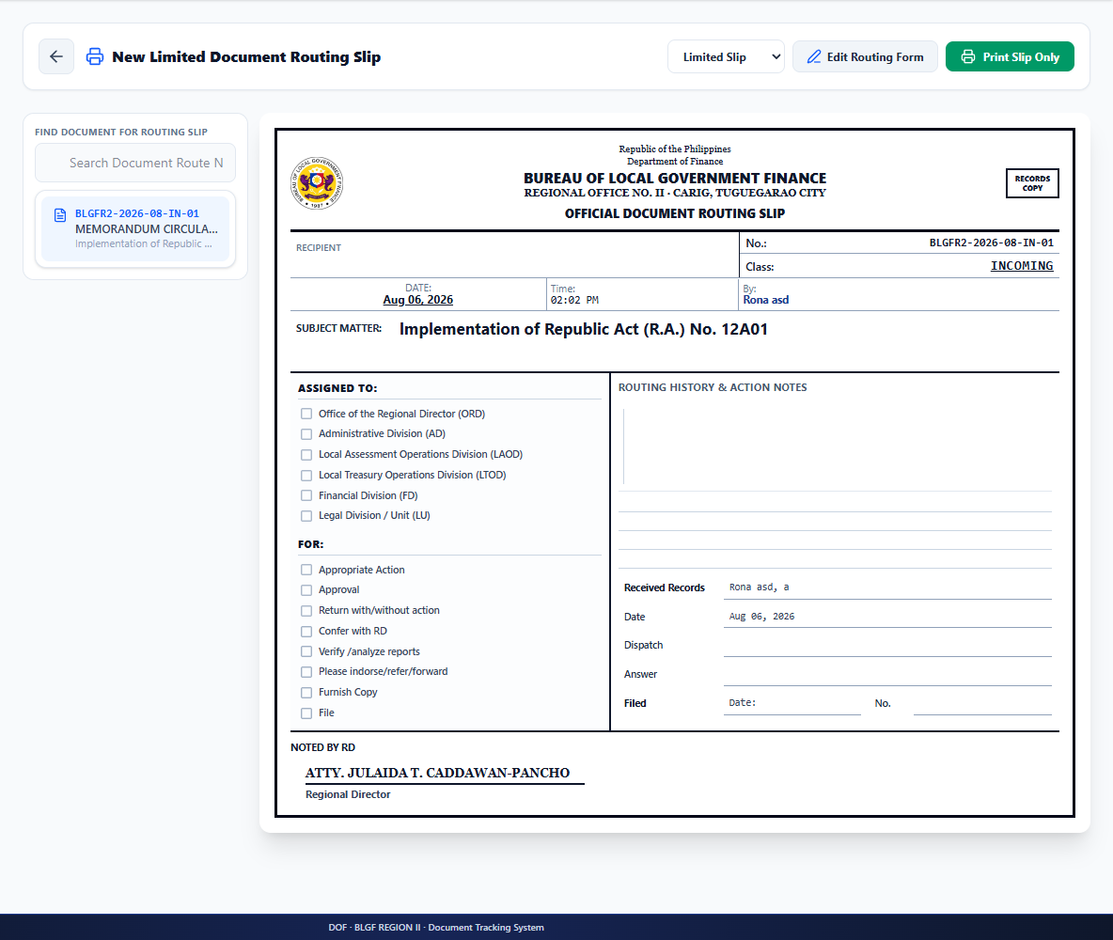
Figure 15. Administrator Routing Slip Feature

- Verify the route number, title, origin, destination, action, dates, and route sequence before printing.
- Attach the correct slip only to the matching physical document or folder.

G. Outgoing Envelope Preparation
The outgoing-envelope feature prepares properly formatted recipient and sender information for physical dispatch. It complements, but does not replace, the outgoing electronic record.
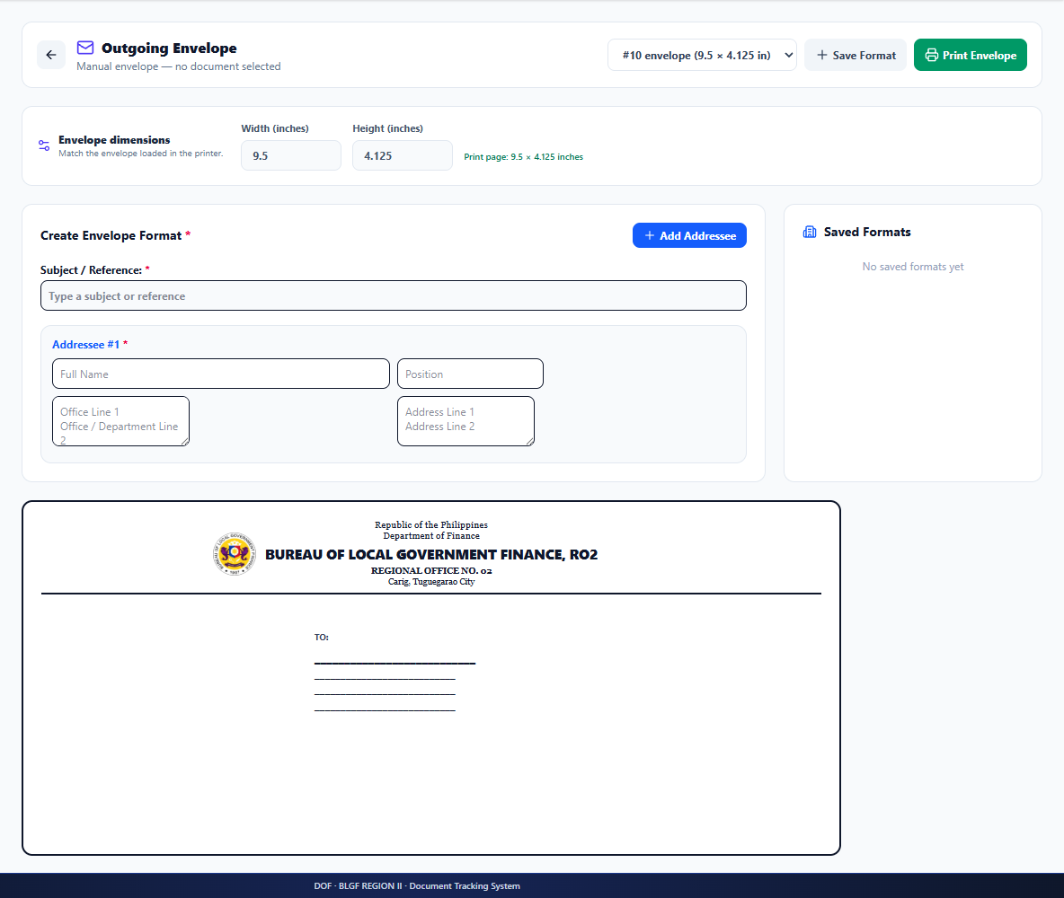
Figure 16. Administrator Outgoing Envelope Feature

  - Select or enter the authorized recipient and address.
  - Preview the envelope format and confirm spelling before printing.
  - Record the dispatch in the envelope log when required by office procedure.

H. Office Directory
The directory maintains active BLGF personnel profiles used for reference and routing. Accurate division, designation, email, and contact information helps prevent misrouting.
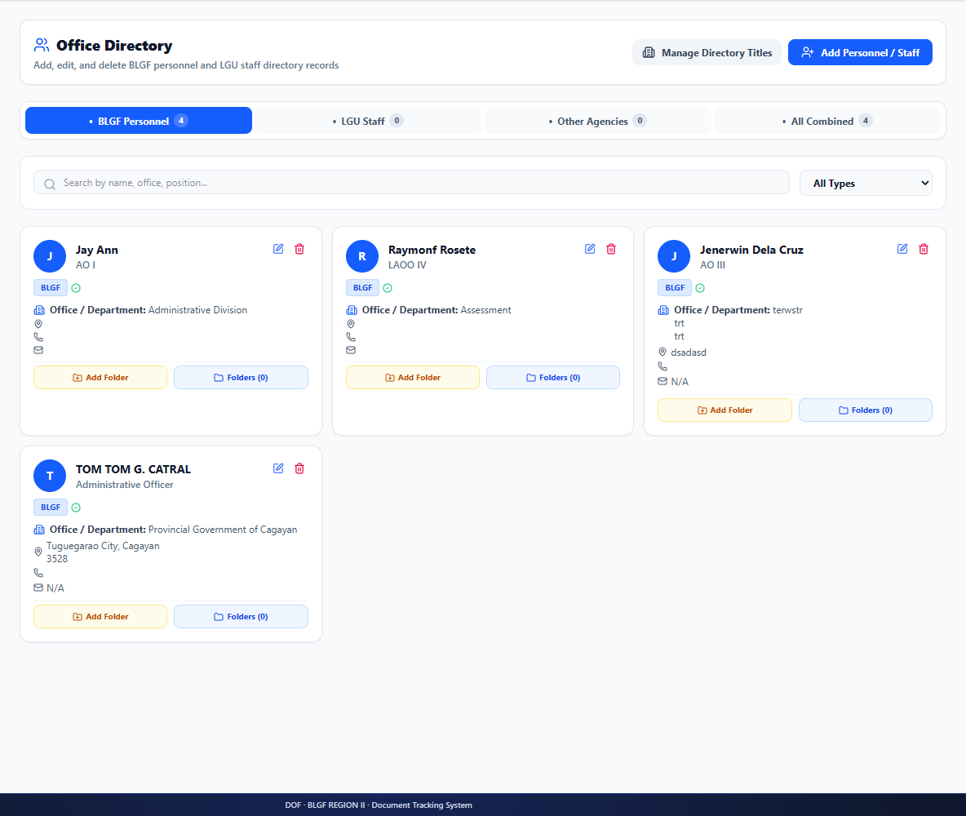
Figure 17. Administrator Office Directory

- Add or edit profiles only from an authorized personnel source.
- Deactivate or correct obsolete entries so recipient lists remain reliable.
- Employee folders and files must follow the user's granted management permissions.

I. QR Code Generator
The QR module encodes a document identifier for faster lookup and association of physical and digital records.
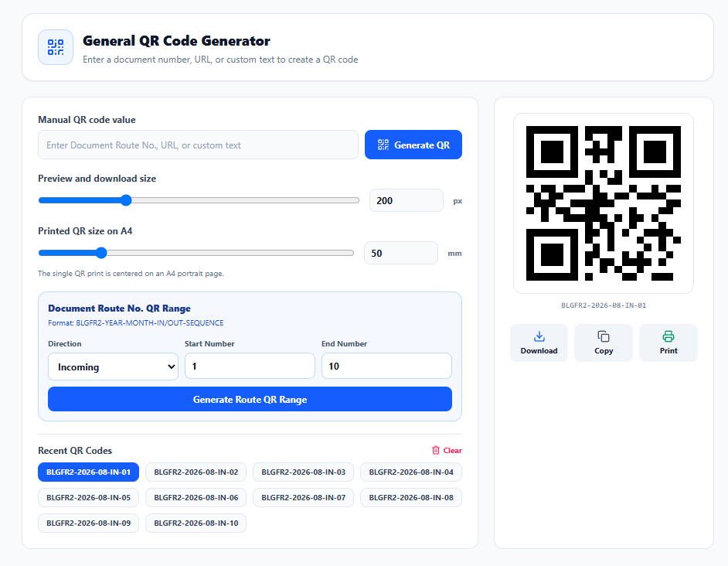
Figure 18. Administrator QR Code Generator

- Enter or select the verified route number.
- Generate and preview the code before download or printing.
- Do not encode passwords, confidential contents, or unrelated personal information.

J. System Audit Logs
Audit logs preserve significant authentication, document, user, and administrative actions for accountability and incident investigation.
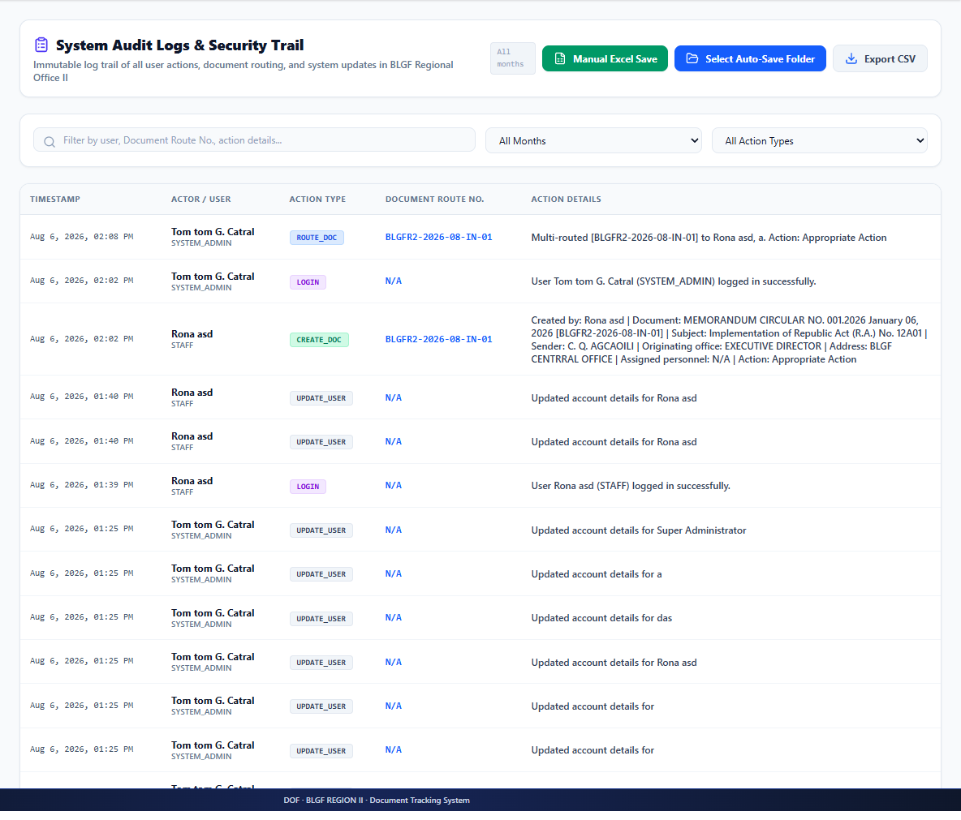
Figure 19. System Audit Logs

- Use search and filters to locate the responsible account, time, action, and affected record.
- Audit entries should be retained and reviewed; an operational error must be corrected through another traceable action.

K. Envelope Dispatch Logs
This view preserves outgoing-envelope preparation or dispatch events separately from document-routing history.
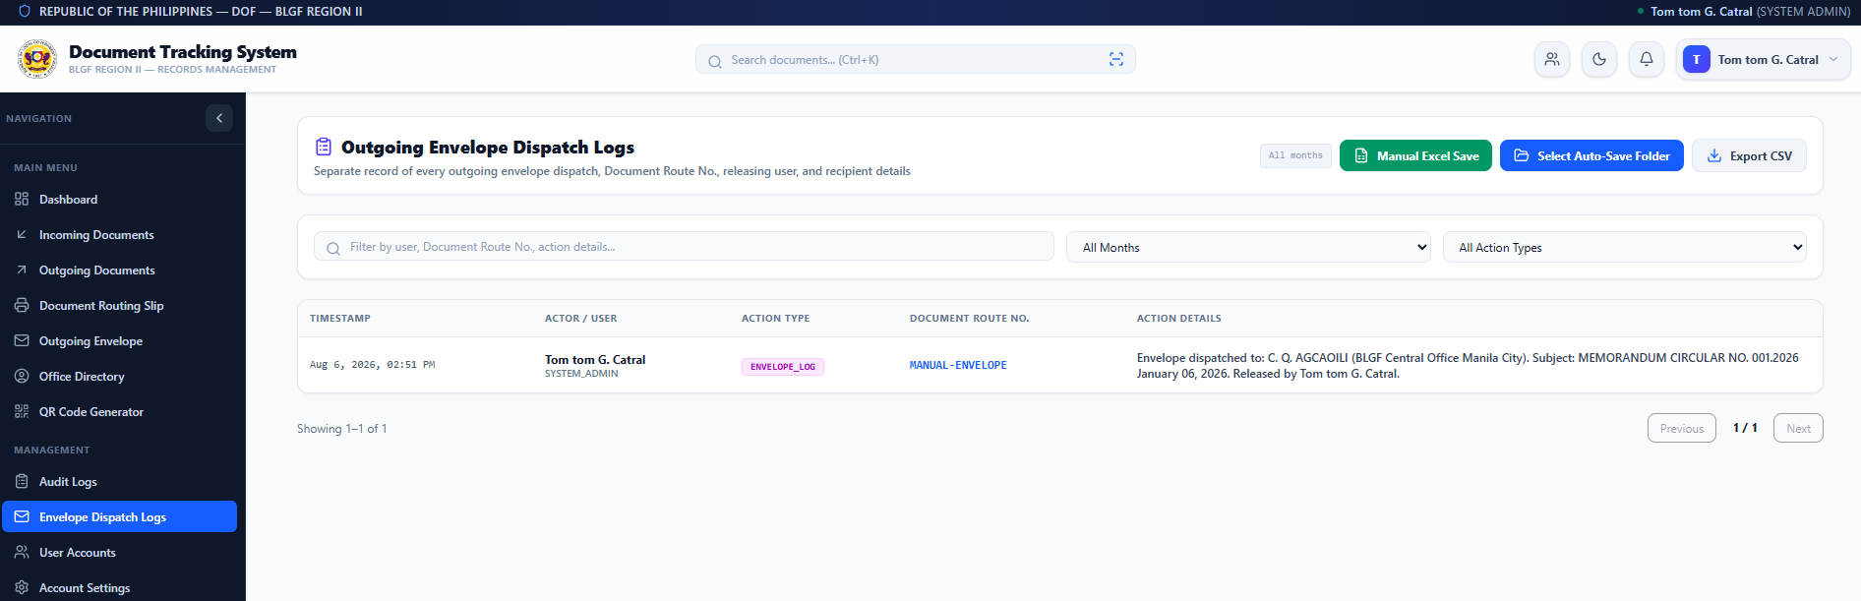
Figure 20. Envelope Dispatch Logs

- Confirm recipient, responsible user, document reference, and date.
- Use the log for follow-up and reconciliation of released physical communications.

L. Personnel Account Management
The personnel list lets authorized administrators search accounts, inspect roles and divisions, activate/deactivate access, edit custom menu permissions, and delete accounts under controlled rules.
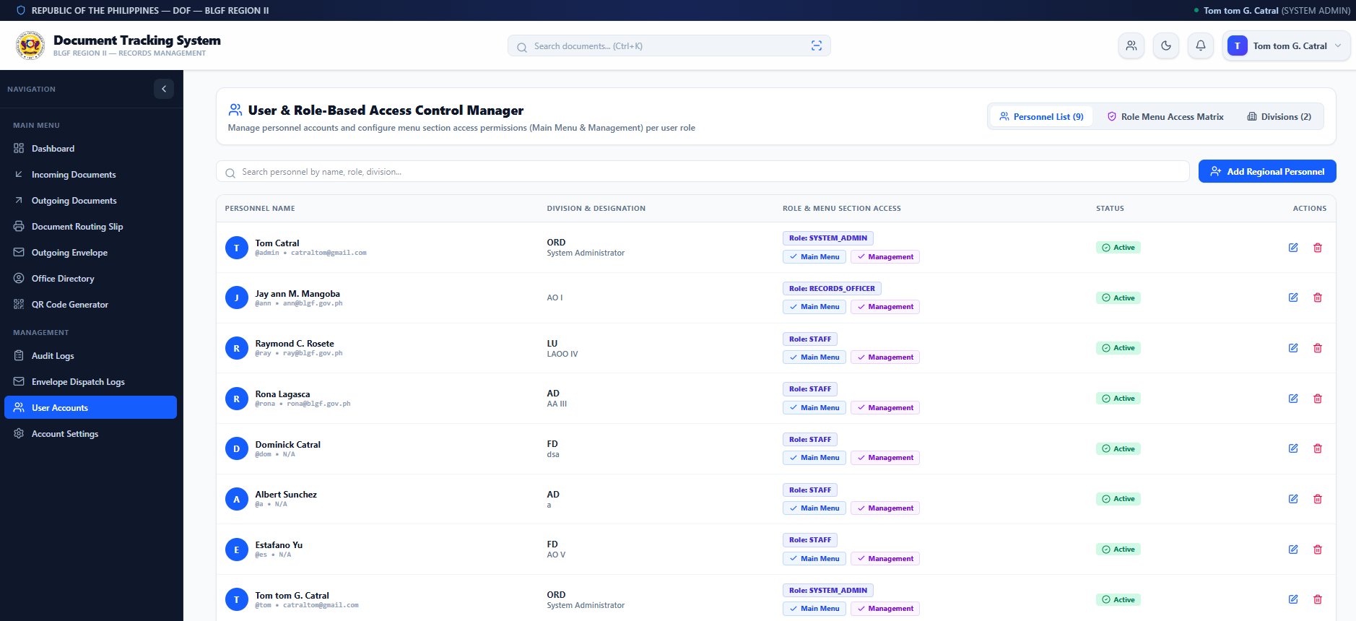
Figure 21. Personnel Account Management

Active/Inactive — immediately controls whether the account may sign in.
Edit Personnel — updates identity, role, division, designation, and permitted menu sections.
Delete User Account — use only when permitted and after checking ownership/history implications; deactivation is safer when audit continuity is required.

M. Role Menu Access Matrix
The matrix applies feature and menu permissions consistently across organizational roles. It covers complete-route visibility, delete authority, workflow-option management, directory operations, main-menu features, and management sections.
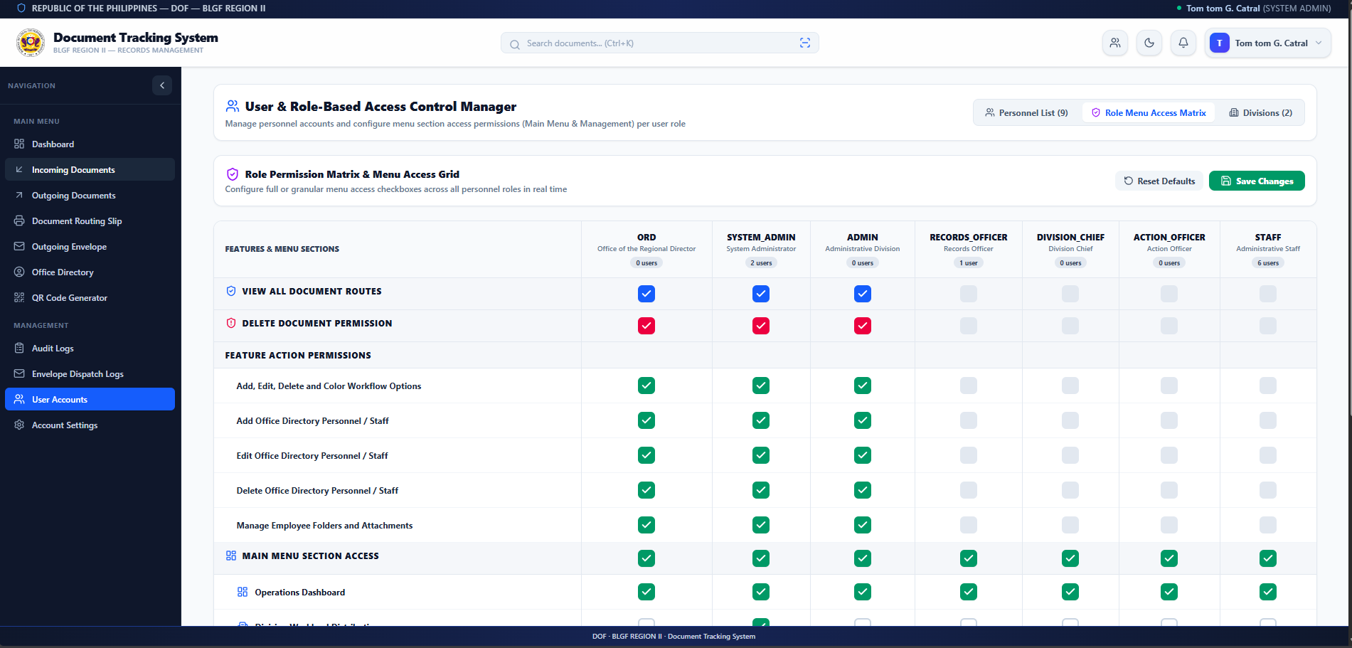
Figure 22. Role and Menu Access Matrix

- Apply least privilege and enable only functions required for the role.
- Review the affected user count before saving a role-wide change.
- Use Reset Defaults only when approved; confirm the resulting access after Save Changes.

N. Create User Account Form
This form provisions a new active personnel account and its initial access profile.
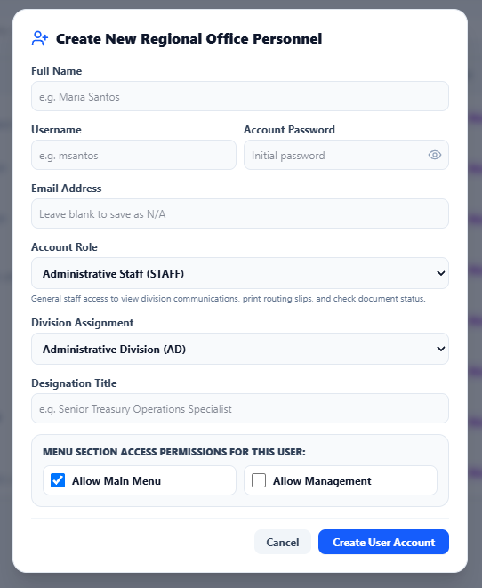
Figure 23. Create New Regional Personnel Account Form

Full Name, Username, and Initial Password — required identity and sign-in fields; usernames must be unique.
Email — supports notifications or recovery when configured; use an official address.
Role — determines default permissions and organizational responsibility.
Division and Designation — identify the user's working unit and position.
Allow Main Menu/Management — apply only the access necessary for assigned duties.

O. Division Management
The division tab maintains organizational codes and names used by routing, filters, user profiles, and reports.
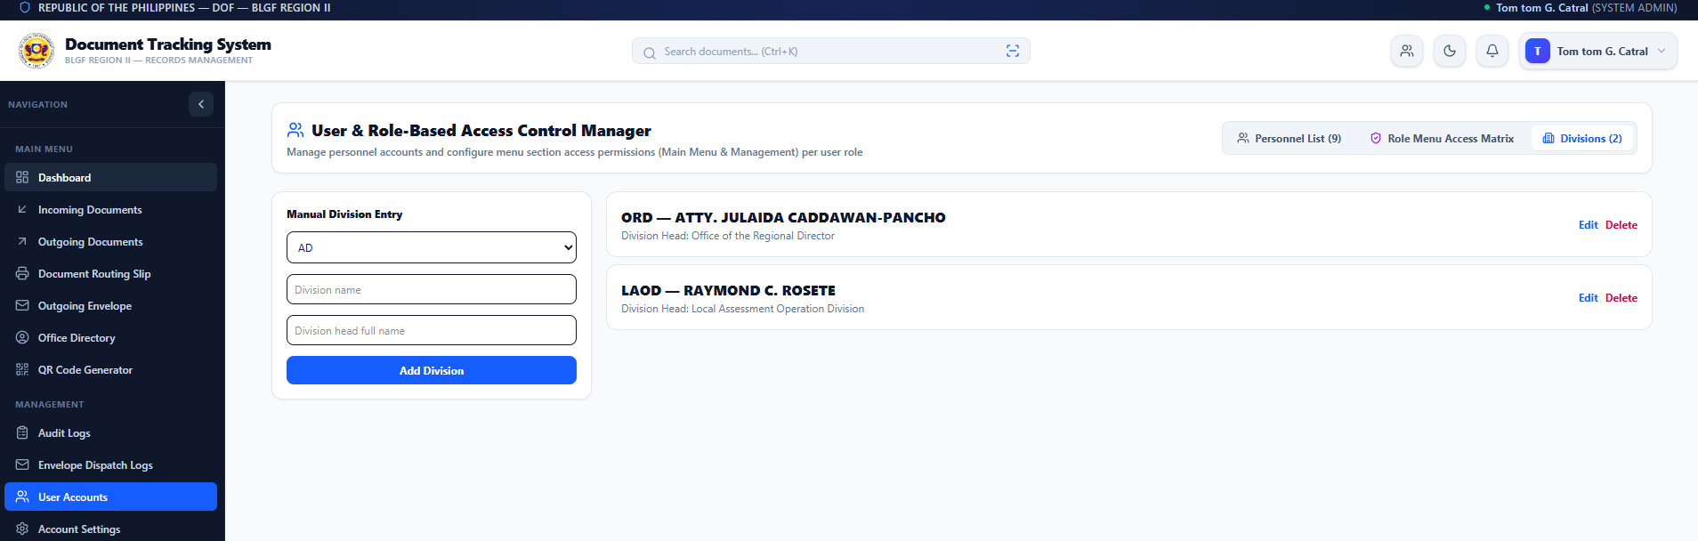
Figure 24. Division Management

- Use an approved, unique division code and official division name.
- Before deletion, verify that no users or documents depend on the division; prefer correction or controlled deactivation where history must remain intelligible.

P. Administrator Account Settings
The administrator can update permitted profile information and change credentials while retaining the assigned system role.
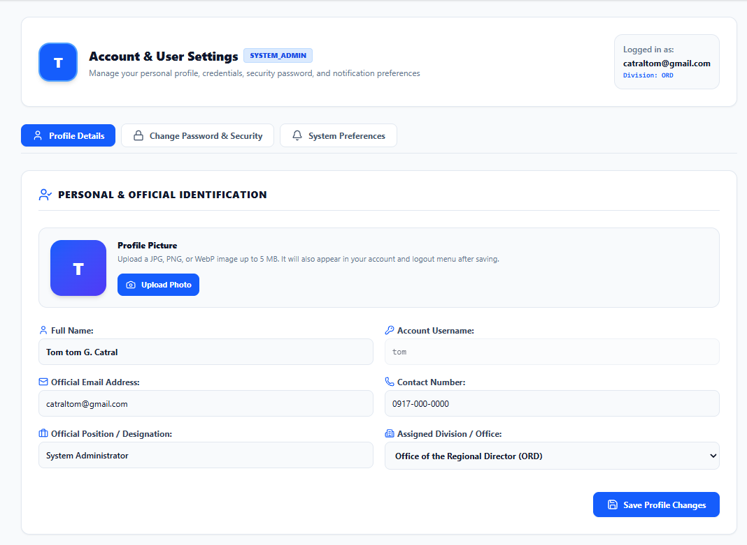
Figure 25. Administrator Account Settings

- Confirm the current password before a credential change when required.
- Use a strong, unique password and do not share the administrator account.
- Review profile and contact information used for accountability and recovery.

4.2.3.1.4 Regular User View
The regular-user interface is intentionally narrower. In the verified STAFF example, User Accounts, audit logs, envelope-dispatch logs, office-directory management, routing slip, and other administrative menus are hidden. The user works with permitted incoming/outgoing records, alerts, routing actions, QR/envelope tools, and personal settings.

A. Regular User Dashboard
The user dashboard shows only accessible document totals and recent transactions. The reduced sidebar demonstrates role-based menu filtering.
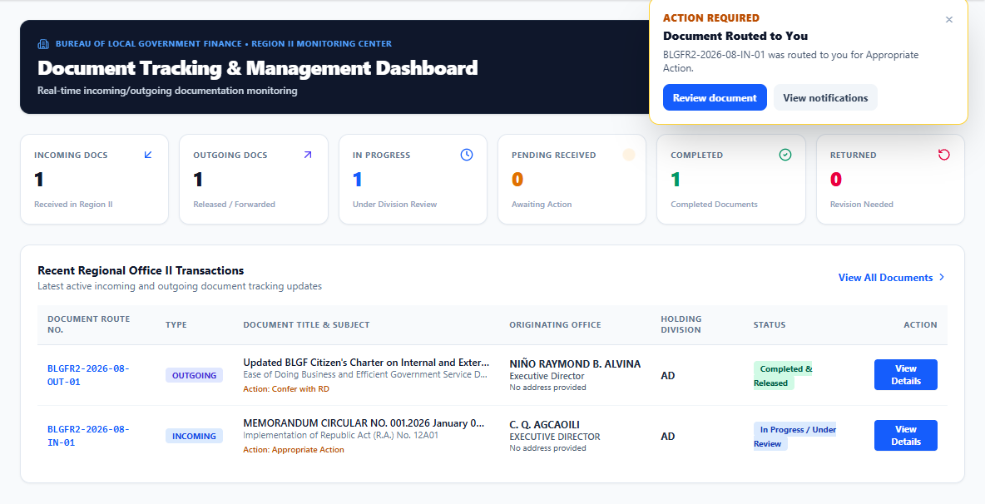
Figure 26. Regular User Dashboard

- Use summary cards or View All Documents to open permitted records.
- Use global search or QR scan to retrieve a known route number.
- The absence of an administrative menu is expected and indicates access control, not a system error.

B. Notifications
The notification drawer informs the user when a document is routed for action. It identifies the route number and requested action without requiring repeated manual follow-up.

Figure 27. Regular User Notification Drawer

- Open the alert and verify the document before acting.
- Dismiss an item only after it has been reviewed; dismissing the alert does not delete the document or its route history.

C. Assigned Incoming Documents
The monitoring center lists documents accessible to the signed-in user. The STAFF example provides View and Route actions but omits administrator-only Delete and Slip controls.
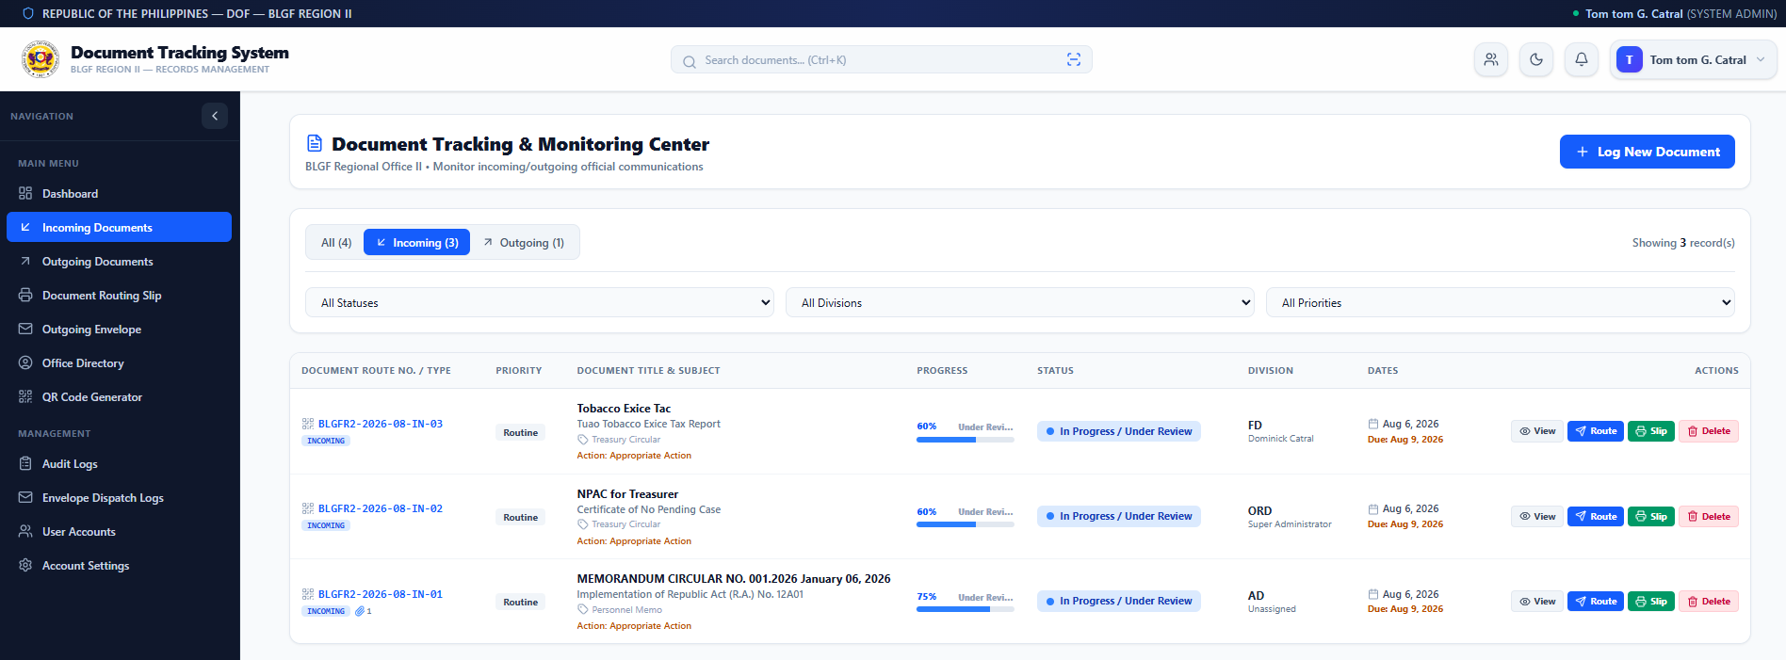
Figure 28. Regular User Assigned Document List

- Use All/Incoming/Outgoing and filters to narrow results.
- Verify status, division, due date, and action requested before opening the record.
- Do not create a duplicate record when a routed document already exists.

D. User Document Details and Attachments
The user sees permitted metadata, attachment controls, lifecycle progress, and the relevant route history. The absence of Delete demonstrates the difference from the administrator view.
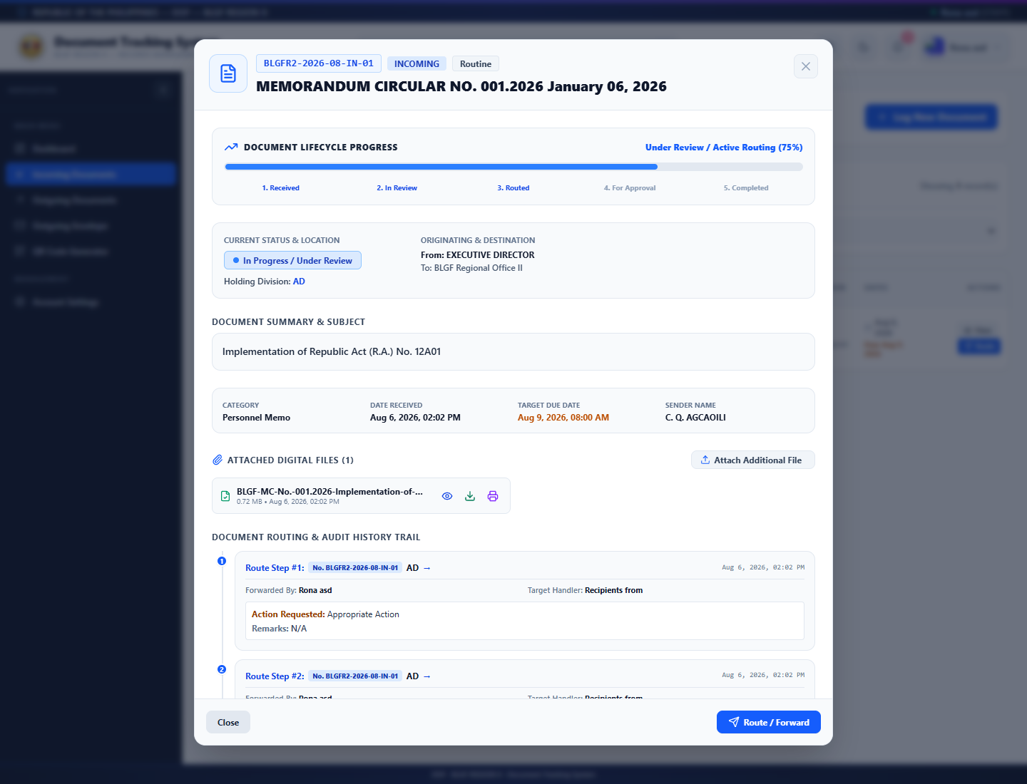
Figure 29. Regular User Document Details

- Open or download only attachments required for official work.
- Attach Additional File only when the file belongs to this route number and is authorized.
- Check the latest route and remarks before selecting Route/Forward.

E. User Routing and Action Form
The regular user selects the next recipient, requested action, status, remarks, and optional reply PDF. Administrative add/edit/delete controls for managed options are not shown.
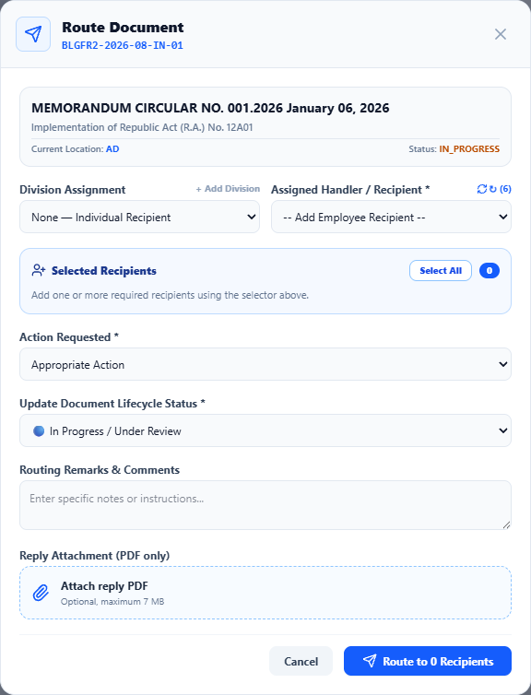
Figure 30. Regular User Route and Action Form

- Choose the correct active recipient or division.
- Use Returned for Revision only with a clear correction reason; use Completed only after confirming the requested work and supporting reply.
- Review recipient count, status, remarks, and attachment before submission.
- Expected result: the action appears in history and the next user receives a notification.

F. User Document Registration and Upload
When permitted, the regular user can log incoming or outgoing records through the same validated form but cannot maintain controlled option lists unless separately authorized.
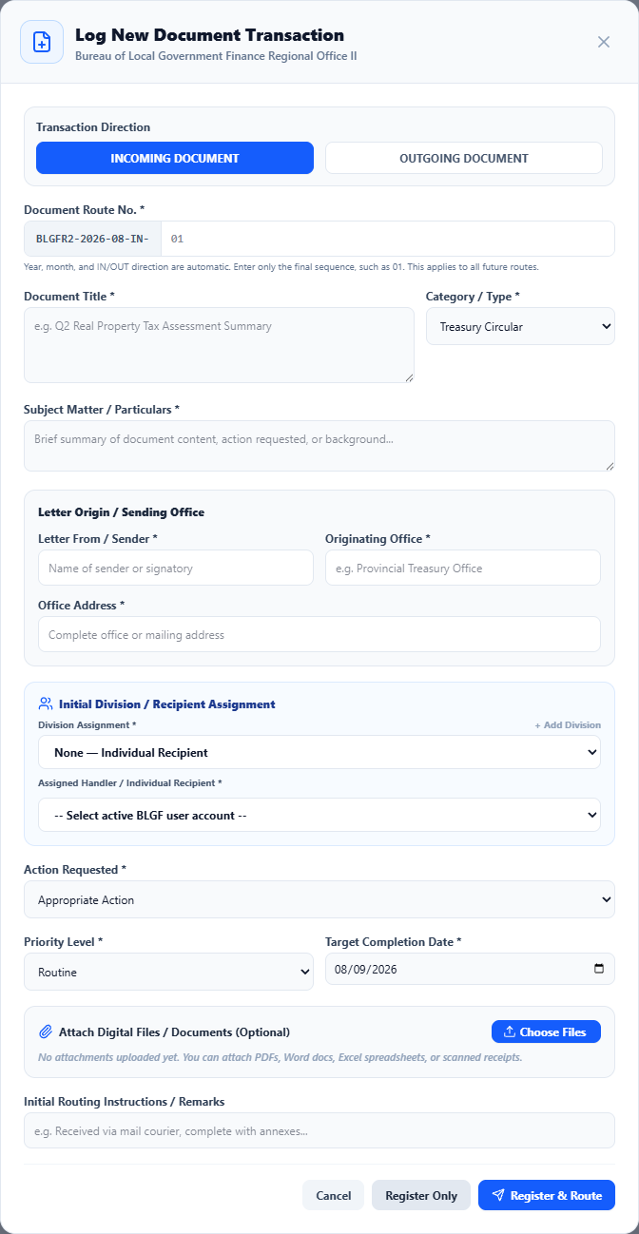
Figure 31. Regular User Registration and File Upload Form

- Complete all required metadata from the source document.
- Select Choose Files and confirm every attachment before Register Only or Register & Route.
- After saving, search the generated route number and verify metadata, attachments, status, and initial route.

G. User Account Settings
A regular user may maintain permitted personal information and change the account password without gaining administrative privileges.
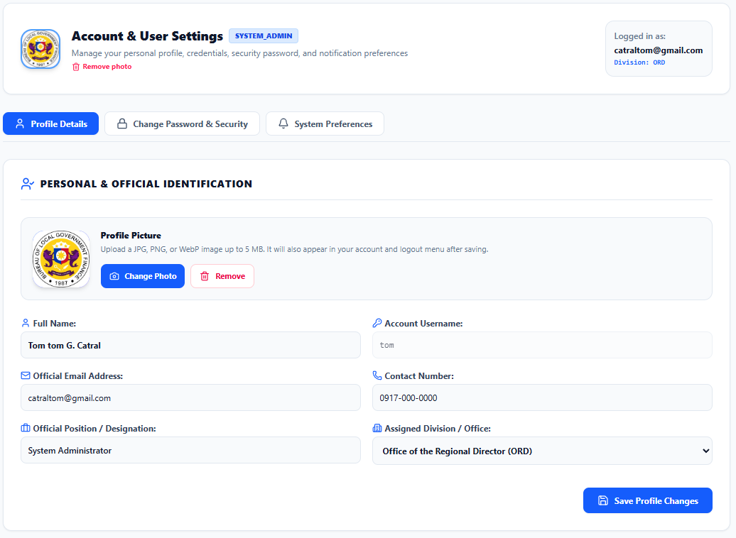
Figure 32. Regular User Account Settings

- Keep the assigned username and profile information accurate.
- Use a strong password, protect it from disclosure, and sign out or lock the workstation when unattended.

Feature | System Administrator | Regular User
Authentication and personal settings | Yes | Yes
Dashboard, search, and QR scan | Organization-wide view | Permitted/assigned view
Register and upload documents | Yes | When role permits
View attachments and route history | Complete history when authorized | Only permitted/related history
Route, multi-route, status, reply PDF | Yes | When assigned and permitted
Routing slip and outgoing envelope | Yes | When menu is enabled
Office directory maintenance | Manage | View/use when enabled
Audit and envelope dispatch logs | Full authorized access | Normally hidden
Users, roles, permissions, divisions | Full management | No access
Delete document/account | Restricted administrator action | No access unless expressly granted

4.2.3.2 Data Model
The data environment was expanded following the presentation pattern used in the BLGF Regional Office II - Web-Based Document Tracking and Records Management System documentation. Each diagram identifies the principal attributes of an implemented entity. Primary keys (PK) uniquely identify records, while foreign keys (FK) preserve relationships even when a user's display name, username, role, or division changes.
Document ownership and routing are identity-based. The documents.assigned_user_id and documents.created_by_user_id fields reference users.id. Likewise, document_routes.from_user_id and document_routes.to_user_id reference users.id. Therefore, a document remains visible to the correct creator, assignee, sender, and recipient after an authorized profile or username update. A document routed to several recipients creates separate route records so each authorized recipient can access the same document without exposing it to unrelated users.
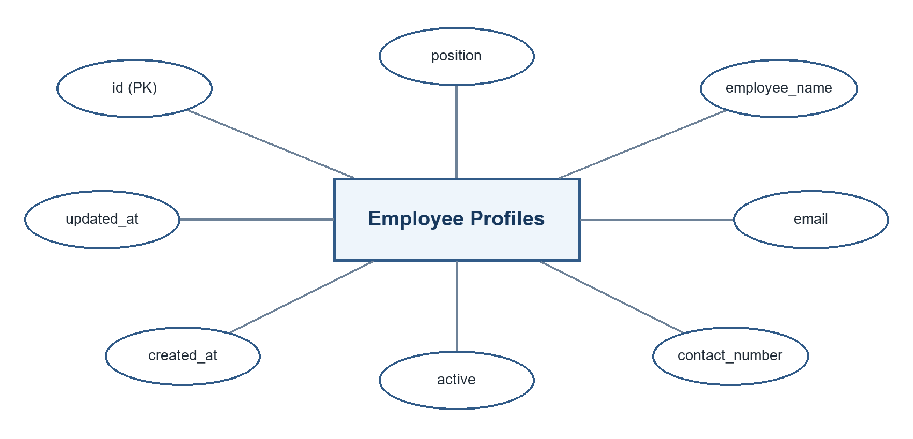
Figure 4.22. Employee Profiles and Positions Data Environment
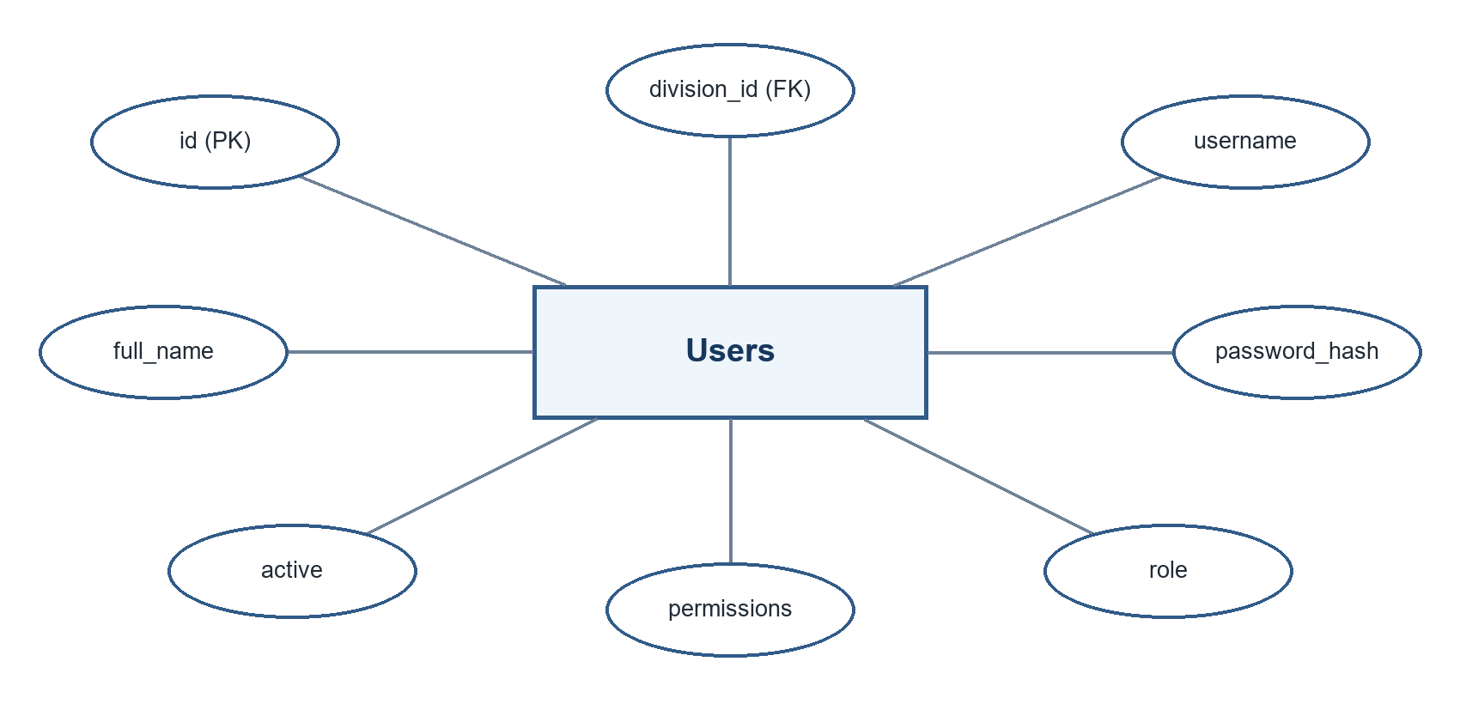
Figure 4.23. Users Data Environment
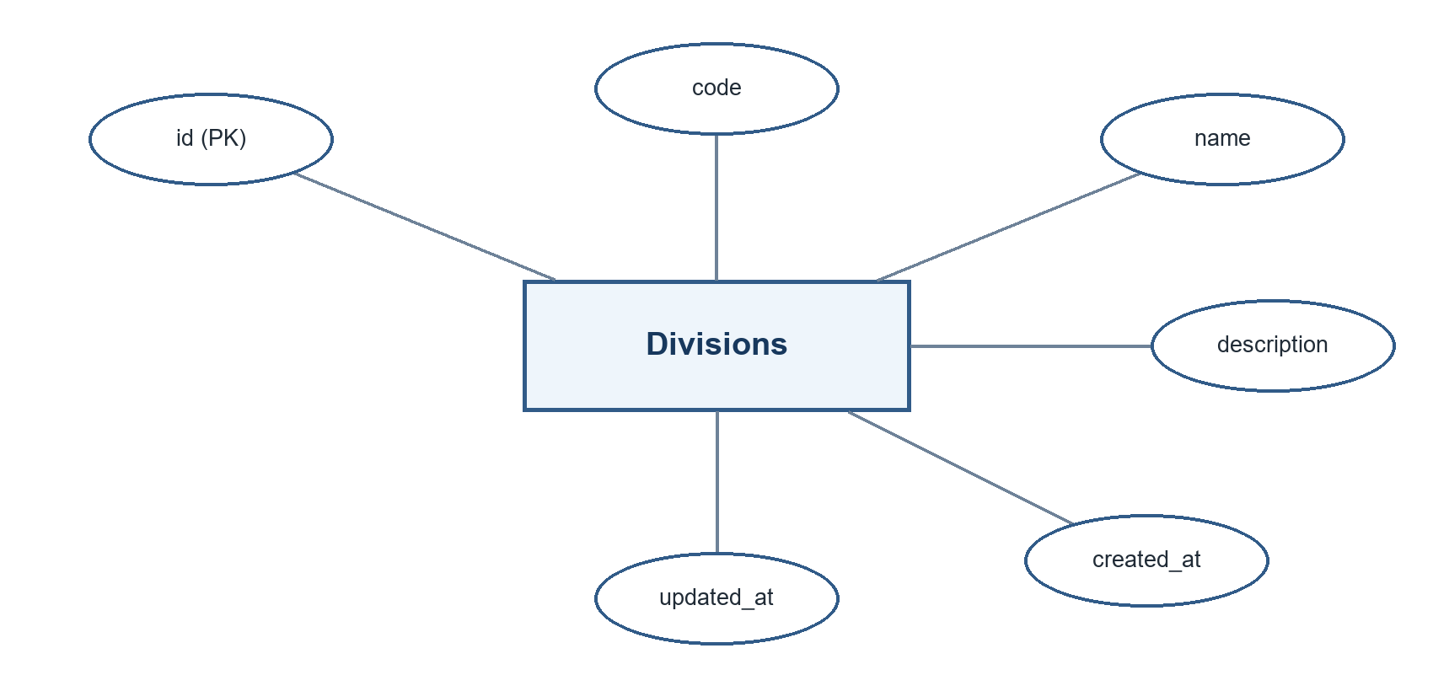
Figure 4.24. Divisions Data Environment
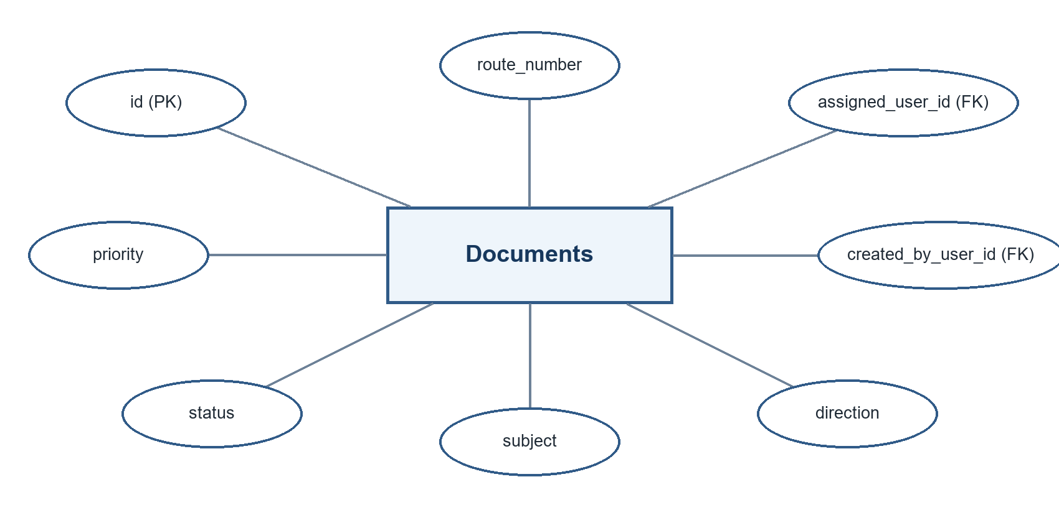
Figure 4.25. Documents Data Environment
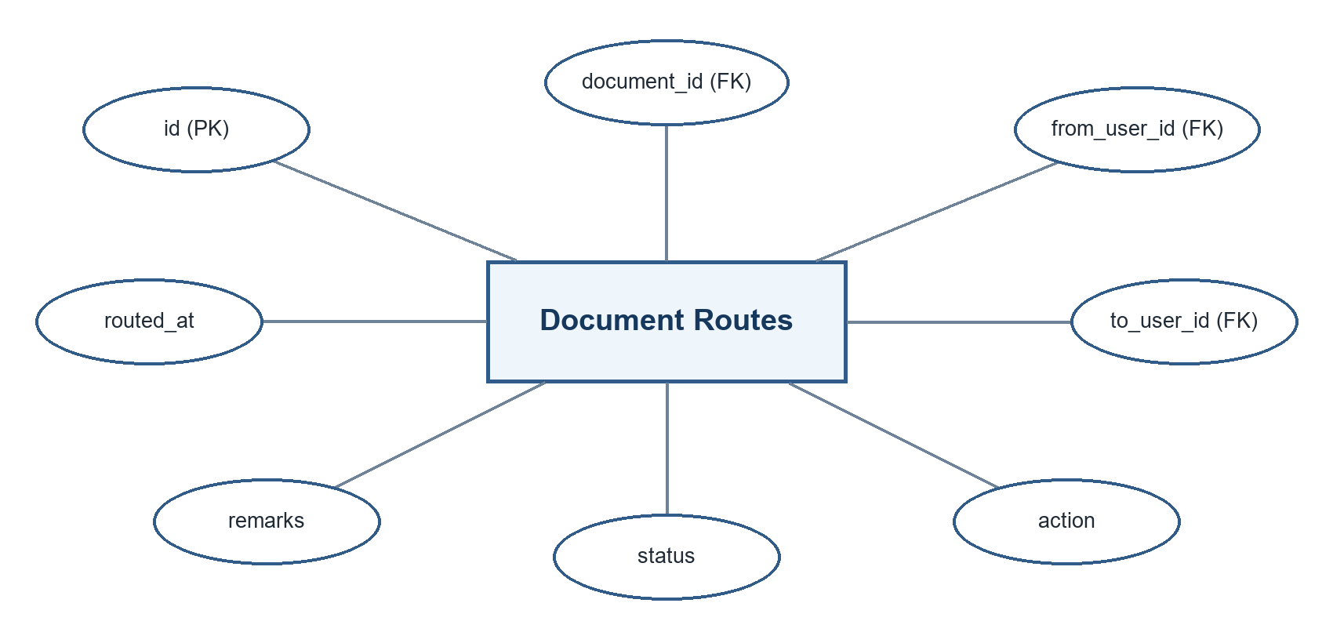
Figure 4.26. Document Routes Data Environment
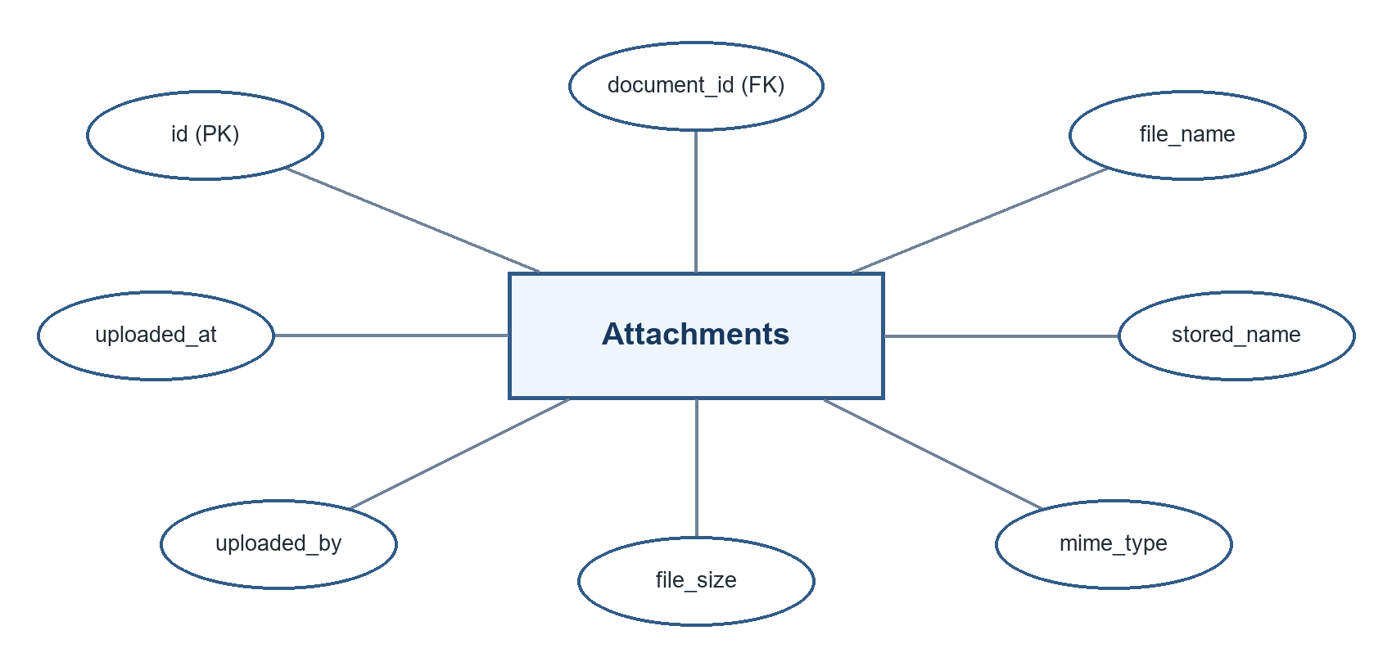
Figure 4.27. Document Attachments Data Environment
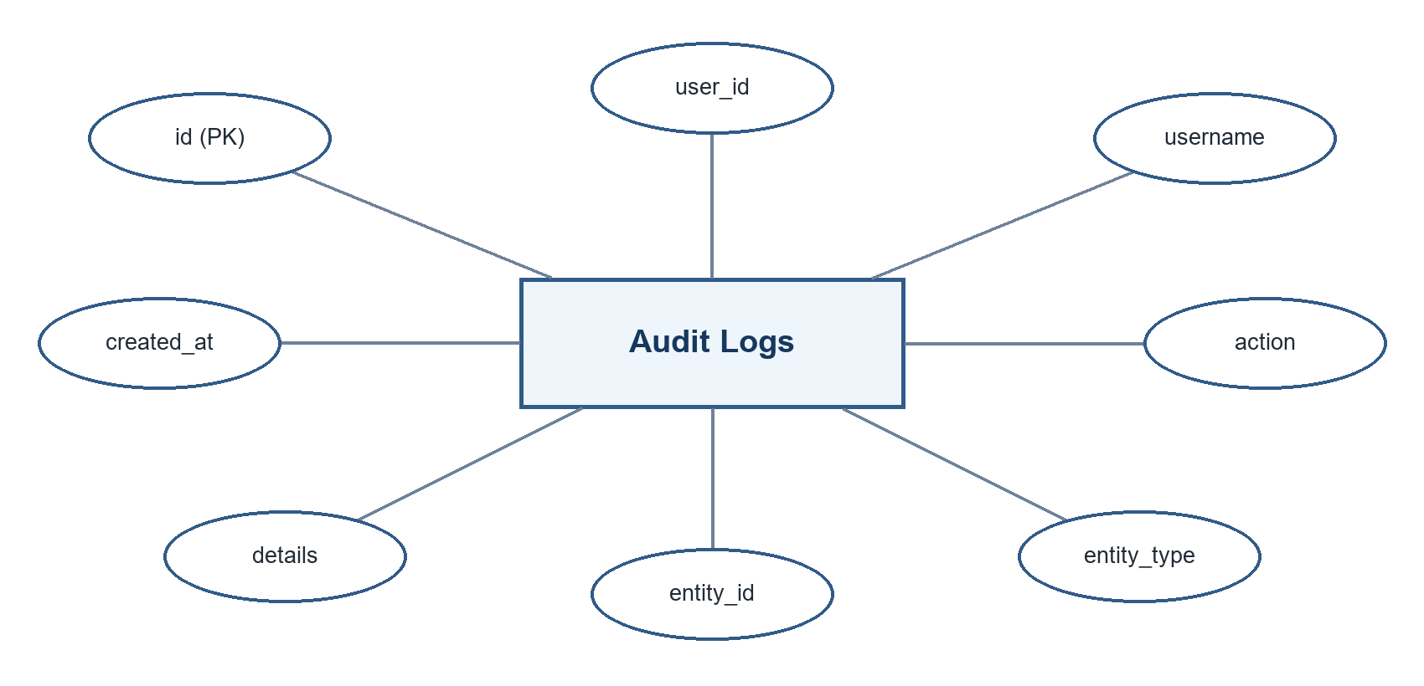
Figure 4.28. Audit Logs Data Environment
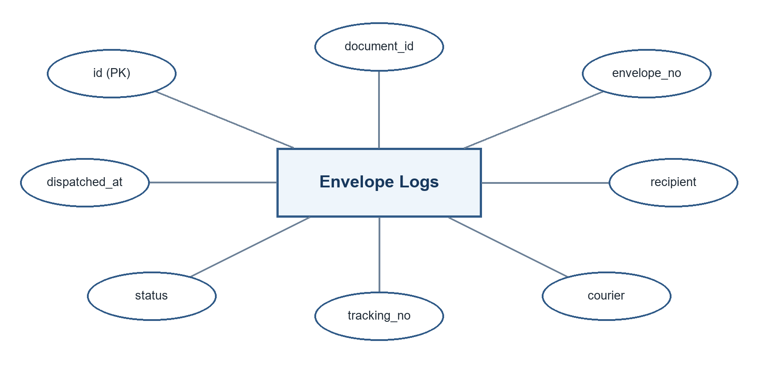
Figure 4.29. Envelope Dispatch Logs Data Environment

Table 4.6. Implemented Data Environment and Integrity Rules
Entity | Primary/Foreign Keys | Purpose and Integrity Rule
employee_profiles | id (PK) | Stores employee directory information, including the position/designation used by office records.
users | id (PK); division_id (FK) | Stores the single account identity used by authentication, roles, permissions, and document access.
divisions | id (PK) | Defines organizational units referenced by user accounts and directory functions.
documents | id (PK); assigned_user_id and created_by_user_id (FK) | Stores document metadata and links ownership to immutable user IDs rather than names.
document_routes | id (PK); document_id, from_user_id, and to_user_id (FK) | Stores every transfer/action and supports one document being routed to one or several recipients.
document_attachments | id (PK); document_id (FK) | Stores file metadata and links each uploaded file to its parent document.
audit_logs | id (PK) | Records accountable system activity for monitoring and investigation.
envelope_logs | id (PK) | Records preparation and dispatch information for outgoing physical envelopes.

Entity | Purpose / Key Data
divisions | Organizational units and codes
users | Credentials, role, division, active state, profile details
documents | Route number, direction, subject, dates, sender/recipient, priority, status
document_routes | Origin, destination, action, status transition, remarks, timestamps
document_attachments | File metadata and relationship to a document or route
notifications | User-specific document alerts and read/action state
audit_logs | Actor, action, description, timestamp, contextual data
employee_profiles | Employee identity, appointment, division, and profile metadata
employee_folders/files | Organized employee supporting records

4.2.4 Table Design
The relational design uses primary keys to uniquely identify records and foreign-key relationships to connect documents, routes, users, divisions, attachments, and notifications. Route numbers require uniqueness at the application level and should also be protected by a database constraint in production. Timestamps support chronological reconstruction. Enumerated status, direction, priority, role, and document-type values promote consistency.
File contents are stored in configured directories while structured file metadata and relationships remain in the application data model. This separation keeps operational queries manageable while allowing controlled retrieval. Database export and backup procedures should always include both structured data and referenced file storage so that restored records remain complete.

4.3 The Extent of Compliance of the Developed System to ISO 25010 Software Quality Standards
Complete this section after pilot testing. The table below is intentionally prepared as an encoding template. Replace each blank with the computed weighted mean and verbal interpretation from actual respondents.
Quality Characteristic | Indicators | Weighted Mean | Interpretation
Functional Suitability | Completeness, correctness, appropriateness | [ ] | [ ]
Performance Efficiency | Response time, resource use, capacity | [ ] | [ ]
Compatibility | Co-existence and interoperability | [ ] | [ ]
Usability | Learnability, operability, accessibility, error protection | [ ] | [ ]
Reliability | Availability, fault tolerance, recoverability | [ ] | [ ]
Security | Confidentiality, integrity, accountability, authenticity | [ ] | [ ]
Maintainability | Modularity, analyzability, modifiability, testability | [ ] | [ ]
Portability | Adaptability, installability, replaceability | [ ] | [ ]
Overall | Grand weighted mean | [ ] | [ ]

CHAPTER V. SUMMARY OF FINDINGS AND RECOMMENDATIONS

5.1 Summary of Findings

5.2 Conclusions

5.3 Recommendations

REFERENCES

Express.js. (n.d.). Express: Fast, unopinionated, minimalist web framework for Node.js. https://expressjs.com/
International Organization for Standardization. (2011). Systems and software engineering—Systems and software Quality Requirements and Evaluation (SQuaRE)—System and software quality models (ISO/IEC Standard No. 25010:2011). https://www.iso.org/standard/35733.html
International Organization for Standardization. (2016). Information and documentation—Records management—Part 1: Concepts and principles (ISO Standard No. 15489-1:2016). https://www.iso.org/standard/62542.html
National Archives of the Philippines. (n.d.). Frequently asked questions. https://nationalarchives.gov.ph/frequently-asked-question
OpenJS Foundation. (n.d.). Node.js documentation. https://nodejs.org/docs/latest/api/
Oracle Corporation. (n.d.). MySQL reference manual. https://dev.mysql.com/doc/
Pressman, R. S., & Maxim, B. R. (2020). Software engineering: A practitioner’s approach (9th ed.). McGraw Hill.
React Team. (n.d.). React documentation. https://react.dev/
Republic Act No. 8792. (2000). Electronic Commerce Act of 2000. Official Gazette of the Republic of the Philippines. https://www.officialgazette.gov.ph/2000/06/14/republic-act-no-8792-s-2000/
Republic Act No. 10173. (2012). Data Privacy Act of 2012. Official Gazette of the Republic of the Philippines. https://www.officialgazette.gov.ph/2012/08/15/republic-act-no-10173/
Republic Act No. 11032. (2018). Ease of Doing Business and Efficient Government Service Delivery Act of 2018. Official Gazette of the Republic of the Philippines. https://www.officialgazette.gov.ph/2018/05/28/republic-act-no-11032/
Sommerville, I. (2016). Software engineering (10th ed.). Pearson.

APPENDICES

Appendix A. Request Letter for Gathering Data

Appendix B. Request for Pilot Testing

August _, 2026

May I respectfully request permission to conduct pilot testing of the Web-Based Document Tracking and Records Management System with selected authorized personnel. The activity will involve task-based use of a controlled test environment and completion of an ISO/IEC 25010 questionnaire. Testing will use non-sensitive or expressly authorized sample data. Participation will be voluntary, and responses will be summarized without unnecessary personal identifiers.

Proposed schedule: August _, 2026, 8:00 o’clock in the morning at the Bureau of Local Government Finance Regional Office 02, Tuguegarao City, Cagayan,

Respectfully yours,

TOM TOM G. CATRAL
Researcher

Appendix C. Users Manual
The instructions below correspond to Figures 9 to 32. Actual menu availability depends on the role-permission matrix. Screens and examples use non-production documentation data; users must apply the same steps only to authorized official records.

C.1 Accessing the System
- Open the authorized system address in a supported web browser.
- Enter the assigned username and password.
- Select Login. Contact the administrator if the account is inactive or credentials are unavailable.

C.2 Registering a Document
- Open Incoming Documents or Outgoing Documents.
- Select the command to add/register a document.
- Enter the unique Document Route Number and required metadata.
- Choose priority, status, dates, sender/recipient, and initial assignment as applicable.
- Attach only authorized files, review the entries, and submit.

C.3 Routing and Acting on a Document
- Open the document details and verify its current status and history.
- Select Route, Transfer, Receive, or the permitted action.
- Choose the destination user/division, action required, remarks, and target date.
- Confirm the transaction and verify that the new route appears in history.

C.4 Search, Notifications, QR, and Slips
- Use list filters or search to locate a route number, subject, sender, recipient, or related metadata.
- Open the notification bell to review documents requiring attention.
- Use the QR module to generate or scan document-identifying information.
- Open Document Slip, select the record, review the routing details, and print using the browser dialog.

C.5 System Administrator Procedures
- Manage user accounts and roles only when authorized.
- Review audit and outgoing-envelope logs for accountability.
- Configure storage directories carefully and test file retrieval.
- Export and back up the database according to the approved schedule.
Review Audit Logs and Envelope Dispatch Logs for unusual, incomplete, or unauthorized activity.
Maintain the Office Directory and Divisions using approved organizational information.
Create accounts with unique usernames, correct roles and divisions, and least-privilege menu access.
Deactivate obsolete access promptly; review dependencies and audit requirements before deleting an account.
Review the Role Menu Access Matrix after personnel or responsibility changes and verify the affected accounts.
Protect attachment storage, enforce HTTPS and strong credentials, and test restoration of the database together with uploaded files.

C.6 Regular User Procedures
Open notifications and assigned lists at the start of the work period to identify pending actions.
Verify the route number, document summary, latest route, requested action, and attachment before responding.
Upload only an authorized file that belongs to the selected document; check the filename and file type.
Route to the correct active recipient, select the real lifecycle status, and provide clear remarks.
For returned or rejected work, state the correction required. For completion, ensure the requested action and final reply are available.
Use search, filters, or QR lookup instead of creating duplicate transactions.
Contact the administrator when a required menu is absent; do not use another person's account.

C.7 Basic Troubleshooting
- Refresh the page and confirm network connectivity if information does not load.
- Verify route-number uniqueness when registration is rejected.
- Check role permissions if a menu or action is unavailable.
- Do not repeatedly submit the same transaction after an error; verify document history first.
- Report persistent errors with the route number, time, action attempted, and a screenshot that contains no unnecessary sensitive data.

Appendix D. ISO 25010 Questionnaire
SYSTEM QUALITY EVALUATION QUESTIONNAIRE
Research Title: Web-Based Document Tracking and Records Management System for the Bureau of Local Government Finance – Region II
Purpose and Confidentiality. This questionnaire evaluates the developed system using the ISO/IEC 25010 software product-quality model. Participation is voluntary. Responses will be summarized for academic purposes and will not be used to identify individual respondents unnecessarily. Do not write passwords or confidential document contents on this form.
Instructions. Complete the assigned pilot-testing tasks before answering. Read every statement and place exactly one check mark (✓) under 5, 4, 3, 2, or 1. Base each answer only on the system functions you actually used or verified. If clarification is needed, ask the researcher without disclosing passwords or confidential document contents.

D.1 Respondent Profile
Privacy reminder: Do not write your name, username, password, personal contact details, or confidential document information. The researcher will assign the respondent code.
Information | Response
Respondent Code | ____________________________ Date: ____________________________
Position / Designation | ____________________________________________________________
Division / Unit | ☐ ORD ☐ AD ☐ LTOD ☐ LAOD ☐ FD ☐ LU ☐ Other: __________
Primary System Role | ☐ Administrator ☐ Records Officer ☐ Division Chief ☐ Action Officer ☐ Staff / Authorized User ☐ Other: __________
Length of Service | ☐ Less than 1 year ☐ 1–5 years ☐ 6–10 years ☐ More than 10 years
Document-Handling Frequency | ☐ Daily ☐ Several times weekly ☐ Weekly ☐ Occasionally
System-Use Experience | ☐ First-time/pilot user ☐ Less than 1 month ☐ 1–6 months ☐ More than 6 months
Pilot Modules Used | ☐ Login/dashboard ☐ Registration ☐ Routing/tracking ☐ Search/QR/slip ☐ Records/files ☐ Administration/logs
Consent to participate: ☐ I voluntarily agree to participate in this system evaluation and understand that my responses will be reported in summarized form.

D.2 Rating Scale
Rating | Response | Meaning
5 | Strongly Agree | The quality requirement is fully evident.
4 | Agree | The quality requirement is generally evident.
3 | Neither Agree nor Disagree | The respondent is uncertain or the result is mixed.
2 | Disagree | The quality requirement is generally not evident.
1 | Strongly Disagree | The quality requirement is not evident.

D.3 System Quality Evaluation
Response columns: 5 – Strongly Agree; 4 – Agree; 3 – Neither Agree nor Disagree; 2 – Disagree; 1 – Strongly Disagree. Check one response per statement.

A. FUNCTIONAL SUITABILITY
Measures whether the system provides correct, complete, and appropriate functions for the intended document workflow.
No. | Evaluation Statement | 5 | 4 | 3 | 2 | 1
1 | The system provides the functions needed to register incoming and outgoing documents. | ☐ | ☐ | ☐ | ☐ | ☐
2 | The system correctly records document status, routing history, assignments, dates, remarks, and attachments. | ☐ | ☐ | ☐ | ☐ | ☐
3 | Search, filtering, notifications, QR tools, routing slips, and logs support the intended office tasks. | ☐ | ☐ | ☐ | ☐ | ☐
4 | The available functions are appropriate for the responsibilities of my assigned user role. | ☐ | ☐ | ☐ | ☐ | ☐

B. PERFORMANCE EFFICIENCY
Measures responsiveness and efficient operation during normal document-processing activities.
No. | Evaluation Statement | 5 | 4 | 3 | 2 | 1
5 | The login, dashboard, document lists, and detail pages load within an acceptable time. | ☐ | ☐ | ☐ | ☐ | ☐
6 | Saving, routing, transferring, receiving, and completing a document respond within an acceptable time. | ☐ | ☐ | ☐ | ☐ | ☐
7 | Search and filtering return results promptly during normal use. | ☐ | ☐ | ☐ | ☐ | ☐
8 | The system remains responsive while processing the expected number of records and users. | ☐ | ☐ | ☐ | ☐ | ☐

C. COMPATIBILITY
Measures operation with the approved browser, device, file formats, and office environment.
No. | Evaluation Statement | 5 | 4 | 3 | 2 | 1
9 | The system works correctly with the web browser and computer approved for office use. | ☐ | ☐ | ☐ | ☐ | ☐
10 | The system can upload, retrieve, display, or download supported document attachments correctly. | ☐ | ☐ | ☐ | ☐ | ☐
11 | Database export and stored records can be used with the approved office environment. | ☐ | ☐ | ☐ | ☐ | ☐

D. USABILITY
Measures clarity, learnability, ease of operation, error prevention, and interface readability.
No. | Evaluation Statement | 5 | 4 | 3 | 2 | 1
12 | The labels, icons, menus, forms, and status indicators are clear and understandable. | ☐ | ☐ | ☐ | ☐ | ☐
13 | I can learn the tasks relevant to my role with reasonable orientation. | ☐ | ☐ | ☐ | ☐ | ☐
14 | The steps for registering, routing, locating, and reviewing a document are easy to follow. | ☐ | ☐ | ☐ | ☐ | ☐
15 | Validation messages and confirmations help prevent or correct user errors. | ☐ | ☐ | ☐ | ☐ | ☐
16 | Text, controls, tables, and dialogs remain readable on the devices approved for office use. | ☐ | ☐ | ☐ | ☐ | ☐

E. RELIABILITY
Measures consistent operation, preservation of confirmed transactions, and useful error feedback.
No. | Evaluation Statement | 5 | 4 | 3 | 2 | 1
17 | The system is available and operates consistently during the evaluation period. | ☐ | ☐ | ☐ | ☐ | ☐
18 | Confirmed document transactions remain saved after refresh, logout, or subsequent login. | ☐ | ☐ | ☐ | ☐ | ☐
19 | The displayed status and routing history remain consistent with completed user actions. | ☐ | ☐ | ☐ | ☐ | ☐
20 | The system provides understandable feedback when an operation cannot be completed. | ☐ | ☐ | ☐ | ☐ | ☐

F. SECURITY
Measures authentication, role-based access, accountability, and protection of records and files.
No. | Evaluation Statement | 5 | 4 | 3 | 2 | 1
21 | The system requires valid user credentials before protected information can be accessed. | ☐ | ☐ | ☐ | ☐ | ☐
22 | Users can view only the documents and functions permitted by their assigned roles. | ☐ | ☐ | ☐ | ☐ | ☐
23 | Routing history and audit logs identify accountable users and actions. | ☐ | ☐ | ☐ | ☐ | ☐
24 | The system handles document attachments and personal information with appropriate access controls. | ☐ | ☐ | ☐ | ☐ | ☐

G. MAINTAINABILITY
Measures how readily authorized technical personnel can analyze, modify, and retest the system.
No. | Evaluation Statement | 5 | 4 | 3 | 2 | 1
25 | The system modules and error information allow technical personnel to identify affected functions. | ☐ | ☐ | ☐ | ☐ | ☐
26 | A change in one module can be introduced without unnecessary impact on unrelated functions. | ☐ | ☐ | ☐ | ☐ | ☐
27 | The system can be retested after corrections, configuration changes, or enhancements. | ☐ | ☐ | ☐ | ☐ | ☐

H. PORTABILITY
Measures adaptability and operation within approved server, storage, and browser environments.
No. | Evaluation Statement | 5 | 4 | 3 | 2 | 1
28 | The system can be installed and configured in the approved server environment. | ☐ | ☐ | ☐ | ☐ | ☐
29 | The application operates on current supported web browsers without requiring specialized client software. | ☐ | ☐ | ☐ | ☐ | ☐
30 | Database and file-storage settings can be adapted to an approved deployment environment. | ☐ | ☐ | ☐ | ☐ | ☐

D.4 Evaluation Summary (For Researcher Use)
ISO/IEC 25010 Characteristic | Item Numbers | No. of Items | Total Score | Mean | Interpretation
Functional Suitability | 1–4 | 4
Performance Efficiency | 5–8 | 4
Compatibility | 9–11 | 3
Usability | 12–16 | 5
Reliability | 17–20 | 4
Security | 21–24 | 4
Maintainability | 25–27 | 3
Portability | 28–30 | 3
Overall System Quality | 1–30 | 30
Computation: Mean per characteristic = total score for the characteristic ÷ number of answered items. Overall mean = total score for Items 1–30 ÷ 30. Do not compute a mean when an item is unanswered; return the form for completion whenever practical.

D.5 Overall Assessment and Comments
Overall, I am satisfied with the developed system. ☐ 5 ☐ 4 ☐ 3 ☐ 2 ☐ 1
Most useful feature(s): ____________________________________________________________________ ____________________________________________________________________
Problem(s) encountered: ____________________________________________________________________ ____________________________________________________________________
Suggested improvement(s): ____________________________________________________________________ ____________________________________________________________________
Respondent Signature (optional): _________________________

Appendix E. Source Code
This appendix presents representative excerpts from the implemented BLGF Region II Document Tracking and Records Management System. The excerpts are taken from the current project files and focus on the controls most important to the study: stable user identity, foreign-key relationships, authentication, role/menu permissions, document visibility, multi-recipient routing, and synchronized account updates. Line numbers are included only as a print reference and may change in later revisions.

E.1 Project Source Structure
Path | Implemented Responsibility
frontend/src/App.tsx | Application state, authenticated navigation, and identity-based document visibility.
frontend/src/components/ | Administrator/user dashboards, document forms, routing, slips, notifications, QR, accounts, divisions, directories, logs, and settings.
frontend/src/services/api.ts | Typed communication with the server and authenticated X-User-Id request headers.
backend/server.ts | Express application, login, synchronization, notifications, audit integration, and API registration.
backend/documents.ts | Document creation, attachments, access enforcement, routing, multi-routing, updates, and deletion controls.
backend/users.ts | Administrator account management and synchronized self-service username/password changes.
backend/mysqlReplica.ts | MySQL persistence, legacy-data backfill, and idempotent foreign-key migration.
prisma/mysql/schema.prisma | Relational models and user-ID foreign-key definitions.

E.2 User-ID Foreign-Key Schema
Source file: prisma/mysql/schema.prisma
0045 model Document {
0046 id String @id @db.VarChar(64)
0047 trackingNumber String @unique @map("tracking_number") @db.VarChar(100)
0048 direction String @db.VarChar(20)
0049 title String @db.VarChar(255)
0050 subject String? @db.Text
0051 category String @db.VarChar(100)
0052 originatingOffice String @map("originating_office") @db.VarChar(255)
0053 destinationOffice String @map("destination_office") @db.VarChar(255)
0054 senderName String? @map("sender_name") @db.VarChar(150)
0055 recipientName String? @map("recipient_name") @db.VarChar(150)
0056 priority String @db.VarChar(30)
0057 currentStatus String @map("current_status") @db.VarChar(30)
0058 currentDivision String @map("current_division") @db.VarChar(20)
0059 assignedUser String? @map("assigned_user") @db.VarChar(150)
0060 assignedUserId String? @map("assigned_user_id") @db.VarChar(64)
0061 dateReceived DateTime @map("date_received") @db.DateTime(3)
0062 targetCompletionDate DateTime? @map("target_completion_date") @db.DateTime(3)
0063 completedDate DateTime? @map("completed_date") @db.DateTime(3)
0064 createdBy String @map("created_by") @db.VarChar(150)
0065 createdByUserId String? @map("created_by_user_id") @db.VarChar(64)
0066 createdAt DateTime @map("created_at") @db.DateTime(3)
0067 updatedAt DateTime @map("updated_at") @db.DateTime(3)
0068 assignedUserAccount User? @relation("AssignedDocumentUser", fields: [assignedUserId], references: [id], onDelete: SetNull, onUpdate: Cascade)
0069 createdByUserAccount User? @relation("CreatedDocumentUser", fields: [createdByUserId], references: [id], onDelete: SetNull, onUpdate: Cascade)
0070 routes DocumentRoute[]
0071 attachments DocumentAttachment[]
0072
0073 @@index([assignedUserId])
0074 @@index([createdByUserId])
0075 @@map("documents")

E.3 Server-Side Document Access Control
Source file: backend/documents.ts
0040 const canViewDocument = (user: User, document: DocumentRecord) => {
0041 const permissions =
0042 user.permissions ||
0043 DEFAULT_ROLE_PERMISSIONS[user.role] ||
0044 DEFAULT_ROLE_PERMISSIONS.STAFF;
0045 if (user.role === 'SYSTEM_ADMIN' || permissions.canViewAllDocuments) {
0046 return true;
0047 }
0048 return Boolean(
0049 document.assignedUserId === user.id ||
0050 document.createdByUserId === user.id ||
0051 document.routes?.some(
0052 (route) =>
0053 route.fromUserId === user.id || route.toUserId === user.id,
0054 ),
0055 );
0056 };

E.4 Secure Document Registration and Ownership
Source file: backend/documents.ts
0191 assignedUserId: directlyAssignedUser?.id,
0192 dateReceived: body.dateReceived || now,
0193 targetCompletionDate:
0194 body.targetCompletionDate ||
0195 new Date(Date.now() + 3 * 86400000).toISOString(),
0196 tags: body.tags || [],
0197 attachments: body.attachments || [],
0198 actionRequested: body.initialAction || 'Appropriate Action',
0199 routes:
0200 initialRecipients.length > 0
0201 ? initialRecipients.map((recipient, index) => ({
0202 id: `route-${Date.now()}-${index + 1}`,
0203 documentId: newDocumentId,
0204 stepNumber: index + 1,
0205 routeNo: body.routeNo || '',
0206 fromDivision: body.currentDivision || 'AD',
0207 fromUserId: actingUser.id,
0208 fromUser: actingUser.fullName,
0209 toDivision: recipient.divisionCode,
0210 toUser: recipient.fullName,
0211 toUserId: recipient.id,
0212 actionRequested: body.initialAction || 'Initial Entry & Routing',
0213 remarks: body.remarks || 'N/A',
0214 statusBefore: 'PENDING' as DocumentStatus,
0215 statusAfter: (body.currentStatus || 'PENDING') as DocumentStatus,
0216 isMultiRoute: initialRecipients.length > 1,
0217 receivedAt: now,
0218 createdAt: now,

E.5 ID-Based Routing to a Recipient
Source file: backend/documents.ts
0518 const recipient = findActiveDatabaseUser(toUserId);
0519 if (!recipient) {
0520 return res.status(400).json({ error: 'Select an active database user.' });
0521 }
0522
0523 if (
0524 routeNo &&
0525 documentsState.some(
0526 (document) =>
0527 document.id !== doc.id &&
0528 (document.routeNo?.trim().toLowerCase() ===
0529 String(routeNo).trim().toLowerCase() ||
0530 document.routes?.some(
0531 (route) =>
0532 route.routeNo?.trim().toLowerCase() ===
0533 String(routeNo).trim().toLowerCase(),
0534 )),
0535 )
0536 ) {
0537 return res.status(409).json({
0538 error: `Document Route No. ${routeNo} is already used by another document.`,
0539 });
0540 }
0541
0542 const now = new Date().toISOString();
0543 const oldStatus = doc.currentStatus;
0544 const stepNumber = (doc.routes || []).length + 1;
0545 markLatestRouteAsProcessed(

E.6 Account and Credential Synchronization
Source file: backend/users.ts
0001 import express from 'express';
0002 import { addAuditLog } from './serverUtils.js';
0003 import {
0004 loadLiveUsers,
0005 saveUserDirect,
0006 saveAuditLogDirect,
0007 deleteUserDirect,
0008 } from './mysqlReplica.js';
0009 import {
0010 User,
0011 AuditLog,
0012 DEFAULT_ROLE_PERMISSIONS,
0013 } from '../frontend/src/types.js';
0014
0015 const MAX_SYSTEM_ADMINISTRATORS = 3;
0016 const withoutCredentials = (user: User) => {
0017 const { password: _password, temporaryPasswordExpiresAt: _expires, ...safe } =
0018 user;
0019 return safe;
0020 };
0021
0022 export function createUsersRouter(
0023 getUsersState: () => User[],
0024 setUsersState: (users: User[]) => void,
0025 getAuditLogsState: () => AuditLog[],
0026 ) {
0027 const router = express.Router();
0028 const getActingUser = (req: express.Request) =>
0029 getUsersState().find(
0030 (user) => user.id === String(req.get('X-User-Id') || '') && user.active,
0031 );
0032
0033 // GET Users
0034 router.get('/', async (req, res) => {
0035 try {
0036 const liveUsers = await loadLiveUsers();
0037 if (liveUsers) setUsersState(liveUsers as User[]);
0038 const actingUser = getActingUser(req);
0039 if (!actingUser) return res.json([]);
0040 const visibleUsers =
0041 actingUser.role === 'SYSTEM_ADMIN'
0042 ? getUsersState()

E.7 Frontend Identity-Based Visibility
Source file: frontend/src/App.tsx
0524 const accessibleDocuments =
0525 currentUser.role === 'SYSTEM_ADMIN' ||
0526 effectivePermissions.canViewAllDocuments
0527 ? documents
0528 : documents.filter((document) => {
0529 const isRoutingParticipant = Boolean(
0530 document.routes?.some(
0531 (route) =>
0532 route.fromUserId === currentUser.id ||
0533 route.toUserId === currentUser.id,
0534 ),
0535 );
0536 return (
0537 document.assignedUserId === currentUser.id ||
0538 document.createdByUserId === currentUser.id ||
0539 isRoutingParticipant
0540 );
0541 });
0542 const userPendingCount = documents.filter((document) => {
0543 if (document.currentStatus !== 'PENDING') return false;
0544 if (
0545 document.assignedUserId === currentUser.id
0546 ) {
0547 return true;
0548 }
0549
0550 const latestRouteTime = document.routes?.at(-1)?.createdAt;
0551 return Boolean(
0552 latestRouteTime &&
0553 document.routes

E.8 API Identity Header and Transfer Contract
Source file: frontend/src/services/api.ts
0022 ...(currentUserId ? { 'X-User-Id': currentUserId } : {}),
0023 ...options?.headers,
0024 },
0025 ...options,
0026 });
0027
0028 if (!res.ok) {
0029 const errorBody = await res.json().catch(() => ({ error: res.statusText }));
0030 throw new Error(errorBody.error || `HTTP ${res.status}`);
0031 }
0032
0033 return res.json();
0034 }
0035
0036 export const api = {
0037 uploadToStorage: async (
0038 kind: 'documentAttachments' | 'profilePictures',
0039 file: File,
0040 ) => {
0041 const formData = new FormData();
0042 formData.append('file', file);
0043 const response = await fetch(`${API_BASE}/storage/upload/${kind}`, {
0044 method: 'POST',
0045 body: formData,
Complete source repository: https://github.com/TomCatral/blgfr2-doctract. The full electronic repository remains the authoritative source; this printed appendix contains the representative portions needed to explain and verify the implemented design.

The complete source code is maintained in the project repository. For printed submission, include only representative excerpts required by the institution; attach the full source electronically or provide repository access according to adviser and office approval.
Path | Contents
frontend/src/ | React/TypeScript user interface, components, types, services, and utilities
backend/server.ts | Express API, workflow logic, storage, authentication, and data operations
backend/schema.sql | MySQL relational schema
backend/utils/ | Database export and supporting utilities
package.json | Dependencies and build, development, lint, and start commands
README.md | Project structure and operating instructions
Repository: https://github.com/TomCatral/blgfr2-doctract

CURRICULUM VITAE


