CAGAYAN STATE UNIVERSITY
CARIG CAMPUS
GRADUATE SCHOOL
WEB-BASED DOCUMENT TRACKING AND RECORDS MANAGEMENT SYSTEM
FOR THE BUREAU OF LOCAL GOVERNMENT FINANCE – REGION II
A Thesis Proposal
Submitted to the Faculty of the Graduate School
Cagayan State University – Carig Campus
in Partial Fulfillment of the Requirements for the Degree of
MASTER OF SCIENCE IN INFORMATION TECHNOLOGY
TOM TOM G. CATRAL
JULY 2026

APPROVAL SHEET
This thesis proposal entitled “Web-Based Document Tracking and Records Management System for the Bureau of Local Government Finance – Region II,” prepared and submitted by TOM TOM G. CATRAL in partial fulfillment of the requirements for the degree MASTER OF SCIENCE IN INFORMATION TECHNOLOGY, has been examined and is recommended for proposal defense.
____________________________________
[NAME OF THESIS ADVISER]
Thesis Adviser
Approved by the Thesis Committee:
Panel Member | Signature | Date
[NAME OF CHAIRPERSON] | ________________ | ________________
[NAME OF PANEL MEMBER] | ________________ | ________________
[NAME OF PANEL MEMBER] | ________________ | ________________

ACKNOWLEDGEMENT
The researcher expresses sincere gratitude to the Almighty for the strength and wisdom to undertake this study; to the thesis adviser and panel members for their guidance; to the officials and personnel of the Bureau of Local Government Finance – Region II for sharing their workflow requirements and operational insights; and to family, colleagues, and friends whose encouragement made this work possible.
The researcher also recognizes the value of the open-source community whose technologies made the development of the proposed system feasible. Any remaining errors or limitations are solely the responsibility of the researcher.

DEDICATION
This work is dedicated to my family, mentors, colleagues, and the public servants whose commitment to accountable and efficient records management inspired this study.

TABLE OF CONTENTS

LIST OF TABLES
Table 1. Functional Scope of the Developed System
Table 2. Software and Hardware Requirements
Table 3. Data Model and Major Entities
Table 4. ISO/IEC 25010 Evaluation Matrix
Table 5. Summary of Findings Template

LIST OF FIGURES
Figure 1. Conceptual Framework
Figure 2. Research Paradigm
Figure 3. System Architecture
Figure 4. Use-Case Diagram
Figure 5. Context-Level Data Flow Diagram
Figure 6. Hierarchical Input Process Output
Figure 7. Input-Process-Output Diagram
Figure 8. Entity Relationship Diagram

ABSTRACT
This study presents the design and development of a Web-Based Document Tracking and Records Management System for the Bureau of Local Government Finance – Region II (BLGF Region II). The system responds to operational challenges commonly associated with manual or fragmented document handling, including delayed routing, limited visibility of document status, duplicate route numbers, difficulty locating records, inconsistent accountability, and time-consuming report preparation. The developed application centralizes the registration of incoming and outgoing documents, routing and transfer history, attachments, notifications, employee records, audit logs, outgoing-envelope logs, QR code generation and scanning, document slips, storage configuration, and database export.
The project uses a developmental research approach and an iterative software development process. Its implementation employs React and TypeScript for the client interface, Express and TypeScript for the application programming interface, and MySQL for persistent storage with a JSON fallback mechanism. Role-based access controls regulate the information and functions available to administrators, records personnel, division chiefs, staff, and other authorized users. The proposed evaluation adopts the ISO/IEC 25010 product-quality model, focusing on functional suitability, performance efficiency, compatibility, usability, reliability, security, maintainability, and portability.
Based on functional inspection of the implemented modules, the system provides a traceable document lifecycle from registration through routing, receipt, action, completion, storage, and audit. Actual user-acceptance scores and statistical findings must be entered after pilot testing with authorized BLGF Region II respondents. The study is expected to support faster retrieval, clearer accountability, better records integrity, and more consistent document-processing practices.
Keywords: document tracking, records management, workflow automation, role-based access control, QR code, audit trail, BLGF Region II, ISO/IEC 25010

CHAPTER I. THE PROBLEM AND ITS BACKGROUND

1.1 Introduction
Government offices create and receive a continuous stream of memoranda, endorsements, requests, reports, communications, and supporting records. Each document may pass through several offices and personnel before a final action is completed. When the process depends heavily on handwritten logbooks, isolated spreadsheets, email threads, or verbal follow-ups, personnel may have difficulty determining where a document is located, who currently holds it, what action is required, and whether a deadline has been met.
Records management is not limited to storing files. It includes the controlled creation, receipt, classification, routing, use, retention, retrieval, and disposition of records. A tracking mechanism therefore needs to preserve both the document and its chain of custody. The ability to view a reliable routing history is especially important in public service, where transparency, accountability, and timely action directly affect organizational performance.
The Bureau of Local Government Finance – Region II requires a practical mechanism for managing incoming and outgoing documents across organizational units. The developed Web-Based Document Tracking and Records Management System provides a centralized interface for document registration, status monitoring, routing, attachments, notifications, audit trails, employee records, storage, QR-enabled identification, and report-related functions. The project is designed around the office’s workflow rather than as a generic file repository.
This study documents the analysis, design, development, and proposed evaluation of the system. It examines how an integrated web application may reduce fragmented records, improve document visibility, support faster retrieval, and strengthen responsibility at each routing step.

1.2 Conceptual Framework
The study is anchored on the interaction of people, processes, data, and technology. Authorized personnel provide document metadata and routing decisions; the application validates and transforms these inputs; the database and configured file storage preserve structured records and attachments; and dashboards, notifications, slips, logs, and search results provide information for operational action. Feedback from users is then used to refine the workflow and interface.
Conceptual Framework
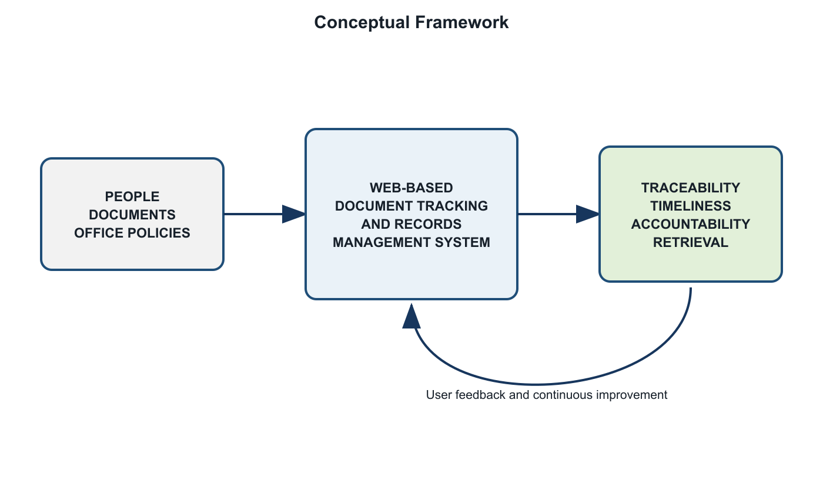
Figure. Conceptual Framework

1.3 Research Paradigm
The Input–Process–Output paradigm guides the project. Inputs include the existing document workflow, user requirements, document metadata, organizational roles, hardware, software, and applicable records-management practices. The process includes requirements analysis, interface and database design, iterative implementation, functional verification, pilot testing, and ISO/IEC 25010 evaluation. Outputs include the operational system, documented workflows, evaluation results, user guidance, and recommended improvements.
Research Paradigm
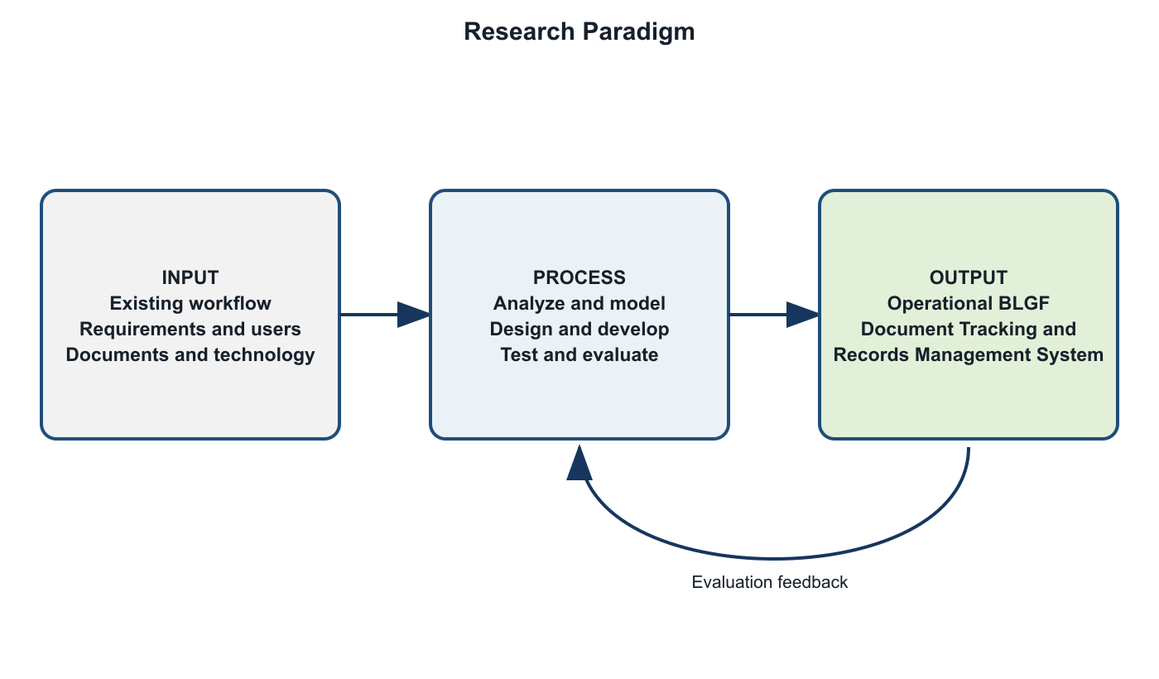
Figure. Research Paradigm

1.4 Objectives of the Study

1.4.1 General Objective
To design, develop, and evaluate a web-based document tracking and records management system that supports the secure, timely, and traceable processing of official documents at BLGF Region II.

1.4.2 Specific Objectives
- To document the existing practices and problems in registering, routing, monitoring, retrieving, and storing official documents.
- To develop centralized modules for incoming and outgoing document registration, unique route-number validation, status monitoring, routing, transfer, and completion.
- To provide role-based access, user and employee management, notifications, audit trails, envelope dispatch logs, and attachment management.
- To support QR code generation/scanning, document slips, configurable file storage, search, filtering, dashboard summaries, and database export.
- To evaluate the system using the ISO/IEC 25010 product-quality characteristics.
- To recommend operational and technical improvements based on testing and user feedback.

1.5 Scope and Limitation of the Study
The study covers the document lifecycle supported by the implemented application: user authentication; incoming and outgoing document registration; division and user assignment; routing and multi-routing; transfer and receiving actions; document statuses and priorities; attachments; notifications; searchable lists and dashboards; official routing slips; outgoing-envelope recording; QR generation/scanning; employee profiles and folders; audit logs; configurable storage directories; MySQL export; and administrative user management.
The application is intended for authorized BLGF Region II personnel and is designed for use through a modern web browser on a networked computer. Access is controlled by predefined roles and permissions. The current implementation uses a React/TypeScript client, an Express/TypeScript server, and MySQL persistent storage, with local JSON files available as a fallback in supported deployments.
The study does not claim to replace national records-disposition policies, digital-signature infrastructure, or a full enterprise content-management platform. System effectiveness depends on correct data entry, reliable network and server availability, proper user-account administration, backup procedures, and staff compliance with approved workflows. Actual ISO/IEC 25010 scores cannot be finalized until the prescribed respondents complete pilot testing and the evaluation questionnaire.

1.6 Significance of the Study
- BLGF Region II Management. Consolidated operational information can support oversight, workload monitoring, accountability, and process improvement.
- Records and Administrative Personnel. Centralized registration, storage, search, routing history, and logs can reduce repetitive encoding and manual follow-up.
- Division Chiefs and Staff. Notifications and document-status visibility can clarify assigned actions, deadlines, and responsibility.
- Clients and Partner Offices. More consistent internal processing may improve response time and service delivery.
- System Administrators. Role management, storage configuration, audit trails, and database export provide tools for controlled system operation.
- Future Researchers and Developers. The study provides a reference for workflow-oriented records systems in comparable public-sector environments.

1.7 Definition of Terms
Term | Operational Definition
Audit Trail | A chronological record of system and user activities related to documents and administrative operations.
Document Route Number | A unique identifier used by the system to register, locate, and distinguish an official document.
Document Routing | The controlled forwarding of a document to one or more authorized users or divisions for action.
Incoming Document | A record received by BLGF Region II from an external or internal source.
Outgoing Document | A record released or transmitted by BLGF Region II to an intended recipient.
QR Code | A machine-readable code used to represent or retrieve document-identifying information.
Records Management | The systematic control of records throughout their creation, use, storage, retrieval, and disposition.
Role-Based Access Control | A security approach in which system permissions depend on a user’s assigned organizational role.
Routing History | The ordered record of offices, users, dates, actions, remarks, statuses, and attachments associated with document movement.
ISO/IEC 25010 | A software product-quality model used in this study as the basis for system evaluation.

CHAPTER II. REVIEW OF RELATED LITERATURE AND STUDIES

2.1 Foreign Literature
International records-management literature treats records as evidence of organizational activity and emphasizes their authenticity, reliability, integrity, and usability throughout the records lifecycle. This perspective supports the inclusion of unique identifiers, metadata, controlled access, routing history, audit logs, and systematic storage in an electronic tracking system.
Workflow information systems coordinate tasks, people, and business rules so that work items move through defined stages. In document-intensive organizations, workflow automation can reduce uncertainty by recording assignment, receipt, action, transfer, and completion events. Dashboards and notifications further convert stored transaction data into actionable information.
Role-based access control limits operations according to organizational responsibility. Applied to document tracking, it helps ensure that users see only the records and functions required by their duties, while administrators retain controlled capabilities for account, configuration, and audit management. Logging complements access control by establishing who performed an action and when it occurred.
QR codes provide a compact method for connecting physical documents to digital identifiers. When a printed routing slip or folder bears a QR code, scanning can accelerate lookup and reduce errors associated with manually typing long identifiers. The value of the code nevertheless depends on authoritative records and secure access in the underlying application.
Software-quality evaluation should be multidimensional. ISO/IEC 25010 identifies characteristics such as functional suitability, performance efficiency, compatibility, usability, reliability, security, maintainability, and portability. These characteristics provide a structured basis for evaluating whether the developed system meets both functional and quality expectations.

2.2 Local Literature
Philippine public offices operate within an environment that values accountability, efficient public service, data protection, and proper records custody. The Electronic Commerce Act recognizes electronic data messages and documents in transactions, while the Data Privacy Act establishes responsibilities for the lawful and secure processing of personal information. These principles make controlled access, accurate records, and appropriate safeguards important in government information systems.
The Ease of Doing Business and Efficient Government Service Delivery Act reinforces the need for simplified and timely government procedures. Although document tracking alone cannot resolve every service delay, accurate visibility into pending records, assigned personnel, target dates, and completed actions can help offices identify bottlenecks and establish responsibility.
The National Archives of the Philippines provides the institutional context for government records management. Local digitalization initiatives commonly seek to improve retrieval and reduce dependence on fragmented paper logs. However, successful implementation also requires approved classification, retention, backup, access, and disposition procedures, together with staff training and management support.

2.3 Synthesis
The reviewed concepts converge on five requirements: reliable document identification, explicit workflow states, controlled access, traceable actions, and usable retrieval. Records-management principles explain what must be preserved; workflow systems explain how tasks move; security models govern who may act; QR technology connects physical and digital records; and ISO/IEC 25010 supplies an evaluation structure.
The proposed system integrates these requirements in a single application tailored to BLGF Region II. Its contribution is not the isolated use of a database or web interface, but the combination of registration, role-based routing, status history, attachments, alerts, storage, employee records, dispatch logs, QR-assisted lookup, and audit functions around the office’s operational document lifecycle.

CHAPTER III. RESEARCH METHODOLOGY

3.1 Research Design
The study uses developmental research with descriptive evaluation. Developmental research is appropriate because the main output is an information system created in response to an identified organizational need. The descriptive component records user perceptions of the finished system using ISO/IEC 25010 quality characteristics.
An iterative development process is applied: (1) requirements discovery, (2) workflow and data modeling, (3) interface and API implementation, (4) module-level verification, (5) integration and user testing, and (6) revision. Short iterations allow the researcher to compare the implemented workflow with office practice and correct gaps before formal evaluation.

3.2 System Architecture
The system follows a web-based client–server architecture. The browser client renders the React interface and calls REST-style endpoints. The Express server performs validation, workflow processing, authentication, file handling, and data access. MySQL stores structured operational data, while configured directories preserve uploaded files. A JSON fallback supports selected local deployments. Production assets are generated through Vite and esbuild.
System Architecture
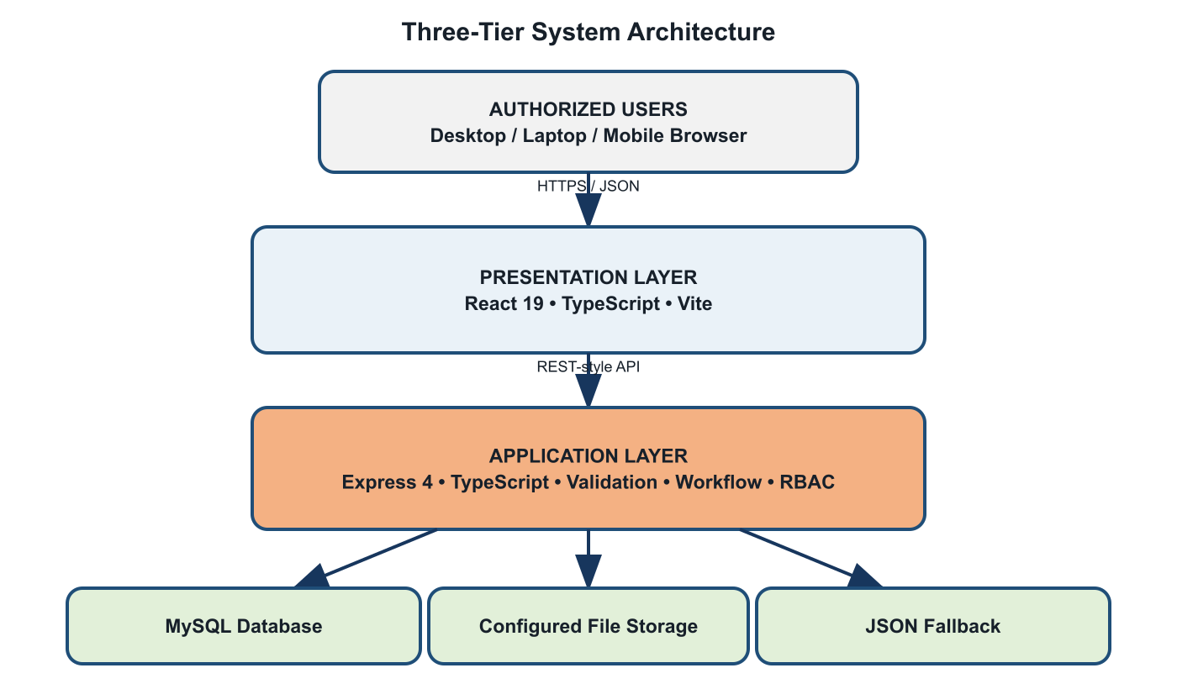
Figure. System Architecture

3.3 Use-Case Diagram
The principal actors are Administrator, Records Personnel, Division Chief, Staff/User, and Authorized Viewer. Available functions vary according to role permissions configured in the application.
Use-Case Diagram
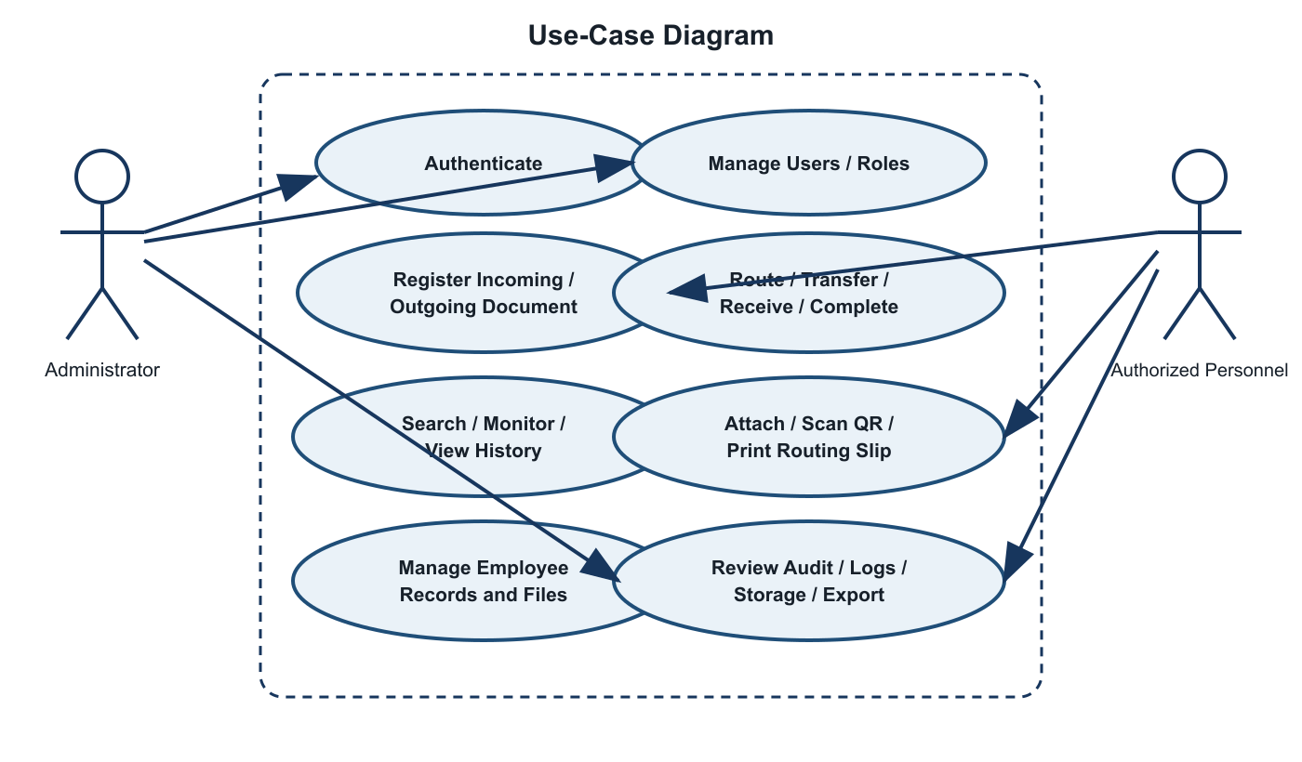
Figure. Use-Case Diagram

3.4 Context Level – Data Flow Diagram
Context-Level Data Flow Diagram
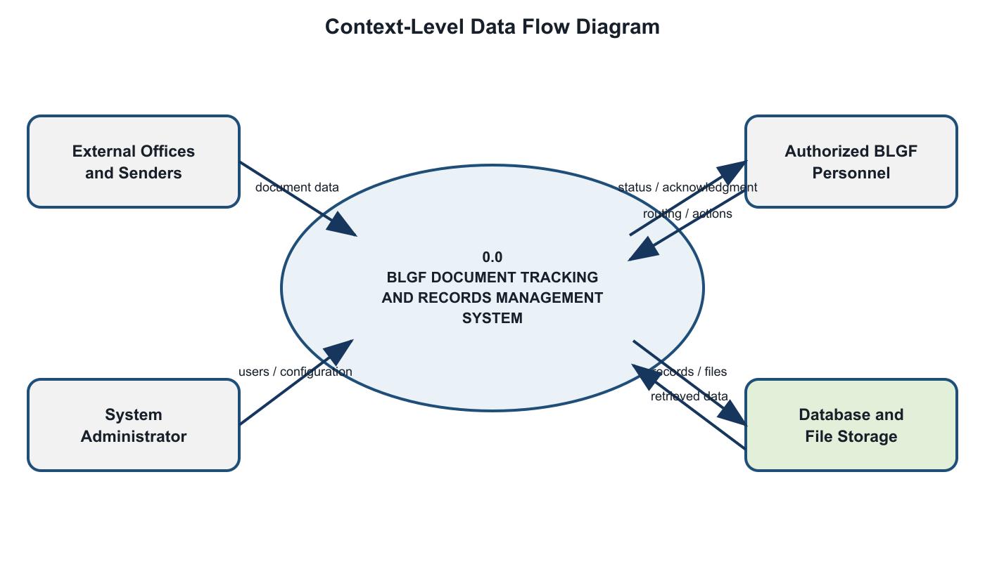
Figure. Context-Level Data Flow Diagram

3.5 Software and Hardware Requirements
Category | Minimum / Required | Recommended
Client Hardware | Dual-core CPU, 4 GB RAM, 1366×768 display | Modern multi-core CPU, 8 GB RAM or higher
Server Hardware | 4-core CPU, 8 GB RAM, 20 GB available storage | Scalable server/VM with monitored backups
Client Software | Modern Chromium, Firefox, or Edge browser | Current supported browser with JavaScript enabled
Server Software | Node.js-compatible runtime, npm, MySQL | Current LTS Node.js, managed MySQL/TiDB, TLS
Frontend | React 19, TypeScript, Vite | Production build served over HTTPS
Backend | Express 4, TypeScript, mysql2, Multer | Process manager, logging, health monitoring
Network | Reliable LAN/Internet connectivity | Redundant connection and secure network controls
Backup | Periodic database and attachment copy | Automated encrypted, tested, off-site backup

3.6 Respondent of the Study
The proposed respondents are authorized BLGF Region II personnel who participate in document receipt, registration, routing, action, release, records storage, supervision, or system administration. Purposive sampling is recommended because respondents must have direct knowledge of the workflow being evaluated.
Final respondent profile: [INSERT APPROVED NUMBER OF RESPONDENTS], consisting of [INSERT GROUPS, SUCH AS RECORDS PERSONNEL, DIVISION CHIEFS, STAFF, AND ADMINISTRATORS]. The final manuscript must report the actual distribution and selection criteria after approval by the adviser and participating office.

3.7 Research Instrument
The primary instrument is a structured questionnaire based on the eight ISO/IEC 25010 product-quality characteristics. Respondents rate statements on a five-point Likert scale: 5 – Strongly Agree, 4 – Agree, 3 – Neither Agree nor Disagree, 2 – Disagree, and 1 – Strongly Disagree. The instrument also includes respondent profile items and open-ended questions for observed issues and recommendations.
Content validation should be performed by the thesis adviser, an information-technology expert, and a records/process representative. A pilot test should verify clarity, completion time, and internal consistency before the main administration.

3.8 Locale of the Study
The study is intended for the Bureau of Local Government Finance – Region II. Data gathering, workflow validation, pilot testing, and user evaluation should be conducted with permission from the authorized regional office and in accordance with its operational and information-security requirements. Insert the approved office address here: [COMPLETE BLGF REGION II OFFICE ADDRESS].

3.9 Data Gathering
- Secure written permission from BLGF Region II and approval of the research instrument.
- Interview or consult process owners to document existing registration, routing, follow-up, storage, and reporting practices.
- Review non-confidential forms, log formats, routing slips, and metadata requirements.
- Configure a controlled test environment using non-sensitive or properly authorized sample data.
- Orient respondents and conduct task-based pilot testing of relevant modules.
- Administer the ISO/IEC 25010 questionnaire and collect open-ended feedback.
- Encode, verify, analyze, and securely retain the resulting data.
- Revise the system and manuscript based on validated findings.

3.10 Data Analysis
Frequency and percentage may describe respondent groups. The weighted mean will summarize each quality statement and characteristic. Where appropriate, standard deviation may describe response dispersion. Open-ended responses will be grouped by recurring theme.
Weighted Mean = Σ(f × w) / N
Weighted Mean Range | Verbal Interpretation
4.21–5.00 | Strongly Agree / Excellent
3.41–4.20 | Agree / Very Good
2.61–3.40 | Neither Agree nor Disagree / Good
1.81–2.60 | Disagree / Fair
1.00–1.80 | Strongly Disagree / Poor

CHAPTER IV. RESULTS AND DISCUSSIONS
This chapter documents the system output already verifiable from the implemented application. Survey-dependent tables remain explicitly marked for completion after formal pilot testing; no respondent score is fabricated in this proposal draft.

4.1 Problems Encountered in the Existing System
The requirements addressed by the system indicate recurring risks in a manual or fragmented workflow: difficulty locating a document after endorsement; dependence on personal follow-up; inconsistent route-number recording; duplicate entries; limited visibility of pending actions and target dates; attachments stored separately from transaction records; incomplete chain-of-custody information; and delayed preparation of logs or reports.
These conditions may result in unnecessary processing time, uncertainty regarding responsibility, weak auditability, and difficulty retrieving historical records. They also make continuity dependent on individual knowledge instead of shared and controlled organizational information.

4.2 The Developed System
The developed application centralizes the document lifecycle and exposes functions according to user role. Incoming and outgoing documents can be registered with metadata, priority, status, target dates, source/recipient information, assigned users or divisions, and attachments. Route numbers are checked for duplication. Routing, multi-routing, transfer, receipt, and status transitions are recorded as ordered history.
Module | Implemented Capability
Authentication and Access | User login, active-account checking, role-based views and action permissions
Dashboard | Operational summaries and access-aware document information
Incoming / Outgoing | Registration, unique route number, metadata, priority, target date, attachments
Routing | Single and multiple recipients, transfer, receipt/action status, remarks, route history
Notifications | Action-required and routing alerts tied to users and documents
Document Slip | Selection and printing of official routing information
QR Tools | QR generation and camera-based scanning support
Envelope Dispatch | Outgoing recipient/releasing details and separate envelope logs
Employee Records | Employee profiles, folders, and supporting files
Audit | Chronological user/system activity records
Storage | Configurable document directories and controlled file access
Administration | Users, divisions, settings, deletion rights, database export

4.2.1 Hierarchical Input Process Output (HIPO)
Hierarchical Input Process Output
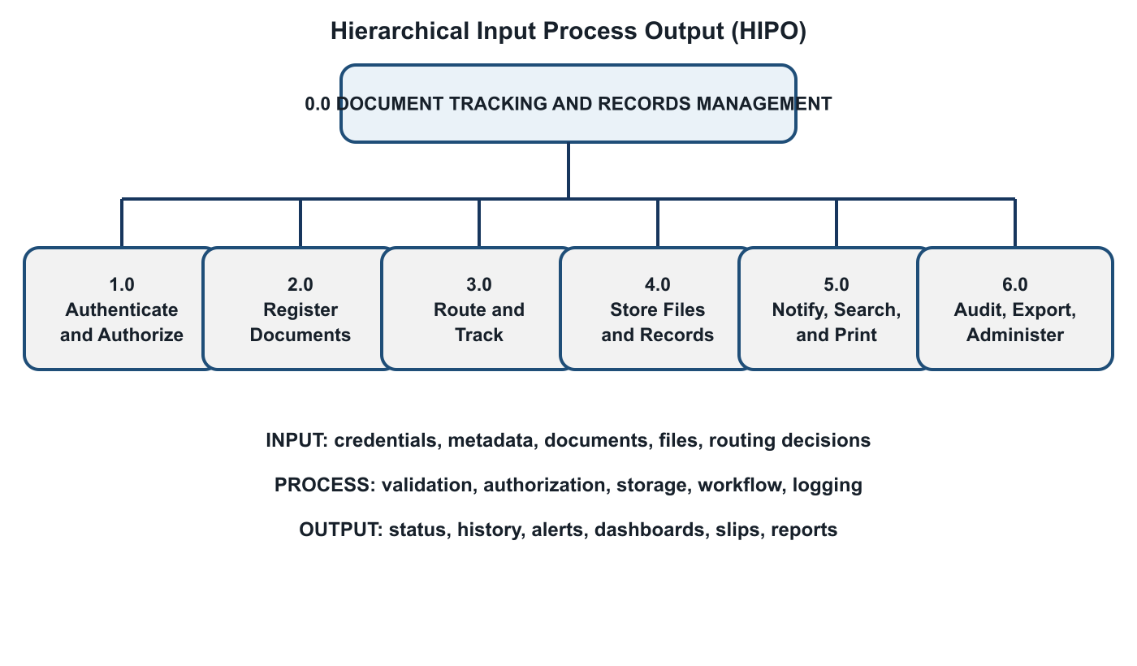
Figure. Hierarchical Input Process Output

4.2.2 Input Process Output (IPO) Diagram
Input-Process-Output Diagram
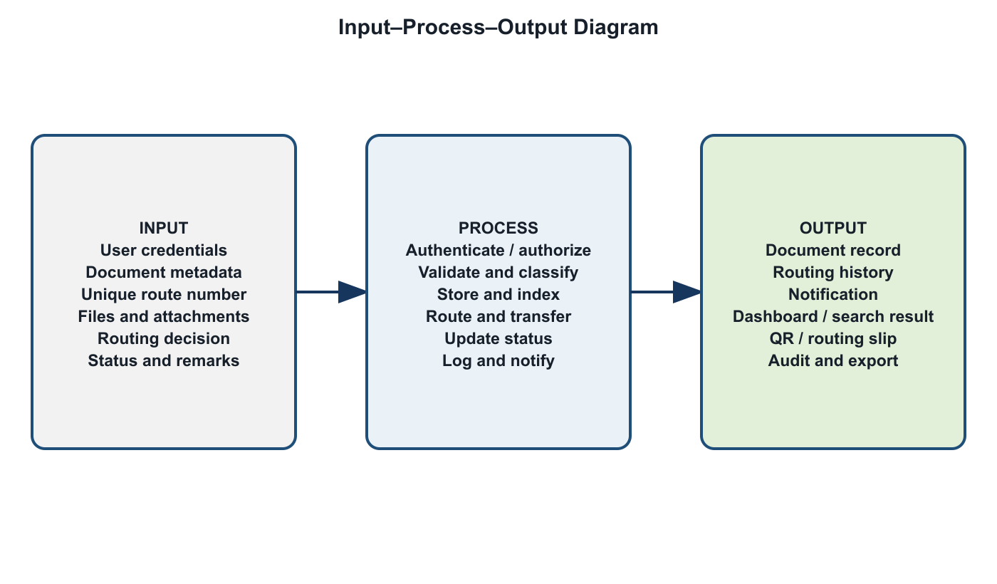
Figure. Input-Process-Output Diagram

4.2.3 Entity Relationship Diagram (ERD)
Entity Relationship Diagram
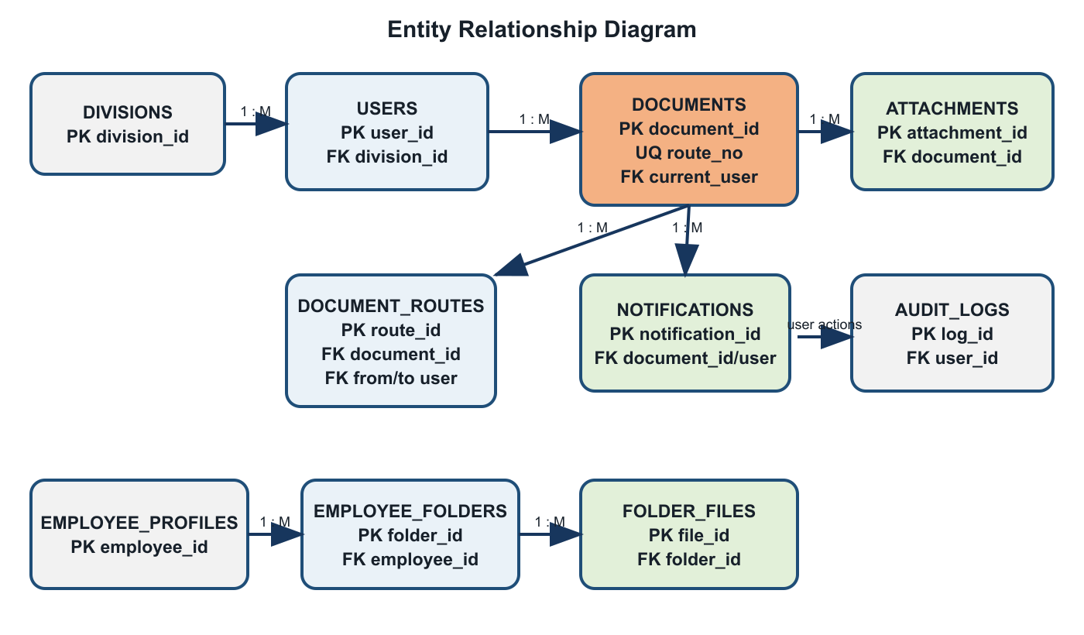
Figure. Entity Relationship Diagram

4.2.3.1 User’s View
After authentication, the user sees only permitted navigation items and accessible documents. Administrators can view all documents and manage users, settings, storage, and logs. Records-oriented roles can register and route documents. Division-level users see records assigned or routed to them and can perform authorized actions. The interface provides modals for document details, creation, routing, and status handling, together with dashboards, notifications, search, and responsive navigation.

4.2.3.2 Data Model
Entity | Purpose / Key Data
divisions | Organizational units and codes
users | Credentials, role, division, active state, profile details
documents | Route number, direction, subject, dates, sender/recipient, priority, status
document_routes | Origin, destination, action, status transition, remarks, timestamps
document_attachments | File metadata and relationship to a document or route
notifications | User-specific document alerts and read/action state
audit_logs | Actor, action, description, timestamp, contextual data
employee_profiles | Employee identity, appointment, division, and profile metadata
employee_folders/files | Organized employee supporting records
issuances / attachments | Issuance metadata and related files
archive_records | Classified records retained for archive functions

4.2.3 Table Design
The relational design uses primary keys to uniquely identify records and foreign-key relationships to connect documents, routes, users, divisions, attachments, and notifications. Route numbers require uniqueness at the application level and should also be protected by a database constraint in production. Timestamps support chronological reconstruction. Enumerated status, direction, priority, role, and document-type values promote consistency.
File contents are stored in configured directories while structured file metadata and relationships remain in the application data model. This separation keeps operational queries manageable while allowing controlled retrieval. Database export and backup procedures should always include both structured data and referenced file storage so that restored records remain complete.

4.3 The Extent of Compliance of the Developed System to ISO 25010 Software Quality Standards
Complete this section after pilot testing. The table below is intentionally prepared as an encoding template. Replace each blank with the computed weighted mean and verbal interpretation from actual respondents.
Quality Characteristic | Indicators | Weighted Mean | Interpretation
Functional Suitability | Completeness, correctness, appropriateness | [ ] | [ ]
Performance Efficiency | Response time, resource use, capacity | [ ] | [ ]
Compatibility | Co-existence and interoperability | [ ] | [ ]
Usability | Learnability, operability, accessibility, error protection | [ ] | [ ]
Reliability | Availability, fault tolerance, recoverability | [ ] | [ ]
Security | Confidentiality, integrity, accountability, authenticity | [ ] | [ ]
Maintainability | Modularity, analyzability, modifiability, testability | [ ] | [ ]
Portability | Adaptability, installability, replaceability | [ ] | [ ]
Overall | Grand weighted mean | [ ] | [ ]

CHAPTER V. SUMMARY OF FINDINGS AND RECOMMENDATIONS

5.1 Summary of Findings
The requirements analysis identified a need for centralized registration, unique document identification, transparent routing, timely notifications, attachment management, retrieval, and auditability. Functional inspection confirms that the developed system implements the major modules required to address these needs. It captures incoming and outgoing documents, route histories, status transitions, assignments, attachments, dispatch information, employee records, and logs in an integrated interface.
Final user-evaluation findings must be added after approved pilot testing. Report the number and profile of respondents, weighted mean for each ISO/IEC 25010 characteristic, overall mean, strongest and weakest indicators, observed task issues, and recurring qualitative feedback.

5.2 Conclusions
The developed system demonstrates that BLGF Region II’s document workflow can be represented in a centralized web application with explicit roles, statuses, routing events, attachments, and audit information. The implementation is technically capable of supporting traceability and organized retrieval. Its organizational effectiveness, however, must be confirmed through controlled deployment, user evaluation, reliable infrastructure, and approved operating procedures.
A defensible final conclusion regarding ISO/IEC 25010 compliance should be written only after actual evaluation data have been collected and analyzed. The present manuscript therefore treats compliance as an evaluation objective rather than an unsupported claim.

5.3 Recommendations
- Conduct formal pilot testing with approved representatives from each relevant user group.
- Enforce HTTPS, strong password practices, least-privilege accounts, session controls, and periodic access reviews.
- Automate encrypted backups of both database records and attachment directories, and test restoration regularly.
- Establish written rules for route-number issuance, metadata quality, status updates, retention, and disposition.
- Provide user orientation, a designated support contact, and periodic refresher training.
- Add automated tests, structured error monitoring, and deployment health checks before wider rollout.
- Consider future integration with official email, digital signatures, retention schedules, and enterprise identity services subject to policy and budget.
- Repeat ISO/IEC 25010 evaluation after major revisions and compare results over time.

BIBLIOGRAPHY
International Organization for Standardization. (2015). ISO 15489-1:2016 Information and documentation—Records management—Part 1: Concepts and principles.
International Organization for Standardization. (2011). ISO/IEC 25010:2011 Systems and software engineering—Systems and software Quality Requirements and Evaluation (SQuaRE)—System and software quality models.
National Archives of the Philippines. (n.d.). Government records management policies, standards, and guidance.
Republic Act No. 8792. (2000). Electronic Commerce Act of 2000. Republic of the Philippines.
Republic Act No. 10173. (2012). Data Privacy Act of 2012. Republic of the Philippines.
Republic Act No. 11032. (2018). Ease of Doing Business and Efficient Government Service Delivery Act of 2018. Republic of the Philippines.
Sommerville, I. (2016). Software Engineering (10th ed.). Pearson.
Pressman, R. S., & Maxim, B. R. (2020). Software Engineering: A Practitioner’s Approach (9th ed.). McGraw-Hill.
React Team. (n.d.). React documentation. https://react.dev/
OpenJS Foundation. (n.d.). Node.js documentation. https://nodejs.org/
Express.js. (n.d.). Express web framework documentation. https://expressjs.com/
Oracle Corporation. (n.d.). MySQL reference manual. https://dev.mysql.com/doc/

APPENDICES

Appendix A. Request Letter for Gathering Data
[DATE]
[NAME OF REGIONAL DIRECTOR / AUTHORIZED OFFICIAL]
[POSITION]
Bureau of Local Government Finance – Region II
[OFFICE ADDRESS]
Dear Sir/Madam:
I am TOM TOM G. CATRAL, a student of [PROGRAM] at [SCHOOL]. I am conducting a study entitled “Web-Based Document Tracking and Records Management System for the Bureau of Local Government Finance – Region II.” In this connection, I respectfully request permission to gather non-confidential workflow requirements, consult authorized personnel, and conduct system testing and evaluation at your office.
All information will be used solely for academic purposes and handled in accordance with applicable privacy, security, and office policies. No confidential document content will be reproduced in the manuscript without written authorization.
Respectfully yours,
TOM TOM G. CATRAL
Researcher

Appendix B. Request for Pilot Testing
[DATE]
May I respectfully request permission to conduct pilot testing of the Web-Based Document Tracking and Records Management System with selected authorized personnel. The activity will involve task-based use of a controlled test environment and completion of an ISO/IEC 25010 questionnaire. Testing will use non-sensitive or expressly authorized sample data. Participation will be voluntary, and responses will be summarized without unnecessary personal identifiers.
Proposed schedule: [DATE / TIME]
Venue or access method: [LOCATION / URL]
Estimated duration: [MINUTES]
Respectfully yours,
TOM TOM G. CATRAL
Researcher

Appendix C. Users Manual

C.1 Accessing the System
- Open the authorized system address in a supported web browser.
- Enter the assigned username and password.
- Select Login. Contact the administrator if the account is inactive or credentials are unavailable.

C.2 Registering a Document
- Open Incoming Documents or Outgoing Documents.
- Select the command to add/register a document.
- Enter the unique Document Route Number and required metadata.
- Choose priority, status, dates, sender/recipient, and initial assignment as applicable.
- Attach only authorized files, review the entries, and submit.

C.3 Routing and Acting on a Document
- Open the document details and verify its current status and history.
- Select Route, Transfer, Receive, or the permitted action.
- Choose the destination user/division, action required, remarks, and target date.
- Confirm the transaction and verify that the new route appears in history.

C.4 Search, Notifications, QR, and Slips
- Use list filters or search to locate a route number, subject, sender, recipient, or related metadata.
- Open the notification bell to review documents requiring attention.
- Use the QR module to generate or scan document-identifying information.
- Open Document Slip, select the record, review the routing details, and print using the browser dialog.

C.5 Administrative Functions
- Manage user accounts and roles only when authorized.
- Review audit and outgoing-envelope logs for accountability.
- Configure storage directories carefully and test file retrieval.
- Export and back up the database according to the approved schedule.

C.6 Basic Troubleshooting
- Refresh the page and confirm network connectivity if information does not load.
- Verify route-number uniqueness when registration is rejected.
- Check role permissions if a menu or action is unavailable.
- Do not repeatedly submit the same transaction after an error; verify document history first.
- Report persistent errors with the route number, time, action attempted, and a screenshot that contains no unnecessary sensitive data.

Appendix D. ISO 25010 Questionnaire
Respondent Group/Position: ____________________ Date: ____________________
Scale: 5–Strongly Agree; 4–Agree; 3–Neither Agree nor Disagree; 2–Disagree; 1–Strongly Disagree

Functional Suitability
1. The system provides the functions required for document registration, routing, monitoring, retrieval, and records management. 5 4 3 2 1
2. The system produces correct document status, routing history, notifications, and logs. 5 4 3 2 1
3. The available functions are appropriate for my assigned work. 5 4 3 2 1

Performance Efficiency
1. Common pages and records load within an acceptable time. 5 4 3 2 1
2. Search, filtering, saving, and routing respond efficiently. 5 4 3 2 1
3. The system supports the expected number of documents and users. 5 4 3 2 1

Compatibility
1. The system operates correctly with the office’s supported browser and environment. 5 4 3 2 1
2. Data and files can be exchanged through the provided import/export or attachment functions. 5 4 3 2 1

Usability
1. The labels, navigation, forms, and feedback messages are understandable. 5 4 3 2 1
2. I can learn the relevant tasks with reasonable instruction. 5 4 3 2 1
3. The system helps prevent or correct input errors. 5 4 3 2 1
4. The interface remains usable on the devices approved for office use. 5 4 3 2 1

Reliability
1. The system is available when required during testing. 5 4 3 2 1
2. Saved transactions remain accurate after refresh or sign-in. 5 4 3 2 1
3. The system handles recoverable errors without losing confirmed work. 5 4 3 2 1

Security
1. Users can access only the documents and functions appropriate to their roles. 5 4 3 2 1
2. Actions are attributable through routing history and audit logs. 5 4 3 2 1
3. Sensitive information is handled with appropriate controls. 5 4 3 2 1

Maintainability
1. The system is organized so defects and affected modules can be identified. 5 4 3 2 1
2. Changes can be introduced without unnecessary impact on unrelated functions. 5 4 3 2 1
3. The system can be tested after maintenance or enhancement. 5 4 3 2 1

Portability
1. The system can be installed or deployed in the approved environment. 5 4 3 2 1
2. The application works on supported current web browsers. 5 4 3 2 1
3. Configuration can be adapted to approved storage and database environments. 5 4 3 2 1
Comments and recommendations:
____________________________________________________________________
____________________________________________________________________

Appendix E. Source Code
The complete source code is maintained in the project repository. For printed submission, include only representative excerpts required by the institution; attach the full source electronically or provide repository access according to adviser and office approval.
Path | Contents
frontend/src/ | React/TypeScript user interface, components, types, services, and utilities
backend/server.ts | Express API, workflow logic, storage, authentication, and data operations
backend/schema.sql | MySQL relational schema
backend/utils/ | Database export and supporting utilities
package.json | Dependencies and build, development, lint, and start commands
README.md | Project structure and operating instructions
Repository: https://github.com/TomCatral/blgfr2-doctract

CURRICULUM VITAE
Field | Information
Name | TOM TOM G. CATRAL
Address | [COMPLETE ADDRESS]
Email / Contact | [EMAIL ADDRESS / CONTACT NUMBER]
Program | [DEGREE / PROGRAM]
School | [NAME OF SCHOOL / UNIVERSITY]
Educational Background | [DEGREE, SCHOOL, YEAR]
Employment / Experience | [POSITION, ORGANIZATION, YEARS]
Training / Certifications | [RELEVANT TRAINING OR CERTIFICATIONS]
Technical Skills | Web application development, document workflow analysis, database and records-system implementation

