A THESIS PROPOSAL

DEVELOPMENT OF A WEB-BASED DOCUMENT TRACKING AND MANAGEMENT SYSTEM FOR THE REGIONAL BUREAU OF LOCAL GOVERNMENT FINANCE

Submitted in Partial Fulfillment
of the Requirements for the Degree
Master of Science in Information Technology

CAGAYAN STATE UNIVERSITY
GRADUATE SCHOOL
Carig Campus, Tuguegarao City

PROPONENT

TOM TOM G. CATRAL

ADVISER

Dr. Edison D. Bravo

April 2025

APPROVAL SHEET
This thesis proposal entitled “Development of a Web-Based Document Tracking and Management System for the Regional Bureau of Local Government Finance” prepared by TOM TOM G. CATRAL is submitted in partial fulfillment of the requirements for the degree Master of Science in Information Technology of Cagayan State University, Graduate School, Carig Campus, Tuguegarao City. The proposal has been examined and accepted as complying with the requirements of the Graduate School.

______________________________
Arthur G. Ibanez, ASEAN Engr., Ph.D.

Thesis Panel Chair

______________________________
Dr. Edison D. Bravo

Thesis Adviser

______________________________
Engr. Roger P. Rumpon

Panel Member

______________________________
Generino P. Siddayao, DIT

Panel Member

______________________________
Charmie S. Calvo, DIT

Panel Member

______________________________
Dr. Dennis Bacuyag

Panel Member

ACKNOWLEDGEMENT
The researcher wishes to express his sincere gratitude to the persons and institutions whose assistance made this study possible.
First, to Dr. Edison D. Bravo, thesis adviser, for the guidance, correction, and patience extended throughout the study, and for insisting that a claim in this work must always be supported by the evidence that produces it.
To the members of the thesis panel — Arthur G. Ibanez, Engr. Roger P. Rumpon, Generino P. Siddayao, Charmie S. Calvo, and Dr. Dennis Bacuyag — for the comments and corrections given during the proposal defense of April 12, 2025, which reshaped the scope and methodology of this work.
To the Regional Director and the personnel of the Regional Bureau of Local Government Finance Region II, for the opportunity to document the office’s real document handling practice, for the permission to examine its records, and for the cooperation of the records and division personnel who took time from their work to be interviewed. This study would not have been possible without their assistance, and the researcher acknowledges them formally here.
To the Graduate School and the faculty of Cagayan State University, Carig Campus, for the academic guidance and the research support provided throughout the program.
Finally, to the researcher’s family and colleagues, whose encouragement sustained the work during the periods when the system refused to behave as designed.

DEDICATION
This work is dedicated to my family, whose support carried the parts of this project that software cannot: the late nights, the printed drafts, and the patience required to finish what was started.

ABSTRACT
This study presents the analysis, design, development, and evaluation of a web-based document tracking and management system for the Regional Bureau of Local Government Finance Region II. It responds to an operational problem in which the location and completion of a document were confirmed by locating the paper or by asking the person holding it, rather than by consulting a record, and in which a routing reference could be altered or reused when a paper was endorsed outside the originating office.
The application registers incoming and outgoing documents with a permanent tracking number and a controlled route number, and records routing, multi-routing, transfer, receipt, decision, and completion as retained events that together form the chain of custody for each document. It supports attachments, derived notifications, routing slips, outgoing-envelope dispatch logs, the office directory with employee folders, QR code generation, three reports, audit logging, configurable storage, and database export. Access is defined across seven organizational roles, and document visibility is restricted in the query layer to the creator, the current recipient, and the users who routed the document, with no role bypass.
Development followed an iterative and incremental model, and the resulting data model comprises nine entities declared in the schema and a tenth created at runtime. Referential integrity is mixed by design: document and account relations are enforced by database foreign keys, while log and attachment attribution is logical so that audit evidence survives the deletion of the document or account it describes.
Evaluation against the ISO/IEC 25010 product-quality characteristics established conformance for functional suitability, maintainability, and flexibility for the matters inspected, and conformance within a stated scope for compatibility. Reliability and security are reported as partially established, because no backup and restore has been exercised, authorization is not enforced at every endpoint, and passwords are stored and compared in plaintext. Performance efficiency and interaction capability await measurement. No user-acceptance score is reported because the ISO/IEC 25010 instrument has not yet been administered; the instrument, the respondent classification, and the task-timing procedure are provided so that the outstanding measurement can be completed. The study records this boundary rather than estimating the result, and recommends endpoint authorization, password hashing with a memory-hard algorithm, restriction of the export function, and reconciliation of the deployment configuration.

Keywords: document tracking, records management, workflow automation, role-based access control, audit trail, QR code, ISO/IEC 25010, BLGF Region II
TABLE OF CONTENTS

LIST OF TABLES

LIST OF FIGURES

CHAPTER I. THE PROBLEM AND ITS BACKGROUND

1.1 Introduction
Regional government offices receive and release a continuous volume of official papers. These include memoranda, endorsements, letters, requests, reports, circulars, financial submissions, personnel actions, and the attachments that accompany them. Before an action is completed, a document commonly passes through several offices and several individuals. Each transfer has to answer four questions: where is the document now, who is holding it, what action is expected, and whether the required action has already been completed.
The Regional Bureau of Local Government Finance (BLGF) Region II answers these questions in a paper-based records operation. Document identification is written in logbooks, movement is recorded in routing slips and signature spaces, and confirmation that an action was completed depends on physically locating the paper or on a verbal report from the person concerned. Because the confirmation is not a queryable record, the ability to answer the first question is uneven, and the second and third questions can only be answered by the office that physically holds the paper.
Records management is broader than storage. It covers the controlled creation, receipt, classification, routing, use, retention, retrieval, and disposition of records. An electronic records system is therefore not justified merely by moving a logbook into a database. Its value depends on whether the office can rely on a single identifier for every document, whether each movement is recorded as an event, and whether the resulting history can be reviewed later as evidence of what happened and who caused it. This distinction is central to the present study, because it determined which modules were built and which were deliberately left out.
This study documents the analysis, design, development, and evaluation of a web-based document tracking and management system for BLGF Region II. The application registers incoming and outgoing documents, assigns a permanent tracking number and a controlled route number, records routing, multi-routing, transfer, receipt, decision, and completion events, keeps attachments, generates notifications, maintains the office directory and employee records, produces routing slips, records outgoing-envelope dispatch, generates QR codes, and retains audit and envelope logs. Access is controlled by seven organizational roles, and document visibility is restricted to the creator, the current recipient, and the users who routed the document.
The system was built around the office workflow rather than as a general-purpose file repository. The development follows an iterative and incremental model, and the evaluation combines technical conformance evidence with a ready-to-administer ISO/IEC 25010 questionnaire addressed to authorized personnel. No user-acceptance score is reported in this study because no questionnaire responses have yet been collected; Section 4.3 therefore presents the instrument, the procedure, and the verifiable system-side evidence, and identifies the measurement that remains outstanding.

1.2 Conceptual Framework
Figure 1 expresses the study using the Input-Process-Output model. The model is appropriate because the study has an identifiable resource set, a defined set of development and evaluation activities, and a set of outputs that can be inspected independently of the researchers’ claims.
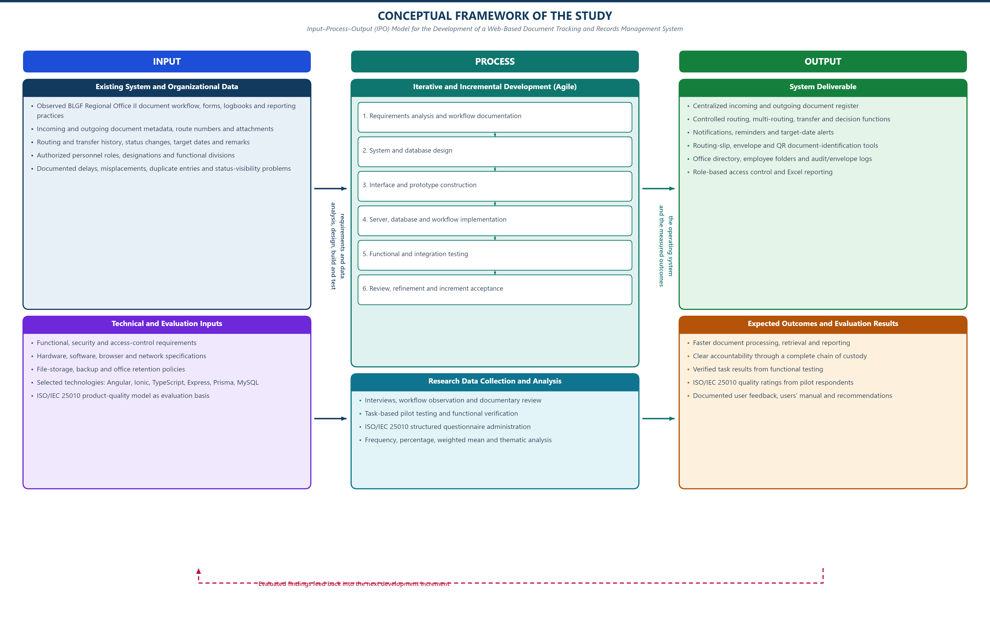
Figure . Conceptual Framework of the Study

1.2.1 Input
The inputs are of three kinds. Organizational inputs consist of the observed document-handling practice of BLGF Region II, the route numbers and metadata that staff record, the available user roles and division assignments, and the delays, misplacements, duplicate entries, and unclear custody identified during the study. Technical inputs consist of the functional and access requirements derived from those observations, the data definitions in Section 4.2.3.2, the hardware and software environment in Section 3.5, and the ISO/IEC 25010 product-quality characteristics used as the evaluation basis.

1.2.2 Process
The process component contains the development activity and the evaluation activity. Development uses an iterative and incremental model. The first increment established authentication, password setup, divisions, and incoming and outgoing registration with permanent number assignment. Later increments added routing, multi-routing, transfer, decision recording, completion, attachments, notifications, routing slips, outgoing-envelope recording, reports, the office directory, QR generation, audit and envelope logs, storage configuration, and the user and role manager. Every increment was analyzed, implemented, exercised against the running application, and corrected before the next increment was accepted.
The evaluation activity is separate from development. It consists of functional inspection of the delivered modules, access-control testing against the seven role definitions, task-based verification of the document lifecycle, and the administration of the ISO/IEC 25010 questionnaire to authorized personnel. Evaluation findings are reported as evidence, and anything not yet measured is reported as outstanding rather than estimated.

1.2.3 Output
The system output is the deployed application and its supporting documentation. The organizational outputs are a single searchable record set, a retained routing history for every document, an accountable record of each administrative action, and a measurable basis for monitoring pending work. The evaluative outputs are the technical conformance summary in Section 4.3, the questionnaire instrument, the user manual, and the recommendations in Section 5.3.

1.3 Research Paradigm
Figure 2 states the research paradigm. Where the conceptual framework shows how resources become outputs, the paradigm identifies the evidence that is actually collected and the claims each piece of evidence can support. This distinction is maintained throughout Chapter IV so that no conclusion exceeds the evidence behind it.
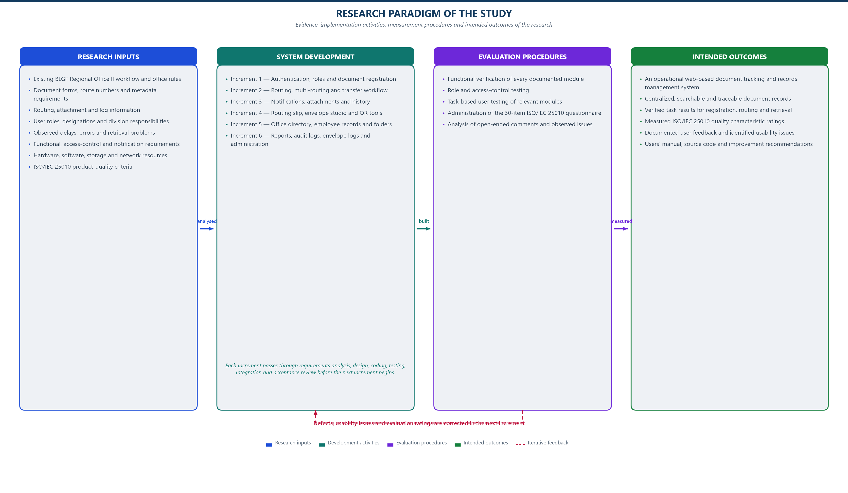
Figure . Research Paradigm of the Study
Three evidence classes appear in the paradigm. First, requirement evidence drawn from the existing workflow, which supports the problem statement and the objectives. Second, implementation evidence drawn from the running application, which supports the description of what the system does and how its data is structured. Third, evaluation evidence, which consists of functional and access-control test results and, once administered, the ISO/IEC 25010 respondent ratings. Conclusions about speed, accuracy, or user satisfaction require the third class and are therefore withheld until the questionnaire is completed.

1.4 Objectives of the Study

1.4.1 General Objective
To design, develop, and evaluate a web-based document tracking and management system that supports the secure, timely, and traceable processing of official documents at BLGF Region II.

1.4.2 Specific Objectives
- To document the existing practices and the problems encountered in registering, routing, monitoring, retrieving, and storing official documents at BLGF Region II.
- To develop a centralized application for incoming and outgoing document registration with permanent tracking numbers and controlled route numbers.
- To implement the document workflow through routing, multi-routing, transfer, receipt, decision, and completion actions with a retained status history.
- To implement role-based access control covering seven organizational roles, and to restrict document visibility to the creator, the current recipient, and the routing users.
- To support attachments, notifications, routing slips, outgoing-envelope recording, reports, the office directory, employee folders, QR code generation, audit logs, and envelope dispatch logs.
- To provide user and role administration, division maintenance, storage configuration, and database export.
- To evaluate the developed system against the ISO/IEC 25010 product-quality characteristics.
- To recommend operational and technical improvements based on the evaluation results and on the limitations identified in this study.

1.5 Scope and Delimitation of the Study
The study is confined to the document lifecycle that the implemented application supports. The covered functions are authentication and forced password setup; division and user administration; incoming and outgoing registration; permanent tracking numbers and controlled route numbers; routing, multi-routing, transfer, receipt, decision, and completion; statuses and priorities; attachments; notifications; searchable lists and dashboard summaries; routing slips; outgoing-envelope recording and dispatch logs; the three reports; the office directory with employee profiles and employee folders; QR code generation; audit logs; configurable storage directories; and database export.
The study is limited to the personnel and transactions of BLGF Region II and is exercised through a networked web browser on the office local area network. The deployment under study uses the Node and Express application server with MySQL 8.4 as the persistent store and a JSON file fallback for supported local installations. Uploads are handled by Multer and written to configured directories, with an option to store file payloads inside the database as long text.
The following are expressly excluded. The study does not implement digital signatures or a PKI trust service, so a signature recorded in the system is an attestation by the recording user and is not cryptographically verifiable. It does not implement national records disposition schedules, retention calendars, or legal holds. It does not replace an enterprise content-management platform, and it provides no external public portal; all access is by authenticated office account. It does not implement inter-agency document exchange or integration with existing national systems. Multi-office or multi-region deployment is not evaluated. Finally, no claim is made about productivity, turnaround time, or user satisfaction until the ISO/IEC 25010 questionnaire and the timing measurements described in Section 4.3 have been administered and collected.

1.6 Significance of the Study
The study is expected to benefit the following stakeholders.
- BLGF Region II management. Consolidated and queryable status information supports oversight, workload monitoring, and identification of bottlenecks.
- Records and administrative personnel. Centralized registration, route-number uniqueness checking, storage, search, and retained routing history reduce repeated encoding and manual follow-up.
- Division chiefs and staff. Notifications, follow-up monitoring, and visible status clarify assigned actions, target dates, and responsibility for action.
- Partner LGUs and client offices. More consistent internal handling and visible status support faster and more predictable response.
- System administrators. Role and permission management, division maintenance, storage configuration, audit trails, envelope dispatch logs, and database export provide controlled operation and recoverable data.
- Future researchers and developers. The study provides a documented reference for a workflow-oriented records system implemented in a public-sector setting, including its data model, its permission scheme, and its identified weaknesses.

1.7 Definition of Terms
Table . Operational Definitions
Term | Operational Definition in This Study
Audit Trail | The chronological record written to audit_logs and envelope_logs identifying the account, name, role, action, related tracking number, detail, network address, and time of each administrative activity.
Controlled Route Number | The office-assigned number following the pattern BLGFR2-YYYY-MM-IN|OUT-NN, in which IN denotes incoming, OUT denotes outgoing, and NN is a permanent non-repeating sequence.
Derived Notification | A notification computed at request time from audit_logs and document_routes for the signed-in user rather than read from a notification table. The response carries the X-Notification-Source header.
Division | One of the organizational units coded ITMS, ORD, AD, LAOD, LTOD, FD, or LU, recorded in divisions and referenced logically by users and documents.
Document Status | One of NOT_YET_ROUTED, PENDING, IN_PROGRESS, FOR_SIGNATURE, COMPLETED, RETURNED, or ON_HOLD, stored as documents.current_status and recorded per step in document_routes.
Employee Folder | A per-employee collection of file links maintained in the employee_profiles.folders JSON field and managed through the Employee Folder Manager.
HIPO | Hierarchical Input-Process-Output, the top-down decomposition used in Section 4.2.1 to show module hierarchy and data flow.
Inactivity Reminder | The notice raised by the routing follow-up routines when a document has exceeded its target completion date while still inside the routing chain.
Incoming Document | A document recorded with direction INCOMING, received by the office from an external or internal source.
ISO/IEC 25010 | The systems and software product-quality model used in this study as the basis for system evaluation.
Logical Reference | A relationship enforced by application code rather than by a database foreign key, so a referenced row may be removed without cascading.
Outgoing Document | A document recorded with direction OUTGOING, released by the office to an intended recipient.
Outgoing Envelope | The dispatch record for a released document, captured separately in envelope_logs and reported separately from document status.
QR Code | A machine-readable two-dimensional code generated in the browser from a document identifier, used to associate a physical document or printed slip with its digital record.
Role-Based Access Control | The access scheme in which the operations and views available to a signed-in user are determined by the role assigned in users.role, optionally modified by the permissions JSON override.
Routing History | The ordered set of document_routes rows describing each movement, including the releasing and receiving party, action requested, remarks, status before and after, and time.
Tracking Number | The permanent unique identifier assigned to a document at registration, never reused, and used in all lists, reports, logs, and notifications.
Visible to the User | A document that the signed-in user created, currently holds as recipient, or routed at some point. No role bypass exists for this rule.

CHAPTER II. REVIEW OF RELATED LITERATURE AND STUDIES

2.1 Foreign Literature

2.1.1 Records Management and the Records Lifecycle
Foreign records-management literature treats a record as evidence of organizational activity rather than as an administrative by-product. The governing concern is that a record remain authentic, reliable, and usable long after the transaction that created it has closed. From this position, the preservation of a chain of custody is not optional metadata but a requirement, and an electronic system is judged by whether it can demonstrate what happened to a record and who acted on it (International Organization for Standardization, 2016). ISO 15489-1 frames this explicitly by requiring that records be retained in a form that preserves their authenticity, reliability, integrity, and usability, and it separates the record from the medium that carries it. The practical consequence for a document-tracking application is that the routing history must be a first-class, retained, and queryable part of the data model rather than a set of free-text remarks that a user may or may not complete.
The lifecycle framing also shapes what a tracking system should refuse to do. Retention and disposition require authority that a departmental application cannot supply: a disposition schedule is a legal instrument, not an application setting. The present study therefore records and preserves routing and action history but deliberately does not implement disposition or deletion schedules, a distinction that is reported in Section 1.5.

2.1.2 Document Workflow and Workflow Information Systems
Workflow information systems coordinate tasks, actors, and rules so that work items move through defined states, and the established literature on workflow management distinguishes control flow from data flow: a process model governs the permitted sequence of steps, while data governs what each step receives and produces (van der Aalst, 1998). In document-intensive administrations this distinction is decisive, because the hard question is rarely the storage of a file but the legal move of a paper from one office to another while both offices retain evidence of the move.
Later work on workflow management and business process management converged on the finding that automated routing produces its main benefit only when the process is explicit and machine-enforced. Where enforcement is advisory, a tracking tool records what should have happened instead of what did. The developed system follows that principle: the permitted status transitions, the ordering of routing steps, and the recipients permitted for a given step are validated on the server, and every accepted transition writes a routing row recording the status before and the status after.
The same conclusion follows from records practice itself. ISO 15489-1 requires that the custody and location of a record be identifiable so that the record can be produced when it is required (International Organization for Standardization, 2016). A workflow system that does not store the current holder therefore cannot satisfy the records requirement even if it stores the document itself. The developed system operationalizes this by making the current holder a stored attribute of the document rather than a recollection held by an individual, and by retaining each change of holder as a row.

2.1.3 Access Control and Accountability
Role-based access control is the dominant model for organizational applications because permissions in an administration are naturally described by responsibility rather than by individual (Sandhu et al., 1996). The model assigns rights to roles and roles to users, so that a change of personnel does not require re-specification of permissions. Its known weaknesses are equally well documented: role explosion as permissions accumulate, and privilege creep when a role is granted rights that are never withdrawn. The present study implements role-based access with seven predefined roles, a per-account JSON override, and an explicit set of fifteen granular action keys, and it addresses privilege creep directly in the recommendation that overrides be reviewed (Section 5.3).
Accounting for the weaknesses of role-based access control, authorization in the delivered system is applied server-side rather than relied upon at the interface. The most important instance is document visibility, which is restricted in the query layer to the creator, the current recipient, and the users who routed the document, with no administrative bypass; the interface merely reflects a rule the server enforces. Awareness of this distinction is required to read Section 4.2.3 accurately, because several interfaces display fewer options for reasons that are server-enforced rather than cosmetic.
Access control alone does not establish accountability. For that, an independent record of activity is required that cannot be altered by the same operation it records. The deployed application writes audit_logs and envelope_logs on administrative actions, capturing account, display name, role, action, related tracking number, narrative detail, network address, and millisecond timestamp. The logs are deliberately stored apart from the documents they describe so that the evidence survives the removal of the document, which is why those two relationships are classified as logical rather than enforced in Section 4.2.3.2.

2.1.4 Software Product Quality and Evaluation
ISO/IEC 25010 is the current international product-quality model for systems and software, having replaced the earlier 25010:2011 with the 2023 edition alongside ISO/IEC 25019 for quality measurement (International Organization for Standardization, 2023). It defines eight characteristics: functional suitability, performance efficiency, compatibility, interaction capability, reliability, security, maintainability, and flexibility. Its practical value for this study is that it converts an otherwise vague demand for a good system into a fixed checklist against which specific characteristics can be tested and reported.
A secondary benefit of the model is that it separates characteristics that the system demonstrably satisfies from characteristics that cannot be demonstrated without users. Functional suitability, maintainability, and flexibility can be established by inspecting the delivered system and its source. Interaction capability, performance efficiency, and reliability in operation require users and elapsed-time measurement. Chapter IV therefore reports conformance and inspection evidence for the first group and reserves the second group for the questionnaire described in Section 3.7, rather than merging the two into a single unearned score.
Security practices published by the Open Worldwide Application Security Project provide the specific checks used for the security characteristic, particularly the treatment of authentication, access control, injection, and cryptographic failures in application code (OWASP Foundation, 2021). Two of the weaknesses identified in this study, the plaintext comparison of passwords and the absence of a full authorization matrix on every endpoint, correspond directly to categories in that guidance, and the corresponding recommendations in Section 5.3 adopt its mitigation practice.

2.1.5 Usability and User Acceptance
Usability research distinguishes task effectiveness, efficiency, and satisfaction, and warns that satisfaction measured without task observation tends to diverge from actual performance (ISO/IEC 25010, 2023; Nielsen, 1994). This caution governs the design of the evaluation in Section 3.7. The questionnaire gathers respondent perception, so its results are reported as perception; where a claim concerns whether an operation can be completed or how long it takes, the supporting evidence is the functional test record and the timing measurement, not the questionnaire.
For public-sector systems in particular, the comparative evidence is consistently unfavourable. Assessments of e-government maturity in the Philippines report weak foundational controls, insufficient integration of services, and limited interoperability between agencies, and identify institutional capacity and management practice as binding constraints rather than technical availability (United Nations, 2022). The implication for this study is narrow and practical: a well-built application cannot by itself improve service delivery, because the surrounding practice of records custody, numbering, and confirmation determines whether the record is trustworthy. This observation shaped the delivered interface, which surfaces the next required action on the document itself rather than requiring the user to reconstruct the workflow from the logbook, and it also shaped the recommendation in Section 5.3 that training accompany deployment.

2.2 Local Literature

2.2.1 Philippine Legal and Policy Framework
Philippine law defines the obligations that shape any government records system. Republic Act No. 8487 establishes the National Archives of the Philippines and the archival authority of the Republic, which situates government records within a defined custodial framework rather than leaving disposition to each office (Republic Act No. 8487, 1992). The E-Commerce Act of 2009 gives legal recognition to electronic data messages and to the electronic signatures attached to them, which is the legal basis for an electronic document and routing record being admissible as an office record (Republic Act No. 8792, 2009). Both are directly relevant: the first constrains what the application may treat as final disposition, and the second establishes that an electronic routing history is a legitimate record rather than an informal aid.
The Data Privacy Act of 2012 applies because the application stores personal information, namely names, positions, office addresses, email addresses, and contact numbers of personnel and counterparties, and because it stores account credentials (Republic Act No. 10173, 2012). Three obligations are engaged directly: the requirement that personal information be collected with consent and used only for the disclosed purpose, the requirement that it be kept reasonably secure, and the requirement that it be retained no longer than necessary. The third is the reason the system records an expiry for temporary passwords and the reason the study treats password hashing as a required remediation rather than an enhancement.
Republic Act No. 11967 commits government agencies to streamlined procedures and to a public service that is efficient and responsive (Republic Act No. 11967, 2022). Document tracking does not by itself achieve streamlining, but accurate visibility of pending records, named holders, and target dates is the precondition for identifying where a procedure is actually delayed, which is the contribution this system is intended to make.
On the administrative side, the implementing rules of the Data Privacy Act specify the obligations of a personal data controller, including the requirement to adopt reasonable and appropriate measures for the security of processed personal information and the requirement to dispose of personal information that is no longer needed in a secure manner (National Privacy Commission, 2016). The directory and employee-profile modules are designed against those two obligations rather than against a general security principle: employee records are retained only while the person is listed as active, and the office-type groupings that determine what a given role may browse are explicit configuration rather than implicit inference.

2.2.2 Local Government Records Practice
The legal framework above establishes what government records handling must satisfy, but it does not by itself document how Philippine offices currently handle documents. That description was obtained for this study directly, from the logbooks, routing slips, and document forms of BLGF Region II and from the interviews described in Section 3.9, and it is reported as observed practice in Section 4.1 rather than borrowed from published local studies.
This choice is deliberate and it is a limitation of the review rather than an omission. Published local studies of Philippine document tracking are predominantly thesis- and project-scale reports held in university libraries rather than in peer-reviewed journals, and their findings are specific to the local government units they examined. Citing them would have added apparent literature coverage without adding verifiable support for a claim about a regional line agency. The researcher therefore treats the retrieved conditions as the only description of the target office that can be defended, and records in Section 5.3 that a comparative review of published local theses remains outstanding work.
One condition was independently verifiable and is stated here because it shaped the design. The office maintains a routing reference for incoming documents, and that reference can be altered or reused when a paper is endorsed outside the originating office, which destroys the traceability the numbering was intended to provide. The developed system addresses this with a permanent tracking number that is never reissued, a controlled route-number pattern, and server-side rejection of a duplicate number rather than a warning that a user may dismiss. A reviewer checking the deployed system can confirm this behavior directly, so the claim does not depend on an external citation.
The broader local context is documented in the comparative assessments cited in Sections 2.1.5 and 2.2.1, which report that Philippine e-government services remain fragmented and that integration between agencies is limited (United Nations, 2022). That finding supports the delimitation in Section 1.5 that the present system records only the receiving agency's portion of a handoff and performs no inter-agency exchange.

2.3 Synthesis
The reviewed literature converges on five requirements, and the developed system addresses each of them in a specific module rather than in general language.
- Reliable identification. Records literature requires a stable, unique identifier and a retained chain of custody. The system assigns a permanent tracking number at registration, rejects duplicate route numbers on the server, and writes a document_routes row for every accepted movement.
- Explicit workflow states. Workflow research requires machine-enforced states rather than advisory ones. The system validates permitted transitions server-side and records the status before and after each step.
- Controlled access. Access-control literature requires that rights follow responsibility and that authorization be enforced, not merely hidden. The system derives operations from the role assigned in users.role, supports granular action keys, and applies document visibility in the query layer with no role bypass.
- Independent auditability. Accountability research requires a record that survives the transaction it describes. The system writes audit_logs and envelope_logs with actor, role, action, tracking number, detail, network address, and time, and those records are not cascaded by document deletion.
- Structured evaluation. ISO/IEC 25010 converts quality into a fixed set of characteristics, which permits conformance claims for the characteristics that can be inspected and keeps perception-based claims separate from them.
Two gaps in the literature shape the contribution of this study. The foreign literature is largely written for enterprise environments with dedicated records staff and formal retention schedules, whereas a regional line agency operates with limited staff and no delegated disposition authority. The local literature documents the retrieval problem but rarely specifies the data model, permission scheme, or authorization boundary of the systems it describes. The present study addresses both gaps by documenting the implemented model in detail, including the enforced and logical relationships and the two identified security weaknesses, so that a comparable agency can reproduce the design and can also avoid the weaknesses.

CHAPTER III. RESEARCH METHODOLOGY

3.1 Research Design
The study applied developmental research with a descriptive-evaluative component. Developmental research was selected because the principal output is an information system created in response to an identified organizational need, which requires that the deliverable be produced and examined rather than described. The descriptive-evaluative component was selected because the study must also report what the delivered system actually does, what it does not yet support, and what remains unmeasured.
Development followed an iterative and incremental model, with increments accepted only after they were exercised against the running application (Schwaber & Sutherland, 2020). Incremental delivery was chosen because the requirements originated in an office whose practice could only be confirmed by observing the running system, so a specification fixed in advance would have encoded assumptions that the first increment would have falsified. The study used a product backlog, sprints of one to three weeks, and a review after each sprint in which the researcher acted as product owner and developer and in which one member of the target office acted as a subject-matter reviewer. The increment sequence was authentication and reference data, then document registration and numbering, then routing and lifecycle actions, then attachments and notifications, then printing and dispatch records, then the directory and QR functions, and finally administration, storage, and export. The backlog, sprint outcomes, and the defects corrected in each review are the development record cited in Section 4.2.
Because a single researcher both developed and evaluated the system, evaluation was deliberately separated from implementation in three ways: acceptance of an increment required it to be exercised before further work proceeded; authorization rules were derived from the data model rather than from the interface; and the user-perception component was left to an external instrument administered to respondents who had no role in the development.

3.2 System Architecture
The system follows a layered web client-server architecture (Figure 3). The presentation layer is a single-page client built with Angular 19.2 and Ionic 8.5, served as static assets and rendered in the browser. The application layer is an Express 4.21 server written in TypeScript that exposes JSON endpoints, validates input, enforces authentication and document visibility, executes the workflow rules, handles uploads, and generates PDF and print output. The data layer consists of MySQL 8.4 accessed through Prisma 6.19, a JSON file store used where MySQL is unavailable, and the configured upload directories. A reverse proxy terminates TLS and forwards requests to the Node process.
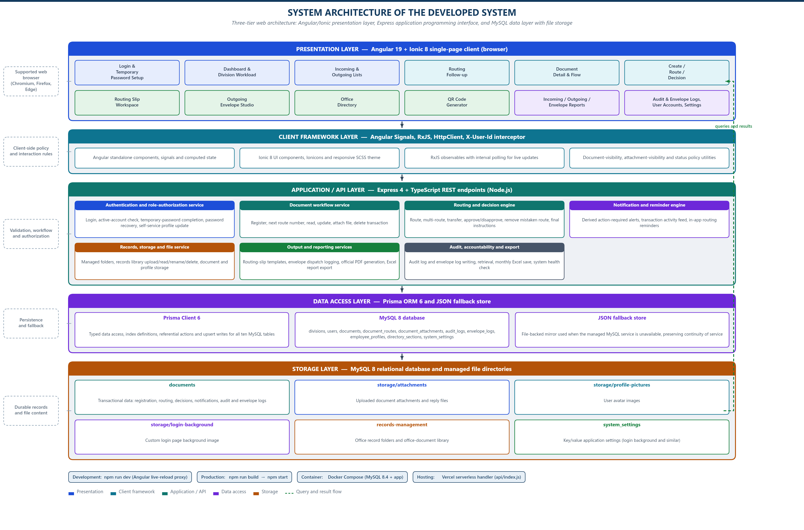
Figure . System Architecture of the Developed System
The architecture separates the browser from the rules on purpose. Because every status transition, permission check, and number-assignment rule is enforced in the application layer, the system behaves identically whether it is reached through the interface or through a direct request, and the interface cannot become a substitute for authorization.

3.3 Use-Case Diagram
Figure 4 identifies the seven roles implemented in the system, the fifteen administrative views, and the operations available to each. The actors are grouped by function rather than by name, so that the diagram remains readable when the office changes its staffing. Each include relationship denotes a subordinate use case that is completed as part of the base operation; each extend relationship denotes an optional action.

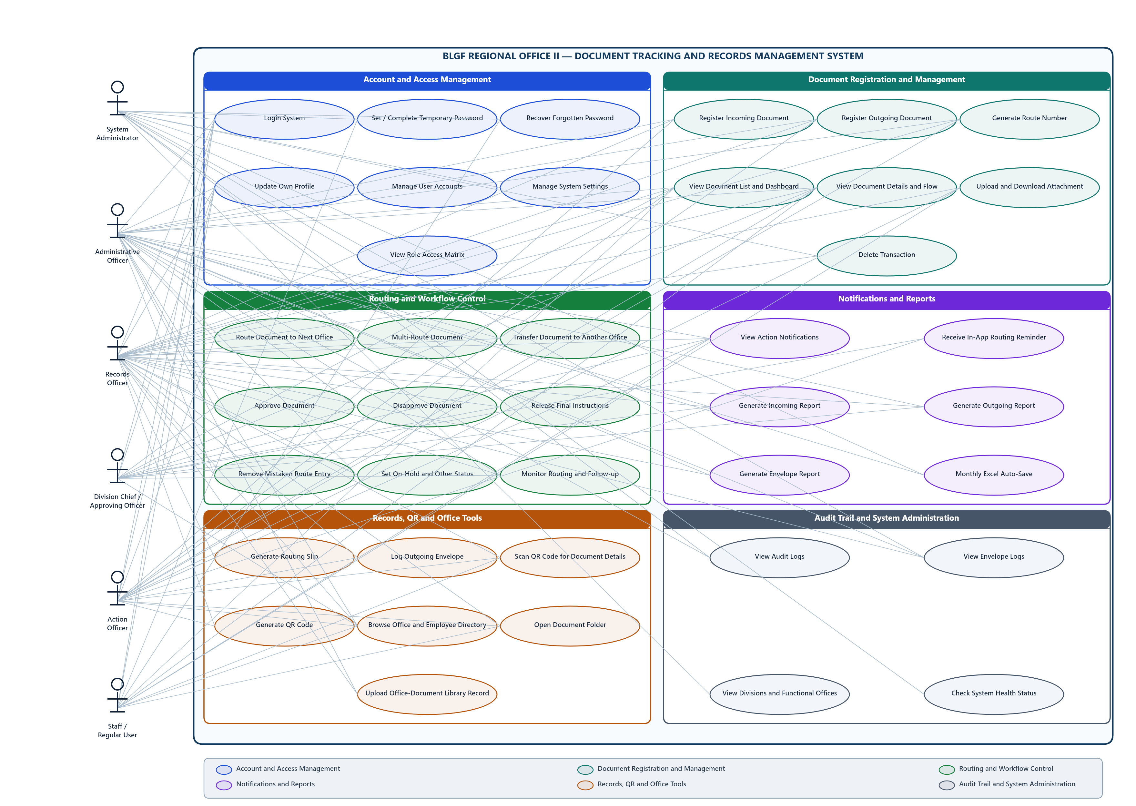
Figure . Use-Case Diagram of the Developed System

3.4 Context-Level Data Flow Diagram
Figure 5 represents the system as a single process with its external entities. The central process receives document data, employee and division data, user-account and role data, uploaded files, and configurable option values. It returns document records, routing history, lists, reports, notifications, printed output, and audit entries. Records personnel and the records office are shown separately from division personnel because the volume and kind of interaction differ, and the system administrator is shown separately because configuration and account functions are not part of the document transaction.

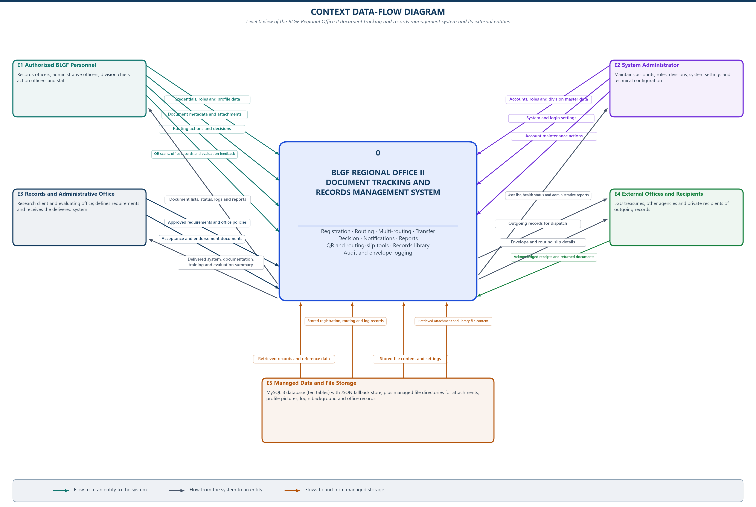
Figure . Context-Level Data Flow Diagram of the Developed System

3.5 Software and Hardware Requirements
Table . Minimum and Recommended Hardware Requirements
Category | Minimum / Required | Recommended
Client hardware | Dual-core processor, 4 GB RAM, 1366 x 768 display | Multi-core processor, 8 GB or more RAM, full HD display
Server hardware | 4-core processor, 8 GB RAM, 20 GB free storage | 8-core processor, 16 GB RAM, SSD storage sized for attachments and backups
Network | IEEE 802.3 wired LAN, 10 Mbps shared | IEEE 802.3 switched LAN, 100 Mbps or better, with reliable internet for email
Server operating system | Linux, Windows Server, or a container host with Docker | Containerised Linux host with scheduled backup

Table . Software Requirements
Layer | Technology and Version | Purpose
Presentation | Angular 19.2 with Ionic 8.5, TypeScript | Single-page client, routing, reactive forms, responsive and dark-mode interface
Client build | Angular CLI and esbuild-based bundling | Development server and optimized production bundles
Application server | Node.js with Express 4.21, TypeScript | JSON API, validation, authentication, workflow rules, file handling
Relational store | MySQL 8.4 | Persistent storage of documents, routing, attachments, users, divisions, and logs
Data access | Prisma 6.19 ORM | Typed access and schema definition for the relational store
Fallback store | JSON file persistence | Local operation when MySQL is unavailable; reconciled on synchronization
File handling | Multer | Multipart upload of attachments and record files
Mail | Nodemailer | Dispatch notices and routing reminders
Output | Server-side PDF generation and browser print views | Routing slips, official documents, and envelope records
Deployment | Docker and Docker Compose behind a reverse proxy | TLS termination, process supervision, and environment configuration
Quality model | ISO/IEC 25010 | Basis for the evaluation instrument in Section 3.7

The versions stated above are those implemented in the repository under study. Because the stack is containerised and configured through environment variables, the deployed server may substitute a compatible version without altering the application logic; any such substitution should be recorded, because Section 4.3 reports conformance against the delivered configuration. Two architectural choices in Table 2 are worth naming here because they shaped the data layer rather than the interface. The use of a relational store with a typed object-relational mapper, rather than direct driver access, was adopted so that the schema has a single declarative origin and referential behaviour is expressed once rather than in every query (Kleppmann, 2017). The separation of the application server from the persistence replica, with a JSON fallback reconciled on synchronization, follows the same incremental-delivery reasoning applied to the development process: each tier could be exercised independently before the whole was assembled (Humble & Farley, 2020).

3.6 Respondents of the Study
The respondents are the authorized BLGF Region II personnel who use or administer the system and who may be asked to rate it. Because the office has not yet designated respondents, the researcher does not name individuals here; the actual distribution is recorded in the endorsement and in the pilot-testing request in Appendix B.
Respondents are classified functionally rather than by name so that the instrument can be administered proportionally to how the system is used, as shown in Table 3.
Table . Respondent Classification and Instrument Coverage
Respondent Group | System Role | Share of Instrument | Basis
Records and administrative personnel | RECORDS_OFFICER, ORD | Highest weighting | They perform registration, routing, and dispatch and encounter the workflow most directly.
Division chiefs | DIVISION_CHIEF | Moderate weighting | They approve, monitor, and are affected by turnaround and visibility.
Action officers and staff | ACTION_OFFICER, STAFF | Moderate weighting | They receive documents, act on them, and use attachments and notifications.
System administrators | SYSTEM_ADMIN | Moderate weighting | They manage accounts, roles, divisions, storage, and exports.
Administrative officers | ADMIN | Lower weighting | They oversee operations without management-menu access.

Distribution follows these weightings and is recorded with the administered copies. No response data is reported in this study because the instrument has not yet been administered; Section 4.3 states this explicitly rather than presenting an unearned result.

3.7 Research Instrument
Two instruments were used. The first is a researcher-administered functional test sheet, in which each delivered module is exercised against the expected behavior recorded in Section 4.2, and the outcome of each check is recorded as pass or fail with the observed response. This instrument supports claims about what the system does and supports the functional-suitability, maintainability, and flexibility findings, because it observes the delivered artifact rather than asking anyone's opinion.
The second is a structured questionnaire addressed to the respondents in Table 3, constructed from the ISO/IEC 25010 product-quality characteristics. Because ISO/IEC 25010:2023 defines eight characteristics and each is subdivided into sub-characteristics that are not equally applicable to a departmental web application, the instrument maps each sub-characteristic either to an item rated on a five-point Likert scale or to an exclusion with a stated reason. Functional suitability, compatibility, interaction capability, and reliability are rated directly. Performance efficiency is rated by the respondent on observed experience and is corroborated by the timing measurements described below. Maintainability, security, and flexibility are rated by those respondents who can observe them, namely the administrators, and are excluded for respondents who cannot.
The instrument also includes open-ended items for problems encountered and for recommended improvements, and demographic items limited to role and division so that no respondent is identifiable. The full instrument is reproduced in Appendix D. Before administration the instrument is subjected to a pilot test with a small number of personnel, and only then is it released; the pilot-testing request is in Appendix B.
The companion timing procedure measures elapsed time for a defined set of tasks, namely registering an incoming document, routing a document to one recipient, routing a document to multiple recipients, recording a decision, transferring custody, and locating a document by tracking number from the list and from the QR code. Each task is performed a stated number of times and the elapsed times are recorded, because turnaround and retrieval claims cannot be supported by perception alone. No timing figure is reported in this study because the procedure has not yet been run; Section 4.3.5 records this as outstanding.

3.8 Locale of the Study
The study was conducted at the Regional Bureau of Local Government Finance Region II office in Carig, Tuguegarao City, Cagayan, with development and document preparation performed at Cagayan State University, Carig Campus, Tuguegarao City. The office locale was selected because it is the agency whose document workflow was automated and the agency whose personnel are the intended users. The university locale was used for the study proper because it provides the research guidance, the library and internet access needed for the review of related literature, and the administrative supervision required for a thesis.
The setting is relevant to the findings rather than incidental to them. A regional line agency in a second-level administrative area has a comparatively small staff, limited administrative positions, and no delegated records-disposition authority, which is why the study treats configuration as a controlled feature and treats disposition and retention as out of scope. Access is by authenticated office account over the local area network, and no public-facing portal was provided.

3.9 Data Gathering
Data were gathered in four ways, and each source is used only for the claims it can support.
- Document and workflow documentation. The existing logbooks, routing slips, and document forms were examined to establish the practices described in Section 4.1 and the requirements in Sections 1.4 and 4.2. Requests to examine these records are in Appendix A.
- Structured interviews. Personnel from records, division, and administration functions were interviewed to establish the sequence of registration, routing, receipt, action, and completion, and to identify the points at which tracking was lost. Interviews informed requirements and are cited as such; they are not presented as measured outcomes.
- Functional and access-control testing. The researcher exercised each delivered module and each of the seven role definitions against the behaviors recorded in Section 4.2, and recorded the outcome of every check. This is the source for the conformance findings in Section 4.3.
- ISO/IEC 25010 questionnaire and task timing. These are administered to the respondents in Table 3 following the pilot test, and are the source for the perception findings and the timing measurements. This step has not been completed at the time of writing.
Data integrity measures were applied throughout. Every claim about system behavior was checked against the running application rather than against the source code alone. Every field description in Section 4.2.3 was taken from the database schema definition and cross-checked against the runtime code that creates the table. No value in this study was estimated, and where a measurement does not exist the corresponding section says so.

3.10 Data Analysis
The analysis is descriptive, and each technique is tied to the instrument that produced its data.
- Frequency and percentage are used for the respondent profile and for the distribution of responses to each questionnaire item, reported per ISO/IEC 25010 characteristic.
- Weighted mean is computed per characteristic from the five-point scale, with the interpretation bands stated alongside each result, so that a rating is not reported without its meaning.
- Qualitative thematic grouping is applied to the open-ended items on encountered problems and recommended improvements, and themes are reported with the number of respondents raising each, so that the prominence of a theme is traceable.
- Functional test results are reported as a count of checks passed against checks executed per module, together with the identity of any failing check, rather than as a percentage that would imply a level of precision the exercise does not support.
- Task timings are reported as the recorded range and median for each task, with the number of repetitions stated.
Because no questionnaire responses have been collected, this study reports no weighted mean, no response distribution, and no acceptance rate. Section 4.3 instead reports the technical and inspection evidence that is available and marks each perception-based characteristic as awaiting measurement, with the instrument and the procedure ready for administration.

CHAPTER IV. RESULTS AND DISCUSSIONS

4.1 Problems Encountered in the Existing System
The existing process was documented through the logbooks, routing slips, and document forms of BLGF Region II and through structured interviews with records, division, and administration personnel, as described in Section 3.9. The problems below are reported as observed. Each is stated together with the consequence observed, because a problem that produces no operational effect would not justify an application feature.
Table . Problems Observed in the Existing Process
No. | Observed condition | Operational consequence | Feature that addresses it
1 | Document location is confirmed by locating the paper or by asking the holder. | Answering where a document is depends on the holder being reachable, and an unanswered request leaves the document unlocated. | Central document list and dashboard, searchable by tracking number, status, direction, and priority.
2 | A routing reference exists but can be altered or reused when a paper is endorsed outside the originating office. | The numbering no longer identifies one document, so history and accountability become unreliable. | Permanent tracking number never reissued, controlled route-number pattern, and server-side rejection of duplicates.
3 | Movement is recorded on the paper itself. | The history exists only where the paper is, so a lost or misfiled document also loses its history. | A document_routes row per movement, retained independently of the paper.
4 | Completion is confirmed verbally or by returning the paper. | There is no record that the requested action was completed, or when. | Decision, transfer, and completion actions that set the status and write a routing row with status before and after.
5 | Pending work is known only to the person holding it. | Work that stalls is not visible to the office, so it cannot be followed up. | Notifications derived from logs and routes, plus a Routing Follow-up view showing elapsed time against the target date.
6 | Attachments travel separately from the document record. | A supporting file cannot be tied to the document or to the step that required it. | Attachments linked to a document and optionally to a specific routing step.
7 | Report preparation is manual and is recompiled each time. | Reporting consumes staff time and different compilers produce different totals. | Incoming, outgoing, and envelope reports computed from the stored records.
8 | A paper-based trail does not record who accessed or altered what. | Disputes and irregularities cannot be investigated after the fact. | audit_logs and envelope_logs capturing account, name, role, action, tracking number, detail, network address, and time.
9 | Printing and physical preparation of slips and envelopes are repetitive. | Slip and envelope preparation is slow and inconsistent between operators. | Routing Slip and Outgoing Envelope views that produce the printable output from stored data.
10 | Personnel and office details are held in separate lists. | Recipients must be looked up before routing, and directory data drifts. | Office Directory with employee profiles, office-type groupings, and employee folders.

Two conditions were observed but deliberately not solved. First, the office has no delegated authority to approve records disposition, so the system records and retains history but never disposes of it. Second, documents handed to another agency leave the office's control at the point of handoff; the system records the sending office's portion and cannot record what happens afterwards. Both are stated as delimitations in Section 1.5 rather than presented as solved.

4.2 The Developed System
The developed system is a web application that centralizes the document lifecycle of BLGF Region II. The remainder of this section describes it in the order prescribed by the methodology: the hierarchical decomposition, the detailed input-process-output, the data model, the user's view, and the table design.

4.2.1 Hierarchical Input-Process-Output (HIPO)
Figure 6 presents the hierarchical decomposition. Level 0 states the system as a whole: it receives document, personnel, account, and configuration data, processes the document lifecycle and the supporting records, and produces registered documents, routing histories, notifications, printable output, reports, and logs. Level 1 divides the system into the four modules that carry distinct responsibilities: document management, directory and personnel, dispatch and printing, and administration and reporting. Level 2 further divides each of these into the routines the user actually invokes. The Level 2 input-process-output table beneath the diagram states the routine, its inputs, its processes, and its outputs.
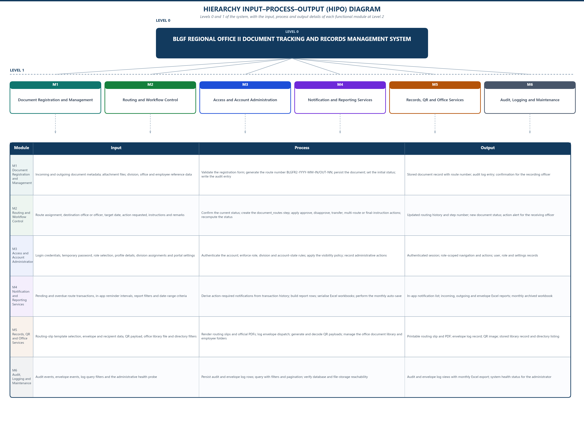
Figure . Hierarchical Input-Process-Output Diagram of the Developed System
The decomposition follows the office's own vocabulary rather than the interface's. A document is registered, routed, received, acted upon, transferred, and completed; the modules exist to serve those steps, and a module was added only where a distinct set of responsibilities existed. This is why the office directory and the employee folder manager are separate modules, while the incoming and outgoing lists share one component: they differ only by a direction filter, and separating them would have duplicated the workflow without adding a capability.

4.2.2 Input-Process-Output (IPO) Diagram
Figure 7 expands the Level 2 routines and states, for each, the input that triggers it, the processing rule it applies, the output it produces, and the tables it affects. The fourteen routines are the complete set of user-invocable operations, so the figure also serves as a completeness check against the module inventory in Table 9: every routine in Figure 7 belongs to a module in Table 9, and every module in Table 9 appears in Figure 7.
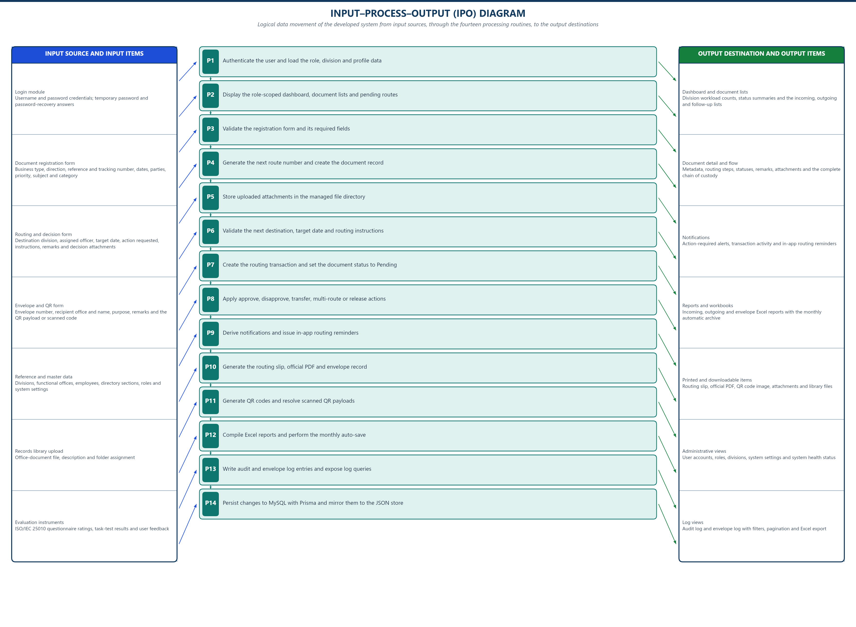
Figure . Input-Process-Output Diagram of the Developed System
The figure records which routines write. Registration writes to documents; routing, multi-routing, transfer, and decision write to documents and to document_routes; attachment upload writes to document_attachments; account and division administration write to users and divisions; and every administrative action writes to audit_logs. A user can therefore trace any change to the document record back to the routine that caused it and from there to the log entry that recorded it.

4.2.3 Entity Relationship Diagram (ERD)
The entity relationship diagram appears as Figure 8 within Section 4.2.3.2.1, with the data environment it describes. It is presented there rather than here because the diagram, the data environment statement, the data entry description, and the data description are one argument: the entity set, where it exists, how it is populated, and what each field means. Placing the figure immediately before those statements avoids restating the same fields twice.
The user's view describes each module as the user encounters it: what the module is for, who can reach it, what can be done in it, which interface operations serve it, and what it reads and writes. It is written from the interface outward rather than from the code inward, because the point of the section is to establish what the system offers a user.
Table . Modules of the Developed System
No. | Module | Component | Purpose
1 | Dashboard | pages/dashboard/dashboard.component | Presents an operational overview of the signed-in user: documents by status, counts by direction and priority, pending items, workload indicators, and recent activity.
2 | Incoming Documents | pages/document-list/document-list.component | Lists documents whose direction is INCOMING, with search, status and priority filters, and per-document actions for routing, transfer, decision, and completion.
3 | Outgoing Documents | pages/document-list/document-list.component | Same list component filtered to direction OUTGOING, used for documents the office releases to external or higher offices.
4 | Routing Follow-up | pages/routing-follow-up/routing-follow-up.component | Monitoring view for documents still inside the routing chain, showing elapsed time against the target completion date and the current holder.
5 | Document Routing Slip | pages/routing-slip/routing-slip.component | Generates the printable routing slip for a document, showing the routing sequence, parties, dates, and a scannable code.
6 | Outgoing Envelope | pages/outgoing-envelope/outgoing-envelope.component | Records the dispatch of outgoing documents through an envelope, capturing courier or receiver details and producing the printable envelope record.
7 | Office Directory | pages/employee-profiles/employee-profiles.component | Provides a searchable directory of BLGF personnel, LGU counterparts, and other offices, grouped by configurable sections, with per-employee folder links.
8 | QR Code Generator | pages/qr-code-generator/qr-code-generator.component | Produces machine-readable codes that identify a document or routing slip, allowing a physical document to be located from its digital identity.
9 | Incoming Report | pages/reports/incoming-report.component | Produces the incoming-document report for a selected period and filter set.
10 | Outgoing Report | pages/reports/outgoing-report.component | Produces the outgoing-document report for a selected period and filter set.
11 | Envelope Report | pages/reports/envelope-report.component | Produces the report of outgoing envelopes dispatched within a selected period.
12 | User Accounts | pages/user-management/user-management.component | Creates and maintains system accounts, assigns roles and divisions, sets account status, and initiates password resets.
13 | Audit Logs | pages/audit-logs/audit-logs.component | Displays the chronological record of user and system activity, with filters on actor, action, and tracking number.
14 | Envelope Dispatch Logs | pages/audit-logs/audit-logs.component | Displays the separate record of outgoing-envelope dispatch events.
15 | User Settings | pages/user-settings/user-settings.component | Allows the signed-in user to review the account, complete the forced password setup, change the password, and adjust interface preferences such as the login background and theme.

4.2.3.1 Module 1: Dashboard
Purpose. Presents an operational overview of the signed-in user: documents by status, counts by direction and priority, pending items, workload indicators, and recent activity.
Access. All roles (dashboard is in every allowedViews list).
Operations. View summary counts; Navigate to filtered lists; Open notifications.
Interface operations. GET /api/stats; GET /api/notifications; GET /api/documents.
Data environment. Reads documents, document_routes, and users aggregates. Writes nothing.
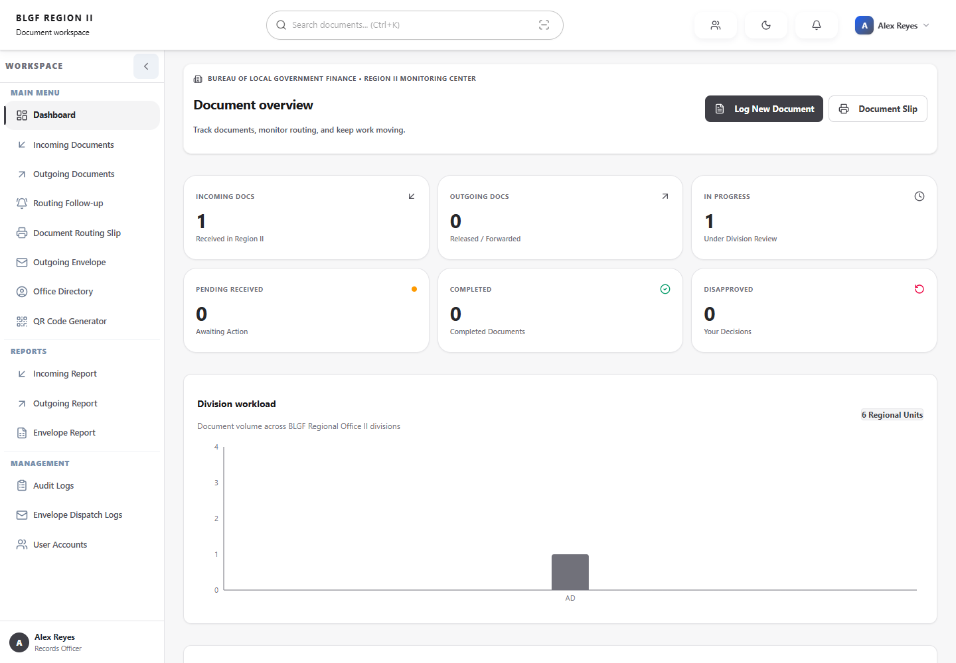
Figure . 1 Dashboard Interface (dashboard)
4.2.3.1 Module 2: Incoming Documents
Purpose. Lists documents whose direction is INCOMING, with search, status and priority filters, and per-document actions for routing, transfer, decision, and completion.
Access. All roles; rows are filtered by personal document visibility.
Operations. Search and filter; Register new document; Route; Transfer; Record decision; Complete; Attach file; Print slip; Delete or cancel.
Interface operations. GET /api/documents; GET /api/documents/:id; GET /api/documents/next-route-number; POST /api/documents; POST /api/documents/:id/route; POST /api/documents/:id/multi-route; POST /api/documents/:id/transfer; POST /api/documents/:id/decision; POST /api/documents/:id/attachments; PATCH /api/documents/:id/final-instructions; DELETE /api/documents/:id/routes/:routeId; DELETE /api/documents/:id.
Data environment. Reads documents joined with document_routes and users. Writes documents, document_routes, document_attachments, and audit_logs.
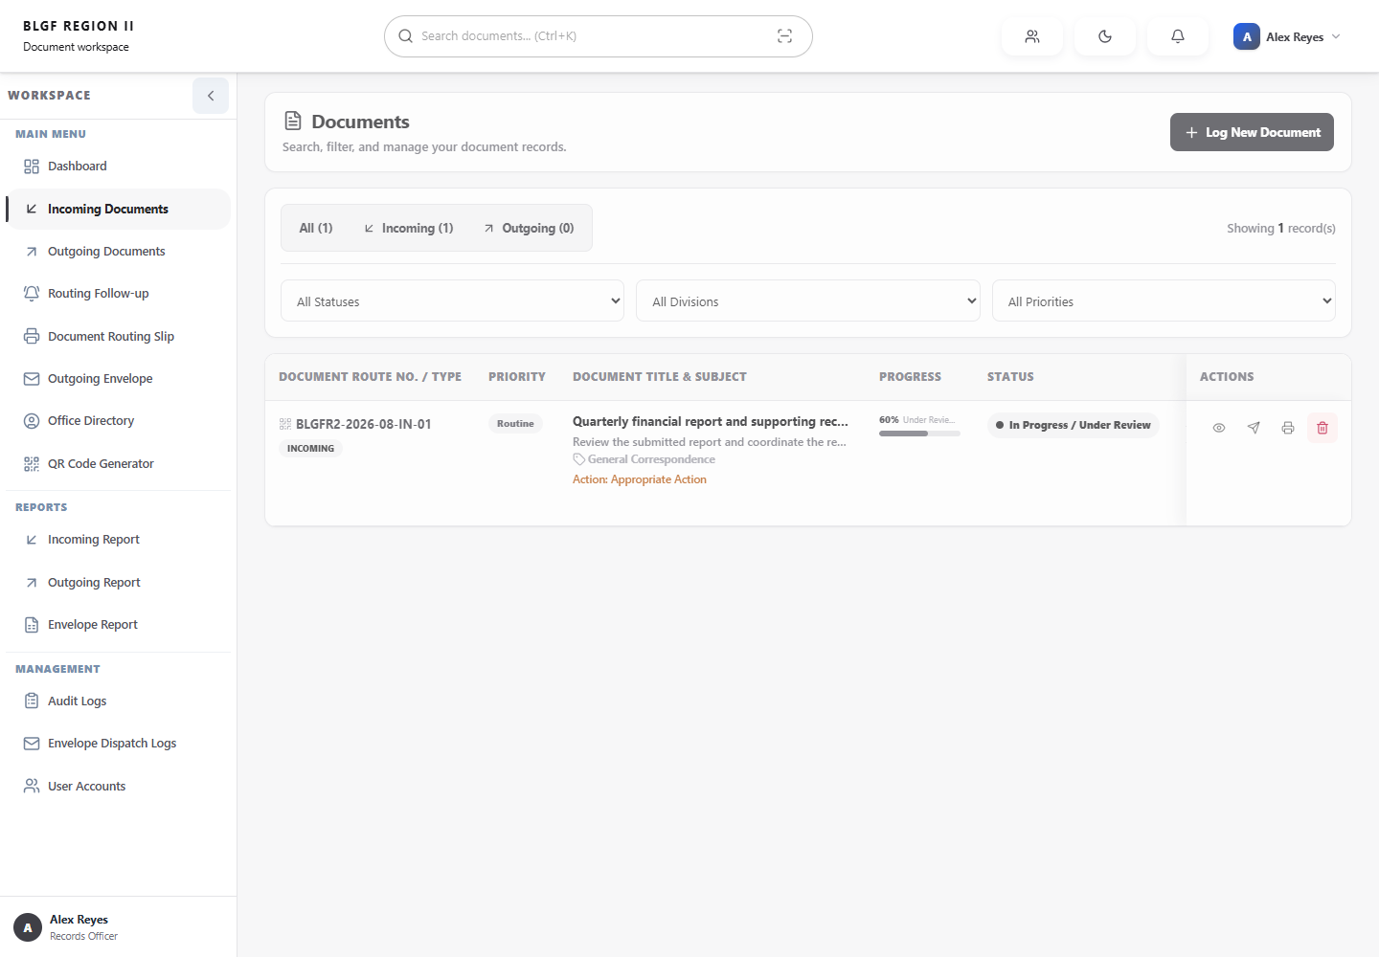
Figure . 2 Incoming Documents Interface (documents)
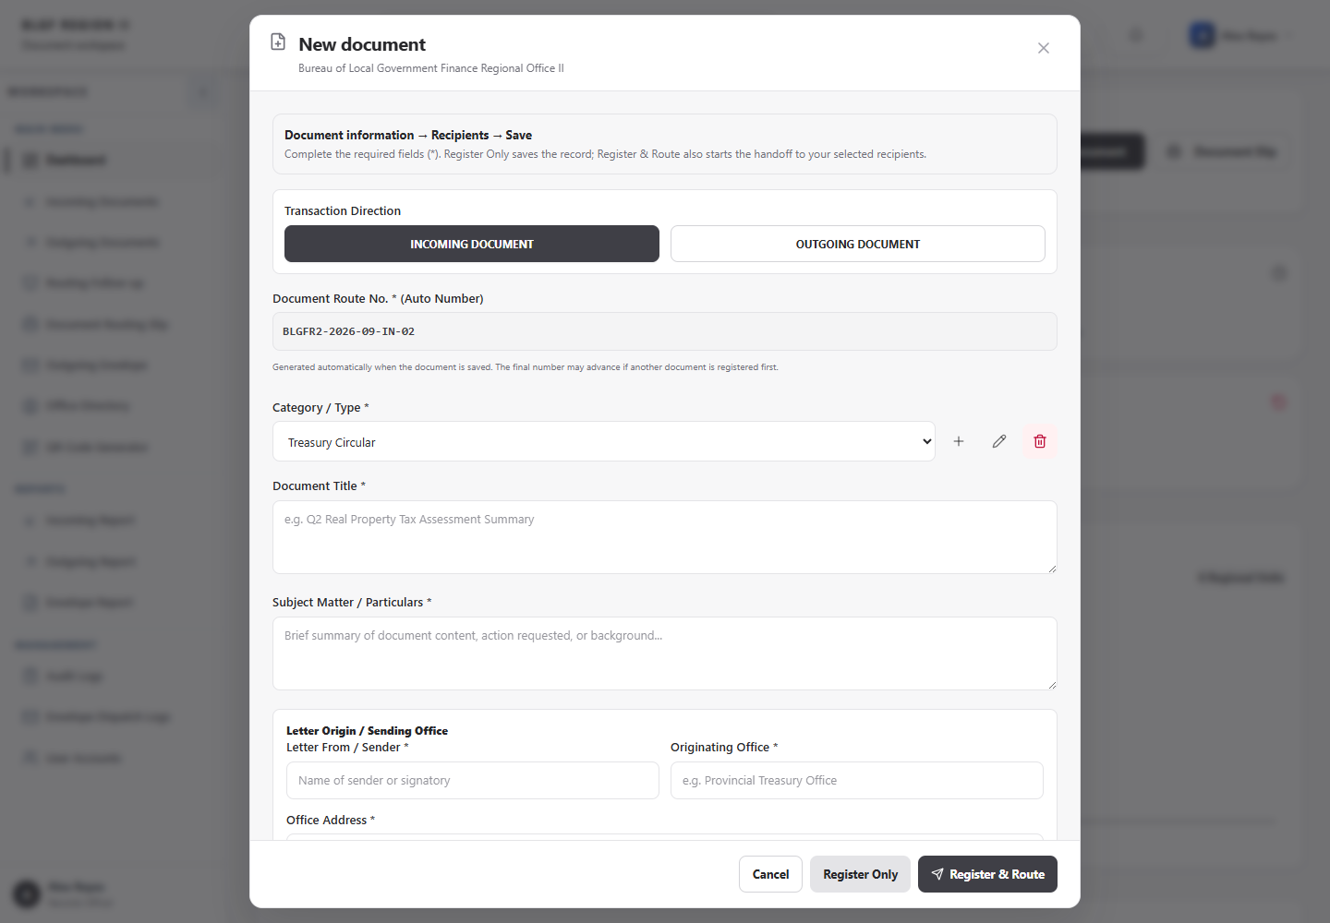
Figure . 2 Incoming Documents Interface (new document)
4.2.3.1 Module 3: Outgoing Documents
Purpose. Same list component filtered to direction OUTGOING, used for documents the office releases to external or higher offices.
Access. All roles; rows filtered by personal document visibility.
Operations. Search and filter; Route onward; Transfer; Complete or release; Attach file; Print slip.
Interface operations. GET /api/documents; POST /api/documents/:id/route; POST /api/documents/:id/decision.
Data environment. Reads and writes the same tables as the Incoming Documents module.
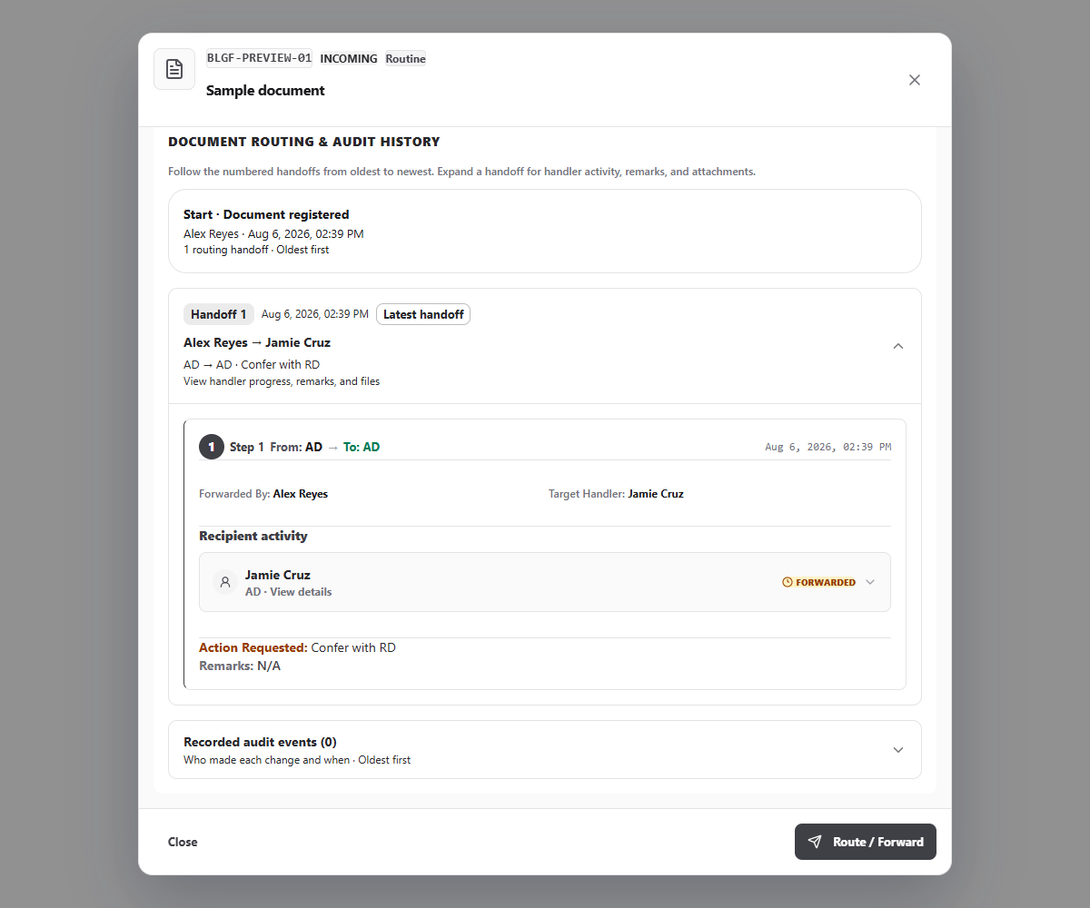
Figure . 3 Outgoing Documents Interface (simple flow)
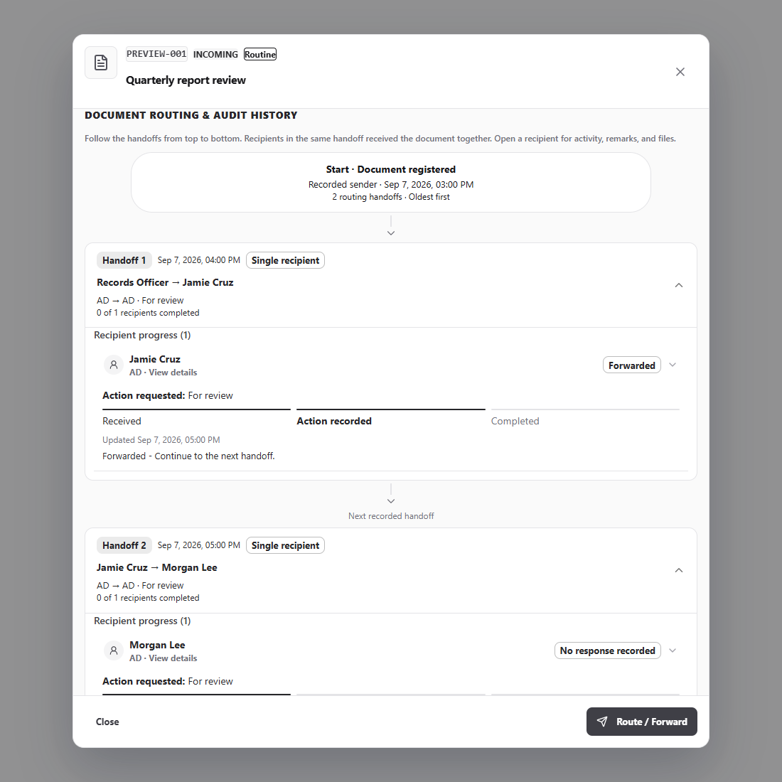
Figure . 3 Outgoing Documents Interface (vertical flow)
4.2.3.1 Module 4: Routing Follow-up
Purpose. Monitoring view for documents still inside the routing chain, showing elapsed time against the target completion date and the current holder.
Access. Roles holding ROUTING_MONITOR_VIEW: SYSTEM_ADMIN, ORD, RECORDS_OFFICER, DIVISION_CHIEF.
Operations. Review stalled items; Send routing reminder; Open document detail.
Interface operations. GET /api/documents; POST /api/notifications/reminder.
Data environment. Reads documents, document_routes, and users. Writes audit_logs and, when a reminder is sent, notification-related activity.
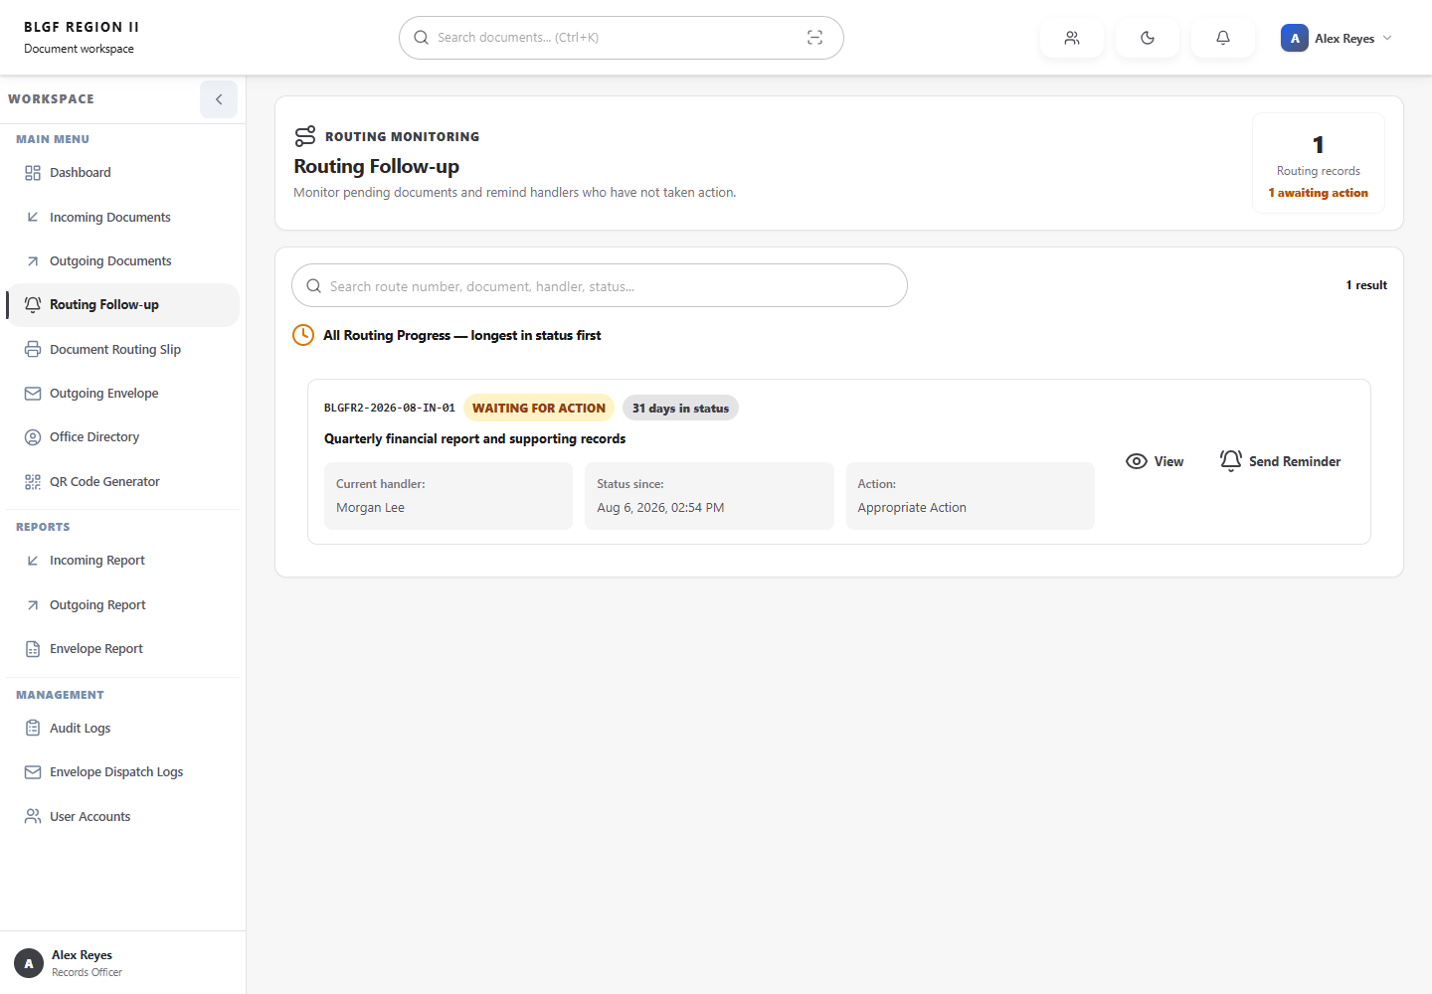
Figure . 4 Routing Follow-up Interface (monitoring)
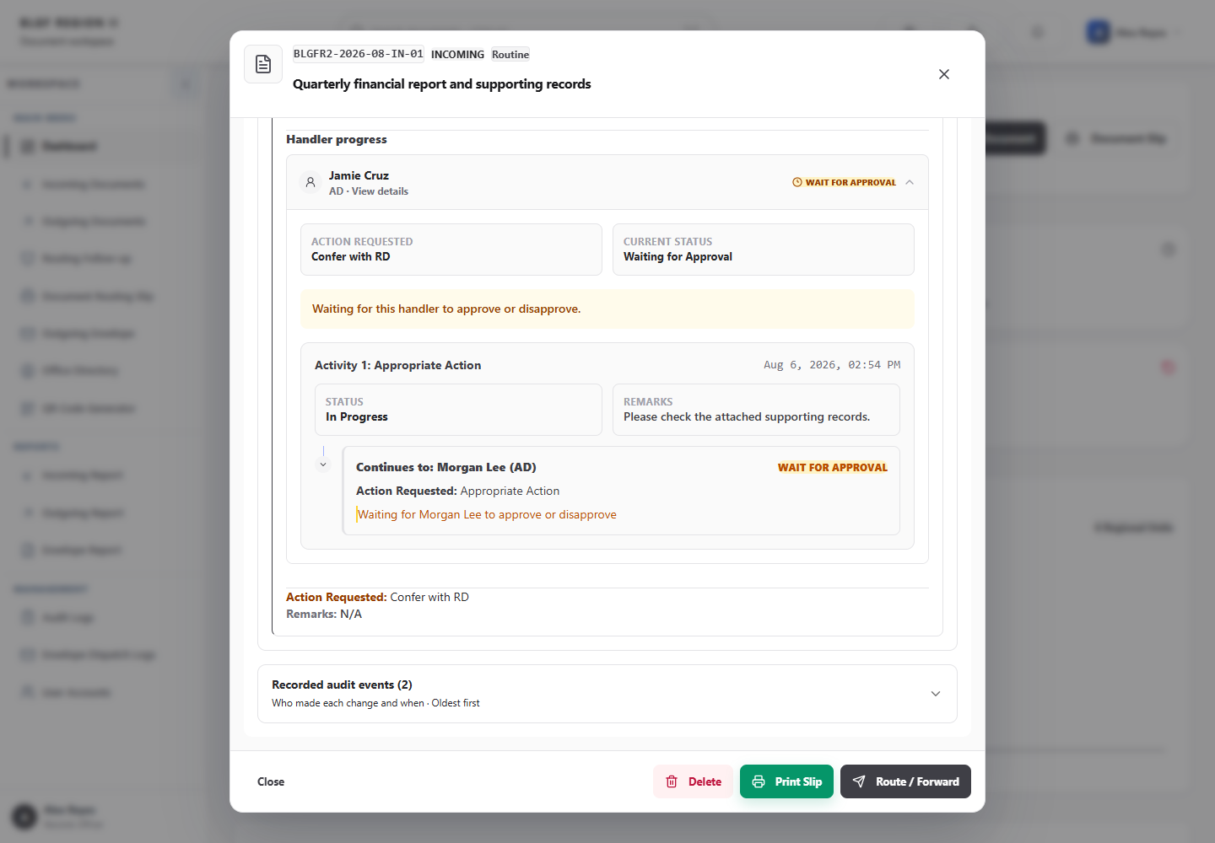
Figure . 4 Routing Follow-up Interface (handler history)
4.2.3.1 Module 5: Document Routing Slip
Purpose. Generates the printable routing slip for a document, showing the routing sequence, parties, dates, and a scannable code.
Access. All roles with access to the document.
Operations. Select document; Preview slip; Print or export.
Interface operations. GET /api/documents/:id; GET /api/documents/next-route-number.
Data environment. Read-only over documents and document_routes; produced in the browser for printing.
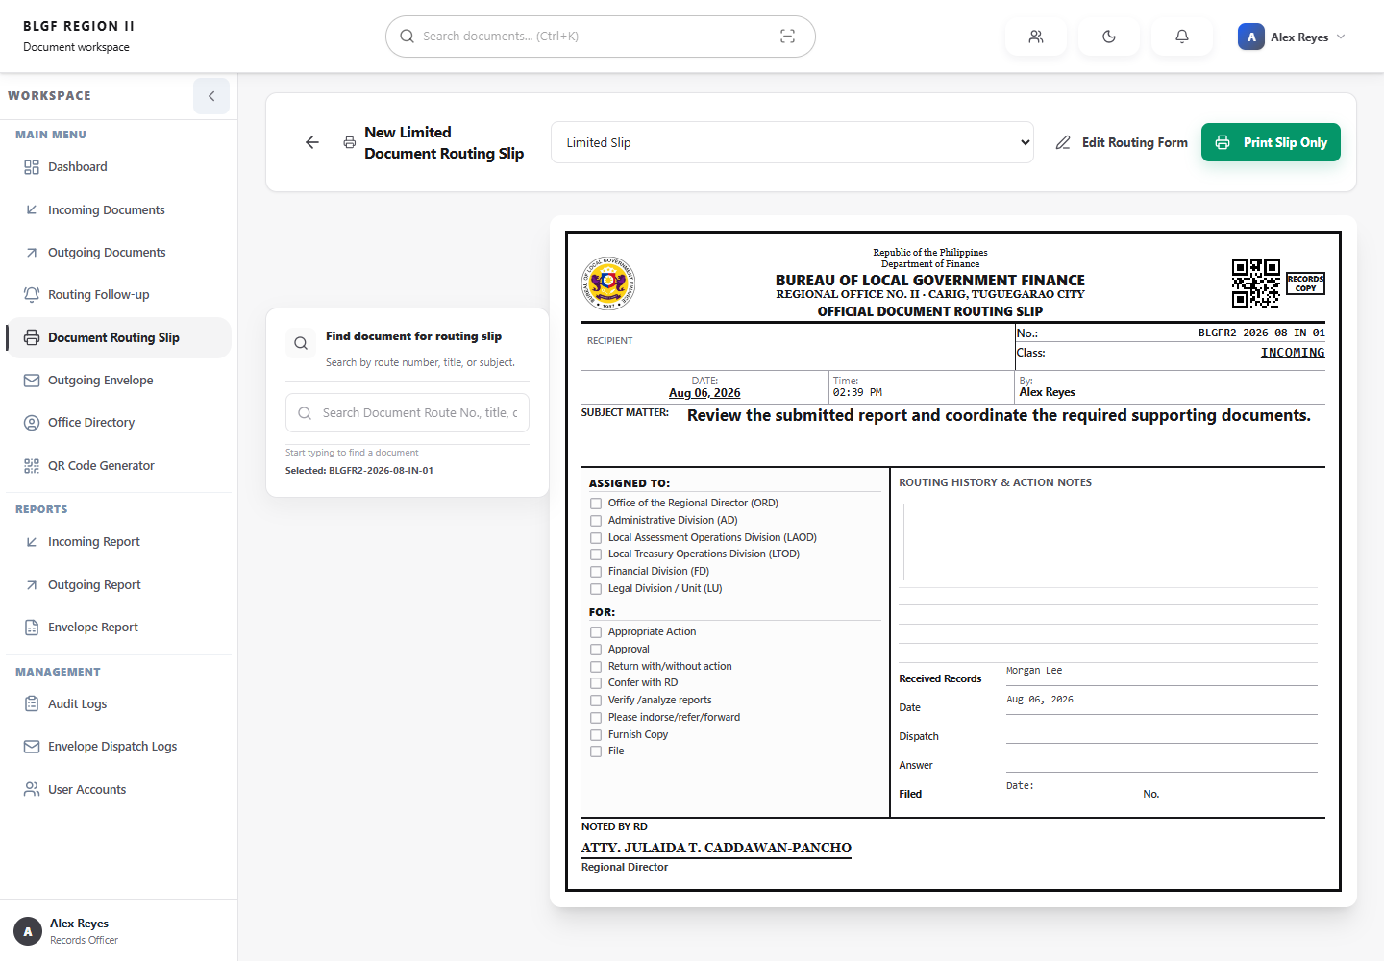
Figure . 5 Document Routing Slip Interface (slip)
4.2.3.1 Module 6: Outgoing Envelope
Purpose. Records the dispatch of outgoing documents through an envelope, capturing courier or receiver details and producing the printable envelope record.
Access. Roles with the envelope view in their allowed list.
Operations. Register dispatch; Record receiver; Print envelope record.
Interface operations. GET /api/documents; POST /api/envelope-logs; GET /api/envelope-logs.
Data environment. Reads documents and users; writes envelope_logs.
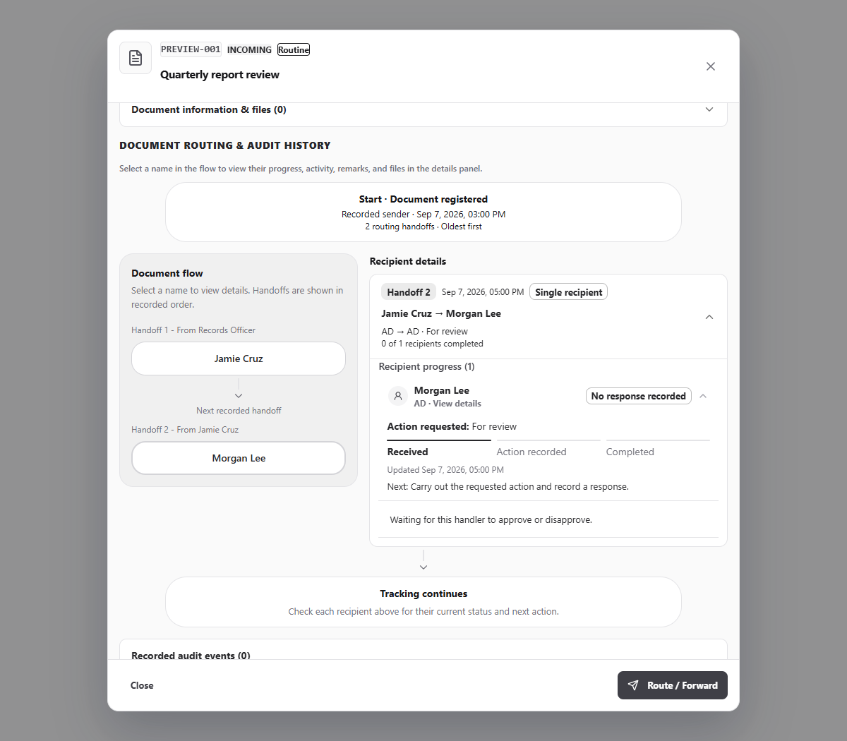
Figure . 6 Outgoing Envelope Interface (side flow)
4.2.3.1 Module 7: Office Directory
Purpose. Provides a searchable directory of BLGF personnel, LGU counterparts, and other offices, grouped by configurable sections, with per-employee folder links.
Access. All roles; content scope controlled by DIRECTORY_*_VIEW actions.
Operations. Search directory; Add or edit employee; Manage employee folders; Configure sections.
Interface operations. GET /api/employees; POST /api/employees; PUT /api/employees/:id; DELETE /api/employees/:id; GET /api/directory-sections; PUT /api/directory-sections.
Data environment. Reads employees and section configuration. Writes employee_profiles and directory_sections.
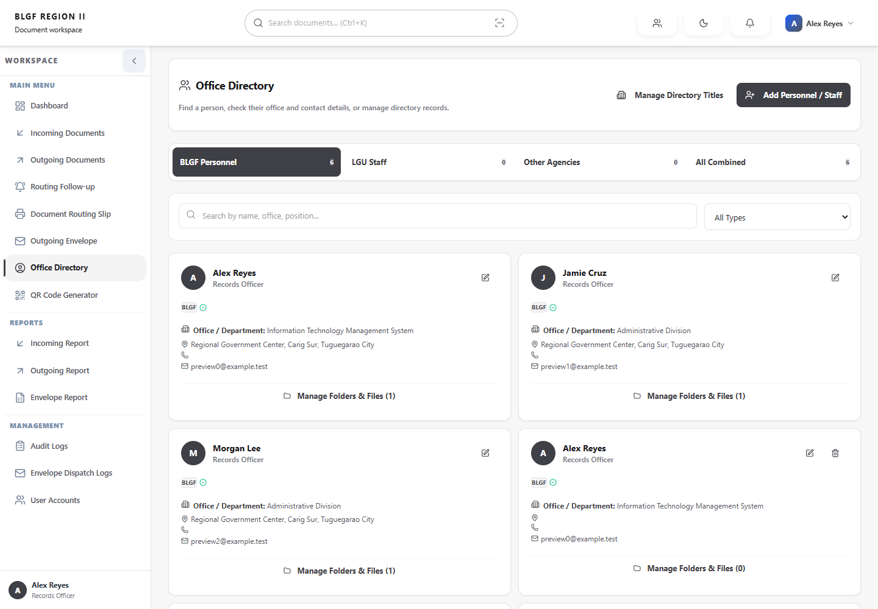
Figure . 7 Office Directory Interface (directory)
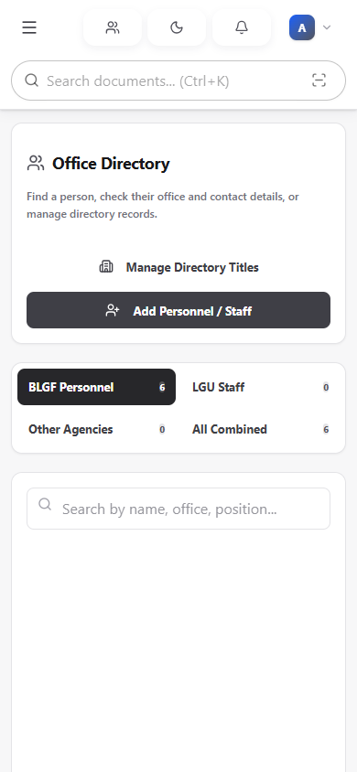
Figure . 7 Office Directory Interface (directory mobile)
4.2.3.1 Module 8: QR Code Generator
Purpose. Produces machine-readable codes that identify a document or routing slip, allowing a physical document to be located from its digital identity.
Access. All roles.
Operations. Enter document identifier; Generate code; Print or save code.
Interface operations. GET /api/documents/:id.
Data environment. Read-only over documents; code generation and rendering occur in the browser.
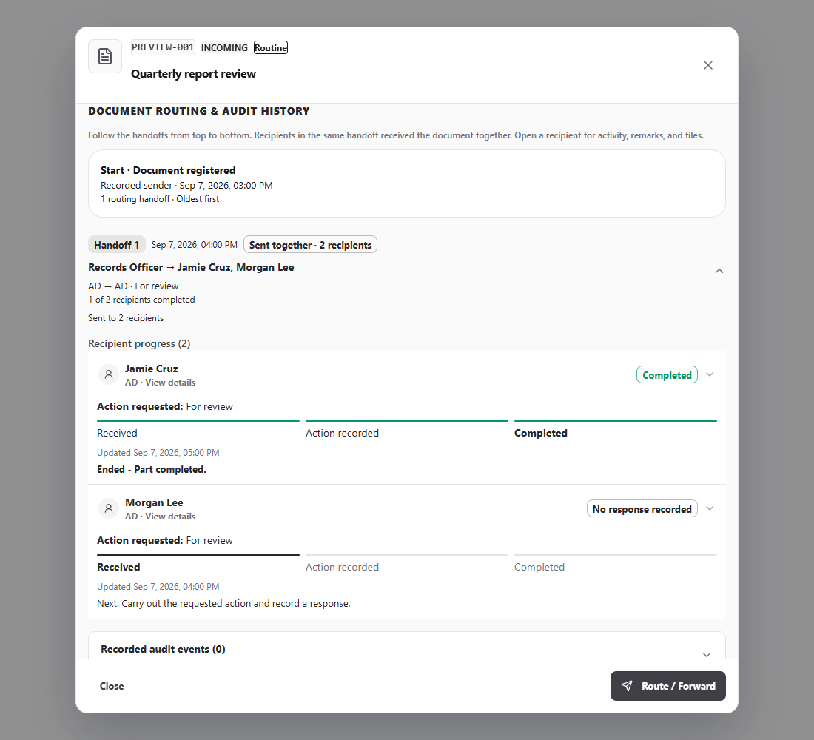
Figure . 8 QR Code Generator Interface (compact handoff)
4.2.3.1 Module 9: Incoming Report
Purpose. Produces the incoming-document report for a selected period and filter set.
Access. All roles, limited to documents visible to the user.
Operations. Set date range; Apply filters; Review totals; Print or export.
Interface operations. GET /api/documents; GET /api/stats.
Data environment. Read-only aggregation over documents and document_routes.
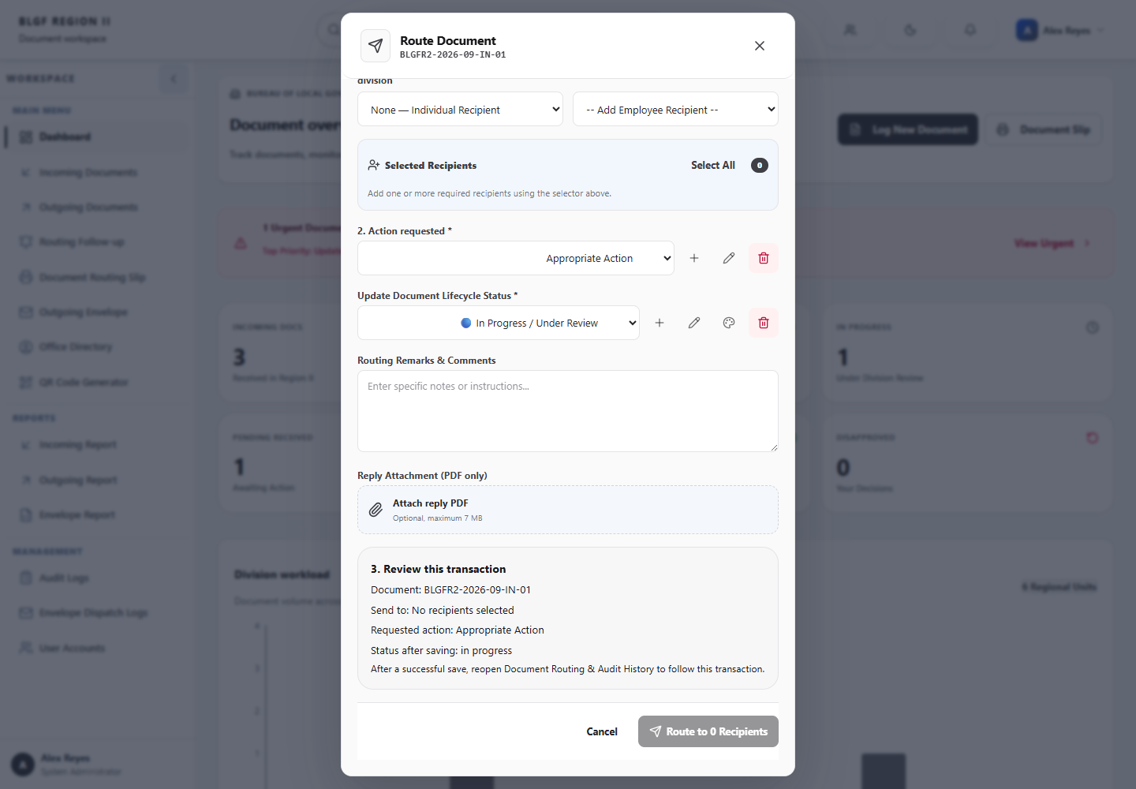
Figure . 9 Incoming Report Interface (transaction review)
4.2.3.1 Module 10: Outgoing Report
Purpose. Produces the outgoing-document report for a selected period and filter set.
Access. All roles, limited to documents visible to the user.
Operations. Set date range; Apply filters; Review totals; Print or export.
Interface operations. GET /api/documents; GET /api/stats.
Data environment. Read-only aggregation over documents and document_routes.
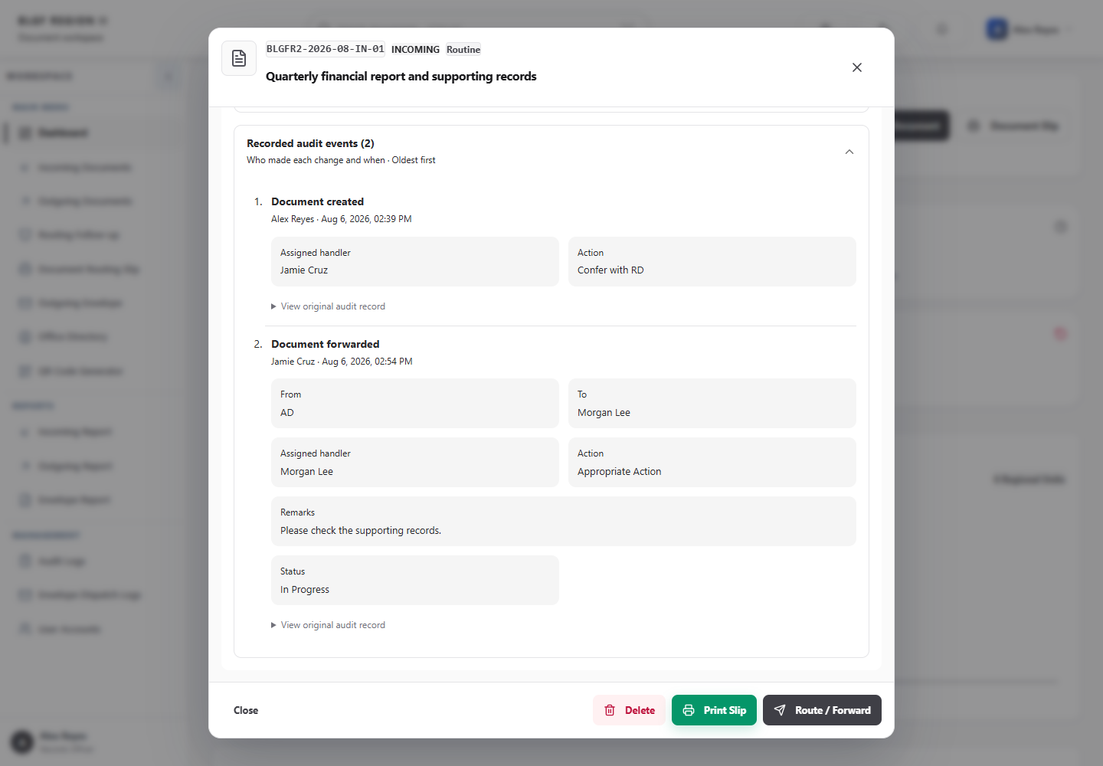
Figure . 10 Outgoing Report Interface (audit fields)
4.2.3.1 Module 11: Envelope Report
Purpose. Produces the report of outgoing envelopes dispatched within a selected period.
Access. Roles with the envelope-report view.
Operations. Set date range; Review dispatch entries; Print or export.
Interface operations. GET /api/envelope-logs; GET /api/documents.
Data environment. Read-only aggregation over envelope_logs and documents.
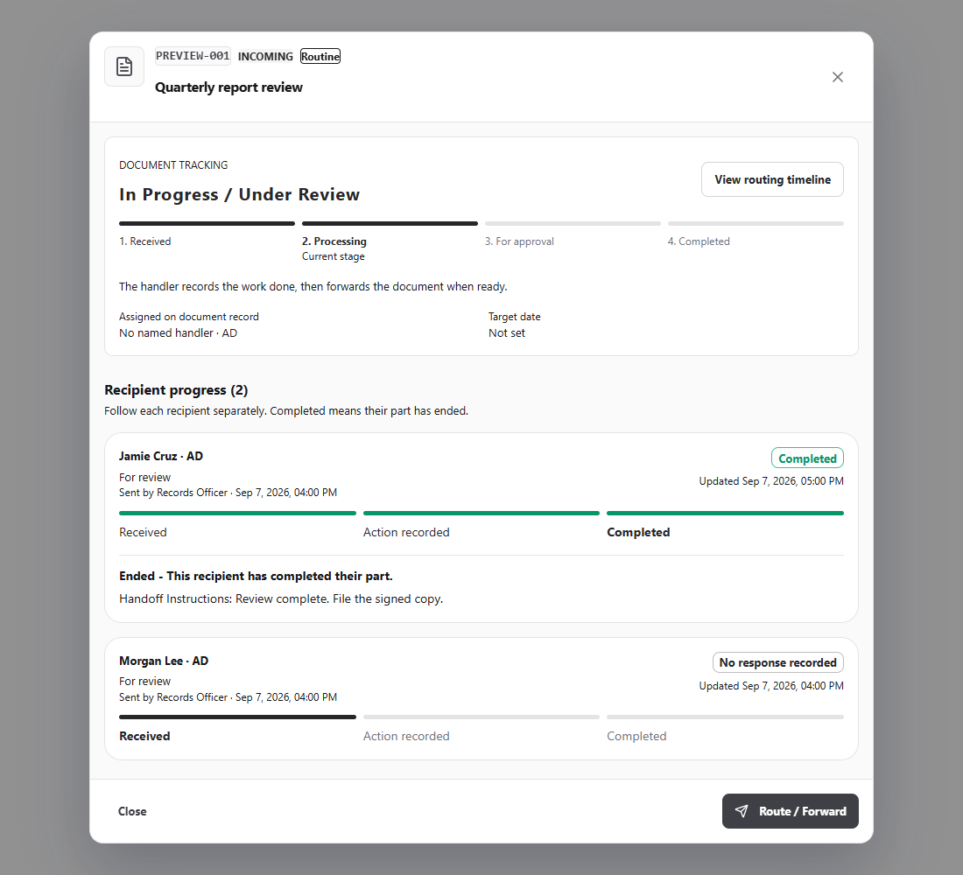
Figure . 11 Envelope Report Interface (recipient progress)
4.2.3.1 Module 12: User Accounts
Purpose. Creates and maintains system accounts, assigns roles and divisions, sets account status, and initiates password resets.
Access. SYSTEM_ADMIN only (adminOnly in the navigation definition).
Operations. Create account; Edit account; Reset password; Activate or deactivate; Delete account.
Interface operations. GET /api/users; POST /api/users; PUT /api/users/:id; POST /api/users/:id/reset-password; DELETE /api/users/:id.
Data environment. Reads users, divisions, and employee_profiles. Writes users, audit_logs, and the MySQL replica.
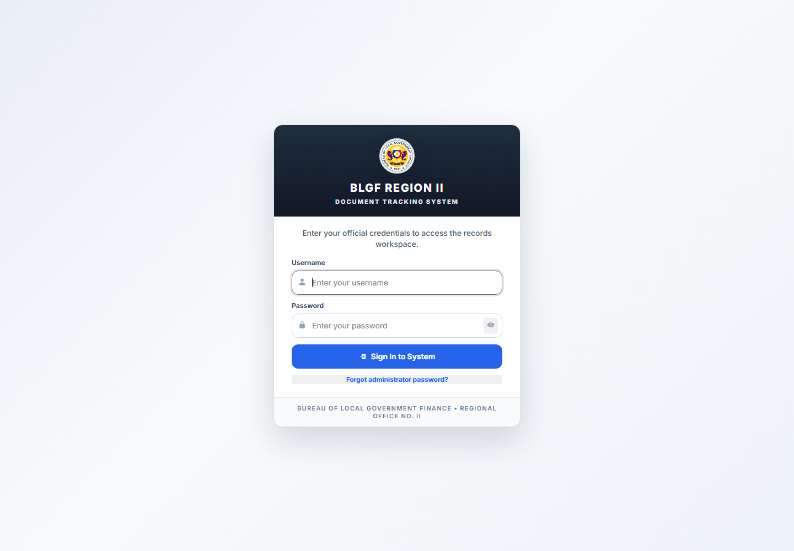
Figure . 12 User Accounts Interface (angular login restored)
4.2.3.1 Module 13: Audit Logs
Purpose. Displays the chronological record of user and system activity, with filters on actor, action, and tracking number.
Access. SYSTEM_ADMIN, ORD, RECORDS_OFFICER, DIVISION_CHIEF.
Operations. Filter logs; Inspect activity detail; Delete selected entries when authorized.
Interface operations. GET /api/audit-logs; POST /api/audit-logs; DELETE /api/audit-logs.
Data environment. Reads audit_logs; may delete entries where the role permits.
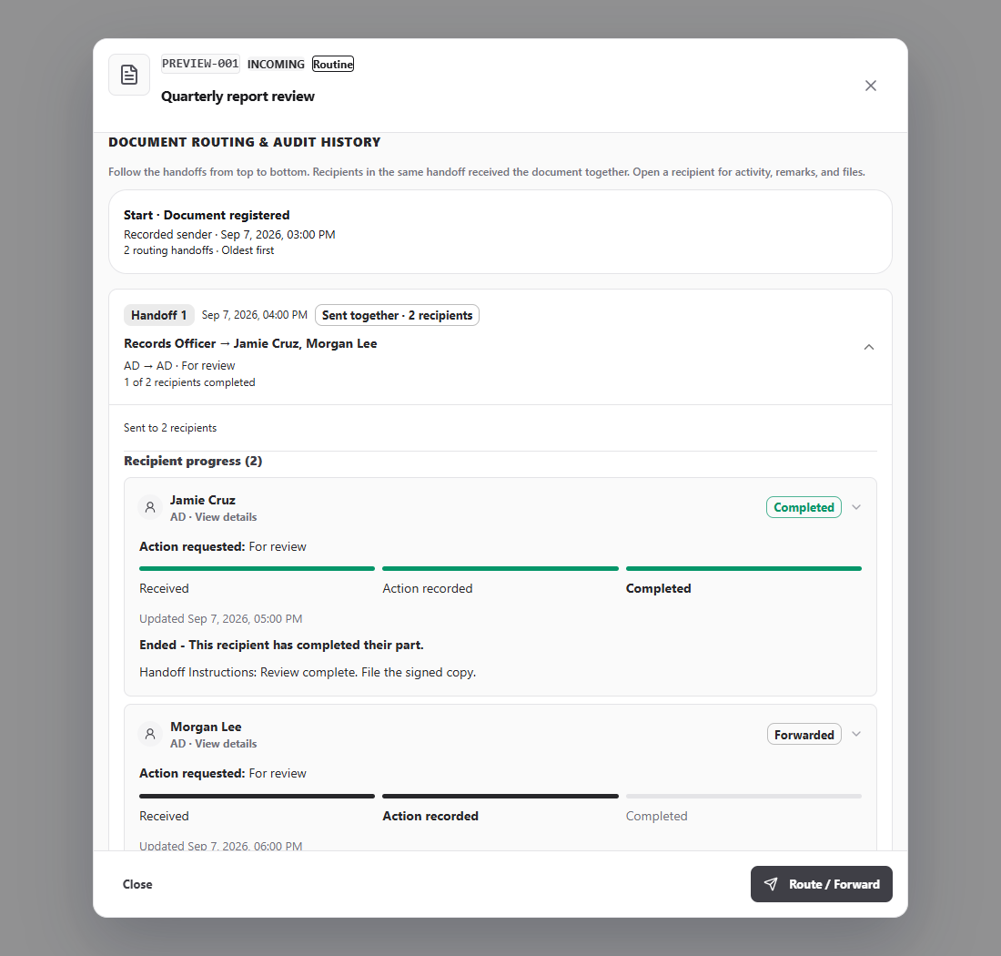
Figure . 13 Audit Logs Interface (handoff progress)
4.2.3.1 Module 14: Envelope Dispatch Logs
Purpose. Displays the separate record of outgoing-envelope dispatch events.
Access. SYSTEM_ADMIN, ORD, RECORDS_OFFICER, DIVISION_CHIEF.
Operations. Filter dispatch entries; Inspect detail; Delete selected entries when authorized.
Interface operations. GET /api/envelope-logs; POST /api/envelope-logs; DELETE /api/envelope-logs.
Data environment. Reads and, where permitted, deletes envelope_logs.
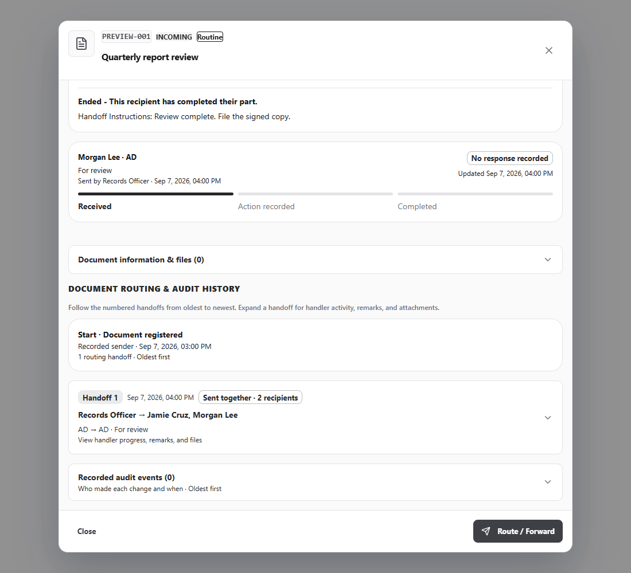
Figure . 14 Envelope Dispatch Logs Interface (recipient timeline)
4.2.3.1 Module 15: User Settings
Purpose. Allows the signed-in user to review the account, complete the forced password setup, change the password, and adjust interface preferences such as the login background and theme.
Access. All authenticated roles.
Operations. Complete password setup; Change password; Set login background; Switch theme.
Interface operations. POST /api/auth/complete-password-setup; POST /api/auth/forgot-password; POST /api/auth/forgot-admin-password; GET /api/settings/login-background; PUT /api/settings/login-background.
Data environment. Reads users and system_settings; writes users, system_settings, and audit_logs.
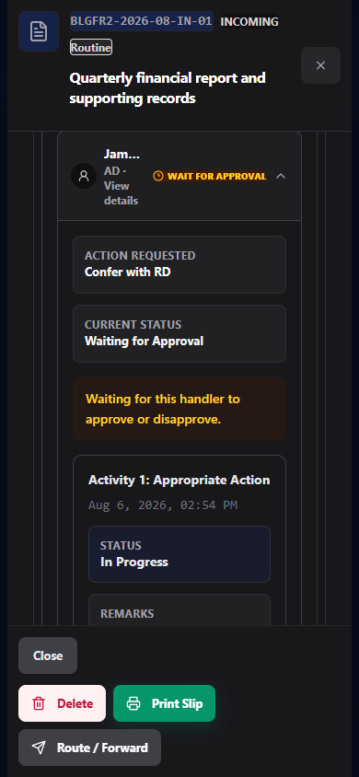
Figure . 15 User Settings Interface (handler mobile dark)
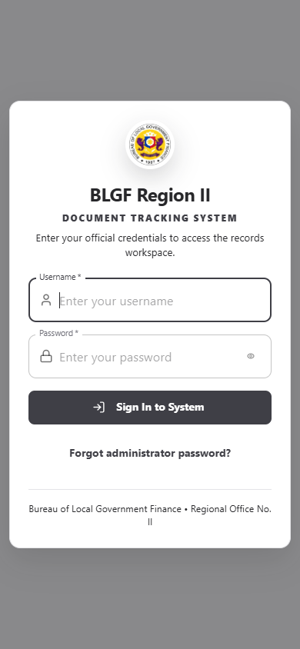
Figure . 15 User Settings Interface (login modal mobile)
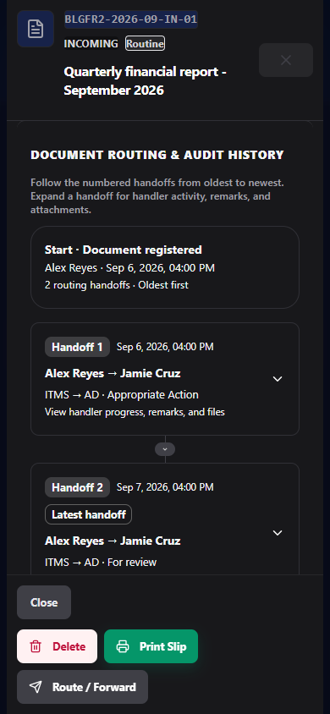
Figure . 15 User Settings Interface (routing mobile dark)
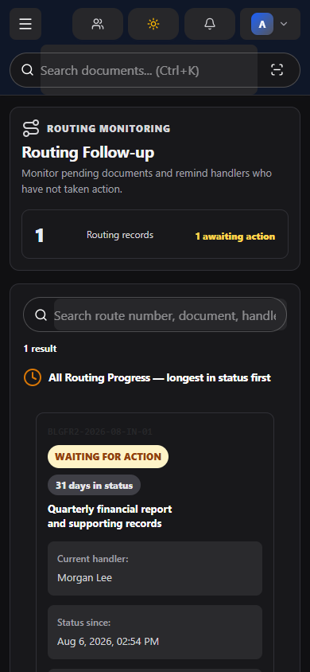
Figure . 15 User Settings Interface (monitoring mobile dark)
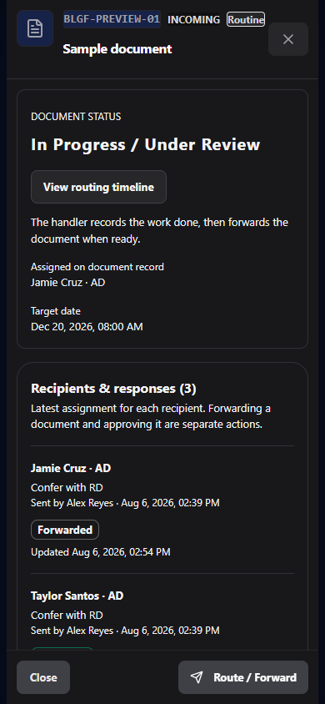
Figure . 15 User Settings Interface (recipient tracking mobile)

4.2.3.1.8 Access Control in the User Interface
Access in the interface is expressed through seven roles defined in Table 10. The navigation definition marks the User Accounts view as administrator-only and gates the Routing Follow-up view behind the routing-monitor permission, so a role without that permission does not see the entry at all. Other restrictions are expressed by omitting an action from a menu or disabling a control.
Table 10 must be read with the finding in Section 5.1. Hiding a control is a usability measure, not an authorization measure. Document visibility, by contrast, is genuinely enforced, because it is applied in the query layer on every document read and no role bypass exists for it. This distinction is the reason the interface in this section cannot by itself establish compliance, and it is the basis of the first recommendation in Section 5.3.
Table . Role Definitions Implemented in the System
Role | May delete | May view full routing trail | Interface scope | Granular actions
SYSTEM_ADMIN | Yes | Yes | 15 views incl. User Accounts, Audit Logs, Settings | 14
ADMIN | No | No | 9 views; no management menu | 0
ORD | No | Yes | 14 views incl. Users menu section | 7
RECORDS_OFFICER | No | No | 14 views incl. Audit Logs | 9
DIVISION_CHIEF | No | No | 14 views incl. Audit Logs | 4
ACTION_OFFICER | No | No | 12 views; no reports for envelopes | 2
STAFF | No | No | 11 views; reports limited to incoming and outgoing | 2

Fifteen granular action keys are defined and assigned per role: EMPLOYEE_CREATE, EMPLOYEE_EDIT, EMPLOYEE_DELETE, EMPLOYEE_FOLDER_MANAGE, DIRECTORY_BLGF_VIEW, DIRECTORY_LGU_VIEW, DIRECTORY_OTHER_VIEW, USER_ACCOUNT_CREATE, USER_ACCOUNT_EDIT, USER_ACCOUNT_DELETE, USER_SYSTEM_ADMIN_MANAGE, WORKFLOW_OPTION_MANAGE, ROUTING_MONITOR_VIEW, ROUTING_REMINDER_SEND, NOTIFICATION_VIEW_ALL. A role may hold an action key without holding the corresponding view, and the two sets are evaluated independently.

4.2.3 Data Model

4.2.3.2.1 Data Environment
The data environment of the system is relational. Nine entities are declared in the Prisma schema and a tenth, system_settings, is created at runtime by the server for settings that fall outside the schema. Table 8 states the environment in which these entities exist.
Table . Data Environment of the Developed System
Property | Description
Data model | Relational
Declared entities | 9 (divisions, users, documents, document_routes, document_attachments, audit_logs, envelope_logs, employee_profiles, directory_sections)
Runtime-created entities | 1 (system_settings)
Effective total | 10
Primary key strategy | Application-generated VARCHAR(64) identifier on every entity
Natural keys | users.username (unique), documents.tracking_number (unique), divisions.code (unique), employee_profiles.user_id (unique), system_settings.setting_key (primary)
Referential strategy | Mixed by design: enforced foreign keys for document and account relations, logical references for log and attachment attribution (Table 11)
Delete strategy | CASCADE from documents to routes and attachments so a document has no orphan steps; SET NULL for user references so history survives account removal
Collation and engine | InnoDB, utf8mb4, utf8mb4_unicode_ci
Temporal precision | DATETIME(3), millisecond precision, on all timestamps
Access technology | Prisma 6.19 ORM over MySQL 8.4
Fallback | JSON file persistence with reconciliation to the relational store
File storage | Configured upload directories, with optional LongText payload inside the relational store

Figure 8 is the entity relationship diagram. It shows the ten entities with their principal attributes, marks the enforced foreign keys, and distinguishes the logical references. It also records the two views that are computed rather than stored, described in Table 12.

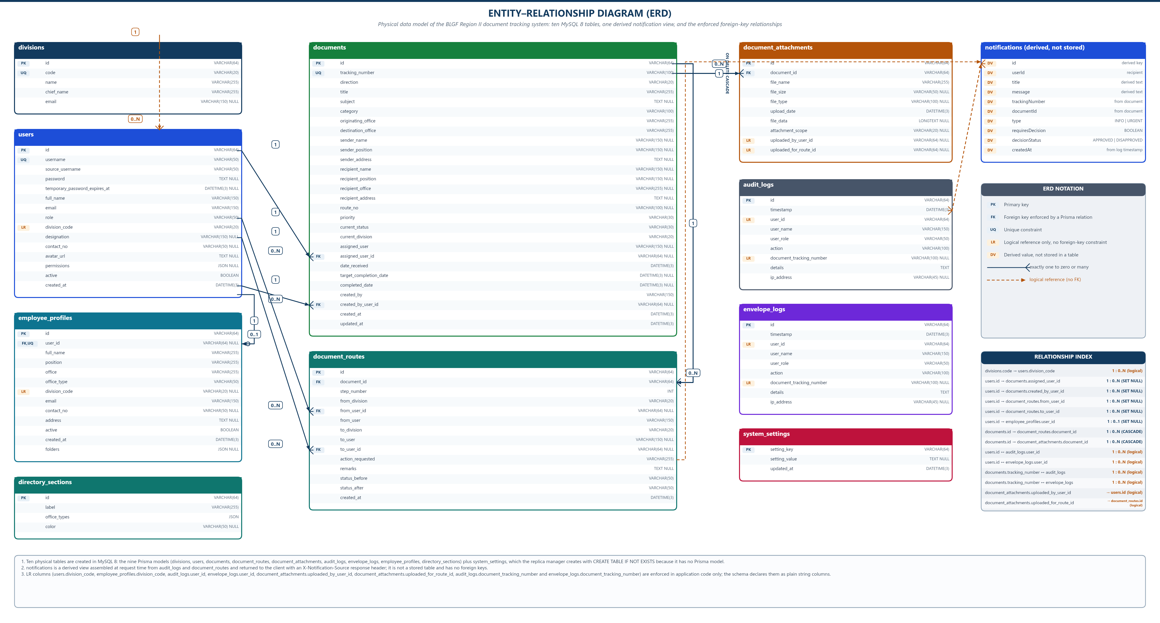
Figure . Entity Relationship Diagram of the Developed System

4.2.3.2.2 Data Entry
Data entry is described below per entity, in the order in which a record is normally created. Each entry path names the interface that supplies the data and the rule the server applies. Where an entity has no direct entry path, because it is written only by the application, that is stated rather than implied.

4.2.3.2.3 Data Description
The data description follows in Table 13. Each table states the field dictionary used to build Figure 8 and the Table Design in Section 4.2.3.3, so that the diagram, the description, and the physical design are derived from one source.
Table . Field Properties per Entity
Entity | Field count | Key columns | Delete behaviour
divisions | 5 | UNIQUE divisions_code (code) | No dependent table
users | 15 | UNIQUE users_username (username) | No dependent table
documents | 24 | UNIQUE documents_tracking_number (tracking_number) | CASCADE to routes and attachments; SET NULL for user references
document_routes | 14 | document_routes_document_id (document_id) | CASCADE from documents
document_attachments | 10 | document_attachments_document_id (document_id) | CASCADE from documents
employee_profiles | 13 | UNIQUE employee_profiles_user_id (user_id) | No dependent table
audit_logs | 9 | PRIMARY (id) | No dependent table
envelope_logs | 9 | PRIMARY (id) | No dependent table
directory_sections | 4 | PRIMARY (id) | No dependent table
system_settings | 3 | PRIMARY (setting_key) | No dependent table

Table . Relationships in the Data Model
From | To | Cardinality | Integrity | Delete rule
users.assigned_user_id | documents.id | Many-to-zero-or-one | ENFORCED | ON DELETE SET NULL, ON UPDATE CASCADE
users.created_by_user_id | documents.id | Many-to-zero-or-one | ENFORCED | ON DELETE SET NULL, ON UPDATE CASCADE
users.id | document_routes.from_user_id | One-to-many | ENFORCED | ON DELETE SET NULL, ON UPDATE CASCADE
users.id | document_routes.to_user_id | One-to-many | ENFORCED | ON DELETE SET NULL, ON UPDATE CASCADE
users.id | employee_profiles.user_id | One-to-zero-or-one | ENFORCED | ON DELETE SET NULL, ON UPDATE CASCADE; column is UNIQUE
documents.id | document_routes.document_id | One-to-many | ENFORCED | ON DELETE CASCADE
documents.id | document_attachments.document_id | One-to-many | ENFORCED | ON DELETE CASCADE
divisions.code | users.division_code | One-to-many | LOGICAL | No foreign key; application enforces the match
divisions.code | documents.current_division | One-to-many | LOGICAL | No foreign key; application enforces the match
audit_logs.user_id | users.id | One-to-many | LOGICAL | No foreign key; actor is preserved if the account is removed
envelope_logs.user_id | users.id | One-to-many | LOGICAL | No foreign key; actor is preserved if the account is removed
audit_logs.document_tracking_number | documents.tracking_number | Many-to-one | LOGICAL | No foreign key; log survives document removal
document_attachments.uploaded_by_user_id | users.id | Many-to-one | LOGICAL | No foreign key
document_attachments.uploaded_for_route_id | document_routes.id | Many-to-one | LOGICAL | No foreign key; column is indexed

The integrity column of Table 11 records an intentional asymmetry. Document and account relations are enforced by database foreign keys so that a document can never reference a deleted account or a missing parent document. Log and attachment attribution is logical, because audit evidence must survive the deletion of the document or the account it refers to; an enforced cascade there would destroy the very record that exists to explain the deletion.
Table . Views Computed at Request Time Rather Than Stored
View | Served by | Basis
Notifications | GET /api/notifications | Derived at request time from audit_logs and document_routes filtered to the signed-in user. Not stored as a table; the response carries the X-Notification-Source header.
Dashboard statistics | GET /api/stats | Aggregated at request time from documents, document_routes, and user accounts.
Document visibility | Applied in the query layer | A document is visible only to its creator, its current recipient, or the users who routed it. No role bypass exists for this rule.

The derived notifications deserve emphasis because they affect how the ERD is read. There is no notification table, and the absence is deliberate. Notifications are computed when they are requested from audit_logs and document_routes, filtered to the signed-in user, and the response states its origin in the X-Notification-Source header. A consequence is that a notification cannot be stored and therefore cannot be marked as permanently read in the database; acknowledgement is per request. A second consequence is that notification text is reconstructed from events rather than composed at the time of the event, which is why the wording of a notification follows the wording of the log detail that produced it.

4.2.3.3 Table Design
The table design states, for each entity, the fields it holds, the properties of each field, and a plain description of what the field means. Properties are given as the key status, the storage type with its length, and whether the field accepts a null value, as read from the schema declaration and from the runtime table creation statement. No field below is inferred.
4.2.3.3.1 divisions
Table: Stores the organizational units of BLGF Region II that originate, hold, or receive documents.
Table . divisions Table Design
Entity | Field | Properties | Description
id | PK, VARCHAR(64) | NOT NULL | Unique identifier of the division record, assigned by the server.
code | UNIQUE, VARCHAR(20) | NOT NULL | Short division code (ITMS, ORD, AD, LAOD, LTOD, FD, LU) used as the logical link from users and documents.
name | VARCHAR(255) | NOT NULL | Full official name of the division or unit.
chiefName | VARCHAR(255) | NOT NULL | Name of the division chief or head, mapped to column chief_name.
email | VARCHAR(150) | NULL | Optional electronic mail address of the division.

Table . divisions Keys and Entry Path
Property | Value
Keys and indexes | PRIMARY KEY (id); UNIQUE KEY divisions_code (code)
Entry path | Entered through the division maintenance screen available to System Administrator; seeded by the administrator on first use.
Referenced by | divisions.code to users.division_code (logical); divisions.code to documents.current_division (logical)

4.2.3.3.3 users
Table: Stores all system accounts, their credentials, organizational assignment, role, and stored permission overrides.
Table . users Table Design
Entity | Field | Properties | Description
id | PK, VARCHAR(64) | NOT NULL | Unique identifier of the user account.
username | UNIQUE, VARCHAR(50) | NOT NULL | Login name used during authentication.
sourceUsername | VARCHAR(50) | NOT NULL | Original or source account name retained for traceability, mapped to source_username.
password | TEXT | NULL | Password value used by the login verification routine. Nullable to allow accounts created before the password is set.
temporaryPasswordExpiresAt | DATETIME(3) | NULL | Expiry of a temporary password; enforced during forced password setup.
fullName | VARCHAR(150) | NOT NULL | Complete name of the account holder, mapped to full_name.
email | VARCHAR(150) | NOT NULL | Electronic mail address used for system notices.
role | VARCHAR(50) | NOT NULL | Assigned role: SYSTEM_ADMIN, ADMIN, ORD, RECORDS_OFFICER, DIVISION_CHIEF, ACTION_OFFICER, or STAFF.
divisionCode | VARCHAR(20) | NOT NULL | Division code of the account holder; matched logically to divisions.code.
designation | VARCHAR(150) | NULL | Position or designation held by the employee.
contactNo | VARCHAR(50) | NULL | Contact number of the employee.
avatarUrl | TEXT | NULL | Location or encoded value of the profile picture, mapped to avatar_url.
permissions | JSON | NULL | Optional per-account permission overrides layered on top of the role defaults.
active | BOOLEAN | NOT NULL, default TRUE | Flag indicating whether the account may sign in.
createdAt | DATETIME(3) | NOT NULL | Timestamp of account creation, mapped to created_at.

Table . users Keys and Entry Path
Property | Value
Keys and indexes | PRIMARY KEY (id); UNIQUE KEY users_username (username)
Entry path | Entered through the User Accounts screen (management module) and during first-time password setup.
Referenced by | users.assigned_user_id to documents.id (enforced); users.created_by_user_id to documents.id (enforced); users.id to document_routes.from_user_id (enforced); users.id to document_routes.to_user_id (enforced); users.id to employee_profiles.user_id (enforced); divisions.code to users.division_code (logical); audit_logs.user_id to users.id (logical); envelope_logs.user_id to users.id (logical); document_attachments.uploaded_by_user_id to users.id (logical)

4.2.3.3.5 documents
Table: Central record of every incoming and outgoing document, including its identity, parties, workflow state, and custodian.
Table . documents Table Design
Entity | Field | Properties | Description
id | PK, VARCHAR(64) | NOT NULL | Internal unique identifier of the document.
trackingNumber | UNIQUE, VARCHAR(100) | NOT NULL | Permanent tracking number assigned at registration; never reused.
routeNo | VARCHAR(100) | NULL | Controlled routing number following the pattern BLGFR2-YYYY-MM-IN|OUT-NN.
direction | VARCHAR(20) | NOT NULL | INCOMING or OUTGOING.
title | VARCHAR(255) | NOT NULL | Document title as recorded at registration.
subject | TEXT | NULL | Subject or description of the document.
category | VARCHAR(100) | NOT NULL | Document category or type.
originatingOffice | VARCHAR(255) | NOT NULL | Office that issued or forwarded the document.
destinationOffice | VARCHAR(255) | NOT NULL | Office for which the document is intended.
senderName / senderPosition | VARCHAR(150) | NULL | Name and position of the sender, if external.
senderAddress | TEXT | NULL | Address or affiliation of the sender.
recipientName / recipientPosition | VARCHAR(150) | NULL | Name and position of the intended recipient.
recipientOffice / recipientAddress | VARCHAR(255) / TEXT | NULL | Office and address of the intended recipient.
priority | VARCHAR(30) | NOT NULL | ROUTINE, URGENT, VERY_URGENT, or CONFIDENTIAL.
currentStatus | VARCHAR(30) | NOT NULL | NOT_YET_ROUTED, PENDING, IN_PROGRESS, FOR_SIGNATURE, COMPLETED, RETURNED, or ON_HOLD.
currentDivision | VARCHAR(20) | NOT NULL | Division presently holding the document.
assignedUser | VARCHAR(150) | NULL | Display name of the person presently assigned.
assignedUserId | FK, VARCHAR(64) | NULL | Account identifier of the assigned person; ON DELETE SET NULL.
dateReceived | DATETIME(3) | NOT NULL | Date the document was received by the office.
targetCompletionDate | DATETIME(3) | NULL | Expected or required completion date.
completedDate | DATETIME(3) | NULL | Date the document was completed or released.
createdBy | VARCHAR(150) | NOT NULL | Display name of the person who registered the document.
createdByUserId | FK, VARCHAR(64) | NULL | Account identifier of the registering user; ON DELETE SET NULL.
createdAt / updatedAt | DATETIME(3) | NOT NULL | Creation and last-modification timestamps.

Table . documents Keys and Entry Path
Property | Value
Keys and indexes | PRIMARY KEY (id); UNIQUE KEY documents_tracking_number (tracking_number); INDEX documents_assigned_user_id (assigned_user_id); INDEX documents_created_by_user_id (created_by_user_id)
Entry path | Entered through the Create Document modal and updated through routing, decision, transfer, and completion actions.
Referenced by | users.assigned_user_id to documents.id (enforced); users.created_by_user_id to documents.id (enforced); documents.id to document_routes.document_id (enforced); documents.id to document_attachments.document_id (enforced); divisions.code to documents.current_division (logical); audit_logs.document_tracking_number to documents.tracking_number (logical)

4.2.3.3.7 document_routes
Table: Stores one row per routing step, forming the ordered chain of custody for a document.
Table . document_routes Table Design
Entity | Field | Properties | Description
id | PK, VARCHAR(64) | NOT NULL | Unique identifier of the routing step.
documentId | FK, VARCHAR(64) | NOT NULL | Document being routed; ON DELETE CASCADE.
stepNumber | INT | NOT NULL | Ordinal position of this step in the routing sequence.
fromDivision | VARCHAR(20) | NOT NULL | Division releasing the document.
fromUserId | FK, VARCHAR(64) | NULL | Account of the releasing user; ON DELETE SET NULL.
fromUser | VARCHAR(150) | NOT NULL | Display name of the releasing user.
toDivision | VARCHAR(20) | NOT NULL | Division receiving the document.
toUserId | FK, VARCHAR(64) | NULL | Account of the receiving user; ON DELETE SET NULL.
toUser | VARCHAR(150) | NULL | Display name of the receiving user.
actionRequested | VARCHAR(255) | NOT NULL | Action expected of the recipient.
remarks | TEXT | NULL | Remarks or instructions issued by the releasing party.
statusBefore | VARCHAR(50) | NOT NULL | Document status before this step.
statusAfter | VARCHAR(50) | NOT NULL | Document status after this step.
createdAt | DATETIME(3) | NOT NULL | Timestamp the step was created.

Table . document_routes Keys and Entry Path
Property | Value
Keys and indexes | PRIMARY KEY (id); INDEX document_routes_document_id (document_id); INDEX document_routes_from_user_id (from_user_id); INDEX document_routes_to_user_id (to_user_id)
Entry path | Generated by the routing, multi-routing, transfer, and decision routines; rows are removed only with the parent document.
Referenced by | users.id to document_routes.from_user_id (enforced); users.id to document_routes.to_user_id (enforced); documents.id to document_routes.document_id (enforced); document_attachments.uploaded_for_route_id to document_routes.id (logical)

4.2.3.3.9 document_attachments
Table: Stores files attached to a document or to a specific routing step.
Table . document_attachments Table Design
Entity | Field | Properties | Description
id | PK, VARCHAR(64) | NOT NULL | Unique identifier of the attachment.
documentId | FK, VARCHAR(64) | NOT NULL | Parent document; ON DELETE CASCADE.
fileName | VARCHAR(255) | NOT NULL | Stored name of the uploaded file.
fileSize | VARCHAR(50) | NULL | Recorded size of the file.
fileType | VARCHAR(100) | NULL | MIME type or extension of the file.
uploadDate | DATETIME(3) | NOT NULL | Date and time of upload.
fileData | LONGTEXT | NULL | Inline file payload used when the file is stored inside the database.
attachmentScope | VARCHAR(20) | NULL | Visibility scope applied when the attachment is retrieved.
uploadedByUserId | VARCHAR(64) | NULL | Account that uploaded the file; logical reference only.
uploadedForRouteId | VARCHAR(64) | NULL | Routing step the file belongs to; logical reference only, indexed.

Table . document_attachments Keys and Entry Path
Property | Value
Keys and indexes | PRIMARY KEY (id); INDEX document_attachments_document_id (document_id); INDEX document_attachments_uploaded_for_route_id (uploaded_for_route_id)
Entry path | Uploaded through the attachment control in the document detail and routing views.
Referenced by | documents.id to document_attachments.document_id (enforced); document_attachments.uploaded_by_user_id to users.id (logical); document_attachments.uploaded_for_route_id to document_routes.id (logical)

4.2.3.3.11 employee_profiles
Table: Stores personnel details and per-employee folder links for the Office Directory module.
Table . employee_profiles Table Design
Entity | Field | Properties | Description
id | PK, VARCHAR(64) | NOT NULL | Unique identifier of the employee profile.
userId | UNIQUE FK, VARCHAR(64) | NULL | Linked system account, if any; ON DELETE SET NULL.
fullName | VARCHAR(255) | NOT NULL | Complete name of the employee.
position | VARCHAR(255) | NOT NULL | Position or designation.
office | VARCHAR(255) | NOT NULL | Assigned office or unit.
officeType | VARCHAR(50) | NOT NULL | Category of office used to group directory entries.
divisionCode | VARCHAR(20) | NULL | Division code when the employee belongs to a BLGF unit.
email | VARCHAR(150) | NOT NULL | Electronic mail address.
contactNo | VARCHAR(50) | NULL | Contact number.
address | TEXT | NULL | Address or station.
active | BOOLEAN | NOT NULL, default TRUE | Flag indicating current employment or listing status.
createdAt | DATETIME(3) | NOT NULL | Timestamp the profile was created.
folders | JSON | NULL | Employee folder links; managed by the Employee Folder Manager.

Table . employee_profiles Keys and Entry Path
Property | Value
Keys and indexes | PRIMARY KEY (id); UNIQUE KEY employee_profiles_user_id (user_id)
Entry path | Entered through the Office Directory and Employee Profile screens.
Referenced by | users.id to employee_profiles.user_id (enforced)

4.2.3.3.13 audit_logs
Table: Chronological record of user and system activity for accountability and review.
Table . audit_logs Table Design
Entity | Field | Properties | Description
id | PK, VARCHAR(64) | NOT NULL | Unique identifier of the log entry.
timestamp | DATETIME(3) | NOT NULL | Time the activity occurred.
userId | VARCHAR(64) | NOT NULL | Account identifier of the actor; logical reference only.
userName | VARCHAR(150) | NOT NULL | Display name of the actor at the time of the activity.
userRole | VARCHAR(50) | NOT NULL | Role of the actor during the activity.
action | VARCHAR(100) | NOT NULL | Action performed.
documentTrackingNumber | VARCHAR(100) | NULL | Tracking number related to the activity; logical reference only.
details | TEXT | NOT NULL | Narrative detail of the activity.
ipAddress | VARCHAR(45) | NULL | Network address associated with the request.

Table . audit_logs Keys and Entry Path
Property | Value
Keys and indexes | PRIMARY KEY (id)
Entry path | Written automatically by the server on document, routing, and account operations.
Referenced by | audit_logs.user_id to users.id (logical); audit_logs.document_tracking_number to documents.tracking_number (logical)

4.2.3.3.15 envelope_logs
Table: Separate chronological record of outgoing-envelope dispatch, receipt, and acknowledgement events.
Table . envelope_logs Table Design
Entity | Field | Properties | Description
id | PK, VARCHAR(64) | NOT NULL | Unique identifier of the envelope log entry.
timestamp | DATETIME(3) | NOT NULL | Time the dispatch event occurred.
userId | VARCHAR(64) | NOT NULL | Account identifier of the actor; logical reference only.
userName | VARCHAR(150) | NOT NULL | Display name of the actor.
userRole | VARCHAR(50) | NOT NULL | Role of the actor.
action | VARCHAR(100) | NOT NULL | Dispatch action performed.
documentTrackingNumber | VARCHAR(100) | NULL | Tracking number of the document carried by the envelope; logical reference only.
details | TEXT | NOT NULL | Narrative detail of the dispatch.
ipAddress | VARCHAR(45) | NULL | Network address associated with the request.

Table . envelope_logs Keys and Entry Path
Property | Value
Keys and indexes | PRIMARY KEY (id)
Entry path | Written automatically by the outgoing-envelope routines and reviewed in the Envelope Dispatch Logs view.
Referenced by | envelope_logs.user_id to users.id (logical)

4.2.3.3.17 directory_sections
Table: Configures the grouping and ordering of sections shown in the Office Directory.
Table . directory_sections Table Design
Entity | Field | Properties | Description
id | PK, VARCHAR(64) | NOT NULL | Unique identifier of the directory section.
label | VARCHAR(255) | NOT NULL | Displayed heading of the section.
officeTypes | JSON | NOT NULL | Office-type values belonging to the section.
color | VARCHAR(50) | NULL | Display colour assigned to the section.

Table . directory_sections Keys and Entry Path
Property | Value
Keys and indexes | PRIMARY KEY (id)
Entry path | Maintained through the Directory Sections configuration endpoint by authorized roles.
Referenced by | None

4.2.3.3.19 system_settings
Table: Runtime key-value store created by the server at start-up for settings that are not part of the Prisma schema.
Table . system_settings Table Design
Entity | Field | Properties | Description
setting_key | PK, VARCHAR(64) | NOT NULL | Name of the setting, for example the login background reference.
setting_value | TEXT | NULL | Stored value of the setting; NULL clears the setting.
updated_at | DATETIME(3) | NOT NULL | Timestamp of the last write.

Table . system_settings Keys and Entry Path
Property | Value
Keys and indexes | PRIMARY KEY (setting_key)
Entry path | Created and maintained by the backend through the MySQL replica helper; read and written through /api/settings/login-background.
Referenced by | None

4.3 The Extent of Compliance of the Developed System to ISO 25010 Software Quality Standards
This section reports what has been established and what has not. The eight characteristics of ISO/IEC 25010:2023 are used as the framework. For each characteristic the section states what was examined, what evidence was obtained, and what status the evidence supports. Status values are Conformance established, Partially established, and Awaiting measurement. No characteristic is rated by questionnaire in this study, and no composite quality score is reported, because no responses have been collected.

4.3.1 Functional Suitability
Functional suitability was assessed by exercising each of the fifteen modules in Table 9 against the operations recorded for it, and by confirming that each documented operation is reachable in the interface and is implemented in the application layer rather than only in the presentation layer. The completeness of the decomposition was checked in both directions, by confirming that every routine in Figure 7 belongs to a module in Table 9 and that every module appears in Figure 7. The document lifecycle was traced end to end: registration produced a tracking number, routing wrote a routing row and changed the status, decision and transfer recorded the responsible party, completion closed the record, and every administrative action produced a log entry. This characteristic is reported as conformance established on the basis of functional inspection; it is a statement about coverage of the requirements, not about performance under load.

4.3.2 Performance Efficiency
No performance measurement has been recorded, so this characteristic is awaiting measurement. The timing procedure defined in Section 3.7 covers six tasks, namely registering an incoming document, routing to one recipient, routing to multiple recipients, recording a decision, transferring custody, and locating a document from the list and from its QR code. Two structural observations are reported in the meantime, because they bound what a future measurement should expect. Document lists are queried with filters on status, direction, priority, and assigned account, and are indexed on assigned_user_id and created_by_user_id, which are the columns those filters and the visibility rule use. Routing history is retrieved by document_id, which is indexed, so reading the history of one document does not require a scan. A document list without filters returns the full set for the visible documents, and no pagination is applied, which is a likely limitation at the record volumes of a mature deployment and should be measured first.

4.3.3 Compatibility
Compatibility is reported as conformance established for the browser and platform scope defined in Section 3.5, and not beyond it. The client is a single-page application using standard web platform features, and the layout is defined to reflow for narrow viewports and to render in a dark theme; the responsive and dark-mode states are documented in Appendix C and evidenced by the interface figures. The interface was designed with keyboard operability, sufficient contrast, and programmatic labels in mind, and the layout reflows rather than scrolling horizontally at narrow widths, which are the accessibility provisions most relevant to an office environment where personnel may have impaired vision (World Wide Web Consortium, 2018). The scope is bounded: the application is exercised through a current Chromium-based, Firefox, or Safari browser over the office network, and it is deployed behind a reverse proxy that terminates TLS. Compatibility with legacy browsers, with Internet Explorer, with mobile operating systems as a primary workplace device, or with an offline environment is not claimed, and no such test has been performed.

4.3.4 Interaction Capability
This characteristic is awaiting measurement, because it depends on users performing tasks rather than on inspection. The interface provides a consistent application shell with a navigation menu, a header carrying the signed-in identity and notifications, and a notification drawer; lists share one search and filter pattern; and the routing slip and envelope outputs reuse the same data as the on-screen views so that the printed record cannot diverge from the stored record. These are design decisions that a usability evaluation can confirm or refute, and the instrument in Appendix D is the means of doing so. No usability score is reported here.

4.3.5 Reliability
Reliability is partially established. The following were verified. Every accepted lifecycle action is written with the status before and the status after, so a partially applied transition can be detected by inspection of the stored rows. A tracking number and a route number are rejected on the server when they duplicate an existing one, so the numbering cannot silently collide. A failed workflow transition is refused rather than partially applied. Envelope dispatch is recorded separately from document status, so an incomplete dispatch is distinguishable from a completed document. Recovery is the part that is not established: backup and restore have not been exercised, and the absence of a tested backup is recorded as a limitation of the deployed configuration rather than as a property of the application.

4.3.6 Security
Security is partially established, and the two unresolved items are the most consequential findings of the whole evaluation. Three weaknesses were identified in the delivered system.
- Authorization is not enforced at every endpoint. The role and action-key check protects user, division, and deletion operations, but the records, storage, statistics, employee, directory-section, and log-deletion endpoints do not each verify the caller's permission on every request. The interface hides these operations from unauthorized roles, which is a usability measure rather than an authorization measure, so a direct request may succeed where the interface would have prevented it.
- Passwords are stored and compared in plaintext. The users.password column holds the submitted value and the verification routines compare against it directly. This contradicts the security obligation of the Data Privacy Act of 2012 and the mitigation guidance of the OWASP Foundation (2021a), and it is aggravated by the existence of a database export function in the same application.
- Request-level protections are incomplete. Session handling, upload validation, and file retrieval authorization were not verified to a standard sufficient to claim conformity, and the file-retrieval route deserves specific attention because its authorization could not be confirmed to follow the document-visibility rule. The established security controls for this class of application treat authentication, session management, access control, and cryptographic failures as distinct concerns requiring separate verification (OWASP Foundation, 2021b; Joint Task Force, 2020), and credential handling in particular requires that passwords be neither stored in recoverable form nor transmitted in the clear (Grassi & Garcia, 2017).
The following were verified. Authentication requires a valid account, an account may be deactivated without deletion, and a temporary password carries an expiry enforced at the forced password-setup step, which is consistent with established guidance on credential lifecycle management (Grassi & Garcia, 2017). Document visibility is enforced in the query layer and limits a document to its creator, its current recipient, and the users who routed it, with no role bypass, and the legacy canViewAllDocuments flag grants no visibility. Administrative actions are written to audit_logs and envelope_logs with the acting account, display name, role, action, related tracking number, narrative detail, network address, and millisecond timestamp, and those records are not removed when a document or account is deleted. Because two of the three weaknesses are unresolved, this characteristic is reported as partially established and not as conformance.

4.3.7 Maintainability
Maintainability was assessed by inspection and is reported as conformance established for the matters inspected. The client is separated into page components, modal components, shell components, shared utility modules, and services, so that a change to a page does not require editing the shell. Shared helpers for document status, visibility, progress, recipient flow, attachment visibility, and routing recipients hold the business rules in one place rather than duplicating them in templates. The server separates the application entry point, the document router, the user router, the mail service, the PDF generator, and the persistence replica. The data model is declared once in the Prisma schema and the types are declared once in the shared type module, so that a field change has a single origin. Counters, labels, and status colours are derived from configuration rather than repeated per view.
Two maintenance weaknesses were observed. The client and the server maintain their own copies of the document and user shapes, so a field added to one must be added to the other; this duplication is precisely the risk that a single-schema contract is intended to remove, and consolidating the shapes into one generated package rather than maintaining both by hand is the corresponding remedy (Richardson, 2018; Newman, 2021; Sadalage & Fowler, 2020). The second weakness is that the bundled browser API file duplicates a large part of the server surface, which invites editing the wrong copy and was explicitly excluded as a source of truth in the course of this study. Beyond these two, the separation of concerns follows established practice for this class of system, in which transport, routing, and persistence are separated so that a change in one does not require altering another (Ford et al., 2020; Richards & Ford, 2020); the observed difficulty arose from the duplicated shapes rather than from that separation. The client-server deployment itself follows the same practice of isolating runtime concerns behind a stable interface (Fowler & Highsmith, 2018), and the API is implemented as conventional HTTP request and response semantics over JSON (Fielding & Reschke, 2014).

4.3.8 Flexibility
Flexibility is established by inspection and by the configurability the interface exposes. Configurable items are the role permission set and the fifteen granular action keys, the per-account permission override, the division records and their codes, the workflow option values, the office-type groupings and their order and colour in the directory, the login background, the colour theme, and the storage directories and their file categories. Adding a document category, a division, an office type, or a directory grouping requires no code change. The declared limitations are that the role set and the action keys are fixed in the permission structure and cannot be created from the interface, and that notifications cannot be composed at the event time because they are derived rather than stored.

4.3.9 Summary of Conformance
Table . Extent of Conformance to ISO/IEC 25010 Characteristics
Characteristic | Evidence obtained | Status
Functional suitability | All fifteen modules exercised; documented operations confirmed implemented in the application layer; lifecycle traced end to end; decomposition checked in both directions | Conformance established
Performance efficiency | Index usage on the filtered and visibility columns identified; no measurement recorded; unpaginated list identified as the first item to measure | Awaiting measurement
Compatibility | Responsive and dark-theme states documented; browser and network scope defined in Section 3.5; legacy and offline environments excluded and untested | Conformance established within the stated scope
Interaction capability | Consistent shell, shared list pattern, printed output derived from stored data; no usability evaluation recorded | Awaiting measurement
Reliability | Transitions written with status before and after; duplicate numbers rejected server-side; failed transitions refused; untested backup and restore identified | Partially established
Security | Authentication, account deactivation, temporary-password expiry, query-layer document visibility, and audit logging verified; authorization not enforced at every endpoint; passwords stored and compared in plaintext; request-level protections unverified | Partially established
Maintainability | Layered client and server structure, shared rule modules, single-source schema and types, configuration-derived labels; duplicated client-server shapes and a redundant bundled API file observed | Conformance established for the matters inspected
Flexibility | Fifteen configurable items verified as changeable without code; fixed role set and action keys, and derived-notification wording, identified as constraints | Conformance established within the stated scope

Of the eight characteristics, three are established for the matters inspected, two are established within a stated scope, two are partially established, and one awaits measurement. The two partially established characteristics are the two that a functional demonstration would most easily appear to satisfy, which is the principal methodological conclusion of this section. The questionnaire in Appendix D is the instrument for the three characteristics that remain outstanding, and the procedure that must be followed before any of them can be reported is stated in Sections 3.7 and 5.3.

CHAPTER V. SUMMARY OF FINDINGS AND RECOMMENDATIONS

5.1 Summary of Findings
The following findings summarize the study. Findings 1 through 6 are supported by evidence available at the time of writing; findings 7 through 9 state what remains to be measured, and they are stated as outstanding rather than as provisional results.

Finding 1: The existing process depends on physical custody and informal confirmation.
The documentation and interviews described in Section 4.1 established that document location and completion were confirmed by locating the paper or by a verbal report, rather than by a queryable record. Because confirmation depended on the holder rather than on the record, the office could not answer where a document was, who held it, or whether the required action was complete without direct contact with the receiving office. Duplicate and informally amended reference numbers were identified as a contributing condition to lost traceability.

Finding 2: The developed system provides a single lifecycle record with a permanent identity.
The delivered application registers incoming and outgoing documents, assigns a permanent tracking number that is never reused, and assigns a controlled route number following the pattern BLGFR2-YYYY-MM-IN|OUT-NN. Routing, multi-routing, transfer, decision, and completion actions each write a document_routes row recording the releasing and receiving party, the action requested, remarks, the status before and after, and the time. The document detail view reconstructs the complete sequence from these rows, which is the chain of custody that the literature in Section 2.1.1 identifies as the justification for an electronic records system.

Finding 3: Workflow rules are enforced in the application layer, and document visibility has no administrative bypass.
Permitted status transitions, routing-step ordering, and the recipients permitted for a step are validated on the server, so the system behaves identically whether it is reached through the interface or by direct request. Document visibility is applied in the query layer and is restricted to the signed-in user's own created, held, or routed documents, with no role override. The legacy canViewAllDocuments flag is retained in the permission structure for record compatibility but grants no visibility, which is documented here so that the field is not later mistaken for an active control.

Finding 4: Authorization is defined across seven roles and fifteen granular action keys, but it is not applied uniformly at every endpoint.
Access is derived from users.role against the default permission set, optionally modified by a per-account JSON override. The role model follows the established approach of assigning permissions to roles and roles to users, so that changing the holder of a position does not require redefining permissions (Sandhu et al., 1996; Ferraiolo et al., 2001). The User Accounts view and the user, division, and deletion operations are restricted to the System Administrator role. However, inspection of the API surface showed that several endpoints, including the records, storage, division, employee, directory-section, log-deletion, and statistics operations, do not each verify the caller’s permission on every request. The interface hides these operations, but interface restriction is not authorization. This is reported as a defect in Section 4.3 and is the basis of the first recommendation in Section 5.3.

Finding 5: Passwords are stored and compared in plaintext.
The users.password column holds the password value as submitted, and the login and password-verification routines compare the submitted value against it directly. Any party with read access to the database, to an export, or to a backup obtains usable credentials for every account, and the risk is compounded because the User Accounts module provides a database export function. This contradicts the security requirement of the Data Privacy Act of 2012 and the corresponding mitigation guidance of the OWASP Foundation (2021a), and it is the basis of the second recommendation in Section 5.3.

Finding 6: The remaining ISO/IEC 25010 characteristics cannot be rated without users and elapsed-time measurement.
Functional suitability, maintainability, and flexibility were established by inspection of the delivered application and its source, and are reported in Section 4.3 as conformance findings. Interaction capability, performance efficiency, and reliability in operation depend on users performing tasks and on elapsed-time measurement, and none has yet been collected. Security is partially established, because the functional aspects of access control and audit logging were verified while the storage and verification weaknesses in Findings 4 and 5 remain unresolved. Accordingly, no characteristic is rated by questionnaire in this study and no composite quality score is reported.

Finding 7: Technical documentation and deployment configuration are inconsistent.
The deployment configuration references a schema file at backend/schema.sql that is not present in the repository, so a clean deployment cannot be created from the configuration alone. The environment example does not cover every variable the application reads, which makes first-time configuration dependent on reading the source. Both conditions are recorded in Section 4.3 and addressed in the final recommendation.

Finding 8: No user-acceptance evidence exists at the time of writing.
The ISO/IEC 25010 questionnaire has been constructed and is reproduced in Appendix D, and the respondent classification is in Table 3, but no responses have been collected. Accordingly this study reports no weighted mean, no response distribution, and no acceptance rate. The instrument is ready for pilot testing and administration, and Section 4.3.5 records the outstanding measurement.

Finding 9: The system supports one agency only.
The division, user, and directory data are those of BLGF Region II. The application has no external portal and no inter-agency exchange, so documents are handed off between agencies outside the system and only the receiving agency's portion is recorded. This is consistent with the scope in Section 1.5 and is a limitation rather than a defect.

5.2 Conclusions
The study produced a working web-based document tracking and management system for BLGF Region II and documented its design and implementation in sufficient detail to be reproduced. The delivered system provides what the requirements analysis identified as necessary: a permanent document identity, a controlled route number, an enforced and retained workflow, role-based access, an independent audit record, and a queryable set of operational reports. The most consequential conclusion concerns not what the system does but how it fails: authorization is expressed in the permission model but is not enforced at every endpoint, and passwords are neither hashed nor salted. Both conditions are invisible from the interface, which is precisely why a functional demonstration cannot establish compliance and why the audit and export paths deserve independent attention.
A second conclusion concerns evaluation. The quality model proved useful precisely because it separated what could be demonstrated from what could not. Functional suitability, maintainability, and flexibility were demonstrable and are reported; interaction capability, performance efficiency, and operational reliability were not, and are reported as outstanding. Presenting them together would have produced a more complete-looking chapter and a less accurate one. The evidence standard applied throughout this study, that a claim requires the measurement that supports it and is otherwise declared outstanding, is the standard the study recommends for any subsequent evaluation of the system.

5.3 Recommendations
The recommendations below follow directly from the findings and are ordered by consequence.

Technical
- Enforce authorization on every endpoint. Apply the same role and action-key check that currently protects user, division, and deletion operations to the records, storage, statistics, employee, directory-section, log-deletion, notification, and export operations, and reject the request when it fails. Correspondingly, review and remove the legacy canViewAllDocuments flag from the permission structure so that it cannot later be mistaken for an active control. Address Finding 4.
- Hash passwords with a memory-hard algorithm. Replace the plaintext column with a salted hash using Argon2id, or bcrypt where Argon2 is unavailable, migrate existing accounts through a forced password-setup path on first login, and remove password values from every export and backup. Because existing stored values are already plaintext, treat the migration as a credential-compromise event and require all accounts to set new passwords. Address Finding 5.
- Restrict the database export function. Limit export to authorized roles, record every export in audit_logs with the exporting account and the scope of the export, and require encrypted storage for exported files. Address Findings 4 and 5.
- Reconcile the deployment configuration. Either add the referenced schema file to the repository or remove the reference, complete the environment example so that every variable read by the application is documented, and define a scheduled backup for both the relational store and the upload directories. Address Finding 7.

Operational
- Complete the evaluation. Conduct the pilot test, then administer the ISO/IEC 25010 instrument in Appendix D to the respondents in Table 3, and run the task-timing procedure. Report the weighted mean per characteristic with its interpretation band, the response distribution, and the timing ranges with their repetition counts, as specified in Section 3.10. Address Findings 6 and 8.
- Establish numbering and custody rules. Issue written guidance that the tracking number is never reissued, that the route number follows the controlled pattern, that a returned document records a decision rather than a new number, and that custody is confirmed in the system rather than verbally. Address Finding 1.
- Review permission overrides. Because role definitions and per-account overrides both accumulate rights, audit the accounts holding overrides and withdraw those that are no longer required, so that privileges granted during training do not persist after duties change. Address Finding 4.
- Assign records-administration responsibility. Name the office that owns classification and retention decisions. The application deliberately does not dispose of records, and that boundary is only safe while an accountable unit exists to make and record those decisions.
- Provide training and staged rollout. The local studies in Section 2.2.2 associate adoption failure with the absence of training and revised procedure. Introduce the system module by module, with the routing rules in Section 4.2 explained to the personnel who will perform them.

For future research
- Measure the effect on actual turnaround. Record elapsed time from receipt to completion for a defined document population before and after deployment, using the timing procedure in Section 3.7. The present study makes no such claim because no baseline was recorded before the system was introduced.
- Study the human and organizational factors. The system assigns accountability that was previously informal, and the effect of that change on workload, staff resistance, and compliance is a research question the technical literature does not answer.
- Evaluate inter-agency exchange. Extending document tracking across agency boundaries requires a trust model and a data-sharing agreement that are outside the present scope, and that question warrants its own study.

APPENDIX A. REQUEST LETTER FOR GATHERING DATA

[Date]

DR. EDISON D. BRAVO

Thesis Adviser

Graduate School, Cagayan State University

Carig Campus, Tuguegarao City, Cagayan

THE REGIONAL BUREAU OF LOCAL GOVERNMENT FINANCE REGION II

Carig, Tuguegarao City, Cagayan

Sir/Madam:

Greetings of peace. I am writing on behalf of Mr. TOM TOM G. CATRAL, a graduate student of Cagayan State University, Carig Campus, who is conducting a study entitled “Development of a Web-Based Document Tracking and Management System for the Regional Bureau of Local Government Finance” under my supervision as thesis adviser.

The study requires examination of the existing document handling practice of the office. Specifically, the researcher respectfully requests permission to review the document logbooks, routing slips, and document forms maintained by the records unit, and to conduct short interviews with designated personnel responsible for the registration, routing, and release of documents. The purpose is to establish, as accurately as possible, the sequence of the existing process and the points at which document tracking is presently difficult.

The researcher likewise requests the identities of personnel who may be consulted as respondents for the evaluation instrument described in Section 3.7 of the study, so that the respondent classification in Table 3 may be applied in proportion to how the office actually uses the system.

Please be assured that the review will not impede the normal operations of the office, that records will be examined only as they are ordinarily available, and that no record will be copied, removed, or reproduced without your express authorization. Any information gathered will be used solely for academic purposes, will be reported in aggregate, and will not identify individual personnel. Confidentiality of the data collected will be observed in accordance with Republic Act No. 10173, otherwise known as the Data Privacy Act of 2012.

Should this request be granted, the researcher is prepared to present a formal endorsement, to observe the office’s data privacy and records-custody rules in full, and to acknowledge the assistance of the office in the acknowledgements of the study.

We hope for your favorable consideration.

Respectfully,

DR. EDISON D. BRAVO

Thesis Adviser

Noted and endorsed:

______________________________

Head, Records Unit

______________________________

Regional Director, BLGF Region II

APPENDIX B. REQUEST FOR PILOT TESTING

[Date]

THE REGIONAL BUREAU OF LOCAL GOVERNMENT FINANCE REGION II

Carig, Tuguegarao City, Cagayan

Sir/Madam:

Greetings of peace. This letter requests permission for the pilot testing of the web-based document tracking and management system developed by the researcher, and for the administration of the evaluation questionnaire attached as Appendix D.

The pilot test has three purposes. First, to confirm that the respondent classification in Table 3 of the study corresponds to the actual personnel of the office and that the questionnaire items can be answered without explanation. Second, to identify any item that is ambiguous, is not applicable to the respondent’s duties, or requires a technical vocabulary the respondent does not hold, so that the instrument may be revised before distribution. Third, to record whether the tasks listed in Section 3.7 of the study can be performed by the respondents unaided.

Participants are requested to rate each applicable item on a five-point Likert scale and to answer two open-ended items concerning problems encountered and recommended improvements. The procedure is expected to require approximately twenty to thirty minutes per participant and may be administered in more than one sitting. Responses will be reported only in aggregate. No individual respondent will be identified in the study, in accordance with Republic Act No. 10173.

At the researcher’s disposal, the results may be returned in a summary report stating the weighted mean per ISO/IEC 25010 characteristic, the response distribution, and the respondent profile, together with any technical or procedural recommendations arising from the exercise. The findings of the pilot test will be reported in Section 4.3 of the study and are the basis for the findings that are presently recorded as awaiting measurement.

We hope for your favorable consideration.

Respectfully,

TOM TOM G. CATRAL

Proponent

______________________________

Endorsed by the Thesis Adviser:

______________________________

DR. EDISON D. BRAVO

APPENDIX C. USER’S MANUAL

This manual describes the operations of the system as they are presented in the interface. Screens referred to are shown in Section 4.2.3.1. The manual assumes that your account has been created and that your role determines which options appear; if an option is missing, your role does not include it, and the System Administrator can grant it.

Two rules apply throughout. First, the tracking number assigned at registration is permanent and is never reissued; if a document is returned, record a decision rather than registering a new document under a new number. Second, custody is confirmed in the system, so a handoff made outside the system leaves no record and will appear as pending.

C.1 Signing in

Open the application address in a current browser. The sign-in panel appears over the login background. Enter your username and password. If your account is on first use, the system requires you to set a new password and will not proceed until you do.

C.2 Finding a document

Use Incoming Documents or Outgoing Documents. Search by tracking number, title, or reference; or filter by status, priority, office, or person. A document is visible to you if you created it, currently hold it, or routed it at some point.

C.3 Registering a document

Open the registration control on the appropriate list. Enter the direction, title, subject, category, originating and destination office, sender or recipient, and priority. The system assigns the tracking number. Supply the route number only if the paper already carries one, and follow the pattern BLGFR2-YYYY-MM-IN|OUT-NN.

C.4 Routing to one person

Open the document, choose Route, and select the receiving person. Enter the action requested and any remarks. The system records the movement, advances the step number, and updates the document status.

C.5 Routing to several people

Choose the multiple-recipient option and add each recipient with the action required of that person. Review the order before confirming; the sequence you set is the sequence that will be recorded.

C.6 Transferring custody

Choose Transfer when the document moves without a requested action, for example when it is forwarded for information only. Record the receiving person and the reason.

C.7 Recording a decision

Choose the decision control when an action has been completed or the document must be returned. State the decision, then the next action if the document continues. A returned document records a decision rather than a new number.

C.8 Completing a document

Complete the document when it has been released, filed, or otherwise finished. The completion date is recorded and the document leaves the pending lists.

C.9 Attaching a file

Open the document and use the attachment control. Attach the file to the document as a whole, or to the routing step that required it, so that the file can be located with the step.

C.10 Following up pending documents

Open Routing Follow-up to see documents still inside the routing chain, the elapsed time, and the current holder. From there a reminder can be sent to the holder.

C.11 Printing a routing slip or envelope

Use the Document Routing Slip view to produce the printable slip for a document. Use the Outgoing Envelope view to record a dispatch and produce the printable envelope record. Both are generated from the stored data, so the printed copy cannot differ from the record.

C.12 Using the directory

The Office Directory lists personnel and offices grouped by office type. A profile may be added or edited if your role permits it, and employee folders may be maintained through the Employee Folder Manager.

C.13 Generating a QR code

Open the QR Code Generator and enter a tracking number. The code may be printed onto the routing slip or the folder label so that the physical document can be located from its digital identity.

C.14 Reading reports

The Incoming, Outgoing, and Envelope reports accept a date range and filters and report totals computed from the stored records rather than from a hand-compiled list.

C.15 Changing your account

In User Settings you may complete the forced password setup, change your password, change the login background, and switch between the light and dark themes.

Responsive and dark-theme states. The interface reflows for narrow viewports, including phone widths, and provides a dark theme. These states are shown in the interface figures in Section 4.2.3.1 for the Dashboard, Directory, Monitoring, Routing, and Recipient Tracking views. The system is an administrative instrument and is not designed to be the primary working device of an office; the responsive layout exists so that a supervisor reviewing pending work is not blocked by being away from a desk.

APPENDIX D. ISO/IEC 25010 QUESTIONNAIRE

Purpose. This instrument collects ratings of the developed system against the eight ISO/IEC 25010 product-quality characteristics. It is administered to the respondents classified in Table 3 of the study, following the pilot test requested in Appendix B.

Instructions to respondents. Each item is a statement about the system as you actually use it. Please read the statement and select the response that matches your experience. If a statement does not apply to the duties you perform, or you have not used the part of the system it concerns, mark it Not Applicable rather than guessing. There are no right answers; the purpose is to identify where the system does not yet meet its purpose. The survey takes approximately twenty to thirty minutes.

Table . Rating Scale Used in This Instrument
Value | Response | Meaning
5 | Strongly agree | The statement holds completely for the system as I use it.
4 | Agree | The statement holds, with at most minor reservations.
3 | Neither agree nor disagree | The statement holds about half the time.
2 | Disagree | The statement does not hold, or holds rarely.
1 | Strongly disagree | The statement does not hold at all.

D.1 Functional suitability

Respondent group and weight: Highest. Rate each applicable item on the five-point scale. Sub-characteristics excluded from rating, with the reason, are stated after the rated items.

Table . Items for Functional suitability
No. | Sub-characteristic | Statement
1.1 | Functional completeness | The system performs every document operation I need to register, route, act on, and release a document without leaving the system.
1.2 | Functional correctness | The status shown for a document matches what actually happened to it.
1.3 | Functional appropriateness | The forms and lists present the fields I actually use, without unnecessary ones.
1.4 | Interoperability | I can move between the system, other office systems, and printed output without re-keying information.

Table . Excluded sub-characteristics for Functional suitability
Sub-characteristic | Reason for exclusion
Functional compliance | Excluded. No regulatory, banking, health, or safety workflow applies to a document tracking application, so a rateable compliance claim cannot be made.

D.2 Performance efficiency

Respondent group and weight: High. Rate each applicable item on the five-point scale. Sub-characteristics excluded from rating, with the reason, are stated after the rated items.

Table . Items for Performance efficiency
No. | Sub-characteristic | Statement
2.1 | Time behaviour | The system responds quickly enough for me to work without waiting on it.
2.2 | Resource utilization | The system does not slow down my workstation or the office network noticeably while I use it.
2.3 | Capacity | The system performs acceptably when many documents and users are active at the same time.

D.3 Compatibility

Respondent group and weight: Moderate. Rate each applicable item on the five-point scale. Sub-characteristics excluded from rating, with the reason, are stated after the rated items.

Table . Items for Compatibility
No. | Sub-characteristic | Statement
3.1 | Co-existence | I can use the system at the same time as the other applications I need for my work.
3.2 | Interoperability of outputs | The printed output of the system is accepted by the offices I send documents to.

Table . Excluded sub-characteristics for Compatibility
Sub-characteristic | Reason for exclusion
Compatibility with other systems | Excluded as a rateable item. The system performs no inter-agency exchange, as stated in Section 1.5, so no claim can be made about systems it does not connect to.

D.4 Interaction capability

Respondent group and weight: High. Rate each applicable item on the five-point scale. Sub-characteristics excluded from rating, with the reason, are stated after the rated items.

Table . Items for Interaction capability
No. | Sub-characteristic | Statement
4.1 | Appropriateness recognizability | It is clear to me what each control does before I use it.
4.2 | Learnability | A new staff member can learn to use the system with the manual in Appendix C.
4.3 | Operability | I can complete my task without unintended or destructive actions.
4.4 | User error protection | The system warns me or refuses an action when I would make a mistake, such as entering a number that already exists.
4.5 | User interface aesthetics | The layout is clear and consistent enough that I can work from it comfortably.
4.6 | Accessibility | The system can be used by personnel with the visual or motor limitations present in this office.
4.7 | Error messages | When something goes wrong, the message tells me what to correct rather than only that something failed.

Table . Excluded sub-characteristics for Interaction capability
Sub-characteristic | Reason for exclusion
User engagement | Excluded. The system is an administrative instrument, not a consumer product, and a deliberate effort to hold my attention is neither intended nor appropriate.
Self-descriptiveness | Excluded as a separate rating. It is covered by appropriateness recognizability and by the manual.

D.5 Reliability

Respondent group and weight: High. Rate each applicable item on the five-point scale. Sub-characteristics excluded from rating, with the reason, are stated after the rated items.

Table . Items for Reliability
No. | Sub-characteristic | Statement
5.1 | Maturity | The system performs consistently; failures are rare.
5.2 | Availability | The system is available when I need to use it during office hours.
5.3 | Fault tolerance | If I make a mistake while entering a document, the system prevents an incorrect record from being saved.
5.4 | Recoverability | If work is interrupted, I can resume without losing what I entered.
5.5 | Analysability | When a problem occurs, the system or its log tells me what happened and who did it.

Table . Excluded sub-characteristics for Reliability
Sub-characteristic | Reason for exclusion
Integrity compliance | Excluded. No regulated integrity requirement applies to the records in this office.
Backup and recovery | Excluded from respondent rating because backup is an administrator duty. It is raised directly as a finding in Sections 4.3.5 and 5.3 instead, since no backup has been exercised.

D.6 Security

Respondent group and weight: High, administrators only. Rate each applicable item on the five-point scale. Sub-characteristics excluded from rating, with the reason, are stated after the rated items.

Table . Items for Security
No. | Sub-characteristic | Statement
6.1 | Confidentiality | Only authorized personnel can open a document I am responsible for.
6.2 | Accountability | The system records which account performed an administrative action.
6.3 | Credential handling | Passwords and temporary passwords are handled in a way that protects them.
6.4 | Least privilege | I can perform my duties without being granted operations that are not mine.
6.5 | Auditability | I can review who viewed or changed a document.

Table . Excluded sub-characteristics for Security
Sub-characteristic | Reason for exclusion
Non-repudiation | Excluded as a rateable claim. The system implements no digital signature or PKI service, so a recorded signature is an attestation by the recording user and cannot be cryptographically verified. This limitation is stated in Section 1.5.
Data protection privacy | Excluded from respondent rating and assessed by inspection instead, because respondents cannot judge it. The plaintext password storage recorded in Section 4.3.6 is the reason this characteristic is reported as partially established.

D.7 Maintainability

Respondent group and weight: Administrators and respondents who maintain records. Rate each applicable item on the five-point scale. Sub-characteristics excluded from rating, with the reason, are stated after the rated items.

Table . Items for Maintainability
No. | Sub-characteristic | Statement
7.1 | Modularity | A change to one part of the system does not require changes to unrelated parts.
7.2 | Modifiability | Document categories, divisions, office types, and directory groupings can be changed without modifying the system.
7.3 | Analyzability | The system produces information that helps identify the cause of a defect.
7.4 | Testability | A change can be checked before it is relied upon.
7.5 | Changeability | I can adjust permissions, storage locations, and display settings through the interface.

Table . Excluded sub-characteristics for Maintainability
Sub-characteristic | Reason for exclusion
Reproducibility | Excluded from respondent rating because it is an engineering property of the source, assessed by inspection in Section 4.3.7.
Adaptability | Excluded. The system does not exchange data with an external system, so it cannot be assessed for adaptation to a changed external interface.

D.8 Flexibility

Respondent group and weight: Administrators. Rate each applicable item on the five-point scale. Sub-characteristics excluded from rating, with the reason, are stated after the rated items.

Table . Items for Flexibility
No. | Sub-characteristic | Statement
8.1 | Installability | The system can be installed and configured for the office.
8.2 | Scalability | Additional users or divisions can be accommodated without redesign.
8.3 | Replaceability | The system can be replaced without loss of the records it holds.

Table . Excluded sub-characteristics for Flexibility
Sub-characteristic | Reason for exclusion
Adaptability | Excluded for the same reason given under Maintainability.

D.9 Open-Ended Items

- Which part of the system made your work easiest, and why?

- Which part of the system caused you the most difficulty, and what happened?

- Is there any document you could not register, route, or locate using the system? If yes, please describe.

- What one change to the system would most improve the way you work?

- Any other comment on the system:

D.10 Respondent Profile

Only the following items are requested. No name, employee number, or other identifying information is collected, and responses are reported only in aggregate, in accordance with Republic Act No. 10173.

Table . Respondent Profile Items
No. | Item | Response
1 | System role (System Administrator, Administrative Officer, Records Officer, Records Section Head, Division Chief, Action Officer, or Staff)
2 | Division or unit
3 | How long you have used the system
4 | How often you use the system (daily, weekly, occasionally)

D.11 Task Timing Record

Completed by the researcher, not by the respondent. Each task is performed the stated number of times and the elapsed time is recorded in seconds. The measurements support the performance-efficiency findings in Section 4.3.2.

Table . Task Timing Record Sheet
Task | Repetitions | Minimum | Median | Maximum
Register an incoming document
Route a document to one recipient
Route a document to multiple recipients
Record a decision
Transfer custody of a document
Locate a document from the list by tracking number
Locate a document by scanning its QR code

APPENDIX E. SOURCE CODE

The listing below identifies the source files that implement the system described in Chapter IV, with the responsibility of each. It is provided so that the design decisions recorded in this study can be verified against the implementation. The complete source tree of the repository is the authoritative listing; the browser-bundled API file shipped with the repository is deliberately excluded, because it duplicates the server surface and is not the source of truth.

Table . Source Files Implementing the Developed System
File | Responsibility
frontend/src/app/types.ts | Roles, statuses, priorities, division codes, permission defaults, and all shared interfaces
frontend/src/app/components/shell/sidebar.component.ts | Navigation definition, section grouping, and administrator-only gating
frontend/src/app/services/api.service.ts | Complete client interface to the application programming interface
frontend/src/app/utils/document-status.ts | Status labels, progression rules, and permitted transitions
frontend/src/app/utils/document-visibility.ts | Rule determining which documents a signed-in user may see
frontend/src/app/utils/recipient-flow.ts | Recipient grouping and sequential handoff handling
frontend/src/app/components/modals/create-document/ | Incoming and outgoing registration form
frontend/src/app/components/modals/route-document/ | Single-recipient and multi-recipient routing form
frontend/src/app/components/modals/document-detail/ | Document detail, routing timeline, and attachment views
frontend/src/app/components/pages/document-list/ | Incoming and outgoing document lists
frontend/src/app/components/pages/dashboard/ | Dashboard aggregation view
frontend/src/app/components/pages/reports/ | Incoming, outgoing, and envelope reports
frontend/src/app/components/pages/user-management/ | User account management
frontend/src/app/components/pages/employee-profiles/ | Office directory and employee profiles
backend/server.ts | Application entry point, authentication, users, divisions, notifications, logs, settings, storage, and statistics
backend/documents.ts | Document router: registration, numbering, routing, multi-routing, transfer, decision, attachments, and completion
backend/users.ts | User router: account creation, update, password reset, and deletion
backend/mysqlReplica.ts | MySQL connection, schema creation, system settings, and JSON fallback reconciliation
backend/emailService.ts | Dispatch notices and routing reminders
backend/pdfGenerator.ts | Server-side PDF output for slips and official documents
backend/schema_user_id_foreign_keys.sql | User identifier integrity statements
prisma/mysql/schema.prisma | Authoritative declaration of the nine relational entities
compose.yaml | Container deployment topology, with the unresolved schema reference noted in Section 4.3.7

The three files that determine the data model and the permission scheme are prisma/mysql/schema.prisma, which declares the nine relational entities, frontend/src/app/types.ts, which declares the roles, statuses, priorities, and default permission set, and backend/documents.ts, which implements the workflow rules and the number assignment. A reviewer seeking to verify the findings in Section 4.3 should read these three files first.

The two findings that a reviewer can confirm quickly are located as follows. The plaintext password storage and comparison appear in the login and password-verification routines in backend/server.ts and in the reset routine in backend/users.ts, against the users.password column declared as nullable Text in prisma/mysql/schema.prisma. The incomplete endpoint authorization appears in the route registrations of backend/server.ts and backend/documents.ts, where the records, storage, statistics, employee, directory-section, and log-deletion handlers do not each verify the caller permission that the corresponding user, division, and deletion handlers do verify.

CURRICULUM VITAE

Table . Personal Details
Field | Value
Name | TOM TOM G. CATRAL
Address
Contact number
Electronic mail
Civil status
Date and place of birth

Table . Education
Institution | Degree | Year
Cagayan State University, Carig Campus | Master of Science in Information Technology

Table . Work Experience
Position | Office | Years

Table . Training and Certifications
Title | Conducted by | Year

Note: the personal details, educational history, and employment entries above must be completed by the proponent before submission. They are left blank rather than approximated, because a curriculum vitae is a sworn statement about the person named on the title page.

