Experiment overview:
Whether assessing the accuracy of expert forecasting, the pros and cons of group communication, or the value of evidence in diagnostic or predictive reasoning, dependencies between experts, group members, or evidence have traditionally been seen as a form of redundancy. We demonstrate that this conception of dependence conflates the structure of a dependency network, and the observations across this network. We want to discover whether there are cases where dependencies yield an informational advantage over independence. More precisely, when a structural dependency exists, but observations are either partial or contradicting, if these observations provide more support to a hypothesis than when this structural dependency does not exist, ceteris paribus. Furthermore, we want to see whether lay reasoners endorse sufficient assumptions underpinning these advantageous structures yet fail to appreciate their implications for probability judgments and belief revision.
Description of procedure:
A research containing two within-subjects experiments is conducted. Between the two experiments, I add a minesweeping game which is also a game using dependent information resources. The two experiments are both in the format of behavioural decision-making tasks and probability judgements tasks.
In experiment 1, Participants were presented with the plane crash. Critically, participants were provided with a prior probability of the plane having crashed due to sabotage (P (Sabotage) = 0.5), along with reliability statistics for the two independent investigators, Bailey and Campbell (error rates – both false positive and false negative – of 20%) when independent. The procedure started with participants providing basic demographics before reading through the plane crash scenario and providing conditional probabilities for their assumptions regarding the influence of a direct dependency on the reliability of a recipient source (Bailey). These conditional probability questions consisted of two ‘if… then’ statements, wherein participants needed to provide a probability (0−100) of Bailey making an error given correct or erroneous information from Campbell. Participants were provided with reminders that both Bailey and Campbell have the same 20% error rates when independent of each other when asked about the dependent case. Then they need to make judgements on which scenario (if either) provides more support for the plane having been sabotaged based on what they know at this point and make probability estimates of the independent scenarios and dependent scenarios. Then they need to make these processes again while provided that Bailey has reported that the plane was sabotaged.
In experiment 2, we further assessed the robustness of Experiment 1. First, to test the generalisability of elicited conditional probabilities, the primary hypothesis under investigation, which was previously always whether the crash was due to sabotage, the conditional probabilities elicited were expanded from two to four questions to reflect all possible states of the world. Previously, these were only concerned with changes in Bailey's chance of error when provided with correct/incorrect information from Campbell, but now this was separated also out by hypothesis (i.e., whether Campbell was correct/incorrect about the crash being due to an accident).
Experimenter’s manual:
All the pictures needed are in the ‘imgs’ file and the sound is in the same working direction of the py file.
First, we could press the ‘continue’ button to enter the experiment (see Fig. 1).
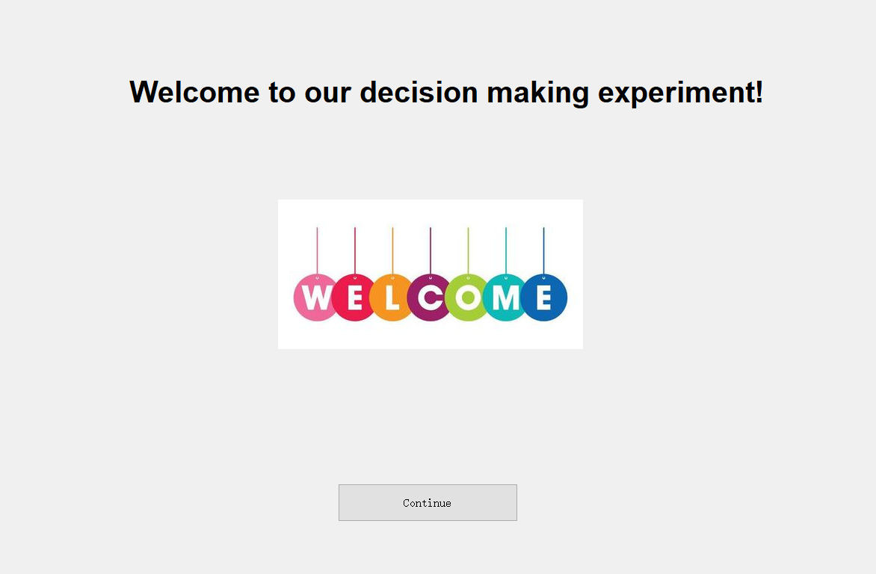
Fig. 1
Then there is a statement of informed consent that the participants need to agree to proceed. You could change the content easily in the Designer. If not tickled, an error window will show and the participants need to press ok then tickle the button and press the ‘continue’ button to continue(see Fig. 2).
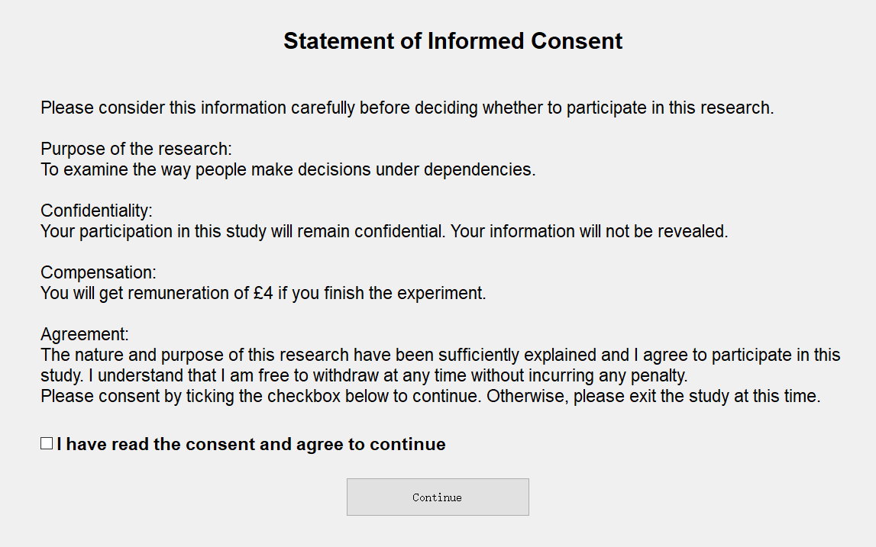
Fig. 2
Then, they need to finish the demographic information table. The age should be between 18 and 90, which could be changed in line 125 in python. And other options can be changed in Designer. Participants need to finish them to continue, or there would be an error message(see Fig. 3).
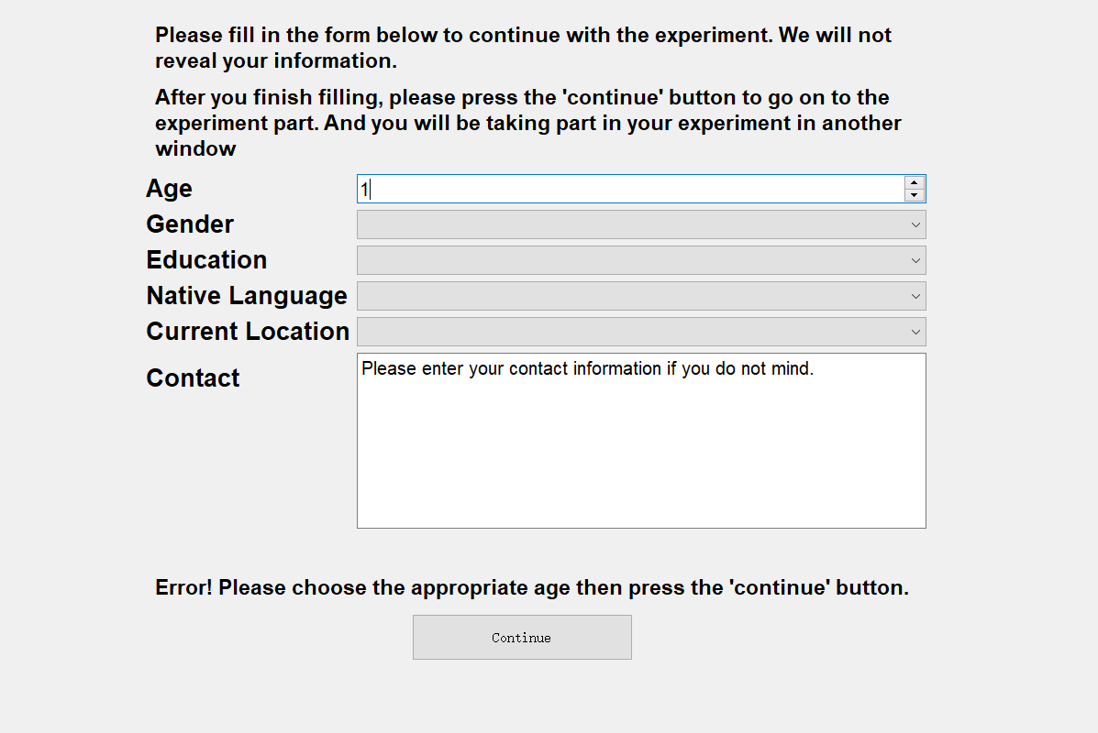
Fig. 3
Then they will see a new window open and it is experiment 1. They need to press the next button to continue(see Fig. 4).
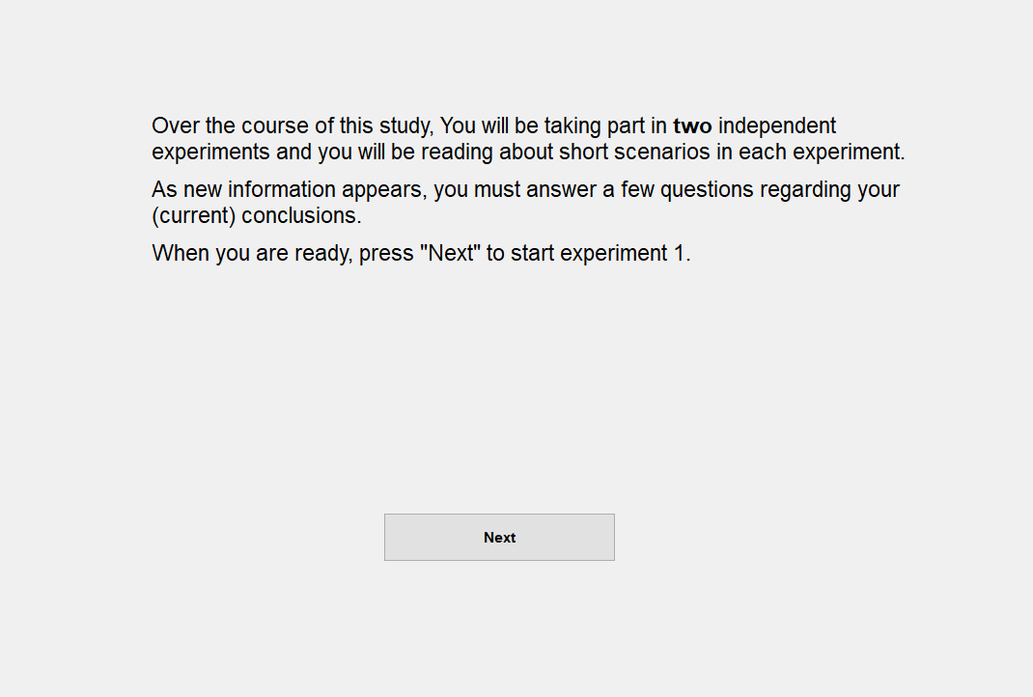
Fig. 4
Then they need to finish the conditional probability task. The baseline error rates (now 20%) can be changed in Designer by changing the text. And the probability value should be between 0-100 and it is set to -1 to avoid the default value. And the range could be changed in Designer(see Fig. 5).
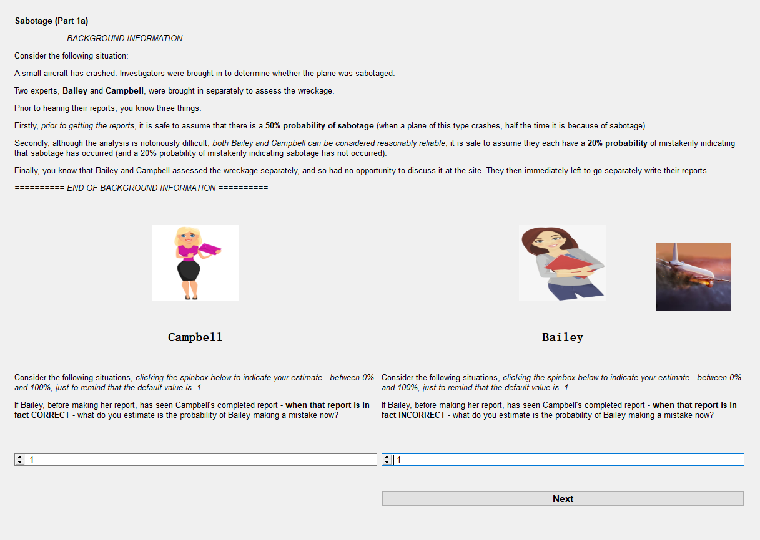
Fig. 5
Then they need to make judgements of the scenarios, input the confidence and the probability of two scenarios. The order of the choices of the judgements are randomly set and could be changed in python in line 168. The confidence and the probability value should be between 0-100 and it is set to -1 to avoid the default value. And the range could be changed in Designer(see Fig. 6).
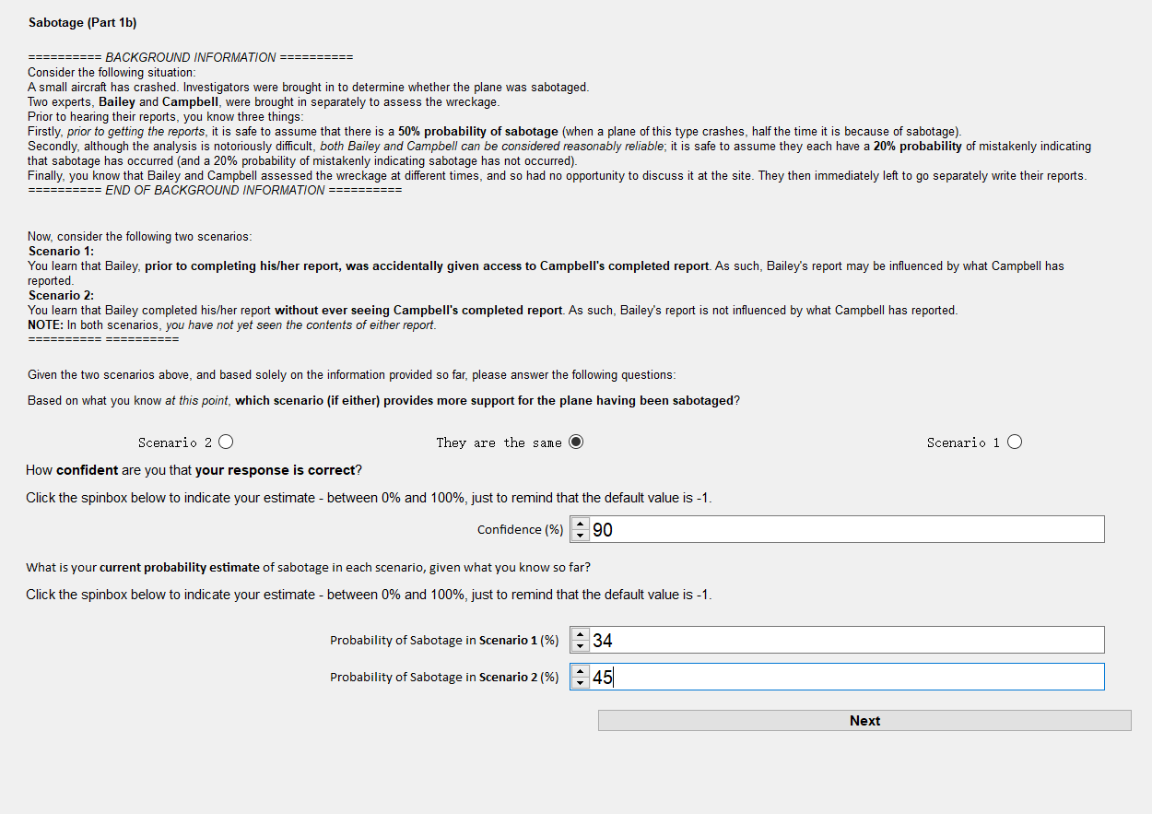
Fig. 6
The error message sample is below(see Fig. 7).
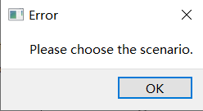
Fig. 7
Then they need to provide some reasons of their latest estimates(see Fig. 8).
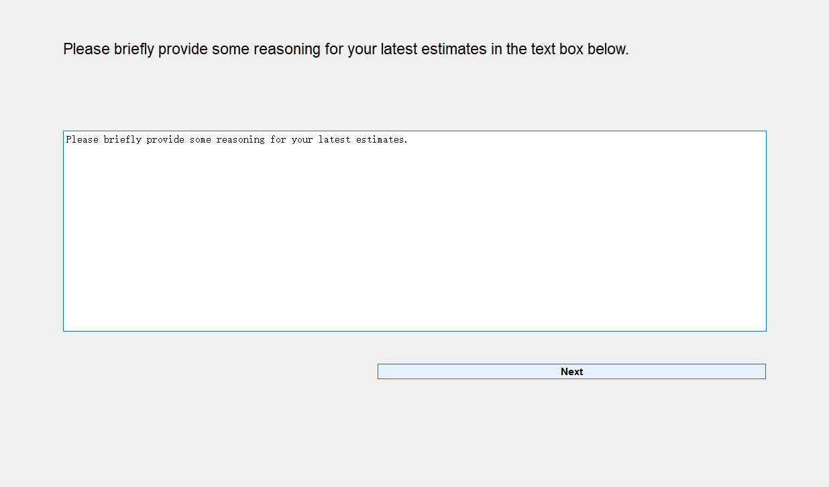
Fig. 8
Then they need to complete the second judgement task which is similar to the first(see Fig. 9).
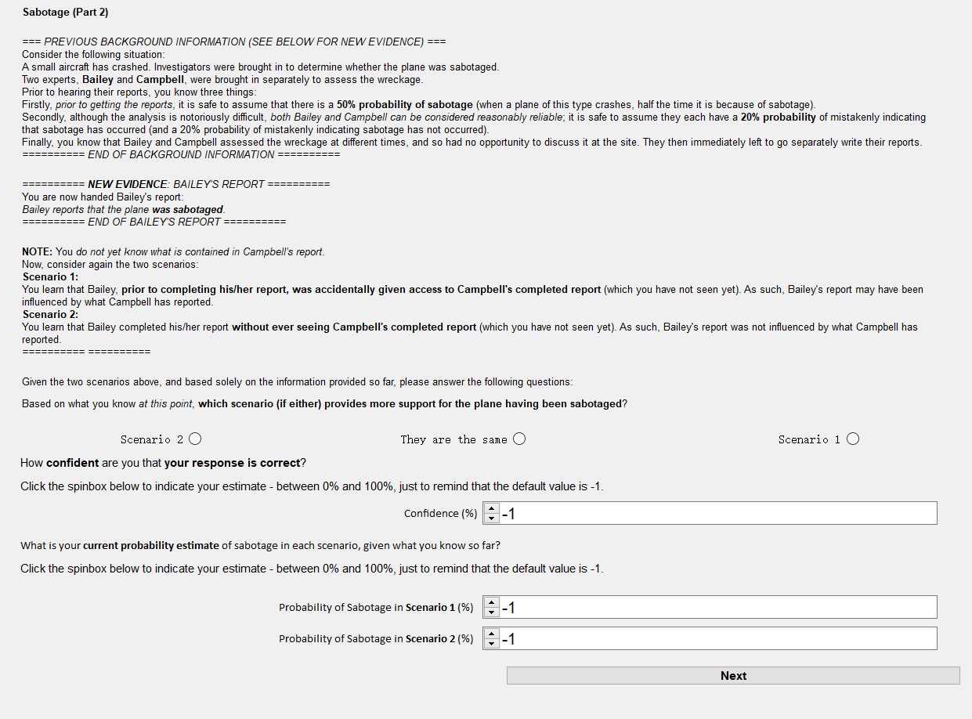
Fig. 9
Then they need to provide some reasons of their latest estimates(see Fig. 10).
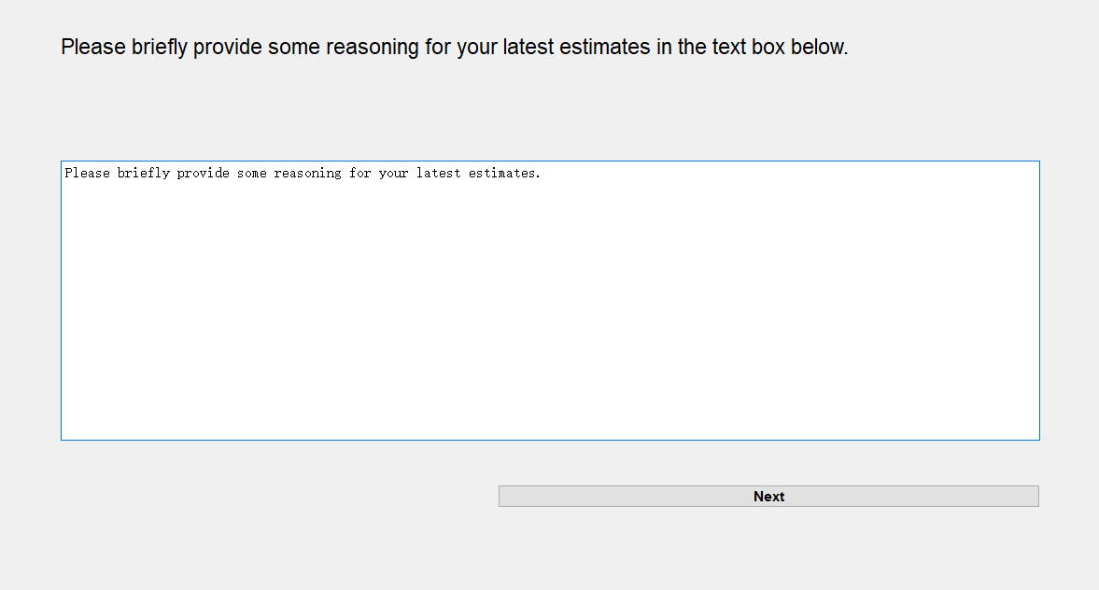
Fig. 10
Then it is the end of experiment 1 and they need to press the button to continue. A window of MineSweeping game and a window of experiment 2 will be opened. They need to finish the game and continue with experiment 2(see Fig. 11).
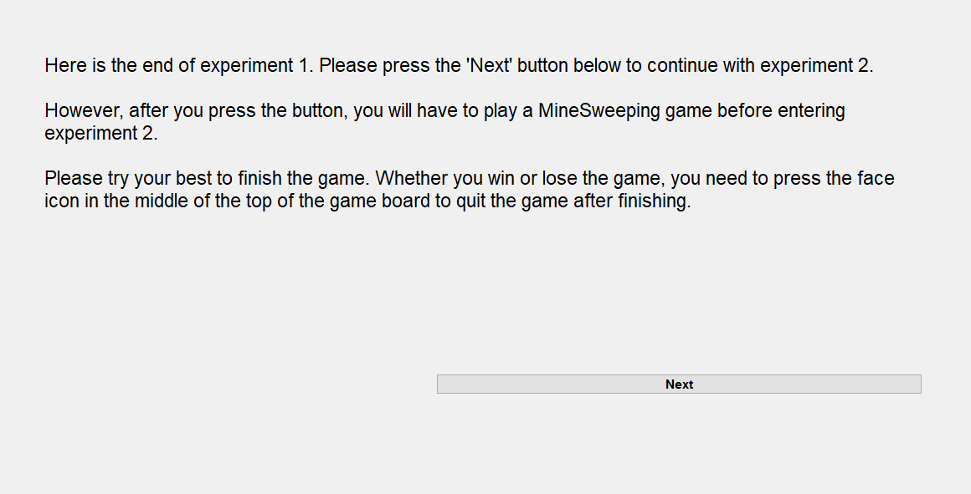
Fig. 11
MineSweeping Game (see Fig. 12).
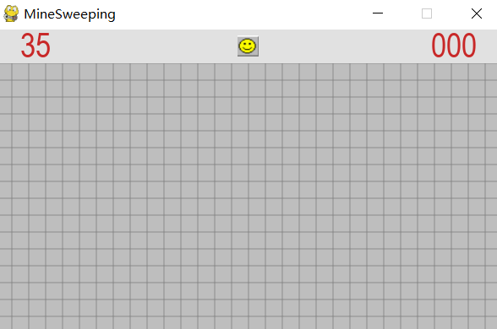
Fig. 12
End of the game (press the face icon to quit) (see Fig. 13).
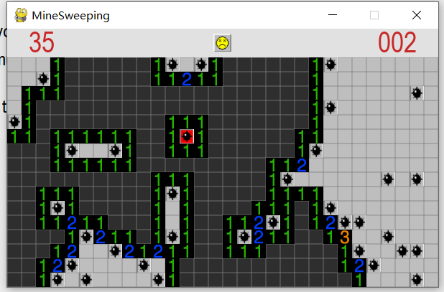
Fig. 13
Then they will enter experiment 2(see Fig. 14).
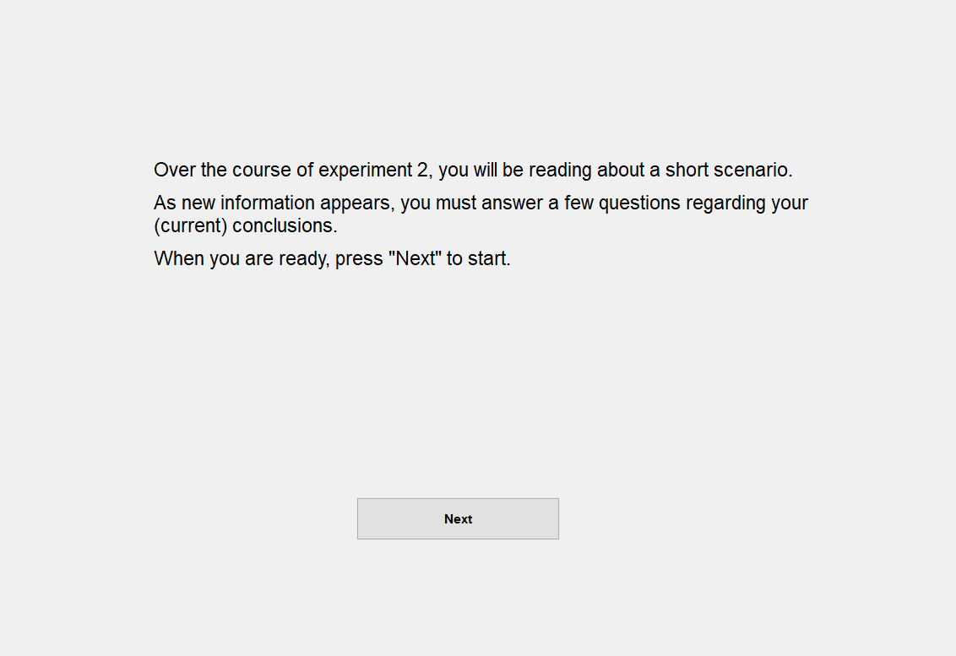
Fig. 14
For the conditional probability task in experiment 2, they need to finish all four questions including sabotage and accident. The baseline error rates (now 20%) can be changed in Designer by changing the text. And the probability value should be between 0-100 and it is set to -1 to avoid the default value. And the range could be changed in Designer (see Fig. 15).
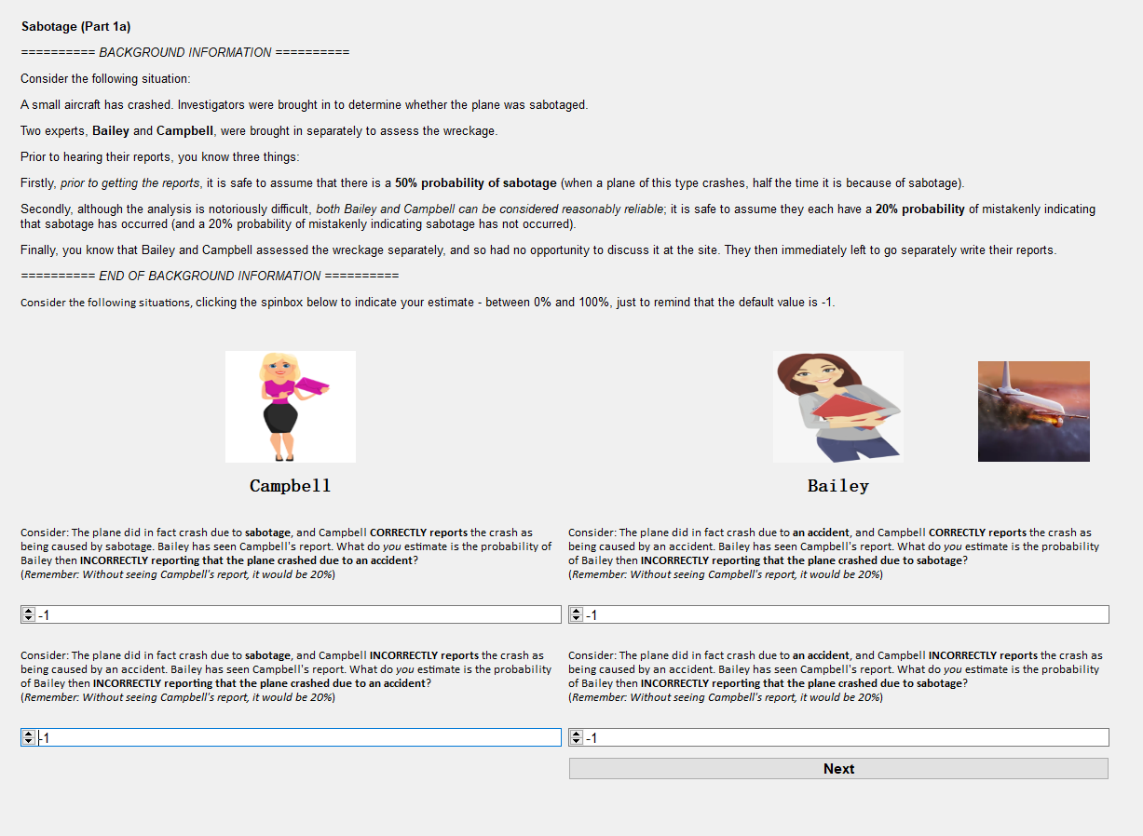
Fig. 15
Then they need to finish a judgement task similar as experiment 1, but now they need to assess the probability of the accident instead of sabotage (see Fig. 16).
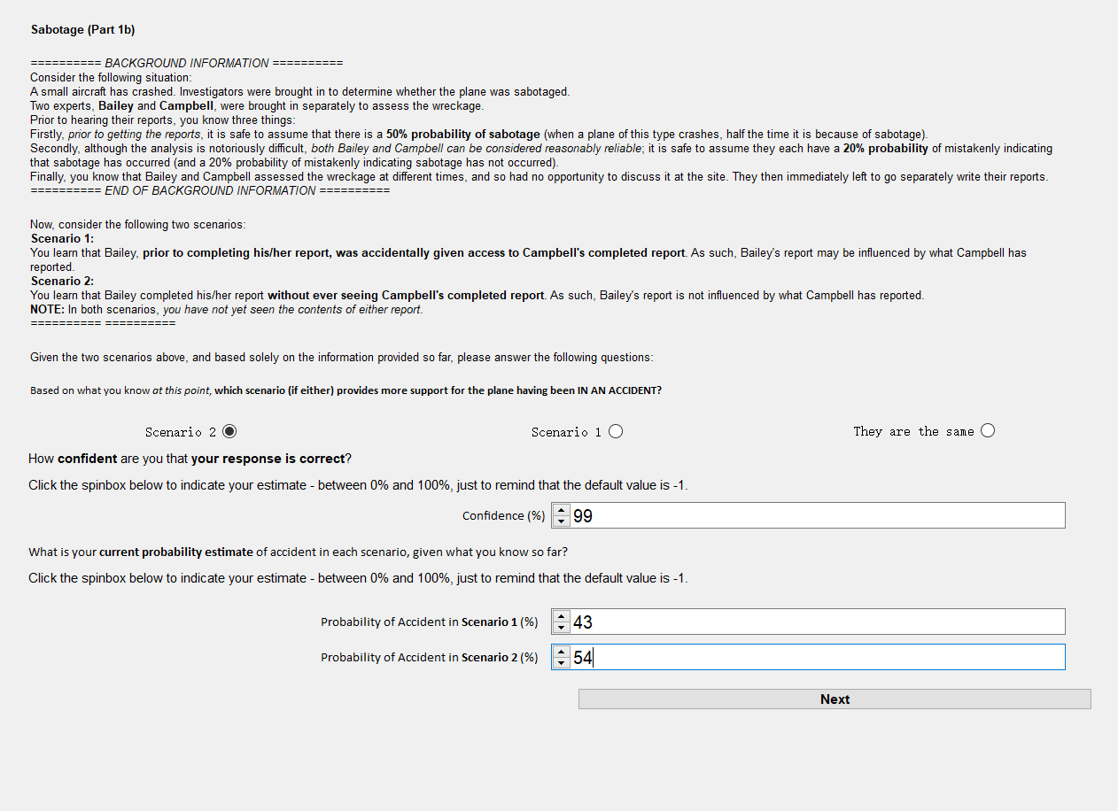
Fig. 16
Then they need to provide some reasons of their latest estimates (see Fig. 17).
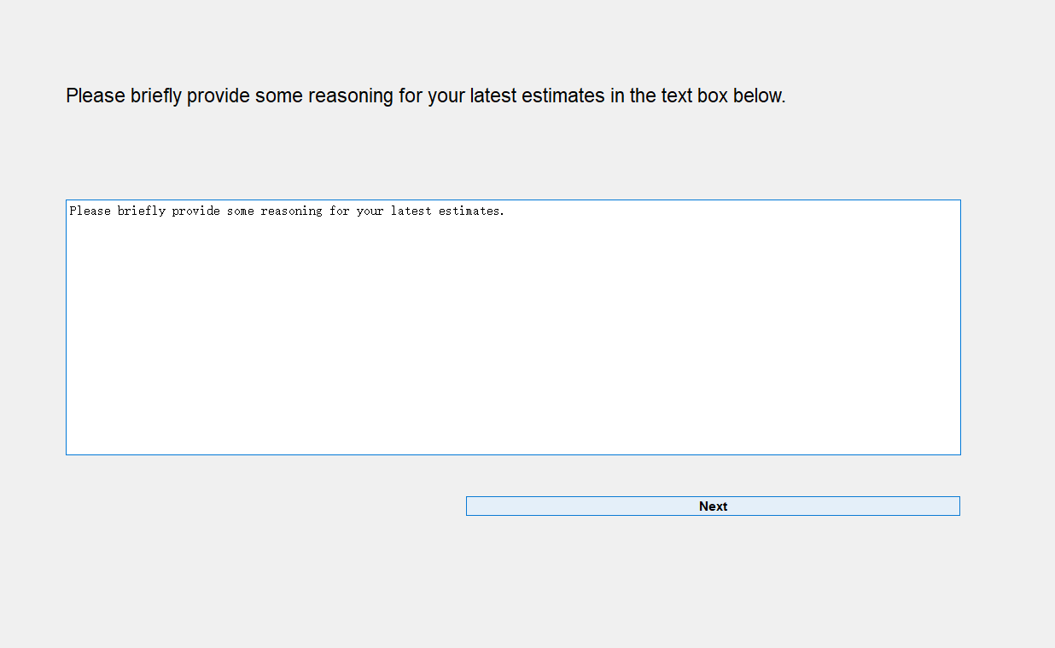
Fig. 17
Then there be a short debrief and the data would be collected(see Fig. 18).
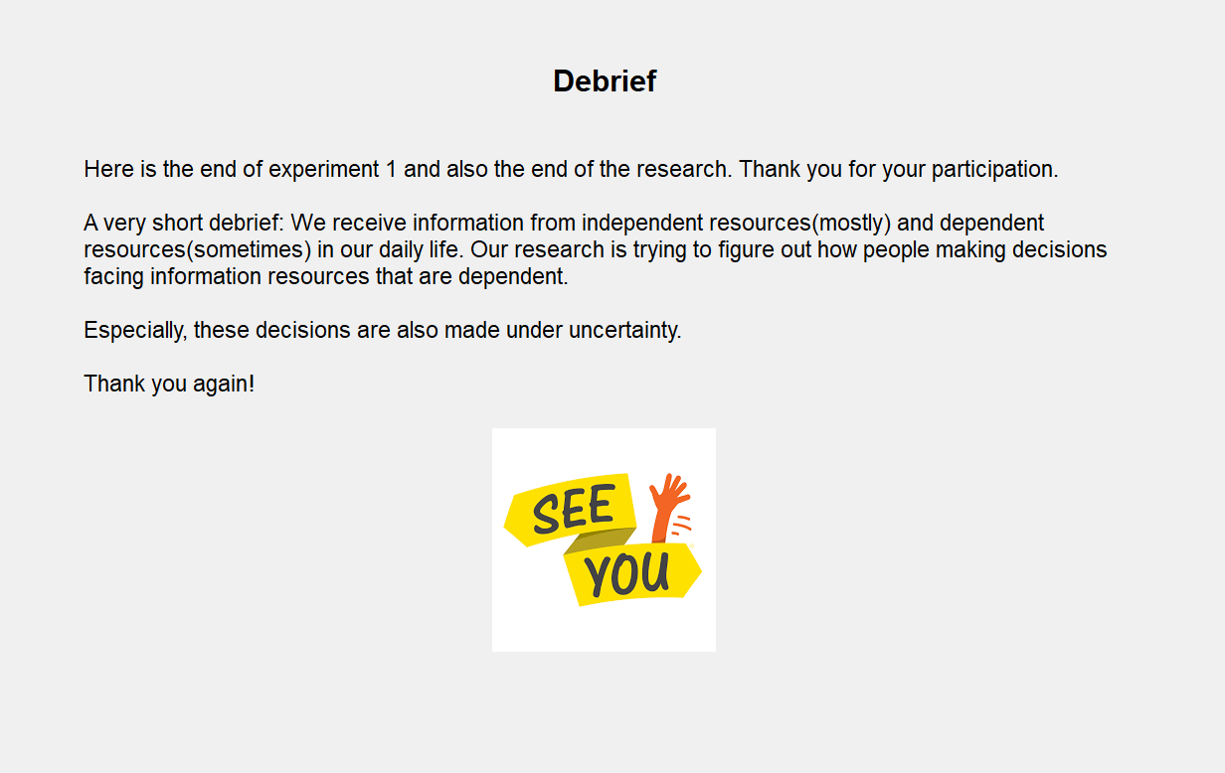
Fig. 18
Data coding of experiment 1(see Fig. 19).
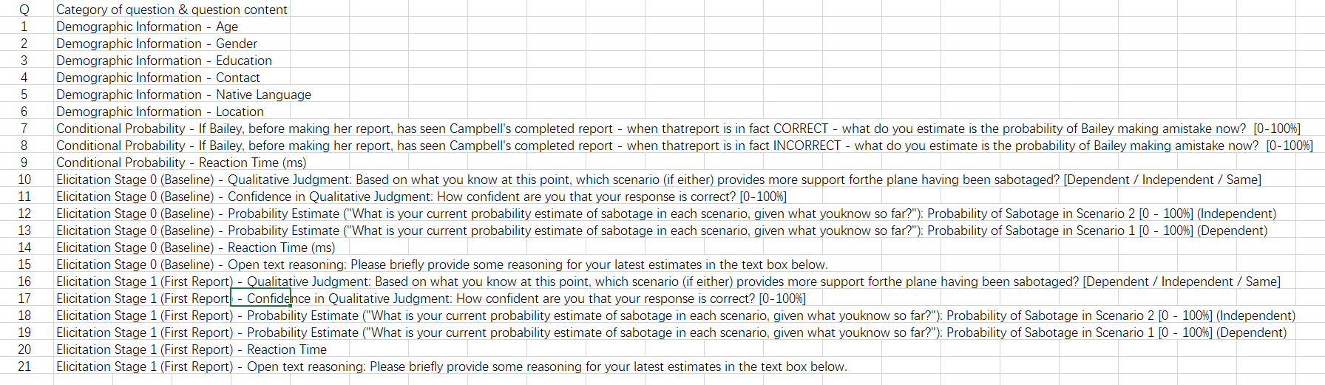
Fig. 19
Data coding of experiment 2(see Fig. 20).
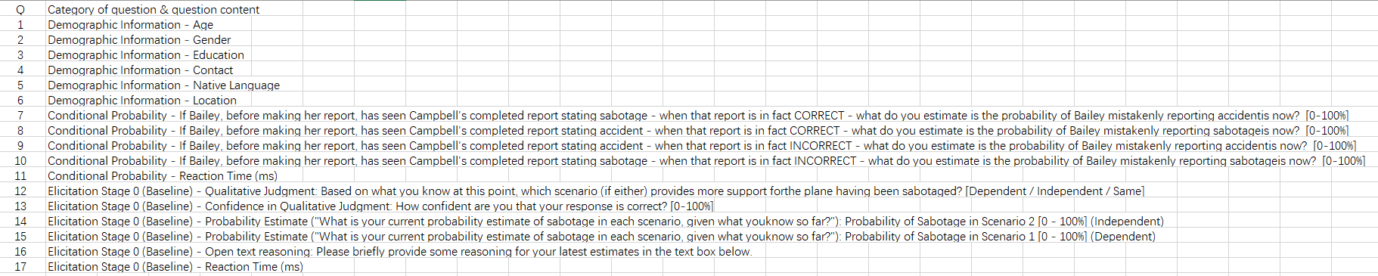
Fig. 20

