**Commit to repository**

git status

git add --all

git commit -m"my comment"

git push

**Pull repository**

git pull

**Hent dit repository**

git clone https://github.com/{username}/{repository-name}.git

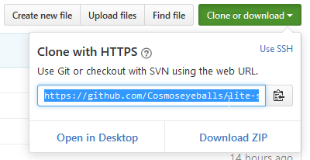

**Basic Git commands**

<https://confluence.atlassian.com/bitbucketserver/basic-git-commands-776639767.html>