**GRIFFITH COLLEGE DUBLIN**

**GRIFFITH COLLEGE CORK**

**GRIFFITH COLLEGE LIMERICK**

**QUALITY AND QUALIFICATIONS IRELAND**

**EXAMINATION**

**HIGHER CERTIFICATE IN COMPUTING**

**STAGE II**

**OPERATING SYSTEMS DESIGN**

**Module code: HCC-OSD**

**BACHELOR OF SCIENCE IN COMPUTING**

**STAGE II**

**OPERATING SYSTEMS DESIGN**

**Module code: BSCO-OSD**

**BACHELOR OF SCIENCE (HONS) IN COMPUTING SCIENCE**

**STAGE II**

**OPERATING SYSTEMS DESIGN**

**Module code: BSCH-OSD**

**Lecturer(s): Dr. Faheem Bukhatwa Bridget Murphy**

**Dale Amenda**

**External Examiner(s): Dr Joseph Timoney**

**Date: 22nd May 2018 Time: 9.45-11.45**

**THIS PAPER CONSISTS OF FOUR QUESTIONS**

**THREE QUESTIONS TO BE ATTEMPTED**

**SECTION A - COMPULSORY**

**SECTION B - TWO QUESTIONS TO BE ATTEMPTED**

**SECTION A – COMPULSORY**

**QUESTION 1**

(a) Describe, with the use of a diagram, the Dining Philosopher problem and outline the problems it demonstrates. Also, outline some possible solutions to the problem.

**(10 marks)**

(b) Describe what a semaphore is and how it works in the context of operating systems.

**(10 marks)**

(c) What does RAID stand for and outline using diagrams the distinctions and functions of RAID 0, RAID 1 and RAID 3?

**(10 marks)**

(d) With reference to deadlocks:

1. State and describe each of the conditions required for a deadlock to happen in a system.

**(4 marks)**

1. Explain the steps involved in deadlock detection using Directed Resource Graphs.

**(6 marks)**

(e) Outline what a threat is and describe five security threats that can occur within systems.

**(10 marks)**

**Total (50 marks)**

**SECTION B - TWO QUESTIONS TO BE ATTEMPTED**

**QUESTION 2**

(a) In demand paging, a process requests pages in the following order: d c a a a c e d c e a e a.

Construct a page trace analysis indicating page faults with an asterisk (*) where memory is divided into three page frames using a **Least Recently Used** page swap algorithm.

**(10 marks)**

(b) With the aid of a diagram, show how internal fragmentation happens in fixed memory partitioning systems.

**(5 marks)**

(c) What is meant by the **page working set** in demand page memory systems? Explain how the optimal size of the working set is determined?

**(10 marks)**

**Total (25 marks)**

**QUESTION 3**

(a) While retrieving data from Track 25, the following list of requests has arrived: Track 50, 70, 10, 30, 5, and 75. The directional bit was indicating that the head was moving from track 0 towards the maximum track of 90. It takes 1ms to travel from one track to next.

Use the SCAN strategy to calculate the total seek time involved in servicing all requests.

**(8 marks)**

(b) Explain the following three components of disk access time: Seek time, search time and transfer time. Which takes the longest?

**(8 marks)**

(c) List **five** events that can cause a process to lose control of the processor?

**(5 marks)**

(d) Explain the operation of SPOOLING?

**(4 marks)**

**Total (25 marks)**

**QUESTION 4**

1. What is the function of a Thread Control Block (TCB)? List four items of information that are contained within a TCB.

**(8 marks)**

(b) With the aid of a diagram, discuss the five states a process can have as it moves through the system. Indicate transitions on the diagram.

**(5 marks)**

(c) Apply the directed resource graphs to check for the presence of a deadlock in the system of processes and resource outlined in the figure. Explain your steps.

**(6 marks)**

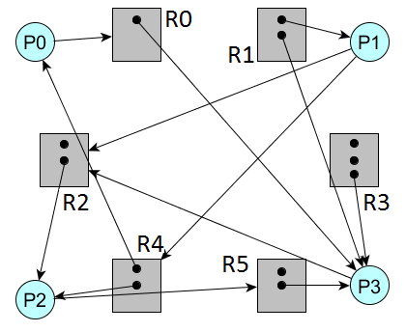

(d) During the course, we discussed a number of memory allocation schemes. Describe the following schemes. Your answer should include at least one advantage and one disadvantage of each.

1. Fixed Partitions;

**(3 marks)**

1. Dynamic Partitions;

**(3 marks)**

**Total (25 marks)**