**Operating Systems Design** : Tutorial 02 - Memory management

*Question 1 : Explain the functions of the Bounds, address and instruction register.*

> Bounds refers to a simple form of virtual memory where access to the memory of a computer is controlled by a processor register, called bounds register. A bounds register stores the highest location accessible by each program. The address register simply stores the location of the data which needs to be accessed and the instruction register stores the location of the instruction executed currently.

*Question 2 : Explain the fixed partitioning memory management system. Use a diagram. List its disadvantages.*

> The fixed partitioning memory management system divides the memory into different partitions of different sizes, and looks for the most suitable. This system requires entire program to be fully loaded and stored, and arbitrary partition sizes lead to undesired results, like the internal fragmentation - memory waste (too large partition size) or longer turnaround time (too small partition size).

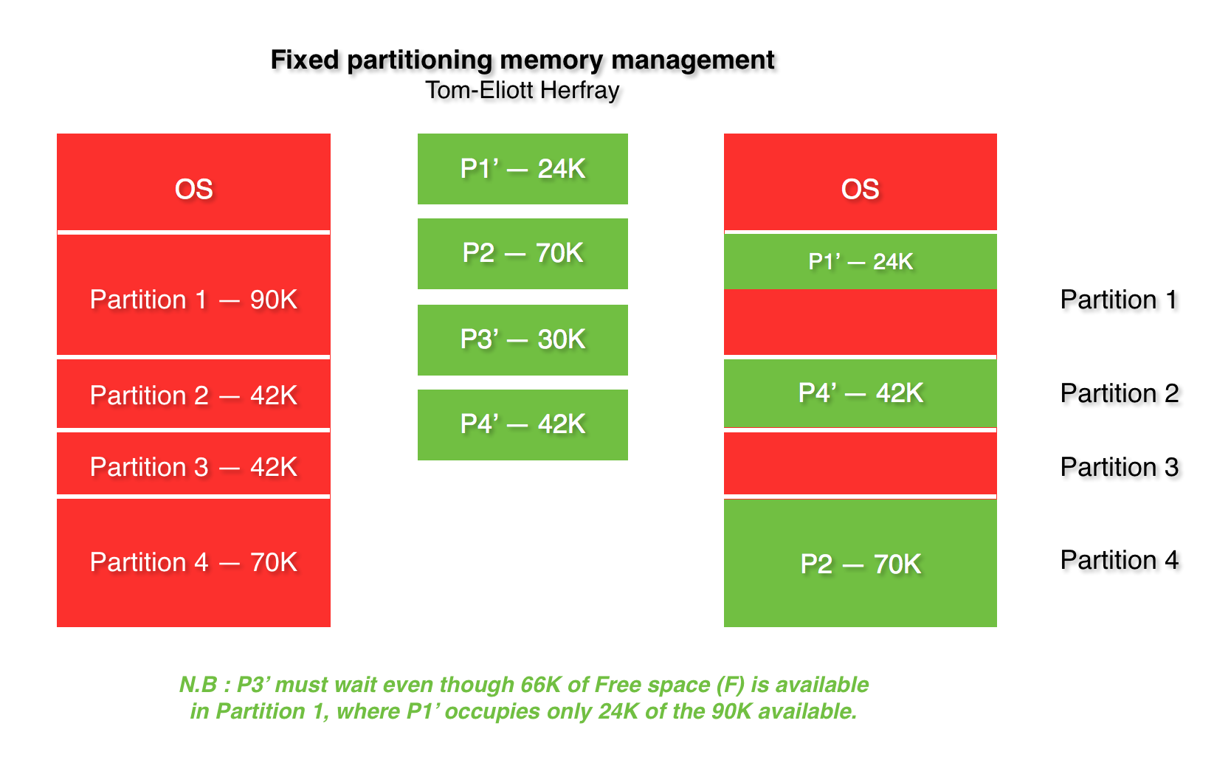

*Question 3 : Explain the first, best, worst and next schemes when allocating memory to a process in fixed partitioning memory system.*

> There are 4 methods of allocation schemes : First Fit (when partition is allocated from the first availability in the Main Memory), Best Fit (will check everything and find the smallest sufficient partition among the free available partition), Worst Fit (will find the largest sufficient in the free partitions available in the Main Memory) and Next Fit (a derivative of First Fit, will find the first sufficient partition from the last allocation point).

*Question 4 : Explain how to join two blocks in dynamic partitioning memory management system. Suggest a table of free partitions and show how to combine two partitions located in memory when deallocating memory in. Give addresses and sizes of partitions.*

> To join 2 blocks in dynamic partitioning memory management system, the blocks must be adjacent, and list changes to reflect starting address of the new free block (block 1 + block 2). The memory block size changes too, to show its new size for the free space (combined total of the 2 free partitions). If we take the example of the course, we have :

Block 1 (in blue) and block 2 (in orange) can be reached via address 7600 which is busy. The 2 blocks being adjacent, we take the addresses 7600 and 7800 and form the “new” address 7600 with a size which is the sum of the size of the previous address 7600 (= 200) and the address 7800 (= 5).

So, we have the address 7600 with a size of 205 and the 2 blocks are combined in a dynamic partitioning memory management system.

*Question 5 : What are the advantages and disadvantages of the compaction operation?*

> The compaction operation is used to recover fragmented sections of memory space by relocating programs into memory (moves the busy block to the top) but it is slow and program changes address memory and have to be relocated.

--

N.B: Schemes & diagrams are made by me.