**Idea:**

Idea is to build army and fight other armies. You will have certain amount of points to create armies and be able to save and load armies. The games modes I have come up with are as follows:

Arena – Start with 1000 points Go up against army that has been randomly placed by an AI but has 10% more points. You place your initial army at the start. Every time you win you get x more points to spend and can choose to spend them at the end of each round to add units or not. Special units will appear at random. Every 5 levels the AI get x% more points to spend

Campaign – Points replaced by money. All armies to fight are pre made campaign is linear as you progress adding new units more points etc etc. Each fight you see the enemy army first and must place your units accordingly to win

Challenge – Fight historical leaders with well set up and thought out armies. Have an easy medium and hard mode where you have 90%,50%,25% of the points of the army you are fighting

Custom – Specify an amount of points each player has and then set up the armies for each to see how the battle would play out

The game will work in a basic rock paper scissors style like follows:

Infantry beat cavalry, cavalry beat archers, archers beat infantry (may add more units to spice up)

**Must:**

* Allow user to create, load and save armies
* Simulate combat between two armies
* Have at least 3-unit types that deal different amounts of damage to other units
* Allow user to change health of units based on points
* Have a few base armies created by me for the user to fight
* Add the custom game mode

**Should:**

* Add more unit types
* Add one of the game modes
* Display a dynamic combat to the user
* Create a GUI for displaying army combat

**Could:**

* Add more game modes
* More variety of units
* Allow user to change units target priority for more control over armies

**Research:**

C++ has a large amount of libraries to use, while I will include all ones learnt about in class (string, csmaths, cstime etc) I intend to use open GL for the GUI side Each cell will be represented like follows

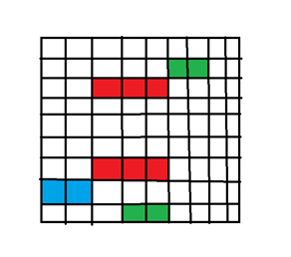 A blue tile would represent Archers, a green one cavalry and red infantry. Health would be denoted by how ”dark” a color is (using their RBG values to display this) while the back end would have each cell represented by a string for all information about each cell to be stored e.g. 0E00 - empty cell 1I20 - infantry with 20 health belonging to player 1.