|  |  |  |  |
| --- | --- | --- | --- |
| Function Tested | Goal of Function | Evidence | Notes |
| File Loading, File Choosing from user | Load files specified by user | 1,2 |  |
| Display Board | Display the Board of the two armies | 2 |  |
| Movement and fighting of units | To move units and make them attack | 3,4 | For undetermined reason Priests are invincible, Once game finished console would crash rather than declaring winner |
| Create army | Create an army from specified amount of points | 5,6 |  |
| User inputs | Get information like coordinates, health, file names | 6 |  |
| Save file | My army accepted as a file and saved in documents | 7 |  |

(1)

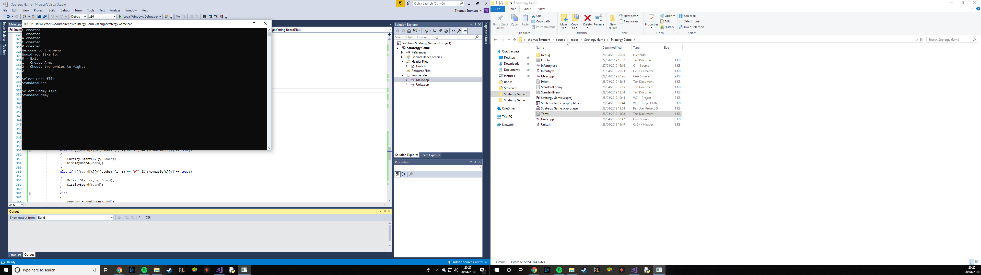

(2)

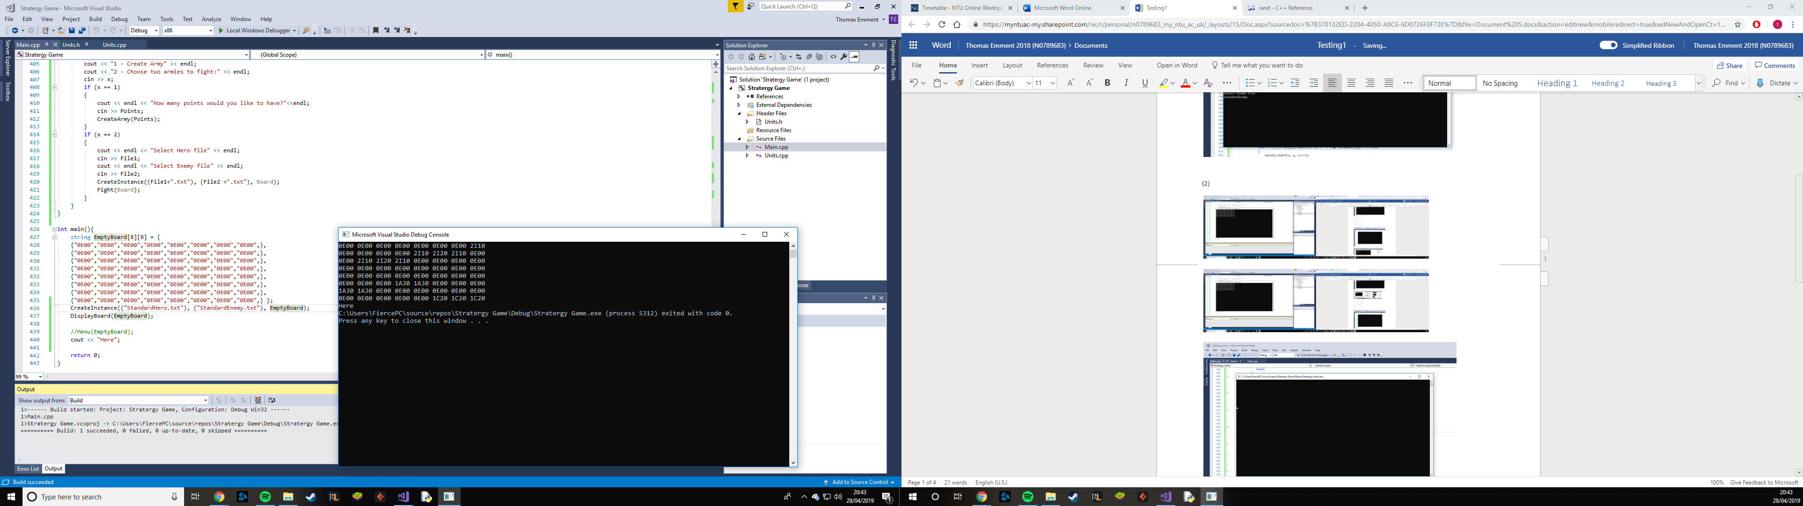

(3)

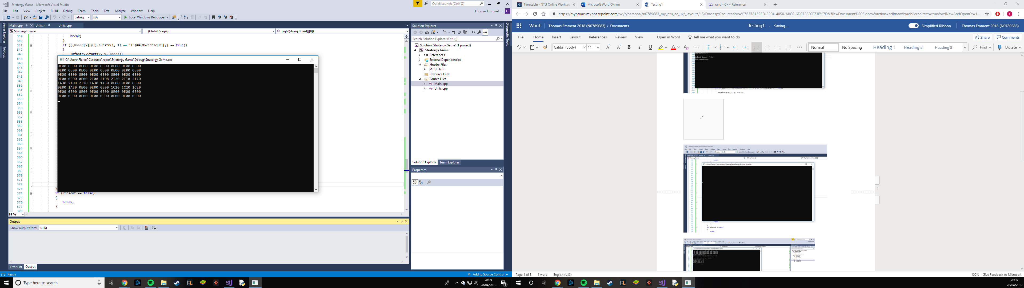

(4)

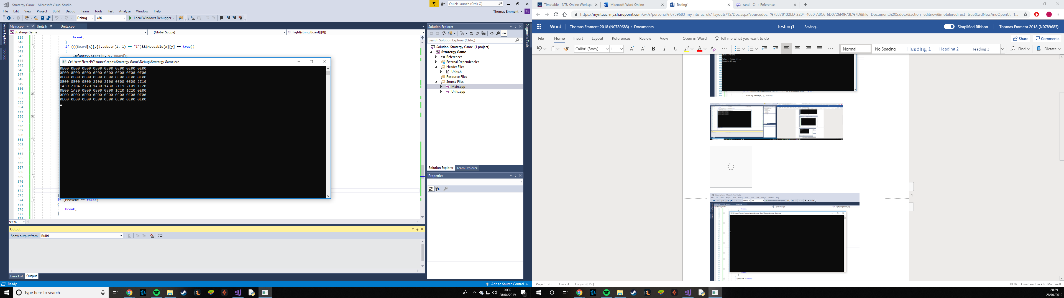

(5)

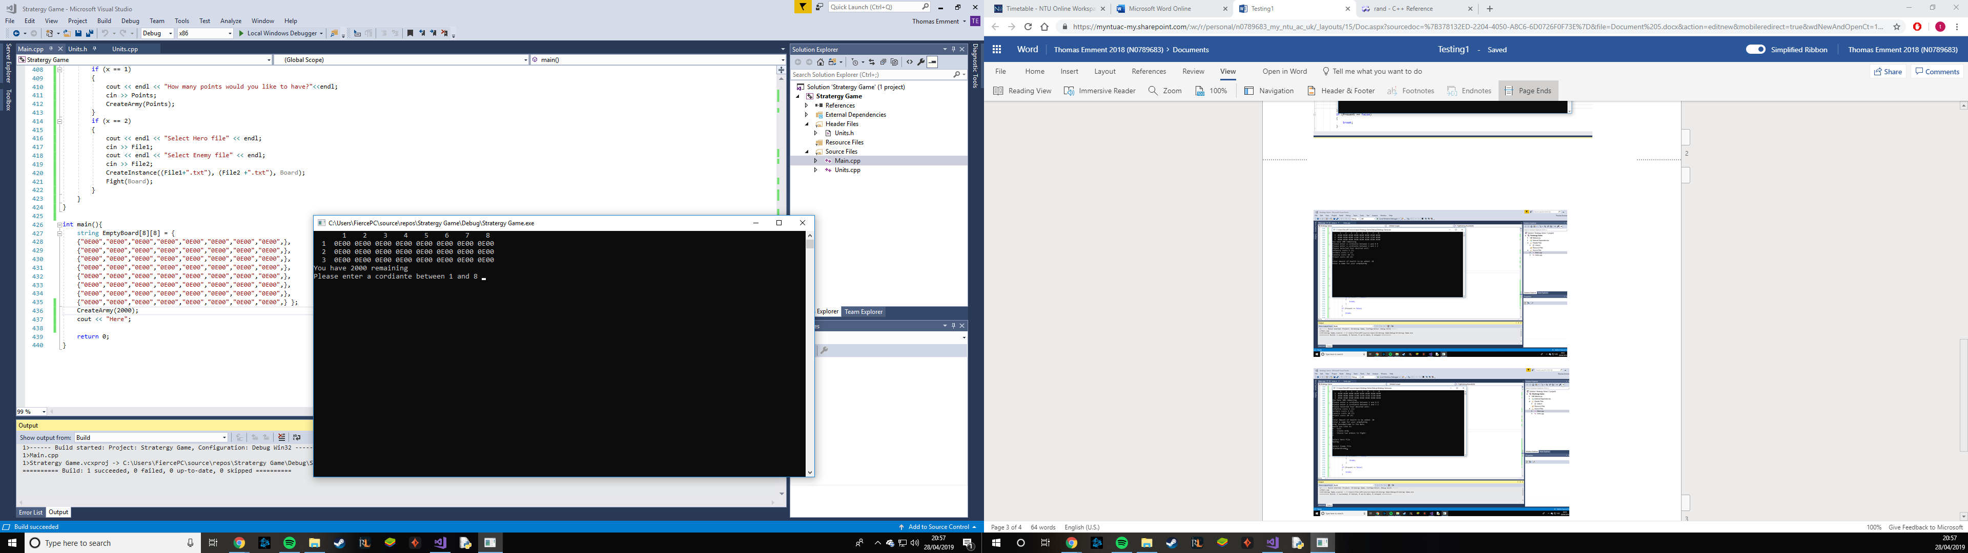

(6)

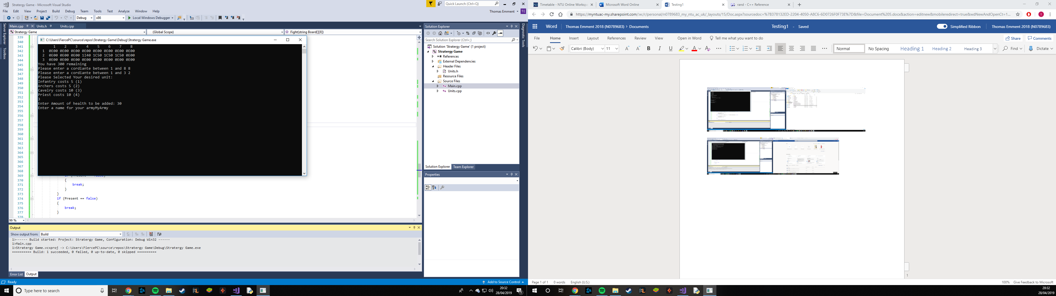

(7)

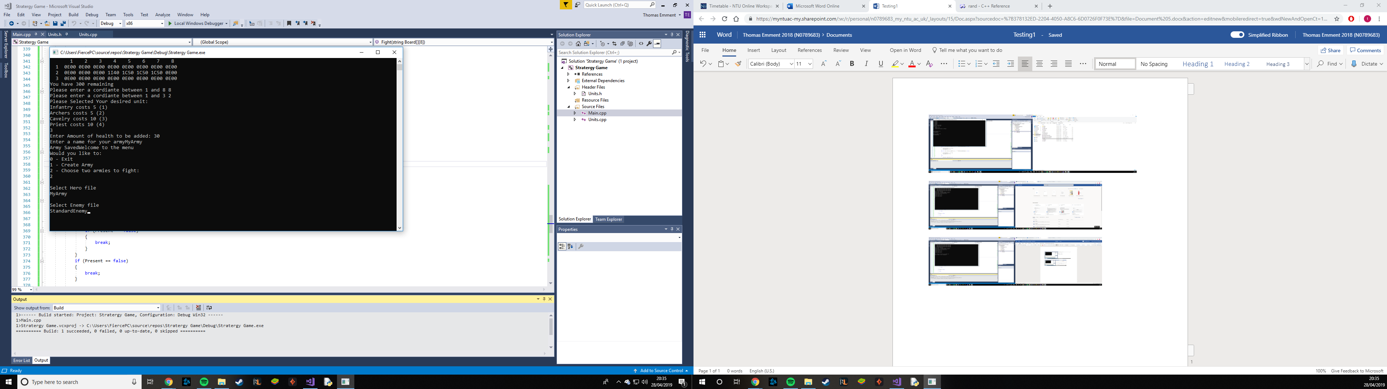

(8)

