**Design:**

**Flowchart:**

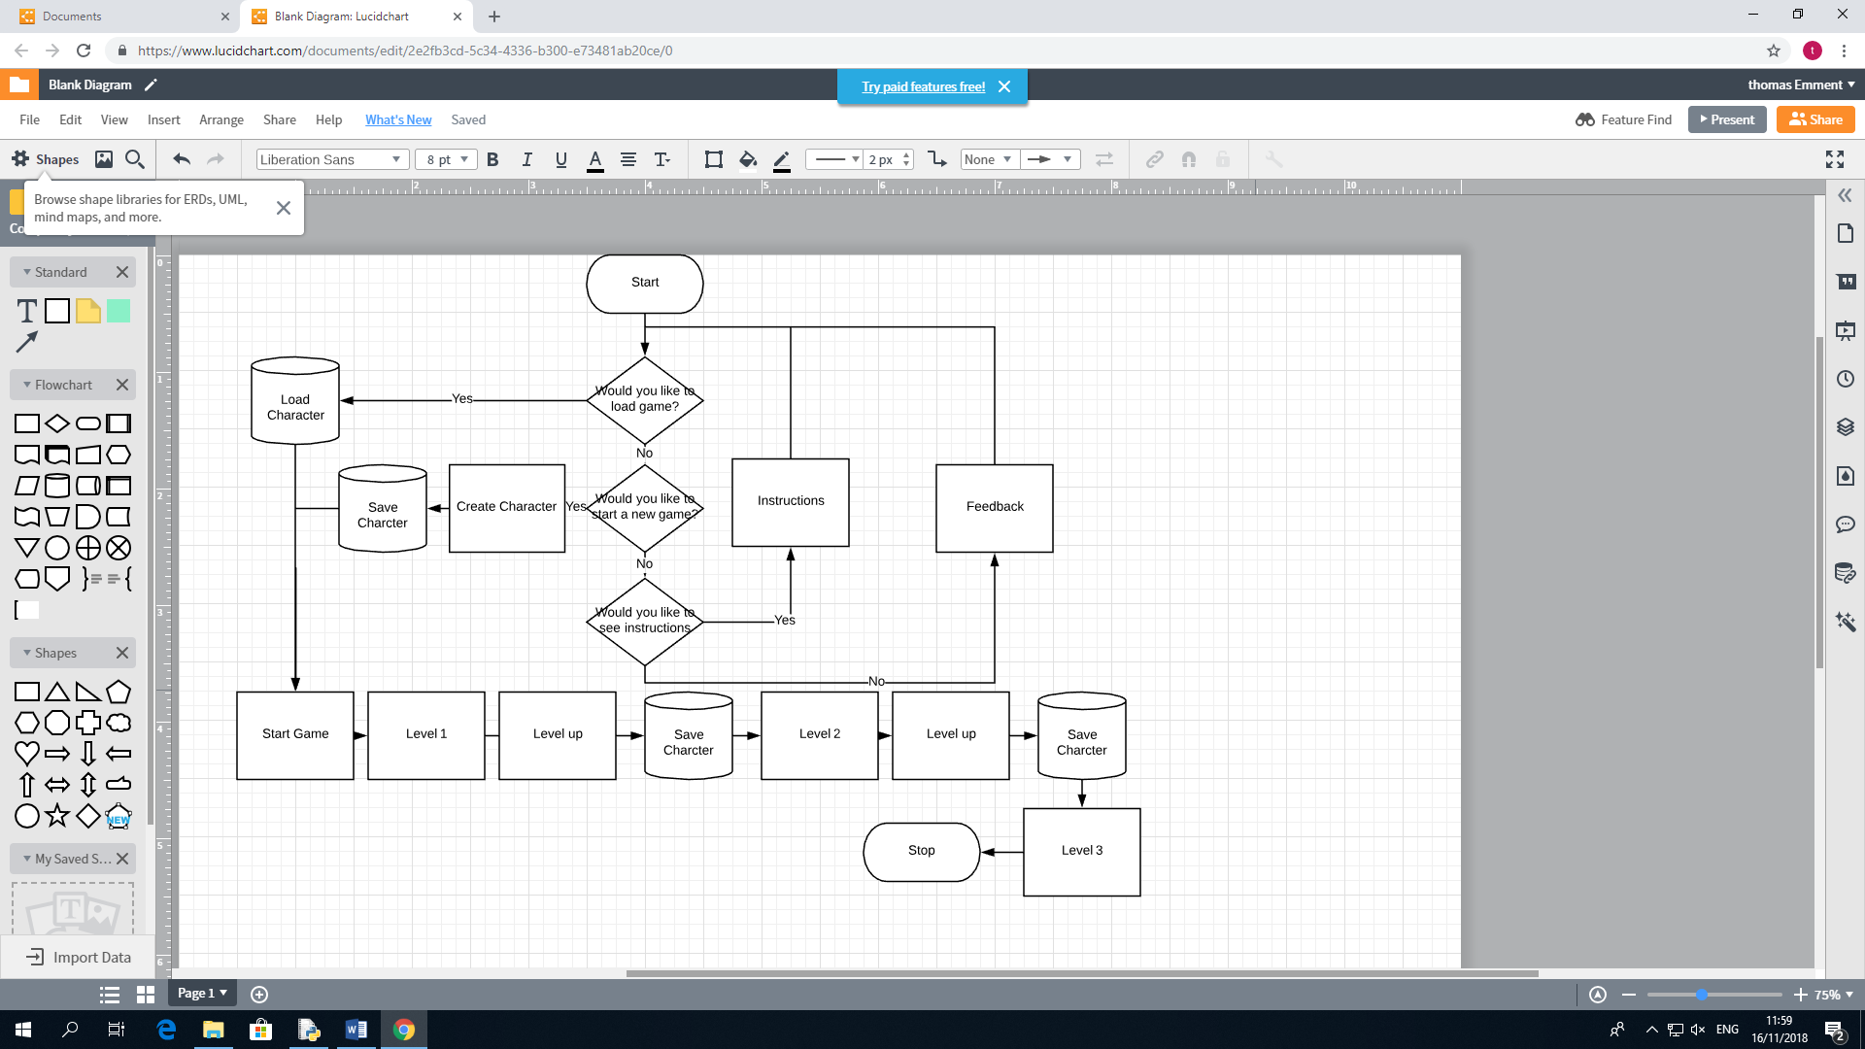

**Database design:**

|  |  |  |  |
| --- | --- | --- | --- |
| Database | Item | Data type | Example |
| Saved_Game_Character | Name | text | Tom |
| Strength | Integer | 1 |
| Health | Integer | 2 |
| Agility | Integer | 3 |
| Dexterity | Integer | 3 |
| Luck | Integer | 4 |
| Level | Integer | 8 |

|  |  |  |  |
| --- | --- | --- | --- |
| Database | Item | Data type | Example |
| Saved_Games_Equitment | Name | text | Tom |
| Head | text | Wooden_Helm |
| Weapon | text | Wooden_Sword |
| Chest | text | Wooden_Boots |
| Feet | text | Wooden_Chestplate |
| Legs | text | Wooden_Leggings |
| Hands | text | Wooden_Gauntlets |

**Class design:**

|  |  |  |  |
| --- | --- | --- | --- |
| Class | Initial | Data type | Class functions |
| Equipment | Level | Integer | None |
| Name | Text |
| Strength | Integer |
| Health | Integer |
| Agility | Integer |
| Dexterity | Integer |
| Luck | Integer |
| Armour | Integer |
| Type | Integer |

|  |  |  |  |
| --- | --- | --- | --- |
| Class | Initial | Data type | Class functions |
| Monster | Level | Integer | Death |
| Name | Text |
| Strength | Integer |
| Health | Integer |
| Agility | Integer |
| Dexterity | Integer |
| Luck | Integer |

|  |  |  |  |
| --- | --- | --- | --- |
| Class | Initial | Data type | Class functions |
| Hero | Level | Integer | Death  Item Inventory  Quest |
| Name | Text |
| Strength | Integer |
| Health | Integer |
| Agility | Integer |
| Dexterity | Integer |
| Luck | Integer |
| Head | Text |
| Weapon | Text |
| Feet | Text |
| Chest | Text |
| Legs | Text |
| Hands | Text |