CSCI 562: Formal Specification Methods - § 31370 - Sp26
Team Project Progress Report I (PDF format as per instructions prompt)

Due: 03-01-2026

Scott Johnson Thomas Perez
s.j.johnson@und.edu thomas.perez@ndus.edu

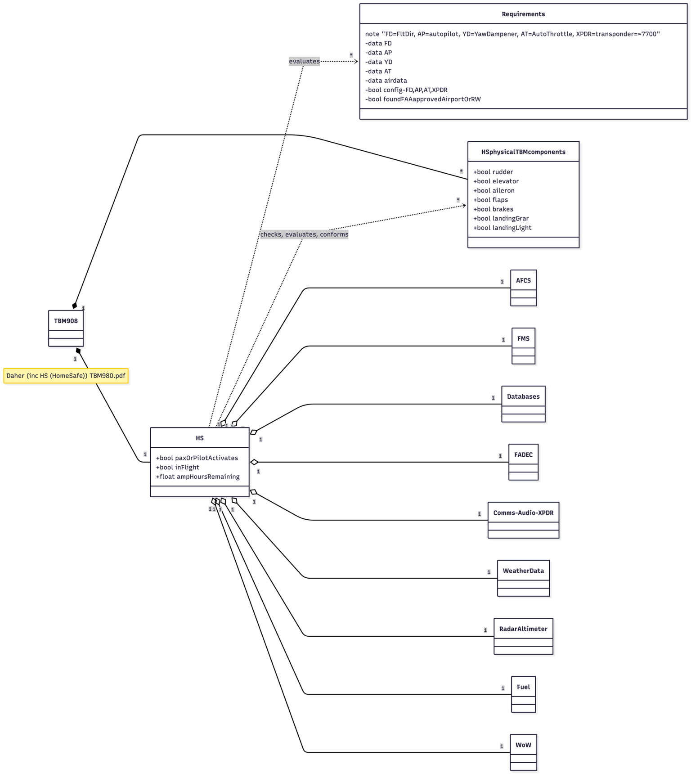
Regarding the instructions for this assignment, there are no [sic] issues, per se. Any issues are actually nuances within the Mermaid UML tool, and they are fairly easily solvable. Eg., one issue is the usage of comments in the Mm (Mermaid) code. It appears as though the implementation is inconsistent, including from project to project.
Another issue is obtaining an official Pilot Flight Manual and Pilot Checklist. Technical documents, especially, are not possible for download or physical delivery for us at this point, apparently, because of copyright considerations.

Assumptions:
• The Pilot Operating Handbook is extremely expensive. Having taught in HP (high-performance aircraft in my past, I can assume certain conditions to be true regarding flight, emergency (Ex ) procedures, minimum FAA requirements for VFR and IFR flight including part 121 and part 135 regulations, ATP certifications requirements, and more.
• Assume that the TBM980 is equipped with all optional equipment and upgrades.

Regarding "what is to be accomplished by the next reporting period" as prompted in our instructions to our assignment:
• Complete the Final Project, but most likely up to (or in the middle of) Zed Notation implementation, (including consideration of the following factors:)
• Pinpoint errors on ongoing progress
• Continually make improvements on ongoing progress
• Check for accuracy, as well as check for logical and sound thinking
• Continually search for verified FAA-approved sources of information
• Learn Zed Notation and/or OCL
• Read relevant chapters in our textbook - "Concise Guide to Formal Methods".

