Laboratory 1: Arduino

Objective: write the text here

# Basic working with Arduino IO, PWM and Serial

<https://www.arduino.cc/en/Guide/Introduction>

Look and do this getting started <https://www.arduino.cc/en/Guide/HomePage>

Also check the References <https://www.arduino.cc/reference/en/>

## First Task to be done

Make an LED Blink and Fade. What is the different between the two ways to realize it?

https://www.arduino.cc/en/Tutorial/Blink

https://www.arduino.cc/en/Tutorial/BlinkWithoutDelay

## Second Task to be done

Make an Buzzer Program

https://www.arduino.cc/en/Tutorial/toneMelody

## Third Task to be done

Expand the Blink Task with a button and a Buzzer

## Third Task to be done

Understand the Serial communication

<https://www.arduino.cc/en/Tutorial/DigitalReadSerial>

## Third Task to be done

Combine task 1.1 to 1.4. Be creative

# LED Matrix

Understand the function of Libraries and how to use them.

<https://www.arduino.cc/en/Reference/Libraries>

## First Task to be done

Given the Hardware (Arduino + LED Matrix 16X8 LED) do a counter and a small application. Read the documentation of the module and apply.

## Second Task to be done

Count with the LED from 0 to 128. As Tipp use the function “matrix.drawPixel(X, Y, COLOR)”

How does this function work?

## Second Task to be done

Draw easy Bitmap on the LED Matrix. As Tipp use the function “matrix.drawBitmap(0, 8, om_bmp, 8, 8, HT16K33_BLINK_CMD);”

How does this function work? What else is nessesary?

## Third Task to be done

Print some Text in the LED Matrix. As Tipp use “matrix.print("Hello");” and “matrix.setCursor(x,0);”

How does this work?

## Third Task to be done

Document and explain all functions and how does the Board work.

# LED Matrix as Terminal Output

Combine the knowledge of the two previous Tasks and write a LED-Banner that plots the data that is send the Arduino via Terminal.

Describe how your program works.

# Wire layout for temperature measurement(Arduino)

Wire layout for temperature measurement

(Arduino/Genuino)

In the first part of the laboratory we will connect the digital thermometer (DS18B20) and the Arduino

Uno, in order to get data from the digital sensor and to measure the temperature.

You need the following:

* 1 or more digital thermometer (DS18B20)
* 1 Arduino Uno or similar board.
* 1 resistor (4,7K Ω)
* Cables (Vcc = red GND = black)
* 1 Breadboard (grey element in the figure)

Figure 1 shows two different operation modes for the digital thermometer, use the one you prefer.

Read the datasheet to know the different characteristics of each mode.

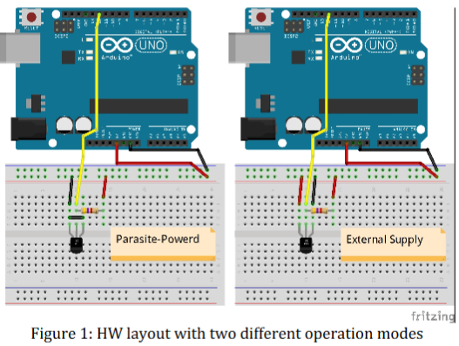

## Implementation

The digital thermometer uses a one-wire protocol for communication. Fortunately the Arduino IDE

already provides an implementation for the protocol (one-wire library). For this exercise we will use

the already existing library. Just download it (http://playground.arduino.cc/Learning/OneWire) and

integrated it into the Arduino IDE.

## : Temperature reading

Using the Arduino implement get the data from sensor and plotted at the Serial console.

## : LED scale

Expand the circuit with 2 LED Matix and Print the Temperature.

Helpful TOOLS

Sketching Tool

<http://fritzing.org/download/>

Arduino IDE

https://www.arduino.cc/en/Main/Software