A Descriptive Analysis of How Psychology Journals Handle Post-Publication Critiques

Whamond, A., Vazire, S., Clarke, B., Moodie, N., Schiavone, S., Thibault, R. T., & Hardwicke, T. E.

04 January, 2024

Fostering critical discussion is essential to upholding the ethos of science as an unbiased, collaborative, and self-correcting endeavor. Journals can support this by offering options for post-publication critique, such as commentaries or letters, allowing peers to voice substantiated concerns of empirical articles. We provide a descriptive, cross-sectional analysis of post-publication critique policies and prevalence across both prominent randomly-selected and psychology journals. We found that 38% of prominent and 23% of randomly-selected psychology journals offered explicit options for post-publication critique. Length and time-to-submit limits were often not stated. Critique prevalence was rare with only a single event identified among two samples of 101 articles. Given the widespread recognition of the replication crisis in psychology, allowing avenues for criticisms to be voiced may help increase the credibility within the field. To support transparency and self-correction, psychology journals should offer clearly stated post-publication critique options and encourage their use.

# Main

*Add ‘Introduction’ section*

Common post-publication critique types including median restrictions, peer review policies, and descriptions

Type

Length

Time-to-submit

References

Peer-review

DOI

Description

Letters

500

8

6

20%

Yes

Concise criticisms submitted shortly after target article published

Commentaries

1200

26

15

55%

Yes

More in-depth critical reviews

Web Comments

600

NA

8

0%

No

Flexible length with almost immediate visibility to readership

# Results

## Journal Policy

For descriptive statistics on journal subdisciplines, post-publication critique acceptance, and COPE membership for both prominent and randomly-selected samples, see Supplementary Information ##. A full list of the journals included in this study, along with their post-publication critique options and restrictions, is provided in Supplementary Information ##.

## Prominent Psychology Journals

In our sample of 100 prominent journals, the median 2021 Journal Impact Factor was 6.92 (IQR = 3.09, range = 5.09 - 25.62). As this represents the entire population of interest for this section of the study, confidence intervals (CIs) are not included for this section of the study. Figure *XX* shows the observed journal policies and, of the explicitly offered critique options identified, how restrictions on length and time-to-submit were stated.

### *Post-Publication Critique Policy and Restriction Statements in Prominent Psychology Journals*

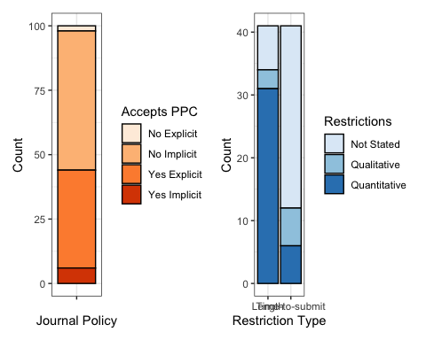

*Note.* PPC = post-publication critique. Orange bar (left) indicates policy statements for each journal included in sample (n = 100). Blue bars (right) indicate how length and time-to-submit restrictions were stated in cases where journals had explicit post-publication critique policies in place (n = 41). Implicit acceptance denoted by archival examples of critiques despite absence of stated policy.

As shown in Figure *XX*, post-publication critique policies were explicitly stated by 38% of journals, and we inferred that they were implicitly accepted (as denoted by archival examples) in 6% of journals. 54% had no advertised post-publication critique policy, and 2% of journals explicitly stated that they did not accept critiques (*Clinical Psychology: Science and Practice and Psychological Bulletin*). 3% of journals accepted two types (commentaries and letters); *International Journal of Mental Health and Addiction*, *Journal of Environmental Psychology*, and *Psychological Science*.

Among the 41 explicitly stated post-publication critique options, restrictions on length were quantitatively stated (e.g., ‘1,000 words’) in 31(76%) cases, qualitatively stated (e.g. ‘brief’) in 3(7%) cases, and not stated in 7(17%) cases. Time-to-submit was quantitatively stated (e.g., ‘4 weeks’) in 6(15%) cases, qualitatively stated (e.g., ‘timely’) in 6(15%) cases, and not stated in 29(71%) cases. Number of references allowed was quantitatively stated (e.g., ‘max 20’) in 15(37%) cases and not stated in 26(63%). Whether critiques were sent for external peer-review was only stated in 16(39%) cases, in 13(32%) cases this was in the affirmative.

When stated quantitatively, length limits ranged from 400 - 8000 words, time-to-submit limits ranged from 4 - 52 weeks, reference limits ranged between 5 -20. Table *XX* shows descriptive statistics for stated quantitative restrictions, broken down by critique type.

### Table *XX*

As expected, results in Table 1 show that commentaries were generally less restrictive on length with the median word limit being 2.5 times that of letters. The median number of references allowed was 1.5 times greater in commentaries compared to letters. Commentaries were also 3.3 times more likely to be sent for peer-review. Interestingly, time-to-submit was less restrictive for letters than commentaries, however, this was only reported in two and four cases (respectively) so limited inferences can be made from this.

## Randomly-selected Psychology Journals

Among our sample of 100 randomly-selected psychology journals, Journal Impact Factor data was unavailable for 25 journals. Median 2021 Journal Impact Factor was 2.47 (IQR = 1.98, range = 0.8 - 16.16). Figure *XX* shows the observed journal policies and, of the explicitly offered critique options identified, how restrictions on length and time-to-submit were stated.

### Figure *XX*: *Post-Publication Critique Policy and Restriction Statements in Randomly-selected Psychology Journals*

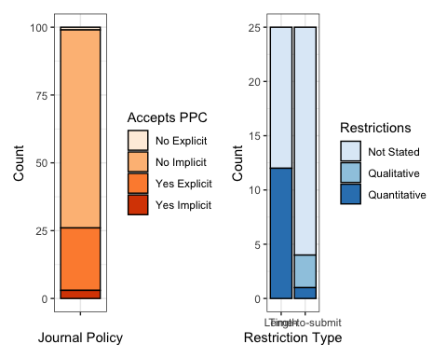

*Note.* PPC = post-publication critique. Orange bar (left) indicates policy statements for each journal included in sample (n = 100). Blue bars (right) indicate how length and time-to-submit restrictions were stated in cases where journals had explicit post-publication critique policies in place (n = 25).

As shown in Figure *XX*, post-publication critique policies were explicitly stated by 23% of journals (95% CI [15.8%, 32.2%]), and we inferred that they were implicitly accepted (as denoted by archival examples) in 3% of journals (95% CI [1%, 8.5%]). 73% of journals (95% CI [63.6%, 80.7%]) had no advertised post-publication critique policy, and 1% of journals (95% CI [0.2%, 5.4%]) explicitly stated that they did not accept critiques (*Clinical Psychology: Science and Practice and Psychological Bulletin*, also included in sample for prominent journals). 2% of journals accepted two types (95% CI [0.6%, 7%]); *Cortex* offered commentaries and ‘verification reports’1 and *Journal of Cognition and Culture* offered commentaries and letters.

Among the 25 cases of explicitly accepted post-publication critiques, restrictions on length were quantitatively stated in 12(48%) cases, and not stated in 13(52%) cases. Time-to-submit was quantitatively stated in 1(4%) case, and qualitatively stated in 3(12%), and not stated in 21(84%) cases. Number of references allowed was stated quantitatively in 4(16%) cases, and not stated in 21(84%) cases. Whether critiques were peer-reviewed was stated in 3(12%) cases, in 2(8%) cases this was in the affirmative.

When stated quantitatively, length limits ranged from 500 - 2650 words, time-to-submit limits were only stated by one journal (as 9 months), references ranged between 5 - 15. Table *XX* shows descriptive statistics for these restrictions, broken down by critique type.

### Table *XX*

As expected, Table *XX* shows that commentaries were overall less restrictive on length with the median word limit being double that of letters. Commentaries were also three times more likely to state quantitative length restrictions than letters. Restrictions on time-to-submit, references, and whether critiques would be sent for peer-review were not stated for any policies on letters. Similarly, no details on restrictions or peer-review were stated for ‘verification reports’ (the one ‘other’ critique type included in this sample).

## PPC Prevalence (results cont.)

# Discussion

*Add ‘Discussion’ section*

# Methods

*Add ‘Methods’ section*

# Data Availability

The data used for this paper are available from the project’s OSF repository (link: <https://osf.io/8k7m4/>)

# Code Availability

The analysis code for all results reported in this paper are available from the project’s OSF repository (link: <https://osf.io/8k7m4/>)

# References

1. Chambers, C. D. [Verification reports: A new article type at cortex](https://doi.org/10.1016/j.cortex.2020.04.020). *Cortex* **129**, A1–A3 (2020).