# Visual Studio Code (VS Code)

## Installation

## Editing, Run/Debug

## Junit

## Installation

Why did we build Visual Studio Code? <https://code.visualstudio.com/docs/editor/whyvscode>

Modern, lightweight (compared to Eclipse)!

Download Visual Studio Code from here: <https://code.visualstudio.com/download>

Go ahead and launch VS Code!

**Make sure you have Java (the language) installed**

Make sure you have Java installed. You will need at least one of these environment variables set to the location of your Java installation: JAVA_HOME, JDK_HOME or PATH.

You can check this by entering: javac -version

Once you have Visual Studio Code installed, you can review (or edit) JAVA_HOME by clicking Code or File | Preferences | Settings. Enter ‘java.home’ and the path to your Java installation is displayed:

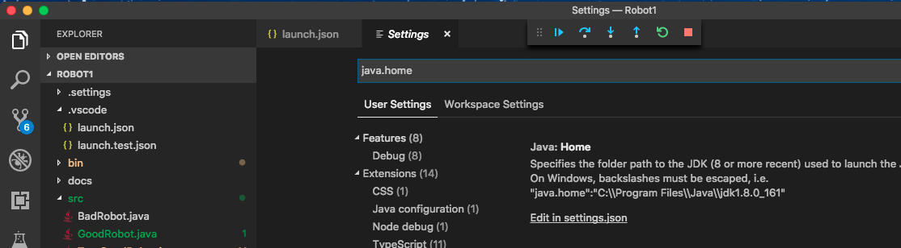

Once you load the editor, install the **Java Extension Pack**, which includes these Extensions:

Language Support for Java ™ by Red Hat Debugger for Java

Maven for Java Java Test Runner (JUNIT)

Java Dependency Viewer

In the editor you can click the Extensions button. Enter ‘Java Extension Pack’ in the search bar to install.

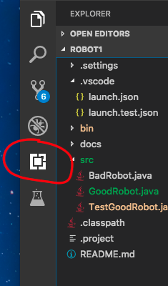

Here’s a nice video to walk through installation and setup: <https://www.youtube.com/watch?v=KQ433E2R3U0>

## Edit, Run, Debug

Run (GoodRobot.java)

Debug Console window shows output

If you have Input (like Scanner.next()) – that is displayed in Terminal window

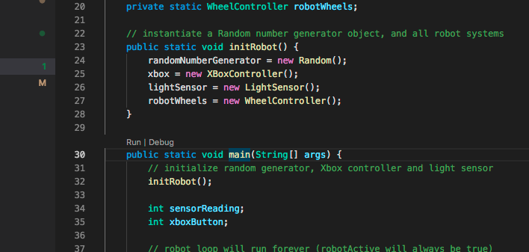

**Debug**

Click left of the line-numbers to set/unset a breakpoint

Click “Debug” to start program

Program will stop on breakpoints

Left pane shows value of variables

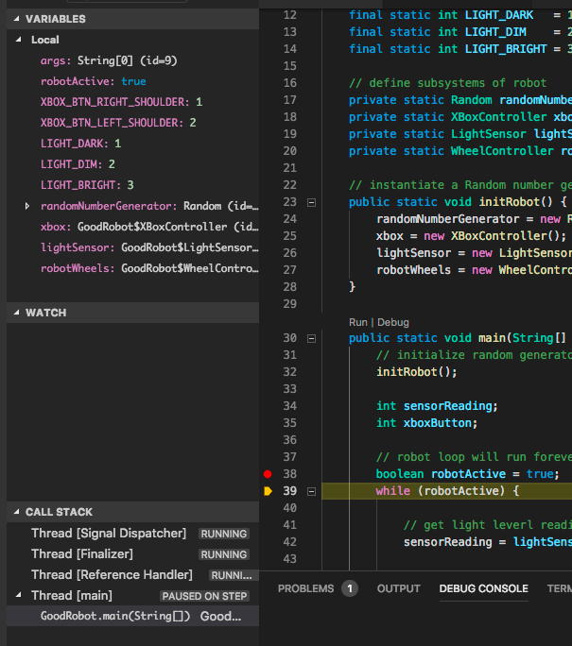

**Junit**

Click the Test icon on left pane (look like a beaker)

Then click ‘Run’ button on the top (circled – the “play” button) – this will run your Junit tests.

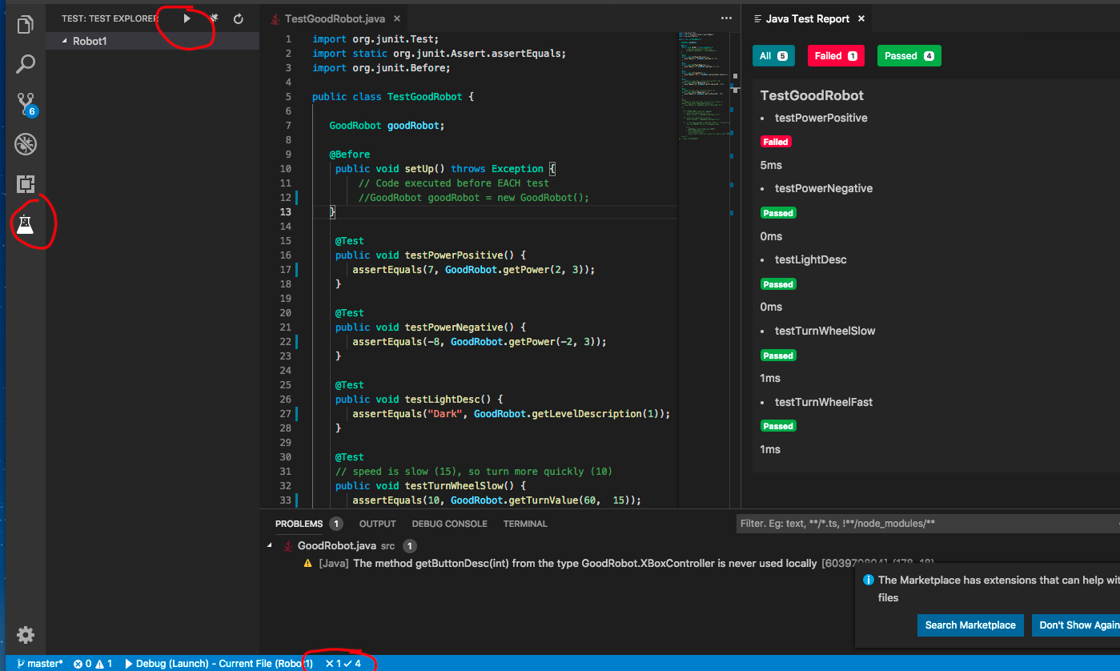

On the bottom margin, click on the results to bring up the Java Test Report. (the red circle on the bottom)

The Java Test Report display which of your Java Tests passed and failed.

A nice web page with more details:

Debugging Java in Visual Studio Code. <https://code.visualstudio.com/docs/java/java-debugging>