Arrival Day — BTC: For Dogs Bulgaria
Table of Contents

Additional Useful Reading

Michael
Don't Judge A Book - Full Stop
Read Now

Geoff - The Balcony Dog
Tips for adopters living in apartments.
Read Now

DANRD
Dogs Are Not Really Disposable
Read Now

Do Scared Dogs Bite?
Dispelling The Myths
Read Now

Rescues And Cats
Do they get on with cats?
Read Now

Do The Dogs Understand English?
Will I need to learn Bulgarian to talk to my dog?
Read Now

Golden Oldies And The Slightly Tarnished
What can they give you?
Read Now
Home

I'm Adopting A Cat
If you are adopting a cat from Break The Chains, many of the same rules apply, but here are a few rules to help your cat adapt to their new life.
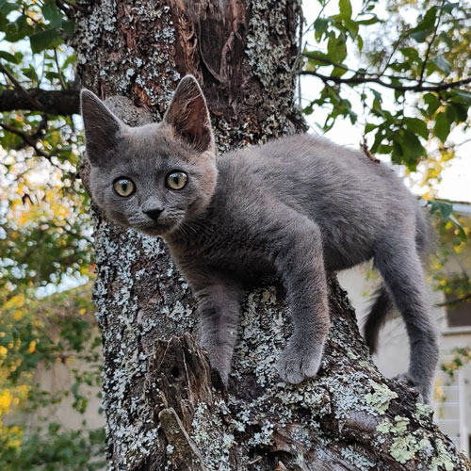
- Six weeks should be allowed before letting a new cat outside - even if they are used to being an outside cat. This advice was given by a lady with over thirty cats and many years experience of rescuing them. Most live only inside.
- If you wish to keep your cat indoors permanently, consider having a 'catio' built where they can enjoy the fresh air. Have different levels where they can climb administration rest.
- An old wives tale which works, is to smear a little butter on their front paws when they arrive - they will wash it off and feel more relaxed.
- I personally don't agree with collars on cats. They can get snared in branches etc.
- Put a baby gate in place to separate your dogs from your cat until they are used to each other, it also provides a quick retreat safe place for the feline.
- Do not give them milk only water as milk isn't healthy for them.
- ALWAYS feed cats away from dogs and preferably on a higher surface.
- Consider installing a cat flap to make things easy for yourselves and the puss once the six week period is up. BTC can check in advance if a cat is used to being allowed outside or not. Please feel free to ask us about your chosen cat.
- Please refer to the section on 'microchips' which will also be relevant to your cat.
Remember, just like any new pet, cats can be 'upset' by the new environment they find themselves transported to. They may hide and will need time before they feel secure enough to let you pet them. Its a good idea to provide an enclosed area, like a box with a hole cut out or a ready made cat igloo. Boxes are much favoured by cats and if you turn a sturdy one upside down and cut out a 'hole' chances are the cat will retreat into it and feel safe. Cat trees are also great because felines feel at their safest if off ground level. They love a high vantage point. Unlike dogs, most cats are territorial focused, not people focused. There are always exceptions, but on the whole, a cat will try to get back to its territory not its owner - hence the six weeks guidance. Patience is very important with cats, they can be skitted easily and it's difficult to gain their trust if they get scared.
We encourage you to read through this app/pack as a lot of the information regarding water and food for example (have access to water at all times including through the night) is transitional to your new cat as well. Many cats like to graze throughout the day for instance.
Please have a litter and surgical spirit to hand - cats will automatically go to a litter and if there is an accident surgical spirit is key for cleaning up. You can use it on the litter tray too as your cats won’t smell it and will still use the tray post clean.
The gift of time is really all it takes to settle your new pet and have its trust. Let them come to you is key while they are in the transitional stage.
Home

Arrival Day
The temptation to smother your new arrival with affection is understandably high. However, as humans, we often use touch and eye contact to convey comfort and trust, which can have the opposite effect on a scared or traumatized dog.
It is incredibly important to learn canine body language (see the Training Tips section), your dog communicates to you through their body language, and if you don't pick up on their subtle messages you could end up with both of you being frustrated and potentially becoming anxious with each other. We often hear owners complaining that their dogs don't listen to them, but do we really listen to our dogs, and understand what they need from the partnership?
To a dog, physical contact can be misinterpreted as a threat, especially from unfamiliar humans. Instead of reaching out to pet or hug them, give them the space they need to feel safe and secure. Try not to “loom” over your rescue dog, or suddenly touch them from behind; instead get down to their level and let them approach you on their terms, allow them to sniff your hand and try not to make any sudden moves. Resist the urder to stroke them immediately, they may see it as an attempt to grab them. If the dog looks uncomfortable then stop, move away and don't force yourself on them. Be patient, earned trust takes time.
Direct eye contact can be seen as an aggressive gesture in the canine world. Instead of staring them down, glance away periodically to signal your non-threatening intentions.
The best way to help a scared rescue dog settle in is to provide them with a predictable and consistent routine. This includes regular feeding times, toilet breaks, and quiet time for rest and relaxation.

Toileting
If you have not already read this section please do so now!
Read Now

Your Needs Vs. The Dog's Needs
Putting The Dog First
Read Now

Fear Triggers
Handle With Care
Read Now

Meeting Resident Dogs
New Dog and Resident Dog Meeting For The First Time
Read Now

The Garden
A Secure Safe Place
Read Now

Diet and Water
When And What To Feed
Read Now

Bathing And Grooming
The Dirt and Grime Of The Past
Read Now

Toys
Introducing Fun And Games
Read Now

Guest and Dog Sitters
Visitors To The House
Read Now

Children
Meeting The Kids
Read Now

Medication
Existing Treatment Needs
Read Now

Veterinary Information
Vets and Bulgarian Rescue Dogs
Read Now
Home

Bathing and Grooming
There is a natural temptation to want to bath your dog with the best of intentions. Some dogs may benefit from this happening sooner, the effects can be calming & help them to relax.
The dirt and grime of their life in a shelter/pound, where bathing and/or grooming will have been infrequent, if possible at all, can result in itching, scratching and sadly a bit of a pong. A wash will therefore be a great way to eradicate this discomfort for them and the unpleasant smells of their journey and previous life.
You would, of course, be advised not to do this within hours of your dog arriving, and each dog should be assessed individually. Obviously we don't expect you to cope with a pong or mess, so there are exceptions. Please ask us if you aren't sure.
If your rescue dog is clearly under stress do not bath them - it will not help you bond; it will not be an enjoyable experience for your dog. Bathing could cause your dog lots of additional strain and could make them fear you more.
Please always wait at least one week (or longer) in this instance, go at the pace of your dog. When you do wash them, a lukewarm shower, with you in it alongside them (gentle spray not power setting), or a bath with shallow water is best.
A groomer straight away could cause too much stress. If in doubt, ask the welfare.
Back
Home

Children
When introducing your new dog to children, please do this very carefully and ALWAYS under strict supervision.
NEVER leave a dog with any child unattended.
As is the same for all people, do not let them 'over fuss' the dog. When the dog is happy, they will go to them. This is a caution that we have to mention not because the dog is not socialized or aggressive, but simply because they have just arrived and will still be stressed, and it is the responsibility of a parent and anyone looking after your dogs and children to do this at all times anyway.
Back
Home

The Use Of Crates and Cages

Please Do Not Use Crate Training With You Rescue Dog
One of the commonly asked questions we get is regarding the use of crates.
We as a rescue DO NOT permit the use of crates.
Many of the rescue dogs have a history of either confinement or the worse kind of 'freedom' in the form of abandonment, therefore crates can disturb them greatly. Our guidance is to wait to assess your dog's needs as time unfolds and not blindly ahead of arrival.
Decide on where your dog will sleep and if that is a room with a door it is perfectly acceptable to close the door during the night.
Have plenty of water down 24/7 and lay some newspaper down near the door if you wish. They will drink a lot as they are not used to indoor heating and need to acclimatise.
If they chew while they're settling in and this is unmanageable for you then you could introduce a large material pen, like the one pictured, just for a few days until they adjust (when they are alone throughout the night). During the day you will be there to comfort them on arrival although the pen can be accessible at all times of course.
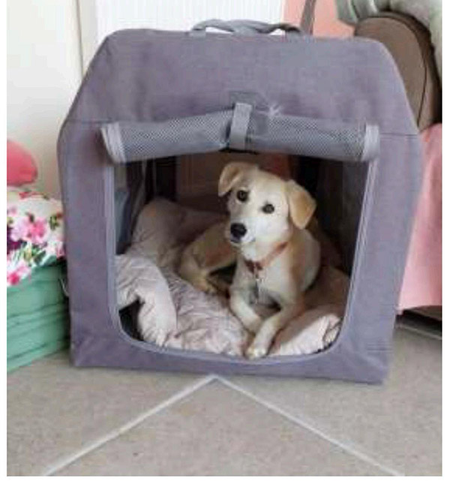
Material safe zones are a great option though not essential as they'll find their own places within your home -'Almond', our Belgium adoption, loved hers as you can tell.
Other options include the tent or teepee type shelters pictured and are all easily available from Amazon and other online retailers if you can not source locally.
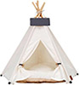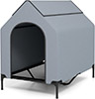
As a rescue we find that crates are open to accidental misuse and we come to rely on them as owners.
There is always a reason why a dog acts a certain way. Time and understanding resolves this, as does our leadership as a responsible leader. Crates as a form of control are not a substitute for our role as an owner.
We ask you not to put the rescue in a crate and close it as this is likely to cause emotional trauma. The sound of metal can remind them of abuse in an agricultural environment where metal is used as a form of cruelty. They are widely used when they are transported to the pound from a place of neglect and rejection for no reason other than a hatred of dogs and additionally when they are put out on the rubbish tips from the same shelter (if they are pound dogs).
Two of our dogs were injured when crates were introduced by owners with doors open and closed. It included a bloodied mouth, emotional distress and a trapped paw.
If the dog world used the word 'cage' (for that is what they are) not 'crate' the use of them would suddenly seem less acceptable.
A safe zone can be created with a wooden pen, yet no one wants one of them in the living room so the assertion that it is for their comfort falls down as they would much prefer a pen. Cages are for the comfort of humans not dogs. Whilst there are exceptions, they should never replace good old fashioned common sense.
For further advice please contact the rescue.
Any cage use must be with the knowledge and permission of the welfare. We offer free advice from owner/dog behaviourists, and this should always be a first port of call.
We DO NOT permit the use of tethering either, as a person must always be at the end of any training lead or tether at all times. The dog knows the difference. They have more than likely been chained up as a form of abuse and they know the difference between being tied up to objects or being in the company of people.
You have signed a contract to this effect.
Home

Diet And Water
When your dog arrives, an upset stomach is normal. It is not unusual to see traces of blood in their faeces - don't panic. It is often just caused by stress and the long journey they have had. You can purchase some inexpensive pro-biotics to add to their food. If they do have an upset stomach feed them a plain diet little and often like chicken and rice, scrambled egg, white fish, mash potato, etc. for a few days, and then we suggest grain free dry dog food to start.
Please ask our advice if the stomach upset is continuous in which case you may need to abstain from food and give water/probiotics only.

A word on dietary needs, water and food resource triggers.

Dietary needs:
Alternate between, for example, wet food in the morning & dry food in the evening. Give the correct amount for your weight of dog. For weight calculation stand on household scales holding dog and then again on your own, deduct the difference to know your dog's weight. Ask your rescuer or a vet if you're not sure. Any 'Pets at Home' store will advise on food amounts and they often will have veterinary clinics with scales. You can check on the food bag for guidance on amounts.
We strongly advice on a vet recommended wet food called 'Chappie'. It is great for sensitive tummies while they're settling in. In the evening give a good quality biscuit like a chappie brand (do not give cheaper ones as they contain too much salt which makes your new family member thirstier). Some dogs respond to grain free food.
>Chicken, rice, pork, beef and chicken, oat and beef stew are all great treat meals (handy tip: boil and keep the stock to pour on biscuits once cooled).
The trick is not to be tempted to compensate for the lives you know they've suffered by giving them too much variety. Keep to a consistent weekly diet so you can pin point and eliminate anything that doesn't suit them.

Water:
They might drink a lot of water because they are not used to warm indoor spaces, dry air and gas central heating, etc. They need to acclimatize. Please have water down at all times in any area they frequent and do not be tempted to remove it. The large intake is normal. Please give them water access during the night-time too.

Food resource triggers:
Please note that even a dog (from any country) that is gentle and laid back around food can guard a bone or any other food type. Resource guarding is common because a bone or treat can trigger a natural instinct to be territorial over it. They might bury and guard it or take a long while eating it, and show signs of understandable possession. Rescue dogs both from the U.K. and abroad have had to survive, and the weaker and smaller dogs like puppies, or the injured, cannot compete. A treat therefore like a bone is not only their prey (they don't know it came from 'Home & Bargain' or the local butchers) but also a prized possession.
Treats that they can eat quickly are advisable until they settle in more and understand that food will always be on tap from now on.
Resident dogs can also be jealous of the new dog. We always advise that you feed the new dog by themselves and keep all other animals and children out of sight of each other at feeding time initially. If you have more than one dog please feed them separately (out of sight of each other), for example in the garden on a bright day or in a separate room. Please ask your rescuer for guidance.
High value treats can be used as a reward when training. For example, when they have gone to the door to be let out to wee. (See Training Tips).
Pop them in a bag or container with high smelling biscuits that make a noise when the bag is gently shaken. They can be used for recall training on future walks too. Remember they will like almost anything that you give them compared to the boring and frugal diet they may be used to in the government dog pound.
Back
Home

Fear Triggers

Things That Might Scare Your Dog
Your rescue might be scared of men - most of the abuse is committed by men in this country.
Additionally, many of the dogs can be frightened of brushes, sticks, mops, plastic bottles and bags, and the noise they make, and household or garden fires; to name just a few.
Your hand raised above their head to pat/stroke them might cause distress. Keep your palm open and low beneath their chin and then your dog won't think you are going to hit them or grab hold of them.

Handling
- Be aware of how you approach and handle your rescue dog. Your hand raised above their head to pat or stroke them might cause distress.
- Keep your palm open and low beneath their chin and then your dog won't think you are going to hit them.
- Try to avoid sudden movements.
All these things can cause a fear reaction. They trigger memories of their troubled past. Time and reassurance will help them to learn that they can no longer be hurt around these objects and gestures. Please understand that some rescue dogs may never fully relax around certain triggers.
For example, one little Jack Russell rescue called Loppy always went as stiff as a board when we picked her up. She never quite trusted that we weren't going to throw her. She loved us, but that little fear always stayed within her. This is why rescues need your love and why the bond you create with your new dog is so rewarding. They need to be needed as humans do too.
The feeling of being special and getting responses from them that they have never given to anyone else is priceless and beautiful.
Back
Home

The Gift Of Time
This beautifully written piece is circulating the rescue world and is relevant to any rescue dog whatever their country of origin including the U.K.

Extreme change can be terrifying for dogs, just as it would be for humans.
Something I hear time and time again when I work with adopters of Bulgarian Rescue dogs, is how they wish they had known the information I share with them right at the very beginning, when their dog first arrives. The reason they say this is because when we start working together, they can see clearly how many things they could have done differently, that would have potentially avoided the problems they are now contacting me for help with.
One of those things is the importance of going slower than they did and taking the time to just get to know the dog that walked through their door and allowing that dog the time and space to adjust to their new and strange world.
I know that when you adopt a dog from, what you perceive to have been an awful existence up until now, and don't get me wrong, for many of these dogs it has been an awful existence by our standards, you just want to give them a better life.
You will want to shower them with love and stuff and wonderful experiences (or should I say, what you believe are wonderful experiences for them). But reality is, and what I want to emphasize here in this post, that no matter how awful your dog's life was in Bulgaria before being rescued and arriving with you, it was the only life they knew. This means, no matter how bad it was for them, it was still what was familiar.
Even though their lives may have been unpleasant, maybe even downright horrific, extreme change can be even more frightening for them.
So, when they arrive with you, EVERYTHING they knew up until that point is gone. EVERYTHING they are experiencing is new and frightening.
They will need the time and space to adjust to the wonderful life they will have with you (eventually). They need time to get used to new surroundings, new sights, new smells, new sounds, new feelings, new experiences and new people.
They still need time to assess all of the stuff and things in their new world to determine if they are safe or not. They still need time to habituate to their new life. They still need time to get to know you.
How long does it take you from meeting a stranger to feeling that you know them? How long does it take you from meeting a stranger to feeling that you trust them?
Sometimes, because we care so much and we want our new family member to be happy and feel loved, we can actually add a whole world of pressure to this transition period for them by trying too hard and by doing too much.
Put yourself in their place:
- Take a step back and consider the life your dog had and how much it has changed.
- Take a step back and imagine how you might feel if the same thing happened to you.
- Take a step back and give them space to breathe, time to watch and a chance to get to know you before you start asking them to DOstuff.
Open up their world GRADUALLY taking care not to overload them with too many new things to process.
Spend time simply hanging out together having silent conversations.
Sit in a room together or the garden, watch what they do, listen to what they say, watch their body language, facial expressions, and physical movements.
Look for how they CHOOSE to interact with you and the environment around them.
Learn to really see the dog in front of you and take the time to find out who they really are and what they really need.
Think of it as a form of Human-Canine meditation time, release your tension, breathe deeply and regularly, drop your energy into a purely peaceful emotional state with no agenda other than to simply tune in to your new friend, and watch closely the impact this has on your dog.
Often, we are so busy doing that we don't know how to slow down and just be, but your new arrival needs you to do this for them.
When we do, the transition into their new lives with us usually goes more smoothly with fewer problems and less stress, for both them and us.
Have patience without expectation.

GIVE THEM THE GIFT OF TIME
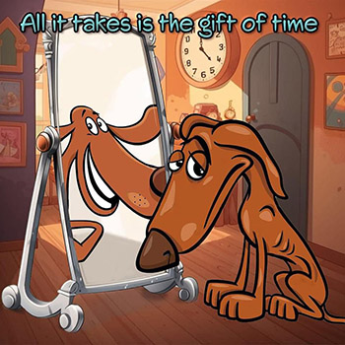

Home

Guests and Dog Sitters
Adopting a dog is very exciting and inevitably people will want to visit and meet your new family member.
Ideally people should wait until the dog settles before visiting. If they visit not long after your rescue has arrived please ensure they do not fuss or smother the dog.
Ask all visitors to sit quietly, talk gently and make no sudden movements. They should never force themselves on your new rescue. Allow the dog to get used to the visitor and when they are comfortable they will initiate any contact themselves. If that happens then advise your guests on the best way to touch / pet your dog.
>A good rule is that if your dog wants to be fussed over or to meet people then they will come and say hello in their own time and on their terms.
Back
Home

Help! I've Lost My Dog

DON'T PANIC!

What to do if your dog goes missing
- Try not to panic: your dog doesn't want to be lost, but it needs your help to get safe.
- Don't immediately leave the area: many dogs try to return to the place they were lost from (often much later or at night). Stay there and calmly call your dog. Patience is the key. You should quietly walk the area, avoid groups of strangers searching and making noise. It will confuse your dog.
- If your dog is missing from a walk when you drove, keep starting your engine - your dog will know the sound of your car - and leave a door or boot open for the dog to jump in. Try not to leave the area in case your dog returns. They often return at dusk or in the night.
- If your dog is missing from a walk, stay in the area. Make sure any gate or door at home is open (even at night); if your dog isn't able to get in then it might run off again. Leave their dog bed and some food outside along with worn clothing or bedding of the person they are most bonded with. Your dog doesn't want to find its own smell - you need to leave out your own worn clothing or bedding to help guide your dog home. The contents of your vacuum are also useful to leave out.
- Make sure you notify all the relevant people as soon as possible: the microchip database company so the chip can be flagged as missing, the dog warden, any local rescues that take in dogs, the local stray pounds, local vets and Leesa. You can find many of these numbers on the local council website.
- If you are near a railway line, please inform Network Rail as dogs are drawn to railway lines: 03457114141 (24 hour emergency helpline). Likewise if you are near a motorway, please inform the Highways Agency: 0300 123 5000 or Traffic Wales: 0845 602 6020.
- Register your dog as missing on doglost: this is a free service that alerts people around the country: Dog Lost UK. They also provide a template for a lost dog poster which you can adapt.
- Get posters out: these need to be around the local area, have photos of your dog on, location missing from, contact telephone numbers and DO NOT CHASE OR TRY TO CATCH, PLEASE REPORT SIGHTINGS ONLY.
In each area there are drone search and rescue groups. There is a national one, Drone SAR (on Facebook), where you can register your dog as missing and they will offer advice. You also need to find the ones local to your area. These are all groups run by volunteers who have lots of experience in tracking and reuniting lost dogs. None of them charge for their service. Some are more open to working with other groups than others.
Please don't rely on a drone to find your missing dog. You need to be out ground searching for it. It is vital that you cover the area in missing posters as well as posting on any local social media pages. You need to ask for sightings only (date/time/location and direction of travel). You do not want people chasing or hunting down your dog, however good their intentions. A dog feeling hunted will be forced into making decisions that aren't safe for it. A dog that is chased is at risk of being injured or killed as a result. If you are working with a lost dog search group they will advise you.
If it's a recent sighting, you need to head to the sighting yourself with one other person. Take smelly food like hot dogs / freshly cooked chicken / tinned fish like mackerel or sardines and quietly walk around while gently calling your dogs name. If its an old sighting, get posters up, lost dogs often do a circuit of the same areas so you want people looking out for it. If your dog doesn't appear, leave some of your own worn clothing or bedding in the area. The dog will be looking for your scent to come back to. Often the lost dog search groups will loan cameras so that the area can be monitored to see if the dog returns. A plan can then be put in place.
When a dog is missing, it goes into survival mode. This means it often won't recognise its owner. It is essential to not get upset by this. If you are at a sighting and you've seen your dog, you should sit on the floor, avoiding eye contact, take off your socks and throw them towards the dog for your scent to get out and sing or hum quietly. Let your dog take the time to work out it is you. This can take minutes or even hours, patience is the key. Do not chase or try to catch your dog. It will run. Your dog isn't thinking like your dog at this point, it is trying to survive. It will become your dog again once you have it safe so patience is essential.
Some dogs are luckily found by drone. If your dog is spotted, follow the advice above. Don't let emotion take over and go racing in to only scare your dog again. Calm and patient is key.
Sometimes dogs need to be trapped, this isn't cruel but is a last resort. The search group will take the lead on this.
Be aware of scammers: there are some not very nice people out there who will contact those with lost dogs demanding money or they will hurt the dog. They don't have your dog, they are trying to scare you into handing over money. Likewise there are scammers pretending to be the lost dog search groups and asking for money, no lost dog search group charges owners as they are all voluntary. Hang up on anyone suspicious and never give payment to anyone that says they have your dog or will need paying to help.
If the worst happens and your dog does go missing, we have a volunteer for the rescue who is also part of their local lost dog search group. They will be able to advise.

Harness:
If you walk your dog on a harness, please make sure it is an escape proof one. One of the most popular brands - Julius K9 - is not escape proof. If a dog panics and reverses, the harness comes off - this is why two point connection is so important. There are lots of different options available, but with all harnesses it is imperative that they are adjusted properly to fit your dog. Check frequently that they haven't become loose.

Trackers:
There are lots of cheap trackers available which run off Bluetooth or phone signal. This includes the Apple Air Tag. These are not worth the money and are very limited in the help they give you to track a lost dog. If you invest in a tracker you want one that uses GPS if you want to find your dog. There are two recommended options:
Tractive:
This is the market leader as it uses GPS but also does live updates. You can set safe zones meaning the battery lasts longer. It also gives health updates. This is cheaper to purchase however there is a yearly subscription charge - its usually cheaper to do the 2 year subscription. The premium package is also better than the basic. www.tractive.com
Pitpat:
This also uses GPS and has live updates. It is more expensive to buy but doesn't have a subscription. www.pitpat.com
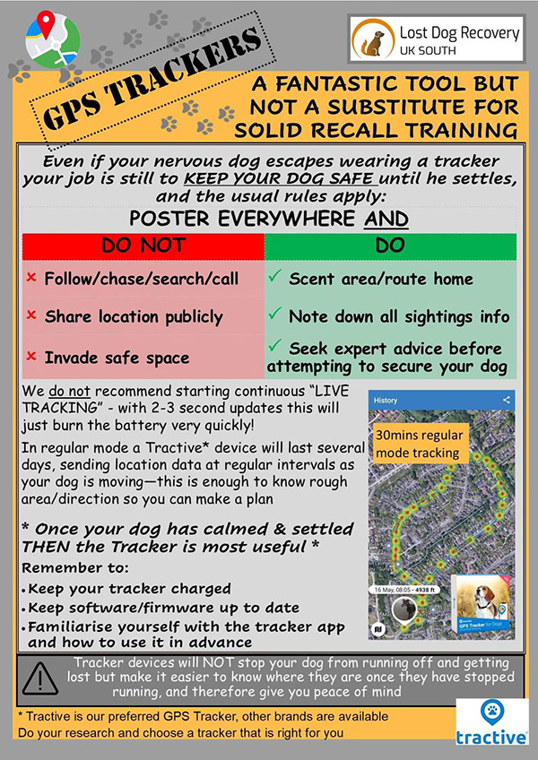
Home

Are They House Trained?

Dispelling The Myths

A word from the rescuer:
I understand why people ask this and many of the natural fallacy's surrounding rescue dogs. Most Bulgarians believe that we are somewhat unsavoury for having dogs in our homes.
It is a myth that homeless dogs aren't going to be adjusted to our lives and homes. It's because they've only ever gone outside that they don't like to go inside. They are creatures of habit and familiarity. It's because they've been tragically abandoned that they only know how to toilet outdoors. They do this without training, after-all if it was with training who would be doing it? Their 'owners', if they had any, neglected them and they were never allowed inside. The opportunity to 'house train' even if applicable would rarely have presented itself prior to rescue or within the rescue centres either U.K. or EU based. Which is why we find families for them, so that you can bring them that experience. Your input, therefore, on your dog's house-proud understandings only need to be a minimum at the most.
A realistic view is that they aren't house trained. They automatically go outside away from where they sleep and eat, so don't need to be trained and that is less commonly known. They just need to understand what a door is and that it is operated and leads to the exit/garden. They can pick this up in less than thirty minutes sometimes, although it may take a couple of days so it's recommended to leave your door open to a secure outside space and that you accompany the rescue dog outside to watch over them.
Of course, praise them when they do go outdoors (positive affirmations) and vocalising their exit with low, strong 'commands' of approval, as though it were your idea: 'go for a wee wee good girl'.
Any rescue dog from any country, including U.K., or even pedigrees sometimes can have accidents or no experience of a house.
They can, of course, arrive stressed after a journey and wee indoors. It doesn't mean that they will always have these issues or nuances. It's not because of their past. It's the normal transition and they just need the gift of time.
Habits can develop that are environmentally triggered, and then they may re-use an area that they previously went in inside. Surgical spirit is the only product that removes any odours to a dogs sense of smell so it is always worth having a bottle. Certainly any habits or problems that arise can be 'nipped in the bud'. Often dogs think they are doing the right thing and it's confusing for them. We mean well, and don't realise we are reinforcing a behaviour rather than discouraging it. For example, one owner didn't take his dog outside immediately on arrival and when she went on a puppy training mat he had laid down he praised her so much that she thought that was what she was always meant to do. She has learnt the right place now!
Never shout at a dog if they do something that's unacceptable to you, and in no circumstances rub their noses in the accident. These old fashioned approaches are known to be unkind and ineffective. They will make your dogs anxious and compound any behaviour not resolve it. 'Training' such as rewarding and positive affirmation mentioned earlier when they wee in your garden, for example, should be introduced by the owner as part of responsible dog ownership.
What I will say, is that when owners have followed our guidelines of going straight into a garden, we've never had a toilet issue in the three hundred dogs I've homed in the last year.
I'll give you one brief example that will make you smile.
Burton was fifteen years old when I met him. He had been ten years on a chain and five years in a government pound linving on concrete and outdoors. I found him a young glamorous family with children, and on the first day of arriving he went to the door to be let out for a wee.
How did he know?
He'd never lived in a house!
They are phenomenal and miracle dogs. They are not feral but grateful and clever.
A rescue centre commented to an adopter they sent to me that none of their U.K. rescues - interbred etc- could be homed straight to a house and she recommended our welfare.
Remember spread the word that these dogs have only ever gone outside; it's what they know and they will seek that familiarity out, as long as owners follow my guidances. Of course, there are exceptions as mentioned above. Sadly the instinct and compulsion to toilet outside can be interrupted by owners and the transport journey. Just as we can find ourselves out of our toilet routine when we travel abroad on holiday.
We can get them back on track of course.
Be kind, be understanding and be compassionate.
Home
HELP! I've Lost My Dog
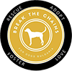

WELCOME TO THE BREAK THE CHAINS DOG RESCUING FAMILY.
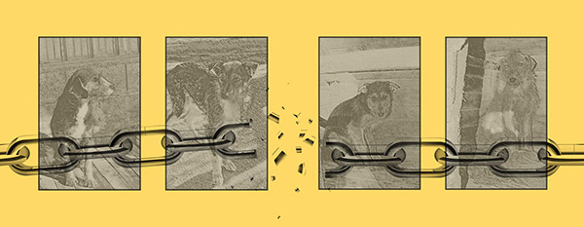
We would like to thank you for rescuing your dog with us. All the necessary information can be found in this welcome pack.
PLEASE READ IT

Introduction
Some dogs adapt straight away, and some don't. In many cases they do not wish to be stroked and fussed right away.
There is no set pattern or guarantee of how a rescue will behave on arrival because like human beings each have their own individual ways. They need time and space to decompress and bond with you. How long this will take is dependent upon them, you, and many other factors.
This is the first thing to understand and applies to all dogs, rescue or otherwise, from the UK or abroad. Any animal entering your home for the first time needs time to find their feet.

An extra word regarding your welcome pack
A new adopter waiting for her rescue said to me recently when I was thanking her for paying attention to the advice it contains, "if you care about the dog, you'll read the welcome pack" and I think that's a well measured comment. She went on to say that its vital because "the last thing I'd want to do is prolong her settling in period".
I cannot answer questions already covered in that pack or during our telephone call. In those instances, I and the team, will redirect you back to the welcome pack in your and the dog's best interests.
Please try to remember that whilst I'm here to assist and invite questions, there is just one of me and many of you, and if I'm being asked for things I've painstakingly transcribed to print or conversation then I'm not focusing on getting your dog to you or saving other dogs.
Read this pack carefully - it prevents unnecessary prolonging of the dog's settling-in period.
Thank you for your understanding.
 MUST READ!
 SHOULD READ!
 Useful Information

Treats For Streets (Shop)
Support the charity via the online shop: Treats For Streets

Medication
Sometimes your dog will arrive with the remainder of some medication to take.
If any medication is due to arrive with your dog this will have been fully communicated to you prior to the dog's arrival and arranged with your consent.
All the dogs have blood tests, non-obligatory for import, and are vaccinated and treated for worms, ticks and fleas before they are transported. However, sometimes there is a necessity/precaution to send medication, such as additional antibiotics, which can be perfectly normal for dogs of all walks of life.
A state vet stamps a certificate that they are fit and safe to travel.
Remember these are dogs that, prior to being rescued, have never been to a veterinary clinic. We do this not because import regulations require us to, but because we go above and beyond in the interests of both owner & dog.
Back
Home

Meeting Resident Dogs

New Dog and Resident Dog Meeting For The First Time
If you are introducing your rescue to your resident dog, then it has been established that the rescue and the existing household pet get on with other dogs. This does not mean however that their relationship will develop instantly.
>Again, try to put yourself in the dog's paws. As with humans they need time to get to know each other and to establish boundaries and trust. They do so by sniffing, weighing up, circling around and possibly communicating with a growl or two and even a bit of physical exchange. This is natural.
Equally, giving the new dog a lot of attention can cause jealousy with the other resident dog(s) and vice versa. Let the animals establish the natural hierarchy amongst themselves. Do not be tempted to raise your voice at one or more dogs, simply reassure them all equally. To do otherwise is the equivalent of chastising/favouritism or shouting 'fight, fight, fight' in a school playground. All these human reactions will hinder progress as opposed to aiding it. It is too soon to introduce training as they've just arrived. Its about letting a living creature decompress and that requires time. If they are all quite comfortable, and your garden is secure, you can let them all off leash. Your dog is less threatened and vulnerable off the leash, so be sure to apply the off leash to all dogs.
Please be aware that this section is not an account of what will happen but a guidance and understanding on what might happen in some situations. They may be bouncing around playfully with each other within minutes. On no account use separation of your new dog away from the family unit as a form of control for responses that are considered natural. A baby gate to let them get used to each other is one thing, a control to manage human anxiety and a lack of our own understanding is another.
A nip is not a bite. A spat is not a fight. Know dog language and train yourself before you can train and understand your dog.
Back
Home

1. Immediate Action at the Scene
Stay put: Many dogs return to the spot they were lost from, often at dusk or night. If you drove there, keep starting the engine - they know your car's sound - and leave the boot/door open.
Guided by Scent: Leave out your worn clothing or bedding. They need to find your scent, not their own. Emptying your vacuum contents in the area also helps.

2. Essential Notifications
Notify the microchip database, dog warden, local rescues, stray pounds, vets, and Leesa immediately.
Emergency Helplines:
- Network Rail: 03457114141 (Dogs are drawn to tracks)
- Highways Agency: 0300 123 5000
- Traffic Wales: 0845 602 6020
REGISTER ON DOGLOST UK (FREE)

3. If You See Your Dog
DO NOT CHASE: This triggers survival mode. Your dog may not recognize you.
Calming Signals: Sit on the floor, avoid eye contact, and throw your socks toward them to get your scent out. Sing or hum quietly and let them work out it's you.

4. Search & Posters
Use posters with photos and your number. State clearly: "REPORT SIGHTINGS ONLY—DO NOT CHASE". A chased dog is at risk of being forced into unsafe decisions or killed.
Contact Drone SAR on Facebook for volunteer tracking assistance.

⚠️ Scammer Warning
Never hand over money to anyone claiming they have your dog or demanding payment for search services. Voluntary groups never charge.

Prevention & Trackers
Ensure your harness is escape-proof (avoid Julius K9 for panicking dogs). For tracking, use GPS (Tractive or Pitpat) rather than Bluetooth tags like AirTags.
BACK TO HOME

Preparation
Getting your home ready before arrival.
Get ready, they are on their way!
Dogs, and in particular ones with a difficult, abusive past and who have just experienced a long journey, may need to find and establish “safe zones”. During the first few days of decompression, they'll need somewhere they feel safe safe to rest and process what is going on.
Having a "special place" like a den of some sort is brilliant, but it all comes down to what the dog feels comfortable with. For instance, Rapunzel, one of our owner's dogs, sits under his desk if she is feeling anxious. She has decided that under the desk is her safe place, and it is where she will always head to if there is something causing her anxiety, like thunder or fireworks.
Crate training is popular in the U.K., sadly metal cages are the most common kind of crates used.
Please read our section on why we prohibit the use of crates and cages, or contact us to learn why they are not needed (with rare exceptions), how they can cause injuries to your dogs and some safe alternatives. However, the best way is their way because they know better than we do what safe means to them and where to find it. Just because we think they feel a certain way doesn't mean they do.
The Use Of Crates

Safe Zones
Most dogs will have a few favourite spaces around the house. This could be their bed or crate, their favourite spot on the sofa, or the room they like most. Turn your dog's favourite spot into their designated safe space. You could add a comfy bed or blankets to their favourite nook, perhaps by the side of the sofa or under a certain table, to make it a safe and snug haven for them.
If your dog doesn't have a favourite spot already, choose somewhere in a room your dog normally spends time in, where they naturally like to rest. Make a cosy den for them and build up positive associations with the space.
See the Dog's Trust video for more inspiration:

An error occurred.
Unable to execute JavaScript.
Make sure all family members, especially children, know where your dog's den is, and to leave them alone when they're in it. Ask visitors not to disturb your dog when they're in this spot.

In The Home
Think about potential dangers in the home. If possible, move cables out of the way or cover them with a plastic sleeve to deter chewing. Look at using dog/stair gates to secure certain areas where you might not want your dog to wander.
Ensure that the rubbish bins are secure - these dogs are used to scavenging for food, they won't take long to find the bins. Are all your cleaning products safely out of the way? Have you made sure all your food is safely stored and not kept in a location that is accessable to the dog? Is your toilet paper stock out of reach?
When the front door is opened, how easy is it for the dog to get out? Think about using gates to create a zone that allows you to get in and close the front door before your dog can get out.
Take some time to wander about your home and see it through a dog's eyes, make it a safe and secure place for them to live.

Outside
Repeat the process outside, thinking of possible escape routes.
- Check for holes in fences and hedges.
- Are the fences and hedges high enough to prevent a determined escape artist from jumping over?
- How easy is it for them to dig under them?
- Is there anything that is next to the fence, wall or hedge that can be used as a step up to jump over - think about wheelie bins and storage boxes.
- Are any of the panels etc. loose to gates or perimeters?
Check over everything even after a home visit because a panel can come loose if for example someone has kicked a football against it post home check
Do you have any plants in your garden that might be poisonous to your dog? Think about how you can ensure your dog cannot get to them.
Talk to your neighbours, explain about your expected new arrival and their background. Let them know what to do if your dog does manage to get into their property (who to call, not to spook them, etc).

Equipment

All the things you will need.
Before the arrival of your rescue dog we would advise purchasing the following equipment:
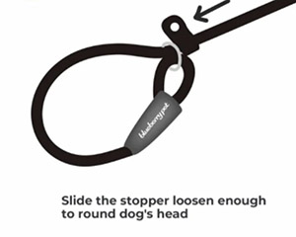

Slip Lead
To assist the transfer of your dog on arrival, please have a slip lead available, as this reduces the chance of a stressed dog escaping during the transfer process.
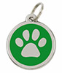

Identity Tag
Please ensure that you have an identity tag with your details to put straight on to your dog upon arrival.
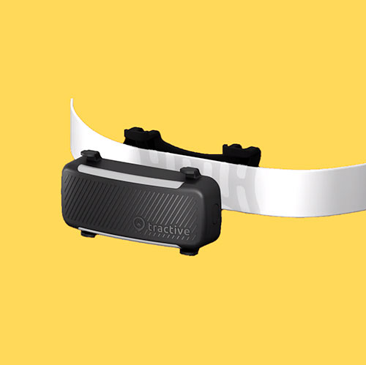

GPS Tracker
It is highly recommended that you look into getting a GPS tracker. Rescue dogs are well known escape artists!
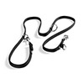

Double Ended Training Lead
To allow for double point of contact.

Well Fitted Harness
There are several options available, we recommend Truelove No-Pull harnesses, adjusted correctly to your dog, of course.
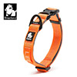

Collar
A well fitting collar. If you choose a Truelove collar then it can match your harness.
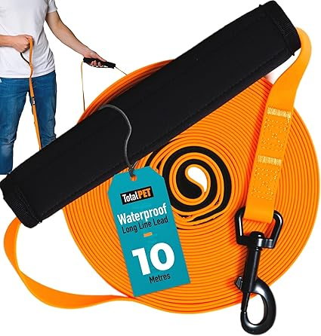

Long Line
A 5m or 10m long training line, will give your dog freedom to explore without the worry of them running off. Perfect for teaching recall and loose lead walking. Caution must still be used to prevent injuries to dogs and humans.


Surgical Spirit
For cleaning up, just in case there are any accidents.
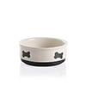

Porcelain Bowls
For inside and outside (water down at all times) and less noise than a disc hitting metal.
Home

Retractable Leads

Our Thoughts On Using The Popular Retractable Leads
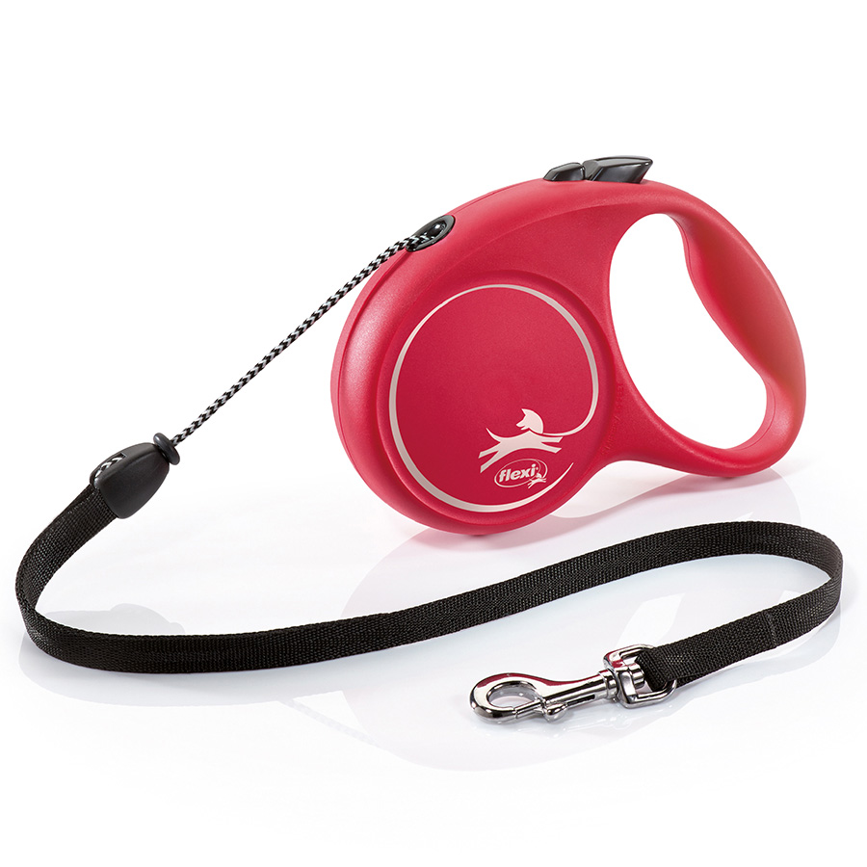
Retractable (or extending) leads are a popular choice among dog walkers, and are easily available from any pet shop.
They are popular primarily because they aren't as confining as regular leashes, allowing dogs more freedom to sniff and poke around on walks. But there are many downsides to using this type of lead.
A retractable lead is nothing more than a length of thin cord or tape wound around a spring-loaded device housed inside a plastic handle. The handles of most retractable leashes are designed to fit comfortably in a human hand. A button on the handle controls how much of the cord is extended.
- Many dogs, especially fearful ones, are terrorised by the sound of a dropped retractable lead handle and may take off running, which is dangerous enough. To make matters worse, the object of the poor dog's fear is then 'chasing' them, and if the leash is retracting as they run, the handle is gaining ground on them - she can't escape it. Even if this scenario ultimately ends without physical harm to the dog (or anyone else), it can create lingering fear in the dog not only of leashes, but also of being walked.
- If the handler is not paying correct attention the lead can easily wrap itself around either the dog, another dog, the handler or another person; or the handler grabs it in an attempt to reel in their dog, without thinking. The cord can cause friction burns, cuts and even amputations. In addition, many people have been pulled right off their feet by a dog that reaches the end of the leash and keeps going. This can result in bruises, "road rash", broken bones, and worse.
- It is nearly impossible to get full control of the situation if the need arises. It's much easier to regain control of, or protect, a dog at the end of a six-foot standard flat lead than it is if they are 20 or so feet away at the end of what amounts to a thin piece of string.
- The thin cord of a retractable lead can break,especially when a powerful dog is on the other end of it. If a strong, good-sized dog takes off at full speed, the cord can snap. Not only can that put the dog and whatever he may be chasing in danger, but also the cord can snap back and injure the human at the other end.
- The "control button" on the handle can fail, meaning you have no control over how far your dog can extend the lead. In no time at all your dog could be at the very end of the lead and you would have no control, which could be a disaster if it happens on a busy road.
- Retractable leads are an especially bad idea for dogs that haven't been trained to walk politely on a regular lead. By their very nature, retractable leads encourage dogs to pull while on the lead, because they learn that pulling extends the lead.


What do you suggest instead?
When walking in an area that needs greater control, such as near roads and traffic, use a standard lead. A double ended training lead is perfect, as this allows easily for two point contact, and can be set to different lengths depending on the circumstances.
When you can give your dog more more independance and agency, when away from traffic etc. then a long training line is a good idea. These are available in several lengths but a 5m or 10m line would be fine. Longer than this and it can get a bit unweildy and you can easily find yourself tangled up.
Pay out the line as the dog moves away, and as they move closer loop it back up to avoid tripping over it.
As always when out with your dog, pay close attention to what is happening. A long line can still get wrapped around you or your dog - or someone else, and this can be painful. Dogs also seem to find it fun to wrap the long line around trees and posts just to make it that much more difficult. (It is possible to train a dog a "legs" command to step out of the lead coils if they seem to be getting tangled.)
This, however, is a much better option than the retractable leads, and comes into it's own when training recall or loose lead walking.
Home

Safety First

All the administration and safety concerns dealt with

ID Tags and Collars
Firstly, please ensure that you have a tag made with your contact details on as soon as possible. Do NOT put the dog's name on the tag. Dog identity tags come in all shaopes and sizes, and can be readily purchased within the UK - every dog should have one.
In the UK, the Control of Dogs Order 1992 states that any dog in a public place must wear a collar with the name and address (including postcode) of the owner engraved or written on it or engraved on a tag. Your telephone number is optional (but we would recommend this). You can be fined up to £5,000 if your dog does not wear an identification tag. You do not have to put your dog's name on the tag, this is optional. Unfortunately, dog theft is a real danger and if the thief knows the name of your dog this may help them pass on the dog to the unsuspecting new owners because it appears they know the dog because the dog responds to their name. We would therefore recommend that you do not put your dog's name on the tag.
When your dog arrives in the UK, they cannot leave their home address for 48 hours (in line with DEFRA regulations). This gives your dog two days to stay in your home (without exploring the wider world) so that they can rest and properly decompress. This only applies to new arrivals in the UK and not for second chance adoptions from the UK. If you do not have a garden this of course will be an exception, and you can contact us for guidance on this.
You will have paid for a recycled/new collar and identity disc with your rescuers contact details on. This ID tag must be kept on your rescue dog until the microchip is registered in your name after the settling in period/subject to the contract being satisfied. The settling in period in terms of registration is considered to be three months. You can put the disc on your own harness or collar.
The collar we send is just to carry the disc to you and is not designed to be your security during walking/garden visits (if you wish to donate the collar & tag back to us, we would be most grateful. You can do this within the UK for your convenience, please ask for the UK address to it send to).
Both your ID disc and the rescuers must be attached to the dog at all times when they have access to your garden or on walks. When the dog is settled, providing your garden is 100% secure, you can take the collar off during relaxation periods.

Microchips & Registration
Your dog will be microchipped, and this will be registered to us (if you are foster family/back-up please ask your rescuer for the guidelines on fostering).
To start the registration process you must request the transfer from us (we will not do it automatically). Alternatively request it directly from the database 'Animal tracker' by logging onto the pet microchip database or call them on the number provided below. Authorisation if applicable may take a few days so allow time for this.
For E.U. Adoptions you must comply with the dog laws set out by your country of residence.
Animal Tracker Telephone Number: 01279 219777
Website: animaltracker.co.uk
Animal Tracker offer all kinds of benefits and services to their customers especially those that have chosen a rescue, such as a lifetime of as many updates to your registration as you like, for example, a change of telephone number/address and they also do engraved identity tags at only £9.99 for two - price correct at time of writing. Be sure to mention that you adopted from Break the Chains for Dogs Bulgaria and ask them about their varying offers.
MOST IMPORTANTLY INVEST IN A GPS TRACKER: the ones that are recommended by experienced trackers are:
Tractive: tractive.com
Pitpat: pitpat.com
BE SAFE NOT SORRY.
In my experience there are two common reasons a dog would choose to escape:

Instinct/Nature:
this is what drives dogs abandoned to the street and is the gut feeling they rely on for survival. All they have ever known is the golden rule of not ending up in a closed-in area. This is for obvious reasons such as when searching for food in public places like café seating areas they would often be chased away or threatened with sticks and stones, or the memory of when they were caught by dog catchers. Containment equals danger and this is worth remembering when your rescue dog is reluctant to go into new rooms or through doorways.

Lack of Exercise Routine:
What I mean by this is dogs that have not regularly been walked often are not used to a walking routine. This is often the case for dogs that have been in public/government shelters where there are not enough staff, or when dogs, who have never been lead trained, panic when on the end of a lead (see above re: containment/restraint).

Flight Risk

Why would my dog want to escape and what should I do to help prevent it?
Many of the dogs have also been 'chain' dogs on metal & wire which has traumatized them. When this happens the dog(s) often become so excited to be able to burn off some energy, or conversely so panicked at being restrained, that they take the chance to back up out of collars or harnesses and run away. Of course, they don't realize the implication of this, such as becoming lost in a strange place and safety issues around cars/traffic/railways etc.
Below are some tips which may help you not only prevent a dog escaping, but also slowly start to prevent the dog wanting to in the first place.

Tip 1 - Safety first: secure the home.
When in the house always keep in mind that your dog is fast, and it only takes a second to escape. The front door should ALWAYS be locked if you are expecting visitors. You could have family and friends who are free to enter your homes without knocking. However, they will not always remember and could walk in and before you know it your dog is gone. By locking the front door this prevents this accident. Use 'Close the door/gate' signs. It may be, for example, that for 30+ years you have not had to worry about closing side gates or front doors if nipping to the car and chances are you might still forget despite your best efforts. By having a sign on the door or gate it's just a gentle reminder.
Triple check - check, check and check again.
- Are you sure you closed the side gate before you to take your dog outside to use toilet?
- Did the door fully close and is not slightly open?
- Did the children leave the gate ajar when going out to play?

Tip 2 - Find your dog a friend to learn from.
If you or a friend already have a friendly dog who is not a flight-risk, then this can help for a number of reasons. Firstly, as dogs are pack animals, they like to be around each other which can sometimes help to be a calming influence on a dog who thinks they need to escape. Secondly, they can learn lessons by observing a dog who does not try to run every time a door is open; they basically look to them to learn how to behave in the given environment.

Tip 3 - Safety when out on a walk.
To help ensure your dog does not escape when on a walk follow these guidelines:
- Always use a collar which is securely fitted. It needs to be tight enough so that it cannot slip over your dog's head. Try and pull the collar over your dog's head, it should not come off. Don't feel bad about having a more tightly fitting collar, it's necessary and as long as it is not hurting your dog's breathing it will cause no harm. Make sure you can get two fingers between their neck and the collar, so you know it's not too tight.
- Use a 'two-point contact' system which means if one form of connection to your dog fails, the other is your back up. Ideally, use a specifically designed two-point contact leash (or two separate leads) with one end connected to the harness and the other end connected to the collar. Two leads and two collars is another option.
- Consider utilising a metal lead (not chain) if your dog shows any signs of snapping at leads, harnesses or collars. A dog in panic mode can easily chew through a lead in a second, so please do be vigilant. This is only in extreme cases which your rescuer will let you know about in advance.
- Remember your pooch can get bored, have the desire to explore, or the in-built desire to chase prey, and may not yet trust you enough to stay. They may not find their way back to you as they do not know the area. They can also head to train tracks and railways away from people to mimic the lonely tracks here.
Please be mindful at all times of flight risk as you might with your own children.

Transport /Owners Private Group

Why 'Whippee Wheels'?
Break The Chains for Dogs Bulgaria (BTC) wanted to find words to describe the happiness of them leaving Bulgaria to go on a journey to their new homes and happy it is. The private messenger group has been set up so that you can all correspond if you wish to, ask questions and stay updated with the courier's journey where possible.
We ask that you remain respectful to one another, and address any sensitive issues to a group member privately. The group is optional, and you are not under any obligation to stay or join. However, please make alternative arrangements independently for support and updates if you decide to leave.
It's important to note that depending on the transport available to me the information below can differ slightly as each service does things individually according to numbers travelling etc. This is a guideline only. As well as the general owners club Whippee Wheels (WW), a secondary group (SG) that is specific to the current dogs travelling and their adopters (for single use only) may open around the French border if not earlier.
Sometimes they are delivering around Europe so focus on that part of the journey first. You'll likely receive an ETA in the SG, listing your dog's name, postcode, which transport they are on (north, south etc.) and the time/date they'll arrive. Remember this is not a dental appointment. It's impossible for these complex logistics to be sent too far in advance or to fit in with your schedules, sorry. The geographical enormity of it determines how they do things and the welfare of the animals. It is out of my control. They are likely to be delivering other dogs not just yours.
Your invite to WW is usually sent the day before transport. Your transport date is when they depart not arrive. The trip normally takes 2-3 days. In order to receive updates, you'll need to be on social media.
Either WhatsApp or Facebook messenger/private groups are the usual communication platforms used by transport. Please ask which is applicable because the choice of platform is usually decided by the transport.
If you aren't on either of these platforms, then you will need to enlist a friend, neighbour or family member to join the transporters choice of platform on your behalf. You'll have to make sure that either you or they have added myself (Leesa McKenna) to Facebook as a friend or to WhatsApp. I cannot invite you to FB platforms unless we are 'connected' as friends. You'll find me quickly on my rescue page, or ask for my personal timeline link (this is NOT Break The Chains).
Be sure to let me know the name you use on Facebook if it's not your legal name or the person you've nominated in your place. Let me know that you've put in a request. I get extremely busy and will not be able to deal with this on the day before transport so be prepared. You'll have my number from our telephone call. Ask if you need these details resending or if you have any questions.
It is your responsibility to make sure that you have done these things well in advance of your transport date and fully understand what's involved.
It may sound detailed but as it unfolds you'll realise how straightforward it is and what a huge trip it is for them.
The journey is a big one for man and dog alike with a lot of logistics involved so we also ask that you work in with your courier for the drop off date and time. The dogs want to be off the van as soon as possible on the home stretch. Your transporters names can vary and are always an independent professional service which loves dogs and ensures a safe delivery. As they are the owners of their own courier business, I reiterate that I have no authority over arrival planning. I will only know the leaving date and approximate journey length subject to extenuating circumstances.
We ask you politely to wait for driver updates rather than request them. They will be posted in good time. There are usually 2-3 drivers per vehicle, and they would greatly appreciate a gratuity which can be in Sterling currency and/or a goody bag for the trip.
Remember that the transporters, in the interests of your dog's wellbeing and all on board, will not stop until each dog is safely delivered (subject to mitigating circumstances). To this end they may also drop-off through the night/early hours. It is advised to book time off work, which with the information provided here should be possible subject to your working circumstances.
We cannot, of course, guarantee specific arrival times so if you can organise a couple of days either side of, or have a dog sitter available it's advisable. You'll also hear from the transporter directly, when he is in reach of your home so please have your phones handy at all times to help them out.
I've uploaded a picture of their lovely van as my Whippee Wheels profile image. You're welcome to check in and interact. You can see a selection of images of one of the transporters below.
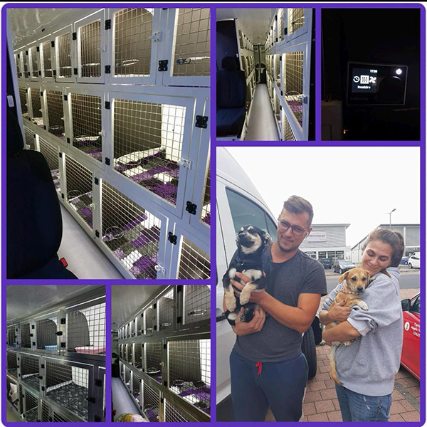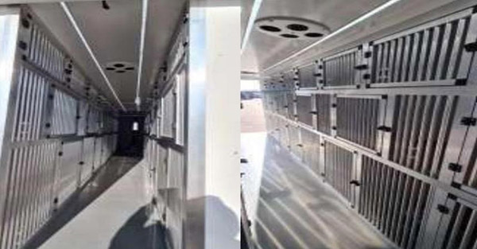
Thank You For Your Time.
The secondary group that includes the drivers is observational for them to ask questions. not us. They must focus on the welfare of the animals and safe driving. Please do not bombard them with questions - sorry but they must concentrate.
WE DO NOT POST DRIVING LICENSE PLATES/ VAN LOGOS OR LEAVING DATES PUBLICLY.
There are people who try to cause trouble for dogs and we act on the side of caution. Once they are on British soil we can relax. We're happy to hear your feedback, reviews and recommendations on my service and your adoptions once your new charges are dropped off and you're welcome to post those straight to my rescue campaign group (Break The Chains - For Dogs Bulgaria) and in the private owner's transport group in messenger (WW); and of course we always like to hear updates on how the dogs are getting on.
Home

Settling In

Walking
When you feel that the relationship is progressing then you can consider taking your dog for a walk. We advise using a harness as some rescue dogs are chain dogs, and collars can upset them initially until they know that they will not be chained up again. Equally we do not recommend chain collars or chain leads for the same reason. These should be avoided. Choke collars, prong collars and e-collars are also not acceptable. Many dogs who have had bad experiences like this will walk in the UK on day 2 with no training so we should never assume their past will define them.
However, harnesses give you a more gentle and secure method of walking your rescue dog, so they are worth investing in. One we do recommend is the affordable non-slip/no-pull harness featured below by Truelove.
Other brands such as RUFFWEAR and HEALING PAWZ also proved very good options. It is worth looking around to find the perfect harness for your dog.
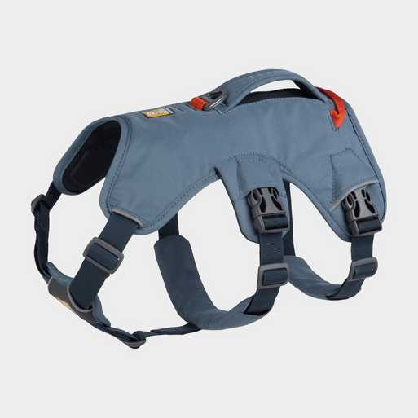
Harnesses are great safety measures if a sudden noise startles them. They cannot slip out of them easily and you have more control. We can send height measurements, and sometimes weight, however you'll have an opportunity to measure your dog on arrival and make your purchase prior to walking. As harnesses are adjustable, we can guide you in advance on the right harness size to buy.
Please be sure to have the right sized harness and that it is adjusted properly, or they will find a way to wriggle out of it, no matter what claims the manufacturers make - these dogs can make Houdini look like an amateur.
Always employ 'two-point contact' - which literally means 2 points of hold, so if one fails you can rely on the backup contact. There are many options available in the high street stores and on the internet. A good idea would be a double ended training lead with one end fastened to the harness and the other end fastened to the collar. Remember just because your rescue seems safe on a collar and lead does not mean they will be if there is a sudden noise that frightens them.
BE SAFE NOT SORRY!
A suitable double countact lead is shown below:
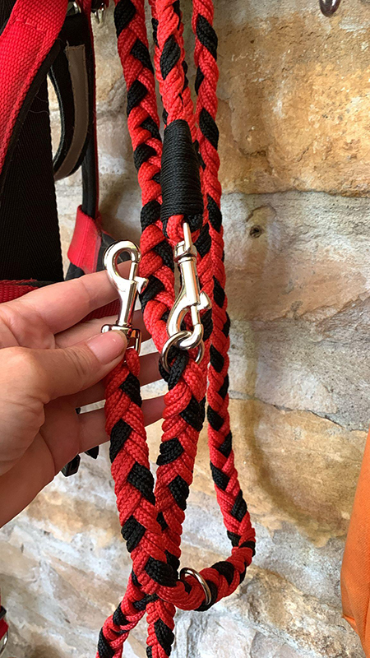
High value treats (cheese, hot dogs, burger bits, cooked chicken) are good for recall on walks, on the lead or when they toilet outside. It is vital to reward them them (always have a treat bag handy).
It is okay if you both go outside and do not get very far, or even if you just sit on a bench and keep each other company.
It is fine if you do not go for walks for the first few days, it is even preferable not to in some circumstances. Let the dog get used to people in the house first. They need to be curious about going out and not frightened or apprehensive. They can feel safe and free in your garden. Curiosity will come after they have adjusted to your home. You will know the right time.
Your rescue also needs the opportunity to exercise and run off lead and you are contracted to take them to enclosed parks and training grounds purpose built for that activity until you have trained them in recall. This is essential for their emotional and physical welfare. By following our advice your rescue, no matter how timid, will be going for walks within a few weeks usually. We state this from experience.
Keep our ID tag on your harness or collar along with the one you purchase with your details on. Do not remove the collar unless you are absolutely sure your garden is secure and always make sure your dog wears it on walks. There is never a reason for your dog not to benefit from going for walks if you follow our advice and approach things in the right way. The most shut down and scared dogs have walked before they've even been stroked with an owner who is following guidelines.
Only when your dog is settled and happy with short walks should you consider longer walks.
When your dog is ready for longer walks consider using a long line, which will provide them with more freedom, but will still allow you some control. But be careful as it is easy for you, your dog and other dogs you might meet to get tangled up if you are not concentrating completely on walking your dog.
Allow your dog time to sniff and rummage about, they are finding there way in the world, and allowing them to sniff is a great way to help to build a calm and confident dog.

An error occurred.
Unable to execute JavaScript.
Home

The First Few Days
When your dog arrives in the UK, they cannot leave their home address for 48 hours (in line with DEFRA regulations). This gives your dog two days to stay in your home (without exploring the wider world) so that they can rest and properly decompress.
This only applies to new arrivals in the UK and not for second chance adoptions from the UK.
During the first few days of decompression they'll need to rest and process what is going on. They need the time to sleep, but the body is still dealing with the journey, new environment, new people and noises etc. That first deep sleep of a rescue dog is wonderful. The pure sighs of relief and release. And the fact that they feel safe enough to do so, is so huge step forward.
Make sure you don't have visitors for the first few days. Wait until your dog is ready. Even though it's exciting, they need time to get used to you, routine, new things and it's a lot to take in. Take each step at the dog's pace. It doesn't matter if they don't go out for a walk. As long as they're safe and they're needs are met.
Use your first few days/weeks/months to help them to feel safe and secure, learn about new things; some might never have seen a dog toy for example! Don't force them into situations they're not comfortable in, especially around children, or large groups. If you don't want to be around people, ask them to leave your dog alone.
You and your dog is what is important here, your bond is the greatest you will ever achieve. Take the time to learn about each other and you'll have the greatest dog in the world.
Patience, understanding, and positive reinforcement are key to building trust and helping your rescue dog overcome their fears. Let them adjust at their own pace, reward them for good behaviour, and most importantly, show them that their new home is a place of safety and love.
The following advice applies to dogs who are taking a little longer to adapt than others may:
- Please do not try to force them out of their safe zones before they are ready.
- Do not take their choices away because that is what you want.
- They will come to you when they wish to.
- You can offer them food by all means but do not be disappointed if they do not take it. This is not a rejection it is just a very natural state of uncertainty.
- Talk to them with gentle tones as you pass or sit close by. Tell them how brave and good and beautiful they are.
- Go down to their level & see if they will let you stoke them under their chin (trying to stoke them on their head first can remind them of being hit & scare them).
It is not important if your dog does not wish to walk outside within the first week. They need to trust you before they walk with you. Again imagine for a moment that you are learning to dance on a new dance floor. Before you let anyone lead you by the hand or lift you up in the air, you need to find your feet and trust your partner.
Try to put yourself in their paws: how would you feel in the position your new rescue dog is in?
Home

The Garden
For at least the first couple of weeks, please do not leave your dog unattended in the garden even if you think your garden is secure.
Bulgarian rescues are notorious escape artists and will scale walls and fences with ease.
When you feel your dog has settled, gradually leave them unattended. Be very aware that these dogs have had to survive anyway that they can. They can jump higher and wriggle through holes smaller than you think and they will be gone in seconds if scared.
In the event of your dog escaping, you must inform a member of our team IMMEDIATELY. You should ring the dog warden, all local rescues and the database company 'Animal Tracker'.
If you and friends or family goes to search for the dog, we cannot stress highly enough DO NOT CHASE OR TRY TO CORNER THE DOG as they will just become more fearful and run further. There are teams that we can contact who are experienced in finding lost dogs.
For further information on what to do press the floating "HELP! I've Lost My Dog".
We advise that you allow the dogs to meet in your garden both on a long leash initially, with you present and watching their interaction at a reasonable distance. Trust your dog to be a dog. We do not recommend that you have your rescue dog off leash until they are more settled. NEVER TIE THE LEASH TO ANYTHING. You must be present and holding the lead at all times.
A scenario might be that you have adopted an older dog, and you already have a younger teenage pooch, should the rescue dog show irritation at them do not react, do not panic and do not be tempted to pull the rescue away. Likewise, if your dog is bouncing around the new arrival or wants to make friends, remember, they are secure in their environment, your new charge is not. I would be grouchy if I had had a long journey and if a stranger was buzzing around me and so would your resident dog if it happened to them. I would tell them to go away, when a dog gives a harmless nip that is the equivalent of 'go away'. When they growl it often translates as 'I do not want to hurt you, so I am giving you fair warning to leave me alone at the moment'. A growl, contrary to belief, can be a very healthy thing.
Back
Home

The Journey
The journey can be traumatic especially when they are leaving the familiarity of what they have known. We all know that your home is better for them than what they have been used to but at this stage they do not know this. They do not know you. They do not know where they are. They will sense that you are not going to hurt them though this will not take away the fears that they may be feeling.
Put yourself in their paws. Ask yourself how you would feel if you were put in a van, 'kidnapped' off the street, 'manhandled' into a cage, taken to a place that you did not know, realize that you're going to be OK, then you are taken somewhere else and no-one can communicate with you to tell you it's going to be 'OK'. It is the equivalent to being taken to planet mars, surrounded by Martians and then they all gather round you to dress and touch you before leading you around on a leash. You may well be petrified, shut down and non-responsive. The dog does not know that you are going to be consistently kind and constantly present in their lives and it may take time for them to trust understand and enjoy your company and their new home.

Slip Lead
Please make sure that you purchase and have available a slip lead like the one shown. The transport have their own though they must ensure that when they are taking the rescue safely into your property that they are using the one you have supplied so that they can leave this with you.
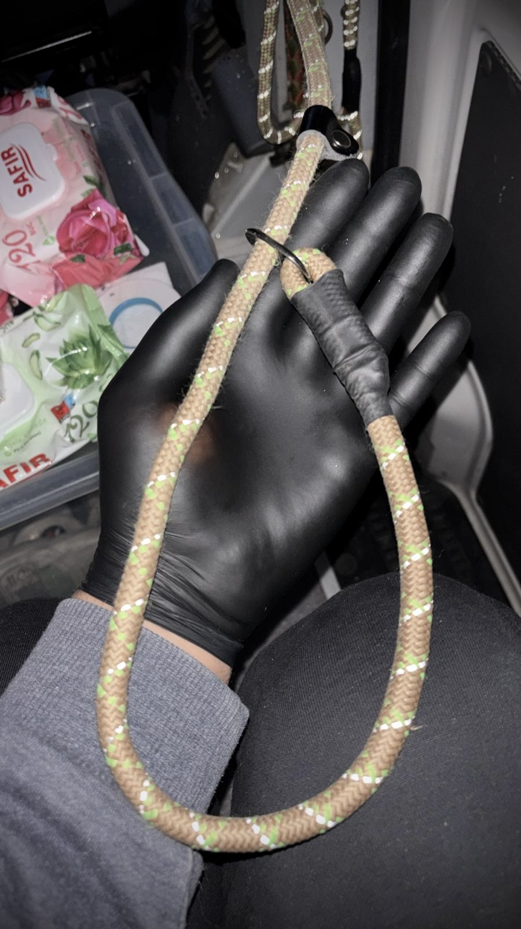
Whilst the continued safety of your animal is not reliant upon a slip lead alone the dogs are used to these during transfers to vetinary clinics, on to the vehicle, etc. and this will be the most convenient & secure method for the driver to complete his service on arrival.
Do not walk your dog for 48hrs while they decompress and take them via the slip lead straight into your garden on arrival to relieve themselves off transport.

Identity Tags
Please ensure that you have an identity tag with your details to put straight on to your dog upon arrival. BTC will happily transfer microchips to the adopter when they can verify with a photograph that they have acquired their own disc.
Please do not rely solely on the welfare's which puts your dog at risk. Ours is for transport and emergencies in the U.K. in the event that a third party cannot get in touch with the owner.
Home

Toileting
When they first arrive (with a double point of contact i.e. lead/collar and harness, or two leads and collars both attached) take them into the garden as they will need the toilet and this will set a precedence. If you do not do this straight away then they will only be able to access the house and then you could be triggering a continued thought process.
The dog will understand that the garden or enclosed area (if no garden) is where they will toilet accompanied by you (see "Are They House Trained"). For adopters without gardens, please secure your dog in advance (you can ask the driver to assist) and carry or walk the animal to your communal garden or nearest grassed area to toilet. We have many apartment living adoptions, and you can speak to other owners in advance to be guided by their experiences. Please ask your rescuer for contact details.
Your dog has probably never been in a home. In this country they are not allowed indoors. This might mean they only wish to toilet outside. However, they may need time to adjust and possibly toilet in the house from anxiety or irritation after holding their wee (sometimes you may see a little bit of blood if it is a bladder irritation).
There is no way to know in advance how your dog will be until they get used to your routine. If you wish, have some newspaper handy (in general, we don't recommend training mats unless they are only a temporary measure, as sometimes they can teach the dog the wrong idea and they think you want them to go there perpetually).
Please do not chastise them if they make an error or toilet inside. You can gently but firmly say 'no’ if you see them about to do it (and lead them into the garden with a treat) or just as they are finishing. It will not be effective or kind after too many seconds have passed as they will not know what they have done wrong. If I was placed in a building with strangers after years of a different life, I might wet myself too.
It is not unusual for dogs to not toilet for the first 24, or even 48 hours of arriving to you. They've had a traumatic experience, and their system is upside down. It can take a week before they get into a routine when toileting. Do not try to engage your dog in a focused toilet training regime within the first two/three days of arriving; they need this time to recover from their journey. It is not unusual for them to start well and go backwards, so be patient, be consistent and build a good routine. You can have your own trigger words or phrase, such as “toilet”, “wee wee” etc.
NEVER, EVER rub your dog's nose in excrement or wee, or scold them, this is just cruel.
If you are struggling with toilet training methods, please consult a member of our team or an independent trainer to learn how you can change your ways to help them more. Dogs are not humans, though in many ways we share the same set of emotional responses. Allow them to experience them and in time they will get there.
Back
Home

Toys and Playing
Very often these dogs do not know how to play. Throw a ball and they may think you are throwing it at them. So gentle encouragement with cloth type toys is better.
Use a firm & gentle 'no' if they take your belongings such as slippers and then immediately hand them one of their toys so they can understand what is yours and what is theirs. Praise them for turning their attentions to the toy.
Be aware that an item like a ball/toy can be similar to a high-value treat (prized-possession) so it may be sensible to introduce them slowly rather than immediately.
Think about slowly introducing things like Ruffle Snuffle mats filled with treats, the act of sniffing out the rewards will help your dog to settle.
They don't always want to share - through no fault of their own.
Back
Home

Training Tips
Training tips will go here.
Home

Veterinary Information
Please note we comply to all regulations and go above our obligations regarding APHA (U.K. government) requirements.
We only have to do tape worm and rabies along with a HC (health certificate), though we also vaccinate, give flea, worming and tick treatments, and blood tests for tick-borne infections, leishmania, dirofilaria and other non-contagious ailments (unless a vet does not consider a specific test necessary in their professional opinion).
In addition we test for brucellosis. This is performed with the same eliza technology as the PCR tests.

A quick note on brucellosis should it come up
If your vet doesn't accept the tests we've done, which are in the passport and stamped by an official government vet, then you have two choices:
- One is to go to another vet, which some of the BTC owners have done successfully and avoided inflated charges.
- The other is to pay the inflated charges which others have paid only to discover the dog is negative which is exactly what we said.
It costs your vet £26 to do these bloods at the defra laboratory, I have seen an invoice and this is fact. Ask yourselves why some are charging inflated costs to retest and some are not. It's a lot of scare mongering but this is NOT a regulation, like Rabies, imposed by the British government; which verifies how it is NOT a threat with dogs from Bulgaria, which is why they they pass through pet control. We have NEVER had a positive result in thousands of dogs.
It is NOT a regulation to get a dog euthanised if they haven't been tested, or even if they had tested positive. None-the-less the dogs are tested here and if the vet doesn't accept this these are the two choices: either go elsewhere, and don't be potentially manipulated, or agree.
They are NOT testing dogs from the U.K. that have holidayed in Bulgaria for example. Remember, if your dog goes on vacation, and travels on a pet passport, you will not be asked to test your dog on your return to see if they contracted brucellosis. It's a sound argument and one you can put to your vet. If it was a threat then we would have to do this.
That's why we vaccinate against Rabies to travel in and out of the U.K. Don't allow yourself to be overwhelmed by alarmist tactics motivated often by profit and bias.
Please do not contact BTC about it (with respect) as we have covered it fully. There is nothing more to add. Fight back to unfair protocols.
We don't ask you to cover the costs of these optional tests. As a small welfare we fund this service. We are a responsible in our rehoming protocols. Additionally, we will give you the choice to opt for a PCR test for antigens too, the cost of which would be covered by yourselves and are a lot more reasonable than a U.K. clinic would charge you.
Most U.K. vets are very happy with our practices. Be aware that non-discriminatory vets will welcome you and your pet, and will put their welfare above profit margin or bias.
Unless a vet states that a dog cannot be neutered/castrated on the grounds of it being a risk to their well-being then our rescues will NOT travel intact.

Cats:
Same applies as for dogs re: castrations/spaying.
They will have flea, tick and worming prior to leaving. They will have the Rabies vaccine and in addition to this:
- Feligen RCP, or similar brand, for the active immunisation of healthy cats against three core feline diseases: feline panleucopaenia, feline rhinotracheitis, and feline calicivirus.
- A "fu felv snap test" to screen cats for feline immunodeficiency virus (FIV) and feline leukemia virus (FeLV).
These tests provide rapid, reference-lab quality results within minutes at the point of care, making them efficient for routine health checks and identifying these serious retroviral infections in cats.
The rescues travel with passports/microchips, and in some cases additional paperwork etc.
Back
Home

What To Expect On Your Rescue Journey
Introducing a rescue dog into your home is like welcoming a new room-mate who's been living out of a suitcase for the past decade - they're probably a bit confused and disoriented. Some dogs will settle in like a seasoned jet-setter, while others may need a little more time to decompress.
If your dog is safe and happy, that should be the key ingredient here. We as humans all to often put too much pressure on our dogs to 'fit in' to our lives. These dogs have been through a lot in comparison to your normal household pet; they've seen and dealt with trauma like no other UK dog. Their key socialisation period was probably spent on the streets, learning how to bin raid and not get caught by dog catchers, watching dogs get caught and trapped, on a chain and/or in the pound for the duration of their lives. All this builds on the dog they are today, and we need to remember that when we're expecting them to fit into our lives.
Patience and understanding are key, as is establishing a predictable routine. Don't be surprised if there's some collateral damage along the way - accidents, chewed furniture, and general mayhem are all part of the aftercare package. Just roll with it, shower them with love, and eventually, they'll start to feel right at home.
Remember, every rescue dog is an individual, and each one requires time and patience to settle into their new environment.
Here are some key points to keep in mind:
- Patience is a virtue: Every dog has their own pace, so don't expect an instant transformation. Some dogs may take weeks or even months to fully adjust to their new surroundings. They don't come with a set timetable.
- Routine is key: Dogs thrive on predictability. Establish regular feeding times, walk times, and bedtime rituals to provide a sense of security and stability.
- Expect mishaps: Accidents, chewing incidents, and general mayhem are all part of the package. Be prepared to roll with the punches and approach these situations with patience and understanding. Remember there is no point in “telling your dog off” if the behaviour has already happened, they won't relate it to the “bad” thing they did but to what is happening when you tell them off - you will only confuse them.
- Shower them with love: Positive reinforcement works wonders with dogs. Reward them with treats, praise, and belly rubs for good behaviour to build trust, confidence and strengthen your bond - but don't smother them.
- Seek help when needed: If you're struggling, don't hesitate to reach out for guidance and support. Remember, you're not alone in this journey and it's much better to seek support sooner rather than later.
What works for one dog may not work for another, and the initial adjustment period can be a roller-coaster of emotions for both the dog and its new guardians. Think about everything they've been through so far in their lives and then add in the new routine, house, people, noises and all the things they're learning. Give them time to process, rest and relax.
Your bonding time is important; giving them what they need and their welfare needs is far more valuable than being able to take them out for a ten mile walk with friends and family, or taking them to your local pub.
It's crucial to remember that many dogs who are rejected early in their adoption journey never had the chance to fully relax and be themselves in their new home. This is often due to a lack of emotional preparation on the part of the human family. Sleep deprivation, messes, and stress can take a toll on both the mind and body, a stark reminder that dog rescue is as much about the human aspect as it is about the dogs themselves.
When welcoming a rescue dog into your life it's essential to have realistic expectations, especially if the dog is exhibiting signs of fear or trauma.
Home

Your Needs Vs. The Dog's Needs

Putting The Dog First
The main thing is not to feel that you are doing anything wrong. If your rescue dog is aloof or withdrawn do not worry. It is a natural and forgivable mistake to have expectations that exceed what that dog can give you and this can lead to giving up on the animal too soon, dismissing them as unresponsive or having no personality.
All dogs are different - just give them the time they need to feel safe.
If it makes you feel any better my mother and I once made this error. I won't blame you for making the same misjudgement though I can at least guide you through the misconceptions more speedily.
Below I have pictured 'Amber' when she first arrived. Her eyes appear empty, she is unresponsive and resigned. She remained like this for some time. On the plus side I am also showing you her face when she learnt to trust us and you can see that she was worth the wait. She had suffered immense abuse and yet she emerged in just a month or so which is miraculously quick. We expected too much too soon so give them time.
Also pictured is Basil, a golden oldie.
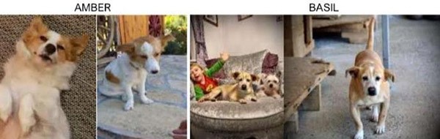
Back
Home

