電通二乙微處理器實驗 實驗結報

實驗名稱 | Lab01
組別 | 09 | 組員 | 許澤邦

- 實驗目的
使用Tinkercad模式Arduino UNO外電路及程式
繪製電路圖
觀察Arduino UNO之輸出
學習將程式碼及實驗報告上傳至Github
- 實驗步驟
填寫分組表單
啓動Arduino IDE,載入Blink程式碼
至www.tinkercad.com註冊帳號，啟動Arduino模擬器
接上LED電路
修改程式，將LED輸出改為Pin 9
觀察LED之閃爍間隔
修改程式，使LED閃爍間隔分別增加為2倍及1/2倍，重新量測試並截圖
畫出電路圖
- 程式碼
// the setup function runs once when you press reset or power the board
void setup() {
// initialize digital pin LED_BUILTIN as an output.
pinMode(LED_BUILTIN, OUTPUT);
}

// the loop function runs over and over again forever
void loop() {
digitalWrite(LED_BUILTIN, HIGH); // turn the LED on (HIGH is the voltage level)
delay(1000); // wait for a second
digitalWrite(LED_BUILTIN, LOW); // turn the LED off by making the voltage LOW
delay(1000); // wait for a second
}
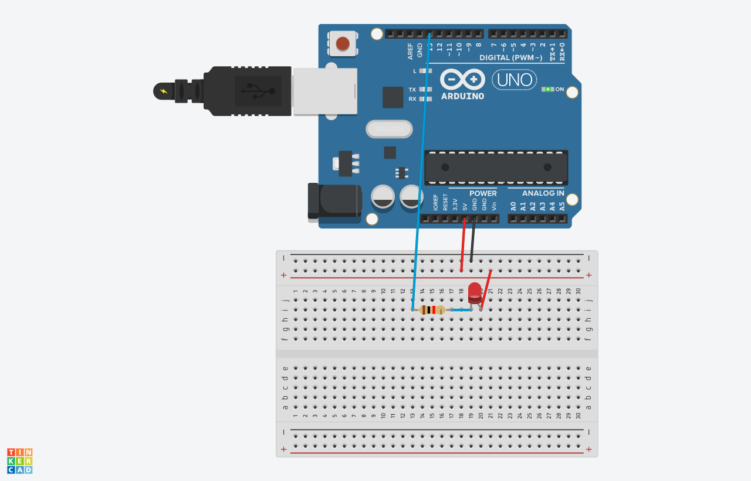
- 實驗結果及分析
LED之閃爍間隔為1秒
- 心得討論
學校電腦很爛和網路都很慢。
- 修正電路圖
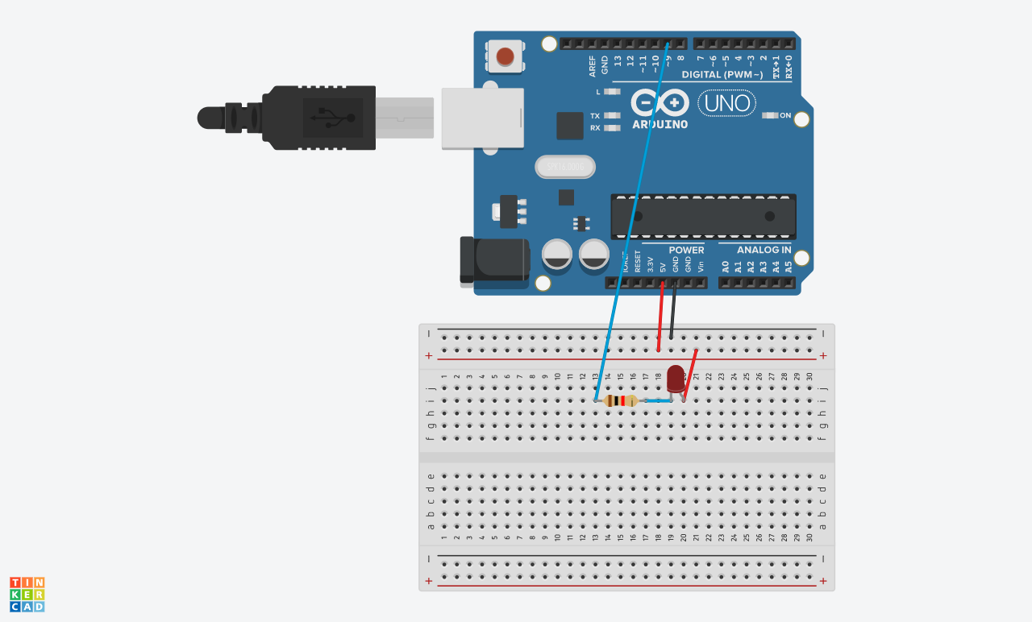
- 修正程式碼

// the setup function runs once when you press reset or power the board
void setup() {
// initialize digital pin LED_BUILTIN as an output.
pinMode(9, OUTPUT);
}

// the loop function runs over and over again forever
void loop() {
digitalWrite(9, HIGH); // turn the LED on (HIGH is the voltage level)
delay(500); // wait for a second
digitalWrite(9, LOW); // turn the LED off by making the voltage LOW
delay(500); // wait for a second
}

// the setup function runs once when you press reset or power the board
void setup() {
// initialize digital pin LED_BUILTIN as an output.
pinMode(9, OUTPUT);
}

// the loop function runs over and over again forever
void loop() {
digitalWrite(9, HIGH); // turn the LED on (HIGH is the voltage level)
delay(2000); // wait for a second
digitalWrite(9, LOW); // turn the LED off by making the voltage LOW
delay(2000); // wait for a second
}

