電通二乙微處理器實驗 實驗結報

實驗名稱 | 電通二乙
組別 | 09 | 組員 | 許澤邦

- 實驗目的
控制LED並檢視狀態
MCS 控制 LED 閃爍
MCS 新增on/off控制器/顯示器各一個
上傳A0資料
- 實驗步驟
修改 MCS_GET code, 加入 MCS Remote
將 A0 電阻值上傳
- 程式碼
#include <LWiFi.h>
#include "MCS.h"
char _lwifi_ssid[] = "AA202_24";
char _lwifi_pass[] = "iteaa202";
MCSDevice mcs("DyghkGs4", "MJ00s9je4Fh4A4kA");
MCSControllerOnOff led("LED_Control");
MCSDisplayOnOff remote("LED");
void setup()
{
Serial.begin(9600);
Serial.println("Connect to Wifi");
while (WiFi.begin(_lwifi_ssid, _lwifi_pass) != WL_CONNECTED) {
Serial.println("Wifi Reconnecting..");
delay(1000);
}
Serial.println("Connect to MCS...");
while (!mcs.connected()) {
Serial.println("MCS Reconnecting..");
mcs.connect();
}
Serial.println("MCS Connected!");
mcs.addChannel(led);
pinMode(7, OUTPUT);
}
void loop()
{
while (!mcs.connected()) {
mcs.connect();
if (mcs.connected()) {
Serial.println("MCS Reconnect");
mcs.addChannel(led);
mcs.addChannel(remote);
}
}
mcs.process(1000);
while(!mcs.connected())
{
Serial.println("MCS.connect()...");
mcs.connect();
}
if (led.value() == 1) {
digitalWrite(7, HIGH);
} else {
digitalWrite(7, LOW);
}
while(!led.valid())
{
Serial.println("read LED value from MCS...");
led.value(); //取得MCS數值
}
Serial.print("done, LED value = ");
Serial.println(led.value());
digitalWrite(7,led.value() ? HIGH : LOW);
delay(200);
if(!remote.set(led.value()))
{
Serial.print("Failed to update remote");
Serial.println(remote.value());
}
}

#include <LWiFi.h>
#include "MCS.h"
char _lwifi_ssid[] = "AA202_24";
char _lwifi_pass[] = "iteaa202";
MCSDevice mcs("DyghkGs4", "MJ00s9je4Fh4A4kA");
MCSDisplayInteger Temp("Temp");
void setup()
{
Serial.begin(9600);
Serial.println("Connect to Wifi");
while (WiFi.begin(_lwifi_ssid, _lwifi_pass) != WL_CONNECTED) {
Serial.println("Wifi Reconnecting..");
delay(1000);
}
Serial.println("Connect to MCS...");
while (!mcs.connected()) {
Serial.println("MCS Reconnecting..");
mcs.connect();
}
Serial.println("MCS Connected!");
mcs.addChannel(Temp);
}
void loop()
{
while (!mcs.connected()) {
mcs.connect();
if (mcs.connected()) {
Serial.println("MCS Reconnect");
}
}
mcs.process(1000);
int sensor = analogRead(A0);
Temp.set(sensor);
Serial.println("Add sensor value.");
delay(200);
}

- 實驗結果及分析
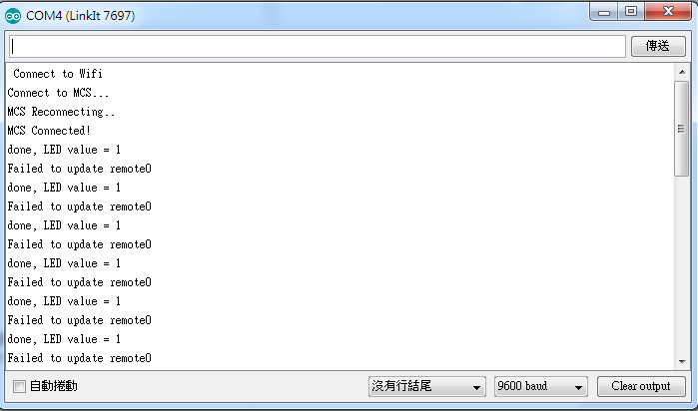
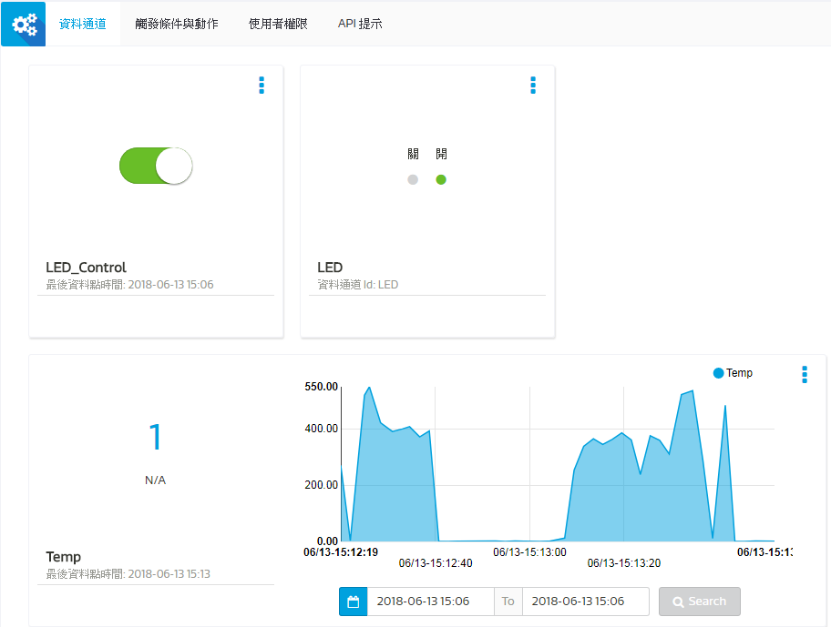
- 心得討論
今天的實驗挺好玩。

