Handover: fca-nsm-api
Source: github.com/TomHyde10/RNS (docs/*.md). File references point to that repository.
Not supplied by requester: target platform and business purpose. Both are left open (see Open questions).
Status legend: UNVERIFIED = not provable from this repo.

What it does
- A small HTTP service with one endpoint, GET /api/reports (server.js:13).
- For a list of companies (identified by LEI), it asks the FCA's National Storage Mechanism (NSM) for their regulatory filings (nsm.js:135-155).
- It keeps only filings from the last N days in chosen categories (default: half-year and annual financial reports) and returns them as JSON (nsm.js:253-305).
- Results are cached per company, in memory or in Postgres, to reduce calls to NSM (nsm.js:157-246, cacheStore.js).
- Taken from a larger app, RNS_Update. Digests, push notifications, feeds and the UI were not carried over (README.md:3-8). That repo was not reviewed.

Inputs, steps, outputs, schedule
Inputs (query string, all optional; server.js:14-18, nsm.js:48-72)
Param | Format | Default | Handling
leis | Comma-separated LEIs | All 21 in leis.json | Trimmed, upper-cased, de-duplicated. Invalid entries are dropped silently.
days | Integer | 7 | Clamped to 1–365. A non-number becomes 7. parseInt accepts "7abc" as 7.
categories | Comma-separated text | Half-year Financial Report,Annual Financial Report | Exact match, case-insensitive. An empty value uses the default.

Steps
- Parse and validate the inputs (nsm.js:254-264).
- Work out the page size per LEI: min(1000, max(100, days × 15)) (nsm.js:74-76).
- For each LEI, in parallel, read the cache (see Caching), or POST to NSM (nsm.js:266).
- If every LEI fails, return 502. Otherwise carry on (nsm.js:268-271).
- Keep filings whose date is on or after now − days (nsm.js:273-283).
- Filter by category, then normalise each filing (nsm.js:96-108, nsm.js:284).
- Return JSON.
Outputs
Status | When | Body
200 | At least one LEI succeeded | leis, dateFrom, days, categories, scanned, count, reports[], failedLeis?, cachedLeis?, deltaLeis?, cacheBackend (nsm.js:289-303)
400 | No valid LEIs and leis.json is empty | {error} (nsm.js:256-258)
502 | Every LEI failed | {error, details} (nsm.js:269-271)
404 | Any other path or method | {error:"Not found"} (server.js:24-25)

Fields on each report (nsm.js:96-108):
Field | Source
lei | NSM lei
company | Non-blank leis.json name, else NSM company, else the LEI
title | NSM headline, else type, else "(untitled)"
category | NSM type
publishedAt | NSM publication_date, else document_date, else submitted_date. Passed through as-is, not reformatted.
url | https://data.fca.org.uk/artefacts/ + download_link, else html_link, else null
id | NSM disclosure_id, else _id
raw | The full NSM item, unchanged

Schedule: none. The service only runs when a request comes in. There is no timer, cron job or background job in the repo. Whatever calls the endpoint, and how often, is UNVERIFIED.

Data flow
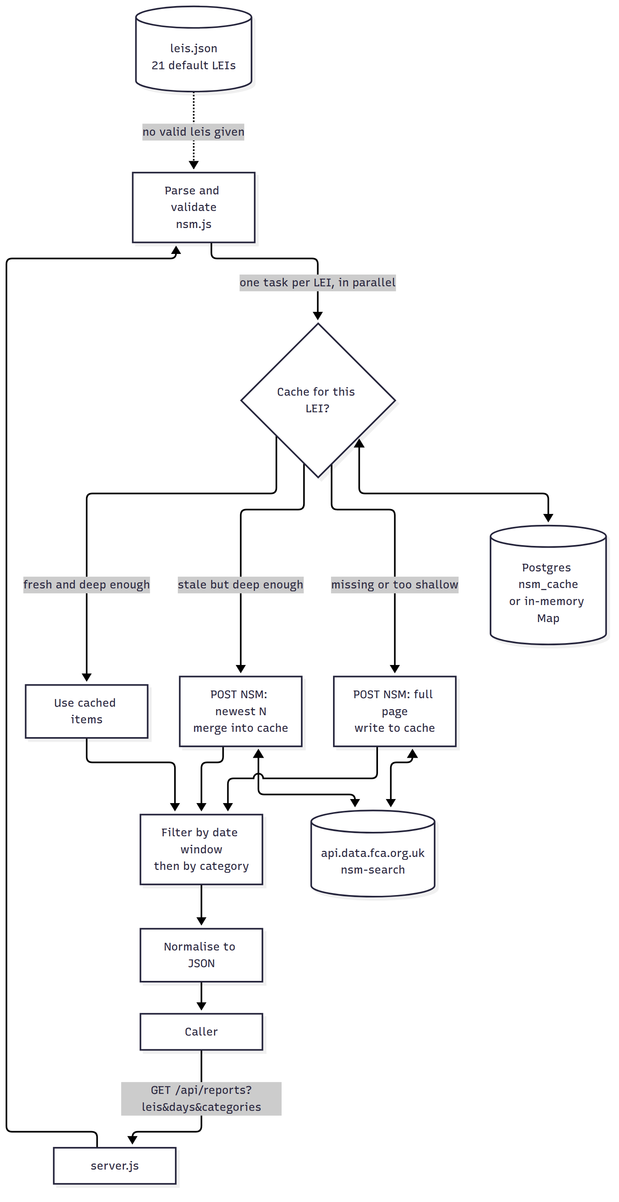

External dependencies
Dependency | Detail | Auth | What breaks if it changes
FCA NSM search API | POST https://api.data.fca.org.uk/search?index=nsm-search (nsm.js:17) | None. Browser-like Origin, Referer and User-Agent headers are sent (nsm.js:40-46). | Everything. The endpoint is undocumented and was worked out from a captured browser request (nsm.js:7-12, README.md:10-13). Any change to the request body, date format, response shape (hits.hits[]._source) or bot filtering breaks it. A timestamp with milliseconds once returned 404 (nsm.js:78-84).
FCA document links | https://data.fca.org.uk/artefacts/ + download_link (nsm.js:18, 92-94) | None | url fields in the response point to the wrong place
Postgres (optional) | Used when DATABASE_URL is set. Creates table nsm_cache on first use (cacheStore.js:39-55). | Credentials in DATABASE_URL | The cache is lost. Requests still succeed without it, and the error is logged for each LEI on each request (nsm.js:206-228).
pg npm package (optional) | ^8.23.0 (package.json:10-12) | n/a | Same as Postgres being unavailable
Node.js ≥ 18 | Uses the built-in fetch (package.json:13-15) | n/a | n/a
GLEIF (manual only) | Suggested for looking up LEIs (README.md:78). Not called by the code. | n/a | n/a

Business rules and edge cases
- One request per LEI. NSM filters by company_lei on its side (nsm.js:10-12).
- Fixed request body. The body copies a captured browser request exactly: company_lei value ["", LEI, "disclose_org", "related_org"], latest_flag: "Y", sort submitted_date desc, dateCriteria with from: null and to: now. Timestamps have no milliseconds (nsm.js:110-133). The server applies no "from" date; the date window is applied afterwards in code.
- Date window. The cutoff is now minus N days, keeping the current time of day (not midnight) (nsm.js:86-90). An item's date is publication_date, else document_date, else submitted_date. Items without a valid date are dropped (nsm.js:273-283). The README.md:49 example shows a midnight dateFrom, which does not match the code.
- Date field mismatch. NSM sorts by submitted_date, but the window filter uses publication_date first. If a filing's publication date is much older than its submission date, the window may treat it differently than expected. UNVERIFIED whether this happens in real data.
- Page size limit. At most min(1000, max(100, days×15)) items per LEI. A company with more filings than that in the window loses the older ones without any warning (nsm.js:24-28).
- scanned counts filings inside the window before the category filter (nsm.js:296).
- Category matching compares the whole string, ignoring case. Net Asset Value(s) does not match Net Asset Value(s) - correction (test/nsm.test.js:58-68).
- Partial failure. Returns 200 and lists the failed LEIs in failedLeis, with error text and up to 2,000 characters of response body (nsm.js:147-150).
- Caching (nsm.js:157-246):
  - Key: the LEI only. One entry serves any shorter window and any category filter.
  - Fresh (younger than the TTL) and page size at least as large as needed: serve from the cache (cachedLeis).
  - Stale but page size large enough: fetch only the newest min(1000, max(100, elapsedDays×15)) items and merge them in (deltaLeis). If that fetch fails, serve the stale entry and report it as cached.
  - Merge: match by disclosure_id, else _id, else lei|type|date|headline. The newer copy wins. Sort newest first (nsm.js:181-197).
  - Missing, or page too small: full fetch. Failed fetches are not cached.
  - Different from the README. README.md:89 says NSM_CACHE_TTL_MINUTES=0 disables caching. In the code, 0 only stops fresh-cache hits. Results are still stored, and each later request does a catch-up fetch (nsm.js:177-179, 234-241). The test test/deltaFetch.test.js relies on this behaviour.
- Company names. A non-blank name in leis.json overrides NSM's company name (nsm.js:97-100).

Config settings
Setting | Where | Default | Effect
PORT | env (server.js:8) | 3000 | HTTP port
NSM_CACHE_TTL_MINUTES | env (nsm.js:171-174) | 10 | Cache freshness. Any invalid value becomes 10. For 0, see above.
DATABASE_URL | env (cacheStore.js:6-7) | unset (memory cache) | Turns on the Postgres cache. Contains credentials.
DATABASE_SSL_CA | env (cacheStore.js:21-23) | unset | CA certificate in PEM format. Literal \n sequences are converted to newlines.
DATABASE_SSL_VERIFY | env (cacheStore.js:20) | verify | false turns off TLS certificate checks
sslmode in DATABASE_URL | connection string | n/a | Overrides both SSL settings above (cacheStore.js:16-18)
TEST_DATABASE_URL | env, tests only (test/postgresCache.test.js:7) | unset | Runs the Postgres test
Default LEI list | leis.json | 21 entries | Used when no valid leis param is given
Hard-coded constants | nsm.js:17-36 | default 7 days, range 1–365, 15/day, max 1000, default categories, LEI regex ^[A-Z0-9]{20}$ | Change requires a code edit

Secrets check: no real credentials found in the repo. README.md:111 has a placeholder connection string (user:password@host). .env is git-ignored (.gitignore:2). In production, DATABASE_URL is a secret and belongs in a secret store.

Known limitations
- A malformed NSM response can crash the service. response.json() has no error handling (nsm.js:152), and the request handler has no try/catch (server.js:13-21). I confirmed that fetchReports throws on invalid JSON. Under Node's default settings, that unhandled error terminates the process (from reading the code; not run against the live server).
- No timeout on NSM calls (nsm.js:138). One slow LEI holds up the whole response.
- All LEIs are requested at once with no limit on concurrent calls (nsm.js:266). With 21 default LEIs, that is 21 simultaneous calls to NSM.
- Two simultaneous requests for the same LEI both go to NSM. There is no sharing of in-progress requests.
- The in-memory cache has no size limit and no eviction. Cached item lists also grow with every merge (nsm.js:175, 238-239).
- No authentication, rate limiting, CORS headers or health endpoint (server.js:1-3).
- The page-size limit can silently cut results (see above).
- The catch-up fetch misses filings if more than its page size were filed since the last fetch.
- clearCache() clears only the memory cache, never Postgres (nsm.js:248-251).
- No logging apart from cache errors and the startup line.
- Tests always mock NSM. There is no test against the live API (test/nsm.test.js:1).

Open questions
- Business purpose and target platform: not supplied by the requester.
- Default LEI list: is it correct? Only 2 of the 21 are confirmed. The README warns the list may be misaligned against the original ISINs (README.md:80-84). UNVERIFIED.
- Who calls this endpoint, how often, and what they do with the results? Digests and notifications lived in RNS_Update, which was not reviewed. UNVERIFIED.
- FCA permission: does the FCA allow automated use of this undocumented endpoint? Is there an official NSM API or data feed that should replace it? UNVERIFIED.
- Date for the window: should it be publication_date or submitted_date?
- TTL of 0: should it mean "no cache at all" (what the README says) or the current code behaviour?
- Other categories: are they needed? What are the full valid type values? Only three were seen: Half-year Financial Report, Annual Financial Report, Net Asset Value(s). UNVERIFIED that this is the full list.
- Hosting: Render's free tier is mentioned as an example (README.md:106). Where it actually runs is UNVERIFIED.

