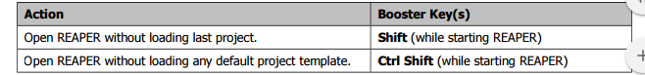

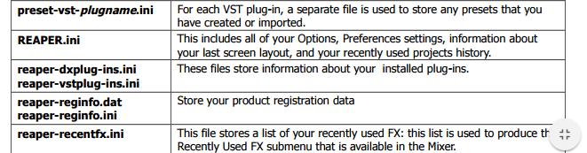

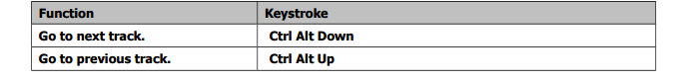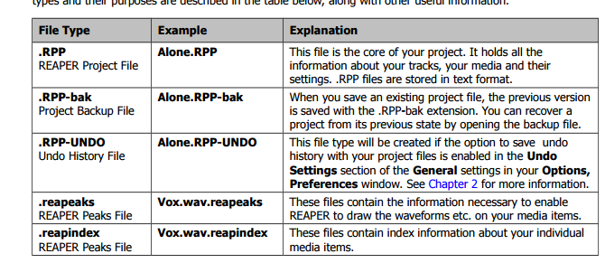

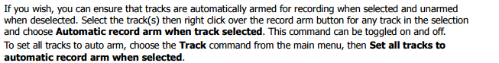

View the Options menu and for now ensure that Show all takes in lanes (when room) is not selected.

. Pressing Ctrl L toggles the display of all takes or active take only (see above)

You can enable the option Monitor track media when recording. If you do this when punching in, say, a guitar or vocals, regular Monitor Input will cause you to hear both the existing and the new material right up to the punch, and during the punch

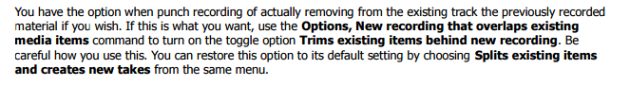

In this case, the option to Display empty take lanes (Options, Take lane behavior menu) has been enabled

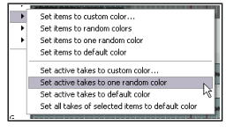

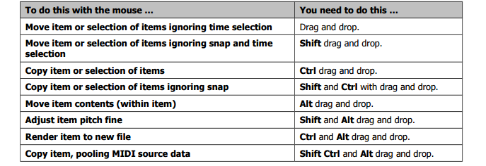

Select an item by clicking on the item. • Select multiple items by using Ctrl Click. • Select adjacent items by using Shift Click.

If there is a time selection current, pressing Shift S will split all selected Item(s) at the beginning and end of the time selection

To reconnect media item that have previously been split: • Select the media items in the track. • Right click over any media item within the selection and from the menu choose Heal splits in items. Heal is different from Glue. In short, heal restores items to their original state, whilst glue renders them to a new file.

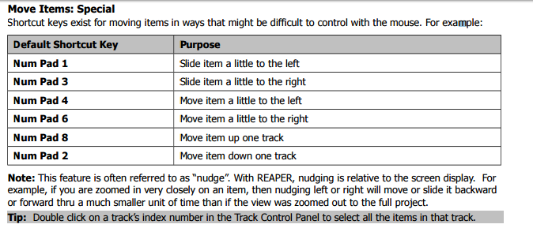

The setting Link loop points to time selection (on your Preferences, Editing Behavior page) determines whether by default the loop points are linked to your time selection. When linked, this means that when you select a time area other than that currently selected, the loop selection changes with it. At any time you can override the default behavior by using the toggle command Loop points linked to time selection on REAPER's main Options menu. Even when this option is disabled (i.e. not ticked), you can still use the Alt key while you click and drag along the timeline to set both the time selection and the loop selection together

The Snap/Grid Settings dialog is accessed by choosing the Options, Snap/Grid Settings command, or by the keyboard shortcut Alt L, or by right clicking on the Grid button on the REAPER toolbar. Alt S is used to toggle the Snap feature on and off

For several of the settings in the Item Properties dialog box there are icons (buttons) available that can be used as a quick way of accessing these commonly used features. The display of buttons is turned on and off in the Appearance, Media page of the Preferences settings

Press the ~ key (Shift `) to maximise the current track. Press Ctrl Alt Up or Ctrl Alt Down until the Vox track is displayed. A

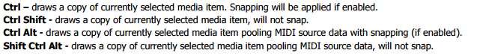

The simplest way to describe ripple editing is this: usually, when you delete part of a media item, a gap is left on the track where the deleted item used to be. With ripple editing, the material on the track is moved over to fill that gap.

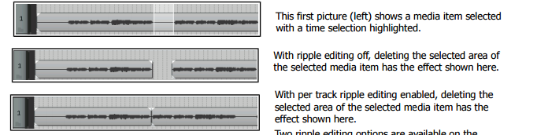

Use the Options, Peak display mode, Show spectral peaks command to turn the display of peaks on and Options, Peak display mode, Normal peaks to turn them off. Another peaks display mode option is to Show spectrogram: this will be considered in the next section.