UGTS APPLICATION / PROOF CAMPAIGN
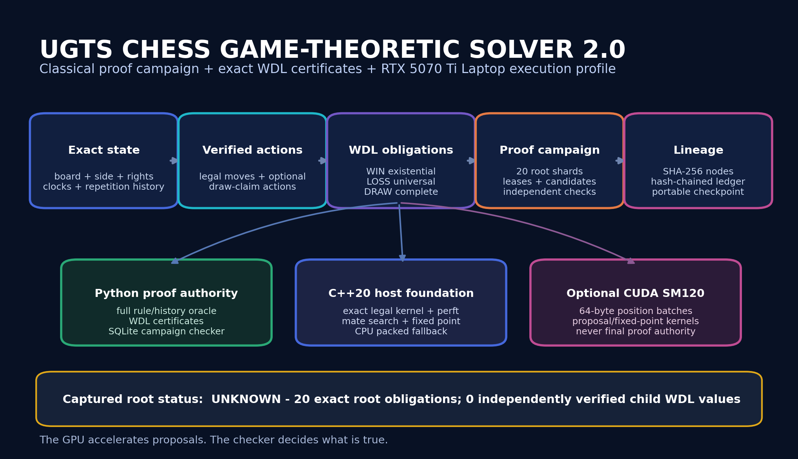
Release field | Value
Canonical identity | ugts.application.chess-proof@2.0.0
Release | UGTS Chess Game-Theoretic Solver 2.0
Target | NVIDIA GeForce RTX 5070 Ti Laptop GPU, nominal 12 GB GDDR7
Captured root value | UNKNOWN
Document date | 29 August 2026
Status | Executable host-validated foundation; CUDA laptop build and long campaign delegated to Codex/device
EVIDENCE BOUNDARY
This release attempts a proof-oriented solution of classical chess. It does not claim that the standard initial position is weakly, strongly or ultra-weakly solved. GPU kernels propose work; independently checked certificates decide truth.

Executive Summary. Release Decision
What has been built, what has been proved, and what remains open.
FORMAL DECISION - GO
Promote Chess 2.0 as an upgraded foundational proof campaign and RTX 5070 Ti Laptop handoff. Freeze the exact rule/history identity, represent claimable draws as actions, issue content-addressed WDL obligations, and keep the classical initial position UNKNOWN until quantified proof obligations close.

Verified release result
Area | Captured result
Initial position | 20 exact root obligations; 0 independently verified child values; root UNKNOWN
Python | 92 tests passed; 20 exact perft checks
Native C++20 | 3 CTest gates passed; depth-5 initial perft 4,865,609 nodes
Packed protocol | 4 positions; 97 moves; 0 differential mismatches
Certificates | Mate certificate verified; exact bounded WIN fixture; initial-depth-2 fixture safely UNKNOWN
Tablebases | Complete KQK max DTM 20 plies; KRK max DTM 32 plies
Distribution | Wheel 332,019 bytes; isolated clean install passed
CUDA laptop | Source and SM120 preset supplied; no physical laptop benchmark claimed in this environment

What the deliverable is for
• Codex can compile the optional CUDA adapters, compare them against the exact Python and C++ host oracles, and record device evidence without weakening proof semantics.
• The twenty first moves can be leased as independent shards, with candidate WDL results kept non-authoritative until a separate checker record is attached.
• The package supplies a reproducible starting point for out-of-core proof DAGs, larger exact endgame partitions, dead-position certificates and distributed replay.

Reading Map. Contents and Claim Ladder
The report moves from proof meaning to exact state, certificates, campaign orchestration, RTX execution and promotion gates.
Sections | Purpose
1-3 | Meaning, source basis and component identity
4-7 | FIDE action profile, UGTS authority and exact history state
8-12 | WDL calculus, certificates, root obligations and SQLite campaign
13-15 | Bounded exact results, retained mate proof and exact KQK/KRK tables
16-20 | C++20 core, packed protocol, RTX profile, VRAM plan and CUDA boundary
21-24 | Codex workflow, global proof architecture, validation and performance evidence
25-28 | Roadmap, mechanism catalog, package map, final definition and references
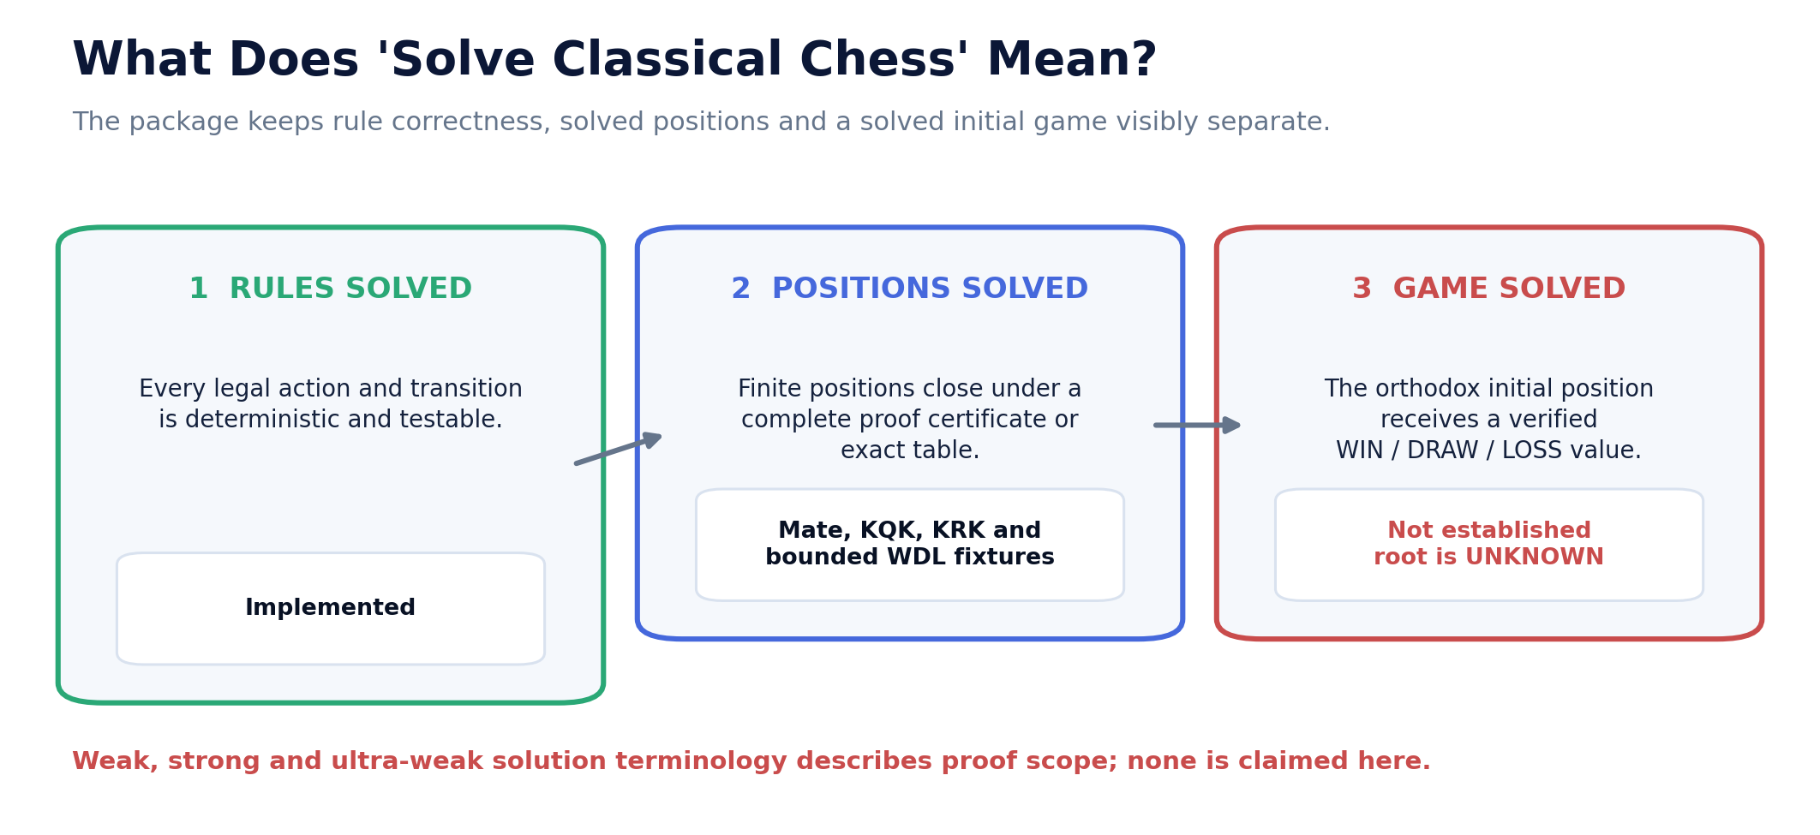
Figure 1. Rules solved, positions solved and the initial game solved are separate claims. Chess 2.0 establishes the first and selected instances of the second; the third remains UNKNOWN.
READING RULE
An exact result is promoted only when its serialized rule profile, state identity, action coverage, certificate graph and independent verification status support it. Search depth, evaluation score and GPU completion do not substitute for those obligations.

1. Source Basis and Component Identity
UGTS supplies authority discipline; chess rules, WDL logic and GPU engineering are explicit application additions.
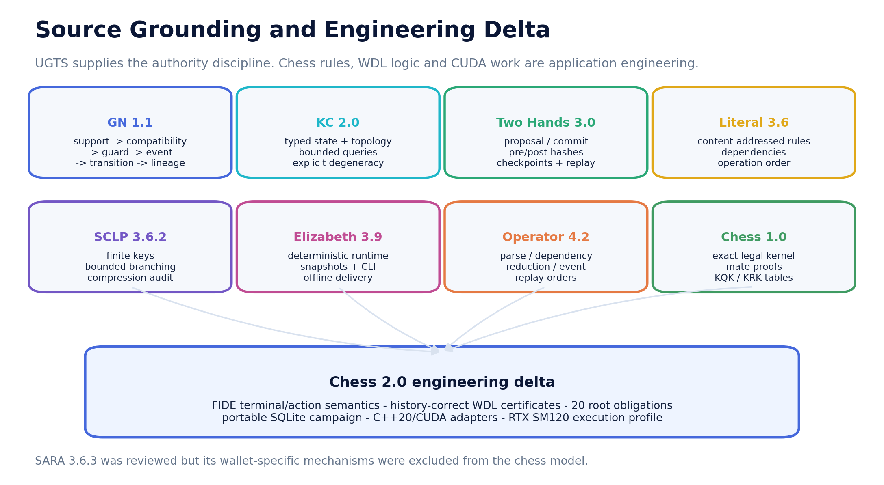
Figure 2. The new chess layer retains the recurring support -> compatibility -> guard -> verified event -> transition -> lineage architecture.

1.1 Immediate source use
Source | Use in Chess 2.0
UGTS-GN 1.1 | Authority chain, packed precision and hardware evidence boundaries
UGTS-KC 2.0 | Typed state, topology, bounded queries and explicit degeneracy
Two Hands 3.0 | Proposal/commit, pre/post hashes, checkpoints and replay
Literal 3.6 / SCLP 3.6.2 | Content addresses, dependency order, finite keys and bounded branching
Elizabeth 3.9 | Deterministic game world, snapshots, CLI and offline delivery
Go 4.2 / Operator 4.2 | Rules-position-game claim ladder; exact certificates; distinct evaluation, event and replay orders
Chess 1.0 | Exact legal kernel, mate proofs, search boundary and complete KQK/KRK tables
Grounding: The source PDFs do not claim a classical chess solution or RTX implementation. The chess/WDL/campaign/CUDA layers are visibly engineering-derived. SARA 3.6.3 was reviewed but its wallet-specific mechanisms were excluded.

2. What a Game-Theoretic Solution Requires
A finite game can be defined exactly while its initial value remains computationally unresolved.

2.1 Three independent claims
Claim | Required evidence | Chess 2.0 status
Rules solved | Every legal action, terminal and transition is deterministic and testable. | Implemented
Position solved | A fully serialized finite state has a complete proof certificate or exact table entry. | Implemented for bounded fixtures, mate certificates, KQK and KRK
Game solved | The orthodox initial position is certified WIN, DRAW or LOSS under one complete rule profile. | Not established; UNKNOWN

2.2 Weak, strong and ultra-weak terminology
• An ultra-weak solution determines the game-theoretic value of the initial position.
• A weak solution also gives a strategy from the initial position that achieves that value against every reply.
• A strong solution gives the game-theoretic value and optimal action for every legal position in the selected state space.
• Chess 2.0 claims none of these for unrestricted classical chess. Its root node is deliberately serialized as UNKNOWN.
WHY UNKNOWN IS A RESULT
UNKNOWN means one or more quantified obligations remain open. It is not a heuristic draw, an engine disagreement, a timeout disguised as a result, or evidence that no solution exists.

3. Classical FIDE Rule and Action Profile
Moves, claimable draws and automatic terminals are distinct action classes.
Action/terminal | Class | Proof treatment
Ordinary move | Legal board transition | Must pass occupancy, motion, special-right and king-safety checks
Current draw claim | Optional player action | Threefold repetition or 50-move condition already present
Claim by intended move | Optional player action | Declared legal move would create third repetition or complete 50 moves
Checkmate | Automatic terminal | Side to move has no legal move and is in check; winner is the opponent
Stalemate | Automatic terminal | No legal move and not in check
Fivefold repetition | Automatic terminal | Exact repetition identity occurs at least five times
75-move rule | Automatic terminal | 150 halfmoves without pawn move or capture; checkmate takes precedence
Dead position | Automatic terminal | Requires an exact certificate that no mating sequence is possible

3.1 Declared profile
rules_profile = fide-classical-2023-claims-as-actions-v2
move claims are optional actions
automatic draws are terminals
checkmate is evaluated before the automatic 75-move terminal
DEAD-POSITION BOUNDARY
The bundled recognizer certifies a conservative exact subset. A global classical proof must add a complete dead-position oracle or attach independently checkable dead-position certificates. Uncovered cases remain UNKNOWN.
Grounding: FIDE Laws of Chess, Articles 5.2, 9.2, 9.3 and 9.6. The official 2023 text states that checkmate takes precedence over the automatic 75-move draw.

4. One Action Through the UGTS Authority Chain
A move generator proposes; only the verifier and atomic transition alter authoritative state.
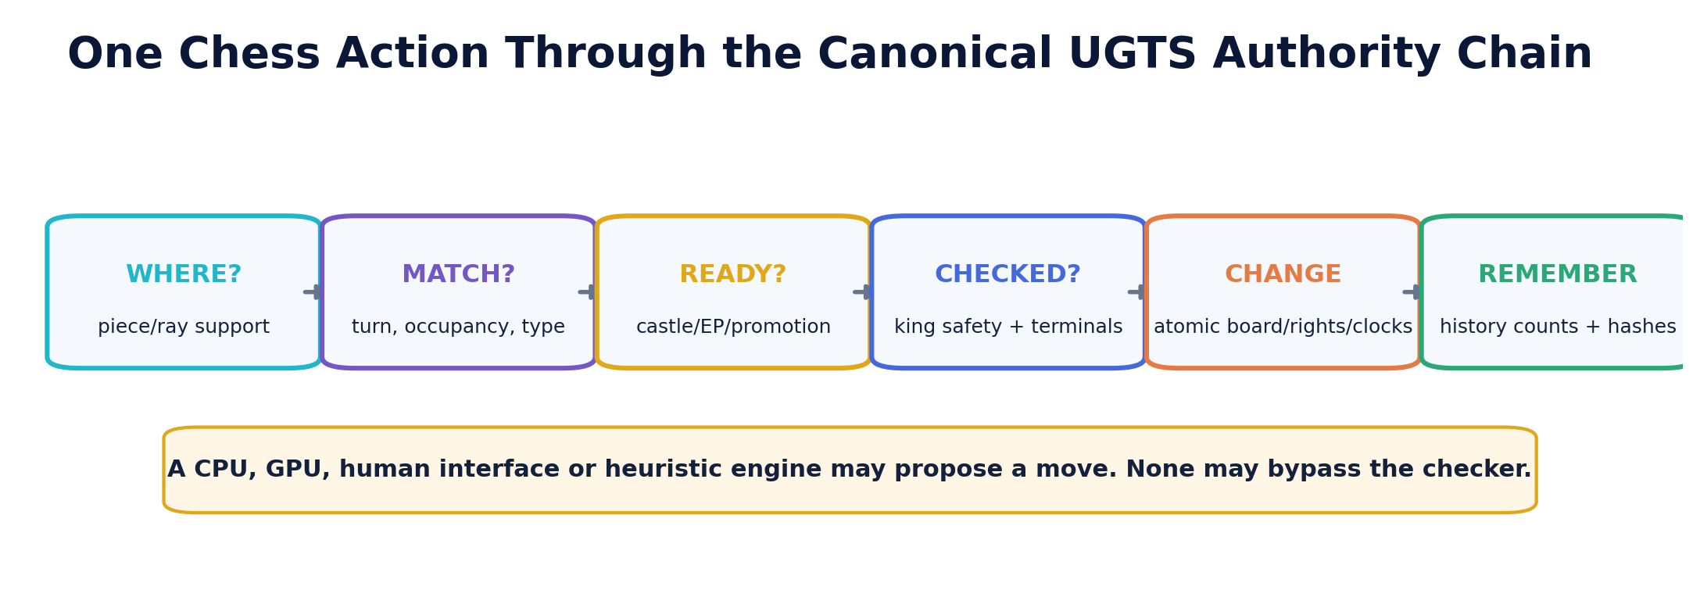
Figure 3. Chess mechanics mapped onto the canonical six-stage authority sequence.
Stage | Chess interpretation
WHERE / support | Rays, jump targets, pawn attack/move supports, king neighborhood
MATCH / compatibility | Correct side, piece type, target occupancy and capture relationship
READY / special guards | Promotion choice, castling rights/path, legal en-passant right
CHECKED / verified event | Move leaves own king safe; terminal classification follows the new state
CHANGE / transition | One immutable patch updates board, side, rights, en-passant and clocks
REMEMBER / lineage | Exact repetition counts, state hashes, move event and replay order
NON-BYPASS RULE
CPU search, CUDA kernels, a human interface, opening book, tablebase adapter or neural policy may order or propose actions. None may set an authoritative WDL value without the same legal and certificate checks.

5. Exact Position and History Identity
A board diagram is not enough to decide repetition, move-count claims or proof replay.
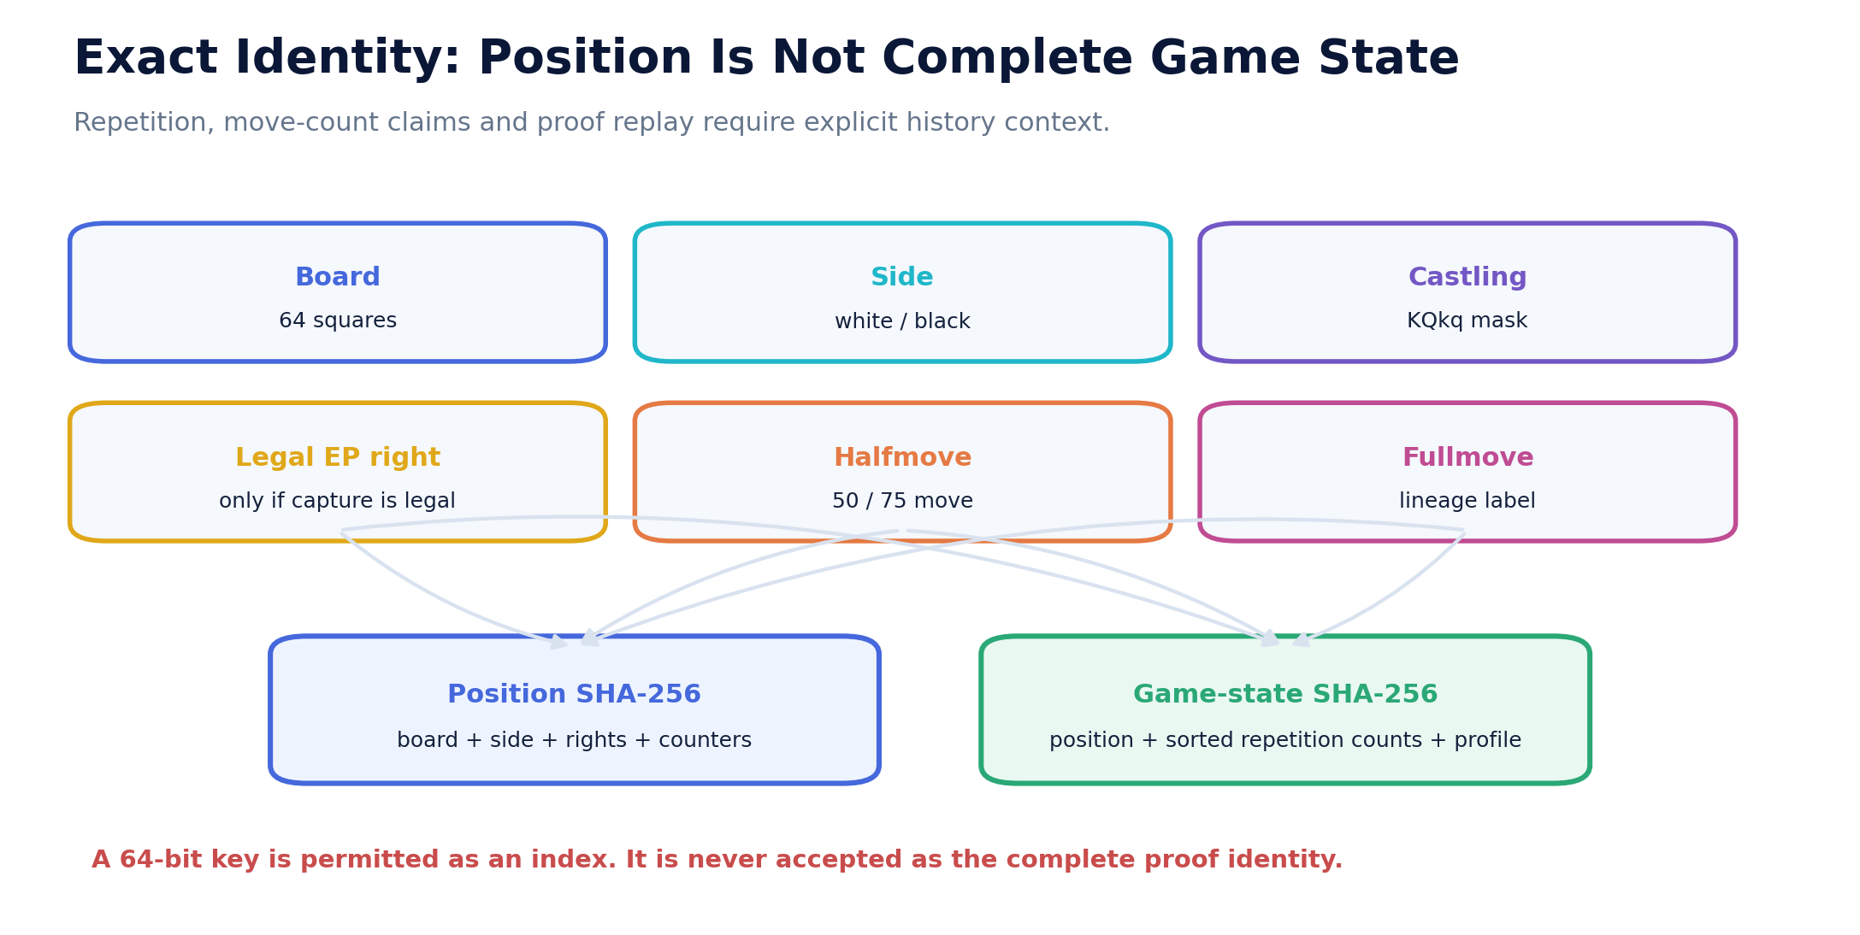
Figure 4. The proof identity includes normalized rule state and exact repetition-count context.

5.1 Authoritative state
Q = (board, side, castling rights, legal en-passant right,
halfmove clock, repetition-count context, rule profile, lineage)
Identity | Role
Position SHA-256 | Exact FEN-level transport identity including fullmove metadata
Game-state SHA-256 | Rule-semantic position plus capped halfmove clock, sorted exact repetition counts and profile ID
64-bit cache key | Permitted only as a fast index; full record must be compared before proof use
Lineage hash | Ordered event evidence; not interchangeable with current-state identity
Grounding: This preserves the recurrent UGTS distinction between coordinates, identity and lineage. SCLP finite keys are indexes, not complete worlds.

6. Repetition, Move Counts and Draw Strategy
A claim opportunity changes available actions but need not end a winning line.

6.1 Exact action semantics
Condition | Record code | Game-theoretic treatment
Threefold now | claim_threefold_current | Player may take DRAW or continue
50 moves now | claim_fifty_move_current | Player may take DRAW or continue
Third repetition by move | claim_threefold_by_move | Claim is attached to the declared legal move
50 moves by move | claim_fifty_move_by_move | Claim is attached to the declared legal move
Fivefold | fivefold_repetition | Forced DRAW terminal
75 moves | seventy_five_move | Forced DRAW terminal after checkmate test

6.2 Repetition identity
• Board occupancy, side to move and castling rights must match.
• An en-passant square contributes only when an en-passant capture is actually legal; a merely printed target is normalized away.
• Exact occurrence counts are stored as sorted SHA-256 identity/count pairs. A rolling checksum alone is insufficient.
• Fullmove number is replay metadata and does not change legal action or terminal rules; the semantic proof hash excludes it.
STRATEGIC CONSEQUENCE
At halfmove 100, a player may already claim a draw. If the same position also contains checkmate in one, WIN remains exact because the player can choose the winning move instead of the optional draw action.

7. Four-Valued WDL Proof Calculus
WIN, LOSS and DRAW are proof claims; UNKNOWN is the safe incomplete value.
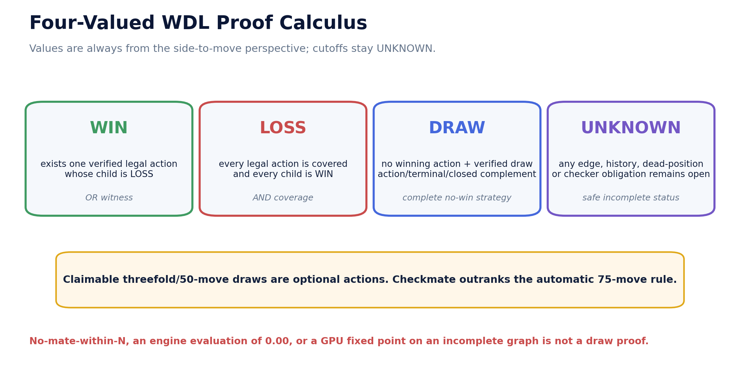
Figure 5. Values are from the side-to-move perspective. Child values are inverted when interpreted by the parent.

7.1 Quantified obligations
WIN(q) := exists legal action a with exact LOSS(child(q,a))
LOSS(q) := every legal action is covered and exact WIN(child(q,a))
DRAW(q) := no winning action exists, coverage is complete, and a draw terminal/action/closed-complement certificate exists
UNKNOWN := any required edge, history state, dead-position decision or checker obligation is open
CUTOFF LAW
A horizon, node budget, time limit, missing child or heuristic score is UNKNOWN. The solver never promotes 'no win found yet' to DRAW.
Grounding: The fixed-point structure follows the bounded exact-solving precedent in UGTS-KC 4.2 Go and the order/certification discipline in the General Operator and Order Addendum.

8. Content-Addressed Certificates and Independent Promotion
A worker result is evidence only after a separate checker validates quantified coverage.
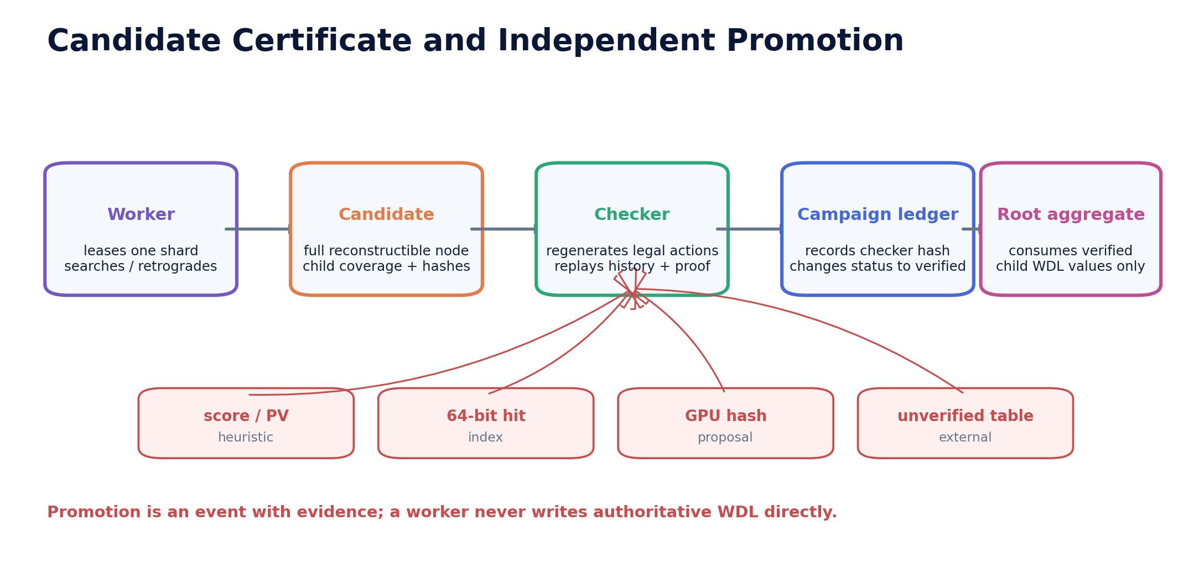
Figure 6. A certificate path and a checker record are both bound into campaign lineage.
Record | Required content
Node identity | Game-state SHA-256, FEN, history counts, remaining depth and rule profile
Child obligation | Action kind, UCI/SAN or claim code, child state hash, child value and child certificate hash
Coverage | terminal, witness, complete or cutoff
Certificate hash | SHA-256 over canonical node content excluding the hash field itself
Checker record | Obligation ID, claimed WDL, certificate SHA-256, child game-state SHA-256 and valid=true
Promotion | Campaign job changes to verified only after checker fields and hashes match
INDEPENDENCE BOUNDARY
The current reference checker runs in the same Python package but through a separate verification path and record. A production campaign should additionally diversify implementations, hosts and reviewers before treating a root certificate as durable evidence.

9. The Initial Position Becomes Twenty Root Obligations
The first exact decomposition is small, stable and independently leaseable.
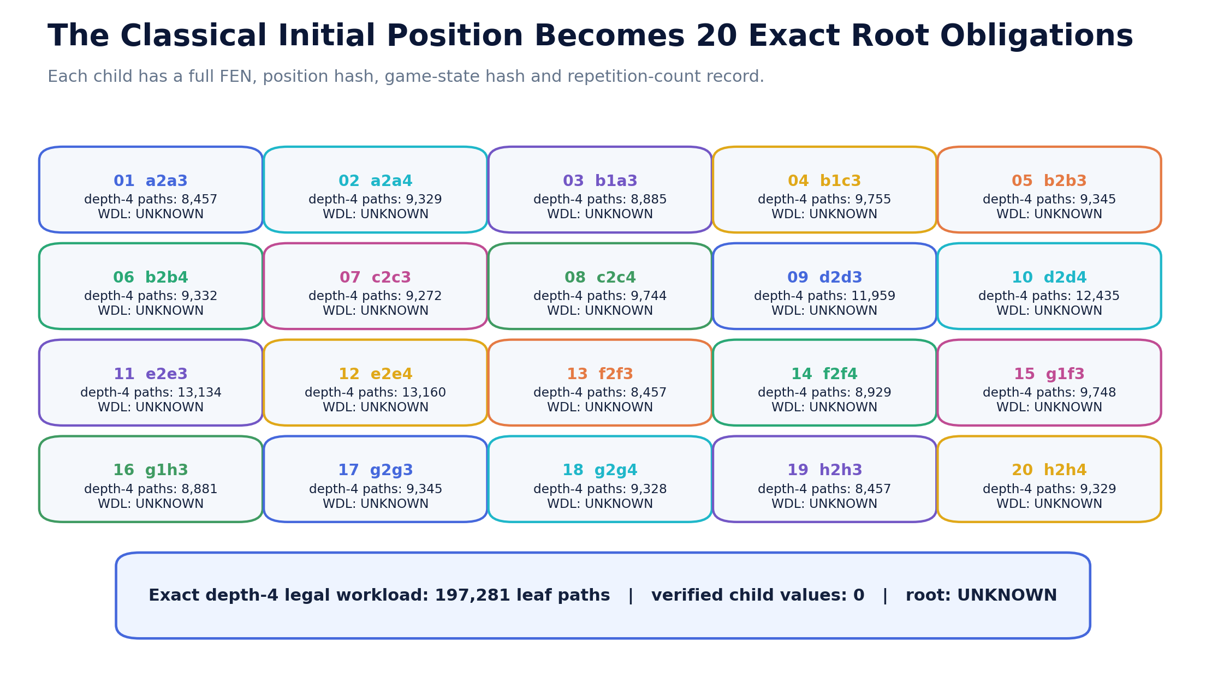
Figure 7. Every legal first move has a stable obligation ID, child state hashes and an exact depth-4 workload count.
Largest shard | Move | Depth-4 leaf paths | Captured WDL
root-12-e2e4 | e2e4 | 13,160 | UNKNOWN
root-11-e2e3 | e2e3 | 13,134 | UNKNOWN
root-10-d2d4 | d2d4 | 12,435 | UNKNOWN
root-09-d2d3 | d2d3 | 11,959 | UNKNOWN
root-04-b1c3 | b1c3 | 9,755 | UNKNOWN
root-15-g1f3 | g1f3 | 9,748 | UNKNOWN
root-08-c2c4 | c2c4 | 9,744 | UNKNOWN
root-05-b2b3 | b2b3 | 9,345 | UNKNOWN
EXACT FIRST CHECKPOINT
The twenty shard workloads sum to 197,281, exactly matching standard initial-position perft depth 4. This checks the decomposition; it does not determine any child's full-game value.

10. Root Aggregation and Current Campaign Status
Only independently verified child values participate in the initial-position result.
Root value | Complete quantified rule
White root WIN | At least one verified child is LOSS for Black to move
White root LOSS | All twenty verified children are WIN for Black to move
White root DRAW | All twenty are resolved, none is LOSS for Black, and at least one is DRAW
White root UNKNOWN | Any required child is unverified or UNKNOWN, unless a verified LOSS child already proves WIN

10.1 Captured ledger state
Metric | Captured value
Root obligations | 20
Verified child values | 0
Root value | UNKNOWN
Event hash chain | valid
Depth-4 leaf-path checkpoint | 197,281
child values are from the child side-to-move perspective
one child LOSS -> root WIN
all children WIN -> root LOSS
resolved mix containing DRAW and no LOSS -> root DRAW
otherwise -> root UNKNOWN
CURRENT FORMAL RESULT
The standard initial position is UNKNOWN in this package. No principal variation, engine score or opening preference is presented as a substitute.

11. Portable SQLite Proof Campaign
Coordination state is mutable; proof records and the event journal are content-addressed and auditable.
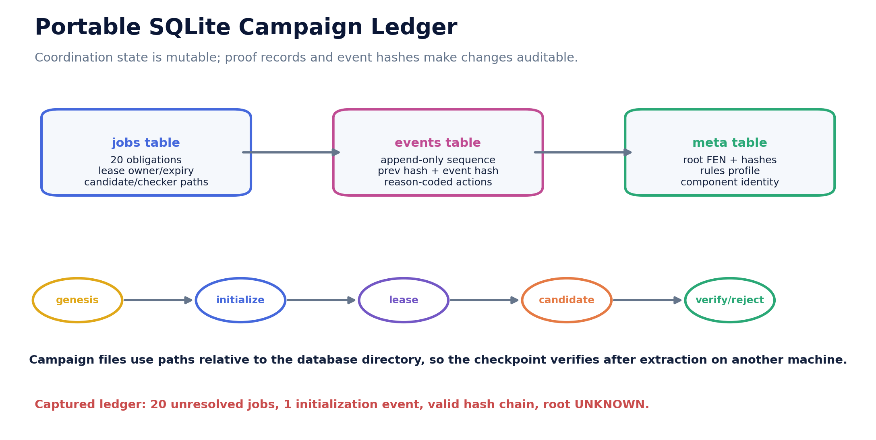
Figure 8. Jobs, events and metadata are separated; path references are package-relative so the campaign remains portable.
Element | Contract
meta | Root FEN/hashes, rule profile, schema and initialization data
jobs | 20 obligations, lease owner/expiry, attempts, candidate WDL, certificate and checker paths/hashes
events | Append-only sequence, canonical payload, previous hash and event hash
Lease | BEGIN IMMEDIATE transaction selects one unresolved or expired job
Candidate | WIN/DRAW/LOSS plus certificate file hash; UNKNOWN cannot be submitted as a candidate
Verification | Separate JSON checker record must match obligation, value, certificate and child state
RELOCATION TEST
The database and its relative shard/certificate/checker paths were copied to another temporary location and reverified. This guards against absolute-path evidence that works only on the packaging machine.

12. Bounded Exact Results and Safe Incompleteness
Two fixtures demonstrate existential closure and honest UNKNOWN propagation.
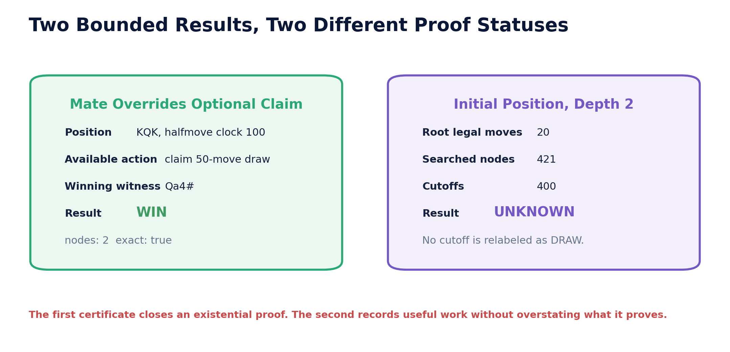
Figure 9. The first fixture is exactly WIN despite an optional draw claim; the second remains UNKNOWN at the ply horizon.
Fixture | Root | Plies | Nodes | Value | Reason
Mate over claim | 8/8/8/1Q6/8/8/k7/2K5 w - - 100 2 | 1 | 2 | WIN | Qa4# is an exact witness; draw claim is optional
Initial position | standard initial FEN | 2 | 421 | UNKNOWN | 400 depth-2 leaf cutoffs remain open

12.1 Certificate hashes
mate root certificate: 87d8a14d9b5af5cbfbccb9522f9c6ae372b66f68992c8749667a80dd1962dfb7
mate child certificate: 891172e29d5aca1a49c857b4c2080284a98b717507e394061efd1f1f3ecb266f
PROOF LESSON
An existential WIN can close early when one exact losing child is found. Universal LOSS and complete DRAW cannot close until all relevant actions and history states are covered.

13. Retained Forced-Mate Certificate
Chess 1.0's OR/AND mate proof remains a compact independently verifiable exact layer.
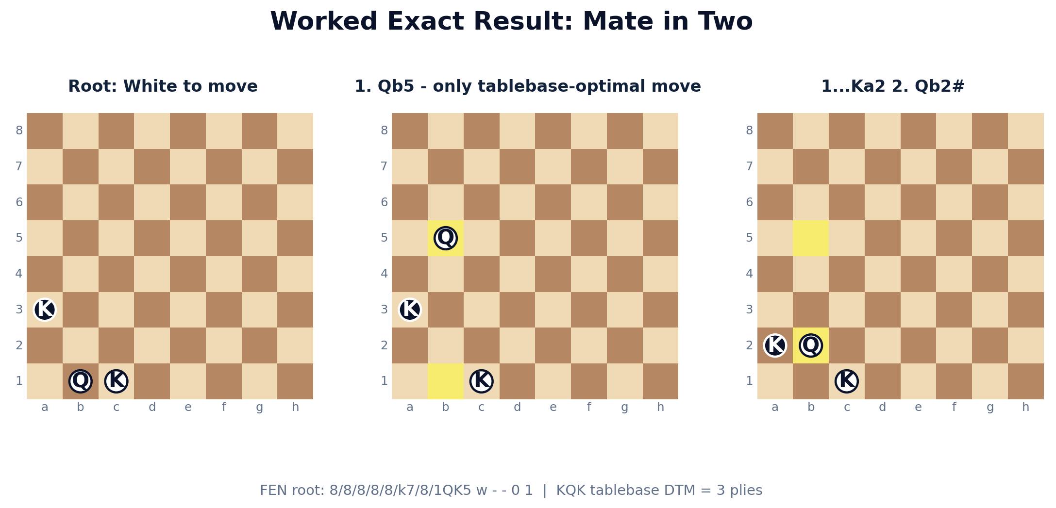
Figure 10. Worked certificate: 1. Qb5 Ka2 2. Qb2# from the declared KQK fixture.
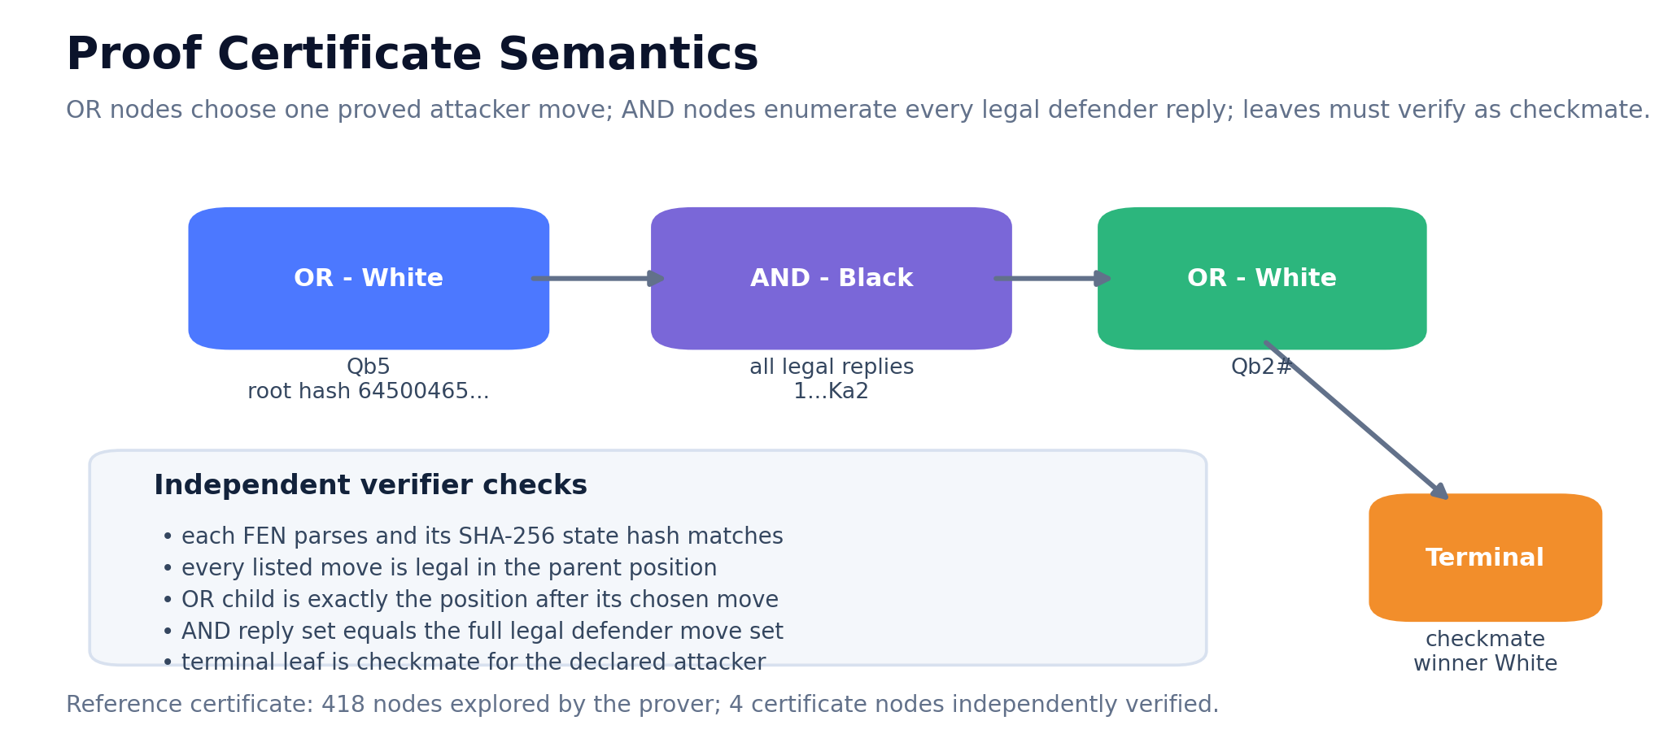
Figure 11. The attacker's OR node supplies one winning move; the defender's AND node enumerates every legal reply.
EXACT SCOPE
This proves a forced mate from one serialized position within the declared horizon. It is not evidence about the game-theoretic value of the 32-piece initial position.

14. Complete KQK and KRK WDL/DTM Tables
Two finite three-piece state spaces are bundled as exact, reconstructible proof partitions.
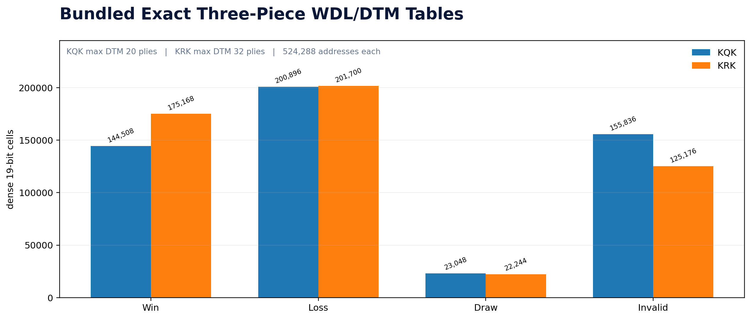
Figure 12. All 2^19 packed addresses are classified as valid WIN/LOSS/DRAW or invalid placement.
Table | Valid | WIN | LOSS | DRAW | Max DTM | gzip bytes
KQK | 368,452 | 144,508 | 200,896 | 23,048 | 20 | 144,368
KRK | 399,112 | 175,168 | 201,700 | 22,244 | 32 | 152,306
TABLEBASE BOUNDARY
Outcome is from the side-to-move perspective. DTM is plies to checkmate under optimal play. These two tables are complete for their declared material signatures, not a substitute for all 3- through 7-piece endgames.

15. Finite Addressing, Generation and External Adapters
Exact tables are proof partitions only when key, decode, legality and rule-profile contracts remain explicit.
Contract | Exact requirement
Address width | 19 bits; 524,288 addresses for king, king, major piece and side-to-move fields
Validity | Overlapping pieces, adjacent kings and illegal check configurations are marked invalid
Generation | Retrograde fixed point seeds checkmates/stalemates and propagates side-to-move WDL/DTM
Transport | gzip payload plus JSON metadata, file length and SHA-256
Probe | Decode address, revalidate material/profile and return WDL/DTM
External adapter | May query larger Syzygy partitions, but must label rule profile and independently recheck transitions

15.1 Why these tables matter to a global attempt
• Solved material partitions become terminal proof nodes for larger predecessor graphs.
• Distance metadata supports deterministic witness extraction and cycle avoidance.
• Hashes permit distributed workers to refer to one exact table version rather than an ambiguous service response.
• A full campaign still needs promotion/capture transitions, 50/75-move policy compatibility and history-aware boundaries.
COMPRESSION RULE
Smaller storage is useful only with a total decoder and exact outcome equivalence. The tablebase key is a finite address, not a claim that chess state is one bit or that all history has disappeared.

16. Native C++20 Foundation
A second implementation provides fast exact checks and a clean CUDA integration boundary.
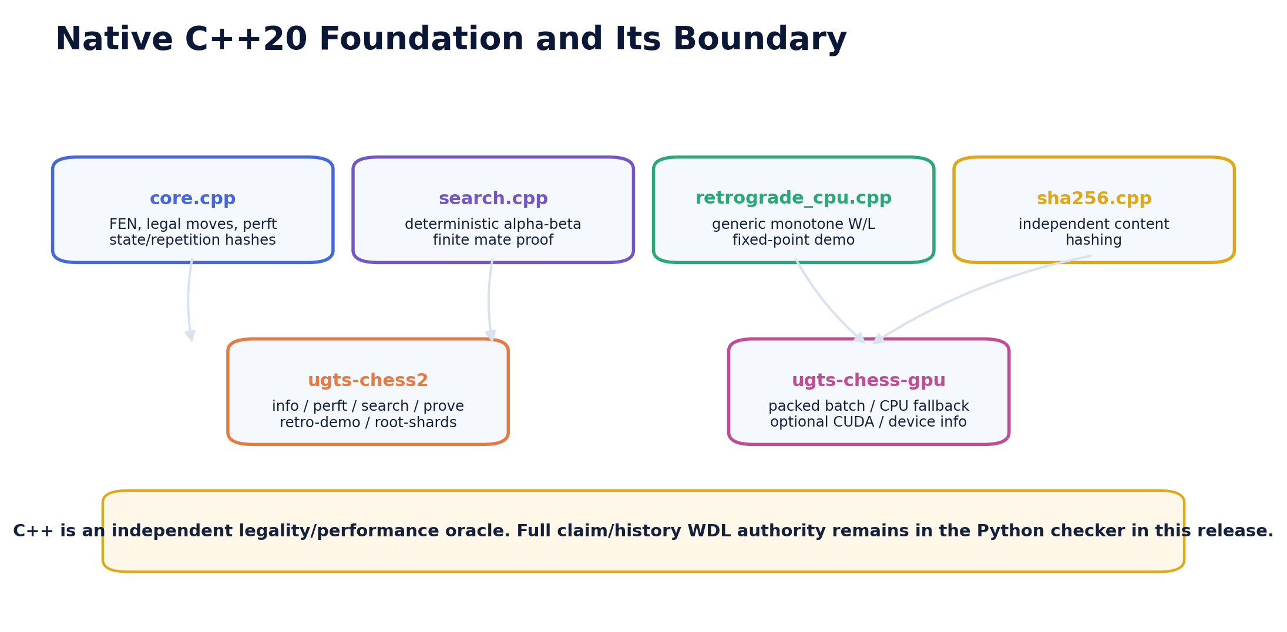
Figure 13. Host legality and performance oracles are separate from the Python history/WDL authority.
Module | Role
core.cpp / fen.cpp | Board representation, attacks, legal transitions, perft and notation transport
search.cpp | Deterministic alpha-beta and bounded mate search; scores are not global proof
retrograde_cpu.cpp | Generic monotone WIN/LOSS fixed-point demonstration
sha256.cpp | Dependency-free content hashing for native records
ugts-chess2 | info, selftest, perft, search, mate, root-shards and retro-demo
ugts-chess-gpu | device-info, packed batch generation and CPU/CUDA self-test
CROSS-IMPLEMENTATION PURPOSE
The C++ layer is not merely a speed port. It provides a second executable implementation for perft, move proposals and fixed-point behavior, enabling differential checks before CUDA results are admitted.

17. Packed Position and Move Proposal Protocol
The wire format is simple enough to inspect, batch and compare across CPU and CUDA backends.
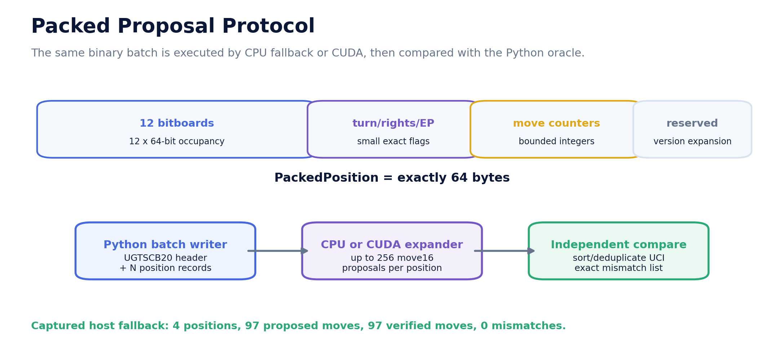
Figure 14. The simple kernel emits pseudo/legal candidates into a versioned binary batch; the Python oracle compares exact legal outputs.
Item | Size/class | Contract
PackedPosition | 64 bytes | 12 bitboards plus turn/rights/en-passant/clock/reserved fields
Packed move | 16 bits | 6 source bits, 6 target bits, 3 promotion bits, spare version space
Input file | UGCB | Header, record size/count and contiguous position records
Output file | UGMV | Per-position counts plus up to 256 encoded moves each
Ordering | Deterministic | Sorted/normalized before differential comparison
Authority | Proposal only | Python exact legal moves remain the captured comparison oracle
CAPTURED FALLBACK
The host CPU backend processed 4 positions and 97 moves with zero mismatches. CUDA compilation and physical-device comparison remain pending.

18. RTX 5070 Ti Laptop Execution Profile
Official product identity is a starting constraint; runtime inspection is the authoritative device record.
Profile field | Value
Product | GeForce RTX 5070 Ti Laptop GPU
Architecture family | NVIDIA Blackwell GeForce laptop
CUDA cores | 5,888
AI TOPS | 992
Standard memory | 12 GB GDDR7
CUDA compute capability | 12.0
Native target | sm_120 / compute_120
Minimum package preset | CUDA Toolkit 12.8 or newer; CUDA 12.8 added compiler support for SM120

18.1 Runtime gate
nvidia-smi --query-gpu=name,memory.total,memory.free,compute_cap --format=csv
ugts-chess-gpu device-info
nvcc --version
• Laptop power limits, clocks, free VRAM, cooling and driver/toolkit combinations vary by model and power mode.
• The build preset targets SM120. Datacenter Blackwell SM100a architecture-conditional kernels are not assumed compatible with GeForce RTX 50-series SM120.
• The package records the actual device name, compute capability, memory, SM count, warp size and maximum threads before a benchmark is promoted.
Grounding: Official NVIDIA GeForce RTX 50 Series laptop specifications, CUDA GPU Compute Capability mapping, CUDA 12.8 release notes, Blackwell compatibility guide and CUTLASS architecture note.

19. VRAM Budget and Out-of-Core Design
The nominal 12 GB frame buffer is a bounded cache, not a complete home for the chess proof graph.
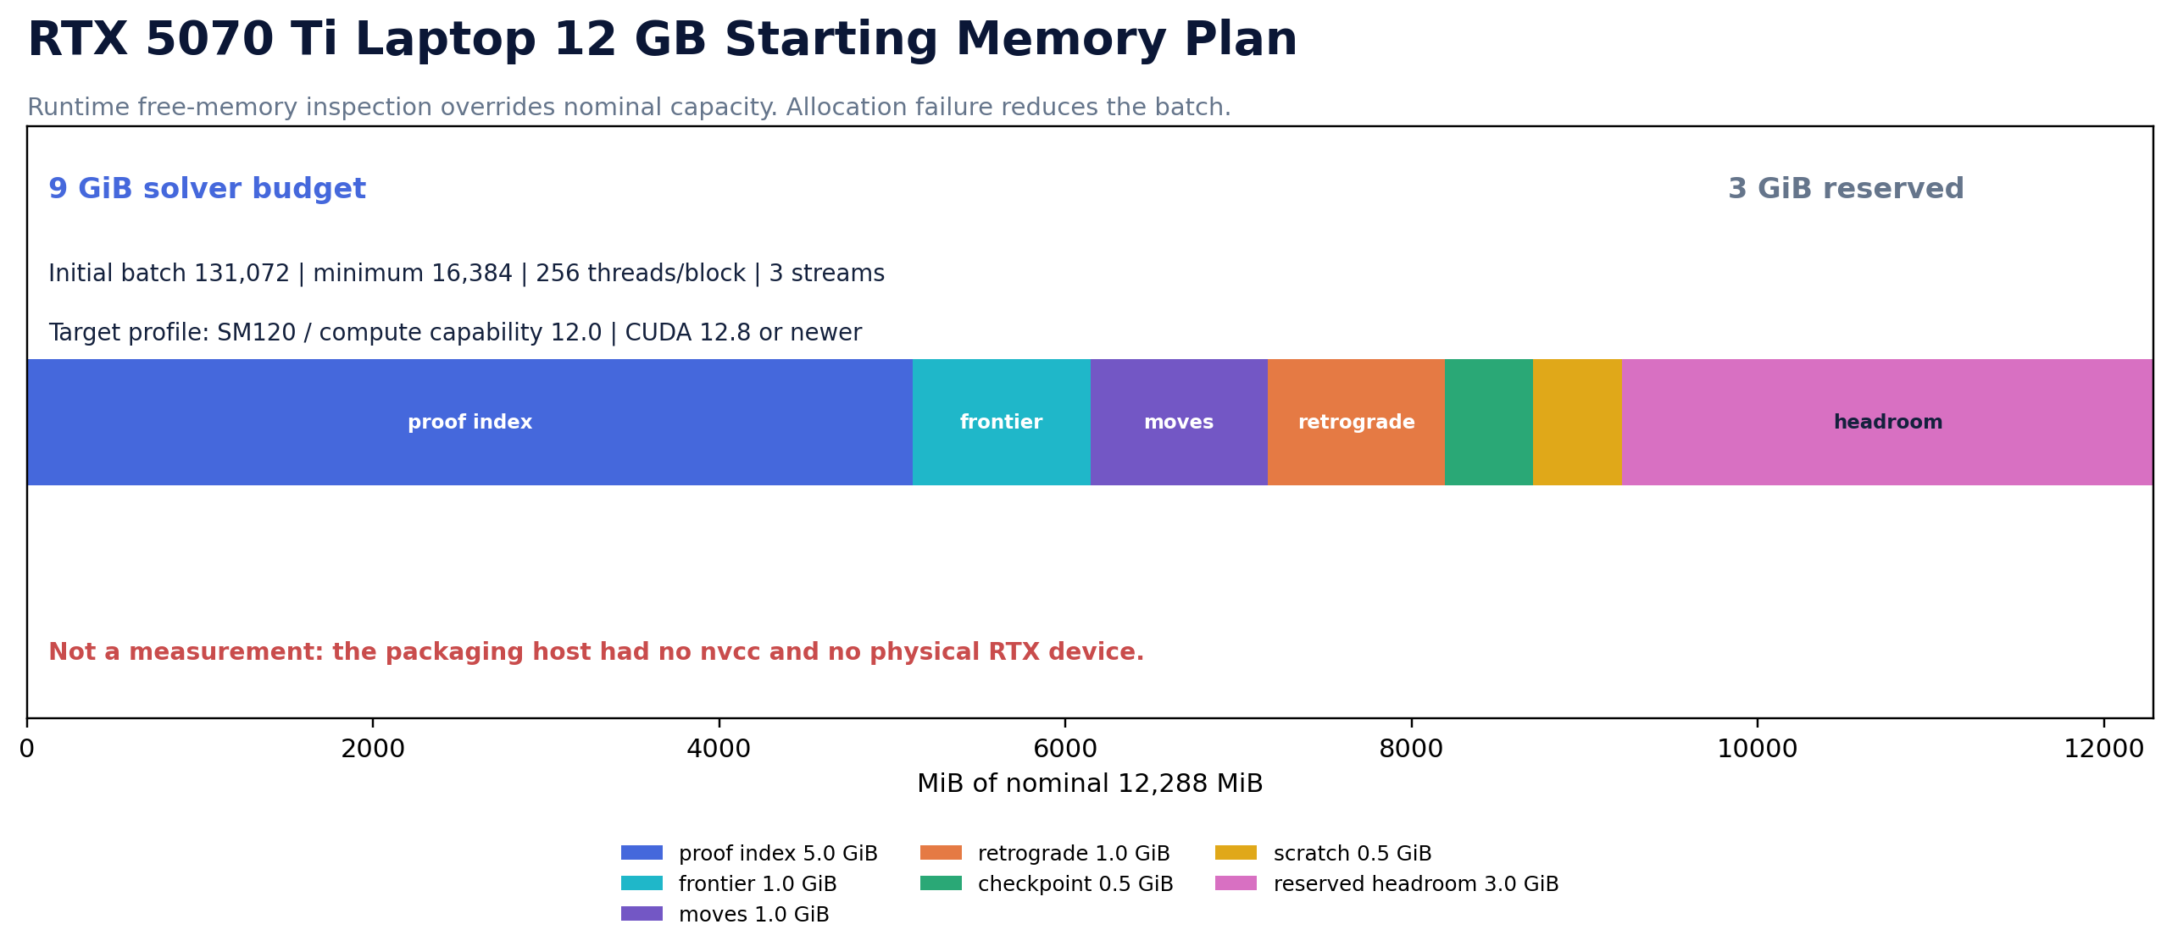
Figure 15. The checked-in starting profile reserves 3 GiB and assigns 9 GiB to solver structures.
Allocation | Starting size | Purpose
Proof/transposition index | 5,120 MiB | Content-addressed lookup and verified-state cache
Frontier | 1,024 MiB | Current batch of unresolved positions
Move buffers | 1,024 MiB | Counts and 16-bit proposal arrays
Retrograde | 1,024 MiB | Outcome vectors and graph work arrays
Checkpoint | 512 MiB | Device-to-host export and integrity staging
Scratch | 512 MiB | Temporary scans, prefix sums and error safety
Reserved headroom | 3,072 MiB | Driver/display/fragmentation/thermal fallback margin
CAPACITY REALITY
Even 9 GiB divided by the 64-byte exchange record holds at most about 151 million records before indexes, move arrays, histories and certificates. A proof-scale campaign must stream, partition, checkpoint and persist to disk.

20. CUDA Kernels and Correctness Boundary
The first GPU code is deliberately simple so that equal-output validation comes before optimization.
Component | Current implementation
Scalar batch expander | One packed position per thread; fixed 256-move slot; output compared with host oracle
Generic retrograde step | One graph node per thread; monotone UNKNOWN -> WIN/LOSS propagation
Device inspector | Queries name, compute capability, total/free memory, SMs, warp and block limits
CPU fallback | Runs the identical batch protocol when CUDA is absent or rejected
CMake profile | UGTS_ENABLE_CUDA=ON; CMAKE_CUDA_ARCHITECTURES=120
Promotion gate | No mismatches, deterministic record order, full reconstructibility and independent proof checker

20.1 Optimization sequence after correctness
1. Measure scalar kernel occupancy, transfer overhead and batch-size behavior on the actual laptop.
2. Add warp-cooperative attack generation and prefix-sum compaction only behind the same binary protocol.
3. Separate hot structure-of-arrays data from the 64-byte exchange record while retaining a total versioned decoder.
4. Add asynchronous streams and double buffering; preserve deterministic per-position move ordering at the comparison boundary.
5. Keep WDL certificate checking on an independent host path until a separately verified GPU checker exists.
PACKAGING EVIDENCE
The delivery host had no nvcc and no physical RTX 5070 Ti. CUDA throughput, VRAM, power, temperature, clocks and long-run stability are intentionally unclaimed.

21. Codex Build, Measure and Promotion Workflow
The supplied scripts preserve device evidence under validation/device rather than overwriting host evidence.
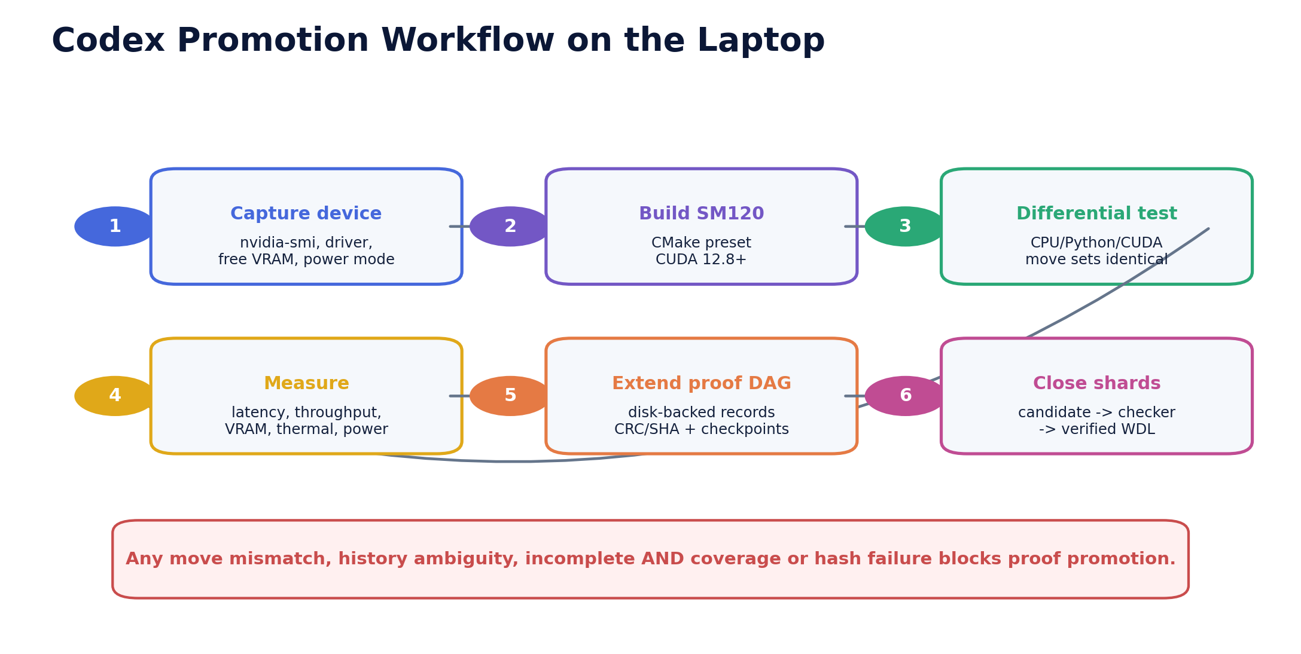
Figure 16. Device capture, SM120 build, differential testing, measurement, proof-DAG extension and shard closure are separate gates.

21.1 First commands on Windows
powershell -ExecutionPolicy Bypass -File scripts/build_rtx5070ti.ps1
powershell -ExecutionPolicy Bypass -File scripts/run_codex_campaign.ps1

21.2 Required measurements
• p50/p95/p99 batch latency, positions/s, moves/s and transfer/compute breakdown
• peak VRAM, host RAM and storage bytes per verified node
• 5-, 15- and 30-minute clocks, temperature, power, fallback and throttling behavior
• differential mismatch count across packaged fixtures and a seeded random legal corpus
• checkpoint/restart reproducibility and event-chain validation after process interruption
RELEASE BLOCKER
Any extra move, missing move, history ambiguity, incomplete AND-node reply set, corrupt checkpoint, hash mismatch or device-dependent result blocks proof promotion.

22. Path from Laptop Experiment to Global Proof Campaign
Progress is measured by independently verifiable obligation closure, not by engine rating or searched nodes alone.
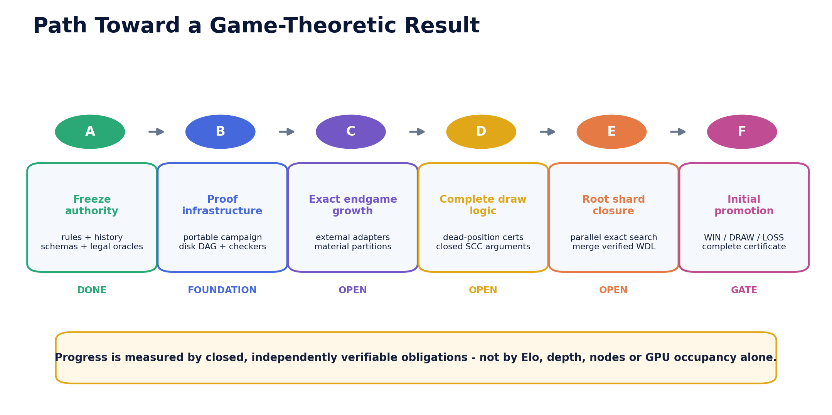
Figure 17. The initial node is promoted only after proof infrastructure, exact coverage and checker diversity are complete.

22.1 Disk-backed proof DAG
• Partition by material signature, rights/history class and canonical hash prefix; store full reconstructible state beside any short index.
• Use append-only frontier and certificate objects with schema IDs, CRC/SHA checks and content-addressed child references.
• Treat opening books, engines and neural policies as prioritizers. They cannot close a proof node.
• Integrate exact tablebase partitions through profile-labeled adapters and boundary transition checks.
• Merge root shards only after independent checker records agree; retain conflicts and rejected candidates in lineage.
SCALE BOUNDARY
A single 12 GB laptop can validate kernels, close small partitions and contribute shards. It is not represented as sufficient by itself to exhaust the full classical game graph.

23. Captured Host Validation
The supplied evidence establishes exact host behavior and packaging integrity, not physical-GPU performance.
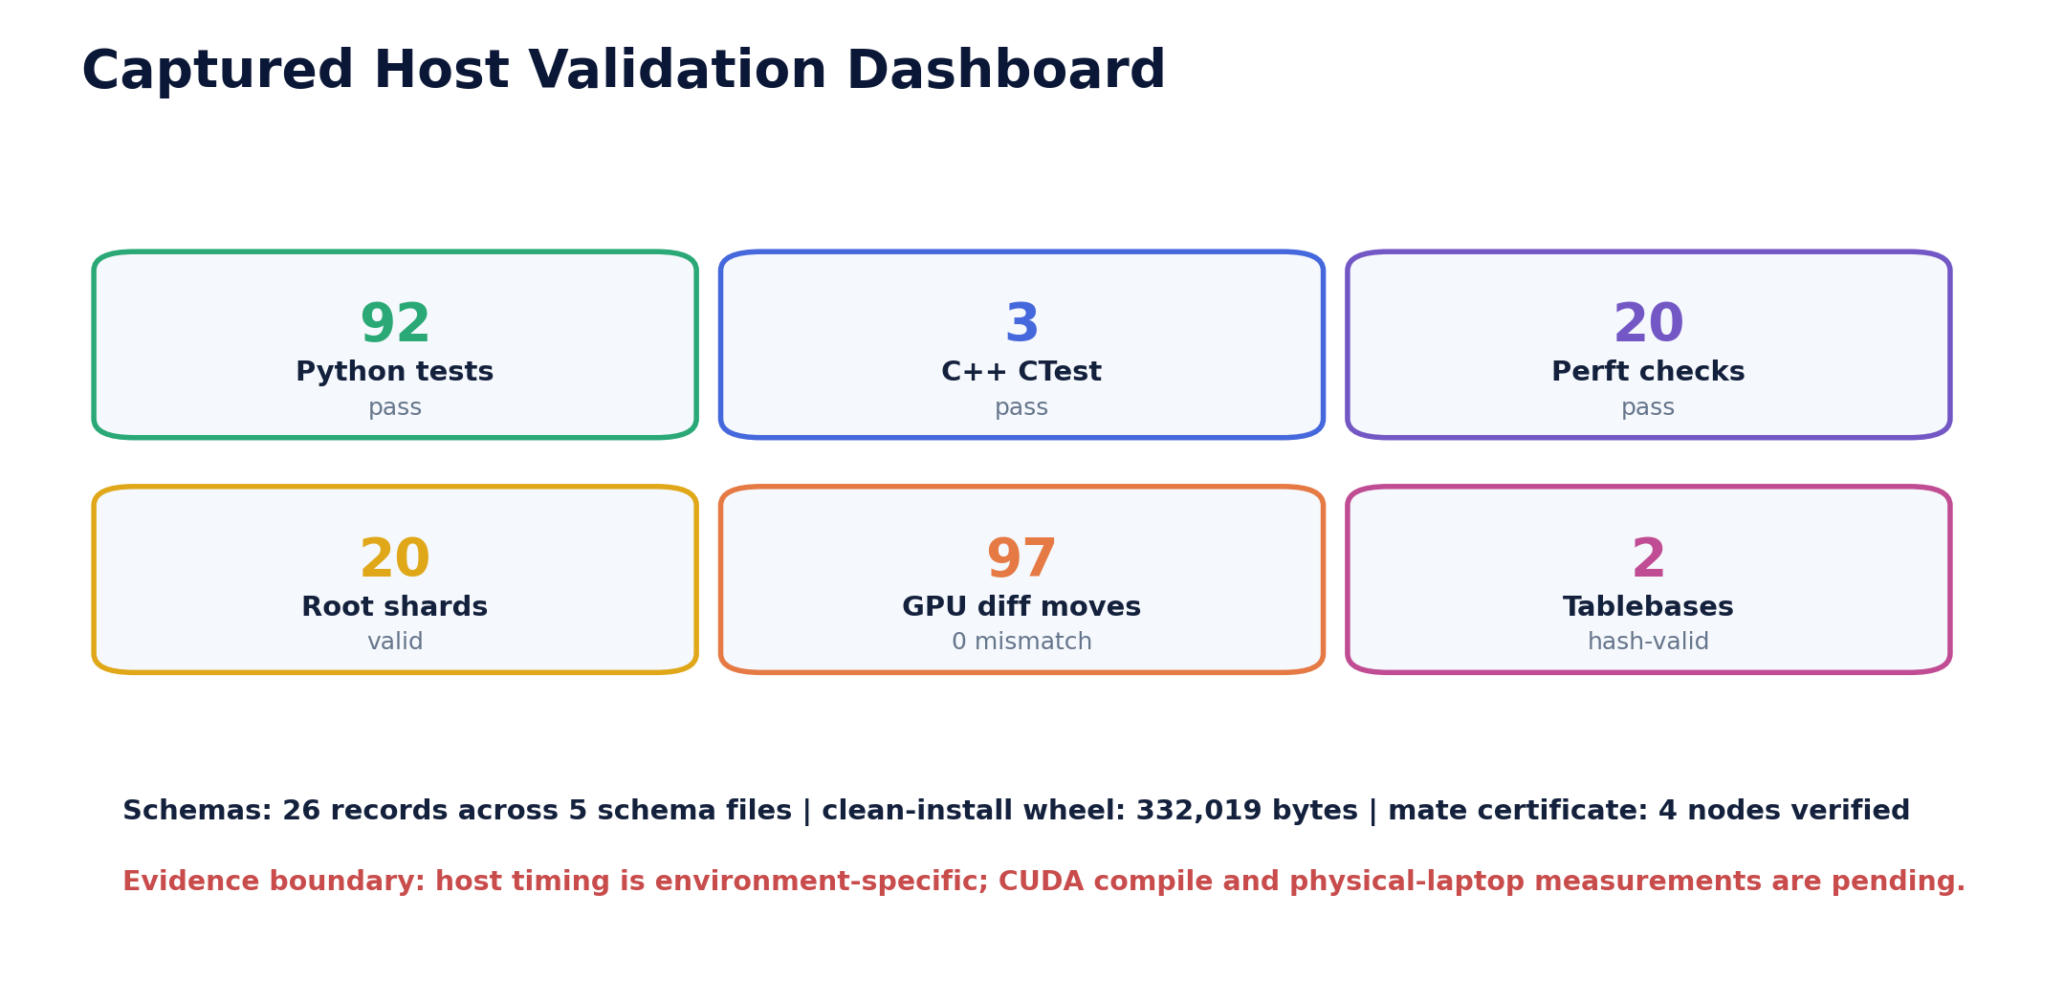
Figure 18. All captured host gates passed; the CUDA device lane remains explicitly pending.
Gate | Count/artifact | Status
Python tests | 92 | PASS
Python perft checks | 20 | PASS
C++ CTest | 3 | PASS
Native packed self-tests | 9 | PASS
Schema documents | 26 | PASS
Mechanism records | 104 | PASS
Wheel clean install | ugts_kc_chess-2.0.0-py3-none-any.whl | PASS
Physical RTX run | 0 | PENDING
VALIDATION MEANING
This validates the supplied attempt and proof machinery; it does not solve the 32-piece initial position.

24. Performance Evidence and Non-Claims
Host timing is useful for regression but cannot be generalized to the user's laptop before measurement.
Measurement | Work | Observed | Boundary
Native initial perft depth 5 | 4,865,609 nodes | 1.344 s | 3.620 Mnodes/s
Maximum RSS during captured depth-5 run | 1,800 KiB | Linux container | host-specific
Packed differential | 4 positions / 97 moves | 0 mismatches | CPU fallback
Tablebase transport | 296,674 bytes | 2 exact files | hash verified
Python wheel | 332,019 bytes | isolated install | PASS

24.1 What is not claimed
• No Stockfish, Leela Chess Zero or other mature-engine strength comparison.
• No RTX speedup, positions/s, energy efficiency, thermals, battery life or sustained laptop throughput.
• No implication that faster move generation changes the mathematical WDL obligations.
• No universal bit-identical floating-point behavior; promoted legality, hashes and proof records use exact integer/serialized boundaries.
• No proof that the Python interpreter, C++ compiler, operating system or GPU hardware is free of defects.
EQUAL-OUTPUT RULE
A performance claim becomes relevant only after CPU and CUDA outputs agree under the same rule profile and checker. Correctness is not inferred from speed.

25. Promotion Gates, Roadmap and Kill Criteria
The campaign is designed to fail safely and visibly when evidence is incomplete.

25.1 Promotion sequence
1. Freeze legal and history authority; maintain cross-implementation perft and transition tests.
2. Compile and differential-test SM120 kernels on the target laptop.
3. Add append-only frontier/proof storage and crash-safe checkpoints.
4. Expand exact endgame partitions with rule-profile and hash commitments.
5. Implement complete dead-position certificates or preserve UNKNOWN.
6. Close one root shard at a time; diversify independent checkers.
7. Promote the initial node only when its complete quantified WDL rule is satisfied.

25.2 Release-blocking failures
• Any legal-move or terminal mismatch, including castling, en-passant, promotion, check or draw-order errors.
• A proof verifier accepts a missing defender reply, illegal edge, wrong pre-state, mismatched hash or unsupported draw closure.
• A 64-bit key, score, GPU hash or cache hit is treated as complete proof identity.
• Repetition history, draw-claim ownership, dead-position scope or 50/75-move policy is implicit.
• A worker directly changes authoritative WDL without an independent checker record.
• Compression or seed reconstruction discards information needed to reproduce legal actions or certificates.
• The UGTS wrapper becomes less auditable than the conventional exact rule/proof implementation it is meant to discipline.
STOP CONDITION
When a boundary cannot be certified, the correct output is UNKNOWN plus a reason-coded open obligation. That is a successful safety behavior, not a reason to fabricate a value.

26. Chess Mechanism Catalog C001-C104
Namespaced mechanism records provide traceability without renumbering the broader UGTS catalogs.
Domain | Count | ID span | Representative records
Proof | 13 | C042-C079 | OR attacker node; AND defender node; Checkmate leaf; ...
Tablebase | 8 | C048-C058 | KXK exact profile; Validity cell; Terminal initialization; ...
Campaign | 7 | C080-C086 | Twenty root obligations; Root WDL aggregate; SQLite obligation ledger; ...
GPU | 7 | C089-C097 | CUDA fixed-point kernel; GPU proposal-only authority; Batch move protocol; ...
State | 7 | C003-C072 | Position tuple; Side-to-move bit; Castling-right mask; ...
Search | 6 | C036-C041 | Alpha-beta negamax; Iterative deepening; Quiescence; ...
Validation | 5 | C033-C103 | Perft oracle; Automated release gates; Python/C++ perft differential; ...
Rules | 4 | C066-C069 | Claim-as-action semantics; Intended-move draw claim; Fivefold automatic guard; ...
Terminal | 4 | C028-C031 | Checkmate relation; Stalemate relation; Dead-position subset; ...
Guard | 3 | C018-C020 | King-safety guard; Castling transit guard; En-passant exposure guard
Identity | 3 | C005-C070 | Piece identity; Repetition identity; Legal en-passant repetition right
Packing | 3 | C049-C092 | Dense 19-bit KXK key; 64-byte packed position; 16-bit move code
Transition | 3 | C023-C025 | Deterministic board patch; Rights patch; Clock and turn patch
Encoding | 2 | C010-C034 | Strict FEN codec; SAN projection
Event | 2 | C022-C026 | Move proposal; Move event record
Governance | 2 | C002-C065 | Evidence boundary; Component-scoped release identity
Native | 2 | C087-C088 | C++20 exact rule oracle; Finite WDL fixed-point demo
Persistence | 2 | C011-C012 | Canonical state record; SHA-256 state identity
Roadmap | 2 | C064-C104 | Distributed global proof sharding; Initial-position proof promotion gate
Storage | 2 | C098-C099 | Disk-backed proof DAG target; 64-bit index boundary
Branch | 1 | C021-C021 | Promotion branch
Compatibility | 1 | C016-C016 | Occupancy and color gate
Compression | 1 | C056-C056 | Gzip table transport
Coordinates | 1 | C004-C004 | Square address
Evidence | 1 | C059-C059 | Tablebase metadata
Heuristic | 1 | C035-C035 | Transparent evaluation
Indexing | 1 | C013-C013 | Compact 64-bit cache key
Integration | 1 | C100-C100 | External tablebase adapter gate
Presentation | 1 | C062-C062 | Offline proof viewer
Profile | 1 | C001-C001 | UGTS chess solver profile
Query | 1 | C032-C032 | Legal move enumeration
Relation | 1 | C017-C017 | Attack relation
Replay | 1 | C027-C027 | Hash-checked replay
Schema | 1 | C061-C061 | JSON contracts
Support | 1 | C015-C015 | Piece movement support
Symmetry | 1 | C057-C057 | Black-strong normalization
Tooling | 1 | C060-C060 | Command-line workflow

26.1 Representative 2.0 additions
ID | Domain | Mechanism | Normalized definition
C065 | Governance | Component-scoped release identity | Name the upgrade ugts.application.chess-proof@2.0.0 rather than treating every UGTS number as one global ladder.
C069 | Rules | Seventy-five-move automatic guard | Terminate at 150 reversible plies, with checkmate taking precedence.
C073 | Proof | WDL four-value lattice | Use WIN, LOSS, DRAW and UNKNOWN; a cutoff is never coerced to DRAW.
C078 | Proof | Content-addressed WDL node | Hash canonical state, profile, children, values and exactness into each bounded WDL node record.
C082 | Campaign | SQLite obligation ledger | Store root jobs, status, leases, candidate certificate paths and verification records in a transactional database.
C087 | Native | C++20 exact rule oracle | Provide a dependency-light native legality/perft/search/mate implementation independent of Python.
C092 | Packing | 16-bit move code | Pack source, destination and promotion into a reversible 16-bit value.
C097 | GPU | Three-stream pipeline | Overlap upload, candidate expansion and download/checking through bounded streams without reordering proof commits.
C101 | Validation | Python/C++ perft differential | Require exact move-path agreement across independent rule kernels on standard stress fixtures.
C104 | Roadmap | Initial-position proof promotion gate | Promote the root from UNKNOWN only after all quantified WDL obligations, history semantics and checker records close.
CATALOG MEANING
An ID records scope, implementation and validation linkage. It is not by itself a claim of scientific novelty, authorship priority, patentability or proof completeness.

27. Accompanying ZIP and Reproduction
The archive is a complete Codex handoff: source, exact data, schemas, campaign state, build scripts, report and captured evidence.
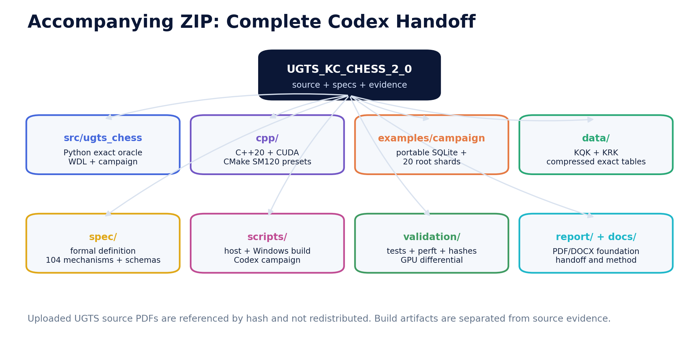
Figure 19. Source PDFs are referenced by title, page basis and SHA-256 but are not redistributed.
Path | Contents
src/ugts_chess | Python rule/history oracle, WDL certificates, campaign, tablebases and CLI
cpp | C++20 core, host tests, packed protocol, CPU fallback and optional CUDA kernels
examples/campaign | SQLite root campaign, 20 shard JSON records and exact depth-4 workload checkpoint
data | KQK/KRK compressed exact tables and metadata
spec | Formal definition, schemas, source register, RTX profile and C001-C104 catalog
scripts | Codex task, Windows SM120 build and campaign run scripts
validation | Host tests, CTest, differential outputs, wheel, manifests and device placeholder
report / web | Editable DOCX, final PDF, diagrams and offline mate-proof viewer

27.1 Host reproduction
cd UGTS_KC_CHESS_2_0_RTX5070TI
PYTHONPATH=src python -m unittest discover -s tests -v
bash scripts/build_host.sh
PYTHONPATH=src python tools/run_validation_v2.py
python tools/generate_report_assets.py
python tools/build_report.py

28. Final Upgraded Definition
The foundation is a proof campaign with optional accelerators, not a search score presented as a solved game.
FORMAL DEFINITION
UGTS Chess Proof Campaign 2.0 is a finite, content-addressed application profile in which complete classical positions and exact repetition context define legal actions; special rights and king safety certify events; immutable transitions update state; claimable draws remain player actions; automatic terminals seed four-valued WDL obligations; certificates record existential witnesses or complete universal coverage; an independent checker promotes results into a hash-chained campaign ledger; exact KQK/KRK tables close bounded partitions; and C++20/CUDA adapters accelerate proposals and fixed-point work without becoming final proof authority.

28.1 Canonical object
UGTS-CHESS-2 = (Q, A, M, G, T, H, V, C, P, L, X)
Q complete typed state A attack/support relations
M deterministic legal moves G terminal and draw guards
T immutable transitions H exact history context
V WIN|LOSS|DRAW|UNKNOWN C certificates/checkers
P campaign partitions L replay/proof lineage
X optional CPU/CUDA adapters

28.2 Current root theorem
initial_position_value = UNKNOWN
reason = 20 exact root obligations exist; 0 child WDL certificates have been independently promoted
RELEASE INTERPRETATION
The package materially advances an attempt by making the open proof explicit, partitioned, portable and executable. It does not overstate that progress as a game-theoretic solution.

Appendix. Source Register, External References and Attribution
Supplied artifacts and current standards are separated from engineering additions and captured package evidence.
ID | Supplied source | Page basis | SHA-256 | Use
S1 | UGTS-GN 1.1 | pp. 2-5, 9-15 | 3a6b6c57118ca4e2... | Canonical support, compatibility, guard, event, transition, lineage; precision and compression boundaries
S2 | UGTS-KC 2.0 | pp. 3-5, 8-15 | a29dd9959ebd300c... | Typed state, query-first patterns, topology, hybrid events, bounded dynamics
S3 | KC Two Hands 3.0 | pp. 5-6, 11-16, 19-20 | 183ffa4e2bf29cfa... | Proposal verification, deterministic commit, state hashes, checkpoints and replay
S4 | UGTS-KC 3.6 | pp. 3-7, 9-14 | e21433cd8378368d... | Definitions as data, content addresses, dependency closure and explicit operation order
S5 | UGTS-KC 3.6.2 SCLP | pp. 7-15 | 6987490a0a7b7ed7... | Finite packed keys, radix tries, bounded branching and storage audits
S6 | UGTS-KC 3.9 | pp. 3-4, 8-13 | d7ee3c91abf60e35... | Deterministic game world, canonical snapshots/hashes, CLI and offline HTML5 delivery
S7 | UGTS-KC 3.6.3 SARA | pp. 1-2, 6-12 | c5a8256e345047d5... | Reviewed but excluded as wallet/security-specific; only its explicit authorization boundary is retained as a governance analogy
S8 | UGTS-KC 4.2 Go Solver | pp. 1-13 and appendices | 1ea7d15b0112a870... | Board-game precedent for rules/position/game-solved separation, exact finite WDL certificates and explicit UNKNOWN boundaries
S9 | UGTS-KC Chess 1.0 | pp. 2-21 | f8bce74ffefeedb4... | Immediate exact rule, bounded mate, KQK/KRK and proof-viewer baseline
S10 | UGTS-KC 4.2 General Operator and Order Addendum | pp. 2-17 and appendices | 413ef9568330e253... | Explicit parse/dependency/evaluation/certification/event/replay order and fixed-point operator contracts
S11 | UGTS Versioning Governance Phase 1 | pp. 1-8 | 1b64495ed32a24a6... | Component-scoped release identity and explicit relationship graph

External standards and current device references
ID | Reference | Edition | Use | Location
E1 | FIDE Laws of Chess | taking effect from 1 January 2023 | Classical move, terminal, repetition and move-count semantics | https://handbook.fide.com/chapter/E012023
E2 | NVIDIA GeForce RTX 50 Series Laptop specifications | current online source | RTX 5070 Ti Laptop core count, memory and Blackwell device family | https://www.nvidia.com/en-us/geforce/laptops/50-series/
E3 | NVIDIA CUDA GPU Compute Capability | current online source | Runtime/compile architecture reference; GeForce RTX 5070 Ti listed under compute capability 12.0 | https://developer.nvidia.com/cuda/gpus
E4 | CUDA Toolkit Release Notes | current 13.x compatibility table consulted 29 August 2026 | Toolkit/driver compatibility and Windows driver-separation boundary | https://docs.nvidia.com/cuda/cuda-toolkit-release-notes/
E5 | Syzygy tablebases | current online source | External exact endgame adapter context; files not bundled | https://syzygy-tables.info/

Attribution and legal boundary
Prepared for Tom Klootwijk. The requester attribution is recorded as supplied and has not been independently verified. This report and package are technical design and validation artifacts. They are not legal proof of identity, authorship, ownership, priority, patentability, exclusive rights, licensing status or scientific consensus.
CLOSING STATEMENT
The strongest evidence in this release is exact and local: legal transitions, bounded certificates, finite tablebases, campaign hashes and passing reproducibility gates. The global classical root remains UNKNOWN until the missing proof obligations are actually closed.

