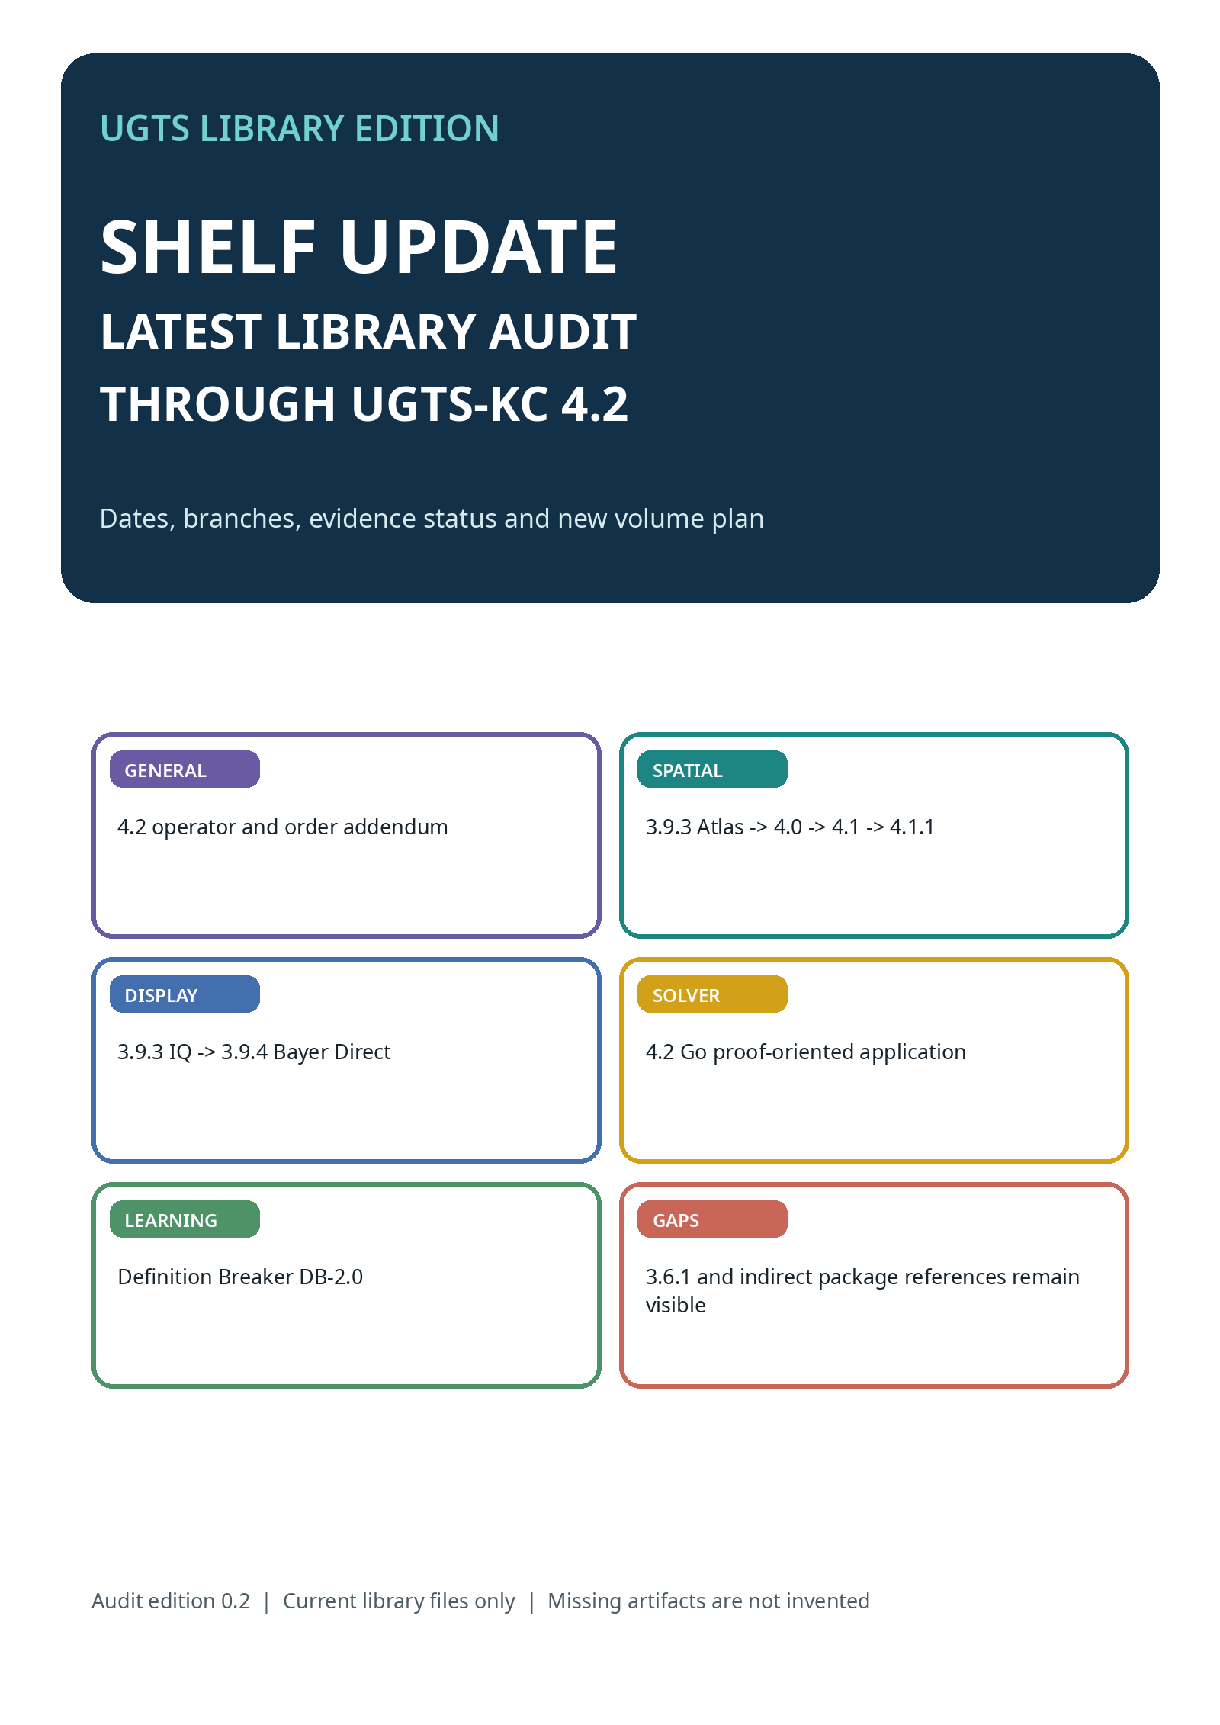

HOW THIS AUDIT WORKS
A trustworthy shelf records version, date, parent, evidence and gaps separately

CURRENT RESULT
The highest general substrate version found in the current ChatGPT library is UGTS-KC 4.2, the General Operator and Order Addendum. A later-created 4.2 Go Solver is an application branch. The latest spatial-device patch found is 4.1.1 Atlas Spatial Seed SLAM Fusion.

Five audit questions
- What version name and release type does the file itself claim?
- When did this artifact appear in the current library?
- What parent or earlier package does it actually build on?
- What was implemented, tested, deferred or explicitly not claimed?
- Is the actual source artifact present, or only referenced by another report?
DATE IS NOT PARENTHOOD
A file created later may be a patch to an older branch. A higher version may be a general addendum while another branch continues with a lower patch number. The shelf therefore prints both chronology and lineage.
Source note: Audit basis: current ChatGPT library metadata plus the release definitions and evidence boundaries inside the surfaced UGTS files. “Latest” means latest found in this audit, not a claim about files outside the current library.

UPDATED CHRONOLOGICAL LEDGER
Directly surfaced files, referenced packages and branch releases

DATE / LIBRARY TIME | VERSION | NAME | STATUS | ROLE / LIMIT
15 Aug 2026 | 1.1 | GPU Native | direct file | Canonical support -> compatibility -> guard -> event -> transition -> lineage.
16 Aug 2026 | 2.0 | Pattern, Kinematics & Dynamics | direct file | Foundation of patterns, fields, topology, motion and bounded dynamics.
16 Aug 2026 | 3.0 | Two Hands Runtime | direct file | Scenes, assets, bimanual interaction, proposal/commit, replay and export.
17 Aug 2026 | 3.6.0 | Literal Referential | direct file | Definitions, dependencies, hashes, hinges and explicit operation order.
17 Aug 2026 | 3.6.1 | Unresolved artifact | referenced missing | Keep an empty shelf card; title, content and counts remain unknown.
17 Aug 2026 | 3.6.2 | SCLP | direct file | Finite geometry, intervals, log-polar calculus, topology and 64-bit keys.
18 Aug 2026 | 3.6.3 | SARA | direct file | Public-only certificate and authorization/secret-egress profile.
23 Aug 2026 | 3.9.0 | KC Elizabeth | direct file | Vector-game project, fixed-step runtime and offline HTML5.
date not audited | 3.9.1 | Native/mobile reference | indirect reference | Preserved by 4.0; direct release report not in this audit set.
date not audited | 3.9.2 | Grove package | indirect reference | Named baseline for later Atlas/native work; not directly audited here.
28 Aug 14:13 | 3.9.3 | IQ Field | direct file | Distance-field, procedural signal and bounded ray-query branch.
28 Aug 14:45 | 3.9.3 | KC Atlas | direct file | Spatial evidence ledger, uncertainty, routes, repeat-scan change.
28 Aug 13:32 | 4.0 | Spatial Evidence Ledger | direct file | Spatial substrate; phone implementation intentionally deferred.
28 Aug 16:47 | 3.9.4 | Bayer Direct | direct file | Tiny direct field-to-pixel display profile; phone gates pending.
28 Aug 17:55 | 4.1.0 | Spatial Seed Native | direct file | POCO source handoff with KSEED; device build deferred.
28 Aug 21:18 | 4.2.0 | General Operator & Order | direct PDF/DOCX | Highest general substrate version found; 15 phases, M630-M885.
28 Aug 21:35 | 4.1.1 | Atlas SLAM Fusion | direct file | Later spatial patch; source/host validated, phone run pending.
29 Aug 05:52 | DB-2.0 | Every Child Directs the World | education branch | Child-operable accessibility and multisensory learning standard.
29 Aug 05:56 | 4.2 | Go Solver | application branch | Exact finite fixtures plus bounded seeded search for larger boards.
DO NOT SORT BY NUMBER ALONE
The file chronology places 4.0 before 3.9.4, 4.2 before the later-created 4.1.1 patch, and the 4.2 Go application after both. This is not an error: the project contains branches.

THE CURRENT FAMILY TREE
One general line, several application and device branches

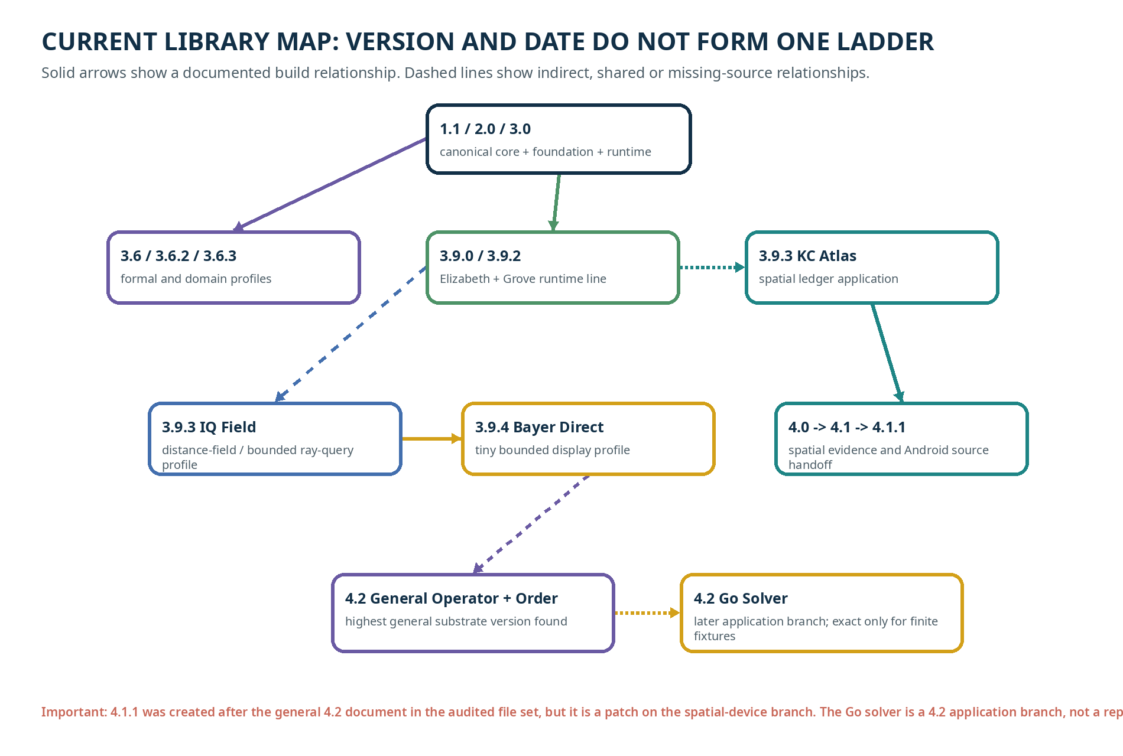
READ THE ARROWS, NOT JUST THE LABELS
A solid arrow means a stated build relationship in the audited source. A dashed line means shared discipline, indirect package continuity or a source gap that must not be silently converted into a full inheritance claim.

LATEST GENERAL RELEASE FOUND: UGTS-KC 4.2
General Operator and Order Addendum

CHILD ROUTE
The newest general rule-book makes every important kind of order visible. It asks: What does this operator mean? Which types may it use? Which part happens first? Is it exact, approximate or effectful? Can it propose a change, and who is allowed to commit it?

What the source reports
- A content-addressed OperatorSpec with syntax, arity, domain, codomain, units, shape, exactness, laws, effects, capabilities, dependencies, invariants, provenance and version.
- Three precedence profiles and a canonical fifteen-phase schedule.
- A 256-entry delta catalog, M630-M885, across sixteen domains.
- 194 executable reference operators and 62 specified contracts rather than false implementation claims.
- 441/441 passing tests, schema and dependency checks, deterministic demo/replay, wheel/source builds and clean-install validation.
HONEST LIMIT
The release does not claim that a finite catalog contains all mathematics, nor a complete theorem prover, universal convergence, universal exactness or physical-device performance. Its completeness claim is structural: every shipped operator and result-affecting order has an explicit record.
Source note: Source: UGTS-KC 4.2 - General Operator and Order Addendum, release decision, validation and final definition.

LATEST 4.2 APPLICATION FOUND: GO SOLVER
Exact finite fixtures and proof-oriented runtime

CHILD ROUTE
A move is not accepted because a point merely looks empty. The solver checks the board, the acting player, capture, suicide and repetition rules. Only a completed exact search may make a solve certificate.
WHAT IS EXACT HERE  The release provides executable solve certificates and deterministic exhaustive reruns for 1x1 and 2x2 fixtures under declared rules and komi. | WHAT IS NOT SOLVED  Larger-board seeded search is explicitly heuristic. The report does not claim 19x19 exact solution or playing strength comparable with established Go engines.

Evidence reported
- 52/52 tests pass; the M390-M449 catalog is contiguous.
- The 2x2 certificate records root hash, certificate hash, transposition digest, node counts and deterministic rerun status.
- The browser board is self-contained and the SGF path is a bounded interchange subset.
- An interrupted or incomplete search is not allowed to emit an exact result.
Source note: Source: UGTS-KC 4.2 Go Solver, move-guard mapping, exact certificates, validation and explicit non-claims.

THE SPATIAL BRANCH
KC Atlas -> 4.0 Spatial Evidence -> 4.1 Native -> 4.1.1 SLAM Fusion

3.9.3 KC ATLAS  Adds a spatial ledger with observations, stable nodes and edges, interval uncertainty, route queries, repeat-scan change, deterministic replay and an offline evidence bundle. The new capture app was postponed. | 4.0 SPATIAL EVIDENCE  Freezes a general capture/observation/verifier/ledger contract. Reports 380 tests and M450-M509. A phone-native implementation is explicitly deferred.
4.1 SPATIAL SEED NATIVE  Supplies a POCO-targeted source handoff with Camera2/IMU interfaces, proposal gates and KSEED seed-plus-evidence storage. No new APK or physical run is claimed. | 4.1.1 ATLAS SLAM FUSION  Merges Camera2/IMU, FAST/BRIEF, guarded triangulation, bounded semi-dense fusion, an ordered verifier, stable IDs and KSEED integrity. Host/source validation passes; phone build and measurement remain pending.
NON-NEGOTIABLE SOURCE BOUNDARY
The complete 4.1.0 source tree was unavailable to the 4.1.1 release. The report therefore labels its work a documented-contract reimplementation against the available repaired 3.9.4.1 source, not a byte-identical merge.
Source note: Sources: KC Atlas 3.9.3, UGTS-KC 4.0 Spatial Evidence Ledger, UGTS-KC 4.1 Spatial Seed Native and UGTS-KC 4.1.1 Atlas Spatial Seed SLAM Fusion.

THE DISPLAY AND FIELD BRANCH
3.9.3 IQ Field and 3.9.4 Bayer Direct

3.9.3 IQ FIELD  A separate 3.9.3 profile for formal distance fields, procedural signals and bounded ray queries. It continues the field/presentation line and reaches M609 in its own merged catalog statement. | 3.9.4 BAYER DIRECT  A tiny NativeActivity presentation profile: integer field programs, an exact 8x8 Bayer matrix and RGB565 palettes. It removes scene, mesh, texture, shader and ray machinery from the APK hot path.
DISPLAY IS STILL DOWNSTREAM
“No rasterization” in Bayer Direct means no triangle/mesh graphics rasterizer and no ray-based image solver in the profile. A finite pixel surface and Android compositor still exist, and they never become substrate authority.
EVIDENCE BOUNDARY
The Bayer release reports an ultra-small test-signed APK and host evidence, but does not claim target-phone installation, sustained frame pacing, thermal behavior, battery use or production signing.
Source note: Sources: UGTS-KC 3.9.3 K-Kij-T Grove IQ Field Edition and UGTS-KC 3.9.4 Bayer Direct Native Edition.

THE EDUCATION AND ACCESS BRANCH
Definition Breaker DB-2.0 now informs the library method

EVERY CHILD DIRECTS THE WORLD
DB-2.0 is the newest education/accessibility artifact surfaced in this audit. It presents a child-operable standard with multisensory routes, digital and physical-play scaffolds, printable systems and explicit control over stop, wait, repair, switching routes, breaks and return.

Library consequences
- Each concept page must support more than one way to perceive and answer.
- No-response, changed-mind and accidental-activation repair are part of access, not mistakes to punish.
- Touch requires consent; hand-under-hand guidance is preferred over forced hand-over-hand control.
- Cooperative roles must not rank children by speech, reading speed or fine-motor performance.
- A physical learning concept is not a toy-safety, clinical or regulatory certification.
SEPARATE VERSIONING
Definition Breaker uses its own DB version line. It informs library access design but does not renumber the formal UGTS substrate.
Source note: Source: Definition Breaker DB-2.0 - Every Child Directs the World, 29 Aug 2026.

GAPS AND INDIRECT REFERENCES
The new audit adds detail without pretending every package is present

ARTIFACT | KNOWN STATUS | TRUSTWORTHY TREATMENT
UGTS Core / Baseline 1.0 | Referenced by later reports | Original source still not present in the audited shelf.
UGTS 3.6.1 | Referenced intermediate | Title, contents, mechanism and test counts remain unavailable.
UGTS-KC 3.9.1 | Referenced native/mobile baseline | Preserved and hashed by 4.0, but no standalone direct report was surfaced.
UGTS-KC 3.9.2 Grove | Named ZIP baseline | Later reports give a filename/hash and use it as a parent; the direct package was not audited here.
UGTS-KC 3.9.4.1 repaired source | Available to 4.1.1 release | Referenced in the merge report; no standalone library report was surfaced by this audit.
Chess solver branch | Not surfaced in current search | No entry is invented. The shelf can be updated if a file appears.
LIBRARY RULE
A reference proves that another artifact was named, not what all of its contents were. We may record the filename, hash, role and stated relationship without teaching unavailable internals as fact.

UPDATED COLLECTION PLAN
Consecutive volumes now incorporate the larger post-3.9 shelf

VOLUME | TITLE | PRIMARY CONTENT
VOLUME 1 | The Six Big Questions | support, compatibility, guard, verified event, transition and lineage
VOLUME 2 | Shapes, Paths, Fields and Motion | patterns, fields, exactness, frames, winding, uncertainty and finite packing
VOLUME 3 | Identity, Rules, Memory and Replay | assets/nodes/lineage, definitions, proposal/commit, replay, spatial evidence and 4.2 order
VOLUME 4 | Making Playable Worlds | Two Hands, Elizabeth, input, collision, animation, audio and offline builds
VOLUME 5 | Maps, Evidence and Change | KC Atlas, 4.0, 4.1 and 4.1.1 with strong observation/authority boundaries
VOLUME 6 | Operators, Solvers and Proof Claims | 4.2 general order, exact certificates, heuristic search and application-specific truth boundaries
THIS INSTALLMENT DELIVERS VOLUMES 1-3
They form the conceptual foundation before later application-specific and device-specific books. Each preserves the latest shelf audit without forcing every branch into one narrative.

SOURCE AND EVIDENCE REGISTER
Primary files added to the shelf after Volume 0

SOURCE | DATE | USED FOR | STATUS
UGTS-KC 3.9.3 IQ Field | 28 Aug 2026 | field/procedural/bounded ray-query branch | direct file
UGTS-KC 3.9.3 KC Atlas | 28 Aug 2026 | spatial ledger, uncertainty, routes and change | direct file
UGTS-KC 3.9.4 Bayer Direct | 28 Aug 2026 | tiny bounded native display profile | direct file
UGTS-KC 4.0 Spatial Evidence Ledger | 28 Aug 2026 | spatial observation/authority contract | direct file
UGTS-KC 4.1 Spatial Seed Native | 28 Aug 2026 | POCO source handoff and KSEED | direct file
UGTS-KC 4.1.1 Atlas SLAM Fusion | 28 Aug 2026 | merged camera/SLAM/verifier/KSEED source | direct file
UGTS-KC 4.2 General Operator & Order | 28 Aug 2026 | general operator records and explicit order calculus | direct PDF/DOCX
Definition Breaker DB-2.0 | 29 Aug 2026 | child agency and multisensory accessibility | direct file
UGTS-KC 4.2 Go Solver | 29 Aug 2026 | finite exact solve certificates and bounded search | direct file
PRIVACY
Technical source reports may contain requester-supplied identifiers. They are unnecessary for child-facing learning and are omitted from these library volumes.

SHELF UPDATE 0.2 COMPLETE
One consecutive library volume, not the end of the project

What this volume establishes
- The current shelf is extended beyond 3.9.0 through the surfaced 4.2 general and application branches.
- Chronology is separated from version and parent relationship.
- The spatial, field/display, solver and education branches remain distinct.
- Indirect artifacts and source gaps are recorded without invented contents.
- The consecutive educational sequence is updated through Volume 6.

Next volume in the sequence
VOLUMES 1-3
The next three files teach the six-question backbone, the geometry/motion language and the identity/replay discipline that every later application will reuse.
EDITION CONTROL
UGTS Library Edition, Shelf Update 0.2, edition 0.2. This educational layer explains source releases and does not modify their formal version numbers.

