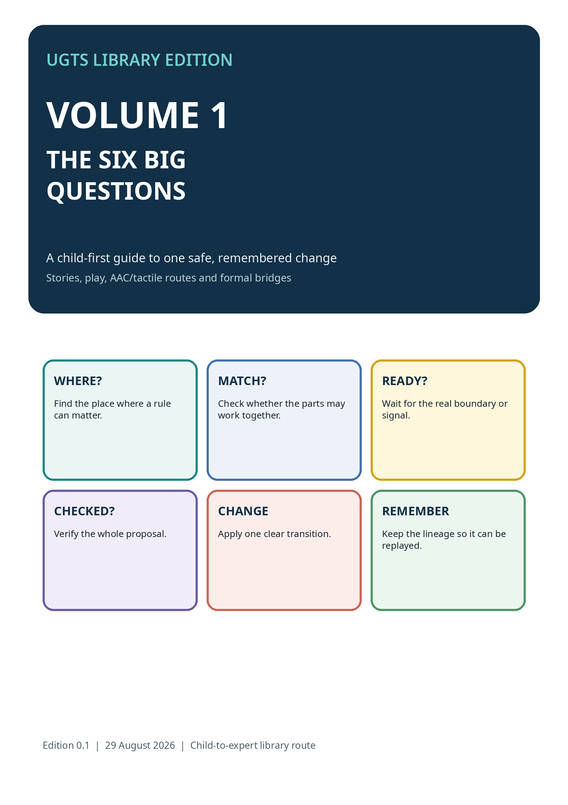

THIS BOOK BELONGS TO THE READER
Choose a route, change your mind, take a break and return

ACCESS PROMISE
A reader may look, listen, touch, point, speak, sign, scan, press, eye-gaze, draw, write or ask a trusted partner. No one has to prove understanding through fast speech, reading or hand control.
I CAN STOP  STOP means stop now. The activity can end without losing progress. | I CAN WAIT  WAIT gives processing time. Silence is not automatic refusal or agreement.
I CAN REPAIR  The reader may say “not that,” undo a mistaken selection or choose another route. | I CAN RETURN  The memory trail helps the reader continue later without starting from nothing.
AGE LABELS ARE INVITATIONS
The concrete route is often comfortable from about age five. Formal vocabulary can be offered whenever it helps. Adults may also prefer the same concrete route.
Source note: Access design is informed by the UGTS Library Volume 0 access rule and the later Definition Breaker child-directed accessibility editions. This book is an educational design, not a clinical assessment.

ONE SAFE CHANGE, SIX QUESTIONS
The permanent backbone of the UGTS library

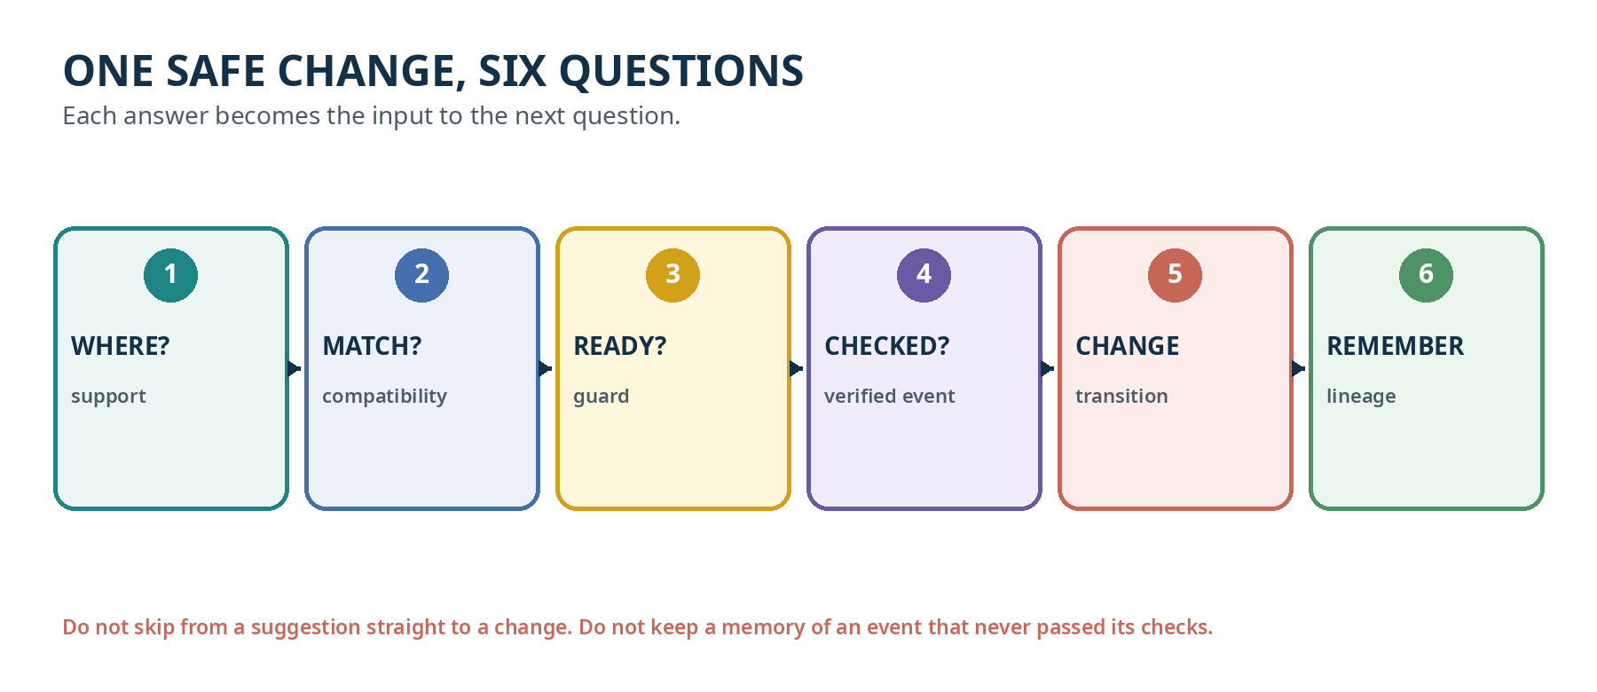
CHILD CHANT
Find the place. Check the match. Wait for the moment. Check the whole idea. Change one thing. Keep the story.
FORMAL CHAIN
support -> compatibility -> guard -> verified event -> transition -> lineage
Source note: Formal basis: the canonical query-first sequence is stated in UGTS-GN 1.1 and retained by UGTS-KC 2.0, Two Hands 3.0, SCLP 3.6.2, KC Elizabeth 3.9 and UGTS-KC 4.2.

STORY: THE LANTERN GATE
A six-question walk through a small world

Nia carries a blue lantern to a garden gate. The gate should open only for a blue lantern, only after sunset, and only after the gatekeeper checks the complete request.
WHERE? | Nia is standing at the garden gate. The lantern and gate are inside the gate rule’s local area.
MATCH? | The gate accepts blue lanterns. A red lantern at the same place would not match this rule.
READY? | The light sensor crosses the declared sunset threshold. “Almost dark” is not silently treated as the same event.
CHECKED? | The proposal contains the right gate, lantern, time, confidence and error status. The gatekeeper accepts it.
CHANGE | The gate changes once from closed to open. The picture may animate, but the authoritative patch is one clear transition.
REMEMBER | The record keeps who proposed, which gate changed, the reason, the before/after state and the event order.
TRY A WRONG VERSION
What goes wrong if the gate opens before MATCH? What goes wrong if the record says it opened even though CHECKED failed?

1. WHERE?
SUPPORT - Where can this rule matter?

CHILD IDEA
Support is a finite local question. It rejects things that are too far away, outside the time window, outside the selected room or outside another declared region before expensive work begins.
TOY EXAMPLE  Only pieces on the green mat are candidates. | GAME EXAMPLE  Only entities near the portal are tested.
MAP EXAMPLE  Only observations whose support volume overlaps the doorway are compared. | BUILDER WORD  SUPPORT: the formal term that stays connected to the child question.
WATCH OUT
Checking the whole world is not automatically safer. It may waste work and create unrelated candidate pairs.
Source note: Formal bridge: support is used throughout the UGTS authority chain. Later releases add domain-specific checks without removing this role.

2. MATCH?
COMPATIBILITY - Are these parts allowed to interact?

CHILD IDEA
Compatibility asks about type, role, sheet, phase, mode, ownership, units, policy or other declared tags. Same place is not enough.
TOY EXAMPLE  A round peg and a round socket match; a square peg at the same place does not. | GAME EXAMPLE  A player may collect a crystal sensor but may not collect a wall.
MAP EXAMPLE  A wheelchair route and a stair-only edge are spatially connected but policy-incompatible. | BUILDER WORD  COMPATIBILITY: the formal term that stays connected to the child question.
WATCH OUT
Compatibility is not a personal judgement about a reader. It is a rule about the typed parts in the modeled system.
Source note: Formal bridge: compatibility is used throughout the UGTS authority chain. Later releases add domain-specific checks without removing this role.

3. READY?
GUARD - Has the important boundary or signal arrived?

CHILD IDEA
A guard gives a typed boundary: a distance reaches zero, a timer reaches a value, a button changes state, a cup crosses a level or a confidence/error interval enters an accepted class.
TOY EXAMPLE  The marble crosses the finish line. | GAME EXAMPLE  Health reaches zero or a player enters a portal band.
MAP EXAMPLE  A measured clearance interval becomes clearly below the allowed threshold. | BUILDER WORD  GUARD: the formal term that stays connected to the child question.
WATCH OUT
Near a boundary, uncertainty may make the answer “ambiguous.” A careful system may wait, measure again or use another rule.
Source note: Formal bridge: guard is used throughout the UGTS authority chain. Later releases add domain-specific checks without removing this role.

4. CHECKED?
VERIFIED EVENT - Did the whole proposal pass?

CHILD IDEA
A proposal becomes a verified event only after all required gates pass: support, compatibility, guard status, confidence, numerical error, policy and any application-specific checks.
TOY EXAMPLE  The group repeats the chosen move and the reader confirms. | GAME EXAMPLE  Collision is in range, layers match and the event margin is safe.
MAP EXAMPLE  Observation, calibration, identity and uncertainty checks all pass before a map change. | BUILDER WORD  VERIFIED EVENT: the formal term that stays connected to the child question.
WATCH OUT
A score, sensor hit, click or picture is evidence for a proposal. It is not automatically authority.
Source note: Formal bridge: verified event is used throughout the UGTS authority chain. Later releases add domain-specific checks without removing this role.

5. CHANGE
TRANSITION - What exact thing changes now?

CHILD IDEA
A transition applies one explicit patch: open a gate, move a node, change ownership, mark a route blocked, add a score or enter a new mode. The patch should preserve declared invariants.
TOY EXAMPLE  Move one token from CLOSED to OPEN. | GAME EXAMPLE  Destroy one collected crystal after the tick, not during collision iteration.
MAP EXAMPLE  Change one route edge from passable to blocked and recompute the affected query. | BUILDER WORD  TRANSITION: the formal term that stays connected to the child question.
WATCH OUT
When two proposals conflict, a deterministic policy must order, merge or reject them. “Both wrote at once” is not an acceptable hidden result.
Source note: Formal bridge: transition is used throughout the UGTS authority chain. Later releases add domain-specific checks without removing this role.

6. REMEMBER
LINEAGE - What must be kept so the change can be explained or replayed?

CHILD IDEA
Lineage keeps stable identity and the accepted change path: event order, parent/child links, route or winding, before/after hashes, external novelty and enough state or checkpoints to reconstruct the result.
TOY EXAMPLE  Add one bead for each accepted move. | GAME EXAMPLE  Save the event sequence and a checkpoint.
MAP EXAMPLE  Keep the observation ID, reason, pre/post state hash and repeat-scan comparison. | BUILDER WORD  LINEAGE: the formal term that stays connected to the child question.
WATCH OUT
A coordinate, compact key or content hash is useful, but none is the whole history by itself.
Source note: Formal bridge: lineage is used throughout the UGTS authority chain. Later releases add domain-specific checks without removing this role.

WRONG-ORDER PUZZLES
The same pieces in the wrong order can make a wrong world

PUZZLE | WHAT WENT WRONG? | REPAIR
OPEN FIRST | A door changes before checking the card. Which question was skipped? | MATCH? and CHECKED?
MEMORY FIRST | The log says a crystal was collected, but the collision proposal was rejected. | Only accepted events belong in authoritative lineage.
PICTURE FIRST | A camera image looks like a blocked doorway, so the route is changed without calibration or uncertainty. | Observation may propose; verification must decide.
POSITION = IDENTITY | Two tokens share one square, so the system merges them. | Position does not replace node identity, route or lineage.
TWO WRITERS | One system opens a gate while another closes it at the same event time. | Use deterministic priority, merge or conflict event.
GUARD WITHOUT SUPPORT | A far-away bell crosses its threshold and changes this room. | WHERE? must reject irrelevant candidates first.
COOPERATIVE RULE
Let the reader choose whether to solve, hear the answer, skip, or ask a partner. The goal is understanding order, not speed.

WORKED EXAMPLE: COLLECTING A CRYSTAL
KC Elizabeth translated into the six-question language

WHERE? | The player and crystal sensor are in the same collision support region.
MATCH? | The collider layers and gameplay roles allow player-collectible interaction.
READY? | The contact set changes from no contact to collision_enter.
CHECKED? | The entity is still active, the score key is valid and the event passes the ordered game phase.
CHANGE | Add points, mark the collectible, emit feedback and defer destruction until the tick is safe.
REMEMBER | The event and canonical snapshot support save, replay, test and state-hash comparison.
WHAT THE PLAYER SEES  A crystal disappears, particles and sound play, and the score changes. | WHAT THE SUBSTRATE KEEPS  Typed entities, contact state, event order, the state patch and enough identity for snapshots or replay.
Source note: Source basis: KC Elizabeth 3.9 fixed-step GameWorld, collision enter/stay/exit, collectibles, snapshots, state hashes and offline browser runtime.

TABLETOP ROOM: THE SIX STATIONS
A cooperative activity with no reading-speed requirement

Materials: six question cards, a support mat, three object tokens, two match connectors, one timer or boundary strip, a YES/NO/UNKNOWN choice, one change arrow and a bead string.
- Place the possible objects near or far from the support mat. The Observer identifies which objects can matter.
- The Matcher checks connector shapes, roles or declared tags. Same location is not enough.
- The Guard Keeper watches the timer, line, cup level or other boundary.
- The Committer repeats the full proposal and asks the reader for confirmation or another response route.
- Move one arrow to show the accepted transition. Conflicting changes must be repaired before moving on.
- The Replay Guide adds one bead and retells the accepted sequence. The reader may correct, undo or stop.
ROLES ARE NOT RANKS
Observer, Matcher, Guard Keeper, Committer and Replay Guide are different ways to contribute. Roles rotate only with consent and can be performed by speech, sign, AAC, touch, switch, gaze or partner-assisted selection.
SAFETY BOUNDARY
Use large, non-hazardous materials. A learning scaffold is not a certified commercial toy. Choking, magnets, cords, batteries, cleaning and other physical risks require qualified review before distribution.

AAC, TACTILE AND PARTNER ROUTES
The concept stays the same while the response route changes

ROUTE | PRACTICE
VISUAL | High-contrast cards, one stable location per question, reduced clutter and a clear preview.
TACTILE | Distinct textures or shapes for each question; stable orientation; object cues; replay bead string.
AUDITORY | Name one option, wait, move to the next, repeat the selected option and request confirmation.
SWITCH / SCAN | Predictable scan order, adjustable dwell, pause/resume, accidental-activation repair and a dedicated STOP route.
EYE / HEAD / FACE | Calibrate gently, preserve the chosen dwell, offer rest and accept small intentional signals.
PARTNER-ASSISTED | The partner presents choices faithfully, does not guess, waits, confirms and records changed-mind repairs.
NO-RESPONSE POLICY
No response is not automatically YES, NO, lack of understanding or refusal. Pause, reduce demands, offer another route and preserve the right to stop.
TOUCH CONSENT
Ask before touching the reader or moving their body. Prefer hand-under-hand invitation and shared exploration over forced hand-over-hand movement.

TWO READY-TO-USE LESSONS
Stop while the reader still has agency and energy

TEN-MINUTE ROUTE  1 minute: show STOP and response routes. 2 minutes: place two objects and a support mat. 3 minutes: ask WHERE and MATCH. 2 minutes: cross one guard. 2 minutes: preview, confirm, change and add a bead. | THIRTY-MINUTE ROUTE  Welcome and sensory forecast. Explore definitions and support. Build compatibility and a guard. Confirm and commit one change. Replay the chain. Offer micro-breaks and an early FINISHED option at every transition.

Accessible assessment
- Show: arrange, point to or touch the right card.
- Tell: speak, sign or use AAC to name the next question.
- Do: carry out one correct support/match/guard sequence.
- Repair: notice and correct a wrong-order story.
- Explain: retell the event with a bead chain, drawing, objects or written trace.
ASSESS THE CONCEPT, NOT THE ACCESS METHOD
Do not use reading speed, speech clarity, eye contact, stillness or fine-motor control as a substitute measure for understanding.

PRINTABLE QUESTION CARDS - SET 1
Cut, enlarge or copy onto separate tactile cards

1  WHERE?  SUPPORT  Where can this rule matter?  TACTILE IDEA  DOT FIELD | 2  MATCH?  COMPATIBILITY  Are these pieces allowed to work together?  TACTILE IDEA  PAIRED NOTCH | 3  READY?  GUARD  Has the needed boundary, time or signal arrived?  TACTILE IDEA  SINGLE RIDGE
ACCESS NOTE
A reader may point, touch, eye-gaze, scan, sign, speak, press a switch or ask a trusted partner to indicate a card. Keep the order stable and always offer STOP, WAIT, AGAIN, HELP and BREAK.

PRINTABLE QUESTION CARDS - SET 2
Cut, enlarge or copy onto separate tactile cards

4  CHECKED?  VERIFIED EVENT  Did the whole proposal pass its checks?  TACTILE IDEA  STAR / BURST | 5  CHANGE  TRANSITION  What exact thing changes now?  TACTILE IDEA  ARROW GROOVE | 6  REMEMBER  LINEAGE  What must be kept so we can replay it?  TACTILE IDEA  LINKED RINGS
MEMORY TRAIL
Use beads, linked rings, stamped shapes, recorded words or a digital event list. The response form may change; the order and meaning must remain recoverable.

FORMAL BRIDGE FOR ADULTS AND BUILDERS
The child questions map to stable technical roles

CHILD QUESTION | FORMAL TERM | BUILDER CONTRACT
WHERE? | support | Finite geometric, temporal, semantic or resource region that admits a candidate.
MATCH? | compatibility | Typed predicate over sheet, phase, mode, role, policy, units, ownership or application tags.
READY? | guard | Declared relation/boundary with crossing, touch, tangency, coincidence, interval and error semantics.
CHECKED? | verified event | Proposal passes support, compatibility, accepted guard status, confidence/error and policy.
CHANGE | transition / commit | Deterministically ordered atomic patch that preserves declared invariants.
REMEMBER | lineage / replay | Stable identity, pre/post state, event order, checkpoints and irreducible external novelty.
4.2 EXTENSION
UGTS-KC 4.2 expands the technical schedule around this backbone: parse, normalize, resolve, type, plan, construct, evaluate, certify, support, compatibility, guard, proposal, commit, lineage and projection. The child six-question route remains the authority core.

SOURCE AND EVIDENCE REGISTER
What is source-derived and what is educational design

SOURCE | USED FOR
UGTS-GN 1.1 | Canonical support/compatibility/guard/event/transition/lineage chain; evidence and precision limits.
UGTS-KC 2.0 | Verified-event condition, patterns, topology, motion, degeneracy and numerical boundaries.
KC Two Hands 3.0 | Proposal verification, deterministic commit, conflicts, checkpoints and replay.
UGTS-KC 3.6 | Definitions, dependencies, hinges and explicit operation order.
SCLP 3.6.2 | Guard intervals, finite packing, winding and bounded grammar.
KC Elizabeth 3.9 | Fixed-step game world, collision events, saves and self-contained HTML5.
UGTS-KC 4.2 | General operator records and fifteen explicit phases.
Definition Breaker DB-2.0 | Child agency, multisensory access, partner fidelity and physical-play boundaries.
DESIGN-DERIVED CONTENT
The stories, cards, tabletop rooms and lesson sequences are educational translations. They are not claims that the source reports themselves prescribe one teaching method.
PRIVACY
Requester identifiers found in technical reports are not required to teach these concepts and are omitted from child-facing pages.

VOLUME 1 COMPLETE
One consecutive library volume, not the end of the project

What this volume establishes
- The six child questions are permanently linked to support, compatibility, guard, verified event, transition and lineage.
- Stories and wrong-order puzzles show why the sequence matters.
- AAC, tactile, switch, gaze and partner-assisted routes preserve the same conceptual challenge.
- Two lesson formats and printable prototype cards are ready for library or family use.
- The formal bridge connects this volume to the latest 4.2 order calculus without overwhelming the child route.

Next volume in the sequence
VOLUME 2 - SHAPES, PATHS, FIELDS AND MOTION
The next book teaches how UGTS describes geometry and movement before asking whether a change is allowed.
EDITION CONTROL
UGTS Library Edition, Volume 1, edition 0.1. This educational layer explains source releases and does not modify their formal version numbers.

