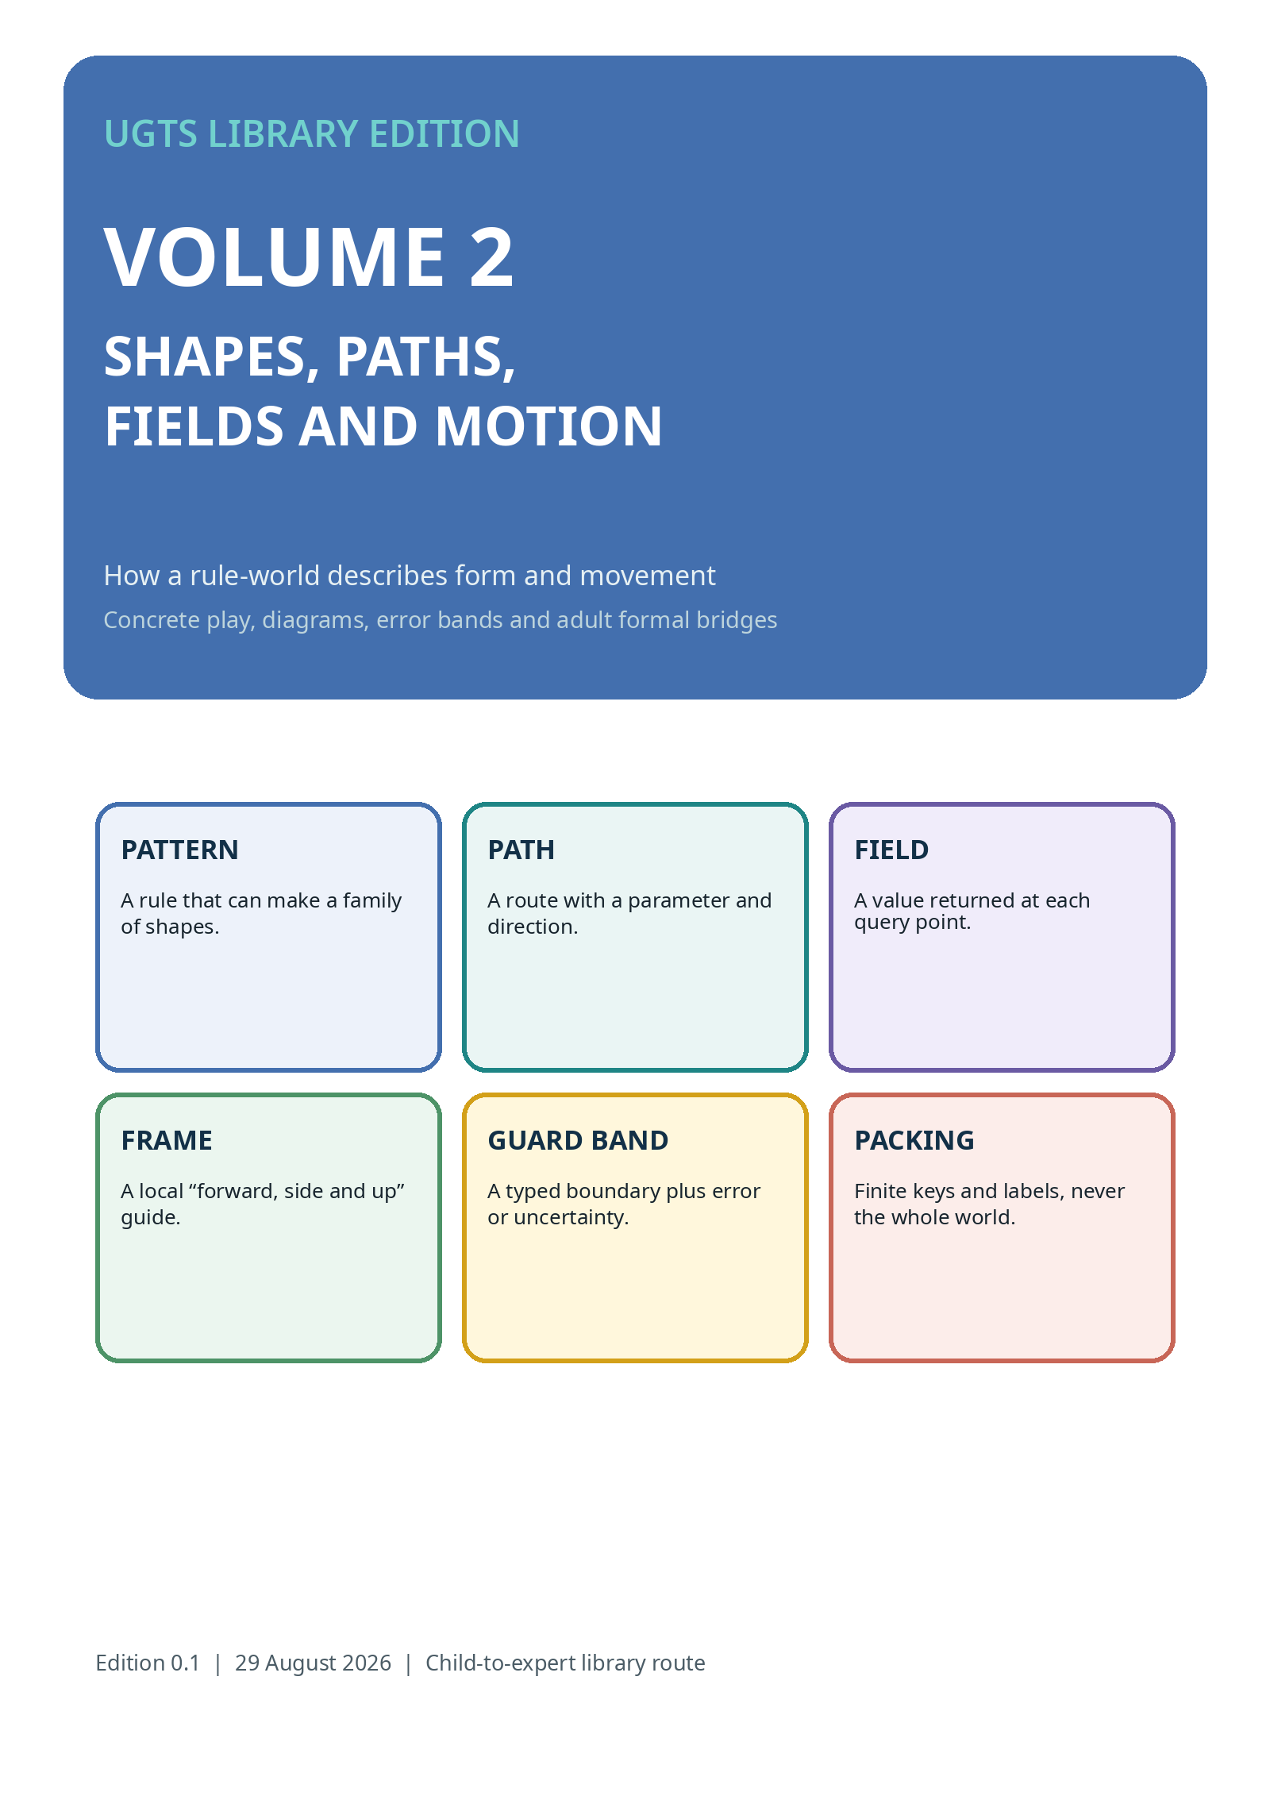

DESCRIBE BEFORE YOU CHANGE
Geometry answers queries; the event chain decides authority

BIG IDEA
UGTS can describe shapes, routes, fields and motion without turning a drawing or rendered frame into the authoritative world. Description supports a proposal; the six-question chain still decides change.
SHAPE  What points belong to a form, boundary or support? | PATH  Where does a parameter place an object, and how does direction change?
FIELD  What value, sign, gradient or status appears at a query point? | MOTION  What is the state at a requested time, with a declared model and error contract?
ACCESS ROUTE
Trace, build, listen, point or describe. A reader may use string, blocks, raised lines, sound cues, movement or a screen. The mathematical role remains the same.

PATTERN, PATH, FIELD OR PICTURE?
Four related things that must not be silently merged

THING | FORMAL ROLE | EXAMPLE
Pattern | A versioned rule with parameters and a domain. | A rose family, spiral law, spline or superellipse.
Path | A parameterized route through positions and possibly orientations. | A curve used for motion, calibration or a sweep.
Field | A function that returns a value at each query point. | Inside/outside sign, temperature, confidence or arrival time.
Picture | A downstream projection for people or displays. | SVG, Canvas, Bayer pixels, camera preview or report figure.
WHY THIS MATTERS
The same curve may be used as a boundary, trajectory, support or calibration sweep. The role must be declared. A picture of the curve is still only a presentation.
Source note: Source basis: UGTS-KC 2.0 pattern instance contract and query set; KC Two Hands 3.0 and Bayer Direct keep presentation downstream.

PATTERN FAMILIES
One rule, many parameter choices

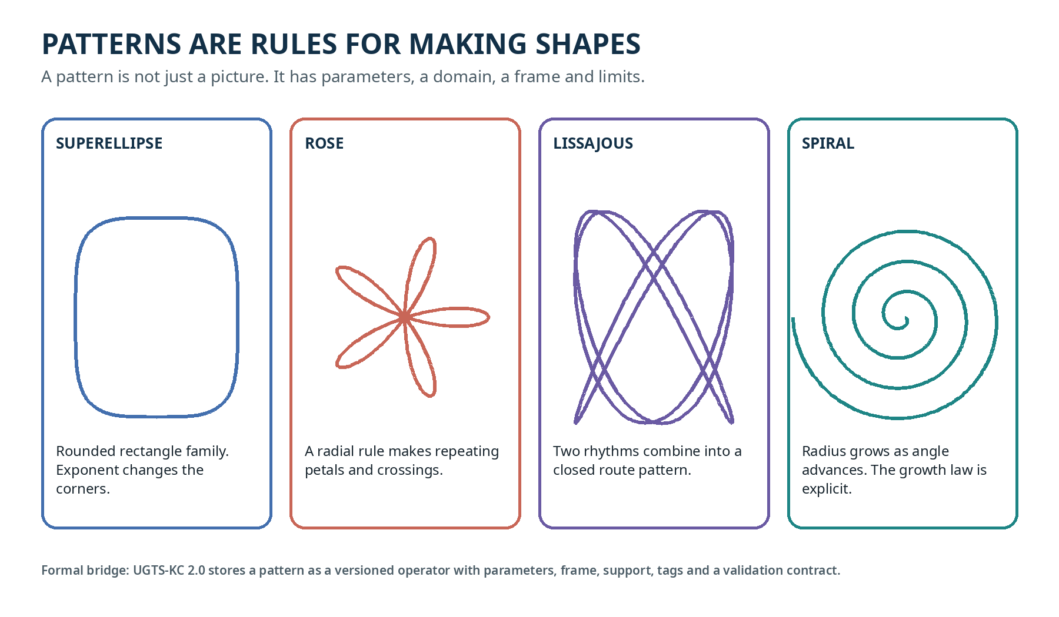
PLAY IDEA
Use a bendable wire or string. Change one parameter at a time: corner roundness, petal count, rhythm pair or radial growth. Name what changed and what stayed invariant.
HONEST LIMIT
A famous mathematical name does not prove a material property, biological law, self-assembly effect or product performance. Those require separate models and measurement.

FIELDS: INSIDE, BOUNDARY AND OUTSIDE
A number or status can live at every query point

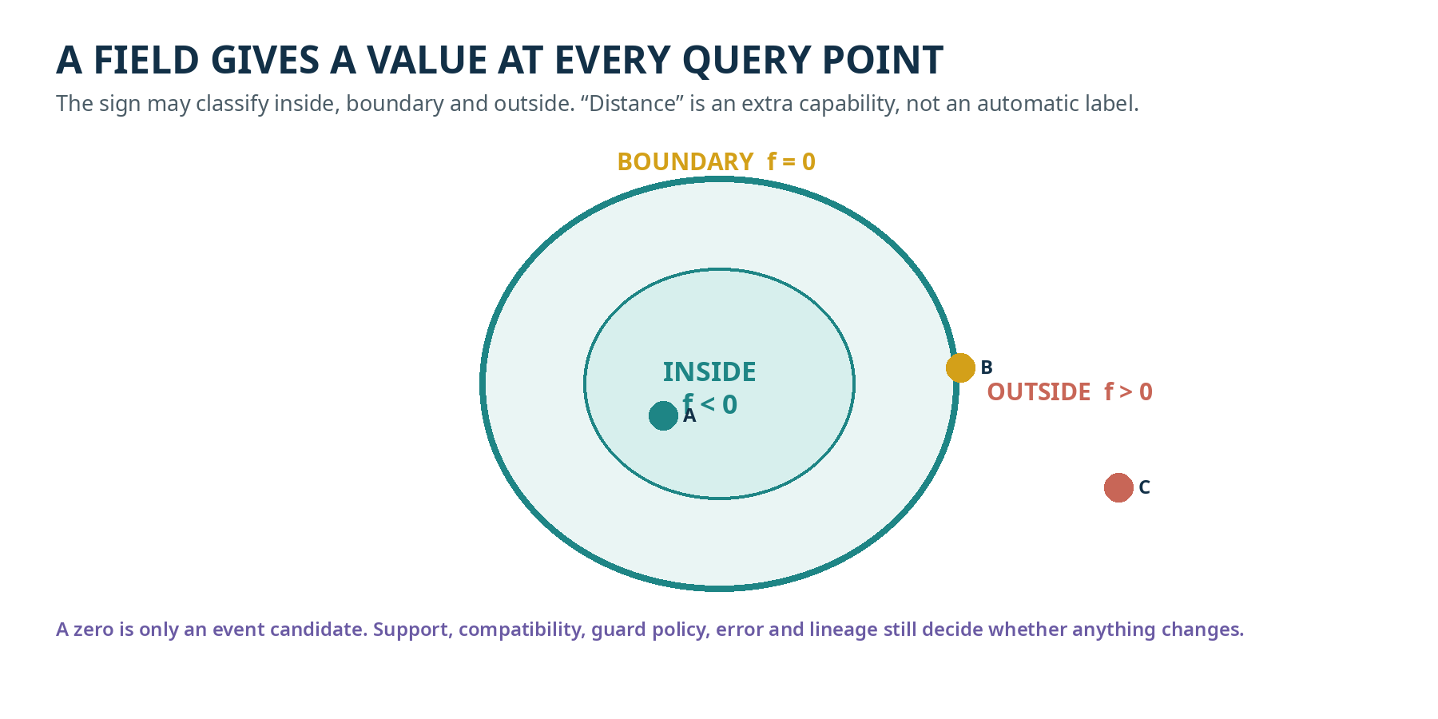
GENERIC IMPLICIT FIELD  May support sign, threshold, gradient or guard queries. It is not automatically exact Euclidean distance. | EXACT SIGNED DISTANCE  Adds a stronger contract: magnitude equals shortest distance under the declared primitive and transform conditions.
EVENT RULE
The zero boundary is a candidate. A change still requires support, compatibility, accepted guard status, confidence/error and deterministic commit.

SUPPORT SHAPES
Ask a small local question before a large exact one

BOX / AABB  Fast finite bounds for scene or map candidates. A box is not the final semantic answer. | SPHERE  Local radial support or exact sphere relation when center and radius are declared.
CONE  Radial reach plus angular direction. Useful for views, sensors and directional relevance. | SHELL  An ordered radial interval for multiscale relevance or lookup.

Hybrid candidate path
ORDER
conventional bounds / index -> local support -> compatibility -> exact pattern, field or trajectory query -> guard classification -> proposal
KILL CRITERION
Use a conventional index instead when the combined support/compatibility system is slower, larger or less accurate at equal error.
Source note: Sources: UGTS-GN 1.1 local radial-angular support; UGTS-KC 2.0 support and kill criteria; Two Hands 3.0 AABB/BVH hybrid path.

MOTION: WHERE, HOW FAST, AND HOW THAT CHANGES
Position alone is not a motion model

CHILD ROUTE
A moving object can have a place, a speed, a turning direction and a “change of change.” UGTS stores only the fields needed by the selected motion profile and keeps the model explicit.
STATE PART | PLAIN MEANING
position | Where the state is at a time.
velocity | How position changes.
acceleration | How velocity changes.
curvature | How strongly a path turns per distance.
torsion | How a three-dimensional path twists out of a plane.
mode | Which continuous or hybrid rule is active.
FORMAL EXAMPLE
For constant acceleration: x(t) = p0 + v0*dt + 1/2*a*dt^2 and v(t) = v0 + a*dt. A relation f(x)=0 becomes a time guard g(t)=f(x(t)).
BOUNDARY
A coordinate chart may change component formulas. A physical force or torque requires a declared mechanics model; coordinate vocabulary does not create dynamics.

MOVING FRAMES
Carry a stable local direction along a route

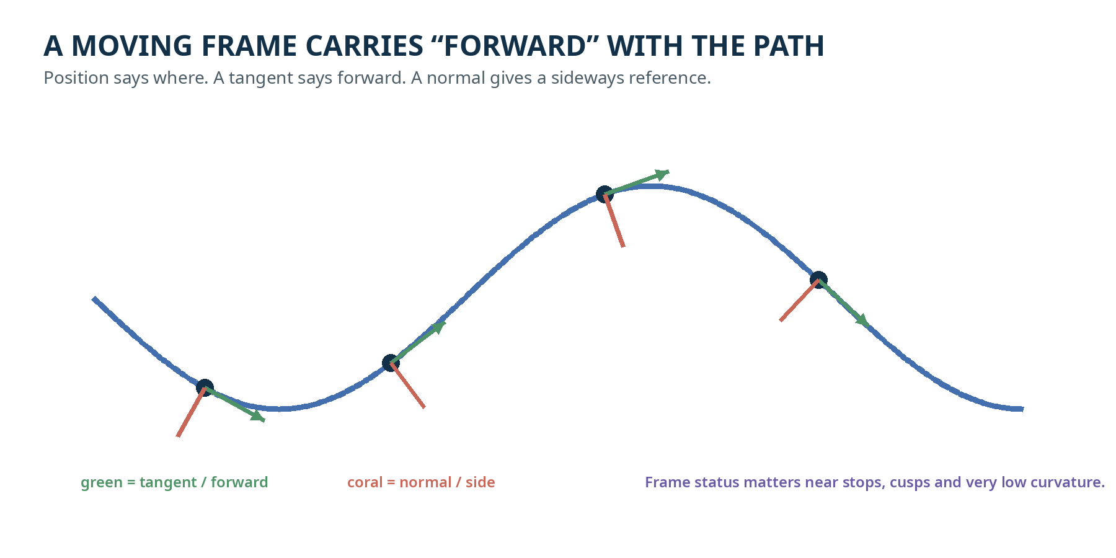
FRENET FRAME  Uses derivatives and curvature. It can become unstable where speed or curvature approaches zero. | BISHOP / PARALLEL TRANSPORT  Carries a rotation-minimizing frame from an initial direction. It requires a numerical transport tolerance.
WHY THE STATUS MATTERS
A frame query should return both orientation and status. “Undefined,” “low curvature,” or “fallback used” is more truthful than inventing a direction.

LOOPS, CROSSINGS AND WINDING
The same coordinate can belong to a different trip

Imagine walking around a circular track three times. You return to the same painted point, but your winding count and route history are different. A projected crossing may also show two route branches that are not actually connected.
POSITION  The current coordinate. | PHASE  Where you are inside one repeating cycle.
WINDING  How many whole cycles have been completed. | ROUTE CLASS  Which obstacle, sheet, braid or portal history distinguishes the path.
COMPATIBILITY RULE
Same position plus different sheet, phase, mode or route class may mean no coupling. A visible self-intersection is not automatically a collision.
Source note: Sources: UGTS-KC 2.0 winding, covering and homotopy descriptors; SCLP 3.6.2 phase plus winding and explicit topology profiles.

GUARD BANDS AND UNCERTAINTY
Sometimes the truthful answer is “not classified yet”

Suppose a doorway is measured as 79.8 cm with a 0.5 cm uncertainty, while a rule requires at least 80.0 cm. The interval overlaps the threshold. A careful system should not silently call it open or blocked.
STATUS | INTERVAL TEST | ACTION
clearly below | upper bound < threshold | Classify below.
clearly above | lower bound > threshold | Classify above.
overlaps guard | interval touches the threshold band | Return ambiguous; remeasure or follow policy.
too uncertain | width exceeds event margin | Reject or simplify the claim.
ONE-BIT JITTER LESSON
A deterministic bit may choose a tiny signed perturbation or route. It is admissible only when its whole interval stays inside the event margin and cannot change the event class or order.
Source note: Source basis: SCLP 3.6.2 certified jitter intervals and sweep bounds; KC Atlas and 4.0 spatial ledger use conservative observation intervals.

SWEEPS AND FINITE SAMPLING
Move a shape along a route without pretending every sweep has a closed form

CHILD ROUTE
Move a cardboard cone or circle along a string. The swept region is every place touched during the trip. If we check only a finite set of stops, we also need a bound on what could happen between them.
EXACT PRIMITIVE  A declared sphere or finite cone may have an exact local relation. | CERTIFIED SWEEP  Sample minima plus a Lipschitz or motion bound produce an interval for the true sweep relation.
DO NOT OVERCLAIM
A translational sweep certificate is not a universal exact signed-distance formula for arbitrary rotation, deformation or grammar-generated motion. Extra motion terms or a specialized solver may be required.

FINITE PACKING AND KEYS
A small address can name a cell without storing the whole world

SCLP supplies two explicit 64-bit layouts for quantized log-radius, angle, modular time and hinge angle. One uses contiguous fields; one interleaves bits in a Morton-style schedule. Both round-trip the same quantized tuple, but the words are intentionally different.
QUANTIZE  Map a declared continuous range to finite integer cells and record the error. | PACK  Place integer fields into a declared fixed-width layout.
PREFIX  Each appended radix bit refines one scheduled interval; it does not directly halve the physical coordinate. | DECODE  Recover the quantized tuple and its declared range/error, not imaginary infinite detail.
COMPRESSION BOUNDARY
A width ratio is not equal-information compression unless the records preserve the required semantics, reconstruction and error. One sign bit does not retain distance magnitude or uncertainty; a seed does not recreate unstored photons.
Source note: Sources: UGTS-GN 1.1 packed precision and compression contracts; SCLP 3.6.2 key layouts and pointerless-storage audit; 4.1/4.1.1 seed-plus-evidence boundary.

APPLICATION: A DETERMINISTIC GAME WORLD
Geometry becomes playable without becoming the sole authority

PHASE | ROLE
input | Resolve named actions into a serializable frame.
controller | Turn actions into intended movement or dash.
physics | Integrate bodies under an explicit fixed step.
bounds | Clamp, bounce or wrap under a declared rule.
collision | Compute candidate pairs and manifolds with filters.
gameplay | Apply hazards, collectibles and win/lose rules through events.
late / camera / flush | Update lifetime, follow camera and perform deferred destruction.
PICTURE VERSUS WORLD
Vector art, particles, HUD, sound and Canvas output are downstream feedback. Canonical snapshots, events, state hashes and project records carry the testable game identity.
Source note: Source: KC Elizabeth 3.9 deterministic GameWorld, vector art, input, animation, collision, saves and self-contained HTML5 runtime.

THREE HANDS-ON ACTIVITIES
Use household materials and preserve reader control

ACTIVITY | STEPS / CONCEPT
STRING PATH | Tape a string route. Move an arrow token along it. At three points, place a “forward” arrow and a “side” arrow. Ask what happens at a sharp turn or stop.
FIELD FLOOR | Mark INSIDE, BOUNDARY and OUTSIDE regions with mats or sounds. Place query tokens and let the reader classify, skip or ask for help.
PACKING BOX | Use four compartments with fixed capacities. Place coded cards, decode them and compare a contiguous order with an interleaved order. Keep a separate card for uncertainty.
ACCESS OPTIONS
Raised string, textured mats, spatial audio, object cues, switch scanning, partner-assisted placement and recorded descriptions can all express the same concepts.
PHYSICAL BOUNDARY
Choose safe material sizes and attachment methods. These are informal learning activities, not manufacturing drawings or certified toys.

FORMAL BRIDGE
Compact dictionary for builders and adult learners

TERM | CONTRACT
pattern | Versioned operator + parameters + frame + support/tags + validation contract.
parametric curve | gamma: U -> R^n with declared parameter interval and derivatives/status.
implicit field | f: R^n -> R with declared sign, threshold and exactness capability.
state_at(t) | Closed expression or bounded integration with a model and error/work contract.
frame_at | Frenet, Bishop or body frame plus validity/fallback status.
route_class | Winding, homotopy, braid, cell or chart descriptor that supplements coordinates.
guard interval | Residual/error interval classified against an event margin.
packed key | Invertible finite quantized address under a declared layout and range.
4.2 CONNECTION
The general OperatorSpec can record each of these operators’ domain, codomain, units, shape, exactness, effects, dependencies and order. A mature domain runtime may remain the implementation while 4.2 supplies schema and handoff discipline.

SOURCE REGISTER AND HONEST LIMITS
What this volume can and cannot establish

SOURCE | USED FOR
UGTS-KC 2.0 | patterns, fields, topology, SE(2)/SE(3), frames, timing, dynamics and kill criteria
UGTS-KC 3.6 | implicit/parametric definitions, hinges and explicit operation order
SCLP 3.6.2 | finite cone/sphere relations, sweep intervals, log-polar calculus, winding and 64-bit keys
KC Two Hands 3.0 | spatial indexing, geometry compilation, independent error budgets and downstream rendering
KC Elizabeth 3.9 | vector/game runtime, fixed-step phases and persistence
KC Atlas / 4.0 / 4.1 | uncertainty intervals, observation/authority separation and seed-plus-evidence boundaries
UGTS-KC 4.2 | general operator and order records
NO MAGIC GEOMETRY
Topology labels do not replace mechanics, conservation laws, sensor calibration or evidence. A finite key does not store infinite detail. A picture does not become authoritative state.
EVIDENCE RULE
Tests and demonstrations establish internal properties of their declared implementations. Application accuracy, physical performance and safety require target-specific measurement and review.

VOLUME 2 COMPLETE
One consecutive library volume, not the end of the project

What this volume establishes
- Pattern, path, field and picture are separated by role.
- Inside/boundary/outside queries are taught without calling every field exact distance.
- Motion, moving frames, winding and route identity are connected to concrete examples.
- Guard intervals teach that “ambiguous” can be the truthful result.
- Finite keys and seed records are presented with reconstruction and evidence boundaries.

Next volume in the sequence
VOLUME 3 - IDENTITY, RULES, MEMORY AND REPLAY
The next book explains why coordinates and pictures are not identity, how definitions live inside the substrate, and how proposals, commits, hashes, checkpoints and spatial evidence form a trustworthy remembered world.
EDITION CONTROL
UGTS Library Edition, Volume 2, edition 0.1. This educational layer explains source releases and does not modify their formal version numbers.

