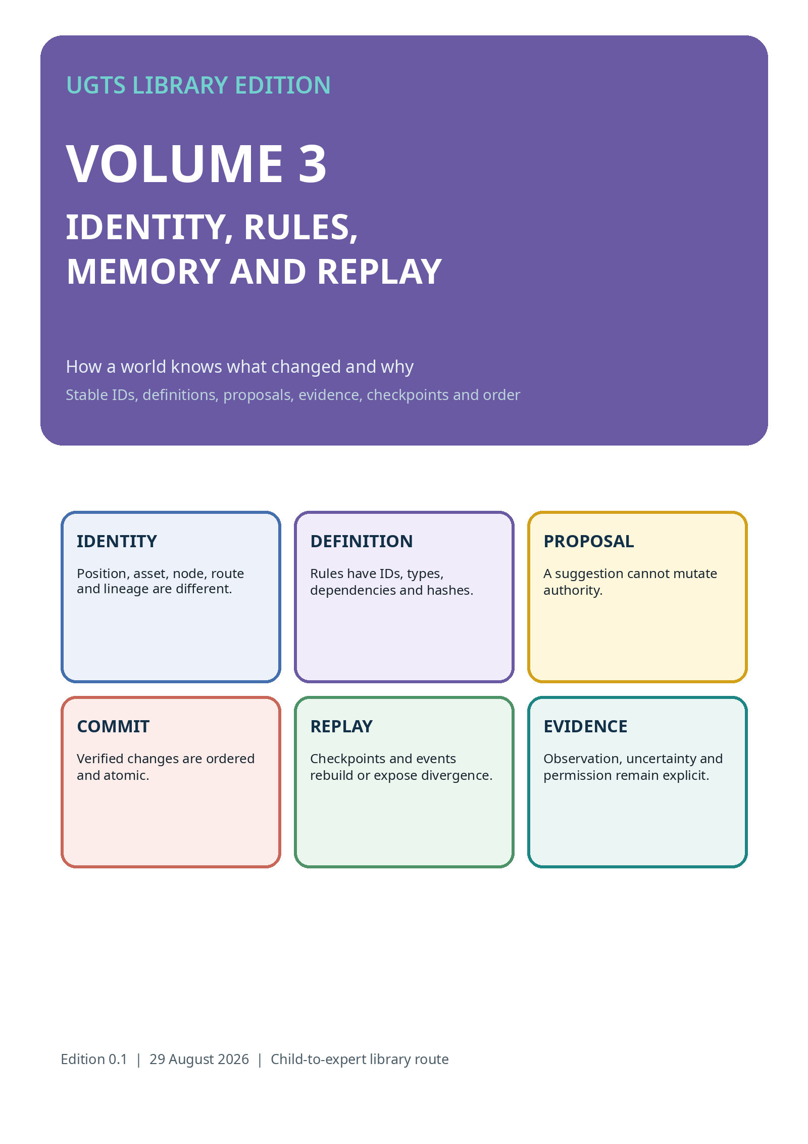

SAME PLACE DOES NOT MEAN SAME THING
Identity needs more than a coordinate

Two red books can sit on one shelf. Two game entities can overlap. A route can cross itself. A map observation can revisit the same doorway. The coordinate helps locate them, but stable identity, type, route and history say which thing or state sector is meant.
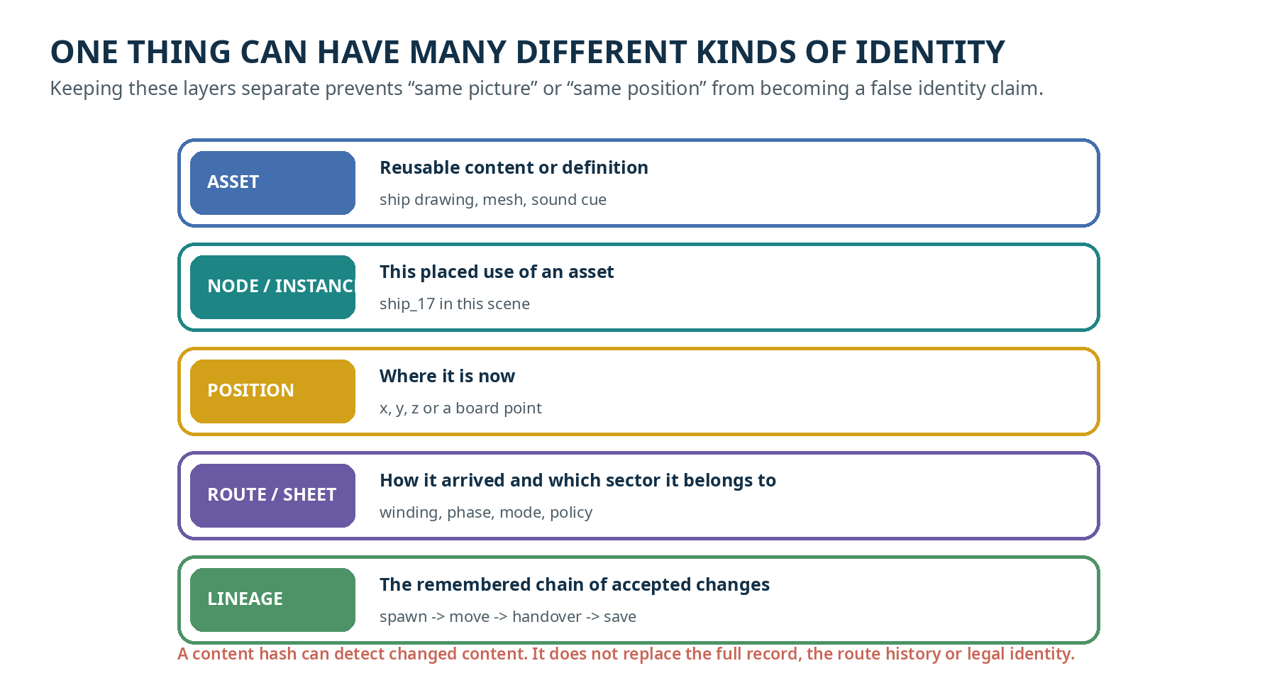
CHILD SUMMARY
Where it is, what reusable thing it uses, which placed object it is, how it arrived and what happened to it are different questions.

STORY: THE TWO RED BOOKS
A library example of stable identity

Book A and Book B have the same red cover and are returned to the same shelf position. Book A has a repaired page and a waiting reservation. Book B is a different copy with another barcode and no reservation.
ASSET | Both may use the same cover design and edition definition.
NODE | Each physical copy has its own stable library item ID.
POSITION | Both may occupy the same shelf slot at different times, or even touch one another.
POLICY | The reservation applies to Book A, not every red book at that coordinate.
CHANGE | Returning, repairing or borrowing one copy changes that item record.
LINEAGE | The event trail preserves which copy moved, when, why and under which rule.
FORMAL LESSON
asset identity != node identity; node coordinate != lineage identity; content hash != legal or personal identity

ASSET, NODE, OBJECT, POSITION, ROUTE, LINEAGE
A builder’s identity dictionary

LAYER | CONTRACT
definition / asset | Reusable content or rule family. Multiple instances may reference it.
node / instance | Stable placed identity in a scene, map, game or ledger.
object / entity | Runtime state bundle that may own components and behavior.
position | Current coordinate or cell; never complete identity by itself.
route / sheet / mode | State sector and compatibility context that can distinguish co-located states.
lineage | Accepted transition history, ancestry, handover, winding and external novelty.
hash | Compact integrity or divergence check over a canonical record; not the full semantic or legal identity.
DESIGN RULE
Store event-critical state compactly, but leave large meshes, source definitions, material graphs and editor metadata in referenced cold storage. Compact does not mean incomplete without a reconstruction contract.
Source note: Sources: KC Two Hands 3.0 state/identity split and asset/node contract; UGTS-KC 2.0 route identity; SCLP finite-key boundaries.

THE RULES MOVE INSIDE THE WORLD
UGTS-KC 3.6 makes definitions first-class substrate data

CHILD ROUTE
A rule card is no longer only a sentence outside the system. It receives a stable name, a type, inputs, outputs, dependencies, an order phase, a source note and a content check.
FIELD | MEANING
id | Stable definition name.
kind | What family of rule or object this is.
domain / codomain | What may go in and what kind of result may come out.
parameters | Declared literal settings.
dependencies | Other definitions required first.
phase | When it is evaluated.
invariants | What must remain true.
provenance | Source-derived, engineering-derived, corrected, bounded or other declared class.
content hash | Canonical change-detection value over the record.
REFERENTIAL CLOSURE
Unknown references, duplicate IDs, bad hashes and undeclared dependency cycles are rejected before execution.

DEPENDENCIES AND ORDER
A rule may need another rule first

Suppose “open the gate” depends on a gate definition, a key definition, a match operator and a time guard. The dependency graph tells us what must be resolved and constructed before the event can be checked.
DEPENDENCY ORDER  Definitions form a directed graph. A deterministic topological order resolves prerequisites. | COMPOSITION ORDER  H2 after H1 is not generally the same as H1 after H2. Transform order is stored literally.
PHASE ORDER  Pure evaluation, certification, support, compatibility, guard, proposal and commit are different phases. | REPLAY ORDER  Accepted events must be applied in their recorded sequence unless a versioned merge law says otherwise.
CYCLE POLICY
A dependency cycle is rejected unless a fixed-point or recursion profile explicitly states initialization, convergence, depth and work budgets.
Source note: Sources: UGTS-KC 3.6 dependency DAG and ten-phase schedule; UGTS-KC 4.2 distinguishes dependency, phase, composition, reduction, parallel, event and replay order.

WHAT A CONTENT HASH CAN AND CANNOT SAY
Useful integrity evidence with a narrow meaning

CAN HELP WITH  Detect changed canonical bytes, support cache keys, compare checkpoints, verify a definition record or find replay divergence. | CANNOT PROVE  Mathematical truth, human identity, ownership, authorization, truthful place/time, uncompromised hardware, safety or legal chain of custody.

Three rules
- Hash the declared canonical record and version the canonicalization rules.
- Keep the full state, definition or event record that gives the digest meaning.
- Use independent provenance, authorization, signatures or measurements when the application requires them.
CHILD ANALOGY
A tamper seal can show that a box changed. It cannot tell who owns the box or whether the contents are true.

PROPOSAL, VERIFICATION AND ATOMIC COMMIT
Parallel detection; one authoritative boundary

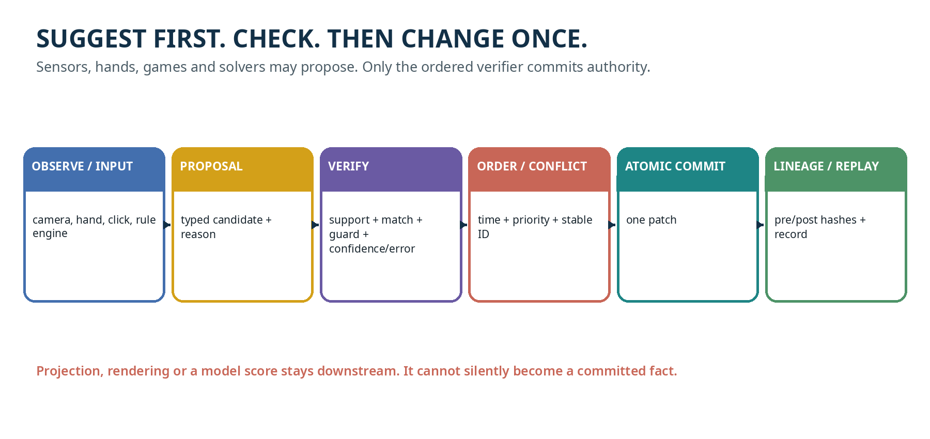
WHY PROPOSALS MATTER
A camera, GPU, hand tracker, game system, search algorithm or human input may be useful and still be uncertain or conflicting. Proposal-only design keeps detection separate from authoritative mutation.
VERIFIED CONDITION
in support AND compatible AND accepted guard status AND confidence >= floor AND numeric error <= event margin AND all application policy gates pass

CONFLICTS AND SIMULTANEOUS EVENTS
A deterministic system must say what happens when patches compete

CASE | EXPLICIT POLICY
different fields | Both patches may be accepted if their declared effects are compatible.
same field, same value | A versioned commutative/idempotent merge may coalesce them.
same field, different values | Use priority and stable tie order, or emit a conflict event.
overlapping time intervals | Use certified event-time intervals and declare whether they are orderable.
coincident constraint | Enter a maintained constraint mode instead of emitting infinite zero-crossing events.
too dense / chatter | Use hysteresis, hold time, coalescing and a stop budget.
NEVER HIDE THE LOSERS
Rejected proposals keep reason codes such as outside_support, incompatible, bad_guard, low_confidence, excessive_error or patch_conflict. Diagnostics are part of explainability.
Source note: Sources: Two Hands 3.0 deterministic ordering/conflicts; KC Atlas spatial proposals; UGTS-KC 4.2 event and replay order.

CHECKPOINTS, HASHES AND REPLAY
Rebuild the story or stop at the first mismatch

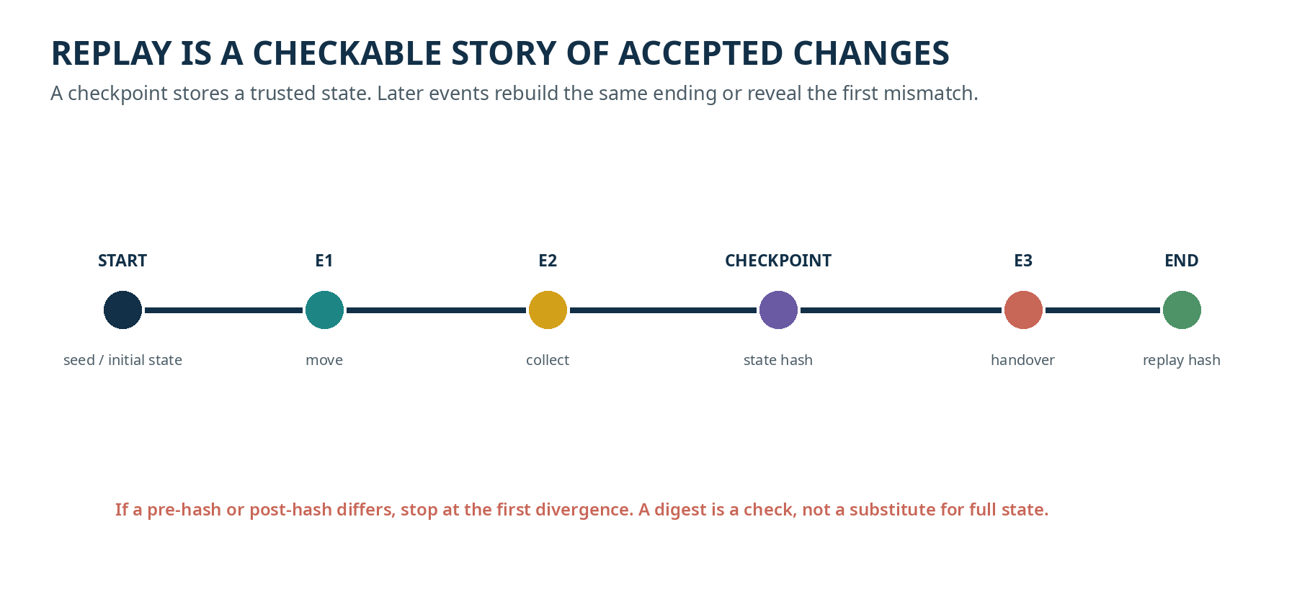
CHECKPOINT  A canonical snapshot at a known sequence. It shortens replay and provides a comparison anchor. | EVENT LOG  Ordered accepted patches with pre/post hashes, reason, route/lineage and external novelty where needed.
RECONSTRUCTIBILITY RULE
Closed deterministic behavior may be rebuilt from seed, definitions and events. External inputs, measurement evidence, topology edits, solver choices and calibration changes must be stored or checkpointed when they cannot be regenerated.

OBSERVATION IS NOT AUTHORITY
The central lesson of KC Atlas and the spatial branch

A camera, model or human note may observe a doorway, obstacle or crack. The observation carries support, source, calibration, uncertainty and confidence. It may propose a map patch, but it cannot directly rewrite the authoritative ledger.
CAPTURE | Record when, where, how and with which calibration profile the evidence was acquired.
OBSERVE | Create a typed observation with bounded uncertainty and provenance.
SUPPORT | Check whether it applies to the relevant map region, object and time.
VERIFY | Check compatibility, guard/error interval, stable identity and policy.
COMMIT | Apply an accepted node, edge or measurement patch with reason and hashes.
REPLAY | Rebuild the ledger, route query and change report from the accepted event sequence.
SAFETY LIMIT
A synthetic route demo, image-only classification or reference ledger is not a real-world evacuation, structural, medical or legal certification.
Source note: Sources: KC Atlas 3.9.3 and UGTS-KC 4.0 Spatial Evidence Ledger.

STABLE IDS AND REPEAT-SCAN CHANGE
Compare the same modeled thing, not merely nearby pixels

CHILD ROUTE
To say “this doorway changed,” the system must first keep a stable doorway identity. Otherwise it may confuse movement, a new camera angle, a different object or failed re-identification with a real change.
CONDITION | TRUSTWORTHY RESULT
same stable ID + non-overlapping measurement intervals | candidate real change
same stable ID + overlapping intervals | within tolerance / not confirmed
different or uncertain identity | re-identification problem, not a certified change
missing calibration or scale | measurement-critical claim deferred
conflicting sources | merge policy or unresolved evidence event required
ROUTE CONSEQUENCE
After a verified edge-state change, constrained reachability may change for one policy mode but remain available for another. The query result is only as trustworthy as the observations, identity and route policy.

SEED PLUS MEASURED EVIDENCE
KSEED stores a recipe and what the recipe cannot recreate

THE SEED CAN RECREATE  Deterministic schedules, stable synthetic IDs, sampling choices, fixtures and procedural display decisions. | THE FILE MUST STILL STORE  Measured luma/IMU summaries, feature and map evidence, accepted events, uncertainty, calibration, checksums and lineage.

KSEED 4.1 integrity layers
- Versioned header with profile commitments and CRC32.
- Typed chunk headers with sequence, lengths, record count, schema ID and CRCs.
- Conditional zlib only when it actually makes the stored chunk smaller.
- SHA-256 chain over ordered chunk headers and stored payloads.
- Replay stops on framing, sequence, CRC, decompression, chain or summary failure.
NO SEED-ONLY MAGIC
A seed does not reconstruct unstored photons. A nominal raw-input/evidence ratio is not equal-information image compression.
Source note: Sources: UGTS-KC 4.1 Spatial Seed Native and 4.1.1 Atlas Spatial Seed SLAM Fusion.

UGTS-KC 4.2: ORDER BECOMES DATA
The latest general substrate release found in the library audit

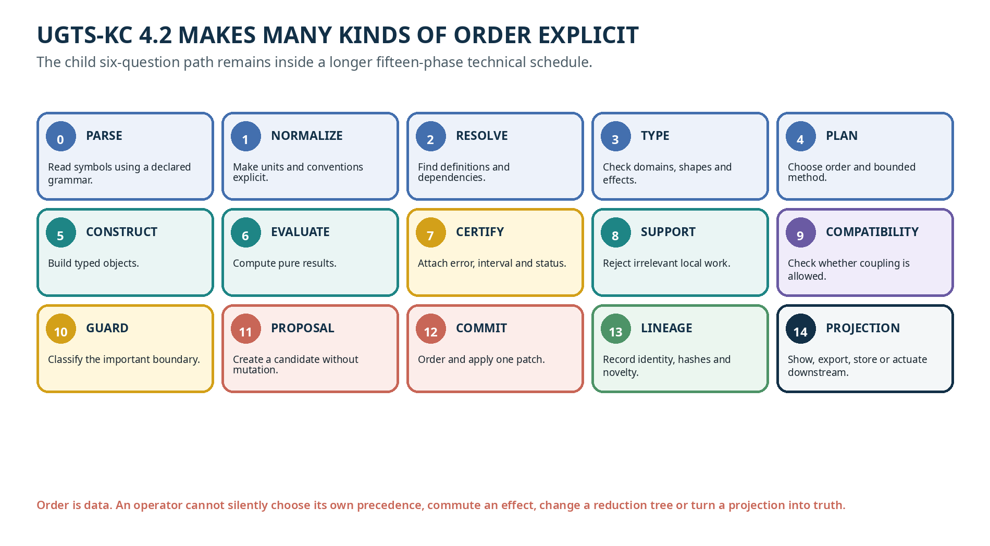
STRONGEST UPGRADE
Ambiguity becomes representable and rejectable. A symbol cannot silently choose its domain; a transform cannot silently commute; a reduction cannot silently change trees; a score cannot silently become state; a projection cannot silently become truth.
FALLBACK POLICY
When a mature domain implementation is simpler, faster, safer or more accurate at equal error, use it. The general layer can remain a schema, oracle and event-handoff contract rather than replacing the domain runtime.

PROJECTION IS NOT TRUTH
Pictures, exports and actuators are optional downstream endpoints

OUTPUT | BOUNDARY
SVG / Canvas / Bayer pixels | Presentation or regression artifact; replaceable without changing authority.
glTF / USDA / mesh | Derived geometry or interchange; may carry independent approximation budgets.
camera preview / overlay | Operator aid; raw or processed image remains observation evidence, not map authority.
solver hint / model score | Proposal or diagnostic unless an application guard promotes a verified result.
actuator command | Downstream effect requiring device feedback, safety and calibration contracts.
content hash | Integrity/checkpoint signal; not proof of truth or ownership.
DELETE TEST
A presentation layer should be replaceable or removable without changing authoritative substrate records. When deleting a picture changes the world state, the architecture has likely mixed projection with authority.

PUBLIC INFORMATION IS NOT PERMISSION
An older-learner safety lesson from SARA

CORE LESSON
Seeing a public identifier, address, document or checksum does not grant permission to recover, use, alter or transfer its secret or protected counterpart.
ALLOWED EDUCATIONAL IDEAS  Public format validation, public test vectors, watch-only consistency, self-owned known-input reconstruction, test networks and non-enumerating search-space measurement. | REJECTED SCOPE  Third-party secret search, mnemonic/passphrase enumeration, private-key scans, signing, broadcast, balance targeting or funds transfer.
CERTIFICATE BOUNDARY
A checksum can detect some transcription errors. It does not authenticate a person, prove ownership or prove that an account has funds.
Source note: Source: UGTS-KC 3.6.3 SARA. This page teaches permission and secret-egress boundaries; it is not a children’s wallet-building mechanic.

FOUR ACTIVITIES
Identity, definitions, proposals and replay without a computer

ACTIVITY | CORE CHALLENGE
IDENTITY DETECTIVE | Give two similar objects different ID cards and histories. Move them to the same place. Ask which facts still distinguish them.
DEFINITION CHAIN | Create three rule cards where C depends on B and B depends on A. Try the wrong order, then topologically sort the cards.
PROPOSAL COUNCIL | Two players propose conflicting changes. Use time, priority or a conflict card. Record accepted and rejected reasons.
REPLAY BEADS | Start from a checkpoint object and replay bead-coded changes. Insert one wrong bead and find the first divergence.
ACCESS ROUTES
Use objects, raised symbols, audio labels, switch scanning, gaze choice or a partner who presents every option faithfully. Offer undo, stop and changed-mind repair.
EVIDENCE NOTE
Success in one activity shows learning in that context. It is not a clinical, cognitive or legal assessment.

FORMAL BRIDGE
Builder contracts for identity and authority

RECORD | MINIMUM MEANING
DefinitionSpec | id, kind, domain, codomain, parameters, dependencies, phase, invariants, provenance, content hash
Instance / Node | stable ID, definition or asset reference, local state, parent, tags and lineage reference
Proposal | event time/type/entity/payload/source/priority/confidence/guard/error/margin/lineage label
Verifier | support + compatibility + guard + confidence/error + policy; emits accept or reason-coded reject
Commit | deterministic order, explicit conflict policy and one atomic state patch
Event record | sequence, pre/post hashes, transition identity, route and external novelty
Checkpoint | canonical snapshot and digest at a declared sequence
Replay | load initial/checkpoint state, apply accepted events in order, stop at first mismatch
Observation | source/capture/calibration/support/value/uncertainty/provenance; proposal-only until verified
KSEED | versioned seed-plus-evidence stream with framing, integrity and reconstruction boundary
PURE VERSUS EFFECTFUL
Pure evaluation may be parallel or cached under a declared order. Effectful state mutation must return to proposal, verification, deterministic commit and lineage.

LATEST SHELF CONNECTIONS
How Volume 3 reaches the newly audited releases

RELEASE / BRANCH | VOLUME 3 CONNECTION
3.9.3 KC ATLAS | Observation, stable map identity, route/change queries and replay.
4.0 SPATIAL LEDGER | General capture/uncertainty/verifier/ledger contract; phone work deferred.
4.1 / 4.1.1 | Seed-plus-evidence storage, native source handoff and source/phone evidence separation.
4.2 GENERAL | Operator meaning and all result-affecting orders become explicit data.
4.2 GO SOLVER | Exact certificates only after complete search; heuristic larger-board work stays labeled false/exact.
DB-2.0 | Child agency and accessible control remain part of how the library is used.
BRANCH RULE
These releases share the authority discipline but do not form one replacement ladder. The shelf update records dates and parent relationships separately.

SOURCE REGISTER AND EVIDENCE BOUNDARY
Primary technical basis for Volume 3

SOURCE | USED FOR
KC Two Hands 3.0 | stable scene/node identity, asset/node split, proposals, conflict policy, checkpoints and replay
UGTS-KC 3.6 | literal definitions, content hashes, dependency closure and operation order
SCLP 3.6.2 | finite keys, winding, lineage and compression/reconstruction boundaries
SARA 3.6.3 | public/private partition, authorization and zero secret egress
KC Elizabeth 3.9 | canonical project/snapshot/hash/save and fixed-step event phases
KC Atlas 3.9.3 | spatial observations, stable map identity, routes, change and publication
UGTS-KC 4.0 | spatial evidence ledger, interval uncertainty and Android deferral
UGTS-KC 4.1 / 4.1.1 | KSEED and native source handoff, host/device promotion gates
UGTS-KC 4.2 | general OperatorSpec and fifteen-phase order calculus
UGTS-KC 4.2 Go Solver | exact finite certificate versus heuristic search boundary
NO LEGAL OR SAFETY PROMOTION
Hashes, requester labels, technical reports and internal tests do not establish ownership, authorship priority, chain of custody, safety certification or physical-device accuracy.

VOLUME 3 COMPLETE
One consecutive library volume, not the end of the project

What this volume establishes
- Position, asset, node, object, route and lineage are separated.
- Definitions become typed, content-addressed records with explicit dependencies and phase order.
- Observation and proposal are kept separate from deterministic authoritative commit.
- Conflicts, checkpoints, replay and divergence are taught as inspectable processes.
- The spatial seed/evidence boundary and the latest 4.2 general order layer are integrated without overclaiming.

Next volume in the sequence
VOLUME 4 - MAKING PLAYABLE WORLDS
The next book will move from concepts into applications: scenes and assets, two-hand interaction, vector art, named input, animation, collision, procedural sound, saves and self-contained browser delivery.
EDITION CONTROL
UGTS Library Edition, Volume 3, edition 0.1. This educational layer explains source releases and does not modify their formal version numbers.

