UNIFIED GEOMETRIC-TOPOLOGICAL
SUBSTRATE
Pattern, Kinematic Calculus and Dynamics Expansion
UGTS-KC 2.0

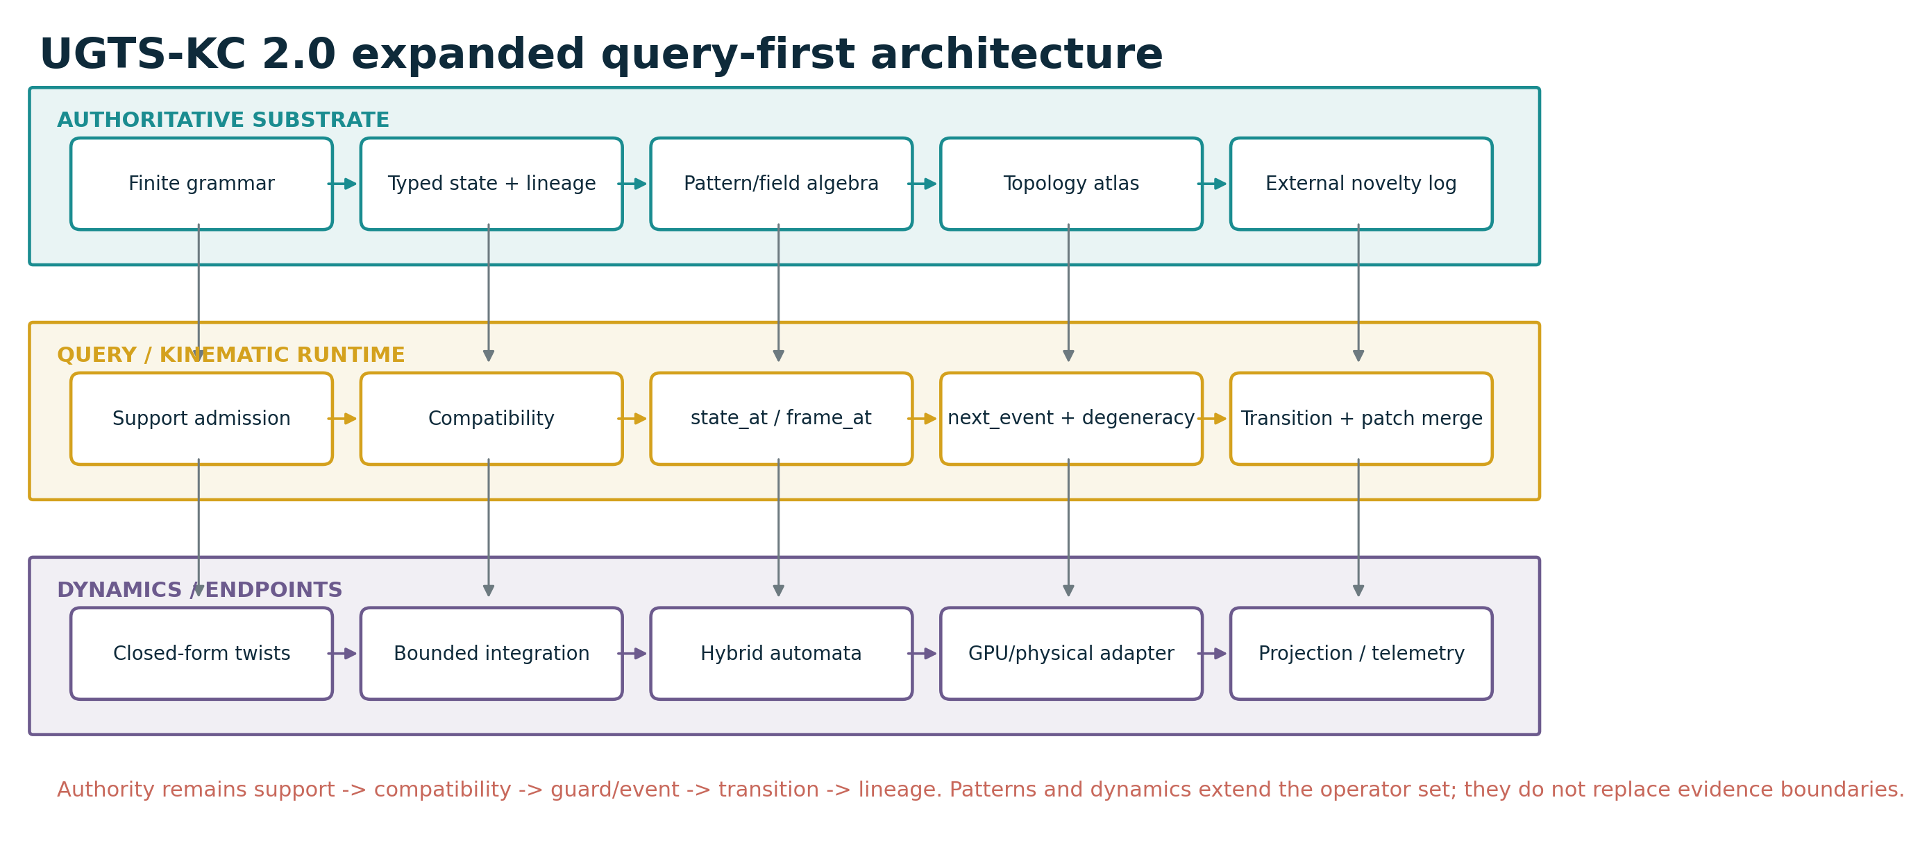
Figure 1. Expanded architecture: pattern and dynamic operators extend the canonical query-first substrate.
Prepared for | Tom Klootwijk
Requester-supplied identifier | NL200678942
Requester-supplied date of birth | 10 July 1990
Version | 2.0.0
Generated | 16 August 2026
Status | Engineering expansion with executable reference validation

ATTRIBUTION AND LEGAL BOUNDARY
The name, identifier and date of birth above were supplied by the requester and are not independently verified. This document is a technical design artifact, not legal proof of identity, authorship, ownership, patentability or priority.

Contents and reading rule
This upgrade is designed to be read as an extension of the supplied UGTS-0 and UGTS-GN 1.1 reports. It preserves their evidence boundary and query-first event architecture while adding a larger, executable pattern and kinematic calculus layer.
- 1. Executive upgrade decision
- 2. Extended substrate architecture
- 3. Parametric pattern calculus
- 4. Field and surface pattern calculus
- 5. Topology expansion
- 6. Kinematic calculus
- 7. Dynamics and hybrid event resolution
- 8. Integration, GPU mapping and memory
- 9. Reference implementation and validation
- 10. Boundaries and kill criteria
- 11. Final upgraded definition
- Appendix A. M198-M257 extended mechanism catalog
- Appendix B. API and exchange dictionary
- Appendix C. Source and package verification
READING RULE
The core is still not a renderer. Geometry supplies typed patterns, fields and local supports; topology supplies explicit gluing and route classes; kinematics supplies state_at(t), frames and feasible motion; dynamics supplies bounded flows; events remain compatibility-gated guard crossings with lineage.

Document control
Source basis | Pages | Filename | SHA-256 prefix | Treatment
UGTS-0 1.0 | 45 | Unified_Geometric_Topological_Substrate(1).pdf | c991aba24cc939ba... | Referenced by hash; not redistributed
UGTS-GN 1.1 | 28 | Unified_Geometric_Topological_Substrate_GPU_Native_Addendum(2).pdf | 3a6b6c57118ca4e2... | Referenced by hash; not redistributed

1. Executive upgrade decision

1.1 Baseline retained
The supplied reports converge on one stable architecture: a finite grammar generates typed state; local radial-angular support removes irrelevant candidates; compatibility determines whether states may couple; an explicit relation or guard defines an event surface; the earliest valid event applies route, topology and lineage updates; irreducible novelty is logged. UGTS-KC 2.0 keeps that pipeline unchanged.
The GPU-native addendum freezes a 197-mechanism normalized baseline. This extension does not rewrite those entries. It appends 60 engineering mechanisms, M198-M257, and labels them as additions rather than pretending they were all source-derived.
Item | Count/status | Meaning
Baseline catalog | 197 mechanisms | Existing source-derived and normalized operators
Engineering additions | 60 mechanisms | 20 pattern, 12 field/surface, 10 topology, 12 kinematic, 6 dynamics/event
Extended total | 257 mechanisms | Baseline plus this versioned extension
Reference tests | 47 passing | Standard-library Python implementation
Physical claims | None promoted | Hardware advantage still requires target measurement

1.2 What is new
- A versioned parametric pattern algebra for superellipses, superformula families, harmonic curves, trochoids, spirals, splines and constant-width profiles.
- A field/surface layer for superquadrics, swept tubes, ruled surfaces, helicoids, catenoids, gyroid/Schwarz periodic fields, compact blends, offsets and arrival-time fields.
- Topology descriptors for winding, covering lifts, homotopy signatures, braid words, cell incidence, discrete Morse critical cells and atlas cocycles.
- SE(2)/SE(3) twist calculus, quaternion and screw interpolation, Frenet/Bishop frames, arc-length maps, curvature limits, jerk-bounded schedules and articulated kinematics.
- Bounded dynamics for symplectic integration, damped modes, graph diffusion, reaction-diffusion, hybrid automata and explicit event degeneracy resolution.

1.3 Upgrade decision
DECISION
GO for a pattern-and-kinematics expansion, provided every new shape is a typed primitive or field, every motion has a parameter and error contract, every topology label has an explicit map or invariant, and every dynamic mode still commits through support, compatibility, guard and lineage.

1.4 Concrete deliverables
- This upgraded PDF and editable DOCX source.
- A machine-readable 60-mechanism catalog in CSV and JSON.
- A JSON Schema and example expanded substrate definition.
- A dependency-free Python reference package covering patterns, fields, topology, kinematics, dynamics and events.
- 47 passing executable tests with captured results.
- Original diagrams, source hashes, file hashes and a reproducible ZIP manifest.

2. Extended substrate architecture

Figure 2. The authoritative path remains query-first. Pattern, kinematic and dynamic operators are typed extensions, not a replacement for the core event calculus.

2.1 Extended state
The compact baseline state remains valid. Pattern-aware motion adds only the fields needed by a selected profile; unused dynamics do not have to occupy the hot record.
q = (position, time, phase, sheet, orientation,
generative_address, branch, policy, uncertainty,
linear_velocity, angular_velocity,
curvature, torsion, mode, dynamic_state)
Coordinates remain non-authoritative for identity. A repeated point on a rose curve, torus-like route or quotient chart can represent different times, sheets, windings, branches or lineage addresses.

2.2 Pattern instance contract
pattern = (mechanism_id, parameters, frame,
support_id, compatibility_tags,
validation_contract)
validation_contract = (domain, units, parameter bounds,
derivative availability,
solver family, error budget)
A pattern is therefore not merely a name such as "spiral". It is a versioned operator with declared scale, phase range, frame, derivatives and validation limits. The same curve may be used as geometry, a local support, a trajectory, a guard, a projection path or a calibration sweep, but the role is explicit.

2.3 Query set
Query | Contract
state_at(entity,t) | Evaluate closed-form or bounded integrated state.
frame_at(pattern,s or t) | Return Frenet/Bishop/body frame and status.
curvature_at(pattern,s) | Return curvature/torsion or a bounded numerical estimate.
next_event(entity,t0,t1) | Solve the earliest supported compatible guard event.
events_in_support(support,t0,t1) | Return events whose pattern or field support intersects the query.
route_class(path) | Return winding/homotopy/braid/cell descriptor.
reconstruct_identity(entity) | Rebuild lineage from seed, transitions and novelty log.

2.4 Verified-event rule
verified = in_support
and compatible
and guard_status in accepted_statuses
and confidence >= confidence_floor
and numeric_error <= event_margin
accepted_statuses may include crossing, touch or tangency,
but the policy must be declared before execution.
NON-NEGOTIABLE BOUNDARY
A curve self-intersection, a zero of a periodic field or a topological crossing is not automatically an interaction. Sheet, phase, route class, mode, policy and lineage still determine compatibility.

3. Parametric pattern calculus
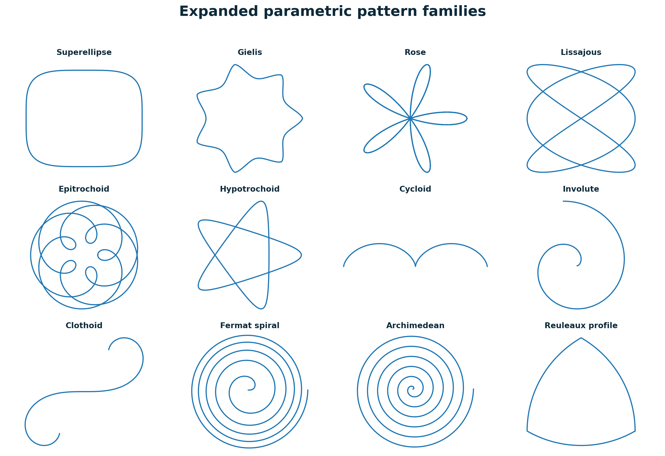
Figure 3. Representative M198-M217 pattern families. The gallery is generated from the bundled reference functions.

3.1 Family taxonomy
Family | Mechanisms | Substrate role
Exponent and radial families | Superellipse, Gielis superformula, rose | Compact template grammar; parameter singularities are bounded.
Harmonic and rolling families | Lissajous, epitrochoid, hypotrochoid, cycloid, trochoid | Useful for periodic route, cusp, contact and calibration tests.
Unwrapping and equilibrium | Involute, catenary, clothoid | Nonuniform curvature and mechanically interpretable shapes.
Spiral families | Fermat, Archimedean | Address/shell sweeps with explicit growth law.
Spline families | Rational quadratic, cubic Bezier, B-spline, NURBS | Local control, bounded degree and explicit knot/weight schemas.
Partition and skeleton families | Reuleaux profile, power cells, sampled medial axis | Constant clearance, routing cells and compressed shape descriptors.

3.2 Pattern grammar
The pattern grammar extends the finite grammar already present in UGTS. Each production emits a normalized primitive and optional derivatives rather than unrestricted symbolic text.
PatternExpr := Primitive(parameters)
| Transform(frame, PatternExpr)
| Restrict(domain, PatternExpr)
| Repeat(period, count, PatternExpr)
| Sweep(profile, centerline, frame_policy)
| FieldGuard(field, threshold, band)
Hard limits: max_depth, max_symbols, max_control_points,
max_period_cells, max_derivative_order.

3.3 Derivative and event semantics
For a parametric curve r(t), the first and second derivatives determine speed, tangent and curvature. Cusps occur when |r'(t)| approaches zero; self-intersections require both coordinate equality and distinct parameter or lineage labels. The event solver must not silently divide by zero or merge branches.
speed(t) = |r'(t)|
curvature(t) = |r'(t) x r''(t)| / |r'(t)|^3 (3D)
cusp status = speed(t) <= speed_floor
crossing = r(t1) ~= r(t2), t1 != t2, plus compatibility policy

3.4 Selected technical notes
- The Gielis superformula is admitted as a bounded radial grammar, not as a universal biological law.
- The clothoid is numerically integrated in the bundled code; its step count and position error belong to the validation contract.
- A generic Bezier or spline blend is not automatically arc-length parameterized and not automatically an exact signed-distance boundary.
- A Reuleaux profile has constant width under its ideal construction; discretized sampling introduces chord error that must be budgeted.
- Voronoi/power cells are routing partitions. They do not replace compatibility, uncertainty or lineage.

4. Field and surface pattern calculus
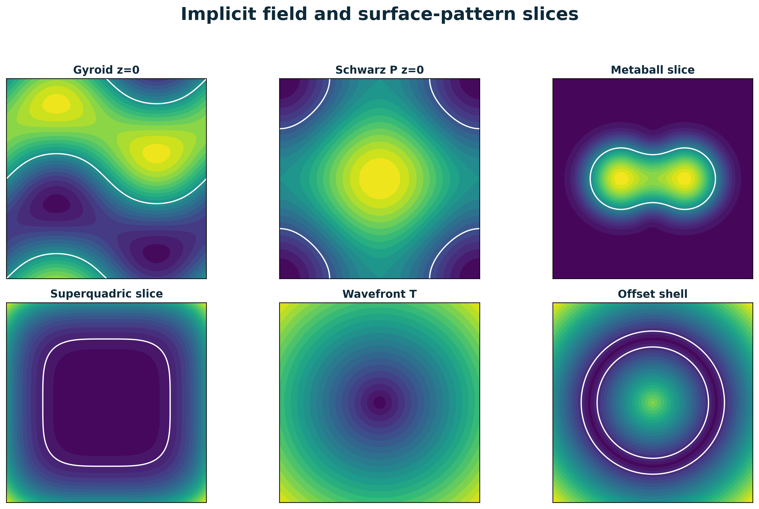
Figure 4. Representative implicit fields and zero contours. Zero is an event/transition candidate only under the declared guard policy.

4.1 Field rule
The baseline report distinguishes exact signed-distance functions from generic implicit fields. UGTS-KC 2.0 keeps that distinction. Superquadrics, periodic trigonometric fields and compact blends are generally implicit fields; they may be used for sign, guard and gradient queries without being mislabeled as exact Euclidean distance.
Field family | Use | Boundary
Superquadric / ellipsoid | Shape and directional metric support | Check positive scales, exponent range and conditioning.
Swept tube / cylinder | Distance to centerline or transported profile | Sample error and moving-frame choice are explicit.
Ruled surface / helicoid / catenoid | Sheet, portal or neck geometry | Mathematical surface properties do not imply physical self-assembly.
Gyroid / Schwarz-P | Periodic field template | Threshold, finite cell count and boundary conditions are required.
Metaball blend | Smooth merge/split benchmark | Kernel support and saturation prevent long-range hidden coupling.
Offset / arrival field | Tolerance band and event-time support | Exact offset requires distance-like input; variable speed requires a solver.

4.2 Sweeps and moving frames
A generalized cylinder transports a profile along a centerline. The frame policy is part of the schema because Frenet frames can become unstable near zero curvature, while Bishop frames trade torsion tracking for rotation-minimizing transport.
X(s,u,v) = c(s) + u e1(s) + v e2(s)
frame_policy = "frenet" when curvature > kappa_floor
| "bishop" for rotation-minimizing transport
| "body" for externally supplied orientation

4.3 Periodic-field topology
The topology of a gyroid-like or Schwarz-P field depends on threshold, domain and boundary identification. The package therefore stores the field formula, threshold, cell bounds and chart/gluing rules separately. A visual resemblance to a labyrinth does not establish a material or energy property.
PHYSICAL BOUNDARY
Minimal-surface names describe mathematical templates. A manufactured structure still requires material constitutive laws, loads, tolerances, losses and measured stability.

5. Topology expansion
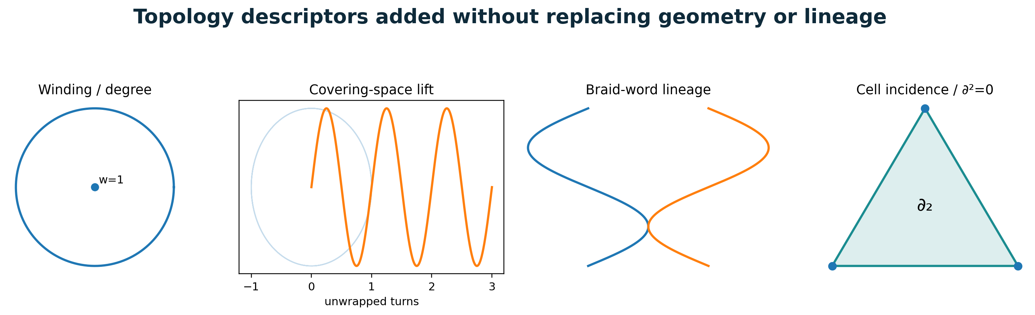
Figure 5. Winding, covering, braid and cell-complex descriptors enrich route identity while keeping geometry and lineage separate.

5.1 Winding, covering and homotopy
A periodic or self-crossing route cannot be identified by coordinates alone. The covering-space lift records traversal count, and the homotopy signature records winding around declared obstacles. These descriptors become compatibility tags and lineage fields, not replacements for the path.
theta_lift = theta_mod + 2*pi*winding
route_class = (winding_obstacle_1, ..., winding_obstacle_n)
same_position and different route_class -> distinct state sectors

5.2 Braid words and multi-entity lineage
Ordered crossings of multiple routes can be recorded by braid generators. The reference reducer only cancels adjacent inverse pairs; it does not claim a complete canonical braid normal form. Word length and generator count are bounded to prevent lineage explosion.

5.3 Cell complexes and incidence invariants
A cell complex stores topology independent of embedding. Oriented boundary maps must satisfy boundary-of-boundary zero. Any portal, split or merge edit that violates this invariant is rejected or logged as an unresolved topology event.
boundary_k : C_k -> C_(k-1)
boundary_(k-1) * boundary_k = 0
topology edit = incidence patch + lineage patch + validation result

5.4 Discrete Morse and persistence descriptors
Discrete Morse critical cells and persistent-homology barcodes are admitted only as bounded diagnostic descriptors. The ZIP defines their exchange form, but it does not bundle a certified persistent-homology solver. They cannot replace exact transition records or full geometry.

5.5 Atlas transition cocycle
Multi-chart portals must agree on overlaps. The cocycle check prevents a route from receiving inconsistent coordinates or orientation when composed through different chart sequences.
g_ij * g_jk = g_ik on every declared triple overlap

6. Kinematic calculus
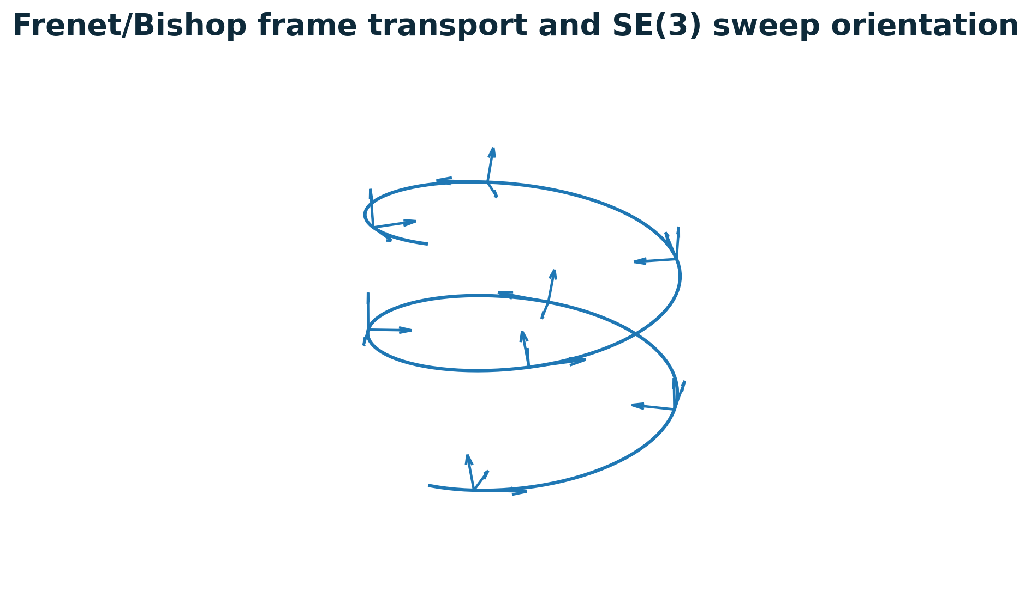
Figure 6. Moving frames transport profile orientation along a 3D curve. Frame status is part of the query result.

6.1 SE(2) and SE(3) state-at-time
Rigid motion is represented on SE(2) or SE(3), not by adding unrelated position and angle values. Constant body twists have closed-form exponentials, supporting horizon-skipping state_at(t) for a restricted motion family.
planar: T(t) = exp(t * twist(vx, vy, omega))
spatial: T(t) = exp(t * twist(omega_vector, v_vector))
state_at(t) cost follows fixed expression size,
not the number of omitted display frames.

6.2 Orientation interpolation
Quaternion SLERP handles unit orientation with shortest-arc and antipodal policies. Screw interpolation uses the relative SE(3) logarithm/exponential so translation and rotation evolve as one rigid transform. Neither operation changes sheet, branch or lineage unless an explicit transition says so.

6.3 Frenet and Bishop frames
Frame | Strength | Boundary
Frenet-Serret | Uses first/second derivatives; exposes curvature and binormal. | Fails or becomes unstable when speed/curvature is near zero.
Bishop / parallel transport | Rotation-minimizing frame across sampled points. | Requires initial normal and numerical transport tolerance.
Body/external frame | Orientation supplied by state or actuator. | Must be normalized and compatible with the sweep frame.

6.4 Arc length and feasible steering
Arc-length tables provide monotone lookup for uniform-speed travel. Curvature limits convert path shape into a speed and angular-rate constraint before event solving.
omega = v * kappa
v <= sqrt(a_lateral_max / max(|kappa|, epsilon))

6.5 Jerk-bounded timing
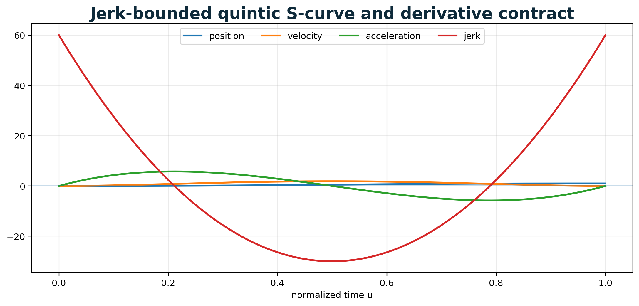
Figure 7. Quintic S-curve. Position, velocity and acceleration are continuous; peak derivatives define the minimum duration contract.
The bundled time law uses s(u)=10u^3-15u^4+6u^5. It is smooth and jerk-bounded over a finite duration, but it is not advertised as globally time-optimal for every path. The duration is enlarged until velocity, acceleration and jerk limits all hold.

6.6 Articulated chains
Forward kinematics composes joint transforms. The optional inverse solver uses damped least squares and reports residual and iteration budget. Singular or unreachable targets return a bounded failure state rather than an invented solution.

7. Dynamics and hybrid event resolution

7.1 Bounded dynamic operators
Operator | Role | Boundary
Symplectic Euler | Fallback state integration with explicit dt. | Qualitative energy behavior improves, but numerical error remains.
Damped second-order mode | Mass-spring-damper actuator/hinge/reset. | Mass, stiffness, damping, forcing and energy boundary are typed.
Graph diffusion | Local exchange over explicit adjacency. | Stability depends on alpha, dt and graph degree.
Reaction-diffusion | Gray-Scott two-field pattern update. | Grid, boundary condition, coefficients and time step are explicit.
Hybrid automaton | Continuous mode flows plus guard/reset transitions. | Mode, guard, reset, priority and lineage are versioned.

7.2 Hybrid calculus
The source threshold/cup and parity-hinge patterns become special cases of a hybrid automaton. A mode carries continuous dynamics; a guard triggers an event; a reset updates state, route and lineage. This unifies static geometry events with dynamic thresholds without confusing the field with the transition.
x' = f_mode(x)
if support and compatibility and g_mode,target(x) crosses 0:
x_plus = reset_mode,target(x_minus)
append(event, route, lineage, confidence)
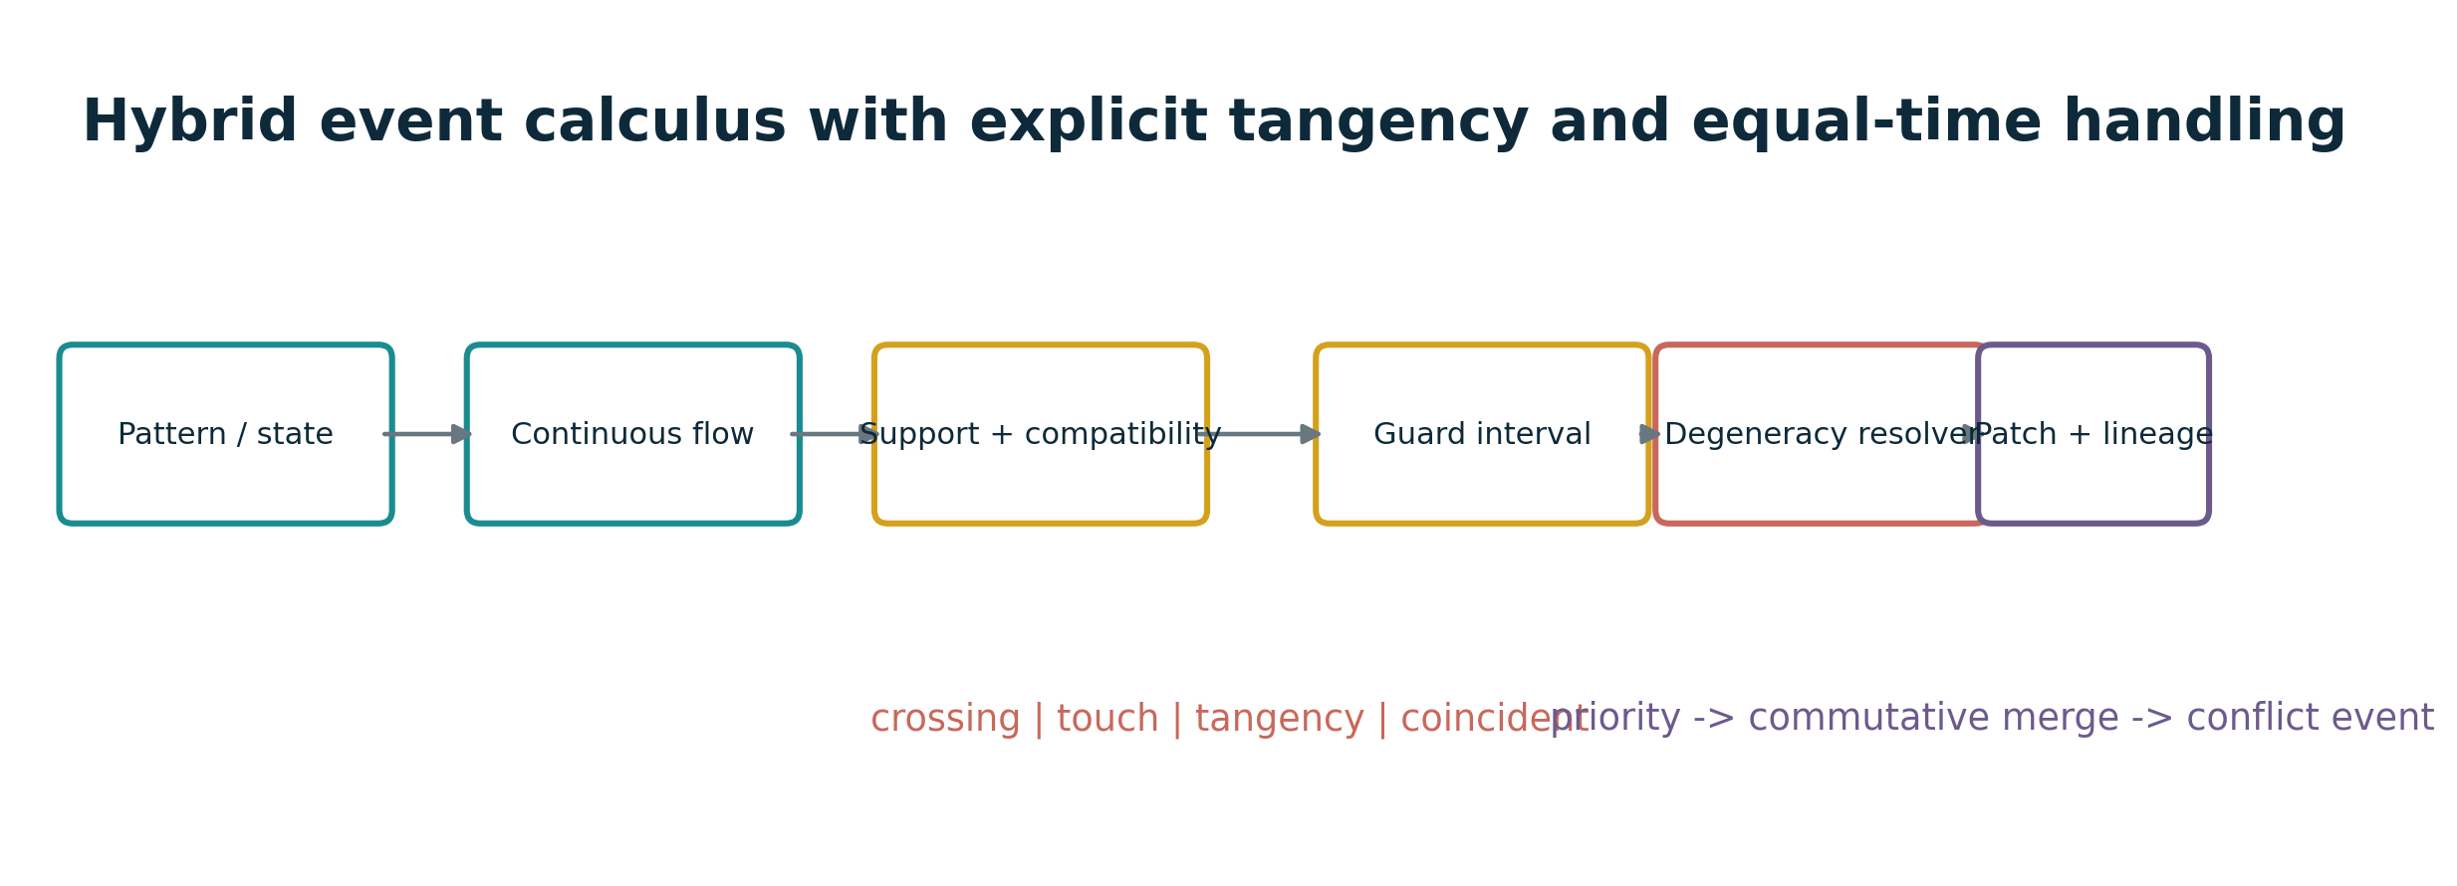
Figure 8. Equal-time and tangency handling are explicit stages before an authoritative patch is committed.

7.3 Event degeneracy classes
Status | Meaning | Resolution
crossing | Guard changes sign. | Commit when support, compatibility and confidence hold.
touch | Guard reaches band but derivative indicates no certified crossing. | Policy may log or reject.
tangency | Guard is near zero and first derivative is near zero. | Use higher-order or interval status; avoid false toggle.
coincident | Guard stays within tolerance over an interval. | Require separate constraint mode; do not emit infinite events.
simultaneous | Two certified event-time intervals overlap. | Apply priority, commutative merge, or conflict event.
CHATTER AND ZENO BOUNDARY
Hysteresis, minimum hold time and event coalescing are mandatory where repeated guard crossings could accumulate. The substrate must report event density and stop when ordering or storage becomes unbounded.

8. Integration, GPU mapping and memory

8.1 Canonical integration path
pattern parameters
-> local support pruning
-> topology / mode / policy compatibility
-> kinematic state and frame query
-> guard value + derivative + error interval
-> degeneracy resolver
-> verified event
-> route / topology / dynamic reset
-> lineage + novelty log

8.2 GPU-native mapping
The existing G64/E32 and G32/E16 profiles can be extended with pattern opcode and parameter-buffer references rather than inflating every hot record. A production GPU path would group candidates by opcode, evaluate derivatives in coherent kernels and compact only verified events.
GPU field/path | Purpose | Boundary
Pattern opcode | u16/u32 enum selecting a versioned primitive. | Unknown opcodes reject with reason code.
Parameter reference | Offset into aligned parameter buffer. | Bounds and schema hash checked before dispatch.
Derivative flags | Availability of r, r', r'', gradient or Hessian. | Missing derivatives force a declared numerical path.
Frame/status output | Tangent/frame, curvature, residual, degeneracy. | Packed only if error remains below event margin.
Compact event append | Verified events only. | Contention and compaction cost must be benchmarked.
PERFORMANCE BOUNDARY
This extension does not claim new Vulkan, FPGA, ASIC or photonic throughput. The Python tests establish functional consistency only. Any GPU or physical performance statement requires target-specific compilation, error comparison and measurement.

8.3 Memory and reconstructibility
Closed pattern parameters and analytic twists may be reconstructed from seed and grammar; integrated dynamics, external inputs, mode changes, solver ambiguities and calibration changes require authoritative event or checkpoint records. Novelty-only retention remains valid only when reconstruction is demonstrated.
- Store pattern parameters once and reference them from instances.
- Store sampled arc-length tables or sweep frames only when their recomputation cost or determinism requires it.
- Log every topology edit, mode reset, external force/calibration change and conflict resolution.
- Treat compact winding, braid or lineage hashes as checksums, not complete identity.
- Measure event/branch density before claiming memory advantage.

8.4 Physical-device boundary
A physical endpoint may implement selected patterns as trajectories, masks, waveguide layouts or actuation schedules. Geometry/topology labels remain routing abstractions unless the relevant Maxwell, fluid, solid, thermal and control equations are solved or calibrated. Full-system energy, drift, latency and false/missed-event rates remain required metrics.

9. Reference implementation and validation

9.1 Package layout
Path | Purpose
report/ | PDF and editable DOCX source.
spec/ | Catalog CSV/JSON, schema, state/event notes and source hashes.
src/ugts_kc/ | Dependency-free reference implementation.
tests/ | 47 unit tests covering geometry, topology, kinematics, dynamics and events.
examples/ | Expanded JSON definition and runnable demos.
diagrams/ | Original report figures generated from the code.
validation/ | Captured test results, counts and SHA-256 manifest.
docs/ | Changelog, evidence boundary and attribution notice.

9.2 Implemented modules
Module | Responsibility
patterns.py | M198-M217 parametric curves, splines, partition and skeleton helpers.
fields.py | M218-M229 implicit fields, sweeps and arrival functions.
topology.py | Winding, covering, homotopy, braid, cell complex and cocycle checks.
kinematics.py | SE(2)/SE(3), SLERP, screw interpolation, frames, timing and chain kinematics.
dynamics.py | Symplectic, damped, graph, reaction-diffusion and hybrid automaton operators.
events.py | Root bracketing, degeneracy classification and equal-time patch resolution.

9.3 Test result
VALIDATION RESULT
47 tests ran under Python 3.13.5; status: PASS. The captured console output is stored in validation/test_results.txt.
The tests cover endpoint identities, periodicity, field signs, spline/NURBS behavior, winding and boundary invariants, SE(2)/SE(3) transforms, moving frames, S-curve limits, forward/inverse kinematics, integration, diffusion, reaction-diffusion, hybrid transitions, root solving and patch conflicts. They establish internal consistency of the bundled implementation, not external performance or complete numerical certification.

9.4 Reproduction
python -m unittest discover -s tests -v
PYTHONPATH=src python examples/kinematic_event_demo.py
# Optional: inspect the machine-readable definition
python -m json.tool examples/expanded_substrate_definition.json

9.5 Validation interpretation
Validation layer | What is established | Status
Functional | Bundled functions satisfy the included unit properties. | PASS
Catalog traceability | M198-M257 count and IDs are machine checked. | PASS
Schema | Example JSON validates structurally against the supplied contract by inspection; no external validator is required by the runtime. | SUPPLIED
Numerical certification | Most functions use ordinary floating point and bounded sampling. | APPLICATION-SPECIFIC
GPU/physical performance | No target benchmark was added in this extension. | NOT CLAIMED
Legal authorship/identity | Requester attribution is recorded but not independently verified. | NOT ESTABLISHED

10. Boundaries and kill criteria

10.1 Numerical kill criteria
- Pattern parameter singularities, spline denominators or frame normalization fall below declared numerical floors.
- Sampled clothoid, tube, arc-length or medial-axis error exceeds the guard/event margin.
- Curvature or torsion becomes ill-conditioned and no fallback frame/status is accepted.
- Equal-time event intervals cannot be ordered or merged without conflicting authoritative patches.
- Time step, graph degree or reaction-diffusion coefficients violate the selected stability budget.

10.2 Topology and lineage kill criteria
- A topology edit violates boundary-of-boundary zero, chart cocycle consistency or declared orientation maps.
- Winding, braid, homotopy or persistent descriptors grow faster than the avoided materialization.
- Split/merge ancestry cannot be reconstructed or compact checksums collide within the application budget.
- Coordinates are used as identity after self-intersection, quotient wrapping or route re-entry.

10.3 Performance kill criteria
- Pattern opcode divergence, derivative evaluation, root solving or event compaction dominates throughput.
- Compatibility pruning is too weak to offset the cost of the richer pattern set.
- Integrated dynamics or dense reaction-diffusion state removes the expected memory advantage.
- A conventional geometry/physics/indexing implementation is cheaper, faster or more accurate at equal error.

10.4 Physical and claim boundary
CLAIMS NOT PROMOTED
No zero memory, zero heat, zero latency, universal O(1), topology-powered energy, physical Klein self-assembly, exact arbitrary-field solver or one-bit-complete-state claim is introduced. Geometry/topology vocabulary remains subordinate to typed state, measured physics and falsifiable error budgets.

11. Final upgraded definition
UGTS-KC 2.0 defines the substrate as a finite, queryable algebra over typed geometry, topology, kinematics and bounded dynamics. Patterns are parameterized objects with frames and derivative contracts. Topology is represented by explicit gluing maps, route descriptors and incidence invariants. Kinematics evaluates state and moving frames without requiring a frame loop for supported closed expressions. Dynamics is admitted through measured or numerically bounded flows. Events remain the sole authority for discrete change.
UGTS-KC 2.0 = (G, P, F, K, D, R, S, C, T, I, L)
G : finite grammar
P : parametric pattern family
F : implicit field / surface family
K : kinematic calculus and frame operators
D : bounded continuous or hybrid dynamics
R : relation and guard family
S : local support predicates
C : compatibility predicates
T : transition and patch family
I : invariants / topology descriptors
L : lineage and external novelty log
The canonical shorthand is therefore expanded, but not replaced:
CANONICAL SHORTHAND
pattern/field + kinematic state -> local support -> compatibility -> guard classification -> verified event -> route/topology/dynamic reset -> lineage + novelty log
The upgrade is technically coherent to the extent demonstrated by the bundled schema, implementation and tests. Performance, physical advantage and application-specific numerical certification remain future measurements.

Appendix A. M198-M257 extended mechanism catalog
These 60 rows are engineering additions. They extend, but do not rewrite, the 197-mechanism baseline. Validation labels refer only to the files shipped in this package.
ID | Domain | Mechanism | Definition and formula | Substrate integration | Validation
M198 | Pattern geometry | Superellipse (Lame curve) | Parametric constant-exponent family |x/a|^n + |y/b|^n = 1 with explicit sign restoration. Formula: x=a*sgn(cos t)|cos t|^(2/n); y=b*sgn(sin t)|sin t|^(2/n) | Pattern primitive; may define support, route boundary or swept profile. | Implemented + tested
M199 | Pattern geometry | Gielis superformula | Bounded radial pattern grammar that generalizes circles, polygons, stars and lobed forms. Formula: r=(|cos(m t/4)/a|^n2 + |sin(m t/4)/b|^n3)^(-1/n1) | Versioned parameter tuple; denominator floor prevents singular numerical blow-up. | Implemented + tested
M200 | Pattern geometry | Rose curve | Polar harmonic petal pattern with integer or rational angular frequency. Formula: r=a cos(k t) | Periodic support/template; winding and event surfaces remain separately typed. | Implemented + tested
M201 | Pattern geometry | Lissajous curve | Two-axis harmonic pattern with declared frequencies and phase offset. Formula: x=A sin(a t+delta); y=B sin(b t) | Kinematic test path, phase compatibility probe or calibration trajectory. | Implemented + tested
M202 | Pattern geometry | Epitrochoid | Point attached to a circle rolling outside another circle. Formula: x=(R+r)cos t-d cos((R+r)t/r); y=(R+r)sin t-d sin((R+r)t/r) | Closed periodic route when radius ratio is rational; otherwise bounded quasi-periodic sample. | Implemented + tested
M203 | Pattern geometry | Hypotrochoid | Point attached to a circle rolling inside another circle. Formula: x=(R-r)cos t+d cos((R-r)t/r); y=(R-r)sin t-d sin((R-r)t/r) | Pattern route with cusp/self-intersection events classified by derivative and sheet. | Implemented + tested
M204 | Pattern geometry | Cycloid | Trace of a point on a circle rolling along a line. Formula: x=r(t-sin t); y=r(1-cos t) | Exact benchmark trajectory for cusp and contact events. | Implemented + tested
M205 | Pattern geometry | General trochoid | Rolling-circle trace with point offset d distinct from radius r. Formula: x=r t-d sin t; y=r-d cos t | Prolate/curtate transition controlled by d/r and classified at d=r. | Implemented + tested
M206 | Pattern geometry | Circle involute | Taut-string unwrapping curve with monotonic arc parameter. Formula: x=r(cos t+t sin t); y=r(sin t-t cos t) | Gear/contact profile and nonuniform curvature benchmark. | Implemented + tested
M207 | Pattern geometry | Catenary | Static hanging-chain profile retained as a bounded mechanical shape, not a generic parabola. Formula: y=a cosh((x-x0)/a)+y0 | Constraint shape or potential-energy equilibrium reference. | Implemented + tested
M208 | Pattern geometry | Clothoid / Euler spiral | Curve whose curvature changes linearly with arc length. Formula: kappa(s)=s/A^2; x=integral cos(u^2/2A^2)du; y=integral sin(u^2/2A^2)du | Curvature-continuous route connector and steering transition. | Implemented numerically + tested
M209 | Pattern geometry | Fermat spiral | Square-root radial spiral with explicit branch sign. Formula: r=a sqrt(|t|), branch selects sign/phase | Two-arm address pattern and bounded sample schedule. | Implemented + tested
M210 | Pattern geometry | Archimedean spiral | Linear radial growth under angular phase. Formula: r=a+b t | Uniform shell-crossing benchmark and address sweep. | Implemented + tested
M211 | Pattern geometry | Rational quadratic Bezier conic | Three control points with middle weight representing exact conic arcs under valid weights. Formula: B(t)=[(1-t)^2P0+2w t(1-t)P1+t^2P2]/[(1-t)^2+2w t(1-t)+t^2] | Conic-support primitive with denominator guard and schema-bound weight. | Implemented + tested
M212 | Pattern geometry | Cubic Bezier segment | Four-point polynomial curve with endpoint tangent control. Formula: B(t)=(1-t)^3P0+3(1-t)^2tP1+3(1-t)t^2P2+t^3P3 | Glyph morph, route segment and local sweep centerline. | Implemented + tested
M213 | Pattern geometry | Open-uniform B-spline | Piecewise polynomial curve with local control and declared degree/knot vector. Formula: C(t)=sum_i N_i,p(t) P_i | Finite grammar output normalized to bounded control points and degree. | Implemented + tested
M214 | Pattern geometry | NURBS curve | Rational B-spline with explicit positive weights and knot vector. Formula: C(t)=sum_i N_i,p w_i P_i / sum_i N_i,p w_i | Exact/approximate CAD-style route with denominator and weight validation. | Implemented + tested
M215 | Pattern geometry | Reuleaux constant-width profile | Three circular arcs producing a convex constant-width curve. Formula: Boundary assembled from radius-w arcs centered at equilateral-triangle vertices. | Constant-clearance support profile and rotation benchmark. | Implemented sampler + tested
M216 | Pattern geometry | Voronoi / power-cell selector | Nearest-site partition generalized by additive site weights. Formula: argmin_i ||x-s_i||^2-w_i | Compatibility/routing partition compiled to local candidate tests. | Implemented + tested
M217 | Pattern geometry | Medial-axis skeletal approximation | Centerline candidates derived from equal-distance pairs or sampled boundary normals. Formula: d(x,A)=d(x,B) with local maximality condition | Compressed shape skeleton; approximation status and sampling density are logged. | Implemented sampled helper + tested
M218 | Field/surface geometry | Superquadric implicit field | Exponent-controlled 3D generalization of ellipsoids and box-like rounded solids. Formula: ((|x/a|^(2/e2)+|y/b|^(2/e2))^(e2/e1)+|z/c|^(2/e1))-1 | Implicit event/support field; not automatically an exact Euclidean SDF. | Implemented + tested
M219 | Field/surface geometry | Anisotropic ellipsoid field | Quadratic form with positive scales or covariance-like metric. Formula: f(x)=x^T A x-1, A positive definite | Directional guard/support with explicit metric and conditioning checks. | Implemented + tested
M220 | Field/surface geometry | Swept tube field | Distance-to-centerline field minus radius using a sampled or analytic curve. Formula: f(x)=min_s ||x-c(s)||-r(s) | Cable, vessel, wormhole-route visualization or collision support; sampled error is declared. | Implemented sampled + tested
M221 | Field/surface geometry | Generalized cylinder / profile sweep | Cross-section transported along a centerline with an explicit moving frame. Formula: X(s,u,v)=c(s)+u e1(s)+v e2(s) | Pattern extrusion using Frenet or Bishop frame; frame choice is schema-bound. | Implemented helper + example
M222 | Field/surface geometry | Ruled surface | Surface formed by linearly connecting corresponding points on two curves. Formula: X(u,v)=(1-v)c0(u)+v c1(u) | Portal sheet, transition membrane or developable approximation. | Implemented + tested
M223 | Field/surface geometry | Helicoid | Ruled minimal-surface family generated by screw motion. Formula: X(u,v)=(v cos u,v sin u,p u) | Screw-symmetry route/sheet example; physical minimality is not assumed in discrete realization. | Implemented + tested
M224 | Field/surface geometry | Catenoid | Surface of revolution of a catenary. Formula: X(u,v)=(a cosh(v/a)cos u,a cosh(v/a)sin u,v) | Neck/pinch geometry with finite guard and no singular-energy claim. | Implemented + tested
M225 | Field/surface geometry | Gyroid periodic field | Triply periodic implicit pattern used as a bounded field template. Formula: sin x cos y + sin y cos z + sin z cos x = c | Periodic support/route field; topology depends on threshold and finite domain. | Implemented + tested
M226 | Field/surface geometry | Schwarz-P periodic field | Triply periodic cosine field serving as a connected-sheet template. Formula: cos x+cos y+cos z=c | Field grammar primitive with threshold and cell count explicitly bounded. | Implemented + tested
M227 | Field/surface geometry | Metaball / R-function blend | Smooth influence-field combination with explicit compact or inverse-distance kernel. Formula: f(x)=sum_i w_i phi(||x-c_i||)-tau | Merge/split event benchmark; kernel support and saturation are declared. | Implemented compact kernel + tested
M228 | Field/surface geometry | Morphological offset / dilation | Parallel-set transform expressed as a field offset when the input is distance-like. Formula: f_delta(x)=f(x)-delta | Guard expansion, tolerance shell and manufacturing clearance; exact only for valid distance fields. | Implemented + tested
M229 | Field/surface geometry | Wavefront / eikonal arrival field | Arrival-time field under a declared local propagation speed. Formula: |grad T|=1/c(x); constant-c case T=distance/c | Event-time support primitive; variable-speed solver is specified separately. | Implemented constant-speed + tested
M230 | Topology | Winding number / degree tag | Integer-valued enclosure/orientation descriptor for closed planar routes. Formula: w=(1/2pi) integral d arg(gamma(t)-x) | Inside/outside and route class metadata without collapsing geometry to a bit. | Implemented polygonal + tested
M231 | Topology | Covering-space lift | Unwrapped coordinate retains traversal count across periodic quotient boundaries. Formula: theta_lift=theta+2pi k | Prevents ambiguity at repeated coordinates and supports lineage reconstruction. | Implemented + tested
M232 | Topology | Homotopy-class route label | Route label stores obstacle winding/signature rather than only endpoint coordinates. Formula: h=(w1,...,wn) for declared obstacle generators | Compatibility and branch selection may require matching or allowed classes. | Implemented descriptor + tested
M233 | Topology | Braid-word transition | Ordered crossings represented by generators sigma_i and inverses with local cancellation. Formula: ... sigma_i sigma_i^-1 ... -> identity | Multi-entity route lineage; word length is bounded and reduction policy explicit. | Implemented reducer + tested
M234 | Topology | Knot/link checksum | Optional low-cost invariant or numerical linking estimate for closed route pairs. Formula: Gauss linking integral or declared discrete approximation | Diagnostic checksum only; not complete knot identity and not used as sole authority. | Specified; numerical certification pending
M235 | Topology | Cell-complex incidence | Vertices, edges, faces and cells connected through oriented incidence maps. Formula: boundary_k: C_k -> C_(k-1) | Topology storage independent of embedding; supports local gluing and route updates. | Implemented boundary matrices + tested
M236 | Topology | Boundary/coboundary update | Topology transition updates primal incidence and dual cochain state consistently. Formula: boundary_(k-1) boundary_k = 0 | Validation rejects edits violating boundary-of-boundary zero. | Implemented invariant check + tested
M237 | Topology | Discrete Morse critical event | Cell pairing identifies local critical cells where topology/routing may change. Formula: Unpaired cells are critical under a declared matching. | Event candidate for simplification or handle birth/death; matching is explicit. | Implemented descriptor + example
M238 | Topology | Persistent-homology summary | Birth/death intervals summarize bounded filtration changes. Formula: barcode={(birth_i,death_i,dimension_i)} | Diagnostic feature vector; does not replace full geometry or lineage. | Specified exchange format; solver not bundled
M239 | Topology | Atlas transition cocycle | Overlapping chart maps are checked for consistent composition. Formula: g_ij g_jk = g_ik on triple overlaps | Prevents incompatible portal/gluing definitions in multi-chart worlds. | Implemented matrix check + tested
M240 | Kinematic calculus | SE(2) rigid transform and twist | Planar position/orientation update represented by the exponential of a body twist. Formula: T(t)=exp(t [v_x,v_y,omega]^) | Exact constant-twist state_at(t) and portal patch primitive. | Implemented + tested
M241 | Kinematic calculus | SE(3) twist exponential | Spatial rigid motion generated by angular and linear velocity. Formula: T=exp([omega,v]^ t) with Rodrigues rotation and V matrix | Constant screw motion, frame transport and analytic state query. | Implemented + tested
M242 | Kinematic calculus | Quaternion SLERP | Shortest-arc interpolation of unit orientations with antipodal handling. Formula: q(t)=sin((1-t)theta)/sin theta q0 + sin(t theta)/sin theta q1 | Orientation interpolation separate from position and topology. | Implemented + tested
M243 | Kinematic calculus | Screw interpolation (SE(3) geodesic) | Interpolate through the relative rigid transform log/exponential rather than independent Euler angles. Formula: T(t)=T0 exp(t log(T0^-1 T1)) | Portal/coupler motion with consistent rotation-translation coupling. | Implemented + tested
M244 | Kinematic calculus | Frenet-Serret moving frame | Tangent, normal and binormal derived from nondegenerate curve derivatives. Formula: T=r'/|r'|; B=(r' x r'')/|r' x r''|; N=B x T | Curvature/torsion diagnostics and sweep orientation where curvature is nonzero. | Implemented + tested
M245 | Kinematic calculus | Bishop parallel-transport frame | Rotation-minimizing frame transported along a sampled curve. Formula: Project previous normal into new tangent plane, then renormalize. | Stable sweep frame through near-zero-curvature segments. | Implemented + tested
M246 | Kinematic calculus | Arc-length reparameterization | Monotone lookup maps path parameter to cumulative distance and back. Formula: s(t)=integral_0^t |r'(u)|du | Uniform-speed queries and event bracketing with declared interpolation error. | Implemented sampled + tested
M247 | Kinematic calculus | Curvature-limited steering | Speed and angular rate constrained by path curvature and lateral acceleration. Formula: omega=v kappa; v<=sqrt(a_lat_max/max(|kappa|,eps)) | Feasible trajectory gate before event solving. | Implemented + tested
M248 | Kinematic calculus | Jerk-bounded quintic S-curve | Endpoint-rest time law with continuous position, velocity and acceleration. Formula: s(u)=10u^3-15u^4+6u^5, u in [0,1] | Smooth phase/route actuation; peak derivatives determine duration contract. | Implemented + tested
M249 | Kinematic calculus | Limit-aware time scaling | Choose trajectory duration so normalized velocity, acceleration and jerk stay within declared limits. Formula: T=max(D*v_peak/vmax, sqrt(D*a_peak/amax), cbrt(D*j_peak/jmax)) | Bounded schedule; not claimed globally time-optimal for arbitrary paths. | Implemented + tested
M250 | Kinematic calculus | Articulated-chain forward kinematics | Compose joint transforms to obtain link and endpoint frames. Formula: T_end=product_i T_i(q_i) | Finite grammar may emit link chains; state query returns all frames and lineage. | Implemented planar chain + tested
M251 | Kinematic calculus | Jacobian damped least-squares IK | Regularized local inverse step avoids singular matrix blow-up. Formula: Delta q=J^T(JJ^T+lambda^2 I)^-1 e | Optional solver with residual, iteration budget and failure status. | Implemented planar chain + tested
M252 | Dynamics and events | Symplectic / semi-implicit integration | Velocity is updated before position for improved qualitative energy behavior in separable mechanics. Formula: v_(n+1)=v_n+a(x_n)dt; x_(n+1)=x_n+v_(n+1)dt | Fallback dynamic state update; timestep and error budget remain explicit. | Implemented + tested
M253 | Dynamics and events | Damped second-order mode | Mass-spring-damper evolution with typed mass, stiffness and damping. Formula: m x''+c x'+k x=f(t) | Actuator, hinge or threshold reset dynamics; energy bookkeeping is measurable. | Implemented + tested
M254 | Dynamics and events | Graph-Laplacian diffusion / coupled modes | Local state exchange over an explicit adjacency graph. Formula: x'=-alpha L x or x''+C x'+Kx=0 | Phase smoothing, consensus or coupled oscillation without hidden global field. | Implemented first-order diffusion + tested
M255 | Dynamics and events | Reaction-diffusion pattern dynamics | Two-field local reaction plus diffusion update on a bounded grid or graph. Formula: Gray-Scott: U_t=D_u Lap U-UV^2+F(1-U); V_t=D_v Lap V+UV^2-(F+k)V | Dynamic pattern generator kept downstream of typed field/state schema. | Implemented grid step + tested
M256 | Dynamics and events | Hybrid automaton continuous/discrete dynamics | Each mode has a continuous flow; guard crossings invoke discrete reset and route changes. Formula: x'=f_m(x); if g_(m,n)(x)=0 then x^+=R_(m,n)(x) | Generalizes threshold cup, parity hinge and event transition into a typed model. | Implemented reference class + tested
M257 | Dynamics and events | Event degeneracy and simultaneity resolver | Classify crossing, tangency and coincidence; resolve equal-time patches by priority or verified commutativity. Formula: Use sign history, derivative, residual interval and patch-conflict graph. | Prevents chatter, unordered lineage and silent overwrite at multi-guard events. | Implemented classifier/resolver + tested

Appendix B. API and exchange dictionary

B.1 Pattern and field functions
Function | Returns | Contract
superellipse(theta,a,b,n) | 2D point | Positive a,b,n.
gielis(theta,m,n1,n2,n3,a,b) | 2D point | Denominator floor; bounded parameters.
clothoid(s,A,steps) | 2D point | Numerical quadrature; steps in validation contract.
bspline / nurbs(control,...) | N-D point | Degree, knots and weights validated.
superquadric_field(p,scales,e1,e2) | scalar | Implicit field, not exact SDF by default.
gyroid_field / schwarz_p_field | scalar | Threshold and finite domain required.
tube_field(p,samples,radius) | scalar | Sampled centerline error declared.

B.2 Topology and kinematics
Function | Returns | Contract
winding_number(route,point) | real near integer | Closed polygonal route; sign carries orientation.
homotopy_signature(route,obstacles) | integer tuple | Obstacle generators are declared by schema.
CellComplex.boundary_squared_zero() | bool | Checks incidence invariant only.
se2_exp / se3_exp | homogeneous transform | Constant body twist.
se3_interpolate(T0,T1,t) | homogeneous transform | Relative log/exponential interpolation.
frenet_frame(r1,r2) | T,N,B,kappa | Requires nonzero velocity and curvature.
bishop_frames(points,normal) | frame list | Sampled rotation-minimizing transport.
quintic_scurve(u,D,T) | position,velocity,accel,jerk | u clamped to [0,1].
dls_ik(lengths,q0,target) | angles,end point | Bounded iterations and residual.

B.3 Dynamics and event resolution
Function | Returns | Contract
symplectic_euler | state step | dt and acceleration callback explicit.
graph_diffusion_step | state tuple | Edges and weights explicit; stability is caller contract.
gray_scott_step | two grids | Periodic boundary in reference implementation.
HybridAutomaton.step | state + mode | Transition priority and reset functions explicit.
bisect_root | root estimate | Requires sign bracket.
classify_event | status string | Uses before/at/after values and optional derivative.
resolve_patches | merged patch + conflicts | Priority first; differing values produce conflict record.

B.4 Exchange schema notes
- Schema version is 2.0.0.
- Attribution fields are included with verification_status=requester-supplied-not-independently-verified.
- Pattern instances reference mechanism IDs M198-M257 and carry parameter and validation objects.
- Dynamics instances declare closed_form, twist, s_curve, integrated or hybrid mode.
- Projection settings remain non-authoritative downstream metadata.

Appendix C. Source and package verification

C.1 Source basis
Document | Pages | SHA-256 | Included in ZIP
UGTS-0 1.0 | 45 | c991aba24cc939ba680697b62b9e19545131cf34060793490bf149c6e2ab522e | false
UGTS-GN 1.1 | 28 | 3a6b6c57118ca4e2d7d7e577508c3477a095d133791f3708cb56a054285225d2 | false
The source PDFs are not redistributed in the package. Their hashes allow the requester to verify which supplied versions were used.

C.2 Package verification
- M198-M257 were counted at 60 and the extended total at 257.
- 47 unit tests passed; captured output is included.
- All diagrams in the report were generated from the bundled functions or schematic drawing code.
- A SHA-256 manifest covers the delivered package files.
- The PDF was rendered from the editable DOCX and visually inspected before ZIP creation.

C.3 Closing statement
The original corpus becomes stronger when patterns are admitted through types and bounds rather than metaphor. Geometry defines curves, fields and supports. Topology defines explicit route classes, gluing and incidence. Kinematics defines frames and state-at-time. Dynamics defines measurable flows and resets. The event calculus remains the authority that turns those structures into verified state change.

