UNIFIED GEOMETRIC-TOPOLOGICAL SUBSTRATE
UGTS-KC 3.0

Jet Kinematics, Constraint and Contact Calculus,
Certified Hybrid Events, Persistent Topology, Multiscale Patterns,
Geometric Dynamics and Reproducible Runtime Contracts
Prepared for Tom Klootwijk | Release date: 16 August 2026
360  atomic mechanisms | 103  new 3.0 mechanisms | 182  passing tests
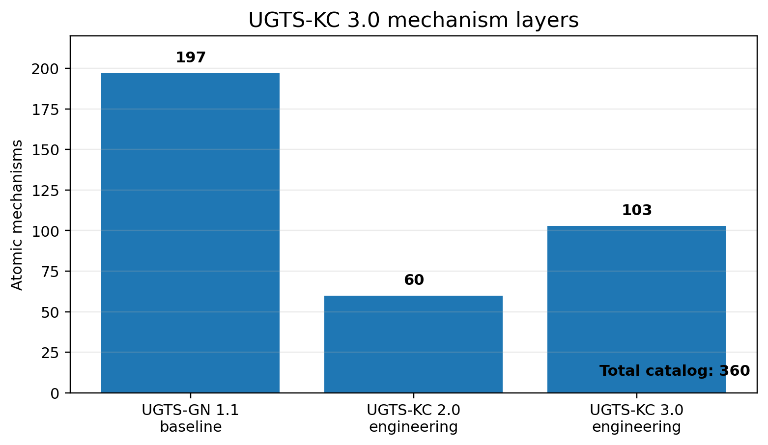
Catalog composition: source-normalized baseline plus append-only 2.0 and 3.0 engineering layers.
READING RULE
The authoritative core is a directly queryable state-and-event substrate. Projection, GPU execution and physical devices remain optional consumers. The canonical chain is support -> compatibility -> guard/certification -> verified event -> atomic transition -> lineage and novelty log.

Requester attribution was supplied by the requester and was not independently verified. Full identity metadata is isolated in REQUESTER_ATTRIBUTION.txt.

Contents
1 | Executive synthesis
2 | 1. Source basis and evidence boundary
3 | 2. Canonical architecture and the 3.0 extension
4 | 3. Mechanism catalog and versioning
5 | 4. Jet, differential and Lie kinematics
6 | 5. Constraint and contact calculus
7 | 6. Certified hybrid event calculus
8 | 7. Persistent topology and topological events
9 | 8. Pattern, field and multiscale expansion
10 | 9. Geometric and field dynamics
11 | 10. Uncertainty, error budgets and reproducible replay
12 | 11. World schema, ABI and capability routing
13 | 12. Reference implementation and examples
14 | 13. Validation and bounded measurements
15 | 14. Limits, kill criteria and roadmap
A | Appendix A. M258-M360 mechanism register
B | Appendix B. Package and source verification

EVIDENCE KEY
M001-M197 are source-derived or normalized. M198-M257 are the carried-forward 2.0 engineering layer. M258-M360 are new 3.0 engineering mechanisms. Validation labels distinguish implemented, tested, prototype and specified contracts.

Executive synthesis
The supplied reports already establish the mature UGTS architecture. The original report defines a finite grammar over typed state, explicit relation surfaces, local radial-angular support, compatibility, earliest-event solving, transition routing, lineage and an external novelty log. The GPU-native addendum carries that architecture into a 197-mechanism normalized baseline and a direct compute/hardware boundary. [SR1 pp. 1-2, 13-16; SR2 pp. 2-7]
UGTS-KC 3.0 does not replace that core. It expands the calculational layer that sits between typed state and verified event commitment. The upgrade makes higher-order motion explicit, adds constrained and unilateral contact dynamics, classifies degenerate and simultaneous events, introduces bounded certification utilities, promotes topology to measurable filtrations and invariants, adds multiscale pattern generators and spatial indices, supplies geometric and field-dynamics integrators, and makes uncertainty and replay integrity first-class.
The complete catalog now contains 360 atomic mechanisms:
- M001-M197: source-derived or source-normalized UGTS-GN 1.1 baseline.
- M198-M257: UGTS-KC 2.0 engineering expansion for patterns, implicit fields, topology calculus, kinematic calculus and bounded dynamics.
- M258-M360: 103 new UGTS-KC 3.0 engineering mechanisms.
The new mechanisms are explicitly engineering-derived. They are not presented as quotations or discoveries from the supplied PDFs. Their admission test is the same as the source reports' admission rule: each item must be representable as a typed state field, transform, support predicate, relation, compatibility gate, event policy, transition, invariant, lineage rule, measurable dynamics operator or reproducibility contract.

Decision
GO for a bounded 3.0 reference substrate. The release is suitable as a mathematical specification, exchange schema, executable reference, test corpus and implementation roadmap. It is not evidence of universal constant-time event solving, zero storage or energy, physical-GPU speed, arbitrary-field exact roots, optical advantage, physical non-orientable self-assembly or complete state in one bit.

1. Source basis and evidence boundary

1.1 Supplied reports
SR1 - Unified Geometric-Topological Substrate. This report defines the UGTS-0 authority split: finite grammar and typed state, relations and guards, topology and identity, external novelty, support admission, compatibility, event solving and transition routing, with game, graphics and hardware as adapters. It states that projection is optional and that one-bit values are schema-bound flags rather than complete state. [SR1 pp. 1-2]
SR2 - Unified Geometric-Topological Substrate GPU-native Addendum. This report retains the canonical query-first sequence and expands the normalized catalog to 197 mechanisms. It adds direct Vulkan/SPIR-V execution, typed state/event ABIs, measured software-device performance, compression contracts and bounded physical-device mappings. It explicitly separates source-derived operators, engineering normalization, measured package evidence and unsupported claims. [SR2 pp. 2-4]
The two PDFs are not redistributed. Their SHA-256 hashes and privacy-safe descriptions are included under sources/.

1.2 Three evidence layers
Layer | IDs | Meaning
Source-normalized baseline | M001-M197 | Extracted or normalized from the supplied source reports and their internal source register.
UGTS-KC 2.0 engineering | M198-M257 | Pattern, field, topology, kinematic and bounded-dynamics additions carried forward into 3.0.
UGTS-KC 3.0 engineering | M258-M360 | New higher-order kinematics, contact, certified events, persistence, multiscale dynamics, uncertainty and runtime contracts.

Every catalog row carries a layer, disposition, validation label and implementation reference. IMPLEMENTED + TESTED means exercised by the bundled reference tests. SPECIFIED means the contract is defined but a complete production implementation is not claimed.

1.3 Non-negotiable boundaries
- Coordinates are not identity. Stable identity requires address, ancestry, invariants and ordered novelty.
- Co-location is not coupling. Compatibility remains a separate typed decision.
- A field zero is a guard or relation surface; it does not imply an exact signed distance or an exact root for every trajectory.
- A one-bit field is a route, mask, orientation, latch or validity flag under a schema; it is not the complete state.
- Topological names are accepted only through explicit gluing, incidence, filtration, group or transfer data.
- A memory or performance reduction is not a correctness proof.
- Hardware claims require named devices, calibrated error, full-system energy and comparison with a conventional baseline.

2. Canonical architecture and the 3.0 extension
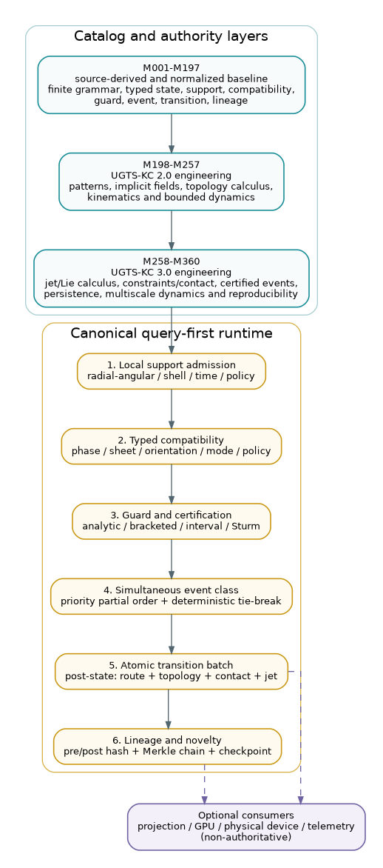
Figure 2. UGTS-KC 3.0 preserves source authority while adding certified event, contact, topology and replay layers.
The canonical shorthand remains:
local support -> typed compatibility -> guard/certification
-> simultaneous event class -> atomic transition batch
-> route/topology/contact/jet update -> lineage + novelty log

UGTS-KC 3.0 inserts additional structure without changing authority:
1. Jet state exposes derivatives through snap rather than hiding them inside an integrator.
2. Constraint and contact layers turn manifold, gap, impact and friction semantics into typed operators.
3. Certified event logic returns crossing direction, tangency/grazing status, interval enclosures and root-count information where supported.
4. Simultaneous-event batching groups events inside a declared tolerance, applies a priority partial order and commits atomically.
5. Topological observables use chain complexes, filtrations, barcodes, monodromy and explicit invariants rather than visual analogy.
6. Uncertainty and replay attach error budgets, canonical hashes, Merkle event chains and checkpoints.
7. Capability routing makes backend support and fallbacks explicit.
The architecture remains query-first. A frame loop may schedule work; it is not the state authority. A GPU kernel may accelerate a declared operator; it does not redefine the world schema. A physical sensor may produce a measured guard; its calibration and uncertainty become state and event metadata.

3. Mechanism catalog and versioning
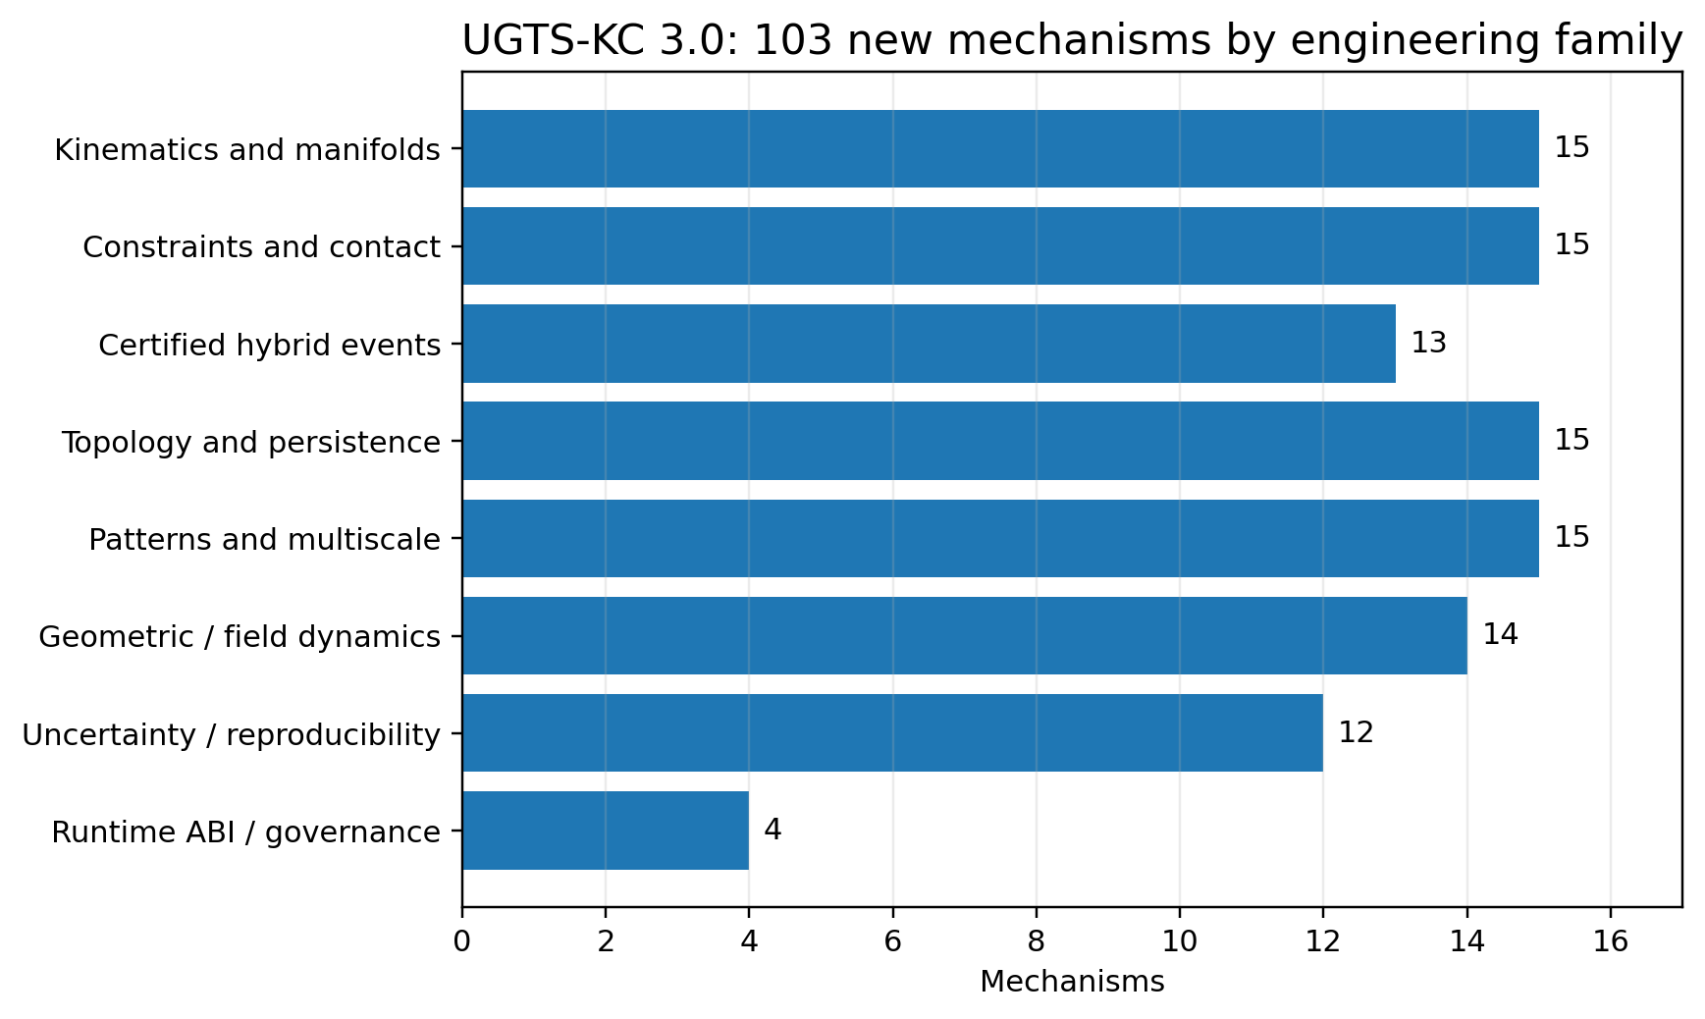
Figure 3. Distribution of the 103 new 3.0 mechanisms across eight engineering families.

3.1 Catalog growth
The 3.0 catalog is append-only. Existing identifiers are preserved, so traces and claims ledgers remain referentially stable. The new range M258-M360 adds 103 mechanisms grouped into eight engineering families.
Family | Count | Main range
Kinematics and manifolds | 15 | M258-M272
Constraints and contact | 15 | M273-M287
Certified hybrid events | 13 | M288-M300
Topology and persistence | 15 | M301-M315
Patterns and multiscale structure | 15 | M316-M330
Geometric and field dynamics | 14 | M331-M344
Uncertainty and reproducibility | 12 | M345-M356
Runtime ABI and governance | 4 | M357-M360

3.2 Version rule
A mechanism identifier names one atomic operator or contract. Backward-compatible clarification may improve its description, but a semantic replacement receives a new identifier. World files state their schema version and capability requirements. Backends publish a capability manifest and a fallback map; silent substitution is not allowed.

3.3 Admission and kill rules
A proposed mechanism enters the core only when its inputs, outputs, units, frame, tolerances and failure states are explicit. It is rejected or demoted when it relies on an undefined physical analogy, an absolute performance statement, hidden state, unbounded recursion, an unmeasurable guard or an implementation that does more work than the materialization it claims to avoid.

4. Jet, differential and Lie kinematics

4.1 Jet-state tower
The 3.0 reference state extends motion to
J(q,t) = (x, v, a, j, s; frame, length_unit, time_unit)

where x is position, v velocity, a acceleration, j jerk and s snap. The orders are stored separately, dimension-checked and evaluated through a declared truncation. Zero-valued higher orders are explicit rather than absent.
This makes event prediction, limit checking and trajectory handoff inspectable. It also prevents an overloaded symbol from standing simultaneously for time, torque, transformation and phase - a correction already emphasized by the earlier UGTS synthesis.

4.2 Material and covariant derivatives
For a scalar field f(x,t) and trajectory velocity v, the reference material derivative is
Df/Dt = partial(f)/partial(t) + grad(f) dot v

A covariant derivative is a separate contract. Ordinary component differentiation is not treated as coordinate invariant when a chart connection or metric is required.

4.3 Lie flow and rigid motion
The release implements or specifies:
- Lie brackets for noncommuting local flows.
- SE(3) adjoint transfer of twists and wrenches between frames.
- Stable small-angle SO(3) left Jacobian.
- Bounded SE(3) logarithm under a declared rotation branch.
- Dual-quaternion rigid transforms and normalized blending.
- Geodesic interpolation and local retraction updates.
- Quaternion Lie-group stepping for orientation.
The practical rule is that rigid motion is composed on the group, not by unconstrained component drift. Every transform carries a frame convention.

4.4 Curve invariants and transported frames
Curvature and torsion are computed from derivatives when the required rank and speed conditions hold. Bishop frames are retained for near-zero curvature where Frenet frames are unstable. Closed transport may accumulate holonomy; this is recorded as a frame-state result, not interpreted as free physical rotation.

4.5 Timing and synthesis
Limit-aware time scaling separates path geometry from timing and applies velocity, acceleration and jerk bounds. Differential flatness is included as a reconstruction contract for systems that actually expose flat outputs; it is not assumed for arbitrary dynamics.

5. Constraint and contact calculus
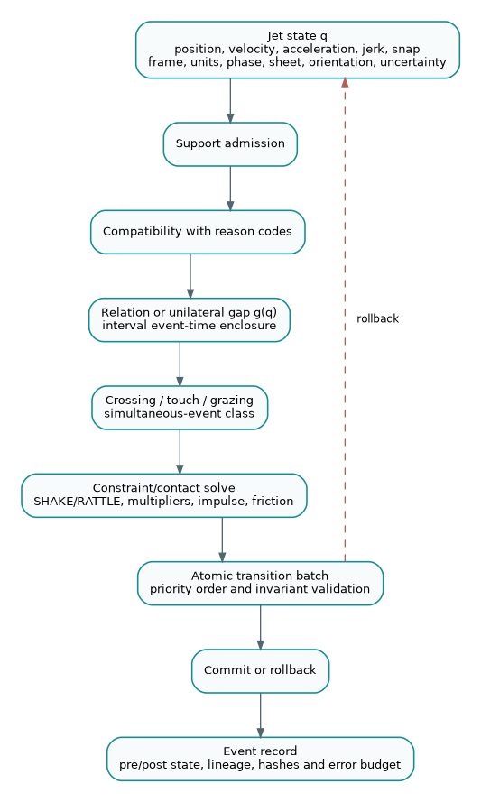
Figure 4. Contact and hybrid-event path from jet state through certified event classification to atomic commit or rollback.

5.1 Constraint types
A holonomic constraint is represented as phi(q,t)=0; a nonholonomic constraint uses a Pfaffian form A(q,t) v = b(q,t). Constraint functions, Jacobians, tolerance, stabilization method and frame are declared in the schema.
The reference package includes:
- constraint Jacobian evaluation,
- Baumgarte stabilization,
- SHAKE position projection,
- RATTLE velocity projection,
- small dense Lagrange-multiplier solves,
- null-space constrained acceleration,
- projected symplectic circle integration.
Projection residuals are returned. A projected point without its residual and tolerance is not a verified constrained state.

5.2 Unilateral contact
A contact candidate uses a signed gap g(q). The ideal normal complementarity condition is
g >= 0, lambda_n >= 0, g * lambda_n = 0

with finite tolerances in software. A negative gap is penetration, zero is contact within policy and positive is separation. The guard direction distinguishes entering, leaving and touching.

5.3 Impact and restitution
The normal impulse solves a declared effective-mass relation and applies a coefficient of restitution in [0,1]. Restitution is not used to manufacture energy. Near-resting contacts may switch to a non-bouncing policy to avoid chatter.

5.4 Friction
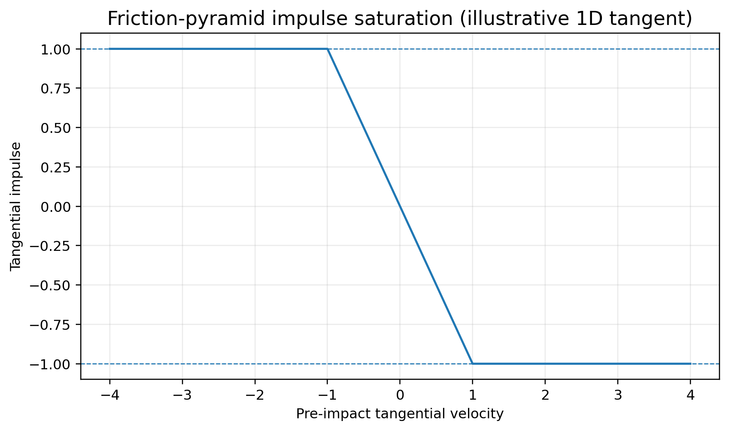
Figure 5. Illustrative friction-pyramid saturation for one tangent direction.
Coulomb friction is a cone ||J_t|| <= mu J_n. The reference includes a friction-pyramid approximation and bounded tangent impulse. The approximation resolution, warm-start state and solver tolerance must be visible because they can change event order and energy dissipation.

5.5 Contact manifold and warm start
Multiple nearby contact points are reduced to a bounded manifold using separation and normal criteria. Cached impulses are keyed to stable contact identifiers and invalidated when topology, frame or feature identity changes. Warm starting is an optimization, not authoritative state unless included in deterministic replay.

6. Certified hybrid event calculus

6.1 Event classification
A guard result is not reduced immediately to true/false. The 3.0 event classifier distinguishes:
- rising crossing,
- falling crossing,
- touch/tangency,
- grazing candidate,
- coincident or unresolved interval,
- no root in the certified interval.
Derivative information and interval residuals accompany the classification. Tangency is not silently reported as a crossing.

6.2 Simultaneous events
Events whose time enclosures overlap within simultaneous_tolerance form an equivalence class. The class is processed through:
1. a declared priority partial order,
2. a deterministic tie-break key for otherwise incomparable events,
3. a proposed state-patch batch,
4. invariant and compatibility validation,
5. atomic commit or rollback.
This prevents result dependence on thread scheduling, hash-table order or small floating-point perturbations.

6.3 Certification utilities
The package includes bounded reference utilities for:
- interval event enclosure,
- Lipschitz root exclusion,
- interval Newton contraction,
- Sturm polynomial root counting,
- interval scalar/vector bounds.
These tools certify only their declared assumptions. They do not make arbitrary implicit fields globally solvable.

6.4 Zeno and hysteresis policy
A Zeno detector watches shrinking inter-event times and reports accumulation rather than iterating forever. Dwell timers, hysteresis and debounce remain explicit policy. A production system must choose whether to regularize, aggregate, stop or hand off the accumulation.

7. Persistent topology and topological events
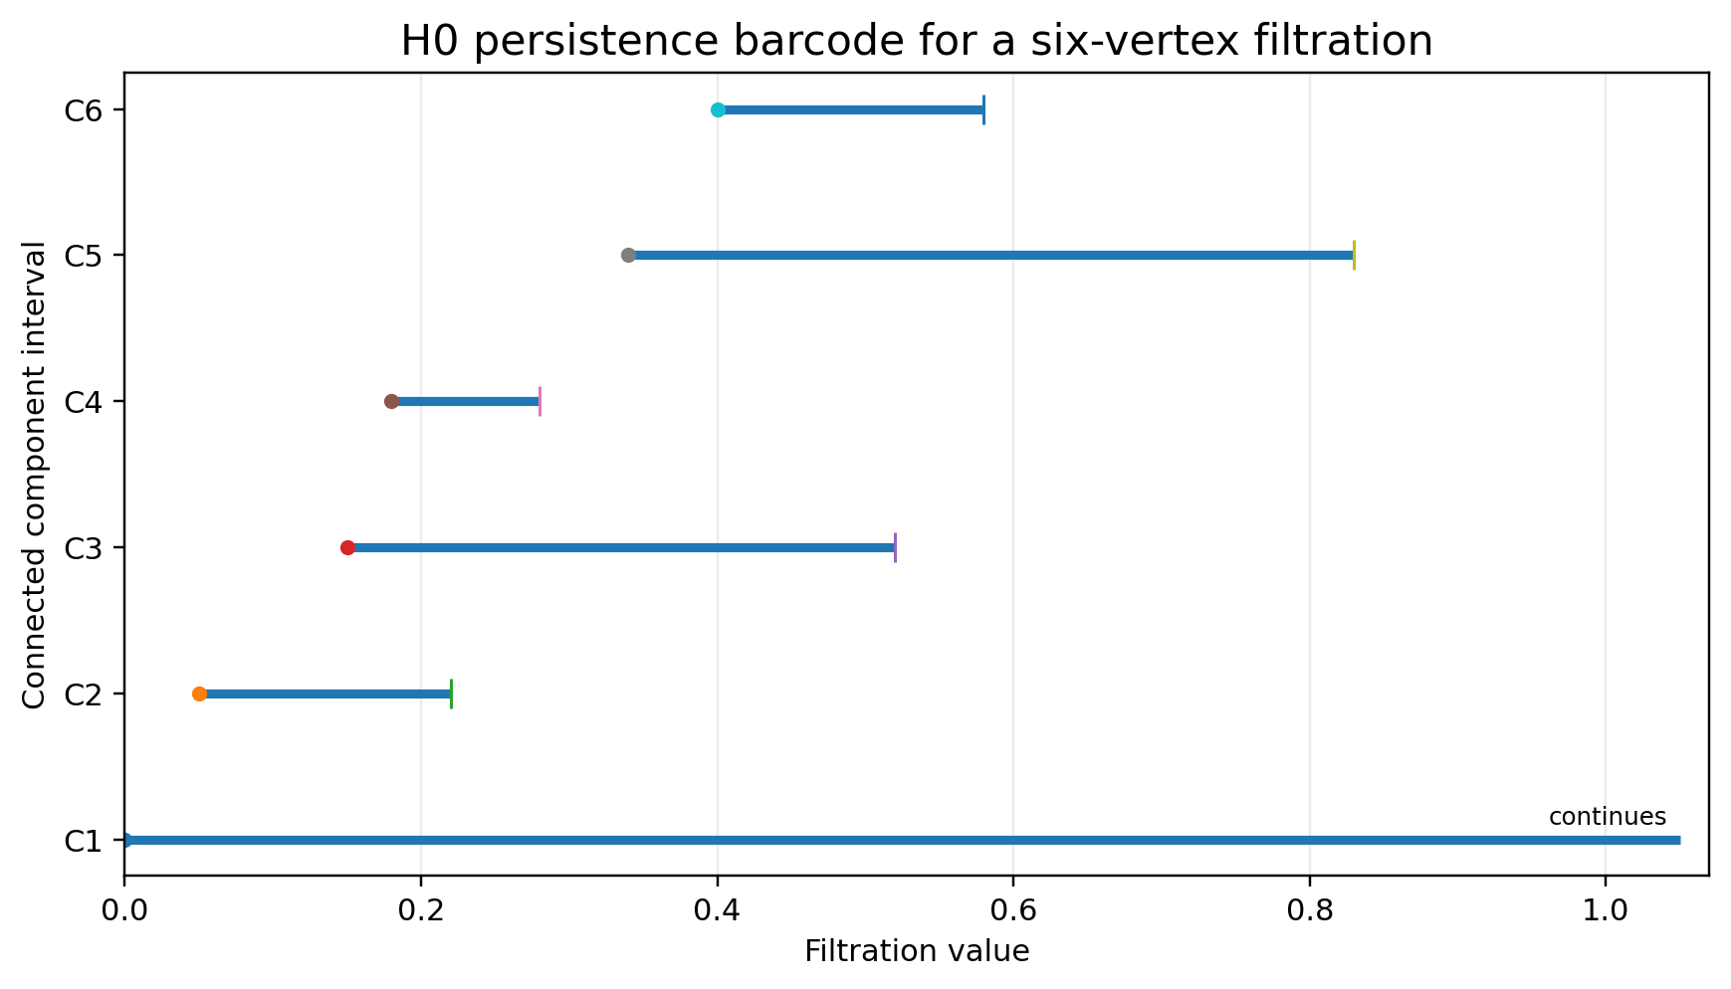
Figure 6. Bounded H0 persistence example. Infinite continuation is a declared interval status, not an infinite computation.

7.1 From names to combinatorics
The earlier UGTS reports already require explicit quotient and gluing maps for Mobius and Klein motifs. Version 3.0 generalizes that discipline: topology is carried by oriented incidence, chain maps, filtrations, group presentations, monodromy or measured invariants - not by a suggestive rendering.

7.2 Simplicial and cubical structures
The reference package supports oriented simplex incidence and checks that boundary composed with boundary is zero. It constructs small Vietoris-Rips complexes, an alpha-complex proxy and cubical lower-star orderings. These are bounded educational implementations, not replacements for specialized large-scale topology libraries.

7.3 Homology and persistence
The package includes:
- Betti-vector calculation for bounded complexes,
- union-find H0 persistence,
- persistence intervals and barcodes,
- a bounded diagram-distance approximation,
- topology-threshold event generation.
A persistent feature becomes an event only under a declared minimum lifetime, dimension and confidence policy. Short-lived features can be retained as uncertainty rather than treated as structure.

7.4 Differential and algebraic topology contracts
A graph Hodge Laplacian supplies a discrete exterior-calculus foothold. Harmonic representatives, winding/linking estimates, fundamental-group presentations and covering-space monodromy are included as explicit contracts. Each requires valid discretization and orientation data.

7.5 Topological change events
Birth, death, merge, split, handle or monodromy changes may be emitted as typed events. The event stores the filtration parameter, before/after invariant, representative or feature identifier, confidence and lineage. Visual change alone is not authoritative.

8. Pattern, field and multiscale expansion

8.1 Carried-forward 2.0 patterns
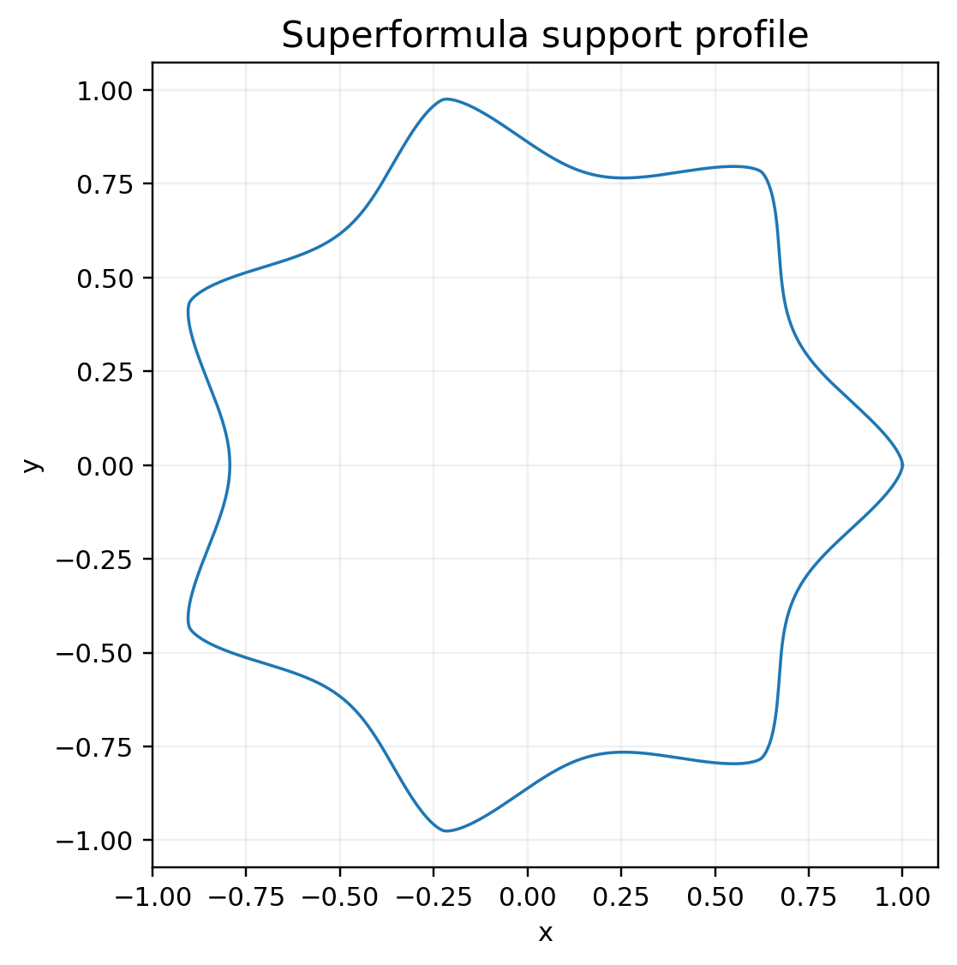  Superformula support profile | 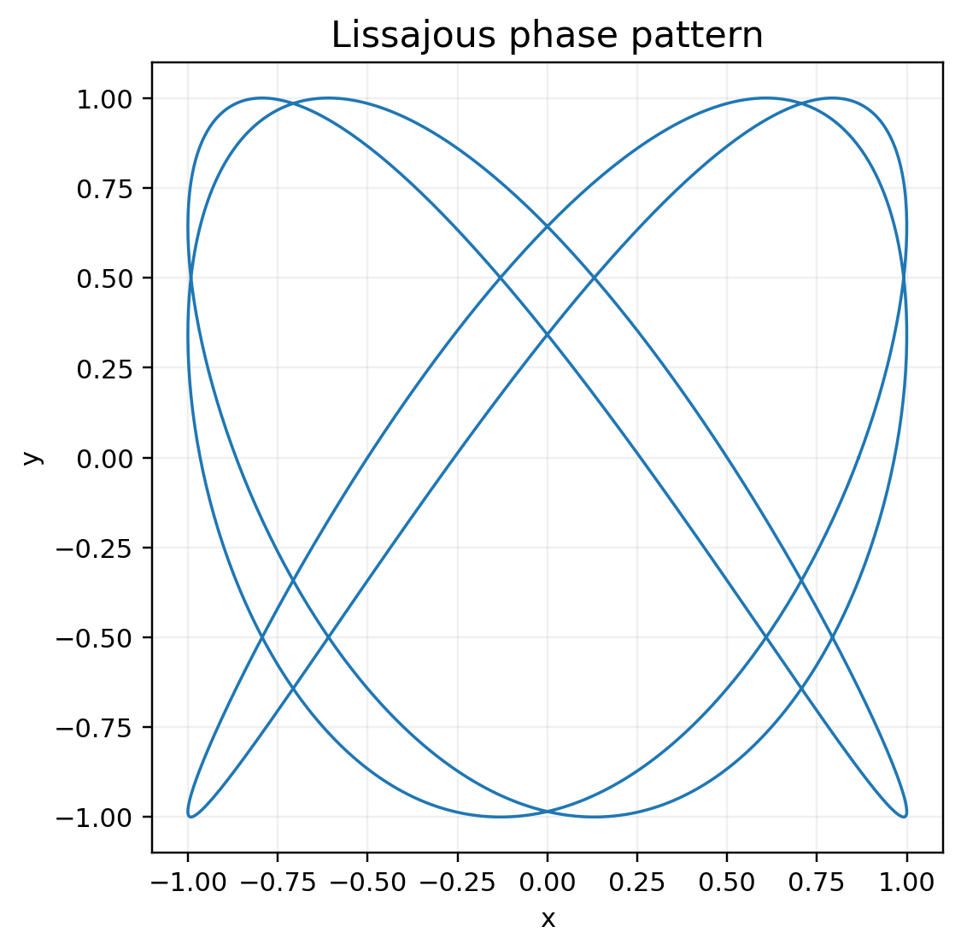  Lissajous phase pattern
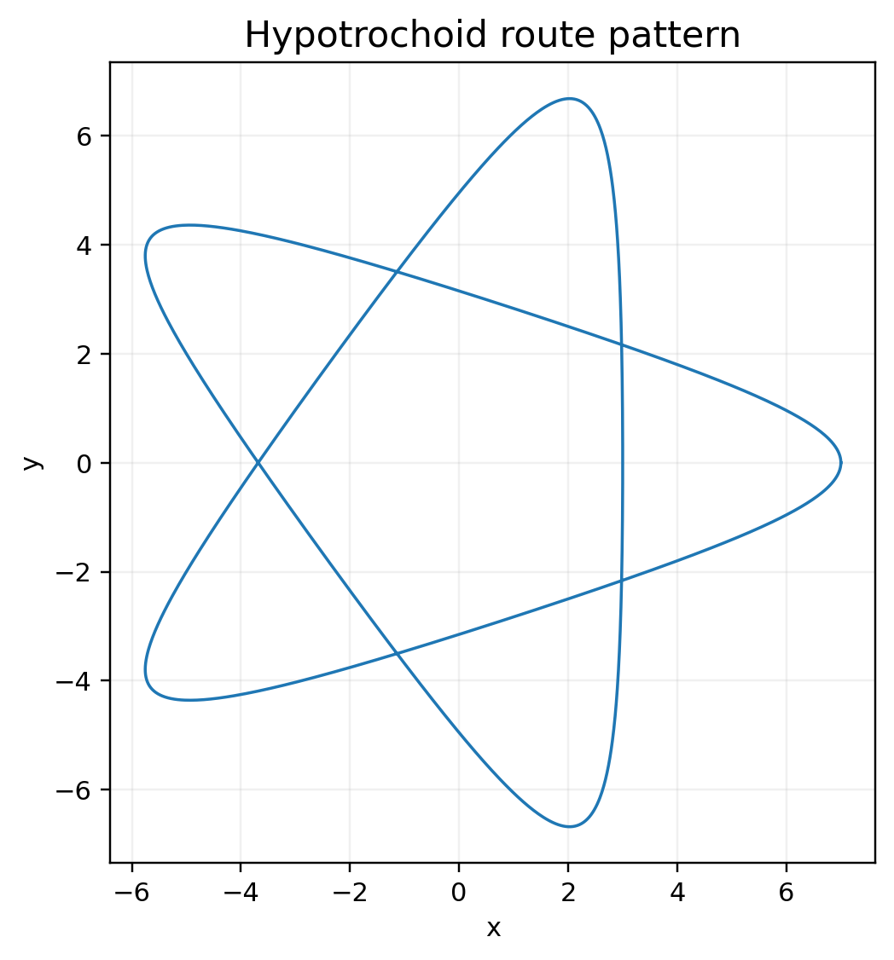  Hypotrochoid route pattern | 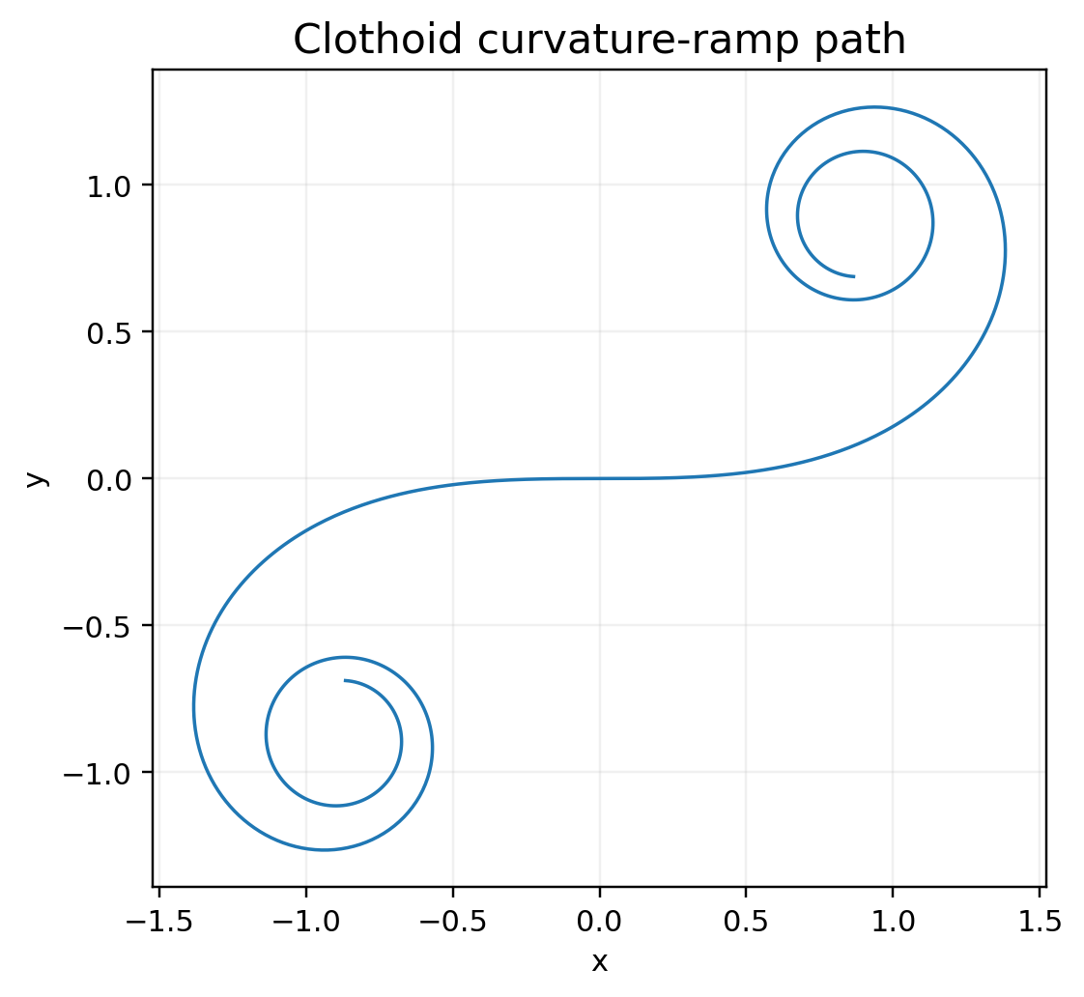  Clothoid curvature-ramp path
Figure 7. Carried-forward parametric pattern examples. Each curve is a typed construction, not an authority by itself.
UGTS-KC 2.0 added 20 parametric pattern mechanisms, 12 implicit field/surface mechanisms, 10 topology-calculus mechanisms, 12 kinematic mechanisms and 6 bounded dynamics/event mechanisms. Version 3.0 retains them unchanged. Examples include superellipses, the Gielis superformula, Lissajous curves, trochoids, clothoids, Bezier/B-spline/NURBS curves, superquadrics, swept tubes, gyroid and Schwarz-P fields, screw motions, transported frames and event-driven dynamics.
These shapes are not merely display motifs. A curve may be a path, support boundary, route, trajectory template or guard. An implicit field may be a relation, contact gap, phase field or downstream projection. The schema states the role.

8.2 Symmetry and substitution
The 3.0 layer adds finite transform sets for wallpaper and frieze symmetries, Penrose and Ammann-Beenker substitution systems and cut-and-project quasicrystals. Expansion depth and point count are bounded. Quasiperiodicity is a construction, not an assertion of infinite physical resolution.

8.3 Spatial partition and sampling
Voronoi cells, Delaunay adjacency, Lloyd relaxation, Poisson-disk samples and blue-noise diagnostics supply local support and sampling patterns. They may accelerate candidate selection or distribute sensors, but they do not replace compatibility or event certification.

8.4 Indexing and multiresolution
Hilbert and Morton keys provide locality-preserving indices with explicit quantization. Haar wavelets and Laplacian pyramids provide bounded multiresolution transforms. Graph Laplacian modes provide spectral patterns tied to a declared graph.

8.5 Implicit field example
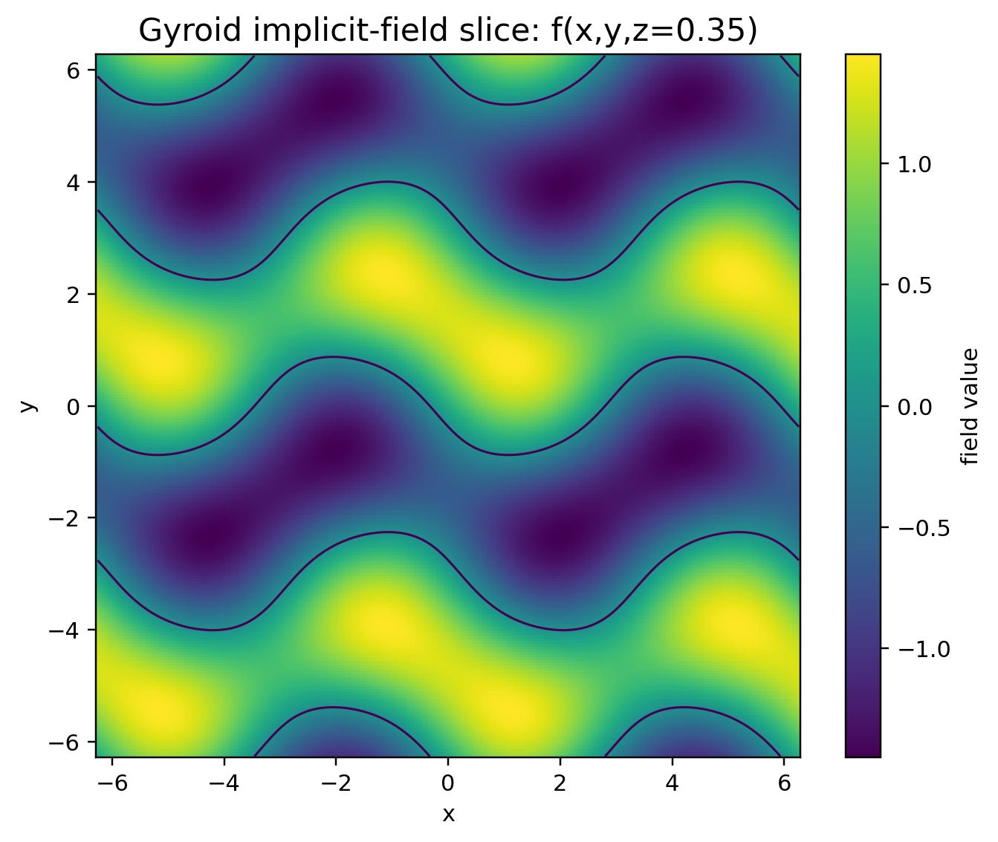
Figure 8. Gyroid scalar-field slice with the zero contour overlaid. Exact-distance status is not implied.
The gyroid slice demonstrates how a periodic scalar field can define supports, phase regions or event surfaces. It is not automatically an exact SDF. Gradients, zero sets and discretization error must be treated separately.

9. Geometric and field dynamics
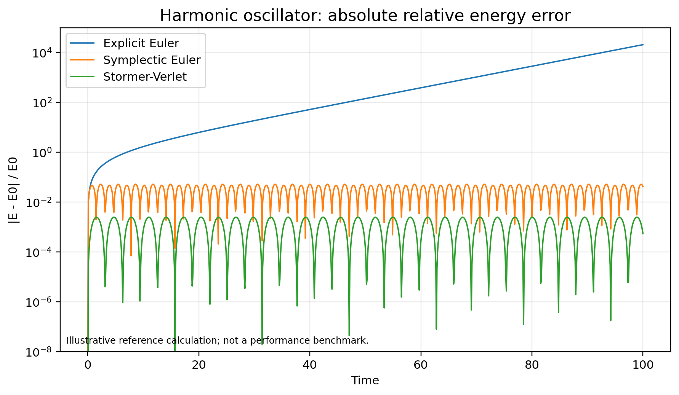
Figure 9. Illustrative harmonic-oscillator energy error. This is a reference calculation, not a performance benchmark.

9.1 Structured mechanical dynamics
The 3.0 package names Hamiltonian canonical flow, Euler-Lagrange flow and discrete variational integration. It implements reference steps for implicit midpoint, symplectic Euler, Stormer-Verlet, velocity Verlet, Lie-group quaternion integration and projected symplectic constraints.
Structure-preserving methods are not universally superior, but they expose invariants and often bound long-time drift better than naive explicit updates. The bundled harmonic-oscillator figure is an illustrative calculation, not a hardware benchmark.

9.2 Field dynamics
The field layer includes:
- semi-Lagrangian advection,
- implicit diffusion,
- wave-equation leapfrog with a CFL check,
- Gray-Scott reaction-diffusion and operator splitting,
- Allen-Cahn phase relaxation,
- Cahn-Hilliard mass-conserving phase evolution,
- graph diffusion,
- eikonal fast-sweeping update.
Every step declares grid spacing, time step, boundary treatment and stability or solver policy. A field update does not become authoritative event state until a relation and verification policy interprets it.

9.3 Event-dynamics coupling
Dynamics proposes a continuous evolution. Event calculus detects the earliest valid guard, advances to the event enclosure, applies the atomic transition, projects constraints if required and restarts the local flow. This avoids stepping through a topology or contact change as if it were ordinary smooth motion.

10. Uncertainty, error budgets and reproducible replay

10.1 Interval and affine uncertainty
The reference package includes closed interval arithmetic, interval vector norms and simple affine forms. Intervals bound possible values under conservative assumptions; affine forms retain selected correlation. Neither is a substitute for a validated physical uncertainty model.

10.2 Statistical propagation
Covariance propagation and unscented sigma points are provided for declared stochastic state. A covariance matrix is kept distinct from a hard interval and from a confidence score. The event record identifies the uncertainty representation used.

10.3 Tolerance policy
A numeric policy contains absolute, relative, time, guard and topology tolerances plus a certification mode. Comparisons use the policy rather than scattered magic constants. Changing tolerance is a schema-visible operation that may change event ordering.

10.4 Deterministic reductions and sampling
A deterministic seed contract, stable pairwise reduction and fixed tie-break rules reduce replay drift. They do not guarantee bitwise equality across every math library or processor. The capability manifest states the reproducibility level.

10.5 Canonical hashes, Merkle chain and checkpoints
Normalized finite JSON can be hashed with sorted keys and schema version. Event hashes are chained so mutation, omission or reordering changes the head. A checkpoint stores world state, schema hash and chain head for bounded rollback.
These are integrity mechanisms. They are not authentication, access control, a cryptographic identity for an entity or proof that the physical input was truthful.

10.6 Error-budget ledger
A verified event may aggregate modeling, discretization, solver, quantization, calibration and measurement allocations. Promotion fails when the total bound exceeds the guard margin or when uncertainty can change event order.

11. World schema, ABI and capability routing

11.1 Schema 3.0
The Draft 2020-12 schema introduces:
- explicit jet fields and frame/unit metadata,
- numeric tolerance and certification policy,
- capability manifest and fallback map,
- relations with support, compatibility, transition, priority, direction and solver,
- holonomic, nonholonomic and unilateral-contact constraints,
- dynamics and integrator records with error budgets,
- topology descriptors,
- simultaneous-event, tie-break, Zeno, atomic-batch and dwell policies.
A validated example world models a planar traveler crossing an x=0 portal, changing sheet and orientation, carrying a circle constraint and a bounded ground-contact policy.

11.2 Jet and contact ABI
The catalog specifies a structure-of-arrays jet-state ABI and a compact contact-event record. A production binary layout must still declare field widths, alignment, endianness, precision, units, frame identifiers and version. Compact records are accepted only when error stays below the event margin.

11.3 Event compaction
M359 defines a prefix-scan event-compaction contract for parallel backends. The bundled Python fallback is stable CPU compaction. The package does not report a new GPU benchmark for this 3.0 layer.

11.4 Capability manifest
Backends publish supported mechanism IDs, precision, certification level and fallback routes. A world may reject execution when a required mechanism is absent, or it may follow an explicit fallback. Silent degradation is prohibited.

12. Reference implementation and examples
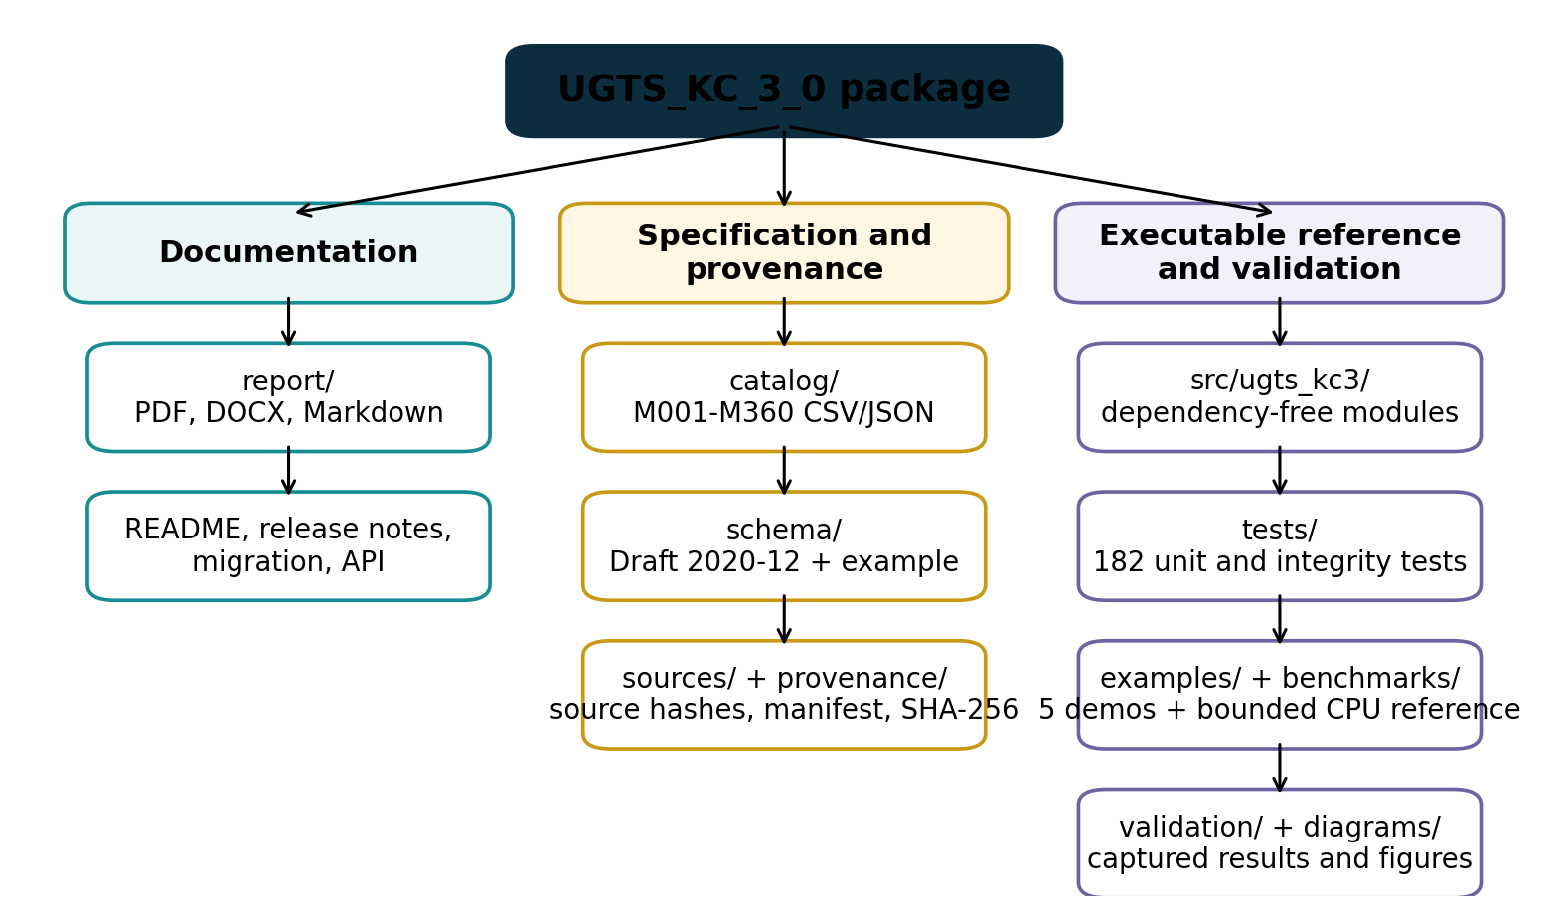
Figure 10. Delivered package layout and verification artifacts.

12.1 Package modules
Module | Responsibility
kinematics.py | Jet state, SE(2)/SE(3), quaternions, dual quaternions, moving frames and derivatives.
constraints.py | Constraint projection, multipliers, impact, restitution, friction and contact reduction.
events.py | Classification, clustering, priority, Zeno detection, interval Newton and Sturm utilities.
topology.py | Simplicial structures, persistence, filtrations, Hodge Laplacian, invariants and monodromy.
patterns.py / fields.py | Parametric patterns, implicit fields and periodic surfaces.
multiscale.py | Symmetries, substitutions, spatial partitions, sampling, indices and transforms.
dynamics.py | Mechanical and field-dynamics reference steps.
uncertainty.py | Intervals, affine forms, covariance, sigma points, hashes, checkpoints and error budgets.
world.py | Query-first world for state, compatibility, next event and transition processing.
io.py | JSON I/O, minimal validation and capability-manifest helpers.

12.2 Example sequence
from ugts_kc3.world import QueryWorld
world = QueryWorld.from_json_file("schema/example_world_v3.json")
state = world.state_at("traveler_A", 1.25)
event = world.next_event("traveler_A", 0.0, 5.0)
record = world.process_next_event("traveler_A", 0.0, 5.0)

The examples also demonstrate contact impulses, H0 persistence, field dynamics and uncertainty/replay integrity.

12.3 Package layout
The ZIP contains editable report sources, machine-readable catalogs, schema, code, tests, examples, diagrams, captured validation and provenance manifests. Source PDFs are deliberately excluded.

13. Validation and bounded measurements

13.1 Automated tests
The final test run completed 182 tests:
Test file | Tests | Coverage focus
test_catalog_integrity.py | 4 | Identifier continuity, counts and layer boundaries.
test_events_topology.py | 39 | Event classification, certification, priorities, persistence and topology.
test_kinematics_constraints.py | 39 | Jet/Lie operations, frames, constraints, impact and friction.
test_multiscale_dynamics.py | 34 | Patterns, indices, transforms, mechanical and field dynamics.
test_patterns_fields.py | 37 | 2.0 parametric curves, surfaces, SDFs and field algebra.
test_uncertainty_io_world.py | 29 | Intervals, replay integrity, schema-adjacent I/O and query world.

All tests passed. The run establishes internal consistency of the bounded implementation, not external physical performance.

13.2 Schema and examples
The schema is valid Draft 2020-12 JSON Schema. The example world validates against it. All five examples executed and their outputs are captured under validation/.

13.3 Reference benchmark boundary
The bundled benchmark is a Python CPU microbenchmark for regression and rough cost visibility. It measures superformula evaluation, SE(3) exponential, interval Newton for sqrt(2) and H0 persistence on a 128-vertex case. Results are recorded with Python version, platform, iteration count and checksum.
It is not a GPU, FPGA, ASIC, photonic or universal throughput claim. It must not be compared across machines without preserving software version, workload, precision and measurement method.

14. Limits, kill criteria and roadmap

14.1 Kill criteria
The 3.0 approach should be rejected or simplified for a target workload when any of the following holds:
- support and compatibility fail to remove enough candidates,
- simultaneous-event classes grow faster than the avoided materialization,
- interval widths or quantization exceed the guard margin,
- contact or topology ordering is unstable under the declared tolerance,
- Zeno regularization dominates the model,
- constraint projection or warm-start state destroys deterministic replay,
- grammar or substitution growth escapes its budget,
- topology computations exceed the scale for the bounded reference algorithms,
- event compaction, global coordination or rollback dominates throughput,
- calibration, drift, actuation or sidecar cost erases a physical-device advantage,
- a conventional integrator, collision pipeline or database index is cheaper, faster or more accurate at equal error.

14.2 Recommended 3.x roadmap
1. Freeze the 3.0 exchange schema and mechanism semantics.
2. Add property-based and randomized differential tests while keeping deterministic seeds.
3. Add certified polynomial/interval event support for more restricted surface-trajectory pairs.
4. Implement sparse constraint graphs and a production contact manifold solver.
5. Add scalable persistence through an established topology backend while preserving the exchange contract.
6. Implement and benchmark prefix-scan event compaction on a named physical GPU.
7. Compare query-first event processing against fixed-step and conventional CCD baselines at equal error.
8. Only after software baselines, connect a measured hardware endpoint with full-system energy and calibration.

14.3 Final decision
UGTS-KC 3.0 is a coherent upgrade because it does not abandon the source architecture. It strengthens the layer between geometry and event commitment: motion becomes a typed jet, constraints and contact become explicit relations, difficult roots receive bounded status, simultaneous events commit atomically, topology receives measurable invariants and filtrations, dynamics receive structured integrators, and replay receives integrity and error contracts.
The package is ready for bounded formalization, testing, backend implementation and falsifiable comparison. Projection and physical realization remain downstream and evidence-bound.

Appendix A. M258-M360 mechanism register
These 103 rows are engineering additions introduced in UGTS-KC 3.0. Full records, including layer, disposition and source-boundary fields, are supplied as CSV and JSON.
ID | Domain | Mechanism | Normalized technical definition | Validation
M258 | Differential kinematics | Jet-state tower | Augment typed state with position, velocity, acceleration, jerk and snap, each with units and frame metadata. | Implemented + tested
M259 | Differential kinematics | Material derivative | Derivative of a field along a trajectory: Df/Dt = partial_t f + grad(f) dot v. | Implemented + tested
M260 | Differential geometry | Covariant derivative contract | Differentiate vector fields with an explicit connection or chart metric; ordinary component derivatives are not coordinate invariant. | Specified
M261 | Differential geometry | Lie bracket of vector fields | Commutator [X,Y]=DY*X-DX*Y used to expose noncommuting local flows. | Implemented + tested
M262 | Lie kinematics | Adjoint frame transfer | Transform twists and wrenches between rigid frames with the SE(3) adjoint. | Implemented + tested
M263 | Lie kinematics | SE(3) left Jacobian | Velocity-to-displacement Jacobian with stable small-angle series. | Implemented + tested
M264 | Lie kinematics | SE(3) logarithm | Recover a bounded rigid-body twist from a transform under a declared rotation branch. | Prototype + tested
M265 | Lie kinematics | Dual-quaternion rigid transform | Represent rotation and translation by a normalized real/dual quaternion pair. | Implemented + tested
M266 | Lie kinematics | Dual-quaternion blending | Weighted normalized blend for rigid transforms with hemisphere alignment; not a general deformation theorem. | Implemented + tested
M267 | Manifold kinematics | Geodesic interpolation | Interpolate state on a declared manifold using exp/log or a retraction rather than component-wise blending. | Implemented + tested
M268 | Manifold kinematics | Retraction update | Map tangent increments back to a manifold when a full exponential is unavailable. | Specified
M269 | Differential kinematics | Curvature and torsion invariant | Compute curvature and torsion from first three derivatives with degeneracy status. | Implemented + tested
M270 | Frame transport | Bishop-frame holonomy | Accumulate net normal-frame rotation after parallel transport around a closed path. | Prototype + tested
M271 | Trajectory timing | Limit-aware time scaling | Compute monotone path timing under velocity, acceleration and jerk budgets. | Prototype + tested
M272 | Trajectory synthesis | Differential flatness reconstruction | Recover state and controls from a flat output for a declared model such as a planar unicycle. | Implemented + tested
M273 | Constraint dynamics | Holonomic constraint manifold | Equality constraint phi(q,t)=0 with value, Jacobian and tolerance contracts. | Implemented + tested
M274 | Constraint dynamics | Nonholonomic Pfaffian constraint | Velocity constraint A(q,t)*qdot=b(q,t) that cannot generally be integrated to position-only form. | Specified
M275 | Constraint dynamics | Constraint Jacobian | Derivative J=partial phi/partial q used for projection, multipliers and rank checks. | Implemented + tested
M276 | Constraint dynamics | Baumgarte stabilization | Feedback term -2*zeta*omega*phi_dot-omega^2*phi to control drift, with explicit tuning. | Implemented + tested
M277 | Constraint dynamics | SHAKE position projection | Iteratively project a trial position onto holonomic constraints within tolerance. | Implemented + tested
M278 | Constraint dynamics | RATTLE velocity projection | Project velocity to the tangent space after the position correction. | Implemented + tested
M279 | Constraint dynamics | Lagrange multiplier solve | Solve constrained acceleration or impulse through J M^-1 J^T with singularity status. | Implemented + tested
M280 | Constraint dynamics | Null-space constrained acceleration | Project unconstrained acceleration into the Jacobian null space. | Implemented + tested
M281 | Contact calculus | Unilateral gap function | Signed separation g(q)>=0 distinguishes open, touching and penetrating states. | Implemented + tested
M282 | Contact calculus | Complementarity contact condition | Normal impulse lambda>=0, gap velocity/acceleration >=0 and lambda*g=0 under a declared time-stepping model. | Implemented + tested
M283 | Contact calculus | Normal impact impulse | Impulse along contact normal computed from effective mass and relative normal velocity. | Implemented + tested
M284 | Contact calculus | Coefficient-of-restitution law | Post-impact separating velocity is bounded by a declared restitution coefficient and activation threshold. | Implemented + tested
M285 | Contact calculus | Coulomb friction cone | Tangential impulse norm is bounded by mu times normal impulse. | Implemented + tested
M286 | Contact calculus | Friction-pyramid approximation | Polyhedral approximation of the friction cone for linear or complementarity solvers. | Implemented + tested
M287 | Contact calculus | Contact manifold reduction and warm start | Select a bounded representative contact set and seed the next solve from cached impulses. | Prototype + tested
M288 | Hybrid event calculus | Guard direction classification | Classify rising, falling, neutral and indeterminate crossings from guard values and derivatives. | Implemented + tested
M289 | Hybrid event calculus | Tangency event classification | Distinguish crossing, touch, coincident and unresolved cases using value/derivative tolerances. | Implemented + tested
M290 | Hybrid event calculus | Grazing-bifurcation marker | Emit a diagnostic when a guard touches zero with near-zero normal velocity and changes event topology. | Implemented + tested
M291 | Hybrid event calculus | Simultaneous event equivalence class | Group event times within a declared temporal enclosure before transition resolution. | Implemented + tested
M292 | Hybrid event calculus | Event priority partial order | Resolve dependencies through an acyclic precedence graph, not an undocumented list order. | Implemented + tested
M293 | Hybrid event calculus | Deterministic tie-break key | Stable key from time bucket, priority, relation ID and lineage hash. | Implemented + tested
M294 | Hybrid event calculus | Zeno accumulation detector | Detect shrinking inter-event intervals approaching a finite accumulation horizon and apply a declared policy. | Implemented + tested
M295 | Hybrid event calculus | Hysteresis dwell timer | Require a guard to remain beyond a threshold for a minimum duration before latching. | Implemented + tested
M296 | Certified numerics | Event interval enclosure | Represent event time as [t_lo,t_hi] plus residual and direction status. | Implemented + tested
M297 | Certified numerics | Lipschitz root exclusion | Exclude a root from an interval when the guard magnitude exceeds a valid Lipschitz displacement bound. | Implemented + tested
M298 | Certified numerics | Interval Newton certification | Contract a root interval using interval derivative bounds and classify unique/no/unresolved roots. | Implemented + tested
M299 | Certified numerics | Sturm polynomial root count | Count distinct real polynomial roots in an interval without sampling sign changes. | Implemented + tested
M300 | Hybrid event calculus | Rollback-safe atomic transition batch | Apply a simultaneous transition set to a snapshot, validate invariants, then commit or roll back as one record. | Implemented + tested
M301 | Discrete topology | Oriented simplex incidence | Signed face incidence of oriented simplices, with mod-2 option. | Implemented + tested
M302 | Discrete topology | Chain-complex consistency | Verify boundary composed with boundary is zero. | Implemented + tested
M303 | Discrete topology | Homology Betti vector | Compute low-dimensional Betti numbers over GF(2) from boundary-matrix ranks. | Implemented + tested
M304 | Persistent topology | Union-find H0 persistence | Track connected-component births and merges over an edge filtration. | Implemented + tested
M305 | Persistent topology | Persistence barcode interval | Store feature birth, death, dimension, representative and confidence. | Implemented + tested
M306 | Persistent topology | Persistence-diagram distance | Bound diagram change with a deterministic greedy matching approximation; exact bottleneck is optional. | Prototype + tested
M307 | Persistent topology | Vietoris-Rips filtration | Create vertices, edges and triangles below scale thresholds for bounded point sets. | Implemented + tested
M308 | Persistent topology | Alpha-complex proxy | Use Delaunay-admissible simplices and circumradius thresholds; current reference is a bounded 2D proxy. | Prototype + tested
M309 | Persistent topology | Cubical lower-star filtration | Order grid cells by maximum incident scalar value and preserve face-before-coface ties. | Implemented + tested
M310 | Discrete exterior calculus | Discrete Hodge Laplacian | Assemble combinatorial k-Laplacian from adjacent boundary operators. | Implemented + tested
M311 | Discrete topology | Harmonic cycle representative | Represent a persistent cycle by a bounded chain chosen under a declared optimization. | Specified
M312 | Topology invariant | Winding and linking invariant | Use winding exactly in 2D and a discretized Gauss linking estimate for separated closed 3D curves. | Prototype + tested
M313 | Algebraic topology | Fundamental-group presentation | Store generators and relations for route classes; simplification is bounded and explicit. | Implemented + tested
M314 | Covering topology | Covering-space monodromy | Apply loop-induced permutations to sheet labels. | Implemented + tested
M315 | Persistent event calculus | Topological change event | Emit an event when a persistence feature crosses a declared lifetime or confidence threshold. | Implemented + tested
M316 | Symmetry pattern | Wallpaper-group transform set | Finite generator set for one of the 17 plane symmetry groups, with bounded lattice window. | Prototype + tested
M317 | Symmetry pattern | Frieze-group transform set | Finite generator set for strip symmetries over a declared period window. | Prototype + tested
M318 | Substitution pattern | Penrose substitution system | Finite-depth thick/thin rhombus substitution with explicit inflation factor and symbol budget. | Prototype + tested
M319 | Substitution pattern | Ammann-Beenker substitution system | Finite-depth square/rhombus substitution counts under an explicit matrix. | Prototype + tested
M320 | Quasiperiodic pattern | Cut-and-project quasicrystal | Select projected lattice points whose internal-space coordinate lies in a bounded acceptance window. | Implemented + tested
M321 | Spatial partition | Voronoi cell field | Assign each query to its nearest seed with deterministic tie policy. | Implemented + tested
M322 | Spatial partition | Delaunay adjacency | Connect seed pairs sharing an empty-circumcircle simplex in bounded 2D sets. | Implemented + tested
M323 | Spatial relaxation | Centroidal Voronoi relaxation | Move seeds toward sample-weighted cell centroids with bounded relaxation. | Implemented + tested
M324 | Sampling pattern | Poisson-disk sampling | Deterministic Bridson-style sample generation with minimum-distance and domain contracts. | Implemented + tested
M325 | Sampling pattern | Blue-noise spectral criterion | Report nearest-neighbor and low-frequency occupancy diagnostics rather than claiming perfect blue noise. | Implemented + tested
M326 | Spatial indexing | Hilbert space-filling index | Map bounded integer grid coordinates to a locality-preserving 2D Hilbert index. | Implemented + tested
M327 | Spatial indexing | Morton / Z-order index | Interleave coordinate bits under an explicit width. | Implemented + tested
M328 | Multiresolution pattern | Haar wavelet basis | Orthogonal dyadic analysis/synthesis with padding policy. | Implemented + tested
M329 | Multiresolution pattern | Laplacian pyramid | Repeated smoothing/downsampling plus residual bands with reconstruction contract. | Implemented + tested
M330 | Spectral pattern | Graph Laplacian mode pattern | Use eigenmodes of a symmetric graph Laplacian as bounded spatial patterns. | Prototype + tested
M331 | Geometric dynamics | Hamiltonian canonical flow | Advance qdot=partial H/partial p and pdot=-partial H/partial q with a declared integrator. | Implemented + tested
M332 | Geometric dynamics | Euler-Lagrange flow | Derive motion from a declared Lagrangian and constraints; symbolic derivation is outside the reference runtime. | Specified
M333 | Geometric dynamics | Discrete variational integrator | Stationarity of a discrete action produces an update map with momentum structure. | Prototype + tested
M334 | Numerical dynamics | Implicit midpoint method | Second-order implicit update solved to a declared residual tolerance. | Implemented + tested
M335 | Geometric dynamics | Stormer-Verlet splitting | Kick-drift-kick splitting for separable Hamiltonians. | Implemented + tested
M336 | Lie-group dynamics | Lie-group orientation integrator | Update orientation through group multiplication rather than additive matrix drift. | Implemented + tested
M337 | Constraint dynamics | Projected symplectic integrator | Symplectic trial step followed by position and velocity projection, with projection error logged. | Implemented + tested
M338 | Field dynamics | Semi-Lagrangian advection | Trace characteristics backward and interpolate under a declared boundary policy. | Implemented + tested
M339 | Field dynamics | Implicit diffusion step | Solve the backward-Euler tridiagonal diffusion system for stable large time steps. | Implemented + tested
M340 | Field dynamics | Wave-equation leapfrog | Centered second-order time update with CFL contract. | Implemented + tested
M341 | Field dynamics | Reaction-diffusion operator splitting | Separate diffusion and reaction updates with declared ordering and substeps. | Implemented + tested
M342 | Phase-field dynamics | Allen-Cahn step | Nonconservative phase relaxation with double-well potential and diffusion. | Implemented + tested
M343 | Phase-field dynamics | Cahn-Hilliard step | Conservative phase separation through a chemical-potential Laplacian. | Implemented + tested
M344 | Arrival-time dynamics | Eikonal fast-sweeping update | Monotone local solution of |grad T|=1/F on a Cartesian grid with positive speed. | Implemented + tested
M345 | Certified numerics | Interval scalar arithmetic | Outward-safe interval operations for bounded reference calculations. | Implemented + tested
M346 | Certified numerics | Interval vector-norm bound | Lower and upper bounds for Euclidean norm from component intervals. | Implemented + tested
M347 | Uncertainty calculus | Affine uncertainty form | First-order correlated uncertainty representation with interval remainder. | Prototype + tested
M348 | Uncertainty calculus | Covariance propagation | Linearized covariance update P_next=F P F^T + Q. | Implemented + tested
M349 | Uncertainty calculus | Unscented sigma-point propagation | Deterministic nonlinear moment approximation under declared alpha, beta and kappa. | Implemented + tested
M350 | Reproducibility | Deterministic Monte Carlo seed contract | Key pseudo-random streams by schema, lineage, mechanism and sample index. | Implemented + tested
M351 | Numerical policy | Floating-point tolerance policy | Centralize absolute, relative, time, guard and topology tolerances in the world schema. | Implemented + tested
M352 | Reproducibility | Deterministic reduction tree | Pairwise reduction with a fixed tree independent of thread scheduling. | Implemented + tested
M353 | Reproducibility | Canonical serialization hash | Hash normalized JSON with sorted keys, finite-number checks and schema version. | Implemented + tested
M354 | Reproducibility | Event-log Merkle chain | Chain event hashes to detect omission, reordering or mutation. | Implemented + tested
M355 | Reproducibility | Replay checkpoint | Snapshot state, schema hash and event-chain head for bounded rollback/replay. | Implemented + tested
M356 | Verification | Error-budget ledger | Allocate and aggregate modeling, discretization, quantization, solver and measurement error. | Implemented + tested
M357 | Runtime ABI | Structure-of-arrays jet-state ABI | Separate position, velocity, acceleration, topology and uncertainty streams with versioned strides. | Specified + schema
M358 | Runtime ABI | Compact contact-event record | Bounded record carrying time interval, contact IDs, normal, impulse, status and lineage hash. | Specified + schema
M359 | GPU runtime | Prefix-scan event compaction contract | Predicate, exclusive scan and stable scatter of verified events with overflow accounting. | Specified
M360 | Runtime governance | Capability manifest and fallback routing | Declare supported mechanisms, precision, certification level and deterministic fallback path. | Implemented + tested

Appendix B. Package and source verification

B.1 Source hashes
The supplied PDFs are not included in the ZIP. Their SHA-256 hashes are recorded in sources/source_pdf_hashes.txt.

B.2 Package manifest
provenance/manifest.json records every payload file's relative path, size and SHA-256 hash. The manifest, checksum list and file list use conventional self-exclusion rules documented inside the manifest. provenance/SHA256SUMS.txt hashes the manifest and all payload files except itself.

B.3 Reproduction commands
python -m unittest discover -s tests -v
PYTHONPATH=src python examples/query_first_contact_portal.py
PYTHONPATH=src python examples/persistence_demo.py
PYTHONPATH=src python examples/contact_demo.py
PYTHONPATH=src python examples/field_dynamics_demo.py
PYTHONPATH=src python examples/uncertainty_replay_demo.py
PYTHONPATH=src python benchmarks/reference_benchmark.py

B.4 Canonical shorthand
local support -> compatibility -> certified guard
-> simultaneous event class -> atomic transition
-> route/topology/contact/jet update
-> lineage + novelty + integrity checkpoint

End of report.

