UGTS-KC 3.9
KC ELIZABETH EDITION
Vector Art, Deterministic Game Runtime
and Self-Contained HTML5 Export
━━━━━━━━━━━━━━━━━━━━━━━━━━━━━━━━━━━━
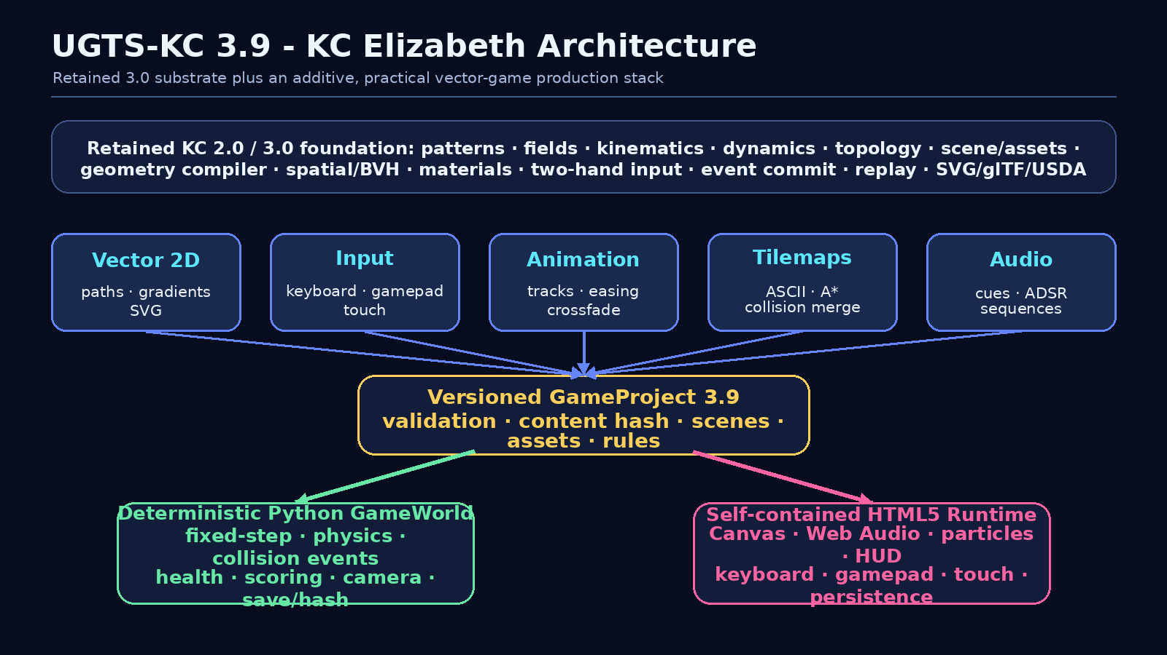
Release architecture overview
Prepared for Tom Klootwijk
Requester-supplied identifier: NL200678942
Requester-supplied date of birth: 10-07-1990
Substrate attribution as supplied: Kees Klootwijk (KC edition)
Version 3.9.0 | Project schema ugts-kc-game-project-3.9

Contents and Executive Summary
Section | Purpose
1. Release definition | What 3.9 adds and what remains compatible.
2. Architecture | How vector assets, project data, simulation and browser output connect.
3. Authoring systems | Vector, input, animation, tilemap and audio APIs.
4. Runtime systems | Entity/components, physics, collisions, gameplay, camera and persistence.
5. Browser deployment | Self-contained Canvas/Web Audio game output and controls.
6. Demonstration | Elizabeth's Vector Garden vertical slice.
7. Validation | Tests, catalogs, schema, syntax, builds and captured evidence.
8. Compatibility and boundary | Migration from 3.0, explicit non-claims and roadmap.

Executive summary
KC Elizabeth 3.9 upgrades the supplied KC Two Hands 3.0 archive from a strong graphics/interaction reference layer into an end-to-end 2D vector-game creation stack. The original 3.0 APIs and 117 tests remain present. The new layer adds a project model, vector artwork, multi-device input, collision/physics, animation, tilemaps/pathfinding, procedural audio, deterministic game simulation, command-line tooling and an offline browser build target.
Release result
A single editable project record can be validated and simulated in Python, then built into a self-contained browser game with keyboard, gamepad and touch controls - without external runtime libraries or network assets.

Measured expansion
- 60 new cataloged mechanisms, M330-M389, extending the combined catalog to 389 mechanisms.
- 108 new automated tests, bringing the complete retained-plus-new suite to 225 tests.
- 11 additive Python modules for vector art, collision, input, animation, tilemaps, audio, game world, projects, HTML5 output, templates and CLI/version metadata.
- A complete demonstration project with editable JSON, exported SVG source assets, deterministic headless smoke run and offline browser build.

1. Release Definition and Scope
The release preserves the canonical UGTS authority chain and wraps it in a pragmatic game-production loop. The game layer is additive: it does not replace the retained scene, geometry compiler, hand interaction, event proposal/commit, replay or interchange modules.
local/spatial support -> compatibility -> guard classification
-> verified proposal -> deterministic event commit
-> scene/topology/dynamic patch -> lineage + replay log
-> optional render/export
vector assets + input actions + scene project
-> fixed-step game world + collision/gameplay systems
-> canonical snapshot/hash/save
-> Canvas/Web Audio HTML5 build

Area | KC Two Hands 3.0 baseline | KC Elizabeth 3.9 addition
Geometry/content | Scene, assets, geometry compilation, materials, SVG/glTF/USDA | Serializable 2D paths, gradients, primitive factories and per-asset SVG.
Interaction | Typed two-hand input and bimanual transforms | Action map spanning keyboard, pointer, gamepad and touch.
Runtime | Deterministic proposal commit, snapshots and replay | Fixed-step 2D game world, body integration, collisions and gameplay components.
Authoring | Python APIs and sandbox | Versioned project JSON, validation, templates and CLI.
Delivery | Reference render/export adapters | Self-contained playable HTML5 Canvas/Web Audio output.
Coverage | 117 tests, catalog through M329 | 225 tests total, catalog through M389.

Compatibility guarantee
All retained source modules remain available under their previous paths. The upgrade is additive under ugts_kc3. The game-project schema is explicitly versioned, and legacy reports/evidence are preserved in dedicated legacy folders.

Pragmatic design choices
- Dependency-free engine runtime: standard-library Python and generated browser APIs.
- Small, inspectable records rather than opaque binary assets.
- Deterministic fixed-step reference simulation for tests and save identity.
- A browser target that can be opened directly or served by any static host.
- Extensible custom component mappings and ordered system phases for project-specific logic.

2. Architecture

Figure 1. Retained substrate and additive 3.9 game stack.

Single source of project truth
GameProject holds metadata, display settings, input actions, vector assets, audio records, tilemaps, scenes, the start-scene ID and build settings. The same canonical dictionary is used for project validation, content hashing, Python scene instantiation and browser embedding.
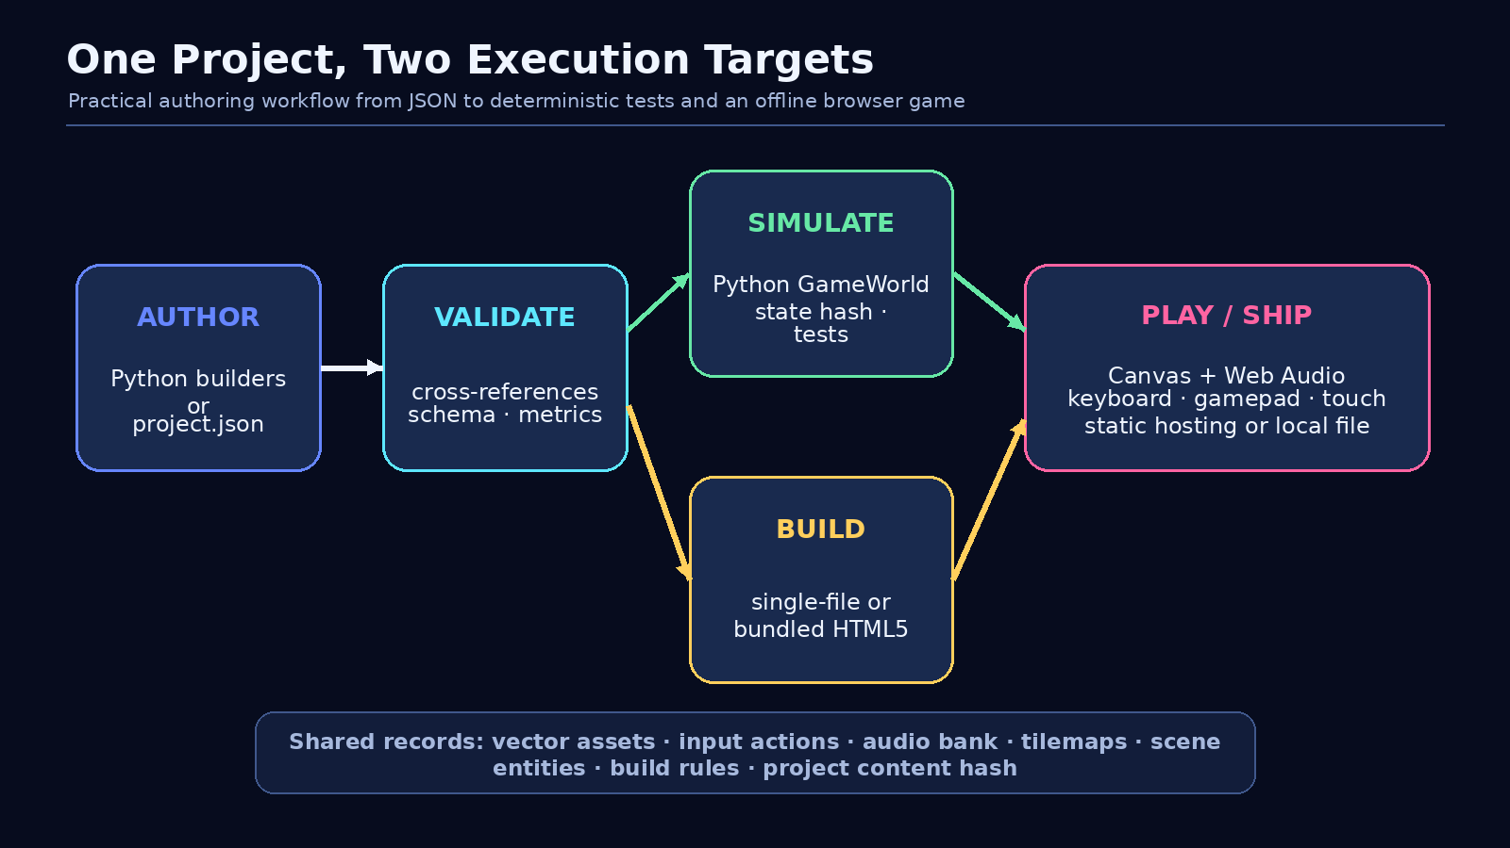
Figure 2. One project feeds headless simulation and browser deployment.

3. Vector Art Authoring
The new vector layer supplies a compact retained-mode artwork format suitable for code generation, JSON storage, SVG inspection and direct Canvas rendering. Assets remain resolution independent and avoid external texture files for the included workflow.
Record | Role | Key guards
VectorAsset2D | Stable asset ID, logical size, pivot, ordered paths, gradients and metadata. | Positive size, unique path/gradient IDs, valid references.
VectorPath | Typed command sequence plus paint and fill rule. | Move-before-draw, finite coordinates, supported commands.
VectorPaint | Fill, stroke, width, opacity, cap/join and fill rule. | Opacity range and non-negative stroke width.
Linear/RadialGradient | Named reusable stop resources. | Finite geometry, positive radius and ordered offsets.
VectorLibrary | Deterministic asset registry. | Duplicate IDs rejected unless explicitly replaced.

Curve and primitive support
- Path commands: move, line, quadratic, cubic and close.
- Adaptive quadratic/cubic flattening to a caller-selected tolerance.
- Rectangle/rounded rectangle, circle, polygon and star factories.
- Deterministic SVG output with correctly centered size/pivot framing.
path = (VectorPathBuilder("ship")
.move_to(28, 0).line_to(-20, -18)
.line_to(-8, 0).line_to(-20, 18)
.close().build(VectorPaint(fill="@hull", stroke="#ffffff")))
asset = VectorAsset2D("ship", (64, 48), (0, 0), (path,), gradients)

Regression found during packaging
Standalone SVG inspection exposed an incorrect viewBox origin for centered procedural assets. Version 3.9 now frames the logical rectangle around the declared pivot, and the test suite includes a regression assertion.

4. Input and Animation

Action-based multi-device input
Gameplay logic consumes named scalar actions. Bindings can sample keys, pointer controls, gamepad axes/buttons and touch axes. Action resolution applies signed scaling, deadzones, optional clamping and thresholds. InputFrame exposes value, down, pressed, released and normalized two-action vectors.
Action pattern | Example bindings | Use
move_x | A/D, arrows, gamepad axis 0, touch move_x | Horizontal movement.
move_y | W/S, arrows, gamepad axis 1, touch move_y | Vertical movement.
dash | Space, Shift, gamepad button 0, touch dash | Edge-triggered burst movement.
pause/restart/save/load | Keyboard and gamepad buttons | Game-shell control.
debug/mute | F3 and M | Runtime diagnostics and audio control.

Deterministic input frames
InputMap resolves raw device state or explicit action values into serializable frames containing current and previous values, thresholds, pointer position and frame index. InputRecorder stores and restores frame sequences for tests and replay-oriented tooling.

Keyframe animation
- Strictly increasing key times and finite scalar/vector values.
- Named easing functions including linear, smooth, polynomial, sine, back and bounce families.
- Once, loop and ping-pong clip time mapping.
- Crossfade blending and predicate-driven animation state machines.
- Dot-path sample application into nested serializable records.
clip = AnimationClip("pulse", 1.0, tracks, mode="pingpong")
player = AnimationPlayer({"pulse": clip})
player.play("pulse")
sample = player.update(1 / 60)
apply_animation_sample(component_record, sample)

5. Tilemaps, Navigation and Procedural Audio

Layered tilemaps
TileMap stores named definitions and same-sized layers over a common origin and tile size. Compact ASCII import makes prototype levels readable in source control. The map API handles tile/world conversion, solidity queries, flood reachability, cost-aware A* paths and merged solid collision rectangles.
Operation | Contract | Practical use
ASCII import | Rectangular rows and complete character legend. | Fast editable prototype maps.
A* path | In-bounds non-solid endpoints; optional diagonals and movement cost. | Grid enemies and puzzle navigation.
Flood search | Returns all reachable cells from a start. | Room/region and placement analysis.
Collision merge | Adjacent compatible solid cells become larger AABBs. | Fewer world colliders.

Procedural sound records
AudioBank validates named oscillator cues and beat sequences. SoundCue combines waveform, start/end frequency, duration, volume, optional noise and an ADSR envelope. Notes use equal-tempered pitch conversion. Python validates and serializes these records; the generated browser runtime realizes them through Web Audio.
- No sampled audio files are needed for the included effects/music.
- Cue references are validated across entities, scene rules and sequences.
- The demonstration includes collect, dash, damage, win, game-over, save and music-pluck cues.
Runtime boundary
Procedural audio playback is implemented in the browser target. The Python layer intentionally remains device-independent data/validation rather than opening an audio device.

6. Deterministic Game World
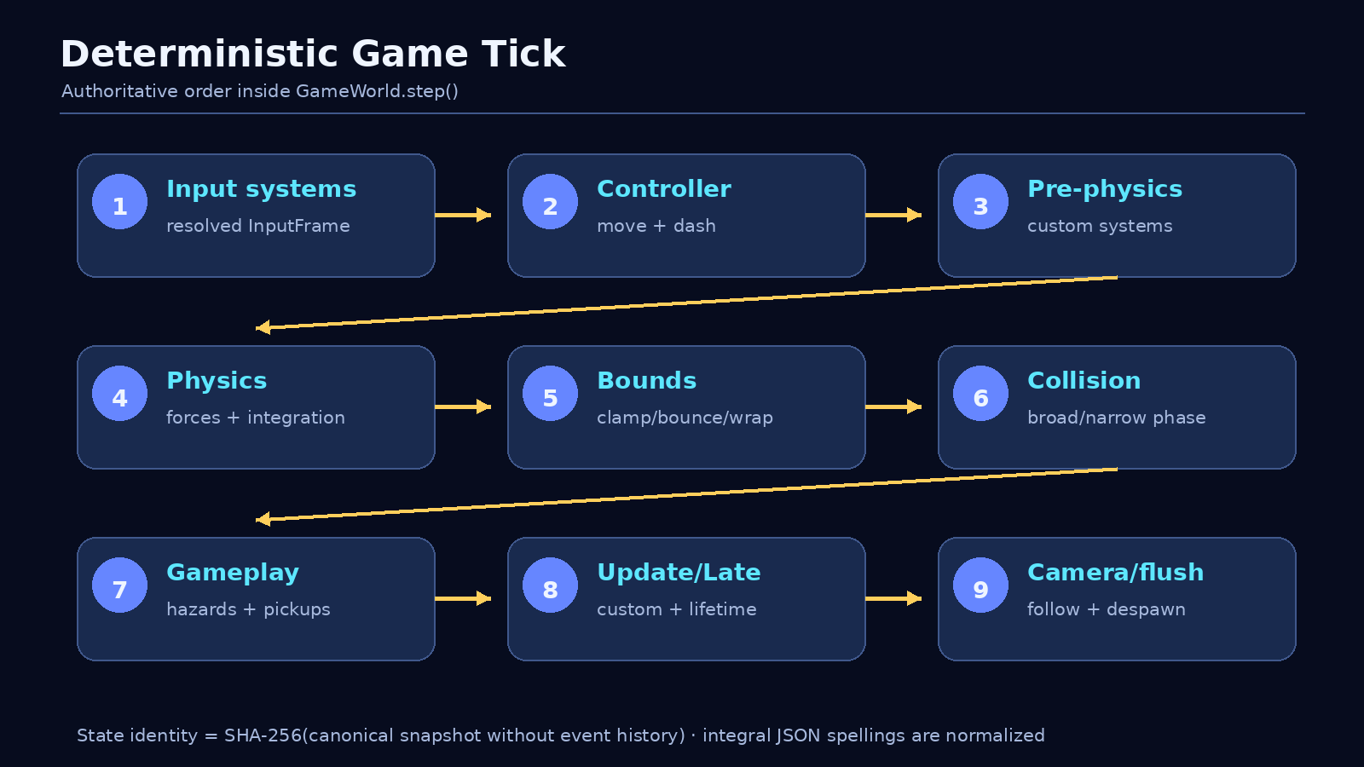
Figure 3. Authoritative fixed-step system order.
GameWorld is a dependency-free entity/component reference runtime. Every simulation tick runs an explicit phase order. Custom systems register by phase, integer priority and stable name, so projects can extend gameplay without weakening deterministic ordering.
Component | Function
Transform2D | Position, rotation and non-zero scale.
Body2D | Dynamic/kinematic/static body, velocity, force, damping, gravity scale and material response.
Collider2D | AABB/circle/convex shape, offset, layer/mask filter and sensor flag.
PlayerController2D | Action-driven velocity and edge-triggered dash with duration/cooldown.
Health2D / Hazard2D | Bounded health, invulnerability, damage cooldown and knockback.
Collectible2D | State-key scoring, sound event and optional deferred destruction.
BoundsConstraint2D | Clamp, bounce or wrap world constraints.
Camera2D / Lifetime2D | Smoothed bounded follow camera and timed entity removal.

7. Collision, Gameplay Events and Persistence

Collision stack
- Shape support: AABB, circle and convex polygon.
- Mixed-shape manifold dispatch with penetration, normal and contact points.
- Layer/mask filtering and non-resolving sensor contacts.
- Spatial-hash broad phase for deterministic candidate pairs.
- Swept AABB time-of-impact query for fast box motion.
- Velocity response with restitution and friction plus penetration correction.

Lifecycle and gameplay events
The contact set is compared across ticks to emit collision_enter, collision_stay and collision_exit. Collectibles and hazards are built on these contacts. Entity destruction requested during a step is deferred until the tick completes, preventing mutation during collision iteration.
Event example | Payload/use
entity_spawned / entity_despawned | Lifecycle inspection and custom systems.
collision_enter/stay/exit | Ordered entity pair, normal, penetration and contacts.
dash | Source entity and dash direction.
collected | Collector, points and state key.
damaged / entity_defeated | Damage, remaining health and source hazard.
sound | Cue ID consumed by presentation or test harness.

Snapshots, hashes and saves
Snapshots include schema, fixed step, gravity, tick/time, game state, entity/component records, active contacts and optional event history. State hashes intentionally exclude event history and use canonical sorted JSON. Numerically equivalent integral spellings, such as 1 and 1.0, normalize to the same identity, preventing hash drift after JSON round trips.
snapshot = world.snapshot()
world.save("save.json")
clone = GameWorld.load("save.json")
assert clone.state_hash() == world.state_hash()

8. Self-Contained HTML5 Runtime
build_html5 validates a GameProject and emits either one self-contained HTML file or an HTML page plus kc-runtime.js. The build also writes the canonical project JSON, launch notes and a build report with project/file hashes and byte counts.
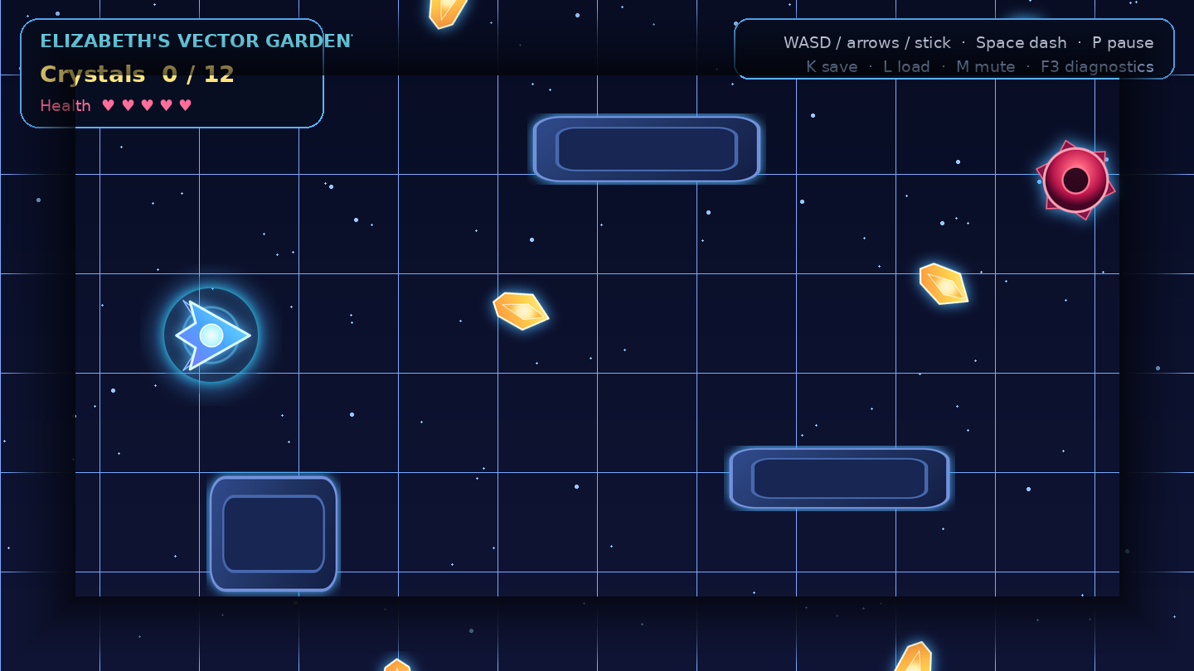
Figure 4. Static inspection render generated from the same vector project records used by the browser build.
Browser subsystem | Implemented behavior
Presentation | Canvas paths, fills/strokes, linear/radial gradients, z-order, transforms, camera, grid and vignette.
Simulation | Fixed-step accumulator, body integration, broad/narrow collision, bounds, pickups, hazards and win/lose state.
Input | Keyboard, gamepad polling and touch joystick/dash controls.
Feedback | Particles, HUD, best score, pause/restart, mute and F3 diagnostics.
Audio | Web Audio oscillator/noise cues and beat-sequence music.
Persistence | Project-ID-scoped local save/load and best-score storage.

Deployment
The single-file output uses no CDN, package manager or network asset. It may be opened directly or hosted by any static server. Browser storage is convenience persistence, not a security boundary.

9. Command-Line Authoring Workflow
The module entry point and installed ugts-kc command make the package usable without writing a custom build script.
Command | Purpose
info | Print runtime version, edition and capabilities.
new | Create a blank or Elizabeth-quest project; optionally build immediately.
validate | Aggregate project errors/warnings and metrics; optional JSON report.
simulate | Run deterministic headless steps with declared movement/dash values.
build-web | Create single-file or split-bundle browser output.
export-svg | Write every vector asset as an individual SVG.
demo | Write and build Elizabeth's Vector Garden.

PYTHONPATH=src python -m ugts_kc3 new my_game \
--title "My Vector Game" --author "Your Name" --build
PYTHONPATH=src python -m ugts_kc3 validate my_game/project.json
PYTHONPATH=src python -m ugts_kc3 simulate my_game/project.json \
--steps 240 --move-x 1 --dash-at 30 --json
PYTHONPATH=src python -m ugts_kc3 build-web \
my_game/project.json my_game/dist

Project validation metrics
- Scene and entity counts.
- Vector asset, audio cue, tilemap and input-action counts.
- Metadata/display/input/audio validation.
- Duplicate IDs and start-scene checks.
- Unknown vector asset, sound cue and tilemap references with exact paths.

10. Elizabeth's Vector Garden Demonstration
The included vertical slice is not merely a screenshot or design document. It is an editable project.json, a set of exported SVG assets, a deterministic headless smoke script and a generated offline browser game under examples/elizabeth_vector_quest/.
Content | Demonstrated capability
Player ship | Vector gradients, camera follow, collision body, action movement, dash, health and bounds.
12 crystals | Sensor collision, score transaction, particles, sound, spin/pulse and win target.
7 obstacles | Static bodies, scaled vector assets and collision response.
4 moving hazards | Kinematic patrol, bounce bounds, damage cooldown, knockback and game-over path.
Portal/background | Decorative vector layers, grid and vignette.
HUD/shell | Instructions, score/health/best state, pause, restart, saves, mute and diagnostics.
Audio | Procedural effects plus an eight-beat music sequence.

Controls
- Move: WASD, arrow keys, gamepad left stick or touch joystick.
- Dash: Space, Left Shift, gamepad button 0 or touch dash.
- Pause: P or Escape. Restart: R. Save: K. Load: L. Mute: M. Diagnostics: F3.

Headless smoke evidence
The checked-in headless_smoke.py loads the exact project file, runs 240 fixed steps with a deterministic movement/dash input sequence and prints tick, state, entity count and state hash. This exercises project loading, scene instantiation, input frames, game stepping and canonical state identity without a browser.
{"tick": 240, "state": {"score": 1, "scene": "vector_garden"},
"entities": 25,
"hash": "cf1317428c6992255e8911f3647a3faaa959f4034b7ccec8ebc92c7b6f4db8ae"}

11. Validation and Release Evidence
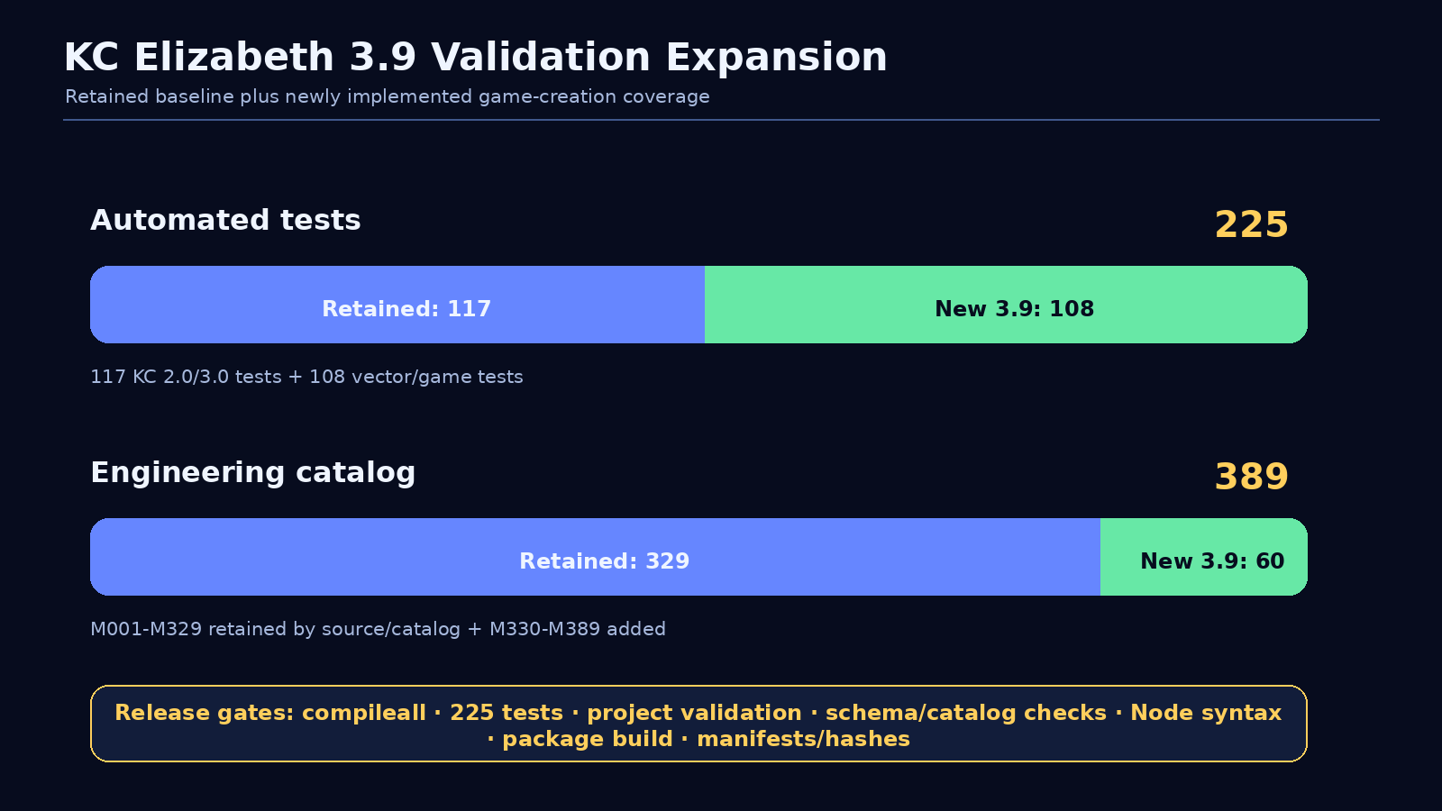
Figure 5. Test and mechanism-catalog expansion.
Gate | Expected release result
Python compile | All source modules compile with compileall.
Automated tests | 225/225 pass: 117 retained and 108 new.
Project validation | Blank and Elizabeth templates pass cross-reference validation.
Round trips | Project and world save/load preserve canonical content/state hashes.
Catalog | M198-M389 engineering catalog is contiguous; M330-M389 contains 60 additions.
JSON schema | Example/template projects satisfy top-level 3.9 schema and runtime validation.
JavaScript | Generated runtime passes Node.js syntax validation.
Browser build | Single-file and split-bundle outputs are generated with reports/hashes.
Package build | Python wheel/sdist metadata build succeeds.
Manifest | All final files receive SHA-256 entries and release metrics.

The validation directory contains machine-readable summaries, command captures, catalog/schema checks, build reports, file manifests and hashes. The original 3.0 evidence is preserved under validation/legacy_3_0 rather than overwritten.

12. Mechanism Catalog M330-M389
KC Elizabeth adds 60 engineering mechanisms across eight domains. Full definitions, formulas, integration notes and validation statuses are available in CSV and JSON under spec/.
Range | Domain | Count | Representative mechanisms
M330-M337 | Vector art | 8 | Asset records, path grammar, gradients, curve flattening, primitives and SVG.
M338-M345 | Collision/physics | 8 | Shapes, SAT, mixed manifolds, filters, sensors, sweep and spatial hash.
M346-M351 | Input | 6 | Actions, multi-device bindings, deadzones, edges, vectors and recording.
M352-M357 | Animation | 6 | Tracks, easing, clip clocks, crossfades, state machines and property paths.
M358-M363 | Tilemaps | 6 | Definitions, layers, ASCII import, transforms, A* and merged collisions.
M364-M368 | Procedural audio | 5 | Pitch, ADSR, cues, sequences and cross-reference bank.
M369-M378 | Game world | 10 | ECS, fixed step, phases, bodies, contacts, controller, gameplay, saves.
M379-M389 | Project/export | 11 | Schema, validation, instantiation, hashes, CLI, simulation, SVG and HTML5.

Combined count
Source-normalized baseline: 197 mechanisms
KC 2.0 additions: 60 (M198-M257)
KC 3.0 additions: 72 (M258-M329)
KC Elizabeth 3.9: 60 (M330-M389)
-------------------------------------------
Extended total: 389 mechanisms

Catalog meaning
Mechanism IDs are engineering catalog entries for traceability and coverage. They are not, by themselves, claims of novelty, patentability, ownership or independent scientific validation.

13. Migration, Compatibility and Evidence Boundary

Migration from 3.0
- Retain existing KC 3.0 scene/geometry/hand/replay workflows where they are useful.
- Create a VectorLibrary for browser-ready 2D art.
- Define device-independent actions in InputMap.
- Express playable objects as EntitySpec component records.
- Create GameSceneSpec rules and initial state, then wrap them in GameProject.
- Validate, simulate headlessly and build HTML5 output.
- Use GameWorld snapshots/hashes for 2D game tests and retained 3.0 replay/event facilities for higher-level authoring workflows.

Explicit non-claims
- No native Vulkan, Direct3D, Metal or physical-device WebGPU implementation is claimed.
- No general rigid-body/joint/deformable physics engine is claimed.
- No skeletal animation suite, multiplayer service, console SDK or OpenXR binding is claimed.
- No full OpenUSD, MaterialX or OCIO runtime integration is claimed.
- No security certification is claimed for project files or browser storage.
- Requester identity, attribution and ownership assertions are recorded as supplied and remain independently unverified.

Post-3.9 direction
The roadmap prioritizes an optional Rust/C ABI core, visual editor, richer asset support, continuous collision and joints, browser tilemap rendering/streaming, optional WebGPU presentation, import adapters, multiplayer proof work and cross-browser automation. Each remains future work rather than an implicit feature claim.

Appendix A - Package Map and Attribution
Path | Contents
src/ugts_kc/ | Retained KC 2.0 pattern/topology/kinematics/field/dynamics oracle.
src/ugts_kc3/ | Retained 3.0 modules plus 3.9 vector/game/project/browser stack.
examples/elizabeth_vector_quest/ | Editable project, SVG assets, screenshot, smoke script and offline build.
templates/ | Blank and full project templates.
spec/ | Contracts, JSON schema and catalogs through M389.
docs/ | Getting started, creation guide, API overview, migration, runtime guide and boundaries.
report/ | Current 3.9 report and retained 3.0 legacy reports.
tests/ | 225 automated tests.
validation/ | Current release evidence and retained legacy evidence.

Attribution notice
Prepared for Tom Klootwijk as the UGTS-KC 3.9 - KC Elizabeth Edition. The requester described the underlying substrate attribution as Kees Klootwijk (KC edition). The identifier NL200678942 and date of birth 1990-07-10 (request format 10-07-1990) were supplied by the requester and are not independently verified.
This report and package are not legal proof of identity, authorship, ownership, patentability, priority, exclusive rights, licensing status or chain of title. No third-party source is silently re-licensed by the attribution wording.

Release identifiers
Identifier | Value
Runtime version | 3.9.0
Codename | KC Elizabeth
Project schema | ugts-kc-game-project-3.9
Combined mechanism range | M001-M389 by source/catalog
Automated tests | 225
Immediate baseline SHA-256 | 624f9af1236ea6a0a637758516ed974238ad92b324949f690f0fcc169d9f7866

