UGTS-KC TWO HANDS 3.0
Interactive Graphics, Game Runtime and Content Substrate
Production companion and tested reference vertical slice

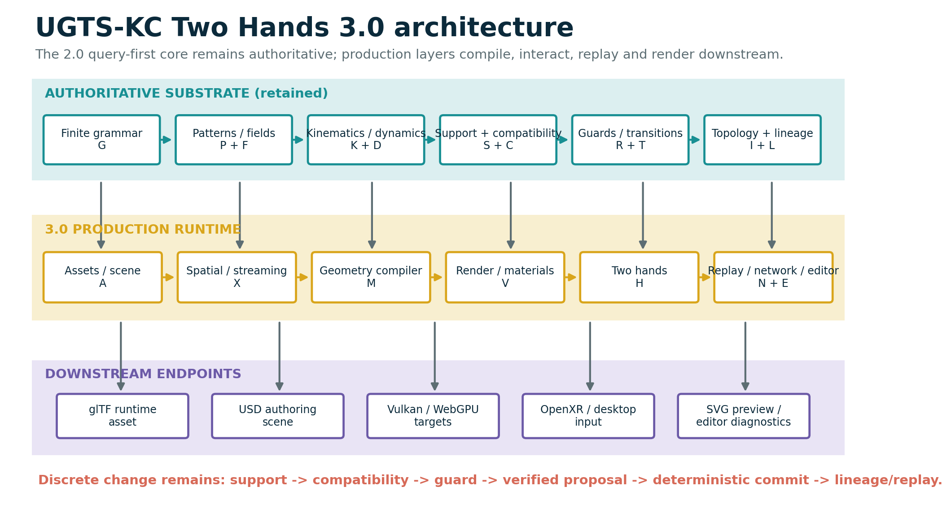
Prepared for | Tom Klootwijk
Requester-supplied identifier | NL200678942
Requester-supplied date of birth | 10 July 1990
Document date / version | 16 August 2026 / 3.0.0

ATTRIBUTION BOUNDARY
The name, identifier and date of birth above were supplied by the requester and were not independently verified. This technical package is not legal proof of identity, authorship, ownership, priority or patentability.

Contents and reading rule
- 1. Executive upgrade decision
- 2. Continuity and evidence discipline
- 3. Formal KC Two Hands 3.0 architecture
- 4. Scene, asset and instance composition
- 5. Geometry compiler and approximation contracts
- 6. Spatial acceleration, culling and streaming
- 7. Rendering, materials, color and interchange
- 8. Game runtime, animation and physics boundary
- 9. KC Two Hands interaction calculus
- 10. Event proposal, replay and networking
- 11. Runnable sandbox vertical slice
- 12. Validation, acceptance and kill criteria
- 13. Final upgraded definition and roadmap
- Appendix A. M258-M329 mechanism catalog
- Appendix B. API and exchange dictionary
- Appendix C. Source, standards and package verification
READING RULE
The core is still not a renderer. Geometry and kinematics define typed state and relations; spatial structures prune candidates; hand, GPU and game systems may propose interactions; only verified deterministic commit changes authoritative state and lineage. Rendering and export remain downstream projections.

Document control
Item | Status / count | Meaning
UGTS source-normalized baseline | 197 mechanisms | M001-M197 retained by source/reference.
UGTS-KC 2.0 additions | 60 mechanisms | M198-M257 pattern, field, topology, kinematics and dynamics.
KC Two Hands 3.0 additions | 72 mechanisms | M258-M329 production runtime and interaction expansion.
Extended catalog total | 329 mechanisms | Baseline plus the two explicitly separated engineering additions.
Executable verification | 117 tests PASS | 47 retained KC 2.0 tests plus 70 new KC 3.0 tests.
Physical-GPU claim | false | No physical Vulkan GPU benchmark is claimed by this package.
Runtime dependency | Python standard library | Matplotlib/CairoSVG are used only to regenerate report diagrams.

Immediate source basis
Source | SHA-256 prefix | Treatment
UGTS-0 architecture PDF | c991aba24cc939ba... | Referenced by hash; not redistributed.
UGTS-GN 1.1 GPU-native addendum | 3a6b6c57118ca4e2... | Referenced by hash; not redistributed.
UGTS-KC 2.0 package | 834997b0139ee43... | Immediate implementation baseline; not nested in this ZIP.
UGTS-KC 2.0 report | a29dd9959ebd300c... | Immediate technical companion baseline.

1. Executive upgrade decision
3.0 changes the center of gravity from mathematical breadth to a usable graphics/game vertical slice.

1.1 Baseline retained
The mature UGTS line remains a query-first relation and event substrate. A finite grammar and typed state define what exists; local support and conventional spatial bounds remove irrelevant candidates; compatibility determines whether supported states may couple; guards and numerical status define candidate events; deterministic transition logic updates scene, route, topology, dynamics and lineage. KC Two Hands 3.0 does not replace that sequence with a frame loop, renderer or physics engine.
UGTS-KC 2.0 already supplied the needed mathematical breadth: parameterized pattern families, implicit fields, topology descriptors, SE(2)/SE(3) kinematics, moving frames, jerk-bounded timing, bounded dynamics and event-degeneracy handling. The remaining production gap was the path from those operators to scenes, meshes, materials, hand interaction, replay and export.

1.2 What is new
- A versioned asset/scene layer with stable node identity, content hashes, transform hierarchies, layers, units and migration history.
- A deterministic geometry compiler for adaptive cubic curves, strokes, swept tubes and bounded marching-tetrahedra field meshing.
- A hybrid spatial layer containing AABB, BVH, ray/frustum queries, streaming cells, interest sets and culling reason codes.
- Typed PBR preview materials, an acyclic procedural material graph, color transforms and a deterministic CPU/SVG renderer.
- Typed left/right hand state, pinch hysteresis, bimanual translation/scale/alignment/twist, cooperative grab and handover lineage.
- A fixed-step event runtime with proposal verification, deterministic conflict resolution, snapshots, checkpoints, rollback and divergence detection.
- glTF 2.0 JSON, USDA, UGTS JSON, replay JSON and SVG output adapters, plus Vulkan/WebGPU/OpenXR production contracts.

1.3 Upgrade decision
DECISION - GO
GO for the 3.0 production companion because it demonstrates one complete path from 2.0 pattern and field definitions to compiled geometry, scene composition, two-hand interaction, authoritative event commit, replay and downstream graphics export. The release remains a reference vertical slice, not a claim of a finished commercial engine.

1.4 Concrete deliverables
Deliverable | Location | Status
Companion report | report/*.pdf and *.docx | Delivered and visually verified.
M258-M329 catalog | spec/kc3_mechanisms_* | 72 additions in CSV and JSON.
Combined M198-M329 catalog | spec/engineering_catalog_* | 132 engineering entries; baseline M001-M197 retained by reference.
Production schema and contracts | spec/*.json and *.md | Supplied; example validates.
Reference runtime | src/ugts_kc3/ | Dependency-free Python implementation.
Retained KC 2.0 oracle | src/ugts_kc/ | Copied for a self-contained test baseline.
Sandbox vertical slice | examples/two_hands_sandbox.py | Executed; outputs captured.
Shaders | shaders/*.wgsl and *.glsl | Layout/preview prototypes; not physical-GPU benchmarks.
Verification | tests/ and validation/ | 117 passing tests plus hashes and manifests.

2. Continuity and evidence discipline
The 3.0 report distinguishes inherited architecture, engineering implementation and future adapter targets.

2.1 Source-derived continuity
UGTS-0 defines the coherent core as finite grammar, typed state, local support, compatibility, event solving, transition, lineage and an external novelty log. Its game integration section explicitly allows conventional meshes, rigid bodies, audio, animation, editor tools and rasterization to coexist with the authoritative query substrate. That separation is the basis of this 3.0 companion.
UGTS-GN 1.1 makes the canonical order even more explicit: local support, compatibility, guard crossing, verified event, route/transition and lineage. It also establishes an important evidence boundary: software Vulkan execution or intermediate code is not the same as measured physical-GPU advantage. KC Two Hands 3.0 retains that distinction.

2.2 Engineering additions
Mechanisms M258-M329 are engineering additions. They are not described as if they were extracted verbatim from the source PDFs. Each catalog row records a normalized definition, formula or contract, integration role and validation status. Fully implemented reference mechanisms are separated from shader contracts, metadata targets, specified boundaries and acceptance gates.
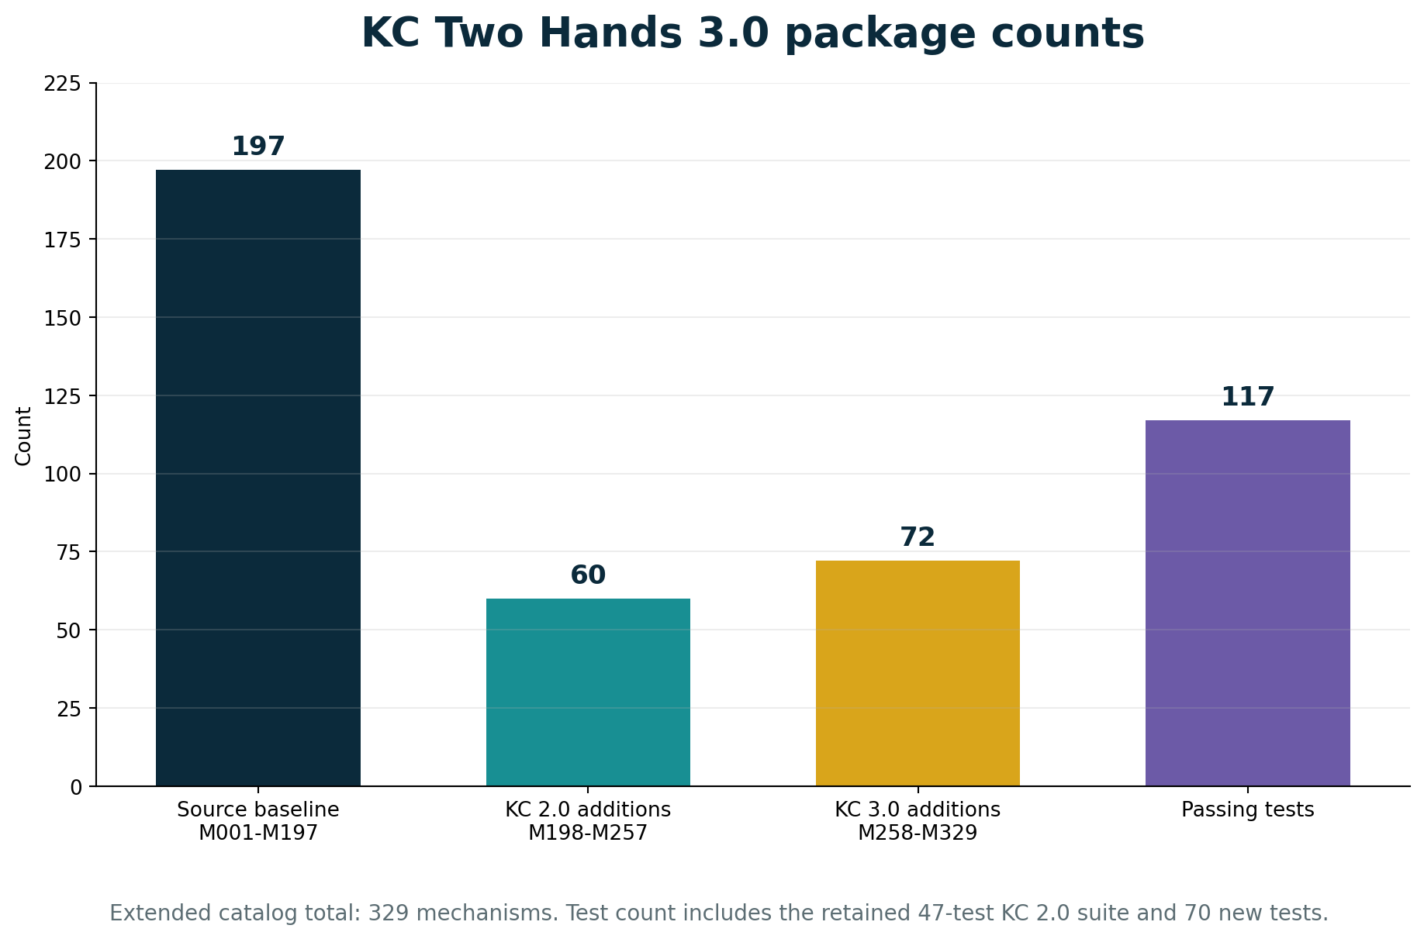
Figure 2. Mechanism and test counts. The 3.0 addition is explicitly separated from the source-normalized baseline and the 2.0 engineering layer.

2.3 Claim boundary
- No universal O(1) world or arbitrary exact event solver is promoted.
- No zero-memory, zero-latency, zero-heat or one-bit-complete-state claim is introduced.
- Topology remains explicit gluing/routing and never substitutes for contact mechanics or conservation laws.
- Generated meshes and pixels are downstream representations unless promoted under a validated application contract.
- Vulkan, WebGPU, OpenXR, OpenUSD, MaterialX and OpenColorIO are integration targets; full conformance is not claimed.
- A named physical GPU, driver, workload, precision, equal-error baseline and measured latency/energy are required before a GPU performance claim is promoted.

3. Formal KC Two Hands 3.0 architecture
Production layers are added around - not inside - the authoritative event core.

3.1 Extended definition
UGTS-KC2 = (G, P, F, K, D, R, S, C, T, I, L)
UGTS-KC3 = UGTS-KC2 + (A, X, M, V, H, N, E)
A : assets, instances, scene layers and migration
X : bounds, BVH, culling, streaming and interest sets
M : curve/field-to-mesh compilation and error contracts
V : materials, color, rendering and interchange outputs
H : left/right hand input and bimanual interaction
N : event sequence, checkpoint, rollback and replay
E : diagnostics, editor inspection and validation gates
The notation does not imply that every field belongs in one hot record. A production implementation should keep stable IDs, transform and event-critical state compact while leaving mesh payloads, material graphs, editor metadata and source definitions in referenced cold storage.

3.2 Canonical production path
pattern / field + kinematic state
-> conventional bounds / spatial query
-> local support pruning
-> topology / mode / policy compatibility
-> guard value + derivative + error interval
-> event proposal
-> deterministic verification and conflict policy
-> scene / topology / dynamic patch
-> lineage + replay / novelty log
-> optional render, export, audio or haptics

Figure 3. The retained substrate remains authoritative. Scene, spatial, geometry, render, hand and replay layers form a production-facing shell.

3.3 State and identity split
q_hot = (position, time, phase, sheet, orientation,
branch, policy, uncertainty, velocity, mode,
node_id, lineage_ref)
node_cold = (asset_id, parent_id, local_transform, bounds,
material_binding, interaction_binding,
layer, tags, editor_metadata)
Node identity, asset identity and lineage are distinct. Multiple nodes may instance the same asset; multiple nodes may share a coordinate; a node may change asset or parent through an event without losing its identity. Content hashes support cache and integrity checks, but they do not replace lineage or legal identity.

3.4 Minimum 3.0 query set
Query | Result / contract
world_transform(node) | Composed parent-to-local transform with cycle rejection.
scene_bounds() | Finite union of visible node bounds or an explicit empty result.
query_aabb / query_ray / query_frustum | Conventional coarse candidates with deterministic ordering.
interest_set(center,radius,tags) | Per-user/client replication and streaming scope.
compile_curve / compile_field | Derived mesh plus approximation metadata.
hand_transform(anchor,left,right) | Bimanual transform or bounded rejection state.
commit_proposals(proposals) | Verified ordered authoritative events plus rejection reasons.
replay_to(sequence) | Reconstructed state or first divergence record.
render_preview / export_gltf / export_usda | Non-authoritative presentation artifacts.

4. Scene, asset and instance composition
A game/graphics substrate needs stable content and scene structure in addition to mathematical primitives.

4.1 Asset contract
An asset is an immutable or content-addressed payload containing a derived mesh, material binding, source-pattern reference, schema hash and compilation metadata. The reference content hash is SHA-256 over canonical geometry and metadata. It is used for cache keys, package integrity and peer negotiation; it is not a substitute for full state, provenance or legal authorship.

4.2 Node and hierarchy contract
A scene node carries stable instance identity, optional asset binding, parent, local transform, visibility, tags, layer and lineage. World transforms use parent-first composition. Every parent edit runs cycle detection before it is accepted. This makes editor hierarchy operations ordinary guarded state changes rather than hidden recursive behavior.
T_world(node) = T_world(parent(node)) * T_local(node)
asset identity != node identity
node coordinate != lineage identity
render mesh != authoritative relation definition

4.3 Layers and variants
The reference layer model applies ordered field opinions over a base node. It demonstrates non-destructive authoring without attempting to reproduce a full USD composition engine. A production adapter may map these opinions to USD layers, references, payloads and variant sets while preserving UGTS node IDs and event lineage.

4.4 Schema, units and migration
Required metadata | Purpose
schema_version | Selects field meanings, bit layouts and migration path.
units_per_meter | Converts authored linear quantities without implicit engine defaults.
up_axis / handedness | Prevents silent orientation changes across adapters.
time_unit / fixed_dt | Separates authored time, simulation ticks and presentation interpolation.
working_color_space | Makes preview and export color transforms reproducible.
determinism_profile | Declares bit-exact, tolerance-certified or presentation-only behavior.
migration_history | Records explicit from/to upgrades and operations.

4.5 Scene graph and spatial relationship
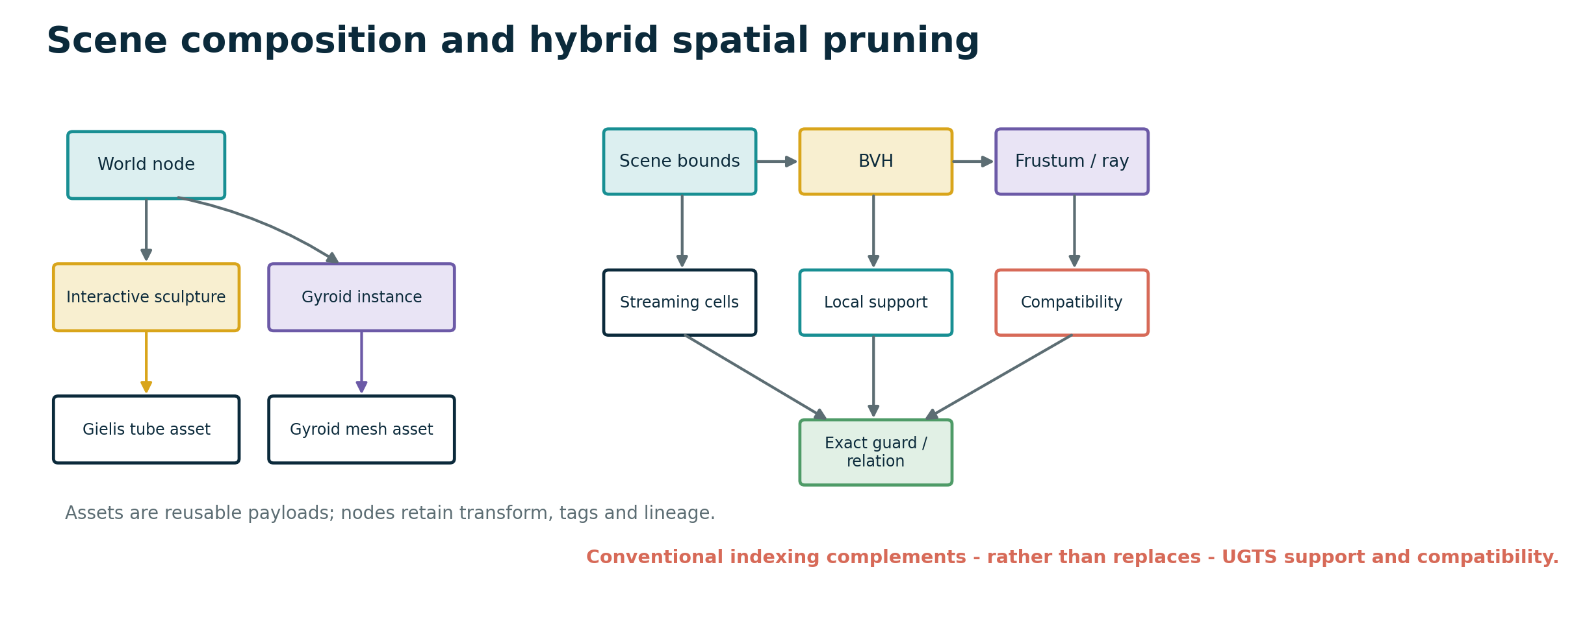
Figure 4. Assets and nodes form the composition graph. Bounds and BVH provide conventional indexing before local support, compatibility and exact guard work.

5. Geometry compiler and approximation contracts
Version 2.0 patterns become usable graphics assets without surrendering authority to a triangle mesh.

5.1 Adaptive parametric curves
The reference compiler flattens cubic Bezier curves using the maximum distance of the interior control points from the endpoint chord. Subdivision stops when the declared flatness tolerance is met or a depth limit is reached. The resulting polyline can feed a stroke, sweep, collision path, arc-length table or editor display.
flatness = max(distance(P1, line(P0,P3)),
distance(P2, line(P0,P3)))
accept segment when flatness <= tolerance or depth == max_depth

5.2 Sweeps and moving frames
A tube mesh is built by sweeping a circular profile along a sampled 3D path. Parallel-transport frames are used so the profile remains stable when curvature approaches zero. Vertices receive angular and cumulative-length UV coordinates. The reference output is deterministic and directly exportable.
v(i,j) = p_i + r * (cos(theta_j) * N_i + sin(theta_j) * B_i)
N_i = normalize(N_(i-1) - T_i * dot(N_(i-1), T_i))
B_i = normalize(T_i x N_i)

5.3 Implicit fields to meshes
Bounded field meshing samples a declared lattice and decomposes each cube into tetrahedra. Crossing edges are interpolated and triangulated. Analytic gradients are preferred for normals; the reference uses centered finite differences when only a scalar field is available. Resolution, bounds and iso value are explicit. There is no hidden infinite raymarch loop.

5.4 Independent error budgets
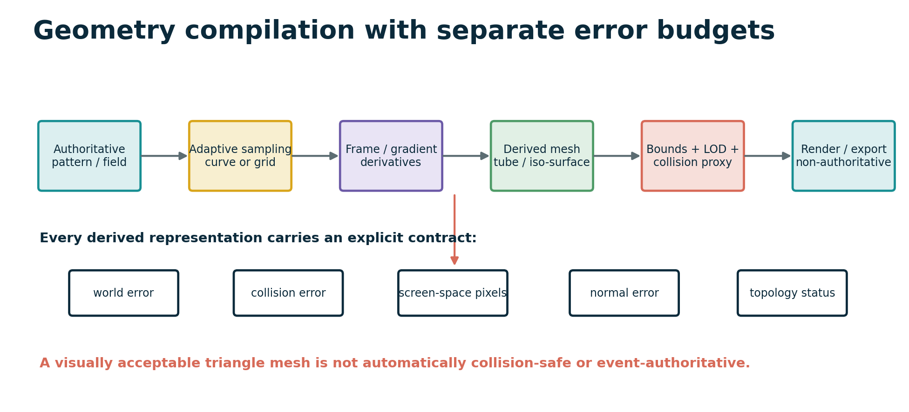
Figure 5. The source pattern or field stays authoritative. Derived render, collision and LOD objects carry independent error and topology status.
Budget | Question answered
world_error | How far may the derived surface move from the declared source geometry?
collision_error | What positional error is acceptable for broad/narrow phase?
screen_space_error_pixels | What silhouette or projection error is acceptable for a view?
normal_error_degrees | What lighting/frame orientation error is acceptable?
topology_preserved | Did compilation/simplification preserve required connectivity and components?

NON-NEGOTIABLE GEOMETRY BOUNDARY
A visually acceptable mesh is not automatically simulation-safe. A collision proxy, LOD or field mesh may be promoted only under an application-specific error and topology contract.

6. Spatial acceleration, culling and streaming
UGTS support predicates work best when combined with ordinary scene indexing rather than treated as a universal replacement.

6.1 AABB and BVH
The reference spatial layer provides finite axis-aligned bounds, unions, overlap, containment, transformed bounds and slab-based ray intervals. A deterministic BVH splits entries at the median center along the longest axis. This is intentionally conventional: it removes broad spatial irrelevance before support and compatibility perform their semantic filtering.

6.2 Hybrid candidate path
BVH / grid / frustum candidates
-> support predicate
-> compatibility predicate
-> exact pattern / field / trajectory evaluation
-> guard classification
-> event proposal

6.3 View and editor queries
Frustum tests use the AABB positive vertex against each view plane. Ray queries return ordered bound hits for picking or coarse interaction. Every rejection can carry a reason code: outside frustum, outside support, incompatible, or visible. These reason codes are important for both editor inspection and performance analysis.

6.4 Streaming and interest management
Bounds enumerate regular-grid cells for a reference world partition. Per-user interest sets combine spatial overlap with required tags. A network adapter can therefore replicate schema, assets, checkpoints and events only for the relevant region while retaining the same authoritative sequence and lineage model.

6.5 Kill criterion
PERFORMANCE BOUNDARY
The hybrid design is rejected for a workload when BVH plus support and compatibility costs exceed a conventional mesh/indexing implementation at equal error, or when event/branch density removes the expected storage and query advantage.

7. Rendering, materials, color and interchange
Presentation becomes practical, replaceable and measurable without becoming state authority.

7.1 Typed preview materials
The reference PBR material records base color, metallic, roughness, emissive, alpha mode, cutoff and double-sided state. A small acyclic graph can read pattern context and combine constants, pattern values, add, multiply, mix and clamp nodes. The graph is deliberately presentation-only; it exposes no state mutation function.

7.2 Light and color pipeline
The CPU preview uses a compact directional Lambert-style shader for deterministic regression images. Scene-linear color may be exposed and passed through Reinhard or fitted ACES-like preview tone mapping before sRGB encoding. The scene schema can name OCIO and ACES targets, but the package does not bundle a production OCIO processor.

7.3 CPU/SVG reference renderer
The renderer transforms scene vertices, projects them through a declared camera, shades triangles and writes SVG. It exists to make the package inspectable and to generate regression artifacts. It is not a rasterization-performance claim and does not redefine the scene or event state.

7.4 Asset and scene interchange
Target | Reference output | Authority
glTF 2.0 | Self-contained JSON with embedded binary buffer, mesh, nodes and PBR fields. | Runtime presentation asset; non-authoritative.
USDA | Readable Xform/Mesh hierarchy with UGTS custom metadata. | Authoring/interchange preview; full USD composition not claimed.
UGTS JSON | Scene, assets, nodes, hands, proposals and authority policy. | Authoritative scene definition when application policy says so.
Replay JSON | Initial scene, ordered events and checkpoints. | Authoritative event/lineage record.
SVG | Deterministic CPU preview. | Non-authoritative projection.

7.5 Backend targets
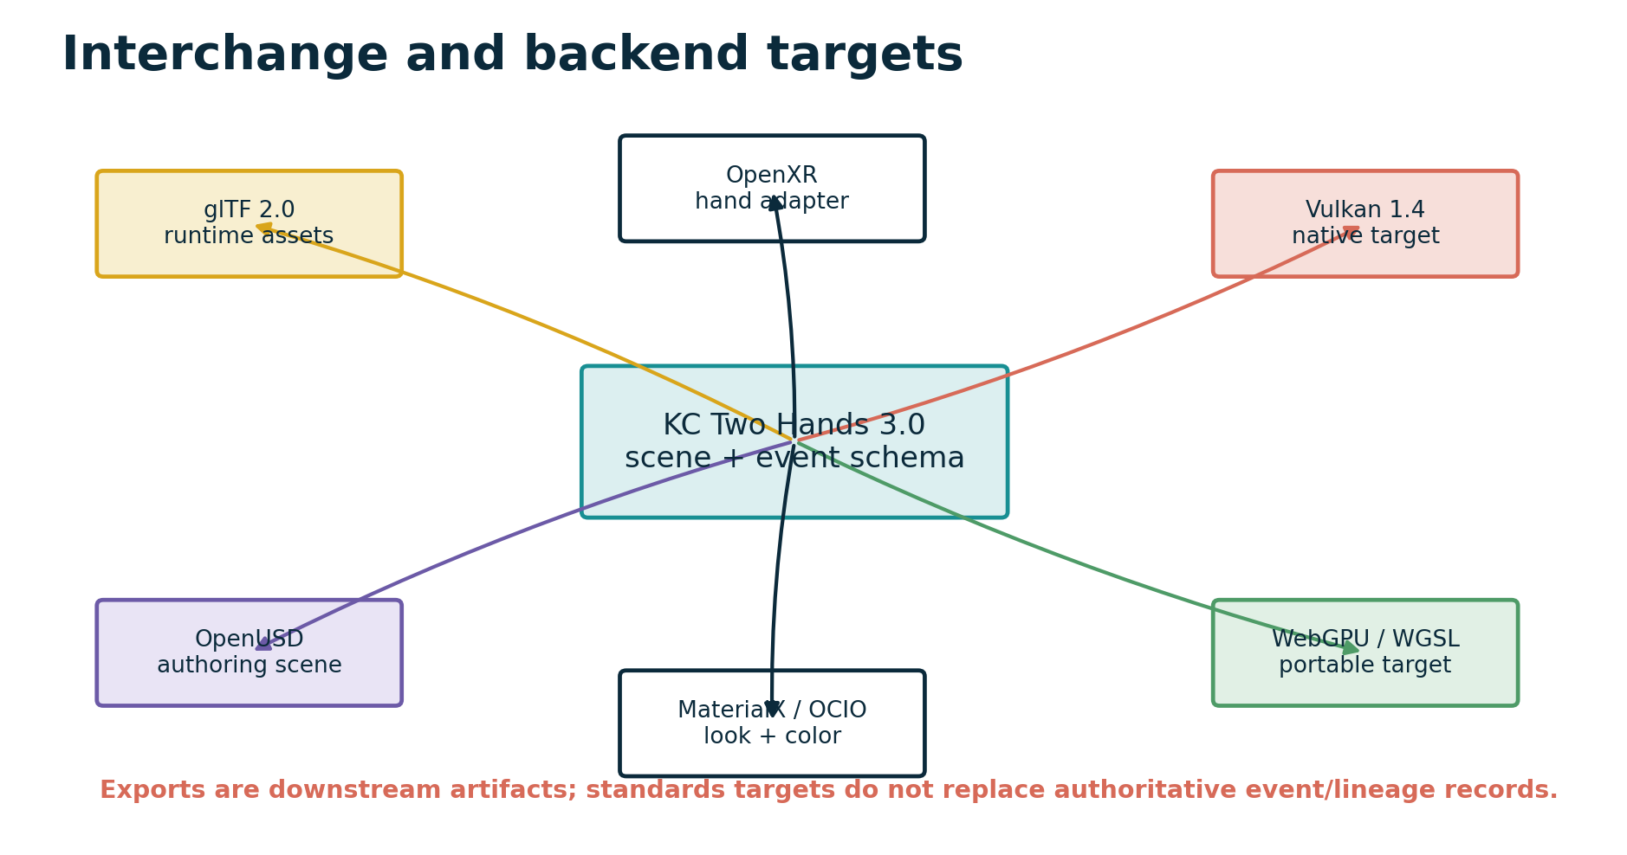
Figure 6. Open standards are adapter targets around a stable KC scene and event schema. The reference package implements only the documented subset.
The Vulkan profile is a physical native target, while WebGPU/WGSL is a portability target. The bundled shader files define instance and event-proposal layouts and a minimal preview pass. They are not compiled 3.0 SPIR-V modules and were not benchmarked on a named physical GPU.

8. Game runtime, animation and physics boundary
A practical game integrates conventional systems while preserving event and lineage authority.

8.1 Fixed-step runtime
KC Two Hands 3.0 separates the fixed simulation clock from input sampling and presentation. Systems may produce proposals during a tick; verification and deterministic commit occur before the tick advances. This produces stable sequence numbers, checkpoints and replay context without claiming cross-vendor bit identity for every floating-point operation.

8.2 ECS mapping
Component / system | Role
Transform + SceneNode | Instance pose, parent, visibility, tags and lineage reference.
Asset + Material | Derived geometry payload and presentation binding.
Support + Bounds | Local semantic admission and conventional spatial pruning.
Compatibility | Sheet, phase, mode, policy, ownership and application tags.
Motion / Kinematics | Closed-form state_at, moving frames or bounded integration.
Guard / Relation | Impact, portal, trigger, interaction or animation event condition.
Constraint | Resting contact, joint, grasp or maintained relation over an interval.
Event / Replay | Ordered patch, pre/post hashes, lineage and correction history.

8.3 Impact versus persistent constraints
impact or portal crossing -> discrete event
resting contact interval -> maintained constraint
joint or cooperative grab -> maintained constraint
constraint release -> discrete event
coincident guard interval -> constraint mode, not infinite events
This division extends the 2.0 tangency/coincidence policy. It prevents a contact manifold or two-hand grab from being represented as an unbounded sequence of zero crossings.

8.4 Animation and physics scope
The catalog defines skeletal hierarchy, animation-state and character-sweep contracts and retains the 2.0 damped least-squares IK operator. The package does not bundle a full skeleton player, rigid-body contact solver or character controller. Unsupported cases are explicitly routed to conventional engine adapters rather than hidden behind topological vocabulary.

9. KC Two Hands interaction calculus
The release name becomes a concrete bimanual input and ownership subsystem.

9.1 Typed hand state
HandPose = (side, wrist_position, wrist_orientation,
joint_positions, joint_radii,
confidence, tracked, source, timestamp)
Left and right are declared schema values. The same structure can be populated by OpenXR hand joints, optical tracking, gloves, controllers, motion capture or deterministic desktop emulation. Device semantics stay in the adapter. Application changes remain gated events.

9.2 Pinch guard
inactive -> active when thumb_index_distance <= enter_distance
active -> inactive when thumb_index_distance >= exit_distance
require exit_distance > enter_distance
The reference detector returns pinch-enter, pinch-exit, hold, missing-joint or tracking-unavailable reason codes. Low confidence resets the reference state; a production application may choose freeze or soften, but the policy must be explicit and replayed.

9.3 Bimanual transform
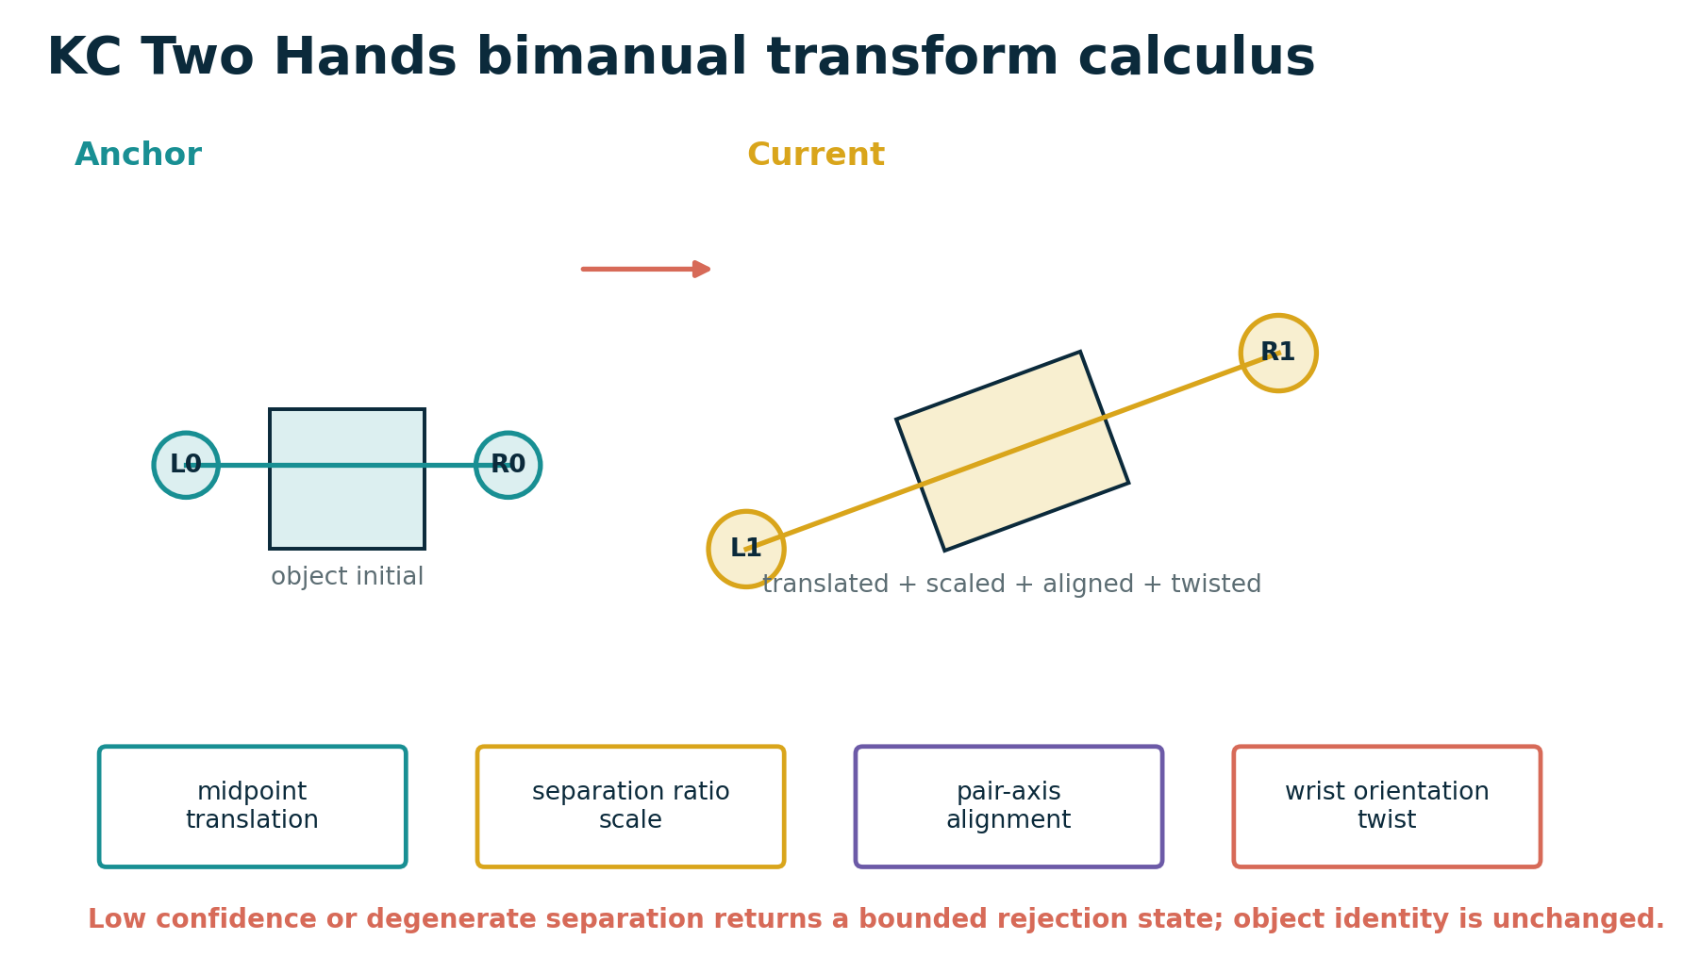
Figure 7. Pair midpoint, separation, pair-axis alignment and wrist twist jointly define the two-hand transform. Degenerate or low-confidence input returns a bounded rejection state.
midpoint m = (p_left + p_right) / 2
scale s = clamp(||right-left|| / ||right0-left0||)
alignment q_a = shortest rotation mapping initial pair axis to current pair axis
twist q_t = averaged wrist-orientation twist around the current pair axis
rotation q = q_t * q_a
world delta = T(m_current) * R(q) * S(s) * T(-m_anchor)

9.4 Ownership and handover
The cooperative-grab state machine distinguishes no owner, one-hand owner and two-hand owner. A second hand joining emits a separate event. When one hand releases a two-hand object, the remaining hand keeps ownership and a handover lineage label is appended. Object identity and scene-node identity do not change.

9.5 Interaction event path
tracked joint poses
-> hand support volumes
-> object / policy compatibility
-> pinch or grab guard with hysteresis
-> verified interaction proposal
-> deterministic transform / ownership patch
-> lineage + replay record

10. Event proposal, replay and networking
Parallel detection is separated from authoritative state mutation.

10.1 Proposal verification
verified = support_ok
and compatibility_ok
and guard_status in accepted_statuses
and confidence >= confidence_floor
and numeric_error <= event_margin
A proposal records ID, event time, type, entity, payload, source, priority, confidence, guard status, numerical error, event margin and lineage label. GPU kernels, input adapters and CPU systems can share this record. Gameplay-critical GPU output is a proposal, not an unchecked state write.

10.2 Deterministic commit and conflicts
Verified proposals are ordered by event time, descending priority, source and proposal ID. Proposals that request incompatible changes to the same entity field at the same event time are resolved by the first ordered winner and the remainder receive explicit conflict rejections. A production system may add commutative merges, but the merge policy must be versioned.
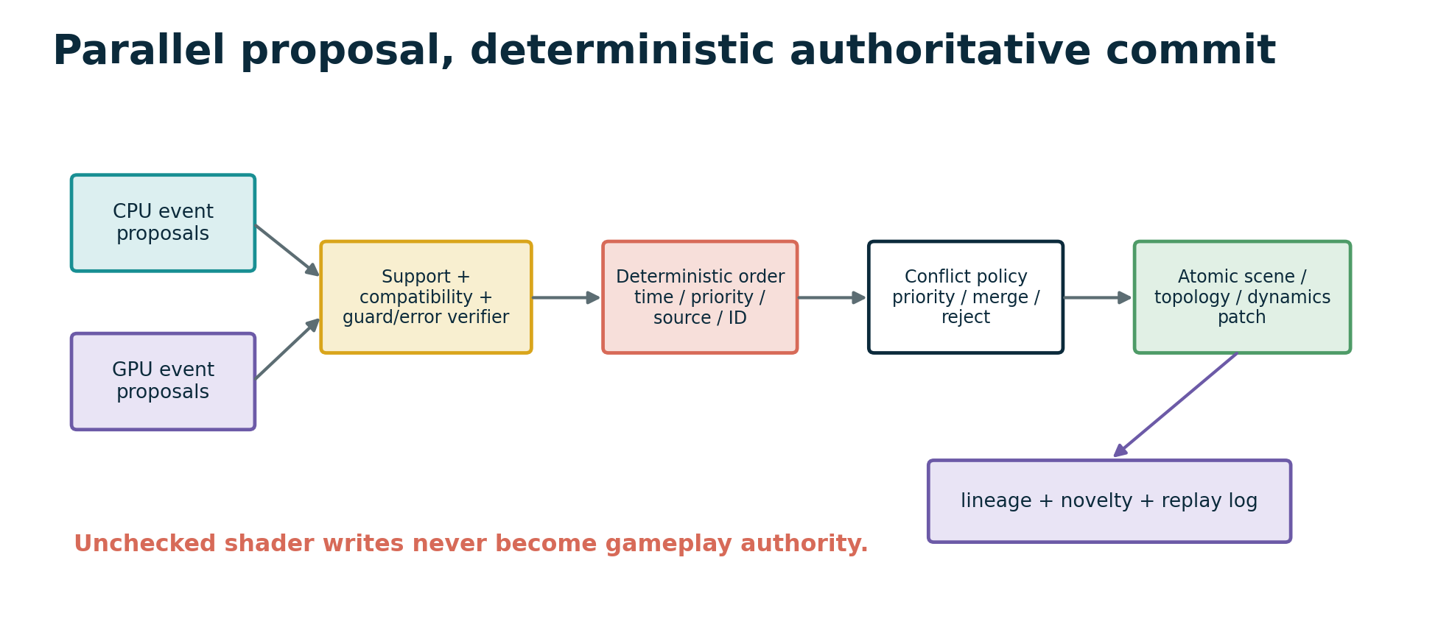
Figure 8. CPU and GPU systems may detect in parallel. Verification, ordering, conflict policy, patching and lineage remain a single authoritative boundary.

10.3 State hashes and checkpoints
Every committed event carries a monotonic sequence and pre/post state hashes. Checkpoints hash a runtime snapshot. Replay begins from the initial scene or nearest checkpoint, applies events in order and stops at the first hash mismatch. The digest is a divergence check; it is never treated as a replacement for full state or lineage.

10.4 Networking profile
- Server-authoritative or designated-authority event commit.
- Schema version and required mechanism negotiation.
- Asset content-hash availability before authoritative replay.
- Interest sets derived from spatial bounds, local support and tags.
- Periodic correction checkpoints and rollback.
- Restricted bit-exact or tolerance-certified numerical profiles.
- Explicit external input and nondeterministic novelty records.
DETERMINISM BOUNDARY
The package demonstrates deterministic ordering and hash-checked replay in one reference environment. It does not claim universal bit-identical floating-point execution across all CPUs, GPUs and compilers.

11. Runnable sandbox vertical slice
One demonstrator exercises geometry, scene, hands, events, replay, rendering and export together.

11.1 Scenario
1. Sample a Gielis pattern and compile it to a swept 3D tube using parallel-transport frames.
2. Sample a gyroid field in bounded space and compile an iso-surface through marching tetrahedra.
3. Create reusable assets, PBR materials and two scene instances under a world node.
4. Render a deterministic SVG preview before interaction.
5. Create a left/right bimanual anchor and evaluate a translated, scaled, aligned and twisted hand pair.
6. Emit and verify a set-transform proposal, commit it authoritatively and append lineage.
7. Render the post-event preview, export glTF and USDA, and write scene, replay and diagnostic JSON.
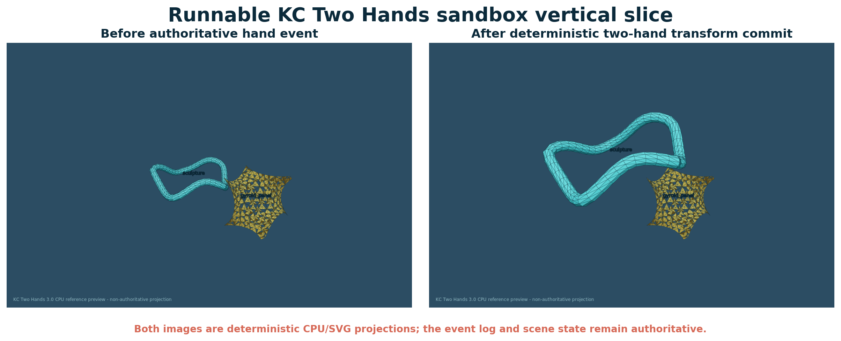
Figure 9. The compiled Gielis tube is transformed by one authoritative two-hand event. The gyroid asset remains stationary. Both panels are downstream SVG previews.

11.2 Captured values
Metric | Captured value
Bimanual status | ok
Translation | (0.325, 0.8, 0.225)
Scale | 1.674136904
Twist | 0.197877141 rad
Confidence | 1.000
Committed events | 1
Visible nodes | 2
Rendered triangles | 1968
Scene hash | e061c325aaacfa32da19743dc5215067cdbd183ceda9bcfbdc80483b904f0b22

11.3 Output artifacts
File | Purpose
sandbox_before.svg / sandbox_after.svg | Deterministic reference projections.
sandbox_scene.gltf | Self-contained runtime mesh/material/scene asset.
sandbox_scene.usda | Readable authoring-oriented scene hierarchy.
sandbox_scene.json | Full embedded scene and geometry definition.
sandbox_replay.json | Initial scene, checkpoint and authoritative event.
sandbox_diagnostics.json | Event timeline, lineage edges and metrics.
sandbox_scene_audit.json | Scene integrity and bounds audit.
sandbox_summary.json | Compact captured run summary.

12. Validation, acceptance and kill criteria
The package establishes bounded functional consistency, not universal production performance.

12.1 Executable verification
VALIDATION RESULT
Python 3.13.5 executed 117 unit tests in the captured run. Status: PASS. The retained 2.0 suite covers pattern, field, topology, kinematics, dynamics and event behavior; the 3.0 suite adds scene, geometry compilation, spatial queries, materials, hand interaction, runtime, replay, render and export tests.

Validation layer | Status | What is established
KC 2.0 retained tests | 47 PASS | Baseline math and event implementation remains internally consistent.
KC 3.0 new tests | 70 PASS | Reference production-layer functions satisfy included properties.
JSON Schema example | PASS | Bundled example validates against the 3.0 schema.
Sandbox execution | PASS | All documented outputs were regenerated.
Catalog traceability | PASS | M258-M329 contiguous; counts check to 72 and total 329.
glTF structural checks | PASS in tests | Version, embedded buffer length and node/mesh references checked.
USDA / SVG structural checks | PASS in tests | Expected scene and projection structures emitted.
Physical-GPU benchmark | NOT CLAIMED | No named physical GPU run for the 3.0 renderer.
Full external-standard conformance | NOT CLAIMED | Targets are documented adapters, not complete implementations.

12.2 Numerical and geometry kill criteria
- Curve flatness, field resolution or normal error exceeds the declared event or visual margin.
- Marching output changes required topology or a lower-detail representation crosses an authoritative guard incorrectly.
- Bimanual separation becomes degenerate, confidence falls below policy, or gesture hysteresis chatters beyond budget.
- FP16/fixed-point/GPU error changes event ordering or exceeds the guard margin.
- Persistent contact is misrepresented as an unbounded coincident-event stream.

12.3 Performance and production kill criteria
- BVH plus support/compatibility costs more than a conventional implementation at equal error.
- Pattern opcode divergence, mesh generation, compaction or resource barriers dominate frame time.
- Asset streaming, shader compilation, replay checkpoints or event logs exceed memory and latency budgets.
- Cross-platform replay diverges beyond the selected deterministic/tolerance profile.
- A conventional renderer, physics engine or editor workflow is cheaper, faster or more accurate for the target workload.
- A physical-GPU advantage is promoted without a named device, driver, thermal/power state, p50/p95/p99 latency and oracle comparison.

12.4 Reproduction
PYTHONPATH=src python -m unittest discover -s tests -v
PYTHONPATH=src python examples/two_hands_sandbox.py
python -m json.tool examples/kc_two_hands_definition.json

13. Final upgraded definition and roadmap
KC Two Hands 3.0 is a tested production companion around the retained query-first substrate.

13.1 Final definition
UGTS-KC Two Hands 3.0 defines a finite, queryable algebra over typed geometry, topology, kinematics and bounded dynamics, extended by stable scene composition, deterministic geometry compilation, conventional spatial indexing, presentation materials, typed bimanual interaction and replayable event commit. Assets and meshes are derived payloads. Nodes and lineage preserve identity. GPU and hand systems may detect in parallel, but discrete change remains event-authoritative.
KC3 = (G,P,F,K,D,R,S,C,T,I,L, A,X,M,V,H,N,E)
canonical shorthand:
pattern/field + kinematic state
-> spatial/support pruning
-> compatibility
-> guard classification
-> verified proposal
-> deterministic commit
-> scene/topology/dynamic patch
-> lineage + replay/novelty log
-> optional render/export

13.2 Release interpretation
STATUS
Technically coherent and executable as a reference vertical slice. Production Vulkan/WebGPU rendering, OpenXR binding, OpenUSD/MaterialX/OCIO integration, character animation/physics and multiplayer transport remain explicit next-stage engineering tasks.

13.3 Recommended next measurements
1. Port the core scene/event records to a native C++ or Rust implementation with a stable C ABI and Python oracle comparison.
2. Compile the 3.0 WGSL/GLSL contracts and run a named physical Vulkan GPU with p50/p95/p99 frame and proposal latency.
3. Implement topology-aware mesh simplification and error propagation from source pattern/field to collision and render LOD.
4. Bind OpenXR hand joints to `HandPose`, capture confidence/fallback behavior and benchmark end-to-end interaction latency.
5. Add skeletal animation, maintained constraints, character sweeps and conventional rigid-body fallback.
6. Exercise server-authoritative event replication, interest management, checkpoints and rollback under packet delay/loss.
7. Integrate OpenUSD composition, glTF packaging, MaterialX looks and OCIO transforms without duplicating authoritative semantics.
8. Compare the vertical slice with a conventional mesh/BVH/physics baseline at equal error and apply the documented kill criteria.

Appendix A. M258-M329 extended mechanism catalog
The complete definitions, formulas and integration notes are supplied in CSV/JSON. This appendix is the compact human-readable index.
ID | Domain | Mechanism | Validation
M258 | Scene and assets | Stable asset identity | Implemented/tested
M259 | Scene and assets | Content-addressed asset hash | Implemented/tested
M260 | Scene and assets | Scene-node transform hierarchy | Implemented/tested
M261 | Scene and assets | Hierarchy cycle rejection | Implemented/tested
M262 | Scene and assets | Asset-instance separation | Implemented/tested
M263 | Scene and assets | Layered scene opinions | Implemented/tested
M264 | Scene and assets | Coordinate-system declaration | Implemented/tested
M265 | Scene and assets | Unit and time-base declaration | Implemented/tested
M266 | Scene and assets | Streaming-region membership | Implemented/tested
M267 | Scene and assets | Schema migration record | Implemented/tested
M268 | Geometry compilation | Adaptive cubic-curve tessellation | Implemented/tested
M269 | Geometry compilation | Dual simulation and presentation error contract | Implemented/tested
M270 | Geometry compilation | Even-odd and nonzero fill rules | Implemented/tested
M271 | Geometry compilation | Stroke expansion | Implemented/tested
M272 | Geometry compilation | Swept tube mesh | Implemented/tested
M273 | Geometry compilation | Parallel-transport sweep frames | Implemented/tested
M274 | Geometry compilation | Implicit-field grid sampling | Implemented/tested
M275 | Geometry compilation | Marching-tetrahedra meshing | Implemented/tested
M276 | Geometry compilation | Field-gradient normal generation | Implemented/tested
M277 | Geometry compilation | Sweep UV generation | Implemented/tested
M278 | Geometry compilation | Collision proxy generation | Implemented/tested
M279 | Geometry compilation | Reference mesh LOD hierarchy | Implemented/tested (reference)
M280 | Spatial and streaming | Axis-aligned bounding box contract | Implemented/tested
M281 | Spatial and streaming | Oriented-bound proxy contract | Specified only
M282 | Spatial and streaming | Deterministic BVH construction | Implemented/tested
M283 | Spatial and streaming | Support-aware broad phase | Implemented/tested
M284 | Spatial and streaming | Frustum visibility query | Implemented/tested
M285 | Spatial and streaming | Ray and picking query | Implemented/tested
M286 | Spatial and streaming | World streaming cells | Implemented/tested
M287 | Spatial and streaming | Per-user interest set | Implemented/tested
M288 | Spatial and streaming | Culling reason codes | Implemented/tested
M289 | GPU and rendering | Pattern-opcode dispatch | Shader contract supplied
M290 | GPU and rendering | Parameter-buffer reference | Shader contract supplied
M291 | GPU and rendering | Derivative availability flags | Shader contract supplied
M292 | GPU and rendering | Render-graph resource contract | Specified only
M293 | GPU and rendering | GPU-driven draw-list contract | Specified only
M294 | GPU and rendering | GPU event proposal buffer | Specified + runtime schema
M295 | GPU and rendering | Deterministic authoritative commit boundary | Implemented/tested
M296 | GPU and rendering | Vulkan backend profile | Specified only
M297 | GPU and rendering | WebGPU/WGSL portability profile | Prototype supplied
M298 | GPU and rendering | CPU SVG reference renderer | Implemented/tested
M299 | Materials and color | Typed metallic-roughness PBR material | Implemented/tested
M300 | Materials and color | Procedural pattern coordinates | Implemented/tested
M301 | Materials and color | Acyclic material graph | Implemented/tested
M302 | Materials and color | Material authority boundary | Specified + enforced by API shape
M303 | Materials and color | Light and shadow contract | Partially implemented
M304 | Materials and color | HDR exposure and tone mapping | Implemented/tested
M305 | Materials and color | OCIO and ACES metadata target | Metadata specified
M306 | Materials and color | Transparency policy | Implemented/tested
M307 | Game runtime and animation | Fixed simulation clock separation | Implemented/tested
M308 | Game runtime and animation | ECS component mapping | Specified
M309 | Game runtime and animation | Skeletal hierarchy contract | Specified
M310 | Game runtime and animation | Animation state-machine contract | Specified
M311 | Game runtime and animation | IK and maintained-constraint bridge | Inherited implementation + specified bridge
M312 | Game runtime and animation | Conventional rigid-body fallback | Specified boundary
M313 | Game runtime and animation | Impact versus persistent constraint split | Specified boundary
M314 | Game runtime and animation | Character sweep-controller contract | Specified only
M315 | Two-hand interaction | Typed hand state | Implemented/tested
M316 | Two-hand interaction | Pinch hysteresis | Implemented/tested
M317 | Two-hand interaction | Bimanual midpoint frame | Implemented/tested
M318 | Two-hand interaction | Bimanual scale | Implemented/tested
M319 | Two-hand interaction | Bimanual twist and alignment | Implemented/tested
M320 | Two-hand interaction | Cooperative grab ownership | Implemented/tested
M321 | Two-hand interaction | Handover lineage event | Implemented/tested
M322 | Two-hand interaction | Tracking confidence and desktop fallback | Implemented/tested
M323 | Networking, editor and validation | Authoritative event sequence | Implemented/tested
M324 | Networking, editor and validation | Checkpoint and rollback | Implemented/tested
M325 | Networking, editor and validation | Deterministic canonical state hash | Implemented/tested
M326 | Networking, editor and validation | Schema and asset negotiation | Specified
M327 | Networking, editor and validation | Editor diagnostics and inspector records | Implemented/tested
M328 | Networking, editor and validation | Replay divergence detection | Implemented/tested
M329 | Networking, editor and validation | Physical-GPU benchmark promotion gate | Acceptance gate; not claimed

Appendix B. API and exchange dictionary
Public reference modules and record fields.

B.1 Python modules
Module | Primary responsibility
math3d.py | Vector, quaternion and matrix conventions.
geometry.py | Curve tessellation, frames, tubes, strokes, field meshing, LOD and proxies.
spatial.py | AABB, BVH, ray/frustum queries, cells, interest and culling reasons.
scene.py | Assets, nodes, hierarchy, layers, bounds, serialization and content hashes.
materials.py | PBR data, preview color pipeline and acyclic material graph.
hands.py | Hand pose, pinch detector, bimanual transform and cooperative ownership.
runtime.py | Fixed-step systems, proposal verification, deterministic commit and snapshots.
replay.py | Checkpoints, rollback, event replay and divergence detection.
render.py | Deterministic CPU/SVG projection.
export.py | glTF, USDA and scene JSON adapters.
diagnostics.py | Scene audits, timelines, lineage edges and runtime reports.

B.2 Core record dictionary
Record | Required fields / meaning
Asset | id, mesh, material_id, source_pattern_id, schema_hash, metadata, content_hash.
SceneNode | id, asset_id, parent_id, local_transform, visible, tags, layer, lineage.
HandPose | side, wrist pose, joints/radii, confidence, tracked, source, timestamp.
EventProposal | ID, time, type, entity, payload, source, priority, gates, error, lineage label.
RuntimeEvent | sequence, event, payload, confidence, lineage, pre/post hash, runtime tick/time.
Checkpoint | sequence, runtime snapshot, snapshot hash.
GeometryErrorContract | world, collision, pixel and normal error plus topology status.
CullResult | item ID, visible flag and reason code.

B.3 Production instance and proposal layout
InstanceRecord:
world transform | bounds | pattern opcode | parameter offset
material index | derivative flags | support/compatibility masks
lineage checksum | LOD policy
EventProposal:
event time | guard value/status | numeric error | confidence
entity | source | priority | requested patch | lineage label
The shader prototypes in `shaders/` express these ideas in WGSL and GLSL. The Python structures are the behavioral reference. A native ABI must freeze alignment, widths, endianness and schema hashes before cross-language or GPU exchange.

Appendix C. Source, standards and package verification
Reproducibility and scope register.

C.1 Source hashes
Role | Filename | SHA-256
UGTS-0 source architecture | Unified_Geometric_Topological_Substrate(1).pdf | c991aba24cc939ba680697b62b9e19545131cf34060793490bf149c6e2ab522e
UGTS-GN 1.1 GPU-native addendum | Unified_Geometric_Topological_Substrate_GPU_Native_Addendum(2).pdf | 3a6b6c57118ca4e2d7d7e577508c3477a095d133791f3708cb56a054285225d2
UGTS-KC 2.0 immediate baseline package | UGTS_KC_2_0_Tom_Klootwijk_Package.zip | 834997b0139ee43d366dbdddcb25116c7f62081e0ff7799ccf700c1257f12b6d
UGTS-KC 2.0 companion report | UGTS_KC_2_0_Tom_Klootwijk_Expanded_Substrate.pdf | a29dd9959ebd300c32d0e1df8fa2c0d4ee15f428892557b98b5f18cd3e878399

C.2 Standards targets checked 16 August 2026
Target | Reference version / role | Package status
glTF | 2.0.1 runtime asset specification | Reference exporter subset.
OpenUSD | 26.08 documentation / scene composition target | USDA text output; full runtime not bundled.
Vulkan | 1.4 native graphics/compute target | Contract only; no 3.0 physical-GPU benchmark.
WebGPU / WGSL | Portable API and shader-language targets | WGSL prototype supplied.
OpenXR | 1.1 and XR_EXT_hand_tracking input target | Schema target; no runtime call.
MaterialX | 1.39 material interchange target | Independent compact graph only.
OpenColorIO / ACES | Color-management workflow target | Metadata and preview transforms only.

C.3 Package verification sequence
1. Copy the retained KC 2.0 Python oracle and 47-test suite.
2. Generate M258-M329 and machine-check contiguous IDs and counts.
3. Compile all Python modules.
4. Run all 117 tests and capture console output and summary JSON.
5. Validate the example definition against the bundled JSON Schema.
6. Execute the sandbox and regenerate SVG, glTF, USDA, scene, replay and diagnostics.
7. Regenerate report diagrams and inspect representative image outputs.
8. Render the DOCX to PDF and page images; inspect every page for clipping, overlap and broken tables.
9. Hash every delivered file and create the final ZIP manifest.
CLOSING BOUNDARY
The package proves a coherent, runnable reference design. It does not prove commercial readiness, external-standard completeness, physical-GPU advantage or legal ownership. Those require separate integration, measurement and review.

