UNIFIED GEOMETRIC-
TOPOLOGICAL SUBSTRATE
GPU-native compilation, physical-device architecture, performance, memory and compression addendum
UGTS-GN 1.1
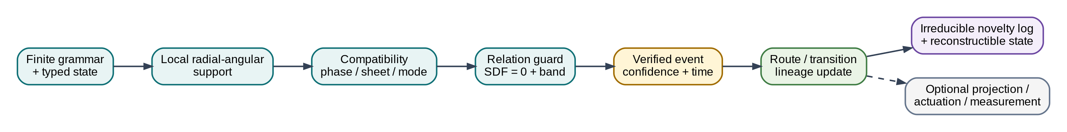
Canonical query-first substrate: support, compatibility, guard, event, transition and lineage.
DELIVERABLE SCOPE
197 normalized mechanisms from 10 source records; four compiled SPIR-V compute modules; direct Vulkan execution; 18 passing reference tests; GPU and physical hardware targets without Unity or Godot adapters.

Date: 15 August 2026
Evidence boundary: source-derived operators are separated from engineering translations, benchmarks and rejected claims.

Contents
- 1. Executive synthesis
- 2. Evidence and normalization discipline
- 3. Canonical substrate architecture
- 4. Addendum: glyph, timeline and threshold structures
- 5. Unified mechanism taxonomy
- 6. GPU-native compiler and runtime
- 7. State and event ABI
- 8. Measured performance
- 9. Memory and compression
- 10. Physical device architecture
- 11. Validation, corrections and kill criteria
- 12. Implementation and reproduction
- Appendix A. Complete 197-mechanism catalog
- Appendix B. Claims ledger
- Appendix C. Metric and register dictionaries
- Appendix D. Source basis and package verification
READING RULE
The core is not a renderer. It is a directly queryable state-and-event substrate. Projection, display, print and actuation are downstream endpoints. [S03 pp. 5-12]

1. Executive synthesis
This addendum integrates the newly supplied glyph-to-bit document into the earlier unified corpus and changes the implementation target. The authoritative computational path is now direct Vulkan/SPIR-V compute or a measured physical device. Game-engine bridges are intentionally absent from the package.
The clean technical substrate is a finite grammar over typed state. Local radial-angular support removes irrelevant candidates; compatibility determines whether co-located states can couple; a relation or guard defines a transition surface; the earliest valid crossing becomes an event; transition logic updates route, topology and lineage; only irreducible novelty must be logged. This is the mature architecture stated by the corpus itself. [S03 pp. 5-12]

Figure 1. Canonical unification. Rendering and actuation are optional consumers, not the state authority.

1.1 What was added
Addition | Technical role | Disposition
Versioned glyph encoder | Separates ordinary 100%=1 from the source-defined 100100_2=36 transform. | Bounded, schema-controlled
Two-pulse timeline | Treats bit positions 5 and 2 as two address pulses separated by three positions. | Retained as encoding/address structure
Log-polar/SDF/BST register model | Provides coordinate addressing, guard evaluation, one-bit route/jitter metadata and branch selection. | Translated into typed GPU fields
Trident/Pythagorean cup | Three channels converge at a threshold and trigger a reset/drain. | Retained as hysteretic state-machine pattern
GPU-native target | GLSL 450 -> SPIR-V 1.4 -> direct Vulkan compute pipeline. | Implemented and validated on named software Vulkan device
Physical-device target | Fixed-function support/compatibility/guard/commit pipeline plus optofluidic endpoint. | Architecture specified; lab validation required

1.2 Concrete deliverables
- 197 normalized mechanisms with source basis, technical definition, GPU realization, physical realization, disposition and validation state.
- Four compiled SPIR-V modules: G64/E32 evaluate, G64/E32 evaluate+commit, G32/E16 evaluate and G32/E16 evaluate+commit.
- A direct Vulkan runtime with device timestamps, cold and cache-seeded pipeline creation, pipeline-cache reload and CPU-oracle validation.
- A dependency-free Python oracle, binary record packers, JSON schema, examples and 18 automated tests.
- A fixed-function Q16.16 RTL reference gate, register map, measurement plan and optofluidic architecture.
- Raw benchmark results, named metrics, memory statistics, compression models and plots.
BENCHMARK BOUNDARY
The validation device is SwiftShader Device (Subzero) (Vulkan 1.3.0, device type CPU/software). The run proves API-native execution and measured performance on that named device. It does not prove physical-GPU, FPGA, ASIC or photonic speed.

2. Evidence and normalization discipline
The source corpus contains exact arithmetic, useful construction rules, visual analogies, speculative physical claims and self-corrections. A clean substrate cannot silently treat all of them as equally established. Every extracted item therefore receives a disposition: RETAIN, TRANSLATE, CORRECTED, BOUNDED, OPTIONAL, DEMOTE or REJECT.

2.1 Admission rule
A motif enters the technical core only when it can be represented as a typed field, coordinate transform, support predicate, relation surface, compatibility predicate, transition/routing map, lineage rule, calibrated transfer function or measurable resource/error quantity.
Disposition | Meaning | Count
RETAIN | Kept as a direct operator or exact construction. | 129
TRANSLATE | Converted from corpus language into a typed/measurable operator. | 37
CORRECTED | Preserved after an explicit arithmetic, dimensional or terminology correction. | 10
REJECT | Excluded from requirements because unsupported or absolute. | 9
BOUNDED | Valid only under a declared schema, relation family or error range. | 7
OPTIONAL | Useful downstream projection or implementation path. | 3
DEMOTE | Retained as analogy or research prompt, not core mechanism. | 2

2.2 Source-derived versus engineering-derived
Layer | Contains | Examples
Source-derived | Operators and structures explicitly present in the PDFs. | Radix thresholds, Pascal parity, cut-and-unroll glyph morphs, parity hinge, SDF boundary, double-vacuum non-coupling, hourglass routing, waveguide B.C.E.
Engineering normalization | A precise implementation that preserves the source motif while adding types and bounds. | G64/E32 and G32/E16 ABI, Vulkan descriptors, Q16.16 squared guard, event FIFO, schema versioning.
Measured package evidence | Results produced by the bundled implementation. | SPIR-V sizes, pipeline creation, dispatch latency, candidate/event rates, memory and validation flags.
Rejected/unsupported | Claims that the sources do not technically establish. | Zero latency/heat/memory, one bit as total state, physical Klein self-assembly, 202.74 J from 0.680 bits, universal O(1).

2.3 Privacy and source handling
The package does not redistribute raw extracted text from the uploaded PDFs. It includes hashes, privacy-safe source notes, normalized mechanisms and a source register. Personal identifiers and unrelated narrative/political passages were excluded from the synthesis.

3. Canonical substrate architecture
The mature corpus defines the substrate as a relation algebra and event calculus. The geometric vocabulary supplies local supports, phase sheets, boundaries and routing. The information architecture supplies typed state, compatibility, lineage and novelty. The implementation supplies direct query and measured event execution.

3.1 State model
q = (position, time, phase, sheet, orientation,
generative_address, branch, policy, uncertainty)

The bundled hot-state profiles implement the subset needed for radial-angular support, topology/mode compatibility, a spherical relation guard, confidence filtering and lineage hashing. The full generative address and irreducible event log remain outside the compact hot record.

3.2 Query kernel
r = length(position)
cos_to_axis = dot(position/r, normalize(axis))
in_support = (r <= radius) and (cos_to_axis >= cone_cos)
compatible = mode_bit and sheet match and orientation match
sdf = r - radius
guard = abs(sdf) - epsilon
confidence = 2^(-32*abs(sdf))
verified = in_support and compatible and guard<=0 and confidence>=floor

The confidence expression is a deterministic benchmark law. It is not claimed as a universal probability model. Physical devices replace it with calibrated confidence or signal-to-noise semantics.

3.3 Topological operators
Corpus structure | Normalized operator | Technical consequence
Double vacuum | Co-located but incompatible phase/sheet/address sectors. | Position equality does not imply coupling.
Möbius/Klein motif | Explicit quotient/gluing map with orientation reversal. | Topology is a routing rule, not material magic.
Four-chamber hourglass | Four-way routing partition with a central event locus. | Transition table selects a chamber/branch at a guard crossing.
Parity hinge | One-bit route/template selector between declared topologies. | Bit has a narrow role; continuous state and lineage remain separate.
SDF = 0 | Event surface with a finite guard band and numerical policy. | Boundary crossing invokes event semantics rather than endless sampling.
Cone/sphere/shell | Local support and domain-of-dependence operator. | Analytic pruning precedes relation solving.

3.4 Identity and persistence
Coordinates are not identity. Persistent identity uses a generative address, invariant history and ordered novelty events. Closed dynamics may be recomputed from seed and grammar; exogenous events must be stored. This is the basis for the package memory models and the distinction between dense state, compact novelty and event-log-only retention.

4. Addendum: glyph, timeline and threshold structures
Figure 2. The new source is admitted as an explicit encoder and threshold-control family, not as ordinary arithmetic or free-energy physics.

4.1 Standard and custom semantics
NON-NEGOTIABLE DISTINCTION
In ordinary mathematics, 100% = 1. The value 36 appears only after selecting a custom source-defined glyph encoder. The schema records the encoder variant so the transform can never masquerade as ordinary percentage arithmetic. [S01 pp. 7-9]

Encoder | Bit sequence | Decimal | Status
standard | 1 | 1 | Ordinary arithmetic
glyph-100101-v0 | 100101 | 37 | Earlier source variant
glyph-100100-v1 | 100100 | 36 | Canonical addendum variant

glyph-100100-v1:
(1 << 5) | (1 << 2) = 32 + 4 = 36

4.2 Two-pulse address/timeline
The sequence 100100 contains two identical 100 groups. The addendum treats them as two pulses at bit positions 5 and 2. Technically, this is a sparse bitset or two-event address pattern. The separation is three bit positions; it does not imply physical time unless a clock and unit are declared. [S01 pp. 8-10]

4.3 Pythagorean and angular geometry
The source uses the scaled 5-12-13 triangle (1.5, 3.6, 3.9). The leg ratio is 3.6/1.5 = 2.4, giving an angle atan(2.4) approximately 67.38 degrees. The package retains this as a parameterized cone-angle example, not a universal constant.

4.4 Fractional shifts and de-phiming correction
Multiplication by 1.5 is not an integer left shift. In a base-2 logarithmic coordinate it is an additive displacement log2(1.5) = 0.5849625007. The source value 0.680 bits -> 202.74 J is dimensionally unsupported and is rejected. An engineering conversion from erased bits to a minimum heat requires a physical temperature and process; even then the Landauer result is a lower bound, not actual device energy.

4.5 Trident and Pythagorean cup
The trident/pinion and Pythagorean-cup material is technically useful when normalized as a three-to-one threshold/reset system: three channels converge, an accumulator rises, a crest crossing latches an event, the state resets or drains, and hysteresis prevents chatter. [S01 pp. 27-29]
IDLE -> ACCUMULATE -> THRESHOLD_CROSS -> EVENT_LATCH
-> RESET/DRAIN -> HYSTERESIS_CLEAR -> IDLE

PHYSICAL BOUNDARY
A Pythagorean cup is a siphon driven by gravity and pressure. It does not create an absolute vacuum, destroy information, recycle energy without loss or supply a self-sustaining topological loop.

5. Unified mechanism taxonomy
The complete catalog contains 197 atomic mechanisms. The entries are deliberately small: each mechanism is one reusable numeric, geometric, topological, event, memory, GPU or hardware operator. The appendix gives the complete source-by-source traceability.
Domain | Count | Representative mechanisms
GPU-native | 23 | GLSL-to-SPIR-V compilation, Direct Vulkan compute runtime, Descriptor ABI, 256-thread workgroup, G64 authoritative state record, E32 full ev...
Physical hardware | 23 | Liquid overclad, Liquid-core guide, Input liquid lens, Solid photonic substrate, 2×2 interferometric kernel, Balanced detection, Spherical-t...
Topology | 16 | Möbius orientation reversal, Klein gluing map, Same coordinate, different sheet, Non-orientable orientation bit, Projected self-intersection...
Audit | 14 | 100% does not ordinarily equal 36, 100101 versus 100100 inconsistency, Information entropy is not automatically heat, Absolute single vacuum...
Numeric/encoding | 13 | Radix digit threshold, Positional power weighting, Literal binary glyph parse, Left-shift pulse placement, Zero-based offset/ordinal distinc...
Projection | 13 | Cartesian-to-log-polar mapping, One-bit sector activation, Phasor coverage accumulation, Subpixel gradient alignment, Pulse-density modulati...
Kinematics | 10 | Stem as cutting/rotation axis, Side-view pyramid as delta triangle, Delta-T changing axis, Loop-to-line release, Localized parity hinge, Spl...
Event calculus | 9 | Relation surface, Support predicate, Compatibility predicate, Earliest valid event, Transition operator, Finite guard band, Confidence thres...
Glyph encoder | 7 | Standard percent semantics boundary, Percent loop decomposition, Slash/phi removal operator, Open-loop terminal suppression, 100100 concaten...
Field algebra | 6 | SDF zero as event boundary, CSG union, CSG intersection, CSG subtraction, SDF gradient orientation, Parity-conditioned field blend...
Routing geometry | 5 | Four-chamber hourglass, Pinch event locus, Invariant eigen-axis, Swept phase arc, Trident 3-to-1 convergence...
Query architecture | 5 | state_at(t), next_event, events_in_cone, reachable relation query, identity reconstruction...
Numeric/fractal | 4 | Pascal parity recurrence, Sierpiński generation, Combination count C(5,3), Power-of-two scale boundary...
Glyph geometry | 4 | D-to-R cut and unroll, B-to-R lower-loop unfurl, Phi loop-plus-stem decomposition, Inward G/shelf transform...
Overlap geometry | 4 | Lens intersection region, Constructive interference interpretation, Tolerance/phase-slip buffer, Mutual-information domain...
Information architecture | 4 | Finite grammar, L-system production, Projective-phase state manifold, Typed state tuple...
Topology/control | 3 | One-bit parity narrow role, One-bit support mask, Deterministic jitter seed
Field geometry | 3 | Global hinge everywhere, Cone SDF, Sphere SDF
Metric geometry | 3 | Scaled 5–12–13 triangle, Leg ratio 2.4, Torque-cone angle
Persistence | 3 | External novelty log, Seed+grammar+log rebuild, Event lineage record
Architecture | 3 | Query-first, no mandatory frame loop, Optional projection, Schema-bound one-bit semantics
Coordinate geometry | 2 | Base-2 log-radius, Local spherical chart
Support geometry | 2 | Cone support, Nested shell support
Fluid threshold | 2 | Pythagorean-cup trigger, Greedy reset cycle
Topology geometry | 2 | Lemniscate crossing, Escher-style shrink to crossing
Identity | 2 | Lineage-based identity, Split/merge lineage
Pruning | 2 | Support rejection, Compatibility rejection
Numerics | 2 | Certified/bracketed root solve, Tangency and degeneracy handling
Indexing | 2 | Log-polar LUT, BST-to-flat-table translation
Risk | 2 | Algebraic closure, Event/branch explosion
Complexity | 1 | Horizon-independent closed expression
Memory | 1 | Novelty-proportional retention
Networking | 1 | Deterministic rollback/replay
Governance | 1 | Query authority and policy

5.1 Numeric, encoding and fractal layer
- Radix thresholds and positional weights.
- Explicit parser modes for literal binary glyphs.
- Sparse pulse placement with shifts and bitsets.
- Hamming weight and active-bit metadata.
- Pascal parity and Sierpinski generation through exact bit tests.
- Log-base-2 address displacement and quantization contracts.

5.2 Geometry and field layer
- D/B/phi cut-and-unroll morphology.
- Torque-axis deformation and split-oval waves.
- Overlap lenses as intersection, tolerance or interference regions.
- Cartesian, polar, log-polar and local spherical charts.
- SDF primitives, CSG, gradients, zero surfaces and guard bands.
- Analytic support cones, spheres, shells and local domains.

5.3 Topology and event layer
- Parity-controlled template/routing selection.
- Phase sheets and co-located non-coupling sectors.
- Möbius/Klein quotient maps with explicit orientation and ports.
- Hourglass partitions and central rank/event loci.
- Earliest valid event solving under support and compatibility.
- Transition, route, lineage and invariant updates.

5.4 GPU, memory and physical layer
- Typed hot-state ABI and packed records.
- SPIR-V compute modules and direct Vulkan pipelines.
- Dense diagnostic versus compact novelty paths.
- Device timestamps, cold/cached pipeline creation and validation.
- Fixed-point support/compatibility/guard datapath.
- Measured optofluidic B.C.E. endpoint and full-system accounting.

6. GPU-native compiler and runtime
Figure 3. Native compilation and execution. The authoritative runtime is Vulkan/SPIR-V, not an engine adapter.

6.1 Compiled module set
Module | Bytes | SPIR-V | Local size | Entry
ugts_g32_evaluate.spv | 5528 | 1.4 | 256x1x1 | main
ugts_g32_evaluate_commit.spv | 6148 | 1.4 | 256x1x1 | main
ugts_g64_evaluate.spv | 4888 | 1.4 | 256x1x1 | main
ugts_g64_evaluate_commit.spv | 5508 | 1.4 | 256x1x1 | main

The runtime descriptor layout reserves set 0 bindings 0-2 for state, events and counters. Evaluate-only modules may optimize the unused counter binding out of the SPIR-V interface; evaluate+commit modules expose all three. The direct runtime creates shader modules, descriptor layouts, pipeline layouts, compute pipelines, buffers, command buffers, timestamp queries and pipeline caches without Unity or Godot.
REFERENCE QUERY CONVENTION
The bundled benchmark modules use target sheet 1, target orientation 0 and compatibility-mask bit 2. The exchange schema and CPU oracle permit explicit values. Production SPIR-V should expose query values through specialization constants, push constants or a query buffer, or compile a versioned fixed-query variant.

6.2 Evaluate versus evaluate+commit
Mode | Operation | Expected scaling behavior
evaluate | Each invocation writes its own event record. | No global atomics; maximum diagnostic throughput.
evaluate+commit | Also atomically increments candidate, support, compatibility and verified counters. | Contention grows with batch size and survivor density.
production compact | Ballot/prefix/append only verified events. | Reduces output memory; requires a measured compaction kernel or hardware FIFO.

6.3 Pipeline compilation and cache
Program | SPIR-V B | Module ms | Cold ms | Cache-seeded ms | Cache B | Reload
G64_E32_evaluate | 4,888 | 0.0062 | 12.891 | 7.504 | 32 | true
G64_E32_evaluate_commit | 5,508 | 0.0029 | 9.544 | 7.279 | 32 | true
G32_E16_evaluate | 5,528 | 0.0034 | 8.548 | 14.652 | 32 | true
G32_E16_evaluate_commit | 6,148 | 0.0036 | 9.540 | 8.490 | 32 | true

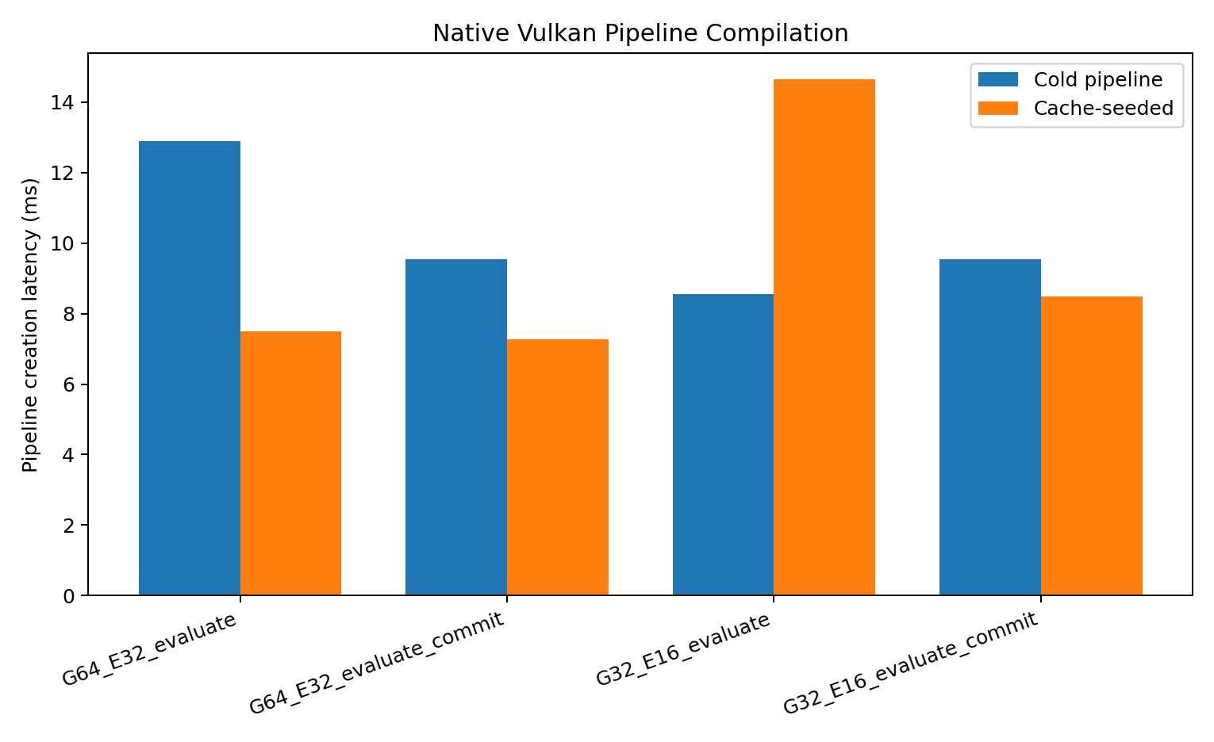
Figure 4. Pipeline-creation measurements on the named validation device. Cache-seeded creation is not guaranteed to be faster on every run or backend.
The 32-byte pipeline cache blobs are implementation-specific. They demonstrate cache extraction/reload plumbing, not a portable precompiled program format. The portable program object is SPIR-V plus the declared ABI.

7. State and event ABI

7.1 Authoritative G64/E32 profile
Record | Bytes | Contents | Use
G64State | 64 | 12 float32 scalars plus four uint32 topology/lineage words. | Authoritative geometric reference and precision oracle.
E32Event | 32 | SDF, guard, confidence, time; verified, route, lineage hash, flags. | Dense diagnostic output and validation.

Offset | Bytes | Field | Meaning
0 | 16 | position_time | x, y, z, query time
16 | 16 | axis_radius | support axis x/y/z and radial reach
32 | 16 | phase_guard | cone cosine, phase, epsilon, confidence floor
48 | 16 | meta | sheet, orientation, compatibility mask, lineage seed

7.2 Packed G32/E16 profile
G32 stores twelve scalar values as IEEE binary16 pairs and packs topology into one word. E16 packs guard and confidence as binary16. This exactly halves dense state-plus-event traffic from 96 to 48 bytes per candidate, but only under a declared precision and guard-margin contract.
PRECISION RULE
Packed or fixed-point records are accepted only when coordinate, axis, radius and guard error remain below the declared event margin. A memory reduction is not a correctness proof.

7.3 Lineage
The 32-bit lineage hash in E32/E16 is a compact checksum for validation and routing. It is not a cryptographic identity and cannot replace the full generative address, branch history and ordered novelty log required for durable persistence.

7.4 Exchange schema
The package includes `spec/schema.json`, a JSON Schema for portable query/state/event exchange. It distinguishes the G64/E32, G32/E16 and Q16.16-squared hardware profiles and records the selected glyph-encoder variant.

8. Measured performance
MEASUREMENT CONTEXT
Runtime: direct Vulkan compute. Device: SwiftShader Device (Subzero). API: 1.3.0. Warmup: 3; measured iterations: 12; timing: device timestamps with 1.0 ns period. physical_gpu_claim=false.

Profile | Mode | p50 ms | p95 ms | p99 ms | CER M/s | SET M/s | ESB GB/s
G64_E32 | evaluate | 12.528 | 21.192 | 22.743 | 83.700 | 4.113 | 8.035
G64_E32 | evaluate_commit | 21.963 | 36.570 | 38.153 | 47.743 | 2.346 | 4.583
G32_E16 | evaluate | 13.307 | 18.860 | 21.321 | 78.798 | 3.748 | 3.782
G32_E16 | evaluate_commit | 19.172 | 32.585 | 33.743 | 54.693 | 2.602 | 2.625

8.1 Meaningful performance names
Symbol | Name | Value | Unit | Scope
CER | Candidate Evaluation Rate | 83.6999 | million candidates/s | G64_E32 evaluate, N=1048576
SET | Spherical Event Throughput | 4.1125 | million verified events/s | G64_E32 evaluate, N=1048576
ESB | Effective Substrate Bandwidth | 8.0352 | GB/s | G64_E32 evaluate, N=1048576
SRG | Support Rejection Gain | 1.8982 | x | G64_E32 deterministic corpus
CRG | Compatibility Rejection Gain | 6.0019 | x | G64_E32 deterministic corpus
EY | Event Yield | 4.9134 | % | G64_E32 deterministic corpus
SCR | State Compression Ratio | 2.0000 | x | N=1048576
ECR | Event Compaction Ratio | 21.0228 | x | G32_E16 evaluate, N=1048576
SNC | State-plus-Novelty Compression | 2.9303 | x | N=1048576
CCF | Commit Cost Factor | 1.7531 | x | G64_E32, N=1048576
PCP | Packed Compute Penalty | 1.0622 | x | N=1048576; software Vulkan device

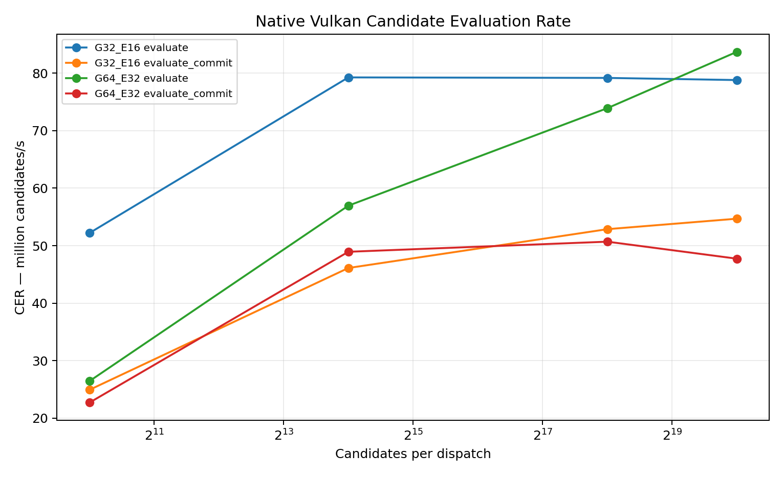
Figure 5. Candidate Evaluation Rate by profile, mode and batch size.
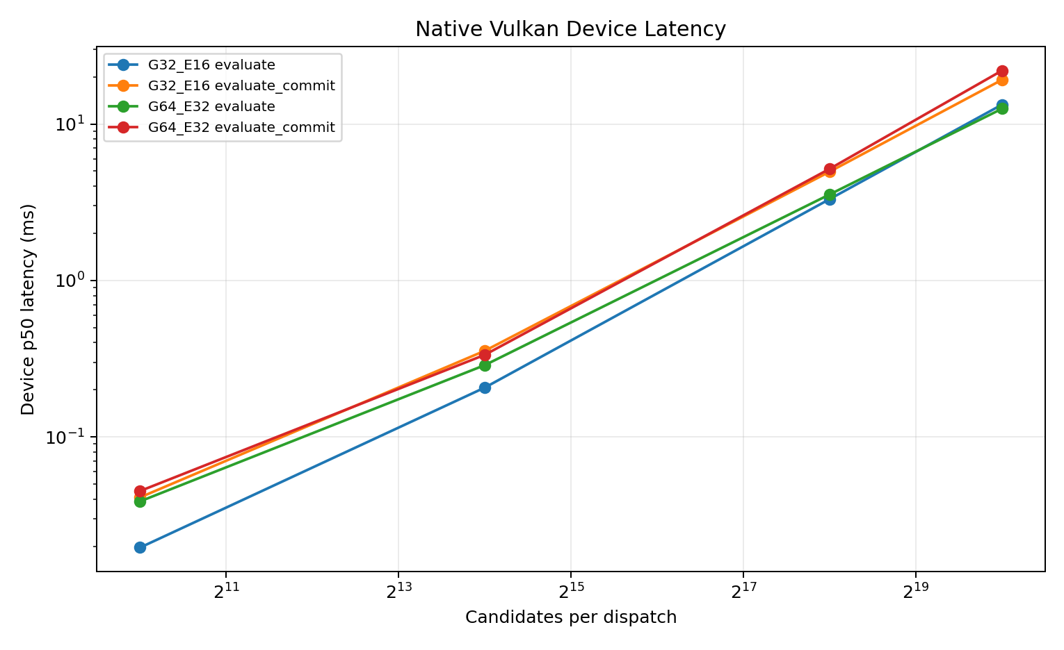
Figure 6. Device-timestamp dispatch latency. Tail latency is reported separately from p50.

8.2 Interpretation
At N=1,048,576, the G64/E32 evaluate path reached 83.700 million candidate evaluations/s and 4.113 million verified events/s on the software Vulkan device. Evaluate+commit cost 1.753x the evaluate p50 in G64/E32 because of global atomic counters.
The packed G32/E16 profile used half the dense memory but had a Packed Compute Penalty of 1.062x on this backend. Packing therefore reduced traffic without guaranteeing greater speed.

9. Memory and compression
Configuration | Bytes | Human | G64 dense | Retention
G64_E32 dense | 100,663,296 | 96.000 MiB | 100.000% | all states + dense outputs
G32_E16 dense | 50,331,648 | 48.000 MiB | 50.000% | all packed states + dense outputs
G32 state + compact E16 novelty log | 34,352,480 | 32.761 MiB | 34.126% | all packed states + verified events only
G32 compact E16 novelty log only | 798,048 | 779.344 KiB | 0.793% | verified events only; state must be rebuildable

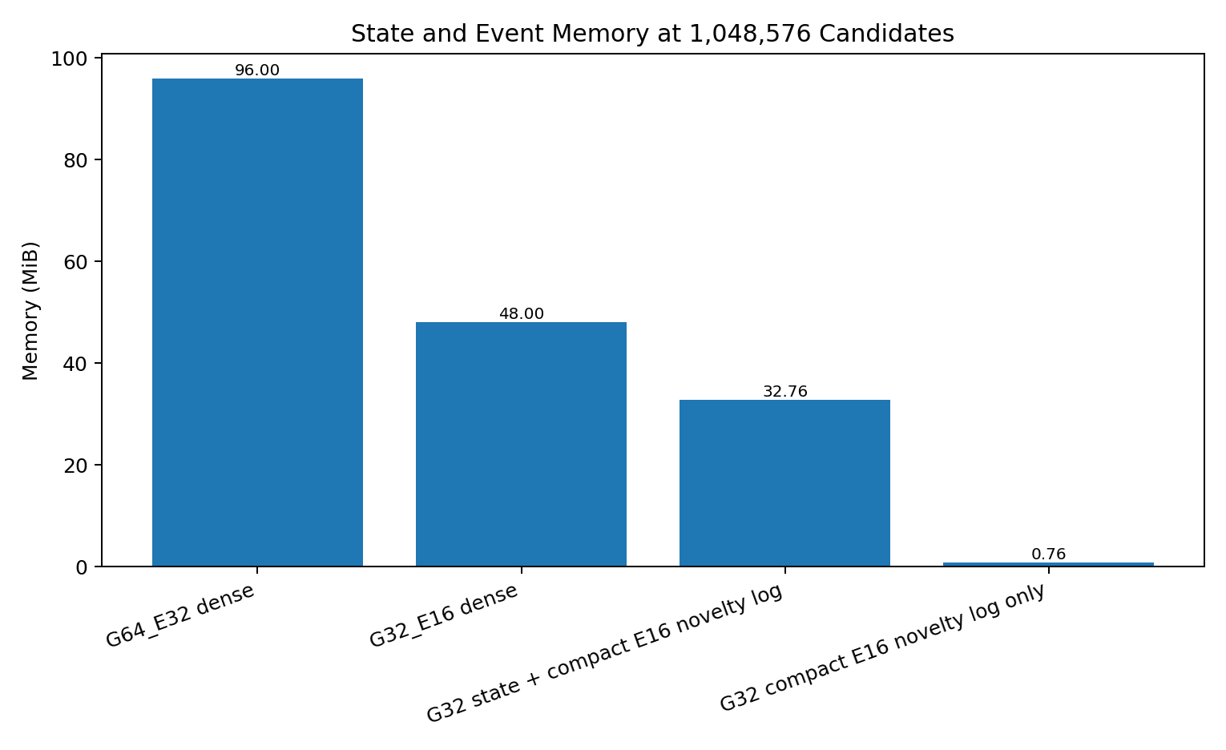
Figure 7. Memory footprint at 1,048,576 candidates.
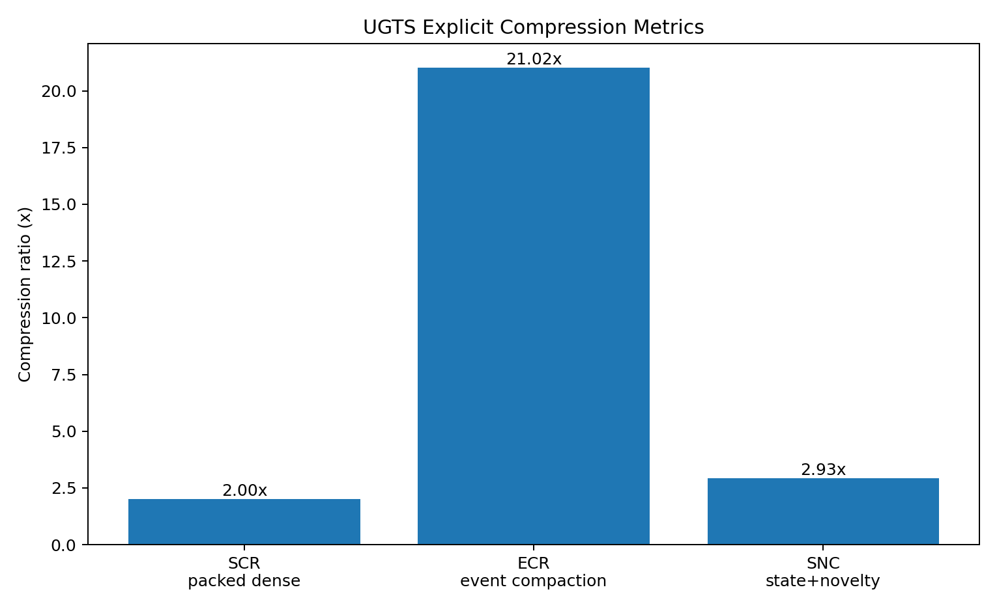
Figure 8. Named compression gains. ECR and SNC depend on observed event yield and reconstructibility.

9.1 Compression names and contracts
Metric | Formula | What it does not mean
State Compression Ratio (SCR) | G64/E32 dense bytes / G32/E16 dense bytes | Does not guarantee faster execution or equal numerical error.
Event Compaction Ratio (ECR) | dense output bytes / verified-only output bytes | Does not include compaction-kernel time; depends on event yield.
State-plus-Novelty Compression (SNC) | G64/E32 dense / (G32 state + compact E16 events) | Requires packed-state validity and verified-event compaction.
Novelty-only retention | verified events x E16 bytes | Valid only when state is reconstructible or authoritative state lives elsewhere.

9.2 One-bit masks
A one-bit support mask for 1,048,576 candidates occupies 131,072 bytes (128 KiB). It can cache a predicate result, but it cannot replace continuous state, topology, confidence or lineage.

10. Physical device architecture
Figure 9. Fixed-function support-compatibility-guard-commit datapath for FPGA/ASIC or custom accelerators.

10.1 Fixed-function digital endpoint
The hardware mapping accepts a state stream or SRAM-resident records, evaluates radial and angular support, checks topology/mode compatibility, tests a relation guard, applies confidence/SNR, updates route and lineage, then writes a verified-event FIFO or DMA stream. It can answer event queries without a display or game engine.

10.2 Q16.16 squared gate
The bundled SystemVerilog reference avoids square roots. With a normalized axis, radial support uses r^2 <= R^2 and angular support uses dot>=0 plus dot^2 >= cos^2(alpha)*r^2. The guard is specified in squared-distance units. For a radial band epsilon, a useful conversion is guard_sq = 2*R*epsilon + epsilon^2 before fixed-point quantization.

10.3 Register and flow control
The portable register map exposes enable/reset/commit, target topology, mode bit, guard and confidence configuration, DMA bases, candidate count, four survivor counters, FIFO level, errors and timestamps. Production devices must use valid/ready flow control and treat FIFO overflow as a measurable missed-event condition.

10.4 Optofluidic and waveguide endpoint
The source hardware line becomes a bounded optofluidic front end: a local radial-angular input is shaped by a liquid lens or overclad, coupled into a compatible guided mode, observed at a balanced detector and declared as a Bounded Compatibility Event only when a measured guard crosses. [S05 pp. 2-10]
Physical layer | Authoritative model | Substrate responsibility
Optical field | Maxwell equations | Input support and declared measurement sector.
Liquid interface | Young-Laplace; fluid mechanics when transient | Actuator state, calibration and uncertainty.
Guided modes | Coupled-mode theory | Mode compatibility and transfer-state tags.
Detection | Detector/electronics noise and bandwidth | Guard, confidence, event timestamp and lineage.
Topology label | Explicit ports, orientation and transfer map | Routing abstraction only; no substitute for physics.

10.5 Hardware metrics
A physical device must report verified events/s, events/J, insertion loss, support and compatibility rejection, median/tail latency, false/missed events, timing jitter, drift, calibration interval, buffer memory and full-system energy. Propagation speed alone is not throughput.

11. Validation, corrections and kill criteria

11.1 Validation completed in this package
- Four SPIR-V modules parsed with the declared entry point, workgroup and descriptor decorations.
- Direct Vulkan shader-module and compute-pipeline creation completed.
- Pipeline-cache extraction and reload completed for all four programs.
- Device-timestamped dispatch completed at four batch sizes for four profile/mode combinations.
- All counter totals matched the CPU oracle.
- The first 4096 event records matched the CPU oracle for every benchmark case.
- 18 dependency-free reference tests passed.
- Device type was detected as CPU/software and physical_gpu_claim was recorded as false.

11.2 Corrections that preserve the useful substrate
Source claim/motif | Technical correction
100% equals 36 | Standard value is 1; 36 belongs to a versioned custom glyph encoder.
1.5 as a fractional bit shift | Use multiplication or log2 displacement 0.5849625007.
0.680 bits -> 202.74 J | Dimensionally unsupported; energy requires a declared physical process and temperature.
Absolute vacuum cup/pinion | Pythagorean siphon normalized as threshold/reset with loss and hysteresis.
Klein bottle self-assembly | Retain only explicit quotient/gluing and routing abstraction.
One bit is complete state | One bit selects route/validity; continuous state, uncertainty and lineage remain.
Zero latency/heat/memory | Include compiler, cache, state, event log, source, actuator, detector, control and calibration.
Universal O(1) | Only fixed closed-expression state queries may be horizon-independent; event and branch costs remain.

11.3 Kill criteria
- Compatibility pruning fails to remove enough candidate relations.
- Event or branch density grows faster than avoided materialization.
- FP16/fixed-point error exceeds the guard margin or changes event ordering.
- Global atomic commit, compaction or FIFO backpressure dominates required throughput.
- Calibration energy/time or drift erases the physical advantage.
- False accepts, false rejects, misses or unordered events exceed the application budget.
- The digital control sidecar performs nearly all useful work.
- A conventional electronic reference is cheaper, faster or more accurate at equal error.

12. Implementation and reproduction

12.1 Package layout
Path | Purpose
spec/ | 197-mechanism catalog, schema, ABI layout, metrics and claims ledger.
gpu/ | Shaders, SPIR-V, direct Vulkan runtime, bootstrap compiler, caches and scripts.
reference/ | Dependency-free CPU oracle and binary packers.
tests/ | 18 executable unit tests.
benchmarks/ | Raw JSON/CSV, derived metrics, plots and summaries.
hardware/ | Device architecture, register map, acceptance plan and RTL reference.
sources/ | Privacy-safe source register and extraction notes.
examples/ | Query/event examples and custom encoder variants.
report/ | This report and source document.

12.2 Reproduction commands
python -m unittest discover -s tests -v
bash gpu/scripts/run_all_validation.sh

On a physical Vulkan machine, unset `VK_ICD_FILENAMES` or point it at the vendor ICD, then rerun the direct benchmark. Record the selected device, driver, power mode and thermal state. Do not compare rates across devices without preserving profile, mode, batch size, precision and error budget.

12.3 Acceptance sequence
Steps 1-7 | Steps 2-8
1. Select encoder and numeric profile. | 2. Validate state ranges, axis normalization and guard margins.
3. Compile and hash the SPIR-V modules. | 4. Create the Vulkan pipeline and persist the cache.
5. Run deterministic oracle vectors. | 6. Benchmark p50/p95/p99 and named rates.
7. Measure memory, compaction and full energy. | 8. Apply kill criteria before promoting a claim.

Appendix A. Complete 197-mechanism catalog
Each row is an atomic extracted or normalized mechanism. Source references use the privacy-safe S01-S10 register. Disposition and validation state prevent exploratory material from being confused with implemented or established operators.
ID | Domain | Mechanism | Source | Normalized technical definition | Disposition | Validation
M001 | Numeric/encoding | Radix digit threshold | S09 pp.1–3 | A digit-count transition occurs at b^k in radix b. | RETAIN | Exact
M002 | Numeric/encoding | Positional power weighting | S09 pp.1–4 | Value is Σ digit_k·b^k. | RETAIN | Exact
M003 | Numeric/encoding | Literal binary glyph parse | S01 pp.2–4; S09 pp.3–4 | Parser mode is part of the schema; `100₂=4₁₀`. | RETAIN | Exact
M004 | Numeric/encoding | Left-shift pulse placement | S01 pp.4–9 | A pulse at bit position k has value 2^k. | RETAIN | Exact
M005 | Numeric/encoding | Zero-based offset/ordinal distinction | S02 pp.1–4 | Offset is zero-based; ordinal is offset+1. | RETAIN | Exact
M006 | Numeric/encoding | Active-bit filtering | S09 pp.4–6 | Extract set-bit positions or popcount; never change numeric identity silently. | RETAIN | Exact
M007 | Numeric/encoding | Zero as inactive/silence metadata | S09 pp.4–5 | A domain-specific interpretation attached to bit state, not arithmetic. | TRANSLATE | Schema-dependent
M008 | Numeric/encoding | Binary 19 decomposition | S09 pp.3–5 | 19 = 16+2+1; Hamming weight 3. | RETAIN | Exact
M009 | Numeric/encoding | Phonetic-to-active-count map | S09 pp.4–7 | Associate an external label count with popcount under a declared language/tokenizer. | BOUNDED | Corpus-specific
M010 | Numeric/fractal | Pascal parity recurrence | S09 pp.6–9 | Cell parity is C(n,k) mod 2. | RETAIN | Exact
M011 | Numeric/fractal | Sierpiński generation | S09 pp.6–14 | Binary parity recurrence yields self-similar triangular occupancy. | RETAIN | Exact
M012 | Numeric/fractal | Combination count C(5,3) | S09 p.6 | Combinatorial count is 10; it is separate from value 19. | RETAIN | Exact
M013 | Numeric/fractal | Power-of-two scale boundary | S09 pp.1–9 | Dyadic levels define exact multiresolution boundaries. | RETAIN | Exact
M014 | Glyph encoder | Standard percent semantics boundary | S01 pp.1,7–8 | Default mathematical parser returns 1.0. | RETAIN | Exact
M015 | Glyph encoder | Percent loop decomposition | S01 pp.2–4 | Represent glyph as two loop primitives and one slash/stem primitive. | TRANSLATE | Constructive
M016 | Glyph encoder | Slash/phi removal operator | S01 pp.2–4 | Delete the slash primitive under an explicit glyph rewrite rule. | TRANSLATE | Rule-defined
M017 | Glyph encoder | Open-loop terminal suppression | S01 pp.6–9 | A source-specific encoder suppresses the final active bit when the terminal loop is open. | BOUNDED | Custom rule
M018 | Glyph encoder | 100100 concatenation | S01 pp.6–9 | Concatenate two 3-bit pulse words to a 6-bit word. | RETAIN | Exact under custom schema
M019 | Glyph encoder | Two-pulse timeline | S01 pp.9–10 | Treat set-bit clusters as two events separated by an address interval. | TRANSLATE | Deterministic
M020 | Glyph encoder | Pulse superposition by OR | S01 pp.6–10 | Combine non-overlapping pulse masks with bitwise OR. | RETAIN | Exact
M021 | Numeric/encoding | Explicit-width complement | S01 pp.18–22 | Complement must specify width and mask; topology route is not unbounded `~x`. | TRANSLATE | Exact when width declared
M022 | Numeric/encoding | Fractional scale correction | S01 pp.11–16 | Multiplication by 1.5 corresponds to a log2 displacement of log2(1.5), not an integer bit shift. | CORRECTED | Exact
M023 | Numeric/encoding | Packed fixed-width record | S06 pp.27–34; S07 pp.26–34 | State fields have declared widths, scales and schemas. | TRANSLATE | Implemented
M024 | Numeric/encoding | Fixed-point financial boundary | S06 pp.27–30 | Use fixed-point/decimal for exact currency-like quantities; unrelated to geometry unless typed. | RETAIN | Established
M025 | Topology/control | One-bit parity narrow role | S05 pp.2,7; S03 pp.5–7 | One bit selects a route, orientation or validity convention; continuous state remains separate. | RETAIN | Implemented
M026 | Topology/control | One-bit support mask | S04 pp.1–2 | A bit masks candidate sectors; it does not encode full geometry. | RETAIN | Implemented
M027 | Topology/control | Deterministic jitter seed | S04 pp.7–10 | Pseudo-random sequence is keyed by lineage/address for replay. | TRANSLATE | Specified
M028 | Glyph geometry | D-to-R cut and unroll | S06/S07/S10 pp.1–2 | A curve segment changes constraint class from loop arc to open segment while upper loop remains. | RETAIN | Constructive
M029 | Glyph geometry | B-to-R lower-loop unfurl | S06/S07/S10 p.1 | Release one loop edge and map it to an open leg. | RETAIN | Constructive
M030 | Glyph geometry | Phi loop-plus-stem decomposition | S06/S07/S10 pp.1–2 | Primitive graph with loop node and axial segment. | RETAIN | Constructive
M031 | Kinematics | Stem as cutting/rotation axis | S06/S07/S10 pp.1–2 | Axis defines local frame, cut plane and rotational reference. | RETAIN | Implemented
M032 | Kinematics | Side-view pyramid as delta triangle | S06/S07/S10 p.2 | Use a 2D triangular cross-section for a conical/pyramidal support. | TRANSLATE | Constructive
M033 | Kinematics | Delta-T changing axis | S06/S07/S10 pp.2–4 | Store reference axis and time derivative separately. | TRANSLATE | Specified
M034 | Kinematics | Loop-to-line release | S06/S07/S10 pp.2–4 | Topology flag selects closed relation vs open parametric segment. | RETAIN | Implemented as route
M035 | Kinematics | Localized parity hinge | S06/S07/S10 pp.3–4 | A graph edge toggles while a pivot node remains invariant. | RETAIN | Specified
M036 | Field geometry | Global hinge everywhere | S06/S07/S10 pp.7–8 | A field parameter switches or blends two implicit functions over the domain. | TRANSLATE | Specified
M037 | Kinematics | Split zero-centered oval | S02 pp.10–12 | Two half-curves share a zero-displacement boundary. | RETAIN | Constructive
M038 | Kinematics | Antisymmetric torsional wave | S02 pp.12–13 | Opposite signed displacement about the central hinge. | TRANSLATE | Physical model dependent
M039 | Kinematics | 2π unrolled into two π arches | S02 pp.13–15 | Partition a periodic path into two half-period intervals. | RETAIN | Exact
M040 | Kinematics | 1:1 arch balance | S02 pp.13–15 | Equal interval length; amplitude balance is a model parameter, not universal stability law. | BOUNDED | Conditional
M041 | Overlap geometry | Lens intersection region | S02 pp.16–19 | Explicit intersection `A∩B` with area/phase/confidence. | RETAIN | Exact geometry
M042 | Overlap geometry | Constructive interference interpretation | S02 p.18 | Combine complex amplitudes where supports intersect. | TRANSLATE | Model dependent
M043 | Overlap geometry | Tolerance/phase-slip buffer | S02 p.18 | Overlap width is a measurable alignment or phase-error margin. | TRANSLATE | Measurable
M044 | Overlap geometry | Mutual-information domain | S02 pp.18–19 | Use overlap membership as a join key; mutual information requires distributions, not area alone. | CORRECTED | Conditional
M045 | Metric geometry | Scaled 5–12–13 triangle | S01 p.5 | Multiply the Pythagorean triple by 0.3. | RETAIN | Exact
M046 | Metric geometry | Leg ratio 2.4 | S01 pp.5,15 | Aspect/torque parameter `q=2.4`. | RETAIN | Exact
M047 | Metric geometry | Torque-cone angle | S01 pp.15–16 | Derive cone half-angle from leg ratio under stated triangle convention. | RETAIN | Exact under convention
M048 | Kinematics | Logarithmic spiral step law | S06/S07/S10 pp.5–6 | Scale changes exponentially with phase. | TRANSLATE | Parameter dependent
M049 | Coordinate geometry | Base-2 log-radius | S01 pp.16–17; S04 pp.1–2 | Multiplicative radial scale becomes additive coordinate displacement. | RETAIN | Implemented concept
M050 | Coordinate geometry | Local spherical chart | S03 pp.5–7; S05 p.3 | Use radial-angular coordinates locally around a query/coupler; not a global world replacement. | RETAIN | Canonical
M051 | Support geometry | Cone support | S03 pp.5–7; S08 pp.15–18 | Admit candidates satisfying radial reach and angular cosine threshold. | RETAIN | Implemented
M052 | Support geometry | Nested shell support | S03 pp.3–6 | Partition radius into ordered intervals for multiscale relevance. | RETAIN | Specified
M053 | Routing geometry | Four-chamber hourglass | S03 p.6; S08 pp.23–26 | Four routing sectors meet at a central rank-changing locus. | TRANSLATE | Canonical abstraction
M054 | Routing geometry | Pinch event locus | S03 p.6; S05 pp.2–5 | A guard surface at which rank, route or mode changes. | RETAIN | Measurable
M055 | Routing geometry | Invariant eigen-axis | S03 p.6; S08 pp.21–25 | A tagged axis/mode remains invariant across route transition. | TRANSLATE | Specified
M056 | Routing geometry | Swept phase arc | S03 p.6; S08 pp.23–25 | Phase parameter maps between routing sectors. | TRANSLATE | Specified
M057 | Routing geometry | Trident 3-to-1 convergence | S01 pp.25–27 | Three input channels merge into one event/reset channel. | TRANSLATE | Constructive
M058 | Fluid threshold | Pythagorean-cup trigger | S01 pp.27–29 | Hysteretic threshold state machine with latch and reset. | RETAIN | Physical principle established; corpus mapping unvalidated
M059 | Fluid threshold | Greedy reset cycle | S01 pp.27–29 | On trigger, emit event then reset selected accumulator/state. | TRANSLATE | Specified
M060 | Glyph geometry | Inward G/shelf transform | S06/S07/S10 pp.30–31 | Additional glyph grammar rule; not core topology. | OPTIONAL | Exploratory
M061 | Topology geometry | Lemniscate crossing | S09 pp.18–25 | A crossing with orientation/chirality state and two lobes. | TRANSLATE | Exploratory
M062 | Topology geometry | Escher-style shrink to crossing | S09 pp.20–27 | Use bounded log-scale coordinate; do not infer infinite physical resolution. | CORRECTED | Bounded
M063 | Field geometry | Cone SDF | S06/S07/S10 pp.7–8 | Implicit conical support/boundary function. | RETAIN | Specified
M064 | Field geometry | Sphere SDF | S03/S05; benchmark | `f(p)=||p||-R` with zero guard. | RETAIN | Implemented and validated
M065 | Topology | Möbius orientation reversal | S06/S07/S10 pp.4–6; S08 pp.10–14 | A quotient boundary reverses orientation when traversed. | TRANSLATE | Mathematically exact abstraction
M066 | Topology | Klein gluing map | S03 pp.2,6; S05 p.5; S08 pp.7–14 | Specify ports and an orientation-reversing identification; use as routing, not literal container. | TRANSLATE | Canonical abstraction
M067 | Topology | Same coordinate, different sheet | S03 p.6; S08 pp.15–19 | State includes sheet/phase/address; coordinate equality alone does not imply coupling. | RETAIN | Implemented
M068 | Topology | Non-orientable orientation bit | S03 pp.5–7 | One bit records local orientation class and toggles at gluing maps. | RETAIN | Implemented
M069 | Topology | Projected self-intersection | S06/S07/S10 pp.5–10 | Treat apparent collision as two distinct sheet/address states unless physical interaction is specified. | CORRECTED | Specified
M070 | Topology | Double vacuum as incompatibility | S03 p.6; S08 pp.6–18 | No coupling because compatibility is false, despite co-location. | RETAIN | Canonical
M071 | Topology | Phase-separated co-location | S03 p.6 | Phase is part of state and coupling law. | RETAIN | Specified
M072 | Topology | Four-way routing partition | S03 pp.6–7 | Two route bits select one of four sectors around an event locus. | TRANSLATE | Specified
M073 | Topology | Portal/gluing transition | S03 pp.5–7 | At event, apply coordinate, sheet, orientation and lineage transform. | RETAIN | Specified
M074 | Topology | Branch transition | S03 pp.5–8 | Branch ID is updated only by a declared transition. | RETAIN | Specified
M075 | Identity | Lineage-based identity | S03 pp.5–8,11–12 | Identity is seed/generative address plus transition history/invariants. | RETAIN | Canonical
M076 | Identity | Split/merge lineage | S03 pp.8,11–12 | Splits create child addresses; merges require explicit reconciliation record. | RETAIN | Specified; stress test required
M077 | Topology | Toroidal/poloidal chart labels | S01 pp.18–26 | Use two periodic coordinates where appropriate; no claim of 4D physics follows. | TRANSLATE | Exploratory
M078 | Topology | Re-entry map | S01 pp.18–28 | Explicit transition maps output port to input address with optional orientation flip. | TRANSLATE | Specified
M079 | Topology | Parity-controlled open/closed boundary | S06/S07/S10 pp.3–8 | Parity selects one of two topology templates; changes occur at guarded events. | RETAIN | Specified
M080 | Topology | Sphere eversion analogy | S08 pp.10–12 | Useful visualization only; not required by substrate. | DEMOTE | Analogy
M081 | Topology | Physical Klein self-assembly | S06/S07/S10 pp.9–12 | Not supported; requires material mechanics and cannot be inferred from SDF parity. | REJECT | Unsupported
M082 | Topology | Topology-powered energy recycling | S01 pp.25–29 | Topology does not create or preserve usable energy without a loss/drive model. | REJECT | Dimensionally unsupported
M083 | Information architecture | Finite grammar | S03 pp.5–7,12 | A bounded set of productions generates typed expressions/state. | RETAIN | Canonical
M084 | Information architecture | L-system production | S06/S07/S10 pp.5–6 | Parametric grammar operator with bounded depth and normalized output. | TRANSLATE | Depth must be bounded
M085 | Information architecture | Projective-phase state manifold | S03 pp.5–7 | Typed product state, not a single coordinate array. | RETAIN | Implemented subset
M086 | Information architecture | Typed state tuple | S03 pp.5–7 | Every field has unit, width and semantic convention. | RETAIN | Implemented
M087 | Event calculus | Relation surface | S03 pp.5–7 | An event candidate is a root of an explicit scalar relation. | RETAIN | Implemented sphere relation
M088 | Event calculus | Support predicate | S03 pp.5–7; S05 pp.3,6 | Local domain selects relevant candidates before event solving. | RETAIN | Implemented
M089 | Event calculus | Compatibility predicate | S03 pp.5–7; S05 p.7 | Coupling requires phase/sheet/address/mode/policy compatibility. | RETAIN | Implemented subset
M090 | Event calculus | Earliest valid event | S03 pp.5–7 | Choose earliest certified root satisfying all gates. | RETAIN | Prototype subset
M091 | Event calculus | Transition operator | S03 pp.5–7 | Apply atomic state patch at event and preserve invariants. | RETAIN | Specified
M092 | Persistence | External novelty log | S03 pp.5–8,11–12 | Closed dynamics may be rebuilt; unpredictable external changes are appended. | RETAIN | Implemented format
M093 | Query architecture | state_at(t) | S03 pp.6–8 | Evaluate closed expression at requested time without replay when possible. | RETAIN | Restricted families only
M094 | Query architecture | next_event | S03 pp.6–8 | Support + compatibility + root solve + branch resolution. | RETAIN | Restricted families only
M095 | Query architecture | events_in_cone | S03 pp.6–7,11–12 | Return events whose supports intersect query support. | RETAIN | Specified
M096 | Query architecture | reachable relation query | S03 pp.6–7 | Graph/grammar reachability under compatibility. | RETAIN | Specified
M097 | Query architecture | identity reconstruction | S03 pp.7–12 | Reconstruct identity without relying on current coordinate. | RETAIN | Specified
M098 | Pruning | Support rejection | S03 pp.7–8; S05 p.6 | Local analytic filter precedes expensive relation work. | RETAIN | Measured by SRG
M099 | Pruning | Compatibility rejection | S03 pp.6–8; S05 pp.6–7 | Filter supported candidates by typed mode/policy mask. | RETAIN | Measured by CRG
M100 | Event calculus | Finite guard band | S05 pp.5–7; benchmark | Use epsilon band around relation zero to tolerate finite precision/noise. | RETAIN | Implemented
M101 | Event calculus | Confidence threshold | S05 pp.3,6–7 | Event commits only if confidence/certification exceeds floor. | RETAIN | Implemented synthetic model
M102 | Event calculus | Hysteresis/debounce | S05 p.10; S01 pp.27–29 | Separate enter/exit thresholds and hold time. | RETAIN | Specified
M103 | Numerics | Certified/bracketed root solve | S03 pp.8–9,11–12 | Return bounded root interval when exact analytic solve is unstable. | RETAIN | Future implementation
M104 | Numerics | Tangency and degeneracy handling | S03 pp.8–11; S05 p.10 | Classify derivative/rank conditions; avoid false crossing. | RETAIN | Risk register
M105 | Field algebra | SDF zero as event boundary | S03 pp.6–7; S06 pp.7–8 | Zero is semantic transition surface, not a reason to raymarch indefinitely. | RETAIN | Canonical
M106 | Field algebra | CSG union | S04 p.2 | Implicit union operator. | RETAIN | Exact for SDF sign
M107 | Field algebra | CSG intersection | S04 p.2; S02 pp.18–19 | Implicit intersection/operator for overlap lens. | RETAIN | Exact for sign
M108 | Field algebra | CSG subtraction | S04 p.2 | Implicit difference. | RETAIN | Exact for sign
M109 | Field algebra | SDF gradient orientation | S04 pp.2,4,9 | Gradient provides normal/orientation; finite difference or analytic derivative. | RETAIN | Specified
M110 | Field algebra | Parity-conditioned field blend | S06/S07/S10 pp.7–8 | Discrete state selects or interpolates implicit geometry. | TRANSLATE | Specified
M111 | Indexing | Log-polar LUT | S01 pp.16–22; S04 pp.1–8 | Index radial-angular parameters by additive log radius and angle. | RETAIN | Specified
M112 | Indexing | BST-to-flat-table translation | S01 pp.15–22; S06/S07/S10 pp.5–6 | Compile tree decisions into breadth-first arrays or direct bit tests; avoid pointer chasing on GPU. | CORRECTED | GPU-specific
M113 | Complexity | Horizon-independent closed expression | S03 p.8 | For fixed expression size, state_at cost need not scale with skipped steps. | BOUNDED | Restricted claim
M114 | Memory | Novelty-proportional retention | S03 pp.8,11–12 | Store seed/grammar/invariants and external events, not every frame, when reconstruction is valid. | BOUNDED | Depends on reconstructibility
M115 | Persistence | Seed+grammar+log rebuild | S03 pp.7–12 | Deterministic replay from versioned seed, grammar and event log. | RETAIN | Specified
M116 | Architecture | Query-first, no mandatory frame loop | S03 pp.1,5–12 | Authoritative runtime serves state/event queries; projection is optional. | RETAIN | Canonical
M117 | Architecture | Optional projection | S03 pp.1,9–10; S04 | Render/print/display is a consumer of query results. | RETAIN | Canonical
M118 | Event calculus | Bounded Compatibility Event | S05 pp.3,5–7 | Verified event requires support, compatibility, guard crossing and confidence. | RETAIN | Implemented synthetic / specified physical
M119 | Persistence | Event lineage record | S03 pp.5–8; S05 p.7 | Event carries route, state flags, time/confidence and lineage. | RETAIN | Implemented
M120 | Architecture | Schema-bound one-bit semantics | S05 p.7 | Every bitfield is versioned and named by schema. | RETAIN | Implemented
M121 | Networking | Deterministic rollback/replay | S08 pp.27–31; S03 pp.7–12 | Replay versioned deterministic transitions plus external event log. | TRANSLATE | Restricted
M122 | Risk | Algebraic closure | S03 pp.8,11 | Composition must remain in a normalized relation family or lose direct-query advantage. | RETAIN | Open risk
M123 | Risk | Event/branch explosion | S03 pp.8,11 | Bound candidate count, branch depth and event density. | RETAIN | Open risk
M124 | Governance | Query authority and policy | S03 pp.6,11 | Policy/provenance is part of compatibility, not hidden side logic. | RETAIN | Specified
M125 | GPU-native | GLSL-to-SPIR-V compilation | Package gpu/shaders + gpu/spirv | Compile compute kernels to SPIR-V; bundled modules are SPIR-V 1.4. | RETAIN | Compiled and inspected
M126 | GPU-native | Direct Vulkan compute runtime | Package gpu/src/ugts_vulkan_bench.cpp | Create shader module, compute pipeline, descriptors, buffers and dispatch directly through Vulkan. | RETAIN | Executed
M127 | GPU-native | Descriptor ABI | Package shader manifest | Set 0 binding 0 state, 1 event, 2 counters/commit. | RETAIN | Validated
M128 | GPU-native | 256-thread workgroup | SPIR-V manifest | One invocation evaluates one candidate. | RETAIN | Compiled
M129 | GPU-native | G64 authoritative state record | Package spec | Four 16-byte vectors: position/time, axis/radius, phase/guard, metadata. | RETAIN | Implemented
M130 | GPU-native | E32 full event record | Package spec | Float-bit scalars plus topology/lineage flags. | RETAIN | Implemented
M131 | GPU-native | G32 packed state record | Package spec | Pair FP16 fields and pack topology metadata. | RETAIN | Implemented and validated
M132 | GPU-native | E16 packed event record | Package spec | SDF plus packed guard/confidence, flags and lineage hash. | RETAIN | Implemented and validated
M133 | GPU-native | Evaluate mode | Benchmark | Write per-candidate result without global counters. | RETAIN | Benchmarked
M134 | GPU-native | Evaluate+commit mode | Benchmark | Add four atomic counters for candidates/support/compatible/verified. | RETAIN | Benchmarked
M135 | GPU-native | Device timestamp measurement | Benchmark | Use Vulkan timestamp queries and host fence timing. | RETAIN | Benchmarked
M136 | GPU-native | Pipeline cache artifact | Benchmark | Persist vendor/driver-specific cache blob; portability is not assumed. | RETAIN | Reload tested
M137 | GPU-native | SPIR-V module manifest | Package gpu/spirv/spirv_manifest.json | Hash and inspect version, entry point, local size and descriptors. | RETAIN | Validated
M138 | GPU-native | Lineage hash | Shader code | Compact deterministic lineage checksum; not a cryptographic identity. | RETAIN | Validated
M139 | GPU-native | Dense output path | Benchmark | Simple validation layout; non-events still occupy output. | RETAIN | Benchmarked baseline
M140 | GPU-native | Verified-event compaction | Spec/derived metrics | Use ballot/prefix scan or atomic append to retain verified events. | TRANSLATE | Metric modeled; compact kernel not benchmarked
M141 | GPU-native | Structure-of-arrays option | Spec | Split position/support/meta streams when hardware favors field locality. | OPTIONAL | Not benchmarked
M142 | GPU-native | Memory coalescing contract | Spec | Records are 16-byte aligned; adjacent invocations access adjacent records. | RETAIN | Implemented
M143 | GPU-native | FP16 error contract | Spec/tests | G32 requires declared range/tolerance; event guard must exceed quantization uncertainty. | RETAIN | Sample validated
M144 | GPU-native | Cold versus cache-seeded compilation | Benchmark | Report shader-module, cold pipeline and cache-seeded pipeline times separately. | RETAIN | Benchmarked
M145 | GPU-native | CPU reference oracle | Benchmark/tests | Scalar implementation checks counters and first 4096 outputs. | RETAIN | Passed
M146 | GPU-native | Deterministic benchmark corpus | Benchmark | Fixed formula yields reproducible support, compatibility and event counts. | RETAIN | Passed
M147 | GPU-native | No Unity/Godot target layer | User requirement | Engine adapters are intentionally absent; ABI is Vulkan/SPIR-V and physical register/stream definitions. | RETAIN | Package audited
M148 | Projection | Cartesian-to-log-polar mapping | S04 pp.1–2 | Transform only in output/sensor stage where radial symmetry helps. | RETAIN | Optional
M149 | Projection | One-bit sector activation | S04 pp.1–2 | Skip inactive sectors before field evaluation. | RETAIN | Optional
M150 | Projection | Phasor coverage accumulation | S04 pp.2–3 | Deterministic complex amplitude/phase accumulation or multisample coverage. | CORRECTED | Not quantum simulation
M151 | Projection | Subpixel gradient alignment | S04 pp.4–6 | Use gradient/normal to orient filter or coverage. | TRANSLATE | Optional
M152 | Projection | Pulse-density modulation | S04 pp.4–6 | Encode scalar magnitude as pulse density over a declared window. | RETAIN | Established technique
M153 | Projection | Anisotropic delta-sigma | S04 pp.5–6 | Shape quantization error by radial/angular sampling density. | TRANSLATE | Requires measurement
M154 | Projection | Chromatic log-radius offset | S04 pp.7–8 | A multiplicative radial scale becomes an additive log-radius offset per channel. | RETAIN | Mathematically exact coordinate identity
M155 | Projection | Wavelength-dependent phase | S04 pp.7–8 | Model dispersion with per-wavelength phase parameters. | TRANSLATE | Physical model required
M156 | Projection | Seeded stochastic blend | S04 pp.7–10 | Use deterministic noise threshold keyed by coordinate/lineage. | RETAIN | Optional
M157 | Projection | Log-polar blue-noise screening | S04 pp.8–10 | Warp screening frequency to maintain intended density under coordinate expansion. | TRANSLATE | Output-specific
M158 | Projection | SDF edge lock | S04 pp.9–10 | Near zero surface, bias threshold using gradient/coverage. | TRANSLATE | Output-specific
M159 | Projection | Dot-gain compensation | S04 p.10 | Calibrate binary threshold to measured process gain. | RETAIN | Established output practice
M160 | Projection | CMYK angular separation | S04 pp.9–10 | Assign independent angular offsets to reduce moiré. | RETAIN | Output-specific
M161 | Physical hardware | Liquid overclad | S05 p.4 | Liquid changes effective index/coupling over a solid guide. | RETAIN | Prototype class established
M162 | Physical hardware | Liquid-core guide | S05 p.4 | Higher interaction with harder loss/packaging constraints. | OPTIONAL | Component class established
M163 | Physical hardware | Input liquid lens | S05 p.4 | Deformable interface couples free-space angular support into guide. | RETAIN | Component class established
M164 | Physical hardware | Solid photonic substrate | S05 pp.4,8 | Provides conventional low-loss routing and couplers. | RETAIN | Established
M165 | Physical hardware | 2×2 interferometric kernel | S05 pp.4,9 | Minimal mode/phase comparison primitive. | RETAIN | Prototype proposal
M166 | Physical hardware | Balanced detection | S05 pp.4,9 | Difference readout reduces common-mode intensity noise. | RETAIN | Established
M167 | Physical hardware | Spherical-to-mode overlap | S05 p.5 | Coupling efficiency is normalized field overlap integral. | RETAIN | Established equation
M168 | Physical hardware | Coupled-mode evolution | S05 p.5 | Track propagation constants, attenuation and coupling. | RETAIN | Established theory
M169 | Physical hardware | Young–Laplace curvature | S05 p.5 | Pressure-curvature law drives lens shape. | RETAIN | Established theory
M170 | Physical hardware | Maxwell field boundary | S05 p.5 | Optical behavior must be solved/calibrated from dielectric geometry. | RETAIN | Established
M171 | Physical hardware | Actuation modes | S05 pp.4,8 | Actuator has range, settling, hysteresis, power and cycle life. | RETAIN | Measure
M172 | Physical hardware | Measured B.C.E. guard | S05 pp.3,5–7 | Detector threshold plus mode/policy compatibility commits event. | RETAIN | Prototype criterion
M173 | Physical hardware | Calibration and drift state | S05 pp.6–10 | Calibration coefficients and uncertainty are first-class state. | RETAIN | Required
M174 | Physical hardware | Events per joule | S05 p.6 | Count verified events over full source+actuator+detector+control energy. | RETAIN | Required
M175 | Physical hardware | Optical insertion loss | S05 pp.6,10 | Report loss beside event throughput. | RETAIN | Required
M176 | Physical hardware | Packaging failure controls | S05 pp.8,10 | Bubble rate, evaporation, swelling, alignment and seal life are kill criteria. | RETAIN | Required
M177 | Physical hardware | Digital commit sidecar | S05 pp.4,7,9 | Use FPGA/ASIC/MCU for thresholds, uncertainty, lineage and safety; this is not a game-engine adapter. | RETAIN | Canonical
M178 | Physical hardware | Fixed-function support engine | Derived architecture | ASIC/FPGA datapath evaluates radial and angular support. | TRANSLATE | Architecture specified
M179 | Physical hardware | Compatibility mask engine | Derived architecture | Bitfield compares before guard evaluation. | TRANSLATE | Architecture specified
M180 | Physical hardware | Event FIFO and lineage commit | Derived architecture | Compact verified events and maintain monotonic sequence/lineage. | TRANSLATE | Architecture specified
M181 | Physical hardware | Fluidic threshold/reset endpoint | S01 pp.27–29 | Optional physical hysteretic reset, not a computation or energy source. | BOUNDED | Requires lab validation
M182 | Physical hardware | Explicit topology transfer map | S05 p.5 | Non-orientable naming is permitted only with port, orientation and transfer matrix. | RETAIN | Required
M183 | Physical hardware | Failure/kill criteria | S05 p.10 | Reject device if loss, drift, false events, actuation speed, packaging or sidecar cost erase benefit. | RETAIN | Required
M184 | Audit | 100% does not ordinarily equal 36 | S01 pp.7–8 | 36 is output of a custom glyph encoder only. | CORRECTED | Exact
M185 | Audit | 100101 versus 100100 inconsistency | S01 pp.3–9 | Canonical addendum uses the later explicit open-loop suppression rule; both encodings are logged as variants. | CORRECTED | Source inconsistency resolved explicitly
M186 | Audit | Information entropy is not automatically heat | S01 pp.17–24 | Thermodynamic energy requires temperature and irreversible erasure model; use Landauer lower bound only as a bound. | REJECT | Dimensionally invalid source claim
M187 | Audit | Absolute single vacuum claim | S01 pp.25–29 | A siphon uses pressure difference and gravity; no absolute vacuum is created. | CORRECTED | Established physics boundary
M188 | Audit | Zero-cost chromatic correction | S04 pp.7–8 | Log-space offset is cheap, not free; report instructions/bandwidth/passes. | REJECT | Absolute claim
M189 | Audit | Perfect alias elimination | S04 pp.4–6 | PDM/dither redistributes error; quality is finite and measurable. | REJECT | Absolute claim
M190 | Audit | Universal O(1) | S03 pp.7–8; S08 pp.15–35 | Only fixed closed-expression state queries may be horizon-independent; event/branch costs remain. | BOUNDED | Canonical correction
M191 | Audit | Zero memory/latency/heat | S05 pp.2,10; S08 | All state, caches, logs, sources, actuators and controls count. | REJECT | Canonical rejection
M192 | Audit | Perfect determinism/exact chaos | S03 pp.8–11; S08 | Finite precision, degeneracies and external novelty require uncertainty and logs. | REJECT | Unsupported absolute
M193 | Audit | One bit as complete state | S05 pp.2,7; S08 | One bit is route/validity only; continuous state and lineage remain separate. | REJECT | Canonical correction
M194 | Audit | No broad phase ever | S08 pp.28–35 | Support/compatibility are themselves analytic broad-phase/pruning operators. | CORRECTED | Terminology correction
M195 | Audit | General AI/world replacement | S03 pp.1,7–12; S05 p.10 | No support in corpus; restrict to state/event substrate. | REJECT | Unsupported
M196 | Audit | Biological one-bit equivalence | S06/S07/S10 pp.13–24 | Use as analogy only; biological/quantum mechanisms are not established by the geometry. | DEMOTE | Unsupported analogy
M197 | Audit | Physical-GPU benchmark boundary | Package benchmark | Results prove API-native execution and correctness on named device, not physical-GPU throughput. | RETAIN | Explicit boundary

Appendix B. Claims ledger
The claims ledger records where the source is exact, schema-bound, translated, corrected or rejected. It is part of the technical deliverable, not a disclaimer added after the fact.
ID | Claim | Disposition | Source | Technical note
C001 | Standard 100% equals 1 | SUPPORTED | S01 pp.1,7–8 | Ordinary arithmetic and source correction.
C002 | Custom `100%` glyph encoder yields 36 | BOUNDED | S01 pp.6–9 | True only under explicit custom rule producing 100100₂.
C003 | 100101₂ yields 37 | SUPPORTED VARIANT | S01 pp.3–4 | Earlier encoder variant before terminal-bit suppression.
C004 | Zero-based index 35 is ordinal position 36 | SUPPORTED | S02 pp.1–4 | Address/ordinal distinction; sum remains 35.
C005 | 19 has binary Hamming weight 3 | SUPPORTED | S09 pp.3–5 | 19=10011₂.
C006 | Three active bits equal three Dutch syllables | METADATA MAP | S09 pp.4–7 | Corpus-specific correspondence, not numeric equality.
C007 | Pascal parity yields Sierpiński structure | SUPPORTED | S09 pp.6–14 | Exact parity construction.
C008 | D/B can be morphed to R by cutting/unrolling a lower loop | CONSTRUCTIVE | S06/S07/S10 pp.1–4 | Valid geometric rewrite, not a unique theorem.
C009 | Parity bit can select open versus closed topology template | SUPPORTED AS COMPUTATION | S03; S06/S07/S10 pp.3–8 | Bit is a route/template selector.
C010 | SDF parity alone makes a physical Klein bottle self-assemble | REJECTED | S06/S07/S10 pp.9–12 | No material mechanics or conservation model.
C011 | Klein bottle is a useful routing/gluing abstraction | SUPPORTED AS ABSTRACTION | S03 pp.5–7; S05 p.5 | Requires explicit ports, orientation and transfer map.
C012 | Double vacuum means two stronger emptinesses | REJECTED | S03 p.6; S08 | Normalized as non-coupling sectors.
C013 | Double vacuum means co-located incompatible sheets | SUPPORTED AS MODEL | S03 p.6 | Typed state and compatibility predicate.
C014 | Universal constant-time world | REJECTED | S03 pp.7–8; S08 | Only restricted fixed-expression horizon independence is plausible.
C015 | Zero-memory world | REJECTED | S03 pp.7–12; S05 p.10 | Seeds, grammar, state, caches and novelty logs consume memory.
C016 | Memory can be proportional to irreducible novelty | BOUNDED | S03 pp.7–12 | Only where closed dynamics are reconstructible.
C017 | One bit encodes complete world state | REJECTED | S05 pp.2,7 | One bit has a narrow route/validity role.
C018 | Log-polar scaling turns magnification into additive radius offset | SUPPORTED | S04 pp.7–8 | Coordinate identity ρ=ln r.
C019 | That correction is zero cost | REJECTED | S04 pp.7–8 | Still costs arithmetic, fetches and bandwidth.
C020 | Feynman vectors are required for rasterization | REJECTED TERMINOLOGY | S04 pp.1–3 | Translated to deterministic phasor/coverage integration.
C021 | PDM/dither eliminates aliasing | REJECTED ABSOLUTE | S04 pp.4–10 | It shapes/redistributes finite error.
C022 | Liquid lenses and optofluidic guides are component classes | SUPPORTED | S05 pp.4–12 | Component feasibility, not system validation.
C023 | Corpus system-level hardware advantage is already proven | REJECTED | S05 pp.10–12 | Requires measured full-system baseline.
C024 | 0.680 bits correspond to 202.74 J | REJECTED | S01 pp.17–24 | Dimensionally invalid without physical process; source number unsupported.
C025 | Landauer bound can translate erased bits to a minimum heat at temperature T | SUPPORTED EXTERNAL ENGINEERING | Engineering correction | A lower bound, not actual device energy.
C026 | Fractional bit shift by 1.5 is a native integer shift | REJECTED | S01 pp.11–15 | Use scale multiply or log2(1.5) displacement.
C027 | Pythagorean cup creates an absolute vacuum | REJECTED | S01 pp.27–29 | It is a siphon driven by pressure/gravity.
C028 | Pythagorean cup supplies a threshold/reset mechanism | SUPPORTED TRANSLATION | S01 pp.27–29 | Useful hysteretic state-machine analogy and physical endpoint.
C029 | Bundled SPIR-V is GPU-native intermediate code | SUPPORTED | Package artifacts | Modules validated for magic, entry, local size and bindings.
C030 | Bundled benchmark proves physical GPU speed | REJECTED | Package benchmark | Device is SwiftShader CPU; only API-native correctness/performance on that device.
C031 | G32/E16 halves dense record memory versus G64/E32 | SUPPORTED | Package benchmark/spec | 48 vs 96 bytes per candidate.
C032 | G32/E16 is necessarily faster | REJECTED | Package benchmark | Packed decode was slower on the validation device.
C033 | Evaluate+commit has no cost | REJECTED | Package benchmark | Atomic commit approximately doubles p50 on largest G64 batch.
C034 | Verified-event compaction can reduce output memory by observed yield | SUPPORTED AS DERIVED METRIC | Package derived metrics | Requires a compaction kernel/FIFO; current dense benchmark does not measure it.

Appendix C. Metric and register dictionaries

C.1 Native metric dictionary
symbol | name | formula | required_context
CER | Candidate Evaluation Rate | N/device_time | device,batch,profile,mode,precision
SET | Spherical Event Throughput | V/device_time | support,compatibility,guard,confidence,error budget
ESB | Effective Substrate Bandwidth | N*(input_bytes+output_bytes)/device_time | logical traffic only; not raw DRAM bandwidth
SRG | Support Rejection Gain | N/N_support | support definition
CRG | Compatibility Rejection Gain | N_support/N_compatible | compatibility schema
EY | Event Yield | V/N | deterministic corpus or workload
CPC | Cold Pipeline Compilation | cold pipeline creation latency | driver/device/module
CPH | Cache-Seeded Pipeline Hydration | cache-seeded pipeline creation latency | cache portability restricted to matching implementation
NPF | Native Program Footprint | SPIR-V bytes + implementation-specific cache/binary bytes | module and driver
SCR | State Compression Ratio | dense_G64E32/dense_G32E16 | same candidate count
ECR | Event Compaction Ratio | dense_output/verified_only_output | event yield; compaction implementation separate
SNC | State-plus-Novelty Compression | dense_G64E32/(G32_state+compact_E16) | state retained plus verified events
CCF | Commit Cost Factor | p50_evaluate_commit/p50_evaluate | same profile and batch
PCP | Packed Compute Penalty | p50_G32/p50_G64 | same mode, batch and device

C.2 Hardware register map
Offset | Register | Access | Meaning
0x0000 | CONTROL | R/W | bit0 enable; bit1 reset; bit2 commit; bit3 clear_counters
0x0004 | STATUS | R | bit0 ready; bit1 busy; bit2 event_fifo_nonempty; bit3 overflow; bit4 calibration_valid
0x0008 | PROFILE | R/W | 0 G64/E32; 1 G32/E16; 2 Q16.16 squared gate
0x000C | MODE_BIT | R/W | compatibility mode bit 0..15
0x0010 | TARGET_TOPOLOGY | R/W | bits7:0 sheet; bit8 orientation
0x0014 | GUARD_CONFIG | R/W | fixed-point guard or profile-specific epsilon
0x0018 | CONFIDENCE_MIN | R/W | float/fixed threshold or SNR code
0x001C | BATCH_COUNT | R/W | number of candidates in dispatch/stream batch
0x0020 | STATE_BASE_LO | R/W | state buffer/DMA base address low
0x0024 | STATE_BASE_HI | R/W | state buffer/DMA base address high
0x0028 | EVENT_BASE_LO | R/W | event buffer/FIFO DMA base low
0x002C | EVENT_BASE_HI | R/W | event buffer/FIFO DMA base high
0x0030 | COUNT_CANDIDATE | R | processed candidates
0x0034 | COUNT_SUPPORTED | R | support survivors
0x0038 | COUNT_COMPATIBLE | R | support+compatibility survivors
0x003C | COUNT_VERIFIED | R | verified events
0x0040 | EVENT_FIFO_LEVEL | R | queued compact events
0x0044 | ERROR_FLAGS | R/W1C | overflow, invalid profile, numeric saturation, calibration/drift faults
0x0048 | TIMESTAMP_LO | R | device timestamp low
0x004C | TIMESTAMP_HI | R | device timestamp high

C.3 State layout
profile | record | offset_bytes | size_bytes | field | encoding | meaning
G64 | state | 0 | 16 | position_time | 4xf32 | x,y,z,t
G64 | state | 16 | 16 | axis_radius | 4xf32 | axis x,y,z, radial reach
G64 | state | 32 | 16 | phase_guard | 4xf32 | cone cosine, phase, guard epsilon, confidence floor
G64 | state | 48 | 16 | meta | 4xu32 | sheet, orientation, compatibility mask, lineage seed
G64 | event | 0 | 16 | scalar_bits | 4xu32-as-f32 | sdf, guard, confidence, event time
G64 | event | 16 | 16 | topology_bits | 4xu32 | verified, route, lineage hash, state flags
G32 | state | 0 | 24 | packed_float_pairs | 6xu32 | twelve IEEE binary16 fields
G32 | state | 24 | 4 | packed_meta | u32 | sheet[7:0], orientation[8], compatibility mask[24:9]
G32 | state | 28 | 4 | lineage_seed | u32 | lineage seed
G32 | event | 0 | 4 | sdf_bits | u32-as-f32 | float32 SDF
G32 | event | 4 | 4 | guard_confidence | u32 | two IEEE binary16 values
G32 | event | 8 | 4 | state_flags | u32 | verified, route, sheet, support, compatibility
G32 | event | 12 | 4 | lineage_hash | u32 | compact checksum

Appendix D. Source basis and package verification

D.1 Source register
ID | Source title | Pages | Status | Role | Privacy treatment
S01 | Glyph-to-bit, 100% and timeline addendum | 29 | PRIMARY ADDENDUM | New addendum: custom glyph encoder, pulse pair, log-polar/SDF register model, trident/cup threshold motif | Personal contextual details omitted from synthesis
S02 | Zero-based timeline, split oval and overlap geometry | 19 | PRIMARY | Index/ordinal distinction; torsional split-oval; double arches; overlap lens as interference, tolerance and shared domain | Narrative and political material excluded as non-technical
S03 | Chronological synthesis of the spherical substrate line | 12 | CANONICAL | Mature interpretive rule: queryable relations, support, compatibility, event solving, transition, lineage, novelty log | None
S04 | Vector graphical art system | 10 | TRANSLATED | Log-polar addressing, SDF/CSG, phasor-like coverage, PDM/delta-sigma, chromatic offsets and prepress output | System name retained only as corpus label
S05 | Practical waveguide liquid-substrate lensing | 12 | CANONICAL HARDWARE | Bounded optofluidic endpoint, measured B.C.E., benchmark vector, fabrication and kill criteria | None
S06 | D–phi–torque extended dialogue (title redacted) | 52 | EXPLORATORY / DEDUPED | Large exploratory branch: glyph morphing, parity hinge, SDF cone, Möbius/Klein motifs, fixed-width records, AR/waveguide and speculative biology | Original title contains personal identifiers; excluded
S07 | D–phi–torque extended variant | 42 | EXPLORATORY / DEDUPED | Near-duplicate branch with a later grounded technical specification and dream/AR analogies | Personal/contextual passages omitted
S08 | Hollowland double-vacuum exploration | 36 | MOTIF SOURCE / CLAIMS AUDITED | Source of double-vacuum, Klein, hourglass, event horizon, UUID, GPU-native and compression rhetoric | None
S09 | 19, radix thresholds and fractal topology | 30 | PRIMARY MOTIF SOURCE | Radix thresholds, active-bit/phonetic map, Pascal parity, Sierpiński, cone/lemniscate/chirality and log-polar motifs | Personal contextual details omitted
S10 | D–phi–torque compact variant | 34 | EXPLORATORY / DEDUPED | Shorter near-duplicate of the D–phi–torque family; useful for glyph, SDF, fixed-width and waveguide motifs | Personal identifiers omitted

D.2 Package checks performed
- Source PDFs hashed; raw text excluded from package.
- Knowledge catalog count checked at 197 and IDs checked M001-M197.
- Python oracle and packers executed through 18 tests.
- SPIR-V modules regenerated from the shader/compiler path and inspected.
- Direct Vulkan run completed and outputs validated.
- Benchmark summaries and charts regenerated from the latest native JSON.
- Report rendered to PDF and visually inspected before packaging.

D.3 Reproducibility boundary
Driver program binaries and pipeline caches are vendor/backend specific. SPIR-V, shader source, ABI, oracle vectors and metric definitions are the portable contract. Physical-device claims require rerunning the package on the named target and measuring full-system energy, error and calibration.

D.4 Canonical shorthand
local support -> compatibility -> guard crossing
-> verified event -> route/transition -> lineage + novelty log

