**Final work in operating systems:**

**Second question:**

**Section 1:**

2 additional methods for testing Is there a process with a particular pid:

1. **By filesystem -/proc:** The /proc filesystem contains an illusionary filesystem. It does not exist on a disk. Instead, the kernel creates it in memory. It is used to provide information about the system.

It contains the useful information about the processes that are currently running, it is regarded as control and information center for kernel.

The proc file system also provides communication medium between kernel space and user space.

We can use the proc to know if there is a process with a particular pid by:

cat /proc/[PID]/stat

if the process exists then the command above will show us all the details on the process (if uid and gid is 0 it is indicating that this process belongs to the **root** user. Can tell us if we have permissions or not) if the process does not exist it will indicate this by notice:

cat: /proc/[PID]/status: No such file or directory

**Image for demonstration:**

When the PID exists:

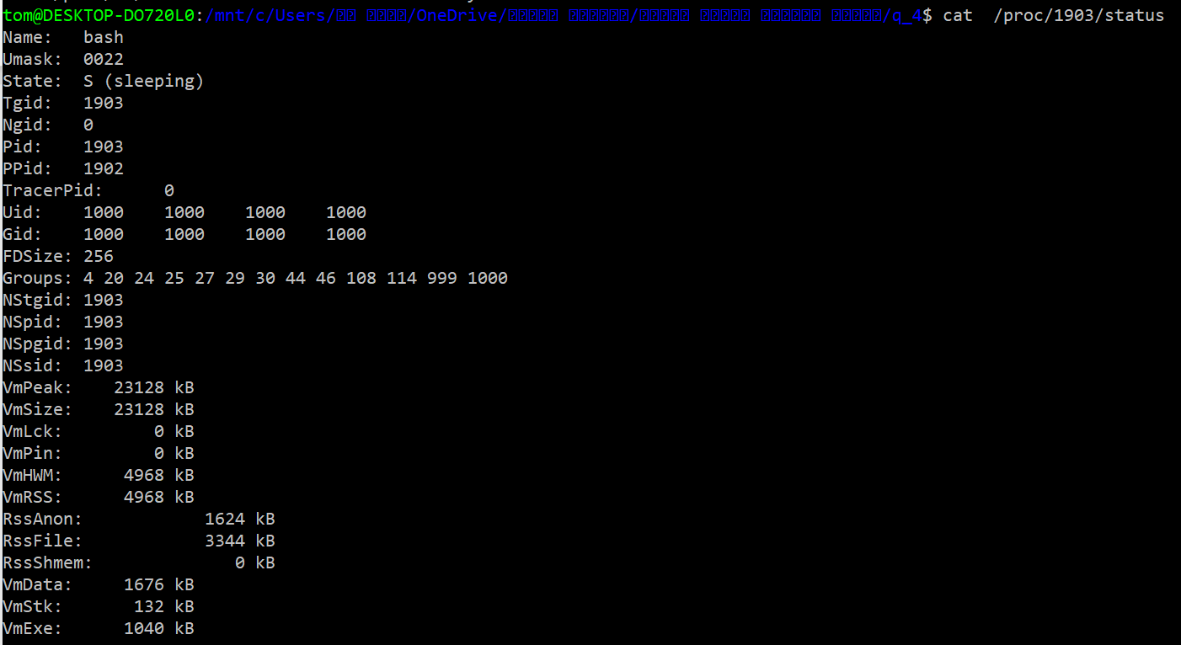When the PID does not exist:



Also we can use the proc to know if there is a process with a particular pid by stat function, the stat function gets a path in the first parameter so we can give her: /proc/pid and if the pid exists then the stat function return 0 else she return -1 and errno is set appropriately meaning if path does not exist, or path is an empty string the errno will be defined as ENOENT, To know if we have permissions for this process we will examine what the uid and gid are in the stat structure.

**advantages:**

* Brings a lot more information about the existing PID besides whether it exists or not
* His status is much more accurate we can see if he is currently running, sleeping, stopping etc. in the cat method.
* This way if we want more information about the specific PID we can get by additional commands that can be attached after cat: / proc / [PID] /
* for example: / proc / PID / maps, file contains the currently mapped memory regions and their access permissions.in the cat method.
* This method can be used via code

**Disadvantages:**

* Does not exist in the Windows operating system, which is very common and therefore not possible on every computer.

1. **By a function - sched_getscheduler(pid_t pid):** This function gets a pid in the parameter so we can send it any pid we want, if the function manages to get scheduler policy then this pid exists If the pid does not exist then the errno will be set to ESRCH, if we do not have permissions then the errno will be set to EPERM if the pid is negative the errno will be set to EINVAL.

**advantages:**

* This method can be used via code
* Gives an accurate indication That is, if the function fails we can know exactly why

**Disadvantages:**

* A less elegant method

3.**By signals:**

**advantages:**

* This method can be used via code
* Gives an accurate indication That is, if the function fails, we can know exactly why
* With the help of the signals it is possible to actually communicate with the process

**Disadvantages:**

* The number of signals received can be less than the number of signals sent, meaning some of the signals can be "lost" along the way.
* Windows not supported, The commands are different.

I want to specify another method - with the help of commands from the terminal: there are many commands that could show us whether a particular pid exists or not for example pidstat, top, ps the advantage that it is very convenient.