**Final work in operating systems:**

**Second question:**

**Section 2:**

**output of commands that confirm changed values:**

**SCHED_OTHER:**

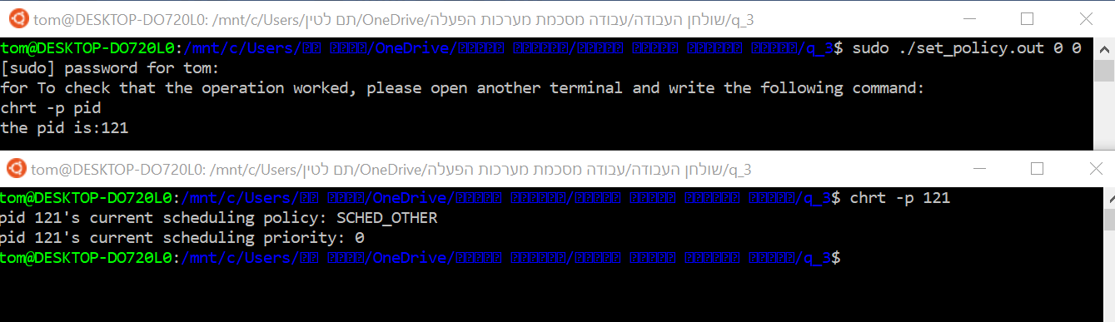**SCHED_FIFO:**

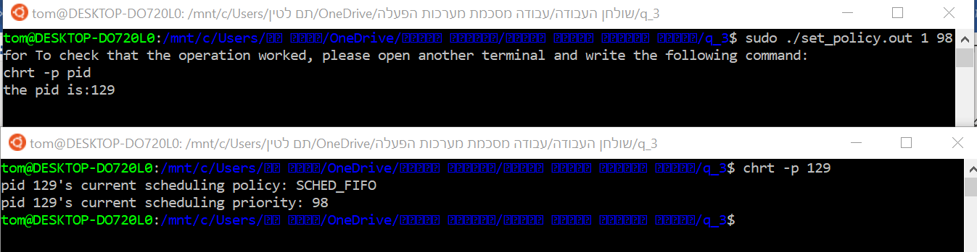**SCHED_RR:**

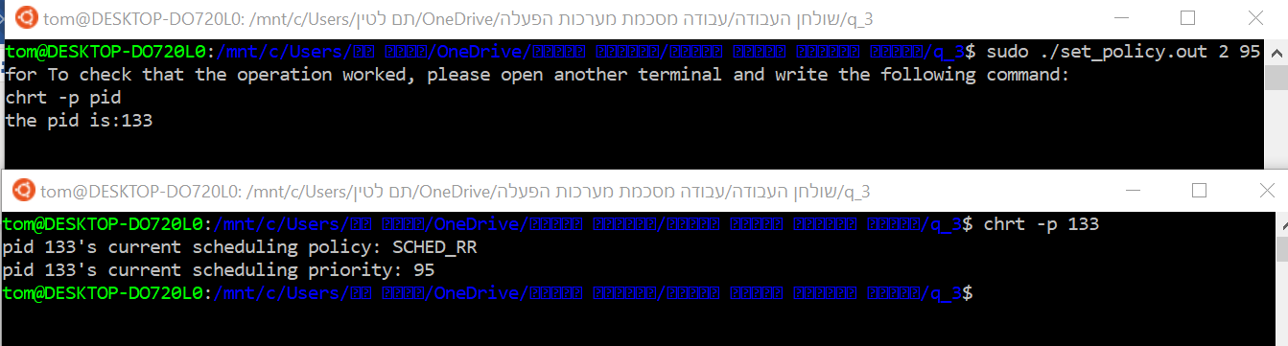**SCHED_BATCH:**

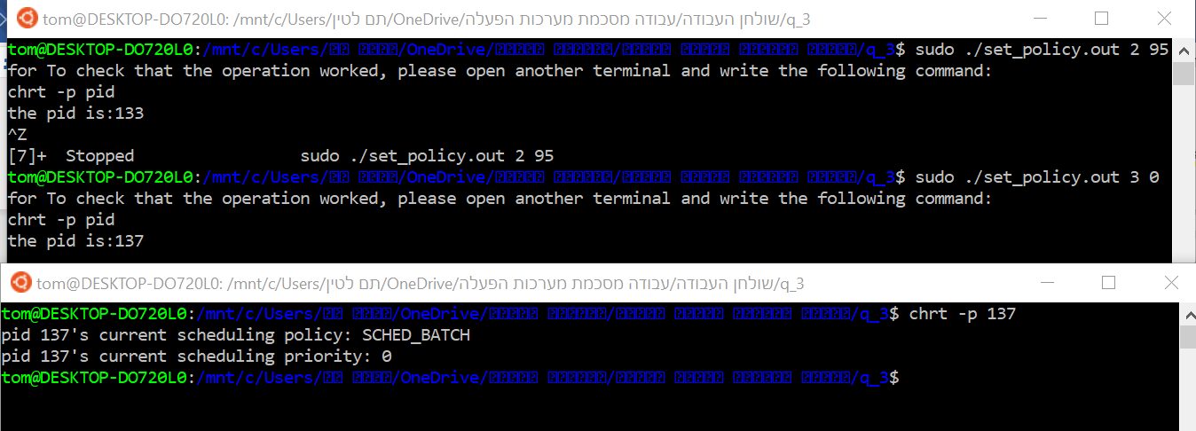

**SCHED_IDLE:**

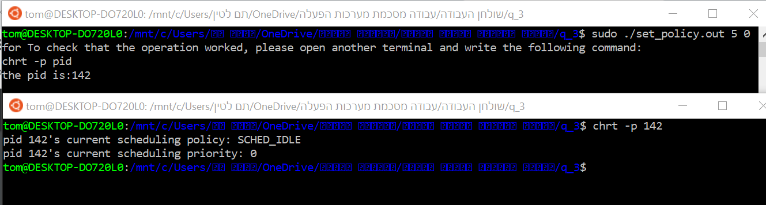

**SCHED_DEADLINE:**

