**Final work in operating systems:**

**Fourth question:**

**Section 1,2:**

The running output for the specified example:

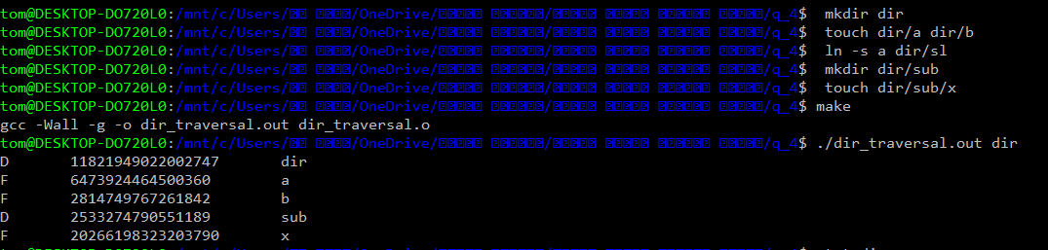

To prove that this is the correct inode for each file I will use the stat command that displays the detailed status of a particular file or a file system:

