Q1. Downloaded.

Q2. See image in folder

Q3. See image in folder

Q4.

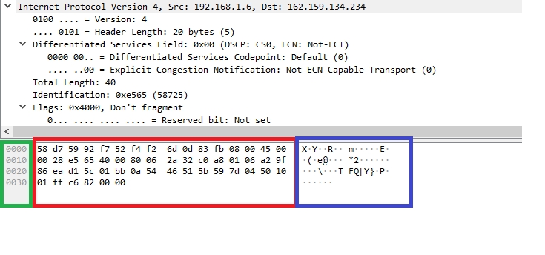

Green – Offset

Red – Packet data (in Hexadecimal)

Blue – Packet data (in ASCII format)

Src – source IP address i.e your IP address

Dst – Destination IP address i.e where the packet is being sent

Version – This is the IP version you are using, usually IPv4 or IPv6, in this case it is IPv4

Header Length – The number of 32bit words forming the header (In this case 5)

Type of service – Indicates the type of quality needed from the service (In this case Not – ETC)

Flags – Used to control if the packet can be fragment (In this case it cannot)

Time to live – The number of jumps to which the packet may be routed over

Q5. The main difference between the two packets is the one looked at in the previous question is TCP protocol and the one linked is IPv4. These are two separate network protocols. While TCP is concerned with the data being delivered once the IP address is found, IPv4 is the fourth version of the internet Protocol (32bits).

Q6.

**World of warcraft**

**Game Design** - The games design philosophy is based around character progression. This is at the center of almost every system in the game to make the play feel like he is growing in power the more time that is invested into the game, hence why it has become renown for being one of the most addictive games on the market.

**Technical Design** – World of warcraft is a MMO (massively multiplayer online) game, as this is the case it needs to host thousands of players on a server at once. This technical challenge was completed by a number of ways. Firstly having hundreds of servers but also a technique called “Sharding” which would alow within a server and cross server players to be placed into the game “Shard” this means that if every player on a WoW server was in the same place the server would usually not be able to handle this, with sharding it caps the amount of players and then moves them to a different “Shard”.

**Halo**

**Game Design** – Halo is one of Microsoft / Xbox’s flagship games. The game design behind there multiplayer is iconic in the industry with halo 2 becoming one of the first big. The design behind there multiplayer was a skill based first person arena shooter. With it being one of the first games to go onto xbox live its following quickly became huge and with halo 3 only grew

**Technical Design –** The AI in Halo is also remembered as another iconic part of the industry. It achieved this very realistic and “Smart” AI by implementing behavior trees. The trees will check the state of the world and then decide on what action to take next.

**Binding of Isaac**

**Game Design –** The Binding of Isaac revitalized the rogue like genre with its responsive controls, quick in and out play time and bizarre theme. The games design is that of very simple to understand making it accessible to any gamer but incredibly hard to master. This design with the varied number of weapons and maps makes it still regarded as one of the best designed games today.

**Technical Design -** The way the game solved the technical problem of replayability was for procedurally generated levels. This kept the game feeling fresh and is the cornerstone to a good rogue like and they executed it perfectly.