Q.1

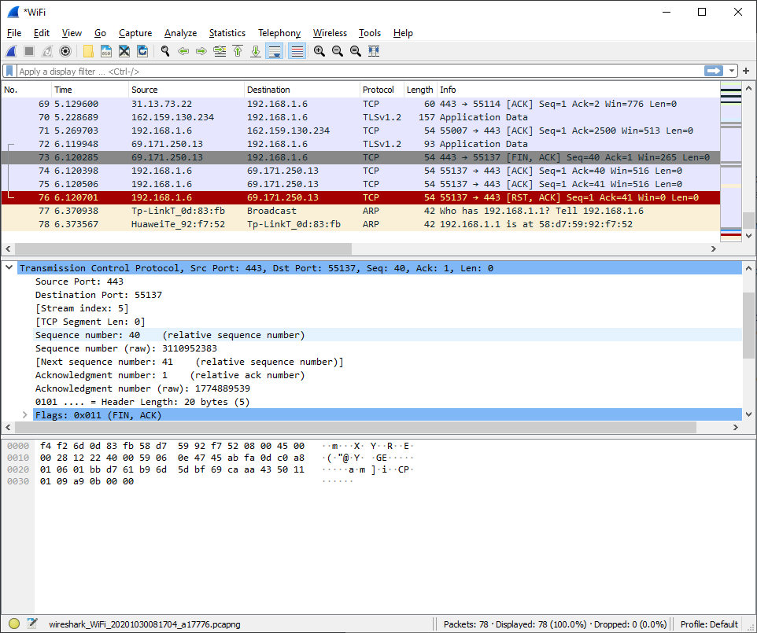

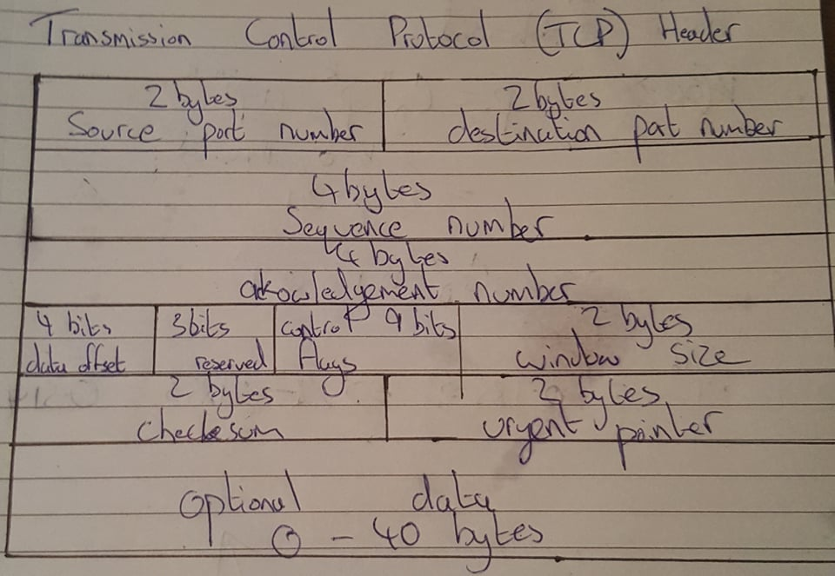

**Src port (Source port)** – port used by the PC sending the TCP

**Destination Port** – port number used by the PC receiving the TCP packet

**Sequence Number** – Used for the segmentation of application data into TCP segments and reassembling them on the other side.

**Window Size Value –** Number of Octets in the TCP

**Checksum –** A cyclic Redundancy Check checksum is calculated by the sender and added to this field before transmission. This field is used by the receiver to verify the integrity of the data in the TCP payload and rejects data that fails the CRC check

**Urgent Pointer –** points to the end of “Urgent” data in the packet

Q.2

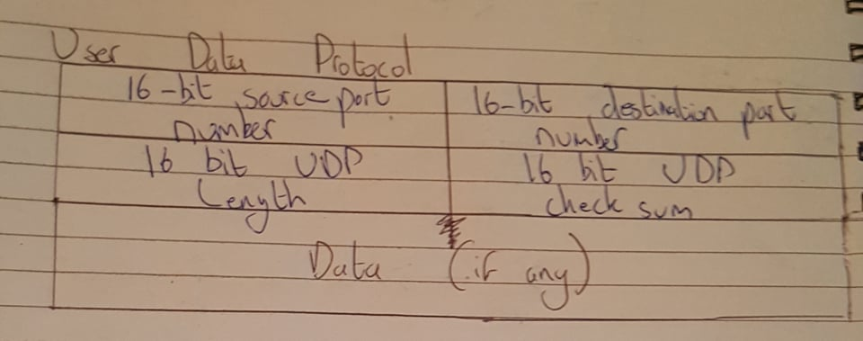

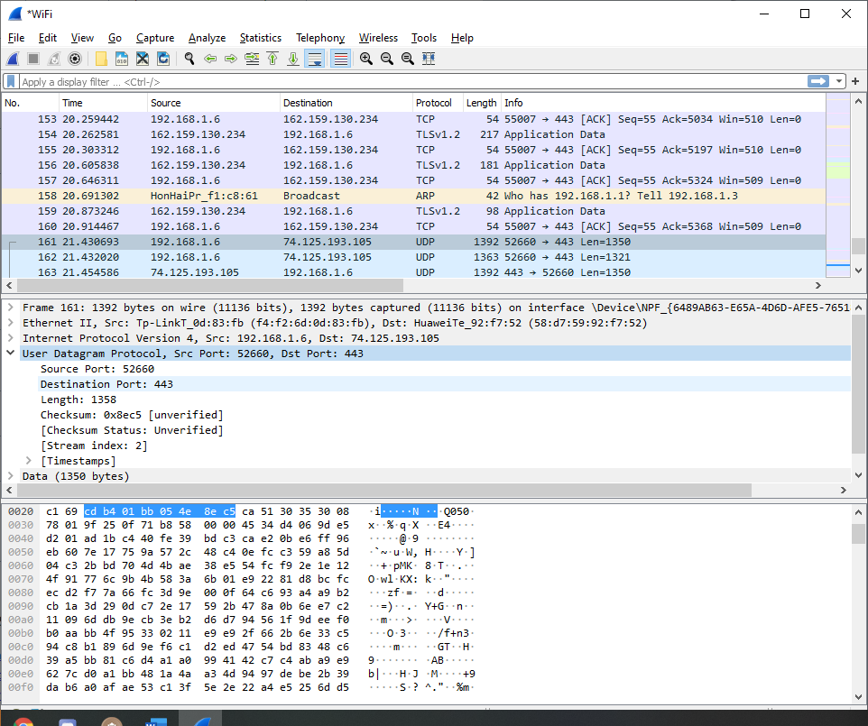

**Source port –** The port of the device sending the data

**Destination port –** The port of the device receiving the data

**Length -** Specifies the number of bytes comprising the UDP header and UDP payload.

**Checksum –** The checksum allows the receiving device to verify the integrity of the packet head3er and payload

Q3.



Q4.

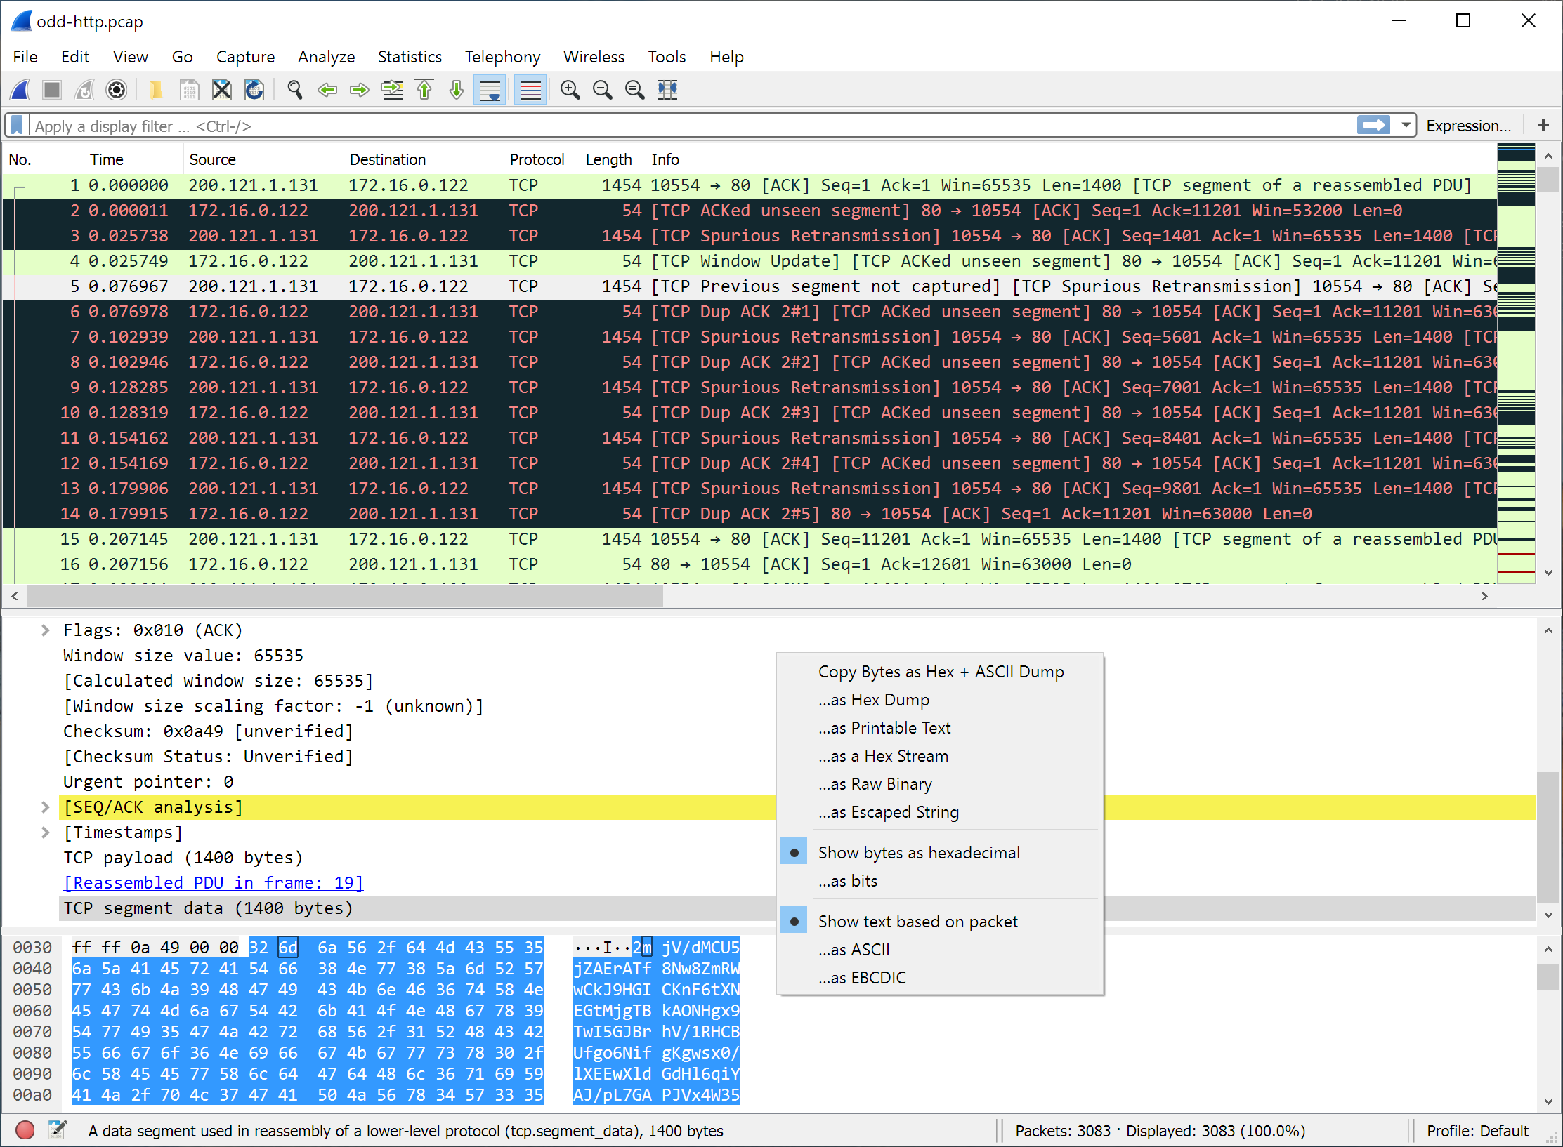

Q5. The “Three way handshake” is an algorithm used by the TCP to establish and terminate a connection. It involves the exchange of three messages between the client and the server. Its main function is that two parties agree on a set of parameters (Starting sequence numbers).

First the client sends a segment to the server stating the initial sequence number it plans to use. The server responds with a single segment that acknowledges the clients sequence number and states its own sequence number. Finally the client responds with a third segment that acknowledges the servers sequence number.

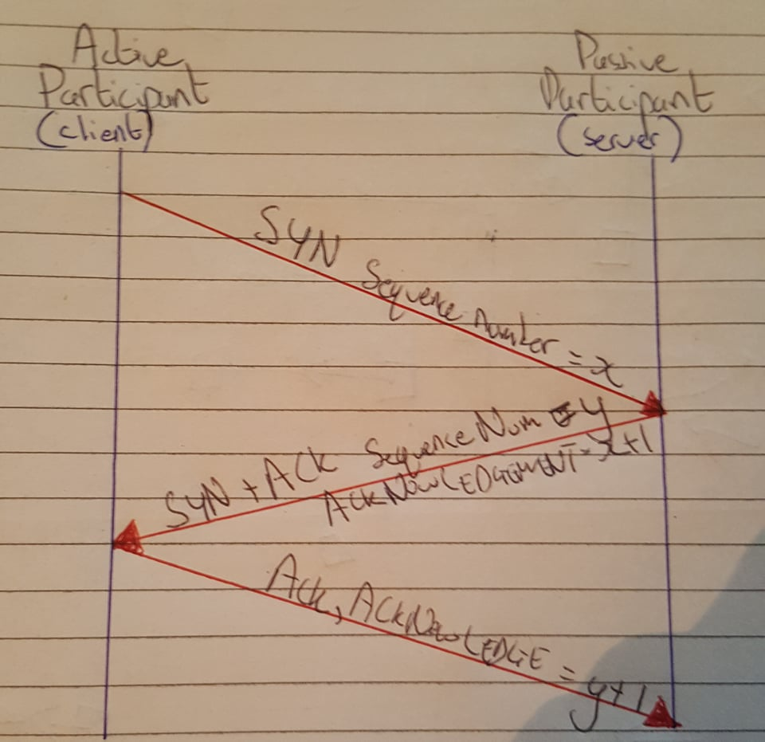

Q6.

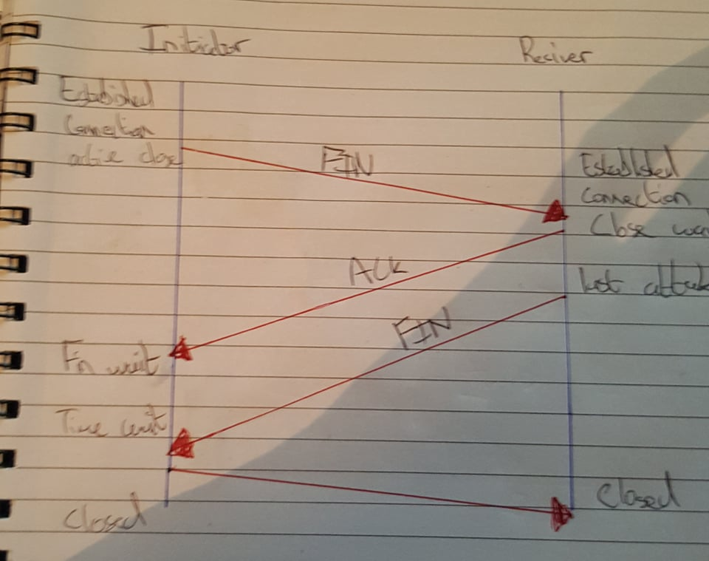

Q7. **What Are Gateways In Case Of Tcp/ip? (Networking tutorial)**  
Gateways provide connectivity between two or more network segments. It is usually a computer that runs the gateway software and provides translation services. This translation is a key in allowing different systems to communicate on the network.

**Q8. Question 6. What Is A Link In Case Of Tcp/ip? (DHCP Interview Questions)**

A link refers to the connectivity between two devices. It includes the type of cables and protocols used in order for one device to be able to communicate with the other.