**LAB-9**

**Objective:-** To implement containerization using Docker.

**Software Used:-** Visual Studio Code, Docker Desktop

Step 1:- Initialising your project and adding dependencies like express, cors and mongoose.

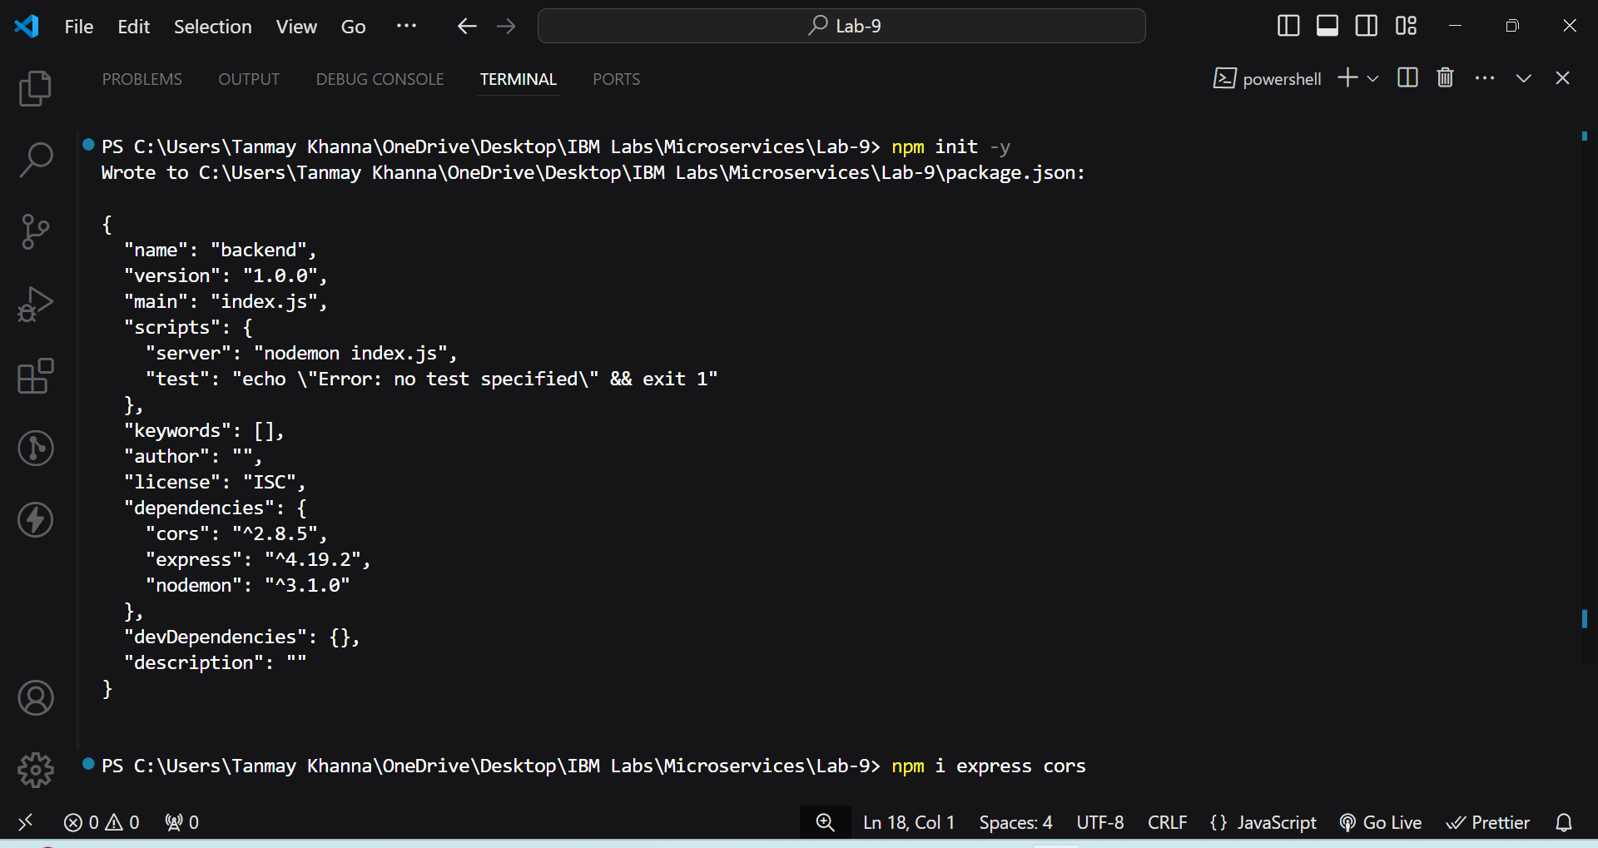

Step 2:- Creating routes in Express.js and performing CRUD operations on your database.

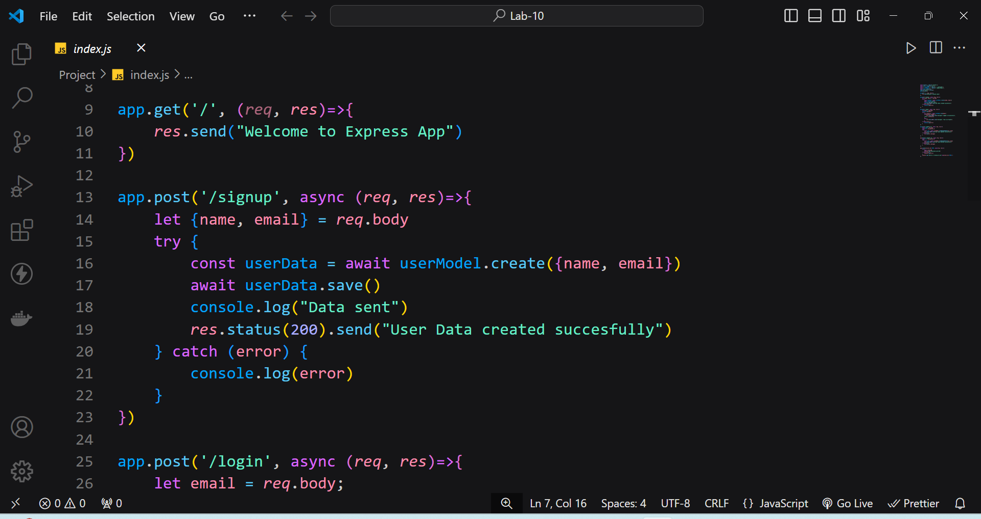

Step 3:- Host this backend project on Render ang generate a url.

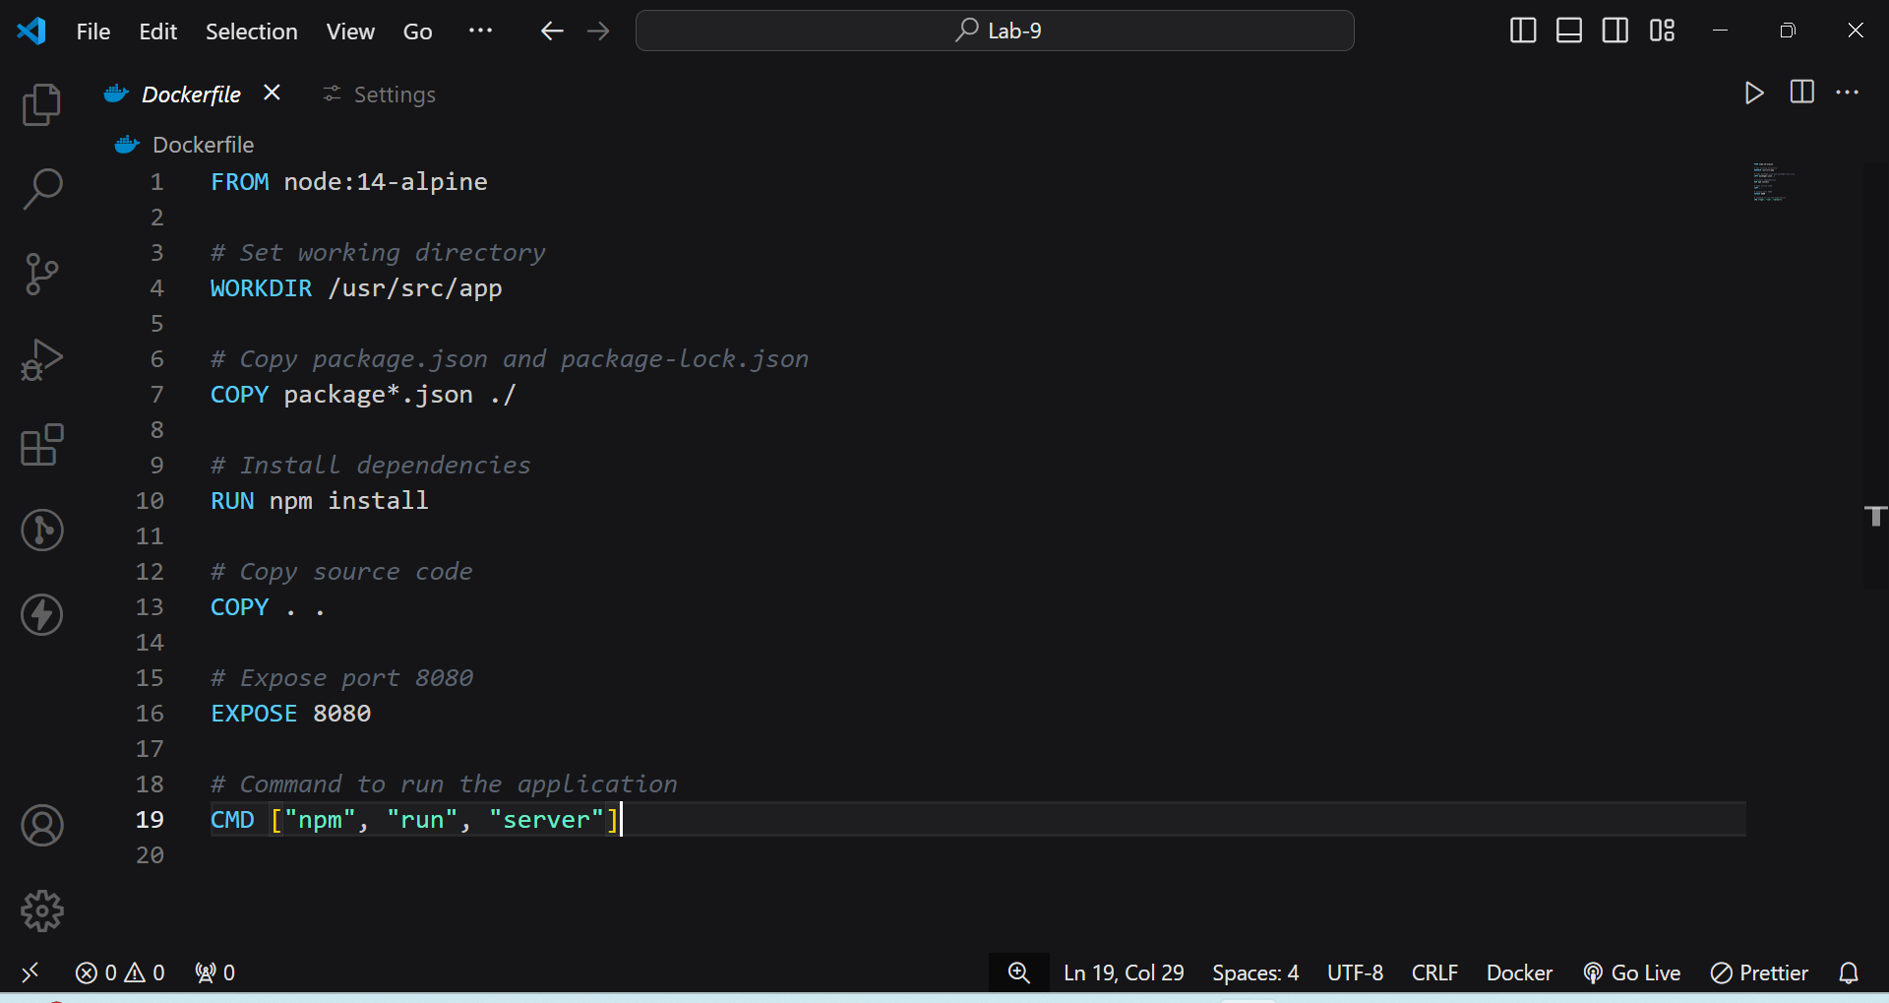

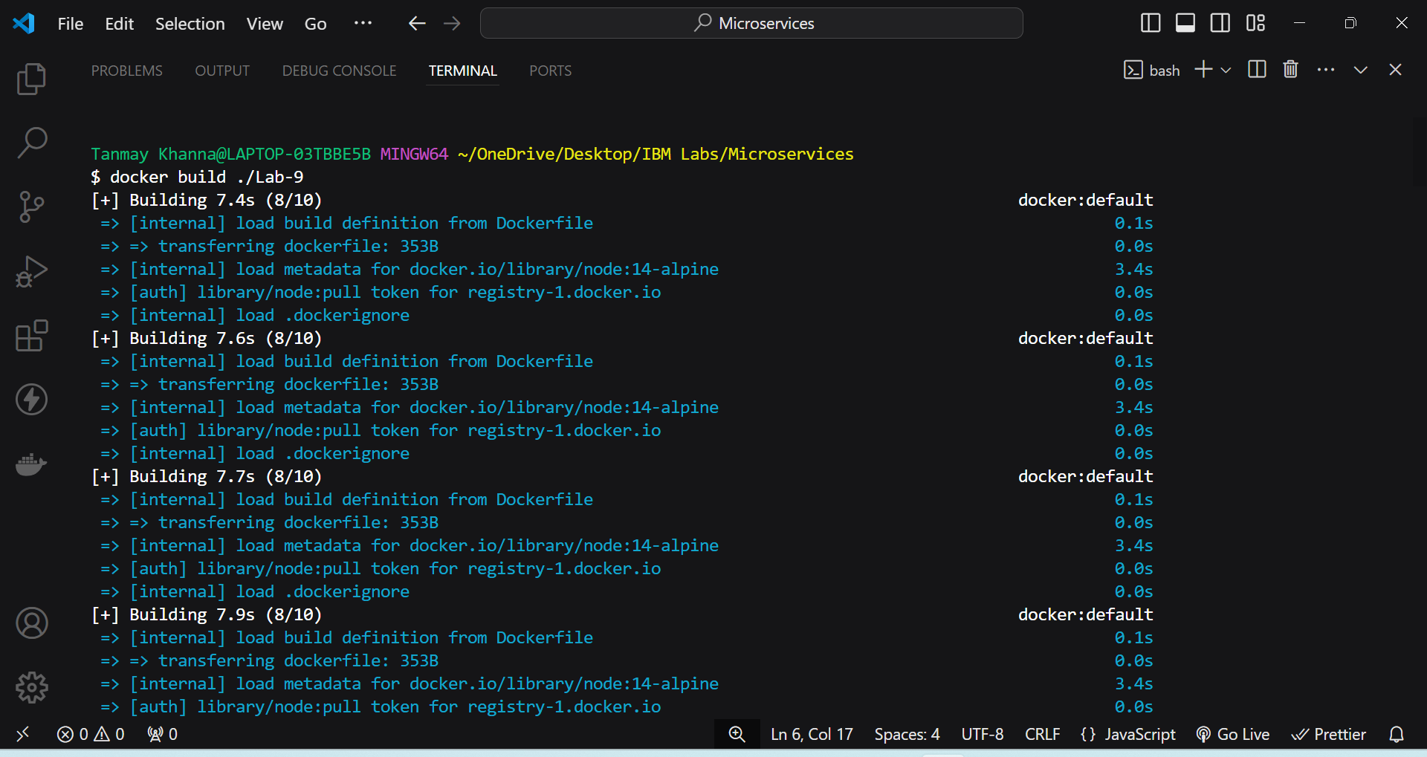

Step 4:- Initiate this project in your local environment on port:8080.

