Neural Networks Projects

Single Time-Series River Flow Prediction

Tom Makkink

2018

**1 Introduction**

The monthly river flow of the Sacramento River at Keswick, California, was recorded from October 1939 to September 1960. We suspect that there could be an underlying pattern to this data, and would like to develop a neural network that predicts future river flow based on previous patterns.

**2 The Data**

The data set was obtained from the Matlab neural network sample data sets for shallow networks, and was loaded as follows:

% Read in the data

p = river_dataset;

p is a 1x264 cell array of scalar values recording the river flow for the 264 months measured, and is illustrated graphically as follows:

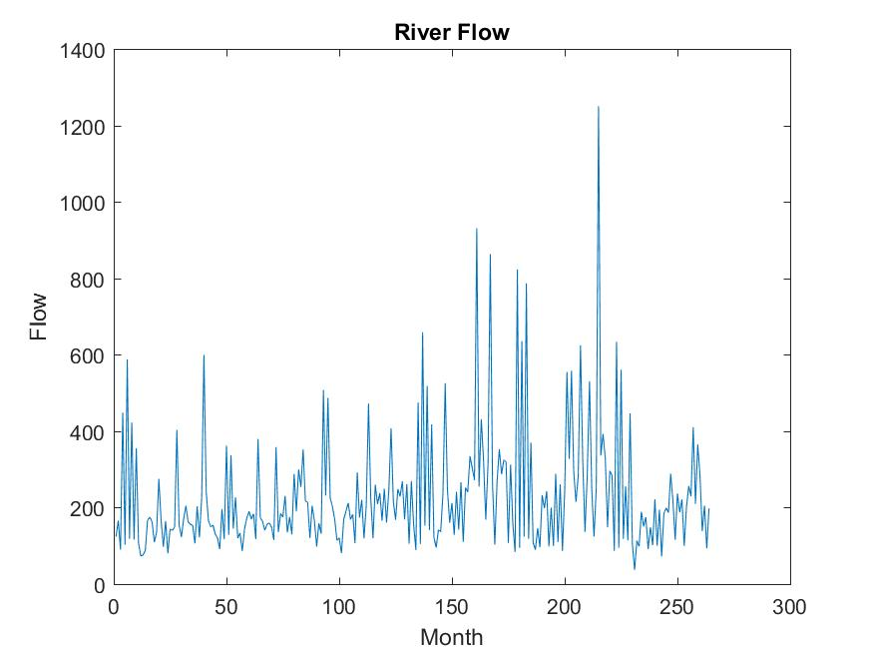

An initial analysis of the data seemed to indicate that there may be some underlying pattern to river flow each month, but there are also clearly dramatic fluctuations which cast doubt in our minds.

**3 Method**

For this problem a feed-forward input time-delay backpropagation network was used, with the following attributes:

* Two hidden layers with 25 neurons in each.
* Hidden transfer layer function tansig, and outer layer function purelin.
* The Training function was Levenberg-Marquardt backpropagation (trainlm).
* A training goal of 1e-2.

net=newfftd(ptrain,ptrain,[1:r],[20, 20]);

%ttest index

ti=[m-n:m];

%training index

tri=[1:m-n-1];

ptrain=p(tri);

net=newfftd(ptrain,ptrain,[1:r],[20, 20]);

%set goal>0 since there is no validation set

net.trainParam.goal=1e-2;

net=init(net);

%initial inputs which have no targets

pi=p([1:r]);

After much experimentation, it appeared that using 2 hidden layers with 20 neurons in them produced good results. Increasing the number of neurons in each hidden layer to 40, did not produce noticeably better results, and increasing the number 70 slowed down the net drastically.

A test set size of 24 was used, to simulate the river flow within two years.

The results are represented graphically below:

‘*’ atest

‘o’ ctest

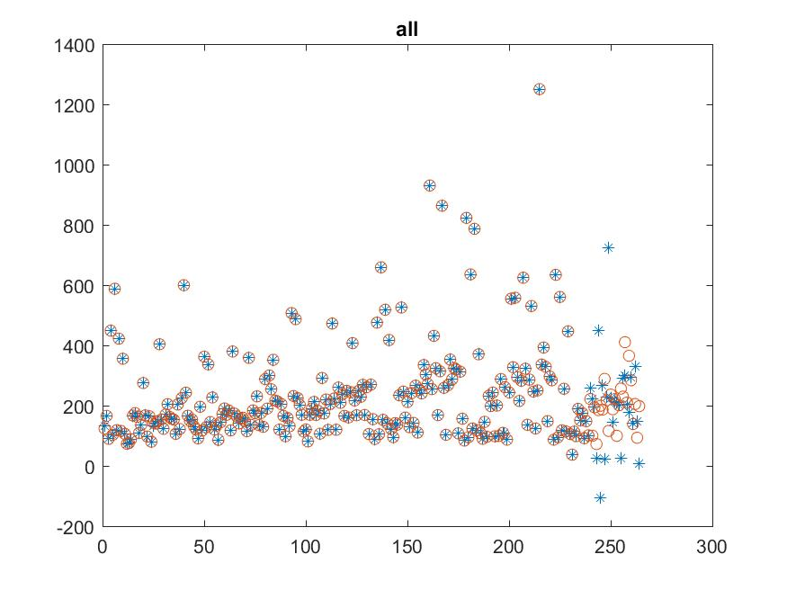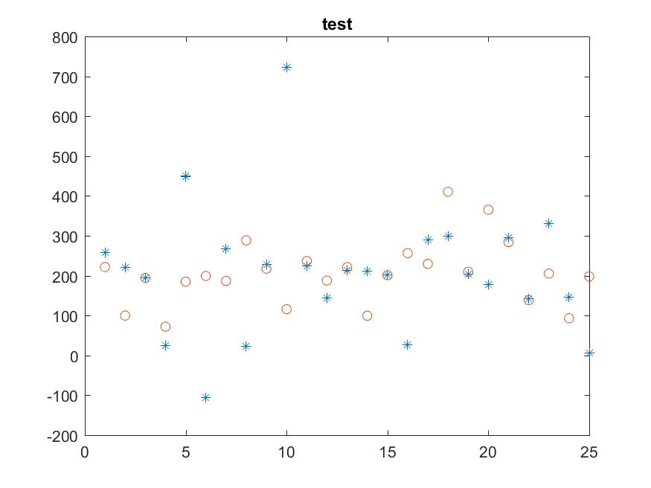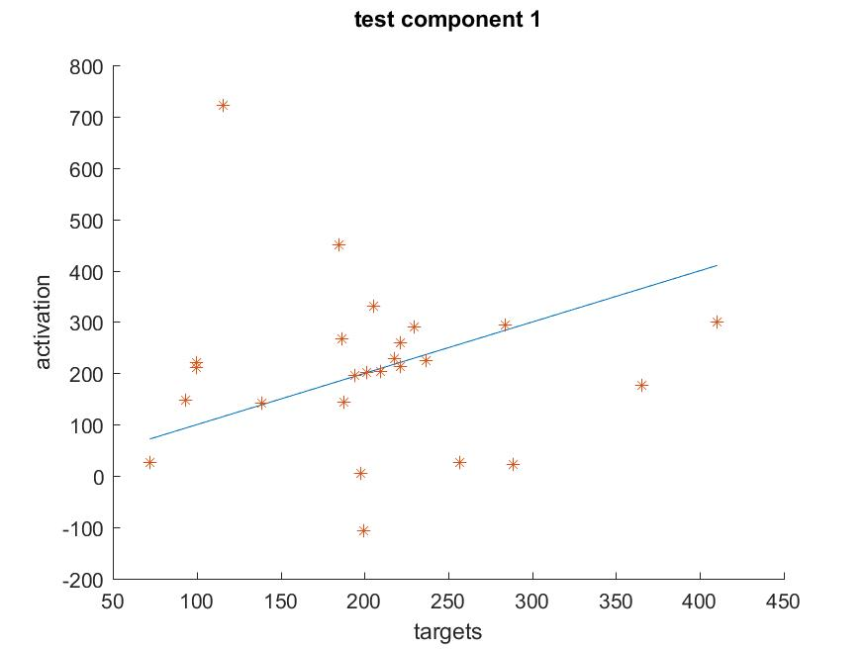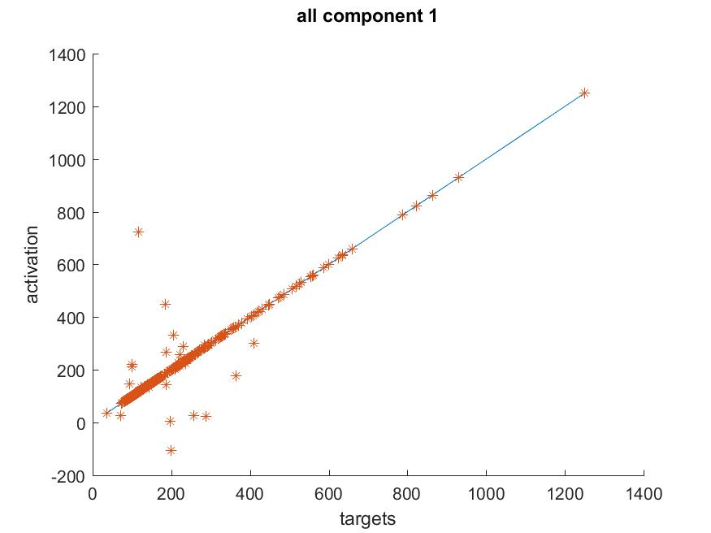

**4 Conclusion**

The results reveal that the neural network was unable to accurately discern a pattern for predicting the monthly river flow. Indeed there are many potential factors such as climate change, deforestation, the construction or destruction of dams, or the use of water as irrigation which may have contributed to these fluctuations.

**5 References**

*https://fr.mathworks.com/help/nnet/gs/neural-network-toolbox-sample-data-sets.html*