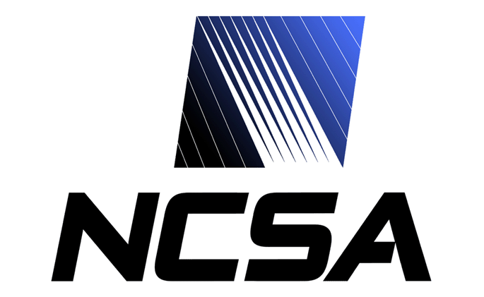
Date: December 15, 2005
From: D. Michael Freemon
Re: LSST Security Architecture

Updated January 18, 2006 DRAFT

Introduction
Proposal for a grid security architecture for DES, LSST, etc.

Requirements
- Scope is authentication/authorization in a grid environment
- Browser-based access
- Use GSI, but hide details, X.509 credentials, etc.
- Support multiple portal servers
- Single Sign-On (SSO) across the portal servers
- Limit trust of portal servers
  - Allow only short-term secrets/credentials to pass through portal server
- Differentiate between two different types of credentials
  - Support “weak accounts/certificates”, requiring only email verification to create
  - Support “strong accounts/certificates”, requiring personal review by an security administrator before issuing
- Preserve the ability for power users to retrieve GSI credentials for client-side applications
- Separate authentication from authorization. Authentication is centralized at NVO, NCSA, plus (possibly) a very small number of others. Authorization is decentralized, i.e. each resource provider is responsible for authorizing use of their resources.
- Individual portal applications need to access resources from multiple administrative domains (resource providers).

Server Environment
- Single registration and login server at NVO; NVO also runs CA. There will be analogous registration/login organizations in EUR, China, and S. America.
- Ten or more portal sites (NVO, NCSA, NOAO, NRAO, STSCI, DES, LSST, etc.)
- Forty or more resource providers (WS, GridFTP, GRAM)

Solution
The proposed solution is described here, and is implemented in two phases.

The first phase involves implementing pubcookie to support only short-term secrets going to the portal server as well as web single signon. This phase also includes the implementation of PURSE for new user registration, and a standard MyProxy installation.

The second phase simplifies the environment, making installation, configuration, and troubleshooting easier for both administrators and users.

Phase 2 Changes

- Use Online CA functionality of MyProxy
- MyProxy authenticates users using the PURSE database (RDBMS)
- Remove SimpleCA and MyProxy processing from PURSE

Phase 2 Benefits

- Single password in one location – no need to keep passwords/passphrases “in-sync”, or to create administrative or support processes to reset passwords, etc.
- Easier to deal with “volatile data” in the x509 certificate (such as CAS authorizations) – simply have the user logoff and logon again
- Simplies PURSE — PURSE is not responsible for creating any certificates, therefore it does not need SimpleCA and does not invoke any MyProxy functionality

Sequence Diagram
Normal User Scenario – Initial Registration

- User navigates to the PURSE website to register as a new user.
- User verification processing proceeds using normal PURSE workflows (email confirmations, personal verification, etc.)
- PURSE uses SimpleCA to create an X509 End Entity Credential and stores it into the MyProxy Credential Repository. [This step goes away during phase 2]
- PURSE inserts a row into the userid/password table.

Normal User Scenario – Accessing the 1st Portal

- User navigates to the portal server in the normal way.
- mod_pubcookie sees no granting cookie, so the user is redirected to the pubcookie login server.
- Logon page is sent to the browser.
- User sends userid and password to pubcookie login server.
- Pubcookie authenticates user against MyProxy.
- MyProxy authenticates user against the PURSE database. [This step is added during phase 2]
- Pubcookie redirects the browser back to the portal server (with a granting cookie). mod_pubcookie on sky1 accepts the granting cookie and the user is logged on.
[There is also a session cookie stored in the browser to maintain the session state with the login server. It is used only by the login server.]
- Apache module mod_myproxy intercepts the incoming request and automatically issues a myproxy-logon to create a local proxy certificate. However, this myproxy-logon will send and accept the pubcookie granting cookie as a passphrase.
- MyProxy Online CA creates a new X509 credential on the fly.
[This step is added during phase 2]
- X509 credential is received in the portal server.
- Portlet accesses grid resources (Web Services, GridFTP, WS-GRAM) in the normal way.

Normal User Scenario – Accessing a 2nd Portal

- At some later point, the user navigates to a second portal server.
- No granting cookie is present, so mod_pubcookie on sky2 redirects the user to the pubcookie login server.
- The login server does, however, see a valid pubcookie session cookie, thus the user is not prompted again for userid/password. Instead, the user is immediated redirected back to the application server (sky2), with a granting cookie.
- Apache module mod_myproxy intercepts the incoming request and automatically issues a myproxy-logon to create a local proxy certificate. However, this myproxy-logon will send and accept the pubcookie granting cookie as a passphrase.
- MyProxy Online CA creates a new X509 credential on the fly.
[This step is added during phase 2]
- X509 credential is received in the portal server.
- Portlet accesses grid resources (Web Services, GridFTP, WS-GRAM) in the normal way.

Power Users
- Power users register as a new user in the same way as the normal user.
- Once registered, power users can access their proxy certificates by retrieving them directly from MyProxy in the normal way.

