

Tools for Data to Knowledge

November 2011
Version 1.0

Ciro Donalek, Caltech
Matthew J. Graham, Caltech (editor)
Ashish Mahabal, Caltech
S. George Djorgovski, Caltech
Ray Plante, NCSA

Contents
Contents 1
Overview 2
Acknowledgements 4
Section 1. Scope 5
What is astroinformatics? 5
Review process and criteria 9
Section 2. Template scenarios 11
Photometric redshifts 11
Classification 11
Base of Knowledge 12
Cross-validation 12
Section 3. Benchmarks 14
Orange 14
Weka 15
RapidMiner 16
DAME 17
VOStat 18
R 19
Section 4. Recommendations 21
Section 5. Computing resources 23
References 24
Appendix A. Test results 25
Orange 25
Weka 25
RapidMiner 27
DAME 28
VOStat 29
Overview
Astronomy is entering a new era dominated by large, multi-dimensional, heterogeneous data sets and the emerging field of astroinformatics, combining astronomy, applied computer science and information technology, aims to provide the framework within which to deal with these data. At its core are sophisticated data mining and multivariate statistical techniques which seek to extract and refine information from these highly complex entities. This includes identifying unique or unusual classes of objects, estimating correlations, and computing the statistical significance of a fit to a model in the presence of missing data or bounded data, i.e., with lower or upper limits, as well as visualizing this information in a useful and meaningful manner. The processing challenges can be enormous but, equally so, can be the barriers to using and understanding the various tools and methodologies. The more advanced and cutting-edge techniques have often not been used in astronomy and determining which one to employ in a particular context can be a daunting task, requiring appreciable domain expertise.

This report describes a review study that we have carried out to determine which of the wide variety of available data mining, statistical analysis and visualization applications and algorithms could be most effectively adapted and integrated by the VAO. Drawing on relevant domain expertise, we have identified which tools can be easily brought into the VO framework but presented in the language of astronomy and couched in terms of the practical problems astronomers routinely face. As part of this exercise, we have also produced test data sets so that users can experiment with known results before applying new techniques to data sets with unknown properties. Finally, we have considered what computational resources and facilities are available in the community to users when faced with data sets exceeding the capabilities of their desktop machine.

This document is organized as follows: in section 1, we define the scope of this study. In section 2, we describe the test problems and data sets we have produced for experimental purposes. In section 3, we present the results of benchmarking various applications with the test problems and data sets and present our recommendations in section 4. Finally, in section 5, we discuss the provision of substantial computational resources when working with large data sets.

Acknowledgements
This document has been developed with support from the National Science Foundation Division of Astronomical Sciences under Cooperative Agreement AST 0834235 with the Virtual Astronomical Observatory, LLC, and from the National Aeronautics and Space Administration.

Disclaimer
Any opinions, findings, and conclusions or recommendations expressed in this material are those of the author(s) and do not necessarily reflect the view of the National Science Foundation.

Copyright and License
“Tools from Data to Knowledge” by Ciro Donalek et al. is licensed under a Creative Commons Attribution-NonCommercial 3.0 Unported License.

Scope

What is astroinformatics?
An informatics approach to astronomy focuses on the structure, algorithms, behavior, and interactions of natural and artificial systems that store, process, access and communicate astronomical data, information and knowledge. Essential components of this are data mining and statistics and the application of these to astronomical data sets for quite specific purposes.

Data mining
Data mining is a term commonly (mis)used to encompass a multitude of data-related activities but, within astroinformatics, it addresses a very particular process (also known as knowledge discovery in databases or KDD): “the non-trivial act of identifying valid, novel, potentially useful, and ultimately understandable patterns in data”.

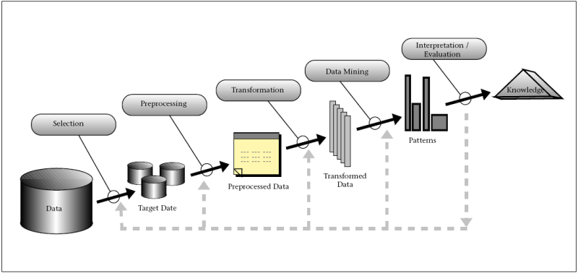
Figure 1: Schematic illustrating the various steps contributing to the data mining process

Data mining is an interactive and iterative process involving many steps (see Fig. 1.). One of the most important is data preprocessing, which deals with transforming the raw data into a format that can be more easily and effectively processed by the user and includes tasks such as:

- Sampling – selecting a representative subset from a large data population
- Noise treatment
- Strategies to handle missing data
- Normalization
- Feature extraction – pulling out specific data that is significant in some particular context

Other steps in the data mining process include model building, validation and deployment and a fuller description of these can be found on the IVOA KDDIG web site [1].

The application of data mining can be broadly grouped into the following types of activity:

Clustering
- Partitioning of a data set into subsets (clusters) so that data in each subset ideally share some common characteristics
- Search for outliers

Classification
- Division of a data set into a set of classes, each of which have specific characteristics exhibited by member data instances
- Predict class membership for new data instances
- Training using a set of data of known classes (supervised learning)

Regression
- Predict new values based on fits to past values (inference)
- Compute new values for a dependent variable based on the values of one or more measured attributes

Visualization
- High dimensional data spaces

Association

Patterns that connect one event to another

Sequence or Path Analysis
- Looking for patterns in which one event leads to a later event

Classification and clustering are similar activities, both grouping data into subsets; however, the distinction is that, in the former, the classes are already defined. There are actually two ways in which a classifier can classify a data instance:

- Crispy classification: given an input, the classifier returns its class label
- Probabilistic classification: given an input, the classifier returns the probability that it belongs to each allowed class

Probabilistic classification is useful when some mistakes can be more costly than others, e.g., give me only data that has a greater than 90% chance of being in class X. There are also a number of ways to filter the set of probabilities to get a single class assignment: the most common is winner-take-all (WTA) where the class with the largest probability wins. However, there are variants on this – the most popular is WTA with thresholds in which the winning probabilities have to also be larger than a particular threshold value, e.g., 40%.

Data mining algorithms adapt based on empirical data and this learning can be supervised or unsupervised.

Supervised Learning
In this approach, known correct results (targets) are given as input to the particular algorithm during the learning/training phase. Training thus employs both the desired set of input parameters and their corresponding answers. Supervised learning methods are usually fast and accurate but they also have to be able to generalize, i.e., give the correct results when new data are given without knowing a priori the result (target).

A common problem in supervised learning is overfitting: the algorithm learns the data and not the underlying function. It performs well on the data used during training but poorly with new data. Two ways to avoid this are to use early stopping criteria during training and to use a validation data set, in addition to training and test data sets. Thus three data sets are needed for training:

- Training set: a set of examples used for learning where the target value is known
- Validation set: a set of examples used to validate and tune an algorithm and estimate errors
- Test set: a set of examples used only to assess the performance of an algorithm. It is never used as part of the training process per se so that the error on the test set provides an unbiased estimate of the generalization error of the algorithm.

Construction of a proper training, validation and test set (also known as the Base of Knowledge or BoK) is crucial.

Unsupervised Learning
In this approach, the correct results are not given to the algorithm during the learning/training phase. Training is thus only based on the intrinsic statistical properties of the input data. An advantage of this approach is that it can be used with data for which only a subset of objects representative of the targets have labels.

For further introductions to data mining with specific application to astronomy, see [2], [3], and [4].

Statistics
Unlike data mining, statistics requires no clarifying definition but the specific emphasis placed within the context of astroinformatics is on the application of modern techniques and methodologies. It is an oft-cited statement that the bulk of statistical analyses in the astronomical literature employ techniques that predate the Second World War, specifically the most popular being the Kolmogorov-Smirnov test and Fisher regression techniques. More contemporary methods can feature a strong Bayesian basis, theoretical models for dealing with missing data, censored data and extreme values and non-stationary and non-parametric processes. There is a good deal of overlap between the ranges of application of statistical analyses and data mining techniques in astronomy - classification, regression, etc. They are, however, complimentary approaches, attacking the problems from different perspectives, i.e., finding a computational construct, such as a neural net, that addresses the issue as opposed to a mathematical model.

For further information about modern statistical approaches to astronomy, see [5].

Review process and criteria
The aim of this study is to identify which of the various free data mining and statistical analysis packages commonly used in the academic community would be suitable for adoption by the VAO. For an objective comparison, we defined two typical problems to which these types of applications would normally be applied with associated sample data sets (see section 2 for a fuller description). The experience of running these tests with our selected applications forms the main basis of our review. Where possible, the same specific method was used but not all of the packages have the same set of methods for a particular class of activity, regression say. Even with the same method, there can be implementation differences, for example, the type of training algorithm available for a multi-layer perceptron neural net. This all means that the reported numerical results (accuracies) of the packages are not necessarily quantitatively comparable, although a qualitative comparison can be made. A number of other criteria were therefore also taken into account:

- Usability:
  - how user-friendly is the application interface
  - how easy is it to set up an experiment
- Interpretability:
  - how are the results shown, e.g., confusion matrices, tables, etc.
- Robustness:
  - how reliable is the interface in terms of crashing, stalling, etc.?
  - how reliable is the algorithm is terms of crashing, stalling, etc.?
- Speed:
  - how quickly does the application return a result?
- Versatility:
  - how many different methods are implemented
  - how many different features are implemented, e.g., different cross-validation techniques
- Scalability:
  - how does the application fare with large data sets, both in terms of number of points and parameters
- Existing VO-compliance
  - is VOTable supported?
  - are other VO standards supported?
  - is it easy to plug-in other software?

Template scenarios
Two of the most common types of problem to which data mining and statistical analysis tools are applied are regression and classification. We have thus defined a regression problem and a classification problem with which to test the various applications. For each problem, we have also defined appropriate sample data sets to use in these tests. The data sets are available for general use from [6].

Photometric redshifts
It has been unfeasible for at least the past decade to obtain a spectroscopic redshift for every object in a sky survey. Rather they are measured for a small representative subset of objects and then inferred using some regression technique for all other objects in the data set based on their photometric properties.

We have defined two sample data sets for this class of problem.

Data set 1

This consists of the SDSS DR7 colors (u-g, g-r, r-i, i-z, z) and associated errors of 638200 galaxies, together with their measured spectroscopic redshifts.

Data set 2

This consists of the SDSS DR7 colors (u-g, g-r, r-i, i-z, z) and associated errors of 72615 quasars, together with their measured spectroscopic redshifts.

Classification
As already noted, it is impossible to take a spectrum of every object in a sky survey. It is equally as impossible to visually inspect every object in a sky survey and attempt to determine what class of object it belongs to. If, however, the classes are known for a subset then a classifier can be trained on them. Any object in the full data set can then be classified based on its measured properties.

We have defined one sample data set for this class of problem.

Data set 3

This consists of the SDSS DR7 colors (u-g, g-r, r-i, i-z) and spectroscopic classification (unknown source, star, galaxy, quasar, high-redshift quasar, artifact, late-type star) for 159845 objects.

Base of Knowledge
The training set, validation set and test set to be used in evaluating an application must all be drawn from the sample data set being considered. A common way of doing this is to divide the sample data set according to the ratios 60-20-20 or 80-10-10 with the largest part in each case being the training set. We have used the 60-20-20 prescription since this gives reasonably sized validation and test sets and so slightly better error estimates than in the 80-10-10 case.

Cross-validation
Cross-validation is a process by which a technique can assess how the results of a statistical analysis will generalize to an independent data set. There are two popular approaches:

k-fold cross-validation
The original sample is randomly partitioned into k subsamples. Of the k subsamples, a single subsample is retained as the validation data for testing the algorithm, and the remaining k-1 are used as training data. The cross-validation process is then repeated k times (the most common value for k is 10), with each of the k subsamples used exactly once as validation data. The k results from the folds are then combined (e.g., averaged). The advantage of this approach over repeated random sub-sampling is that all observations are used for both training and validation, and each observation is used for validation exactly once.

Leave-one-out cross-validation
A single observation from the original sample is used as the validation data, and the remaining observations as the training data. This is repeated such that each observation in the sample is used once as the validation data. Leave-one-out cross validation is usually very computationally expensive because of the large number of times the training process is repeated.

In our tests, we have employed 10-fold cross-validation (where possible) which is a good trade-off between the two approaches.

Benchmarks
We tested four data mining applications and two statistical analysis applications. Detailed output from the results is given in Appendix A.

Orange
Platform: Cross-platform
Website: http://orange.biolab.si
Developers: University of Ljubljana
Stable release: 2.0
Development: Active
Language: Python
License: GNU General Public License
Data mining methods implemented: Most standard data mining methods such as classification trees, kNN, random forest, SVM, naïve Bayes, logistic regression, etc. and the library of methods is growing.
Data input format: Tab-delimited, CSV, C4.5, .arff (Weka format) – tab-delimited files can have user-defined symbols for undefined values with a distinction between “don’t care” and “don’t know”, although most algorithms will consider these equivalent to “undefined”.
Scalability: Not scalable. The UI crashes when some common learning algorithms are asked to handle a file with ~160000 entries (~7.5MB in size).
Astronomical use: Orange has not yet been used in any published astronomical analysis.
Test results:
Photometric redshift: Fails – application crashes.
Classification: >90% accuracy for two classifiers
Comments:
The “Orange Canvas” UI is quite intuitive. All tasks are performed as schemas constructed using widgets that can be individually configured. This interface is quite convenient for people who run at the thought of programming since it allows a more natural click-and-drag connection flow between widgets. Widgets can be thought of as black boxes which take in an input connection from the socket on their left and output their results to the socket on their right. Workflows can thus be easily constructed between data files, learning algorithms and evaluation routines. However, although it is quite straightforward to setup experiments in the UI, their successful execution is not always guaranteed.

The lack of scalable data mining routines is a major negative factor. Although some of the routines may be accessed via Python scripting (and so not crash with the UI), they are still too slow to feasibly run on larger datasets, e.g., ~2 GB in size.

Good documentation is available for both the UI and the scripting procedures with examples provided for the most common usage patterns. The scripting examples, in particular, are much more useful and thorough, including how to build, use and test your own learners.

Weka
Platform: Cross-platform
Website: http://www.cs.waikato.ac.nz/~ml/weka
Developers: University of Waikato
Stable release: 3.6.4
Development: Active
Language: Java
License: GNU General Public License
Data mining methods implemented: Most standard methods have been implemented. There is also a wide range of more classification algorithms available [7] as plug-ins to Weka including learning vector quantization, self-organizing maps, and feed-forward ANNs.
Scalability: Except for some models that have been especially implemented to be memory friendly, Weka learners are memory hogs. The JVM ends up using a lot of resources due to internal implementation details of the algorithms. This can be easily seen when using the “Knowledge Flow” view. There are quite a few standard methods (such as linear regression) that do not scale well with the size of the data set. Data set sizes of up to 20 MB can rapidly cause the JVM to require heap sizes of up to 3 GB with some of these learners.
Data input format: Most formats – CSV, .xrff, C4.5, .libsvm – but the preferred format is .arff (attribute-relate file format).
Astronomical use: Weka has been used in astronomy to classify eclipsing binaries [8], identify kinematic structures in galactic disc simulations [9] and find active objects [10].
Test results:
Photometric redshift: Using linear regression - rms error = 0.0001 for subset of galaxies, rms error = 0.5642 for quasars
Classification: 92.6% accuracy
Comments:
Resource usage is a major issue with Weka. It is not a lightweight piece of software, although, to be fair, it never claims to be, but nonetheless scalability takes a big hit as a result.

The “Explorer” interface is a collection of panels that allows users to preprocess, classify, associate, cluster, select (on attributes), and visualize. The same issues are tackled in the “Knowledge Flow” interface with the use of widgets and connections between them to design workflows, in a very similar manner to the Orange interface and with the same degree of user-friendliness. Unfortunately, programming a learner directly, rather than using the interfaces, requires a thorough knowledge of Java which not every user will have.

Weka can connect to SQL databases via JDBC and this allows it to process results returned by a database query. In fact, its Java base ensures both its portability and the wide range of methods available for use. There is also a popular data mining book [11] that covers the use of most data mining methods with Weka.

RapidMiner
Platform: Cross-platform
Website: http://rapid-i.com/content/view/181/196/
Developers: Rapid-I and contributors
Stable release: 5.1.x
Development: Active
Language: Java
License: AGPL version 3
Data mining methods implemented: Most standard methods have been implemented. There are plug-ins available to interface with Weka, R and other major data mining packages so all operations from these can be integrated as well.
Scalability: It suffers from the same scalability issues as Weka as the JVM consumes all the heap memory available to it. However, RapidMiner does not crash like Weka when this happens. This makes it a better choice when fine-tuning experiments to try and optimize the memory footprint.
Data input format: Operators (like Orange widgets) are available for reading most major file formats, including Weka’s .arff. There are also convenient file import wizards which allow the user to specify attributes, labels, delimiters, types and other information at import time.
Astronomical use: RapidMiner has not yet been used in any published astronomical analysis.
Test results:
Photometric redshift: Using linear regression – galaxies run out of memory (as per Weka), std error on intercept = 0.006 for quasars
Classification: ~80% – 90% accurate
Comments:
Weka has an easy-to-use interface and an abundance of tutorials available online in both document and video (via YouTube) format. It has a large and active user community, to the extent of having its own community conference, and there is regular activity on the discussion forums. These can certainly be of assistance in dealing with some of the quirks of the system, for example, when loading up a new canvas within the “Cross Validation” operator where the training and testing operator setups must go.

DAME
Platform: Web app
Website: http://dame.dsf.unina.it/
Developers: UNINA-DSF, INAF-OAC and Caltech
Stable release: Beta 2.0
Development: Active
Language: Various
License: Free for academic/non-profit use
Data mining methods implemented: Multi-layer perceptron trained by back propagation, genetic algorithms and quasi-Newton model; support vector machines; self-organizing feature maps; and K-means clustering.
Scalability: The web app approach hides the backend implementation details from the user and offers a much cleaner input-in-results-out layout for performing data mining experiments. Large data sets only need to be uploaded once and then successive experiments can be run on them.
Data input format: Tab or comma-separated, FITS table, VOTable
Astronomical use: DAME has been used in astronomy to identify candidate globular clusters in external galaxies [12] and classify AGN [13].
Test results:
Photometric redshift: None available
Classification: 96.7% accuracy
Comments:
A provided data mining service removes any headaches concerning installation or hardware provision issues. The supporting infrastructure appears to be robust and large-scale enough for most experiments. The user documentation is quite informative, choosing first to explain some of the science behind the data mining techniques implemented rather than simply stating the parameter setup required. The service also supports asynchronous activity so that you do not require a persistent connection for a particular task to complete.

The UI is not as intuitive as some of the others in this review – you actually have to read the documentation first to understand how to make a workspace, add a data set and run an experiment. There is also currently no status information about the progress of a running experiment and it can be quite difficult to abort a large one once it is running.

VOStat
Platform: Web service
Website: http://astrostatistics.psu.edu/vostat/
Developers: Penn State, Caltech, CMU
Stable release: 2.0
Development: Active
Language: R
License: Free for academic/non-profit use
Data mining methods implemented: Plotting, summary statistics, distribution fitting, regression, some statistical testing and multivariate techniques.
Scalability: There does not appear to be significant computing resource behind this service so that data sets of ~100 MB in size (CSV format) are problematic – the service has an upper limit of ~20 million entries in a single file.
Data input format: Tab or comma-separated, FITS table, VOTable
Astronomical use: VOStat has not yet been used in any published astronomical analysis.
Test results:
Photometric redshift: Using linear regression – only works with subset of galaxies, std error on intercept = 0.06, no response for quasars
Classification: Not supported
Comments:
As with DAME, the web service means that there is nothing to install or manage locally. However, the current performance is not acceptable – over an hour for just ~70000 entries which resulted in a terminated calculation and not a returned result. There might a valid reason for this, e.g., a bug in the code, but this also indicates the service not being particularly well tested.

R
Platform: Cross-platform
Website: http://r-project.org
Developers: R Development Core Team
Stable release: 2.14.0
Development: Active
Language: N/A
License: GNU General Public License
Data mining methods implemented: In addition to the language itself, there is a large collection of community-contributed extension packages (~3400 at the time of writing) which provide all manner of specific algorithms and capabilities.
Scalability: R has provision for high-end optimizations, e.g., byte-code compilation, GPU-based calculations, cluster-based installations, etc., to support large-scale computations, and can also interface with other analysis packages, such as Weka and RapidMiner, as well as other programming languages
Data input format: Most common formats – also supports lazy loading, which enables fast loading of data with minimal expense of system memory.
Astronomical use: R has been used for basic statistical functionality, such as nonparametric curve fitting [14] and single-linkage clustering [15].
Test results:
Given that R is not an application but a language, the two test problems which we have considered in this review could be tackled in any number of ways and so there is little merit in finding specific solutions.

Comments:
R is a powerful programming language and software environment designed specifically for statistical computation and data analysis – as mentioned above, it forms the backend of the VOStat web service. It is free and open source, supporting both command-line and GUI interfaces and well-documented with tutorials, books and conference proceedings. However, it’s advanced features have limited uptake in astronomy so far and domain-specific examples are required.

Recommendations
We have ranked each of the reviewed applications (except R) in terms of the different review criteria we identified in section 1 (1 is best, 5 is worst):

 | Orange | Weka | RapidMiner | DAME | VOStat
Accuracy | 4 | 3 | 2 | 1 | -
Scalability | 5 | 3 | 3 | 1 | 2
Interpretability | 4 | 1 | 2 | 2 | 4
Usability | 1 | 3 | 2 | 4 | 5
Robustness | 5 | 3 | 2 | 1 | 4
Versatility | 3 | 2 | 1 | 4 | 5
Speed | 3^{b} | 2^{b} | 1^{b} | 1ª | 2ª
VO compliance | 4 | 5 | 3 | 1 | 2

The speed criterion was divided into two classes – (a) web-based apps and (b) installed apps.

DAME and RapidMiner have the best overall rankings of web-based and installed apps respectively, with DAME just edging out RapidMiner when all apps are considered together. However, DAME does require work to bring it to a larger astronomical audience. Specifically, the user interface wants improving and there needs to be much better documentation in terms of user guides, tutorials and sample problems. The current restricted set of algorithms offered by DAME is less of an issue since there is active development by the DAME team to broaden the range offered. A larger user base could also aid this by contributing third-party solutions for specific algorithms and methods. Lastly, interfacing DAME with VOSpace would provide an easy way for large data sets, in particular, to be transferred to the service for subsequent analysis and allow DAME to participate more easily as a component in workflows.

Given the prevalence of R in other sciences, it makes sense to leverage this and support its wider application in astronomy. The KDD guide [2] has been written to introduce astronomers to various data mining and statistical analysis methods and techniques (among other things). Chapter 7, in particular, focuses on a set of about 20 methods that are in common use in applied mathematics, artificial intelligence, computer science, signal processing and statistics and that astronomers could (should) be using but seldom do. Most of these techniques already have support in R with descriptions and examples. Collating this information in a systematic way (in an appendix to the KDD guide, say) and adapting it specifically to astronomy, for example, employing appropriate data sets, such as transient astronomy-related ones, would give a quick buy-on to astronomers to both these techniques and R.

Additional effort that would benefit the use of R in astronomy would be to provide a package which integrated it with the VO data formats, e.g., VOTable, and data access protocols, e.g., SIAP and SSAP. This would provide a powerful analysis environment in which to work with VO data and fill a major gap in the existing suite of VO-enabled applications. Such integration exercises are also seen as an easy way for the VAO to get traction with existing user communities.

We believe that a program of VAO work in Yr 2 aimed at improving DAME and integrating R with the VAO infrastructure provides a straightforward way to bring relevant domain tools and expertise into the everyday astronomy workplace with a minimum of new training or knowledge required. Further expansion of DAME’s capabilities with specific algorithms targeted to solving specific classes of problems, e.g., time series classification with HMMs, then provides an additional area of activity to pursue in subsequent years.

Computing resources
During the course of our review, it was frequently noted that one of the biggest challenges to the scalability of data mining and statistical analysis applications was not the algorithms themselves, but a lack of suitable computing resources on which to run them. Single server or small cluster instances are fine for data exploration but it is very easy to come up with scenarios which require significant computational resources. For example, a preprocessing stage in classifying light curves might be characterizing a light curve for feature selection and extraction. A single light curve can be characterized on a single core in about 1s., say, but a data archive of 500 million would require ~6 days on 1000 cores, which is clearly beyond the everyday resources available to most astronomers.

There are essentially three types of solution available: local facility, national facility, and cloud facility. Many home institutions now offer a high-performance computing (HPC) service for members who need access to significant cluster hardware and infrastructure but do not have the financial resources to purchase such. Keeping everything local and in-house keeps it familiar but inevitably you end up competing for the same resources with other local researchers and it is still not free.

National facilities tend to offer resources at least an order of magnitude or two larger than what is normally available locally and a successful allocation has no cost associated with it. However, you are most likely then competing for resources against much larger scope projects and so you could easily get lost in the noise. The allocation process for such resources is also probably more bureaucratic and periodic and so requires more planning, e.g., you need to know six months in advance that you are going to require ~150 khrs of CPU time.

Cloud facilities offer (virtually) unlimited resources on demand so you are not in danger of competing with anyone for resource. They are supposed to be economically competitive but some management skill is required to achieve this. Studies [16, 17] have shown that only by provisioning the right amount of storage and compute resources can these resources be cost-effective without any significant impact on application performance, e.g., it is better to provision a single virtual cluster and run multiple computations on it in succession than one cluster per computation.

It is outside the remit of the VAO to provide significant computational resources but it should certainly be considered whether it could take a mediation role and liaise/negotiate with academically-inclined commercial providers for pro bono allocations to support suitable astronomical data mining and statistical analysis projects.

References
[1] http://www.ivoa.net/cgi-bin/twiki/bin/view/IVOA/IvoaKDDguideProcess
[2] http://www.ivoa.net/cgi-bin/twiki/bin/view/IVOA/IvoaKDDguide
[3] Ball, N.M., Brunner, R.J., 2010, IJMPD, 17, 1049 (arXiv:0906.2173)
[4] Bloom, J.S., Richards, J.W., 2011, arXiv:1104.3142
[5] http://astrostatistics.psu.edu
[6] ftp://ftp.astro.caltech.edu/users/donalek/DM_templates
[7] http://wekaclassalgos.sourceforge.net
[8] Malkov, O., Kalinichenko, L., Kazanov, M.D., Oblak, E., 2007, Proc. ADASS XVII. ASP Conf. Ser. Vol 394, p. 381
[9] Roca-Fabrega, S., Romero-Gomez, M., Figueras, F., Antoja, T., Valenzuela, O., 2011, RMxAC, 40, 130
[10] Zhao, Y., Zhang, Y., 2008, AdSpR, 41, 1955
[11] Data Mining: Practical Machine Learning Tools and Techniques by Witten, Frank and Hall
[12] Brescia, M., Cavuoti, S., Paolillo, M., Longo, G., Puzia, T., 2011, MNRAS, submitted (arXiv:1110.2144)
[13] Laurino, O., D’Abrusco, R., Longo, G., Riccio, G., 2011, arXiv:1107.3160
[14] Barnes, S.A., 2007, ApJ, 669, 1167
[15] Clowes, R.G., Campusano, L.E., Graham, M.J., Söchting, I.K., 2011, MNRAS, in press (arXiv:1108.6221)
[16] Berriman, G.B., Good, J.C., Deelman, E., Singh, G., Livny, M., 2008, Proc. ADASS XVIII. ASP Conf. Ser. Vol 411, 131
[17] Juve, G., Deelman, E., Vahi, K., Mehta, G., Berriman, B., Berman, B.P., Maechling, P., 2010, Proc. Supercomputing 10

- Test results
Detailed results from testing the various applications are presented here.

Orange

Photometric redshift
The application crashes. The “Regression Tree Graph” widget is also not able to detect the scipy Python module and some other modules that do exist on the system.

Classification
Learner | CA | Brier | AUC
Forest | 0.928 | 0.103 | 0.989
Tree | 0.919 | 0.144 | 0.963
CA: Classification Accuracy
Brier: Brier Score
AUC: Area under ROC curve

Evaluating random forest crashes the UI on this dataset. Scripting takes a long time, but worked.

Weka

Photometric redshift
For some reason, Weka crashes when running Linear Regression on data set 1 even when a smaller subset is used than the size of data set 3. This happens with heap sizes up to 3 GB. Following available information about memory friendly learners in Weka – these only require the current row of data to be in memory -, tried the K* learner with the first 10000 instances of the data set to produce:
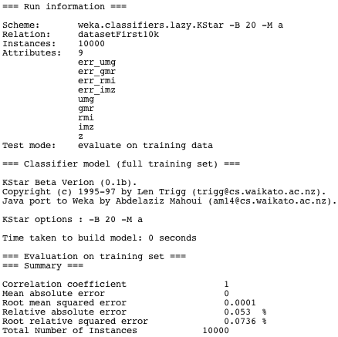

Linear Regression successfully ran with data set 3 and a 2 GB heap size:
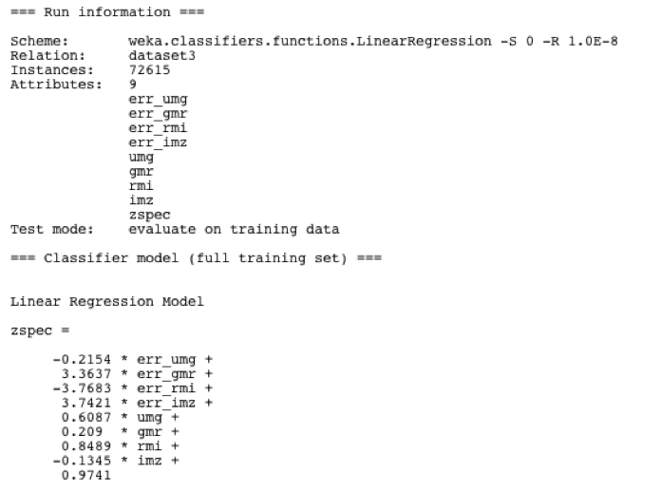

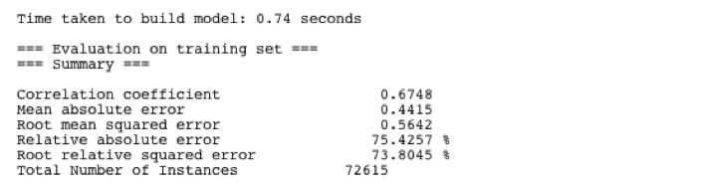

Classification
This successfully ran with 1 GB heap size and the J48 learning algorithm:
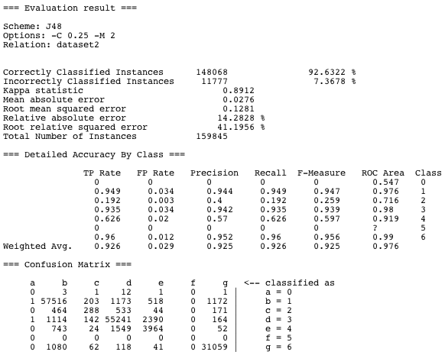

RapidMiner

Photometric redshift
With data set 1, there was the same problem as with Weka – the Linear Regression operator runs out of memory. Data sets approaching 2 GB need an alternative computing infrastructure for some algorithms. Linear Regression successfully ran with data set 3 and a 3 GB heap size:
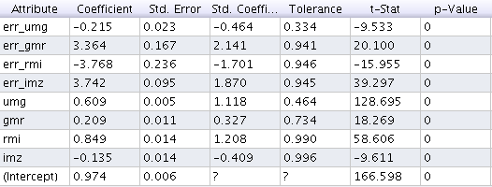

Classification
This ran successfully with Random Forest and a 2 GB heap size:
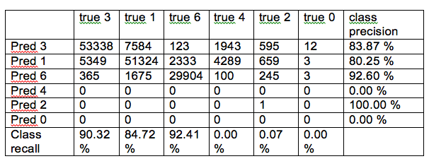

DAME

Photometric redshift
No results

Classification
A binary classification problem with tried, distinguishing between quasars and non-quasars. This ran successfully with a multi-layer perceptron and quasi-Newton model.

 | Quasars | Others
Quasars | 50360 | 1971
Others | 2202 | 73343

VOStat

Photometric redshift
Data set 1 was rejected as too large. Using a subset of the first 10000 entries gave (after 20 minutes computation):
(Intercept) | -0.06527
Err_umg | 0.08089
Err_gmr | -0.34405
Err_rmi | -1.40068
Err_imz | 2.05216
Umg | -0.03881
Gmr | 0.14472
Rmi | 0.23599

The server did not respond for over 1.5 hours with data set 3.

Classification
No classification algorithms are supported.

http://wiki.pentaho.com/display/DATAMINING/Handling+Large+Data+Sets+with+Weka

