**Exercise sheet - Quizzes**

**Week 4:**

1. Providing the input is: OCT 31. What is the expected output of this program?

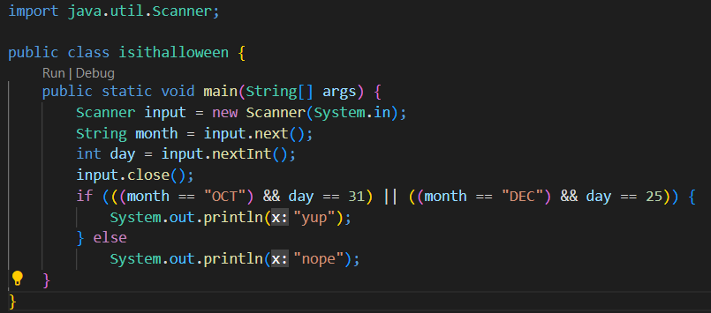

1. yup
2. **nope**
3. The program will return an error.

**Explanation:** use equals() method to compare the string, not use “==”.

1. It is said that **the random() method returns a pseudo-randomly selected number between 0.0 and 1.0.**
2. **True**
3. False
4. If you are using a single character value, you will use:
5. **the primitive char type**
6. character
7. String
8. integer
9. Which character is an escape sequence?
10. A bracket ()
11. A dot
12. **A backslash (\)**
13. It is said that **the list can store as many items as the memory allows. Array can only have limited space upon its initiation and not be appended any further.**
14. **True**
15. False
16. It is said that **the list provides wider tools to access and modify its items, while Array is limited by its staticity and cannot be excessively modified.**
17. **True**
18. False
19. It is said that **the array cannot provide its size without being explicitly declared so. List's current size can be received through function list.size().**
20. True
21. **False**
22. It is said that **the Shuffle algorithm of the Collections class can be used directly on List-type sets of objects and Array-type sets of objects.**
23. True
24. **False**
25. The command for concatenating two strings is
26. string1.concat();
27. **string1.concat(string2);**
28. Concat string1(string2);
29. string1(concat(string2));