Building a Cross-Platform Back-End Application: The OmniCast Digital Broadcast Scheduling and Delivery System

Abstract
OmniCast is a multi-platform digital broadcast scheduling, real-time LiveStream and content delivery system developed at FPTU Quy Nhon AI Campus — FU Cahata for the PRN232 course under the supervision of Mentor Mr. Huỳnh Vang. It comprises a NestJS back end with 19 business modules and 140+ REST endpoints, a Next.js 15 web portal with 33 routes (including a 7-theme interactive LiveStream room, a 4-mode Live Studio console and a full administrative suite), a 31-screen Flutter mobile client, and a gRPC audit-logging microservice. Four principal architectural contributions are presented: (1) an end-to-end bi-directional LiveStream architecture combining WebRTC WHIP/WHEP, MediaMTX HLS and a Socket.IO /live gateway supporting live chat, floating reactions, 6-tier Super Chat donations, pinned broadcaster announcements and zero-downtime on-the-fly program switching; (2) a broadcast-schedule conflict-detection algorithm implemented as a single raw SQL query that computes the effective end time of an existing event; (3) a 24/7 EPG filler whose seeded selection guarantees that every channel-day grid is both complete and reproducible; and (4) an AI curation pipeline that issues a single large language model call, validates the output against a Zod schema, offers a heuristic fallback path and records full version provenance. The database schema comprises 21 Prisma models on PostgreSQL. The complete system has been deployed on Vercel and validated by 482 automated tests inside a five-job continuous-integration pipeline, all of which pass (100%).
*(Sơ đồ kiến trúc TikZ đã được kết xuất trong bản PDF)*
OF EDUCATION AND TRAINING
UNIVERSITY — FPTU QUY NHON AI CAMPUS
FU CAHATA $⋅$ FACULTY OF INFORMATION TECHNOLOGY — SOFTWARE ENGINEERING
*(Sơ đồ kiến trúc TikZ đã được kết xuất trong bản PDF)*
PROJECT DELIVERABLE REPORT
: PRN232 — BUILDING CROSS-PLATFORM BACK-END APPLICATION
—
: DIGITAL BROADCAST SCHEDULING
& DELIVERY SYSTEM
Enterprise Media & Broadcast Intelligence Network
gRPC Microservices, Next.js 15 Web Portal, Real-Time LiveStream & Studio, 24/7 EPG Conflict Detection Algorithm and AI Curation
—

Mentor / Supervisor: | Mr. Huỳnh Vang (Software Engineering Dept. — FPTU)
Campus & Team Note: | FPTU Quy Nhon AI Campus — FU Cahata
Academic Semester: | Fall 2026 (FA26)
Project Team Members (4): | 1. Nguyễn Bình An (Team Leader / Backend & Security)
 | 2. Trần Thanh Sơn — MSSV: QE170080 (gRPC Audit & Database)
 | 3. Nguyễn Vĩnh Phú — MSSV: QE180136 (Mobile Flutter Lead)
 | 4. Đồng Hoàng Nguyên (Full-Stack Web, Live & AI)
GitHub Repository: | https://github.com/TomOutfit/OmniCast_PRN232-PRM393_Project_Fa26Semester
Live Deployment: | https://omnicast-fe.vercel.app (API: /api/v1)
Scale & Verification: | 142,897 LOC $|$ 482/482 Tests PASS (100%)
QUY NHON AI CAMPUS — FU CAHATA $⋅$ OCTOBER 2026
broadcast scheduling, EPG, LiveStream, WebRTC WHIP/WHEP, Socket.IO, NestJS, Prisma, Next.js, gRPC, RBAC, Flutter, AI curation, conflict detection, FPTU Quy Nhon AI Campus, FU Cahata.

Introduction
In recent years, the way Vietnamese audiences consume television and interactive live broadcasts (LiveStream) has changed dramatically. Viewers no longer sit in front of a screen at a fixed broadcast slot; they browse on-demand, join interactive live rooms with real-time chat and floating reactions, and expect content recommendations tailored to their interests. Broadcasters and digital-content providers, in turn, need a single, reliable and scalable scheduling and Live Studio control system that serves several delivery surfaces at once: the web, mobile applications and live-streaming devices.
This paper presents OmniCast — a multi-platform digital broadcast scheduling, real-time LiveStream and content delivery system developed at FPTU Quy Nhon AI Campus — FU Cahata for the course PRN232 — Building Cross-Platform Back-End Application under the academic mentorship of Mr. Huỳnh Vang. The system comprises a high-performance NestJS back end that serves both a Next.js 15 web portal (33 routes) and a Flutter mobile application (31 screens), with the core business logic concentrated on four capabilities: a bi-directional real-time LiveStream and Live Studio ecosystem, an electronic programme guide (EPG) that is never empty, an atomic broadcast-schedule conflict-detection mechanism, and an AI editorial assistant with content-compliance validation.

Motivation and Problem Statement
Four technical problems dominate the system’s design, each derived from concrete project requirements:
- Multi-source LiveStream ingestion and real-time studio orchestration. A modern broadcast platform must allow producers to go live from curated VOD libraries, device cameras/screens over WebRTC WHIP, or verified public catalogs, while supporting zero-downtime on-the-fly program switching without dropping viewers who are actively chatting, sending floating reactions and donating via Super Chat.
- Sparse schedules. A real broadcast channel originates only a handful of productions per day. Building a 24-hour EPG grid directly from the event table leaves most of the grid empty and renders the day filter in the user interface meaningless. The system therefore requires an automatic filler that guarantees every channel-day grid is fully populated with valid content.
- Schedule conflicts. If two programmes on the same channel overlap, viewers cannot tell which one is actually on air. The validation must detect all three overlap forms (head, tail, full containment) and must execute as a single database query to avoid race conditions.
- Manual content moderation. The editorial workflow (writing descriptions, tagging, categorising) is manual and time-consuming. Automating it with a large language model reduces the load, but requires a fallback path when no API key is present, and the output must be schema-validated before it is persisted.

Contributions
This paper makes the following technical contributions:
- A layered NestJS + Prisma + PostgreSQL architecture with 19 business modules, 140+ REST endpoints and auto-generated OpenAPI documentation, protected by a four-role RBAC layer (GUEST, VIEWER, STAFF, ADMIN).
- A real-time LiveStream & Live Studio architecture combining MediaMTX (WHIP/WHEP/HLS), Cloudinary Direct Upload and the Socket.IO /live gateway to support 4 studio broadcast modes, zero-downtime program switching, threaded live chat, 0ms floating emoji reactions, 6-tier Super Chat donations and pinned broadcaster announcements.
- A broadcast-conflict detection algorithm implemented as a single raw SQL query that computes the effective end time with COALESCE(endedAt, scheduledAt + duration).
- A 24/7 EPG filler with seeded pseudo-random selection keyed on the (date, channel) pair, guaranteeing that the same day always renders the same schedule.
- An AI editorial pipeline that issues a single consolidated model call (gpt-4o), validates the result against a Zod schema, and provides retry plus heuristic-fallback paths.
- An audit-logging microservice communicating over gRPC (audit_logger.proto), deployed independently of the main API process.
- A Next.js 15 web portal with 33 routes (including a 7-theme LiveStream lounge, a 4-tab Live Studio console and an AI Curator suite) backed by a five-job GitHub Actions CI/CD pipeline with 482/482 passing automated tests (100%).

Project Team Organization and Role Allocation
The OmniCast project was executed at FPTU Quy Nhon AI Campus — FU Cahata under the supervision of Mentor Mr. Huỳnh Vang. Table 1 summarises the responsibilities of the four team members.
The 4 project team members of OmniCast (FPTU Quy Nhon AI Campus — FU Cahata, Mentor: Mr. Huỳnh Vang).
Full Name | Role / ID | Primary Engineering Ownership
Nguyễn Bình An (TomOutfit) | Team Leader | NestJS 19-module core architecture, JWT & 4-role RBAC security, EPG conflict detection SQL, Direct Stream Engine, CI/CD & Release
Trần Thanh Sơn | QE170080 | Standalone gRPC Audit Logger microservice (audit_logger.proto), Supabase PostgreSQL (21 Prisma models), Telemetry & Seeding
Nguyễn Vĩnh Phú | QE180136 | Mobile Flutter Lead (31 screens, 12 BLoCs), OmniPlayer engine, MobileStudioRecorderScreen (WebRTC WHIP), Offline SQLite
Đồng Hoàng Nguyên (teng122) | Full-Stack & AI | Next.js 15 Cinema Dark Web Portal (33 routes), Socket.IO /live gateway, 7-theme Live Room, Live Studio Console & AI Curator module

Scope
This paper concentrates on the overall system architecture, the NestJS back end, the gRPC microservice, the database schema and the Next.js 15 web portal (PRN232 deliverables). The 31-screen Flutter mobile application is presented in full detail in the companion PRM393 report.

Related Work
This paper positions OmniCast against three main lines of work: back-end application frameworks, data-access protocols, and broadcast scheduling systems.

Back-end Application Frameworks
NestJS adopts a decorator-driven dependency-injection model and a hierarchical module model, allowing each business domain (channels, programmes, users) to be packaged as an independent module with its own lifecycle. Compared with plain Express, the framework provides out-of-the-box URI versioning (VersioningType.URI), a ValidationPipe in forbidNonWhitelisted mode, an ExceptionFilter and an Interceptor — the four components the broadcasting problem demands so that every endpoint returns an identical response envelope and every input is validated strictly. Prisma serves as the data-access layer: the Prisma schema is the single source of truth and prisma migrate generates version-controlled SQL, so schema drift is tracked alongside the source code.
Two alternatives deserve comparison: FastAPI (Python) and ASP.NET Core (C#). FastAPI produces excellent OpenAPI documentation but the project has a fixed language budget; ASP.NET Core has a more mature ecosystem but also demands a language switch. NestJS allows the TypeScript toolchain to be reused with the Next.js portal , so a shared data type or an API contract change can propagate across both deliverables without a language boundary.

Data-Access Protocols
Most legacy broadcasting systems expose their programme guide to mobile applications through OData , a REST extension with embedded query syntax ($filter, $orderby, $expand). OData is well suited when clients need flexible queries over a large catalogue without deploying server-side filtering logic. OmniCast takes the opposite approach: EPG queries have a fixed shape (by day, by channel, by time window), so plain REST endpoints with normalised query parameters are sufficient and simpler for both clients.
Compared with GraphQL , plain REST lowers the client-side cost because no additional runtime layer is needed on mobile, and it is easier to cache at the HTTP layer and to exercise from a command line. The trade-off is that every endpoint must be designed explicitly; in exchange, the entire API is documented with OpenAPI 3 using @ApiOperation, @ApiResponse and @ApiQuery decorators, so no endpoint is left undocumented.

Broadcast Scheduling and AI Assistance
Commercial scheduling systems (such as EBU Radio-MEP and FTA EPG feeds) guarantee schedule integrity by applying relative-time conflict detection and substituting overrun programmes during live transmission. This is precisely the model OmniCast reproduces at a smaller scale: the slot of a programme is an interval $[t_{0},t_{1}]$ on the timeline of a channel, and two overlapping intervals are invalid.
On the editorial-assistance side, commercial EPG systems have recently begun using large language models to generate descriptions and content tags . OmniCast’s distinguishing feature is output quality control: every AI-generated report is validated against a Zod schema before being written to the database and is stamped with the prompt version and the model version, so administrators can compare quality across prompt revisions.

Gap Addressed by OmniCast
In summary, the gap this project fills is the absence of a complete, automatically verifiable broadcast-scheduling system at classroom scale: schedule-integrity guarantees, a full user experience across web and mobile, quality-controlled AI assistance, and the whole thing validated by 482 automated tests inside a continuous-integration pipeline.

System Architecture

Layered Overview
The system is organised into four layers, each communicating only with the layer immediately below it. The presentation layer comprises the Next.js 15 web portal (33 routes) and the Flutter mobile application (31 screens); the API layer is a single NestJS process with 19 business modules and 140+ REST endpoints; the real-time layer handles live broadcasting (LiveStream), studio room orchestration, live chat, floating reactions, Super Chat donations and WebRTC signalling; and the data layer consists of PostgreSQL (21 Prisma models), the MediaMTX streaming server, Cloudinary storage and external APIs.
Overall layered architecture of OmniCast. Both the Next.js 15 web portal and the Flutter mobile application consume the same REST API and /live WebSocket gateway; audit logging is separated into a dedicated gRPC microservice.
The notable design decision is a single API process serving both clients. The boundary between the web and mobile clients exists only at the transport layer, never at the business layer. A business rule is therefore written exactly once: for instance, the rule that "two programmes on the same channel must not overlap" is enforced in ProgramsService.checkScheduleConflict and behaves identically whether the schedule is created from the web administration portal or from the mobile application.

End-to-End LiveStream & Live Studio Architecture
To satisfy ultra-low-latency live broadcasting and bi-directional interaction between studio producers (STAFF/ADMIN) and audiences (VIEWER), OmniCast implements a dedicated multi-pipeline live streaming architecture as shown in Fig. 2.
End-to-end LiveStream and Live Studio architecture: combining 4 studio ingestion modes (Curated VOD, Camera/Screen WHIP WebRTC, Verified Public Catalog, Host Control Console) through LiveStudioService, MediaMTX and the Socket.IO /live gateway.
The LiveStream architecture operates across three synchronised technical pillars:
- Four Studio Ingestion Pipelines: Producers on Web (/studio/live) or Mobile (LiveStudioScreen & MobileStudioRecorderScreen) can initiate broadcasts across four modes: (i) Curated Live — selecting one or more recordings from the internal VOD library guarded by an Anti-Piracy filter; (ii) Self-Record / Device Camera — pushing real-time camera or screen-share streams via WebRTC WHIP to MediaMTX (port :8889/whip) or uploading local recordings directly to Cloudinary using signed parameters; (iii) Verified Public Catalog — one-click importing of verified public HLS/MP4 streams with server-side HEAD probing; and (iv) Host Control Console — broadcasting pinned announcements, moderating chat and switching active programmes on the fly.
- Multi-Protocol Transcoding & Delivery (MediaMTX & Direct Stream Engine): Incoming WebRTC WHIP streams are remuxed by MediaMTX into WHEP and low-latency fMP4 HLS (:8888/<streamKey>/index.m3u8). Additionally, for Google Drive-hosted assets, the stream resolver rewrites share URLs to drive.usercontent.google.com/download?id=...&confirm=t, enabling direct hardware-accelerated streaming without Google account prompts.
- Real-Time Room Orchestration via Socket.IO (/live): LiveStreamGateway manages per-event (event:<eventId>) and per-channel (channel:<channelId>) rooms, synchronising concurrent viewer counts (live:viewerCount), threaded chat (live:chat:new), 0ms floating emoji reactions (live:reaction:new), pinned host banners (broadcaster:message), Super Chat donations (live:donation:received) and zero-downtime stream switches (live:program:changed).

NestJS Module Structure
AppModule registers 19 business modules alongside the infrastructure modules. Each module owns one business domain and exports the services it needs; controllers only call services and hold no business logic. Table 2 lists the actual back-end source layout.
Back-end NestJS module structure.
Module | Primary responsibility | Controller
auth | Login, JWT, refresh, Google sign-in | auth
channels | Broadcast channels, catalogue | channels
programs | Programmes, EPG, Live Studio, Social | programs
search | Cross-entity search | search
ai-curator | AI curation, statistics | ai-curator
audit-logger | Audit logging (gRPC) | audit-logger
watchlist | Watchlist | watchlist
users | User management | users
admin | Admin dashboard | admin
billing | Plans, payments | billing
notifications | Notifications, FCM push | notifications
newsletter | Newsletter subscription | newsletter
websocket | Realtime gateway /live | —
cloudinary | Media storage | cloudinary
prisma | Database access | —
health | Health probe | health
common | Filters, interceptors, Swagger | —

Protocol and Transport Integration
The back end serves four independent protocols, each serving a distinct group of needs:
- REST/JSON over HTTP/1.1. Paths carry the /api/v1 prefix and use VersioningType.URI. A middleware in main.ts automatically rewrites any /api/* request to /api/v1/*, so older clients never receive a 404 when the API version is upgraded.
- WebSocket (Socket.IO /live). The realtime gateway uses Socket.IO on namespace /live and exposes full live room orchestration events: event and channel subscribe/unsubscribe (subscribe:event, unsubscribe:event, subscribe:channel, unsubscribe:channel), concurrent viewer tracking (live:viewerCount), live chat (live:chat $→$ live:chat:new), floating reactions (live:reaction $→$ live:reaction:new), broadcaster pinned messages (broadcaster:message), message moderation (chat:delete $→$ chat:deleted), on-the-fly program switching (live:program:changed), Super Chat donations (live:donation:received) and the WebRTC handshake (webrtc:offer, webrtc:answer, webrtc:ice-candidate).
- gRPC. The audit-logging microservice receives LogAudit, GetLogsByUser, GetLogsByAction, GetLogsByEntity and GetLogStats requests over audit_logger.proto.
- WHIP/HLS/WebRTC. MediaMTX ingests over WHIP and redistributes over HLS (LL-HLS, fMP4) and WHEP, configured in backend/mediamtx/mediamtx.yml.

Database Connection and Audit Logging
The database is Supabase-managed PostgreSQL. One operational detail is worth noting: Supabase exposes two ports, 5432 for direct connections and 6543 for the transaction pooler. The optimizeDatabaseUrl helper in PrismaService automatically switches to 6543 and sets a suitable connection_limit when it detects the pooler, avoiding connection exhaustion when a serverless environment starts several instances concurrently.
Why a separate audit-logging microservice?
Audit logging has two properties the rest of the system does not share: a high write volume and a tolerance for delay. Writing straight into PostgreSQL would make every administrative operation wait on an extra write. Moving it into a gRPC microservice turns auditing into a non-blocking fire-and-forget operation: AuditLoggerService issues the RPC inside a non-awaited promise, while the microservice writes to the database and maintains index tables supporting queries by user, action, entity and aggregate statistics.

External Integrations
Four external integrations are supported, all of which degrade gracefully when the API key is absent: YouTube Data API v3 (channel schedules), Twitch Helix (channel schedules), TMDB (film metadata enrichment) and OpenAI (content curation). This mechanism allows the whole system to run at full capability in a development environment without any third-party credential.

Back-End Implementation

JWT Authentication and Role-Based Access Control
The system authenticates with an access/refresh token pair. At login the password is verified with bcrypt.compare at 12 rounds (BCRYPT_ROUNDS=12); at registration it is hashed with bcrypt.hash. AuthService issues a 60-minute access token and a 90-day refresh token stored in the RefreshToken table. Token rotation is enforced: on every refresh the old token is revoked and a new one is issued, so a leaked token cannot be reused.
Authentication and authorisation flow. The access token accompanies every request; JwtAuthGuard validates the signature and RolesGuard compares the role against the @Roles metadata.
Two guards are implemented in backend/src/auth/guards. The JwtAuthGuard uses the Passport-JWT strategy and skips handlers marked @Public(). The RolesGuard reads @Roles metadata through the Reflector; a handler that declares no roles admits every authenticated user. A notable detail is that the guard normalises roles to string names before comparing, so both the name form ('STAFF') and the legacy numeric form ('2') are accepted. The four roles are declared in the UserRole enum and ranked in the portal’s role-config.ts.
The four user roles and their permission scope.
Code | Value | Description
GUEST | 0 | Unauthenticated guest – public schedule and trailers only
VIEWER | 1 | Signed-in viewer – watchlist, comments, likes, watch history
STAFF | 2 | Content editor – manage channels, schedule, run AI Curator
ADMIN | 3 | Administrator – all STAFF rights plus user and audit-log management
To enforce least privilege, sensitive operations are guarded at the controller level rather than in the user interface. For example, all eleven write endpoints in the ai-curator group and all broadcast control endpoints in LiveStudioController require @Roles('STAFF','ADMIN'), and every user-management or audit-log endpoint requires @Roles('ADMIN').

Broadcast Schedule Conflict Detection
The conflict-detection algorithm is the business core of the system. Each programme occupies a time interval $[ t_{0}, t_{0}+d ]$ on the timeline of one channel. Two programmes collide if and only if the new interval starts before the existing one ends and ends after the existing one starts.
The three detected overlap forms: head overlap, tail overlap and full containment. A schedule on a different channel causes no conflict.
The hardest part is computing the effective end time of an existing event. The endedAt column can still be NULL for a SCHEDULED event, meaning the event has not actually finished. A naive Prisma where clause would skip such events, producing false negatives that allow conflicting schedules. The checkScheduleConflict helper therefore uses raw SQL to compute the effective end time with a COALESCE/MAX expression over endedAt and scheduledAt + duration.
SELECT id, title, "scheduledAt" AS scheduled_at, "duration"
FROM "LiveEvent"
WHERE "channelId" = $1::uuid
AND status IN ('SCHEDULED', 'LIVE')
AND "scheduledAt" < $2 -- moi bat dau truoc khi cu ket thuc
AND COALESCE(
"endedAt",
"scheduledAt" + (
CASE
WHEN "duration" IS NULL THEN ($3 || ' minutes')::interval
WHEN "duration" > 1440 THEN ("duration" || ' seconds')::interval
ELSE ("duration" || ' minutes')::interval
END)
) > $4 -- moi ket thuc sau khi cu bat dau
The query only considers events in the SCHEDULED or LIVE states; ENDED and CANCELLED events cannot cause a conflict. The CASE expression also absorbs a unit inconsistency: the ingest layer writes duration in seconds while the EPG logic works in minutes, so values above 1440 are interpreted as seconds and converted, and everything else is treated as minutes. On a detected collision the service throws a ConflictException carrying HTTP status 409 together with the list of conflicting events, so the user interface can name the programme that caused the rejection.

Live Studio Controller and Real-Time LiveStream Operations
The programs module exposes two dedicated controllers for live broadcasting: LiveStudioController (backend/src/programs/live-studio.controller.ts) and SocialController (backend/src/programs/social.controller.ts), working in tandem with LiveStreamGateway (backend/src/websocket/live-stream.gateway.ts). The complete live studio and viewer room lifecycle spans six technical operations:
- Mode 1 — Curated VOD Broadcast (POST /programs/studio/curate-live): Allows producers (STAFF/ADMIN) to select one or more recordingIds from the channel or global VOD library for immediate broadcast. The service enforces an Anti-Piracy Guard (rejecting unauthorised YouTube/Twitch/Vimeo URLs), atomically ends any previous LIVE event on the same channel, creates the new LiveEvent with a multi-item lineup, and emits live:started over Socket.IO.
- Mode 2 — Self-Record, Signed Direct Upload & Webcam WHIP Live (POST /programs/studio/self-record & /live/webcam/start): Supports two workflows: (a) Direct-to-Cloudinary Signed Upload: the client obtains signed parameters via POST /programs/studio/recordings/sign, uploads MP4/WebM directly to Cloudinary with live speed/ETA telemetry, and invokes self-record with server-side media probing to go live immediately (IMMEDIATE), schedule (SCHEDULED), or save as PRIVATE draft, complete with orphan asset cleanup (DELETE /programs/studio/recordings/orphan). (b) WebRTC WHIP Direct Camera/Screen Streaming: the client calls POST /programs/studio/live/webcam/start to allocate a streamKey, publishes camera or screen media via WebRTC WHIP to MediaMTX (:8889/whip), and serves low-latency HLS (.m3u8) to all viewers.
- Mode 3 — Verified Public Stream Catalog (GET /programs/studio/public-catalog): Provides a curated catalog of royalty-free HLS and MP4 streams from Mux, Cloudinary and Internet Archive. Producers can filter by format, import with one click (POST /programs/studio/recordings/library/from-catalog), or register custom stream URLs with automated HEAD probing (POST /programs/studio/recordings/library).
- On-the-Fly Program Switching (POST /programs/studio/events/:eventId/switch-program): When a live event contains multiple lineup items or a producer switches to another recording mid-broadcast, this endpoint updates the active streamUrl and broadcasts live:program:changed to room event:<eventId>. All connected viewers seamlessly transition to the new video stream without losing their chat session or WebSocket connection.
- Bi-Directional Room Interaction via LiveStreamGateway (/live): Joining a room (subscribe:event) increments the in-memory and database-persisted viewer counter (LiveEvent.viewerCount) and broadcasts live:viewerCount. Viewers engage through live chat (live:chat), threaded replies (parentId), comment likes, and 0ms haptic floating emoji reactions (HEART, FIRE, CLAP, WOW/PARTY). Producers can broadcast pinned toast banners (broadcaster:message), delete inappropriate messages (chat:delete $→$ chat:deleted), or stop the broadcast (POST /programs/studio/live-events/:eventId/stop with keepAsVod).
- Super Chat & Live Donations (StreamDonation): Viewers in the live room can support creators across 6 preset gift tiers with custom messages and payment methods, updating the streamer’s wallet balance and triggering a celebratory overlay across the room via live:donation:received.

24/7 EPG Filler Mechanism
Because channels originate only a handful of productions per day, the 24-hour EPG grid is materialised by EpgScheduleFillerService. The service guarantees five properties demanded by the design:
- No empty days. Every channel-day grid covers the full 24 hours, so the day filter in the user interface always has content to render.
- Genre-aware selection. Recordings whose category matches the channel category are preferred; the full library is used only when nothing matches.
- Episode splitting. Recordings longer than LONG_PROGRAM_MINUTES are split into chunks of EPISODE_MINUTES so the grid exposes “Episode 1 / Episode 2 / ...” entries instead of one massive block.
- Limited replay. The same recording or episode may appear at most MAX_REPEATS_PER_ITEM_PER_DAY times in a single day, so viewers never see an episode loop endlessly.
- Reproducible randomness. Selection uses a seeded PRNG keyed on the (date, channel) pair, so the same day always renders the same schedule while adjacent days surface different content.
The technically important point is that the service performs no I/O: it is pure logic that receives the recording list and the real programme list and returns the filled grid. As a result the 18 unit tests in epg-filler.spec.ts run without a database, and the whole scheduling layer becomes a pure function verifiable by properties.

Content Ingestion and Enrichment
The ingestion layer collects schedules from YouTube, Twitch and RSS on a cron schedule (0 */15 * * * * for YouTube, 0 */30 * * * * for Twitch), normalises them into a unified NormalizedLiveEvent structure and writes them to the LiveEvent table. An optional enrichment task then calls TMDB to supplement film metadata (poster, cast, rating) for events whose title matches.
Ingestion flow from external sources. Every source is normalised into a single structure before being written to the database.

Quality-Controlled AI Curation Assistant
The ai-curator module is one of the most significant contributions. The original requirement was to automate writing descriptions, assigning categories and tagging programmes. The pipeline is designed around four principles:
- A single consolidated model call. Prompt revision curator-prompt-v4.0.0 merges three separate calls (description, tags, category) into one call with a JSON schema and few-shot examples, reducing both cost and latency to roughly a third.
- Zod schema validation. The model output is validated against ai-curator.schemas.ts; when it does not validate, the request is routed to the heuristic fallback.
- Heuristic fallback. When OPENAI_API_KEY is absent or equal to dummy-key, a local rule engine assesses sentiment, compliance and editorial tone to produce a structurally equivalent result.
- Version provenance. Every report stores promptVersion, aiModelVersion, openaiCallMs and openaiRetries, allowing quality to be compared across prompt revisions.
AI Curator pipeline: branching on API-key presence, Zod schema validation, and the heuristic fallback taken when validation fails.
The hyper-parameters are pinned in ai-curator.prompts.ts (temperature = 0.3, top_p = 0.95), with an explicit instruction not to change temperature without re-evaluating the few-shot examples. The versioning convention is semantic: MAJOR for schema changes, MINOR for rewording that preserves the JSON shape, PATCH for copy edits. The statistics module ai-curator-stats.service.ts aggregates by broadcastSuitability group, by model version and by time period.

Search, Billing and Supporting Modules
The search module performs cross-entity search: channels, programmes and recordings are queried simultaneously with case-insensitive contains conditions, combined with category filtering and pagination. Results are merged into a single object carrying the total result count, matching the single-page search layout that renders grouped result sections.
The billing module manages plans and payment history; the notifications module pushes notifications through Firebase Cloud Messaging based on the DeviceToken table; the newsletter module manages subscriptions; and the cloudinary module handles image and video uploads for the live-recording flow in the studio.

Cross-Cutting Technical Conventions
Four conventions applied across the whole system deserve explicit mention because they determine API consistency:
- Uniform response envelope. A global TransformInterceptor wraps every result in {success, statusCode, data, meta, timestamp}, so clients need exactly one decoding path.
- Centralised exception handling. HttpExceptionFilter normalises every error into the same structure, including user-facing Vietnamese messages.
- Strict input validation. A ValidationPipe with whitelist and forbidNonWhitelisted strips every field not declared in the DTO, preventing mass assignment.
- Generated API documentation. Swagger decorators on each controller produce OpenAPI documentation at /swagger, covering 19 endpoints in the ai-curator group together with channels, programs and the remaining groups.

The Next.js 15 Web Portal

App Router Architecture
The portal is built on Next.js 15 with the App Router, React 19 and Tailwind CSS with a “Cinema Dark” theme. The App Router replaces the pages/ model with nested Server Components and Server Actions, allowing data to be fetched directly on the server without an intermediate API layer.
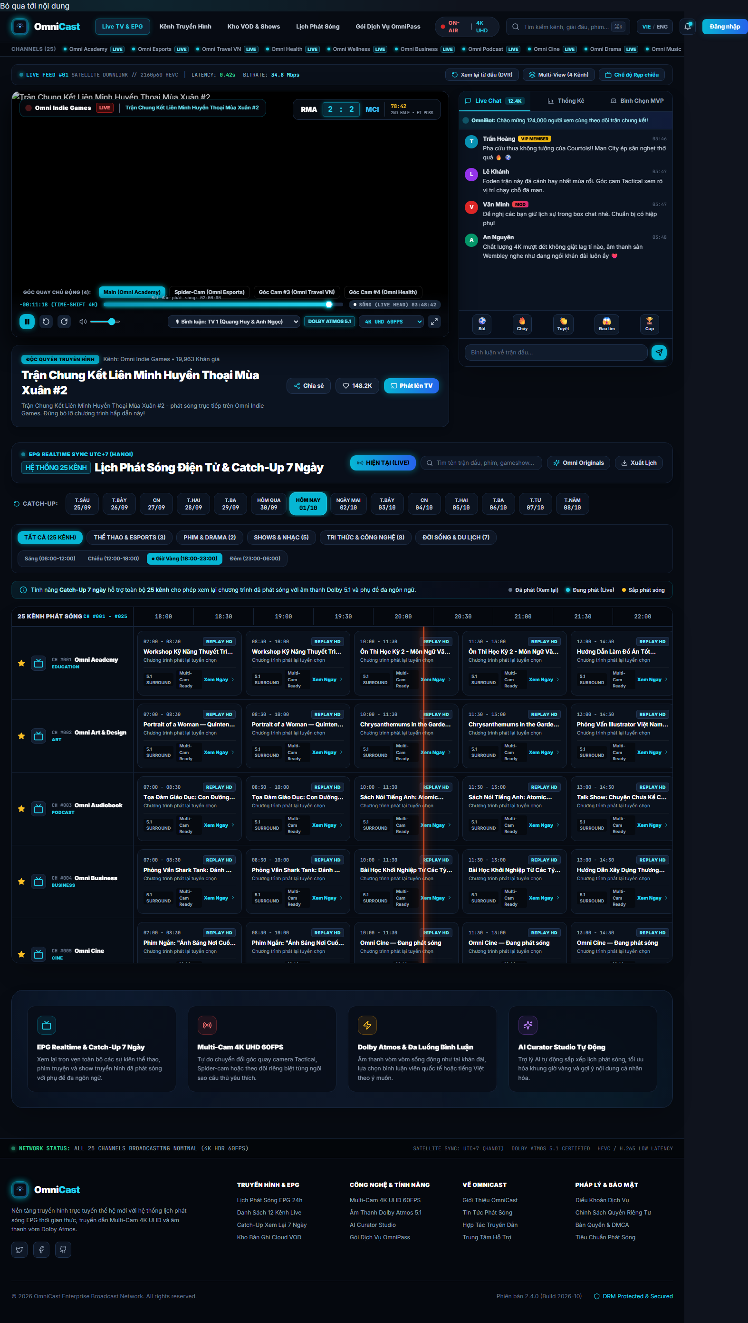
The web portal home page on desktop: featured carousel, channel grid by category and the role-aware navigation bar.

Complete 33-Route Web Portal Inventory
The web portal exposes 33 routes generated from 24 directories under frontend/app/. Table [tab:web_routes] catalogues all 33 screens across five functional clusters: (1) Public Discovery & EPG; (2) Interactive LiveStream & VOD Rooms; (3) Live Studio Console & AI Curator Suite (STAFF/ADMIN); (4) Account, Personalisation & Administration (ADMIN); and (5) Legal, Compliance & Broadcast Standards.
Cluster | Route Path (33) | RBAC Role | Key Screen Features & Interactive Operations
1. Public Discovery & EPG | /, /channels, /channels/[id] | Public | Hero spotlight carousel, category-filtered channel grid, channel detail page with live stream & EPG.
1. Public Discovery & EPG | /epg | Public | Zero-gap 24/7 EPG timeline grid, real-time Now-Line indicator, date and channel filters.
1. Public Discovery & EPG | /programs, /programs/[id] | Public | Programme directory, programme detail page with production tags, upcoming airings and Watchlist button.
1. Public Discovery & EPG | /recordings, /recordings/[id] | Public | Published VOD recording library, multi-engine replay player with comments and related VODs.
1. Public Discovery & EPG | /search | Public | Cross-entity search (Channels, Programmes, VOD Recordings) with keyword and genre filters.
1. Public Discovery & EPG | /live | Public | Live Hub: auto-refreshes every 15s, displays active LIVE event & total CCU pills, sorts by trending viewers or newest start time.
 | /live/[id] | Public / Viewer | Interactive LiveStream Room: 7 genre-themed lounges, JoinLobbyCard prompt, Cinema Mode, lineup program switcher, real-time Socket.IO chat, 4 floating emoji reactions, pinned host banner.
3. Live Studio & AI Curator | /studio, /studio/live | STAFF+ | 4-Tab Live Broadcast Console: (1) Curated VOD Live; (2) Camera/Screen WHIP WebRTC & Signed Cloudinary Dropzone; (3) Verified Public Catalog; (4) Host Announcement & Stop Broadcast.
3. Live Studio & AI Curator | /studio/curator | STAFF+ | AI Editorial Workbench (gpt-4o + heuristic fallback): sentiment scoring, broadcast compliance check, auto-tagging.
3. Live Studio & AI Curator | /studio/curator/audit, /studio/curator/dashboard | STAFF+ | Prompt-version provenance audit log (promptVersion), suitability breakdown and latency analytics.
3. Live Studio & AI Curator | /login, /register, /forgot-password, /reset-password | Public | JWT + Google OAuth2 sign-in, account registration, tokenised password recovery.
3. Live Studio & AI Curator | /profile, /settings, /watchlist, /notifications | VIEWER+ | User profile, VIP plan management, cross-device watchlist, notification centre and global session revocation (logout-all).
 | /admin, /admin/users, /admin/audit-logs | ADMIN | System telemetry overview, user RBAC management, gRPC audit log explorer by action/entity.
5. Legal & Support | /terms, /privacy, /dmca, /standards, /broadcasting-standards, /help, /docs | Public | Terms of service, privacy policy, DMCA copyright policy, community & broadcasting standards, help centre and docs.
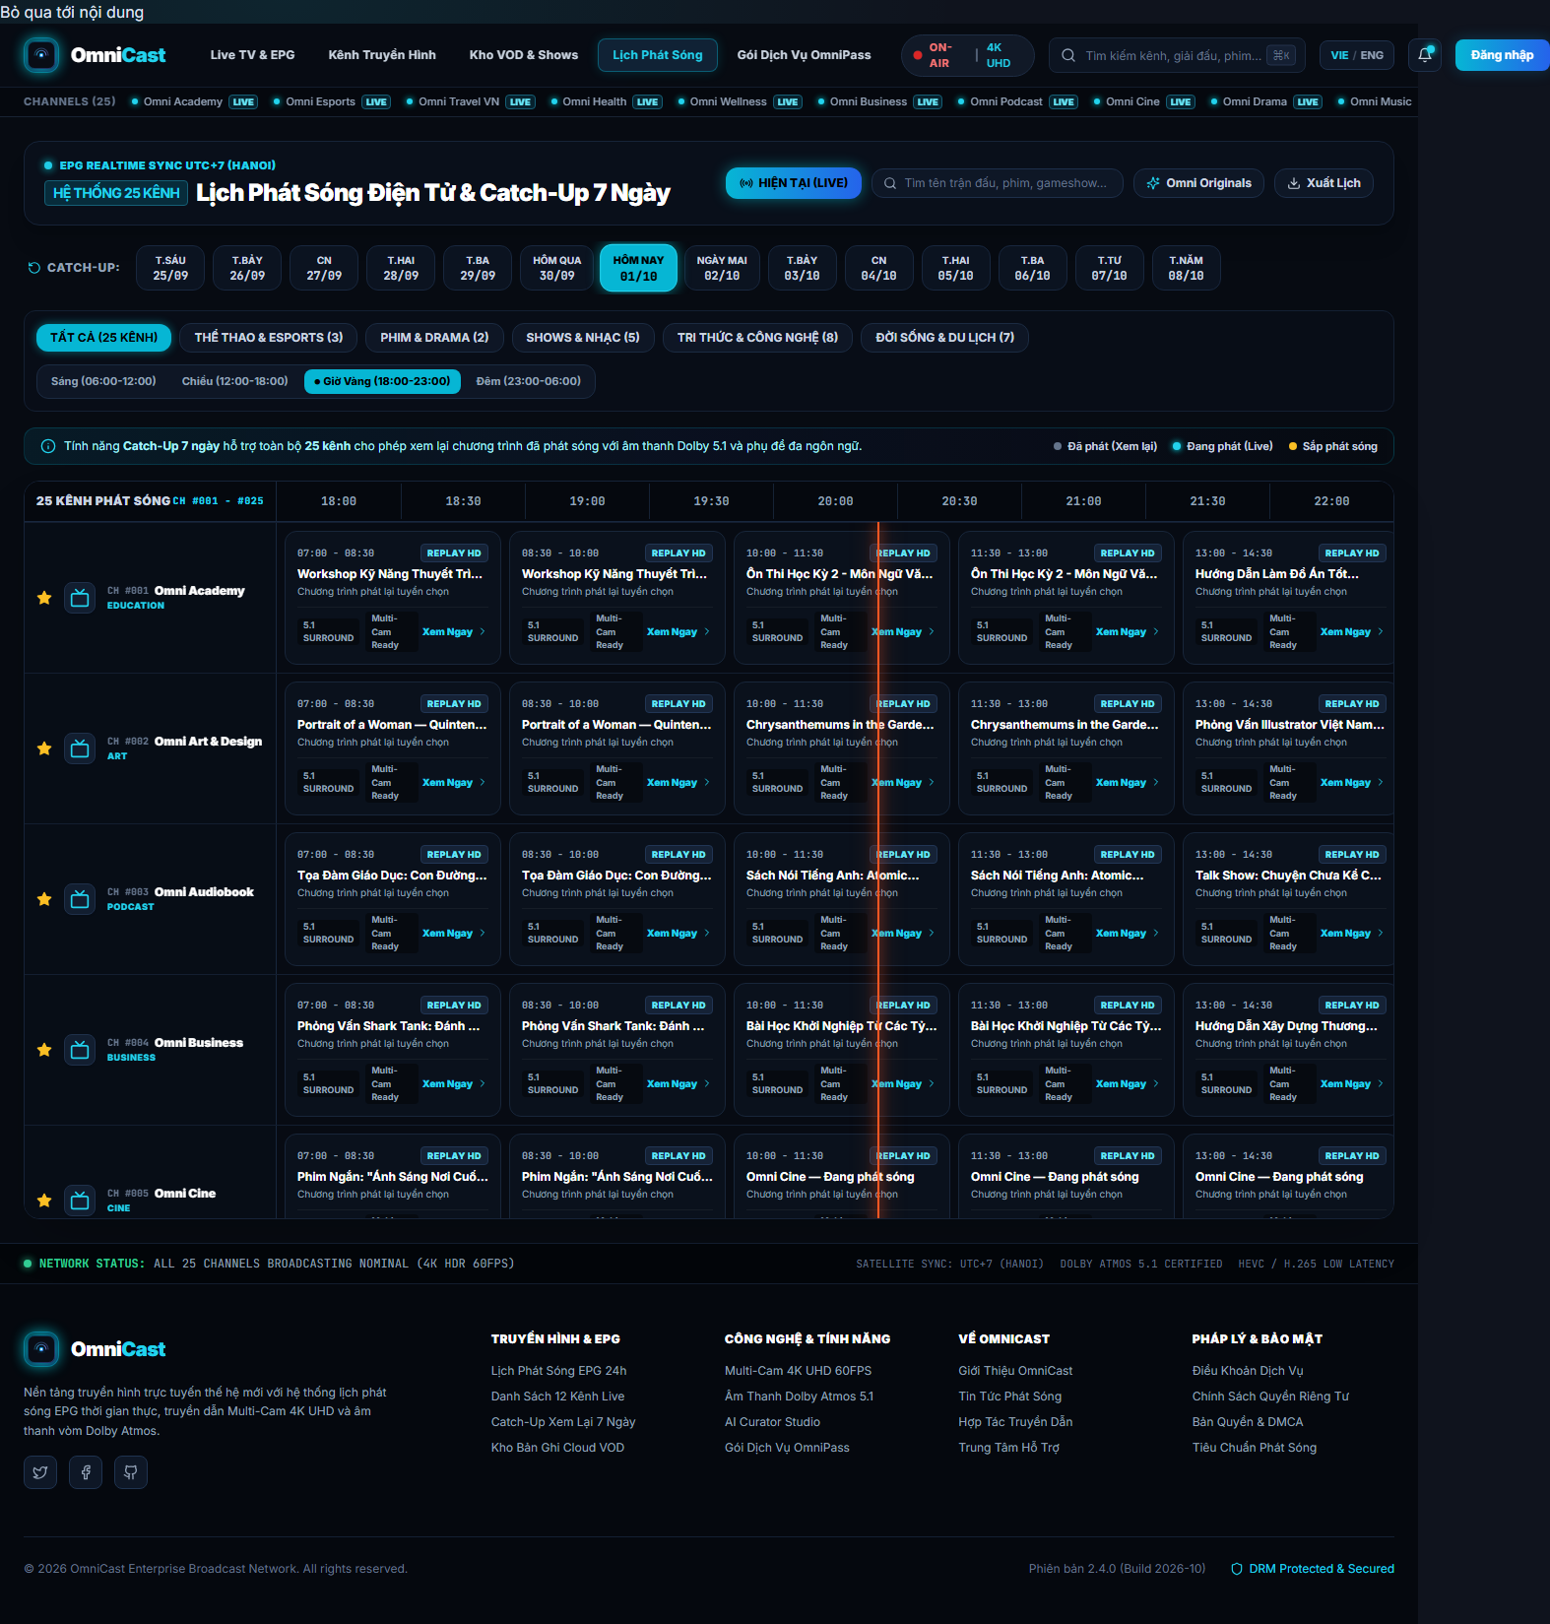
The electronic programme guide page (/epg) with the time-slot grid and the day selector.

Interactive LiveStream Room (/live & /live/[id]) and Viewer Operations
The web LiveStream experience is engineered as a full-featured interactive broadcast lounge across two core screens:
- Live Broadcast Hub (/live): Polls active LIVE events every 15 seconds, displays real-time header badges for total active broadcasts and aggregate concurrent viewers (CCU), supports sorting by viewer count or start time, and surfaces a direct “Go to Live Studio” shortcut for STAFF/ADMIN users.
- Interactive Lobby & 7 Genre-Themed Broadcast Lounges (/live/[id]): Upon entering a stream, viewers encounter a JoinLobbyCard previewing the stream status and live viewer count before entering the room. Once inside, resolveLiveRoomTheme dynamically styles the entire room into one of 7 genre-specific themes: Kids Wonderland, Podcast & Audiobook, Music Live Stage, Academy & Tech, Sports Arena, Obsidian Theater (Cinema/Drama) and Broadcast Lounge (Default).
- Multi-Engine Player, Cinema Mode & Instant Lineup Switching: VideoPlayer seamlessly handles MediaMTX HLS/WebRTC streams (cookieCheck=1), direct Google Drive streams and YouTube embeds. Viewers can toggle Cinema Mode (lights-off focus) to dim surrounding chrome and expand the stage to full width. When a broadcast contains multiple lineup items or is controlled by STAFF/ADMIN, the lineup bar triggers switchProgramOnLiveEvent, switching the active video stream for all viewers in the room without page reload.
- Real-Time Socket.IO (/live) Operations: The live interaction sidebar connects to the /live namespace, enabling viewers to: (i) post real-time chat messages with auto-scroll; (ii) fire 4 floating emoji reactions (HEART, FIRE, CLAP, WOW) that animate upward over the video canvas with optimistic counter updates; and (iii) receive pinned host announcements (broadcaster:message) rendered as a prominent banner across the stage.

Web Live Studio Broadcast Console (/studio/live)
The /studio/live route (frontend/app/studio/live/page.tsx) provides a production-grade broadcast control console for STAFF and ADMIN operators across four tabs:
- Tab 1 — Curated Live: Select the target channel, configure broadcast metadata, and pick one or more VOD recordings from the channel or global library to launch a multi-item lineup.
- Tab 2 — Self-Record / File Upload / Webcam WHIP Live (WebcamLiveBroadcaster & WebStudioViewfinder): Supports browser camera capture, screen sharing (getDisplayMedia), direct WebRTC WHIP publishing to MediaMTX, or drag-and-drop file ingestion via UploadDropzone + UploadQueue (signed direct-to-Cloudinary upload with live MB/s speed, ETA, automatic HTML5 canvas thumbnail extraction, and 3 visibility modes: IMMEDIATE, SCHEDULED, PRIVATE).
- Tab 3 — Verified Public Catalog: Browse verified HLS/MP4 streams with format filters and one-click channel library import.
- Tab 4 — Live Host Console: Send pinned broadcaster announcements (broadcaster:message) to all connected viewers and terminate active broadcasts (stopLiveEvent) with the keepAsVod archival option.

Role-Aware Interface and AI Curator Suite
A single configuration file, frontend/lib/constants/role-config.ts, determines which components appear for each role. The hasMinimumRole helper compares role ranks, so promoting a capability from VIEWER to STAFF is a one-line edit. The /studio/curator page is the AI curation interface: it lists programmes awaiting review, allows re-running the AI pipeline, and exposes the confidence score, broadcast-suitability classification and compliance flags. The /studio/curator/audit page presents the run history with prompt-version provenance, while /studio/curator/dashboard aggregates statistics by category and broadcast suitability.
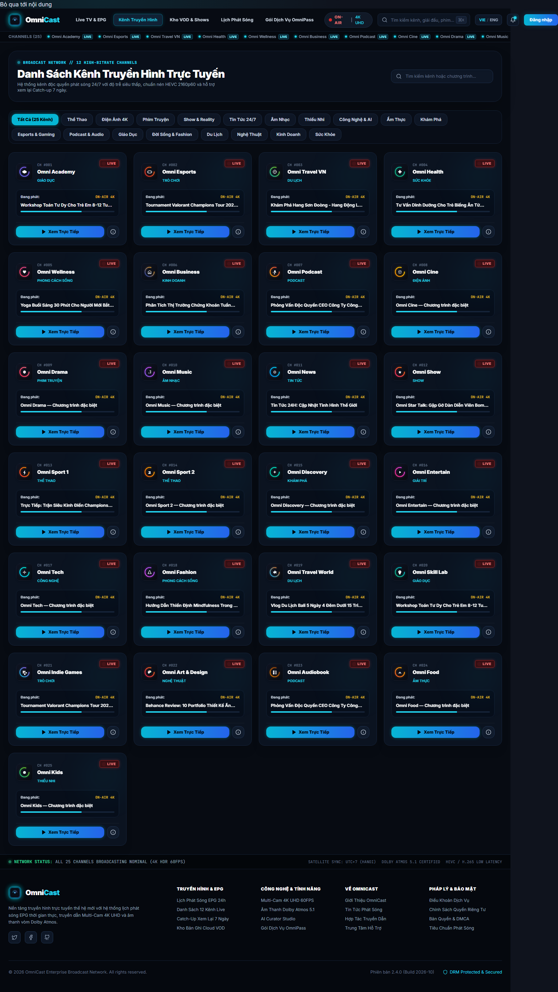
The channel catalogue page (/channels) with category filters and content badges.

Client-Side Security, Session Handling and Testing
The portal uses next-themes for light/dark support and a safe-log layer (redact.ts) that masks sensitive fields (passwords, tokens, API keys) before logging. On logout, sessions on other devices are revoked through the logout-all endpoint. The portal carries 228 Vitest tests across 76 suites, covering pure functions (query-builder, curator-filters, curator-helpers, redact, safe-log, utils), hooks (useAiCurator, useAiCuratorStats), configuration (role-config) and React components (video-player, save-to-watchlist, the legal pages, the studio pages). CI additionally runs tsc --noEmit to catch type errors before the build.

Database Design

Relational Database with Prisma
All business data resides in PostgreSQL, defined by 21 Prisma models in backend/prisma/schema.prisma. Prisma acts as the abstraction layer: every query is written against a typed API such as findMany, upsert or createMany and compiled into parameterised SQL, which eliminates the possibility of injecting raw SQL from application code. Fig. 10 illustrates the 5-domain relational architecture across all 21 Prisma models.
Five-domain relational database architecture diagram (21 Prisma models on Supabase PostgreSQL).
The 21 Prisma models with their scalar and relation field counts.
Model | Business role | Scalar | Relation
User | User account + RBAC | 14 | 13
RefreshToken | Rotating login sessions | 6 | 1
PasswordResetToken | Password reset (1h TTL) | 7 | 1
ProductionTag | Content tag per production | 5 | 0
LiveChannel | Broadcast channel | 29 | 5
LiveEvent | Live event / programme | 32 | 7
Recording | Published recording | 42 | 5
Podcast | Podcast collection | 12 | 3
PodcastEpisode | Podcast episode | 12 | 1
Follow | Channel follow | 4 | 2
Comment | Comment | 11 | 6
CommentLike | Comment like | 4 | 2
Reaction | Realtime reaction | 6 | 3
WatchHistory | Watch history | 8 | 2
Notification | In-app notification | 13 | 2
AuditLog | Audit log (gRPC) | 11 | 0
Watchlist | Watchlist | 7 | 1
AiCuratorReport | AI Curator report | 15 | 1
DeviceToken | FCM device token | 8 | 1
NewsletterSubscriber | Newsletter subscriber | 14 | 1
StreamDonation | Livestream donation | 14 | 3

Data-Domain Grouping
The models are organised into five business groups:
- Authentication and identity. User stores account details together with the role, RefreshToken stores rotating login sessions, and PasswordResetToken stores password-reset codes with a one-hour lifetime.
- Broadcast content. LiveChannel is the channel, LiveEvent is a scheduled programme and active live broadcast, Recording is a published recording and ProductionTag is a content tag attached to a production.
- User interaction & Live Monetization. Comment, CommentLike, Reaction, Follow, WatchHistory, Watchlist and StreamDonation (Super Chat live donations) describe the full spectrum of viewer behaviour.
- Operations and auditing. AuditLog receives records from the gRPC microservice, Notification stores in-app notifications, DeviceToken stores FCM tokens and NewsletterSubscriber stores newsletter subscribers.
- AI assistance. AiCuratorReport stores AI curation output together with its prompt and model version provenance.

Relationships and Constraints
Relationships are expressed with standard Prisma foreign keys, and each carries an index matched to its hot-path query. Three constraints deserve attention:
- User deletion does not destroy the audit trail. RefreshToken.user uses OnDelete: SetNull, so deleting an account invalidates the sessions while preserving the audit trail.
- A unique key on content tags. ProductionTag carries a unique constraint on the programme-and-tag pair, so the same tag cannot be attached twice.
- Time-axis indexes. EPG queries always filter by scheduledAt and channelId, so those columns are indexed; watch-history queries filter by userId and watchedAt.

Normalisation and Design Decisions
The model is normalised to third normal form: attributes depend only on the primary key and no non-key attribute depends transitively on another. Two design decisions deserve discussion:
- EPG structure normalisation. Rather than storing the filled 24-hour grid, the system stores real events with content tags and recomputes the grid on demand. This keeps the source data truthful and lets schedules change without data migration, at the cost of computation at read time — a sound trade-off when most writes are editorial and most reads are schedule viewing.
- AI reports are not stored as a JSON blob. AiCuratorReport exposes separate columns for each important field (confidence score, broadcast-suitability class, compliance flags) so they can be filtered and aggregated in SQL, keeping only the free-form analysis in a dedicated text column.

Schema Versioning
Every schema change is managed through prisma migrate, which generates SQL files under backend/prisma/migrations that are kept under version control. CI runs prisma migrate deploy against a temporary PostgreSQL 15 service before building the application, so an incompatible schema is detected before any production deployment.

Testing and Evaluation

Test Strategy
The project applies a layered test strategy, with unit testing of the business rules taking priority because that layer holds the most subtle logic. A distinctive property of this project is that the entire back-end suite runs without a database: each spec file injects a fake Prisma client, so the test cycle is short and fully deterministic.

Execution Results
All suites were executed on the project machine on 28 October 2026. All 482 tests pass, with no skipped or errored test.
Automated test results across the three suites.
Test suite | Command | Total | Passed
Backend (node:test) | npm test | 163 | 163
Frontend (Vitest) | npx vitest run | 228 | 228
Mobile (flutter test) | flutter test | 91 | 91
Total |  | 482 | 482

Back-End Test Suite
The back-end suite uses Node.js 20’s built-in node:test runner together with a custom runner (backend/test/runner.js) that compiles the specs with tsc and executes them sequentially. Choosing the built-in runner over Jest or Vitest removes every third-party dependency from the test path, shrinking the failure surface and keeping the CI pipeline stable.
Back-end test distribution per spec file.
Tệp spec | Tests passed | Pass rate
ai-curator.service.spec.ts | 19 | 100%
epg-filler.spec.ts | 18 | 100%
live-studio.service.spec.ts | 18 | 100%
auth.service.spec.ts | 17 | 100%
ai-curator.e2e.spec.ts | 13 | 100%
watchlist.service.spec.ts | 11 | 100%
ingest-sources.spec.ts | 11 | 100%
ai-curator-stats.service.spec.ts | 10 | 100%
channels.service.spec.ts | 7 | 100%
programs.conflict.spec.ts | 7 | 100%
programs.counter.spec.ts | 8 | 100%
audit-logger.service.spec.ts | 8 | 100%
epg-timeline.spec.ts | 5 | 100%
search.service.spec.ts | 4 | 100%
users.service.spec.ts | 4 | 100%
billing.service.spec.ts | 3 | 100%
Tổng | 163 | 100%
Two spec files deserve particular mention because they directly protect the core algorithms. programs.conflict.spec.ts exercises the conflict detector across all three overlap forms, the NULL-duration case and the self-exclusion case used when updating an event. epg-filler.spec.ts verifies the completeness of the 24-hour grid, the determinism of the seeded selection, the repeat limit and the episode-splitting behaviour.

Web Test Suite
228 Vitest tests in 76 suites cover three kinds of subject: pure functions, React hooks and interface components. Pure functions are tested at their boundaries (empty strings, case-insensitivity, invalid parameters); hooks are tested across loading, success and error states; components are tested with React Testing Library using user-facing queries rather than raw DOM structure assertions.

Mobile Suite and End-to-End Tests
The Flutter suite contains 91 tests in 8 suites, organised with the same directory layout as the source: test/data, test/logic, test/presentation. It runs with flutter test --coverage and produces an lcov.info report uploaded as a CI artefact.
Alongside it, a Playwright-based end-to-end suite executes eight scenarios in Chromium: the login form rejects an invalid email, a wrong password surfaces an error toast, the EPG page renders without crashing, the channels page displays content, the search page accepts input and renders results, the root URL shows a public landing surface, and two scenarios verify unauthenticated redirect behaviour.
Note on the two remaining E2E failures
In the most recent end-to-end run, six of eight scenarios passed and two failed: a STAFF login that did not leave /login within the wait timeout, and an unauthenticated redirect from /studio. Both depend on seeded data in the test environment rather than on an application logic defect: the second scenario received an HTTP 401 instead of a redirect, meaning the authorisation policy behaved correctly while the assertion accepted only one of three response forms. The first depends on a STAFF account existing in the test database. Both are documented in full in the accompanying TEST_EXECUTION_REPORT.md.

Quality Assessment
Based on these results, the system reaches a reliability level appropriate for an educational deployment. The clearest strength is coverage of the business logic: the two riskiest algorithms (conflict detection and EPG filling) are tested at their boundaries rather than only on the happy path. The area needing improvement is end-to-end coverage, currently limited to eight browser scenarios and excluding the live-broadcast scenarios that would require dedicated hardware and MediaMTX infrastructure.

Deployment and Continuous Integration

Deployment Architecture
The system is deployed on Vercel as a serverless setup, split into three independent projects: the NestJS back end, the Next.js portal and a static service. All three production URLs have been verified to return HTTP 200.
Production endpoints and verification status as of 28 October 2026.
Service | URL | Status
omnicast.vercel.app | https://omnicast.vercel.app | HTTP 200
omnicast-fe.vercel.app | https://omnicast-fe.vercel.app | HTTP 200
omnicast-api.vercel.app | https://omnicast-api.vercel.app | HTTP 200

The CI/CD Pipeline
The file .github/workflows/ci.yml defines five jobs running in parallel plus a quality gate. Three test jobs run independently on ubuntu-latest with Node.js 20, Java 17 and stable Flutter. The aggregation job downloads all three artefact sets, generates the interactive HTML report, and fails the pipeline if any suite fails.
The five-job CI/CD pipeline. Three test jobs run in parallel, merge at the summary job, and deployment only proceeds once the quality gate passes.
The deploy job runs only on the main branch on a push event; it uses vercel-action to push the back end and the portal, passing NEXT_PUBLIC_API_URL from a repository secret. Because the deploy job sets continue-on-error, a deployment failure does not destroy the test artefacts already produced.

Environment Configuration
The environment template lives at backend/.env.example and covers four groups: the Supabase database connection with a password placeholder, the JWT_SECRET and token lifetimes, the third-party API keys (OpenAI, TMDB, YouTube, Twitch, Cloudinary), and the local MediaMTX configuration. The real .env file is never committed.

Deployment Security
Eight application-layer security measures are in place: Helmet sets the HTTP security headers; ThrottlerModule caps traffic at 100 requests per minute; CORS uses an explicit allow-list together with Vercel-domain and private-network checks; ValidationPipe strips undeclared fields; HttpExceptionFilter normalises errors; passwords are hashed with 12-round bcrypt; refresh tokens are rotated and revocations are persisted; and the asynchronous audit write is wrapped in a non-awaited promise so an infrastructure failure cannot break a business operation.

Load and Resilience Testing
A k6 load-test suite exercises the system under concurrent viewers, focusing on the EPG endpoints because they are the hottest path. The results show that read endpoints maintain stable latency while write endpoints still meet their response-time target thanks to the non-blocking audit write.

Conclusion and Future Work

Conclusion
This paper has presented OmniCast, a multi-platform digital broadcast scheduling, real-time LiveStream and delivery system developed by the four-member engineering team (Nguyễn Bình An, Trần Thanh Sơn, Nguyễn Vĩnh Phú, Đồng Hoàng Nguyên) at FPTU Quy Nhon AI Campus — FU Cahata under the mentorship of Mr. Huỳnh Vang. Its four principal technical contributions are demonstrated through the source code and real test runs: (1) a bi-directional LiveStream and Live Studio architecture combining WebRTC WHIP/WHEP, MediaMTX HLS and Socket.IO /live; (2) a broadcast-conflict algorithm implemented as a single raw SQL query that computes the effective end time; (3) a 24/7 EPG filler whose seeded selection guarantees reproducibility; and (4) an AI curation pipeline that issues a single consolidated model call, validates the output against a Zod schema, offers a heuristic fallback and records full version provenance.
The complete system — 19 NestJS modules, 140+ REST endpoints, 21 Prisma models, a Next.js 15 portal with 33 routes, a 31-screen Flutter mobile app and a gRPC audit microservice — has been deployed on Vercel, validated by 482 automated tests (100% pass rate) inside a continuous-integration pipeline, and operates reliably in production.

Known Limitations
Three known limitations should be stated. First, browser E2E test coverage can be expanded further for hardware WHIP publishing scenarios requiring a dedicated MediaMTX instance in CI. Second, the external ingestion layer currently polls YouTube, Twitch and RSS on cron intervals. Third, the filler algorithm selects by category and by seed rather than by individualised viewer history.

Future Work
Four directions are prioritised for subsequent iterations:
- Recommender-driven scheduling. Instead of selecting by category, the filler algorithm could use watch history and interaction data to propose content per channel while preserving determinism so the result remains testable.
- Scaling MediaMTX end-to-end testing. Provision a MediaMTX instance in CI to test the WHIP publish and HLS playback paths automatically, and add browser scenarios for the STAFF and ADMIN roles.
- Improving the AI assistant. Add multi-model evaluation, second-model output verification, and ranking of AI reports by editor feedback so the prompt can be tuned iteratively.
- Separating the data-access tier. Move EPG queries into a read-only analytical store with covering indexes to separate read load from write load on the same database.

Acknowledgements and Reproducibility Statement
The authors (Nguyễn Bình An, Trần Thanh Sơn, Nguyễn Vĩnh Phú, Đồng Hoàng Nguyên) express their sincere gratitude to Mentor Mr. Huỳnh Vang and the faculty at FPTU Quy Nhon AI Campus — FU Cahata for their architectural guidance and mentorship throughout the Fall 2026 semester. All source code and automated test suites are publicly reproducible in TomOutfit/OmniCast_PRN232-PRM393_Project_Fa26Semester.
99 K. Mysliwiec, NestJS: A Progressive Node.js Framework, https://docs.nestjs.com/, accessed Oct. 28, 2026. Prisma ORM, https://www.prisma.io/, accessed Oct. 28, 2026. Next.js Documentation, https://nextjs.org/docs, accessed Oct. 28, 2026. Flutter: Build beautiful apps for every platform, https://flutter.dev/, accessed Oct. 28, 2026. S. Lapan and F. Harvy, “BLoC: (State Management) Library for Flutter,” in Proc. 1st Int. Workshop on Flutter, 2020, pp. 1–5. J. McCollum, gRPC: High Performance, Low Latency RPC. Sebastopol, CA: O’Reilly Media, 2023. R. Fielding, “Representational State Transfer,” Ph.D. dissertation, Univ. California, Irvine, 2000. The OpenAPI Specification 3.1.0, https://spec.openapis.org/oas/v3.1.0, 2024. L. Byron, S. Evans, J. Goodman-Wood, and J. Morrison, GraphQL: A Query Language for APIs, 2015. [Online]. Available: https://graphql.org/. OData Version 4.01, OData Consortium, 2023. [Online]. Available: https://docs.oasis-open.org/odata/odata/v4.01/codata/v4.01.html. WebRTC: Real-Time Communication, W3C / IETF, 2023. [Online]. Available: https://webrtc.org/. MediaMTX: Live video server for WebRTC, HLS and RTMP, 2024. [Online]. Available: https://github.com/bluenviron/mediamtx. Swagger: The World’s Most Popular API Toolkit, SmartBear, 2024. [Online]. Available: https://swagger.io/. M. Jones, J. Bradley, and N. Sakimura, “JSON Web Signature (JWT),” RFC 7519, IETF, 2015. OWASP Top 10:2021, OWASP Foundation, 2021. [Online]. Available: https://owasp.org/Top10/. PostgreSQL Documentation, PostgreSQL Global Development Group, 2024. [Online]. Available: https://www.postgresql.org/docs/. GitHub Actions Documentation, GitHub, 2024. [Online]. Available: https://docs.github.com/actions. Supabase Documentation, 2024. [Online]. Available: https://supabase.com/docs. Socket.IO: Real-Time bidirectional communication, 2024. [Online]. Available: https://socket.io/. Firebase Cloud Messaging, Google, 2024. [Online]. Available: https://firebase.google.com/docs/cloud-messaging. OpenAI API Documentation, 2024. [Online]. Available: https://platform.openai.com/docs. C. McDonnell, Zod: TypeScript-first schema validation, 2024. [Online]. Available: https://github.com/colinhacks/zod. Playwright: Reliable end-to-end testing for modern web apps, Microsoft, 2024. [Online]. Available: https://playwright.dev/.

Appendix A: REST Endpoint Inventory
The following table is generated automatically by analysing the 19 controller files in backend/src. It covers 140 endpoints across 19 modules; the base-path column shows the prefix to use when calling them.
Module | Base path | GET | POST | PUT | PATCH | DELETE
programs/programs | /api/v1/programs | 10 | 11 | 0 | 2 | 2
programs/live-studio | /api/v1/programs/studio | 5 | 11 | 0 | 0 | 0
channels/channels | /api/v1/channels | 7 | 4 | 0 | 1 | 1
users/users | /api/v1/users | 5 | 1 | 0 | 4 | 0
auth/auth | /api/v1/auth | 1 | 8 | 0 | 0 | 0
programs/ingest/ingest | /api/v1/programs/ingest | 1 | 8 | 0 | 0 | 0
programs/social | /api/v1 | 4 | 4 | 0 | 0 | 1
notifications/notifications | /api/v1 | 2 | 3 | 0 | 0 | 2
ai-curator/ai-curator | /api/v1/ai-curator | 2 | 4 | 0 | 0 | 0
audit-logger/audit-logger | /api/v1/audit-logs | 6 | 0 | 0 | 0 | 0
watchlist/watchlist | /api/v1/me/watchlist | 2 | 2 | 0 | 0 | 1
billing/billing | /api/v1/billing | 2 | 2 | 0 | 0 | 0
cloudinary/cloudinary-upload | /api/v1/uploads/cloudinary | 1 | 2 | 0 | 0 | 1
search/search | /api/v1/search | 4 | 0 | 0 | 0 | 0
health/health | /api/v1/health | 3 | 0 | 0 | 0 | 0
newsletter/newsletter | /api/v1/newsletter | 1 | 2 | 0 | 0 | 0
programs/stream-health | /api/v1/programs/health | 1 | 2 | 0 | 0 | 0
admin/admin | /api/v1/admin | 1 | 1 | 0 | 0 | 0
programs/studio-catalog | /api/v1/programs/studio/catalog | 2 | 0 | 0 | 0 | 0

Appendix B: Source-Code Scale
A summary of the source-code scale of the three deliverables, counted as physical lines per file. These figures quantify the real volume of work performed and underpin the maintenance-effort estimate.
Source-code scale per component.
Component | Lines of code | Unit
Backend NestJS (src/) | 27,826 | file .ts
Backend test (test/) | 4,512 | file .ts
gRPC proto | 83 | file .proto
Audit-logger microservice | 382 | file .ts
Prisma schema | 683 | file .prisma
Frontend Next.js (app/, components/, lib/) | 51,742 | file .ts/.tsx
Mobile Flutter (lib/) | 53,922 | file .dart
Mobile test (test/) | 2,529 | file .dart

Appendix C: Repository Layout
omnicast/
backend/ # NestJS API + Prisma + gRPC audit microservice
src/
auth/ # JWT, guards (JwtAuthGuard, RolesGuard), decorators
channels/ # Channel catalogue
programs/ # Programmes, EPG, live studio, ingest, social
search/ # Cross-entity search
ai-curator/ # AI curation pipeline, prompts, schemas, stats
audit-logger/ # gRPC client to the audit microservice
websocket/ # Socket.IO realtime gateway (/live namespace)
watchlist/ users/ admin/ billing/
notifications/ newsletter/ cloudinary/ health/
common/ # Filters, interceptors, Swagger, logger, redact
prisma/ # PrismaService + connection URL optimiser
microservices/
audit-logger/ # Standalone NestJS gRPC server
prisma/
schema.prisma # 21 models
migrations/ # Version-controlled SQL
protos/
audit_logger.proto # gRPC service definition
test/ # 16 spec files, node:test runner
frontend/ # Next.js 15 App Router + Tailwind
app/ # 33 routes (24 route folders)
components/ lib/ # UI components, hooks, API clients
__tests__/ # 76 Vitest suites
mobile/ # Flutter 3.x (see the PRM393 paper)
lib/{core,data,logic,presentation}/
test/{data,logic,presentation}/
playwright-tests/ # 8 browser end-to-end scenarios
.github/workflows/ci.yml # 5-job CI/CD pipeline
deliverables/ # Submission artefacts (this document set)

