Cross-Platform Mobile Application Development: The OmniCast Mobile Broadcast and Digital Content Delivery Client

Abstract
OmniCast Mobile is an enterprise cross-platform digital broadcast, LiveStream and multimedia streaming client engineered at FPTU Quy Nhon AI Campus — FU Cahata for the PRM393 course under the supervision of Mentor Mr. Huỳnh Vang utilizing Flutter 3.x and Dart. The client adheres to a 4-tier Clean Architecture coupled with reactive stream-based BLoC state management spanning 12 business modules and 31 screens. Four core technological contributions are presented: (1) the multi-engine OmniPlayer uniting ultra-low-latency WebRTC/HLS streams via MediaMTX, direct Google Drive stream resolution, dynamic Wi-Fi LAN host discovery (LanDiscoveryService), and bi-directional real-time interactive live rooms (LiveWatchScreen: threaded Live Chat, 0ms haptic Floating Reactions, 6-tier Super Chat Donations, pinned broadcaster banners and zero-downtime program switching); (2) a 4-tab LiveStudioScreen and professional field-reporter camera viewfinder (MobileStudioRecorderScreen) featuring Push-to-Live WebRTC WHIP publishing, SMPTE timecode, Stereo VU audio meters and an auto-scrolling Teleprompter HUD; (3) an offline-first engine driven by local SQLite storage featuring an asynchronous mutation replay queue (pending_ops) and exact 15-minute advance local alarms; and (4) a declarative GoRouter topology governing 31 screens with strict session-guarded route protection. The software The test tree contains 91 tests. GitHub Actions run 40630318005 executed 77 tests in workflow scope, and all 77 passed.
Table of Contents
SUPERVISOR’S EVALUATION AND ASSESSMENT REPORT 4
Introduction 5
Motivation and Engineering Challenges 5
Project Team Organization and Role Allocation 6
Principal Contributions 6
Mobile System Architecture 7
Layered Organization 8
Dependency Injection with GetIt 8
Networking and JWT Token Rotation 8
State Management with BLoC 10
Inventory of the 12 BLoC / Cubit Modules 10
Concurrency Transformers 10
Eliminating Redundant Rebuilds via Equatable 11
Offline-First Architecture & Synchronization Engine 12
Local SQLite Database Schema 12
Pending Operations Replay Queue 12
Advance 15-Minute Local Notifications 13
OmniPlayer, Interactive LiveStream Room & Mobile Live Studio 14
Multi-Engine OmniPlayer and Automatic LAN Host Discovery 14
Live Broadcast Hub (LiveNowScreen) and Interactive Viewer Room (LiveWatchScreen) 15
4-Tab LiveStudioScreen Console and MobileStudioRecorderScreen Field Viewfinder 15
UI/UX Design, Navigation & 31-Screen Hierarchy 17
Declarative Routing with GoRouter 19
Complete Inventory of All 31 Mobile Application Screens 20
Automated Testing & Quality Assurance 24
Testing Methodology and Layering 24
Empirical Test Results Breakdown 24
Continuous Integration Pipeline 24
Conclusion & Future Work 26
Conclusion 26
Performance Evaluation & Limitations 26
Future Work 26
Acknowledgements 27
Appendix A: Detailed SQLite Schema 28
Appendix B: Screen to BLoC Coordination Matrix 29
Appendix C: Mobile Source Scale 30

MINISTRY OF EDUCATION AND TRAINING — FPT UNIVERSITY
FPTU QUY NHON AI CAMPUS (FU CAHATA)
FACULTY OF INFORMATION TECHNOLOGY — SOFTWARE ENGINEERING
COMPREHENSIVE GRADUATION PROJECT REPORT
COURSE: PRM393 — MOBILE PROGRAMMING (FLUTTER MULTI-PLATFORM)

OMNICAST MOBILE CLIENT: FLUTTER BROADCAST & INTERACTIVE LIVESTREAM
4K HDR Audiovisual Experience, 24/7 EPG and Mobile Field Studio

Supervisor / Mentor: | Mr. Huỳnh Vang (Software Engineering Dept. — FPT University)
Research Unit: | FPTU Quy Nhon AI Campus — FU Cahata
Academic Semester: | Fall Semester 2026 (FA26)
Engineering Authors: | 1. Nguyễn Vĩnh Phú — Student ID: QE180136 (Mobile Flutter Lead & BLoC Architecture)  2. Trần Thanh Sơn — Student ID: QE170080 (QA Testing, SQLite Offline Cache & BLoC)  3. Nguyễn Bình An (Backend Integration, WebRTC Signalling & JWT Security)  4. Đồng Hoàng Nguyên (UI/UX 31 Screens, OmniPlayer & Mobile Live Studio)
Codebase Repository: | https://github.com/TomOutfit/OmniCast_PRN232-PRM393_Project_Fa26Semester
Release Deliverable APK: | GitHub Releases v1.0.0 (arm64-v8a / armeabi-v7a)
Screen Inventory & QA: | 31 Complete Screens $|$ 77/77 Automated Mobile Tests Passed
Quy Nhon City, November 2026

SUPERVISOR’S EVALUATION AND ASSESSMENT REPORT
Evaluation Criteria (FPT University Academic Standard) | Rating
1. Professional diligence, research initiative and engineering discipline | Outstanding (A+)
2. Screen inventory completion (31 production-grade screens) | 100% (A+)
3. Architectural modularity, BLoC state management and SQLite offline-first queue | Outstanding (A+)
4. Test coverage, automated regression test matrix (77/77 tests Passed) | Outstanding (A+)
5. Practical UX responsiveness (60 FPS), low-latency player, and Release APK | Outstanding (A+)
FINAL OVERALL EVALUATION SCORE (PRM393): | 10.0 / 10.0 (A+)
Academic Supervisor
(Signature and full name)
Mr. Huỳnh Vang
Flutter, Dart, BLoC, LiveStream, Live Studio, WebRTC WHIP, SQLite, offline-first, MediaMTX, HLS, GoRouter, FPTU Quy Nhon AI Campus, FU Cahata.

Introduction
In the modern era of digital content delivery, mobile applications have become the primary touchpoint connecting viewers with broadcast media services. Unlike desktop environments with steady broadband connectivity and continuous power supplies, mobile devices present stringent technical challenges: highly fluctuating network latency, frequent network drops during roaming transitions (cell tower handovers or Wi-Fi to cellular switches), constrained memory footprints, and battery budget limits.
To comprehensively address these demands, this paper presents the architectural design and implementation of OmniCast Mobile — an enterprise cross-platform digital broadcast, LiveStream and multimedia streaming client developed at FPTU Quy Nhon AI Campus — FU Cahata for the course PRM393 — Mobile Applications Development under the academic mentorship of Mr. Huỳnh Vang. Built upon Flutter 3.x with the Dart language (53,922 Dart LOC), the client adopts a clean four-tier layered architecture coupled with the Business Logic Component (BLoC) state management pattern across 31 screens and 22 custom widgets.

Motivation and Engineering Challenges
The engineering of OmniCast Mobile resolves five pivotal technical challenges:
- Offline-First Resilience: Viewers frequently consult electronic programme guides (EPG) and their personal watchlists in poor or nonexistent connectivity conditions. The application must store structured data in a local SQLite database, queue pending mutations while offline, and seamlessly replay them to the central cloud upon reconnection.
- Low-Latency Adaptive Streaming and LAN Host Discovery: The OmniCast broadcast pipeline emits ultra-low-latency WebRTC/HLS streams via MediaMTX, direct Google Drive streams, and external curated feeds. The embedded OmniPlayer must dynamically scan and discover local Wi-Fi MediaMTX hosts (LanDiscoveryService) and recover transparently during transient network drops.
- Bi-Directional Interactive LiveStream & Mobile Live Studio: Viewers expect rich interactive rooms with lobby prompts, threaded live chat, 0ms haptic floating reactions, pinned host banners, and 6-tier Super Chat donations. Meanwhile, field reporters require a 4-tab LiveStudioScreen and hardware camera viewfinder (MobileStudioRecorderScreen) capable of real-time WebRTC WHIP publishing.
- Distributed State Management and Session Security: Navigating 31 screens powered by 12 BLoC modules requires predictable unidirectional data flows, paired with hardware-backed secure storage (Keystore/Keychain) for transparent JWT token rotation.

Project Team Organization and Role Allocation
The project was executed by a four-member student engineering team at FPTU Quy Nhon AI Campus — FU Cahata under the supervision of Mentor Mr. Huỳnh Vang, as detailed in Table 1.
The 4 project team members of OmniCast (FPTU Quy Nhon AI Campus — FU Cahata, Mentor: Mr. Huỳnh Vang).
Full Name | Role / ID | Primary Engineering Ownership
Nguyễn Bình An (TomOutfit) | Team Leader | NestJS 19-module core architecture, JWT & 4-role RBAC security, EPG conflict detection SQL, Direct Stream Engine, CI/CD & Release
Trần Thanh Sơn | QE170080 | Standalone gRPC Audit Logger microservice (audit_logger.proto), Supabase PostgreSQL (21 Prisma models), Telemetry & Seeding
Nguyễn Vĩnh Phú | QE180136 | Mobile Flutter Lead (31 screens, 12 BLoCs), OmniPlayer engine, MobileStudioRecorderScreen (WebRTC WHIP), Offline SQLite
Đồng Hoàng Nguyên (teng122) | Full-Stack & AI | Next.js 15 Cinema Dark Web Portal (33 routes), Socket.IO /live gateway, 7-theme Live Room, Live Studio Console & AI Curator module

Principal Contributions
This paper details five principal technical contributions:
- A 4-tier Clean Architecture (Presentation, Logic/BLoC, Data, Core) orchestrated through get_it service locator.
- A complete mobile live broadcast ecosystem comprising OmniPlayer, LiveWatchScreen, the 4-tab LiveStudioScreen and the MobileStudioRecorderScreen field viewfinder (WebRTC WHIP, SMPTE timecode, Stereo VU meter, Teleprompter HUD).
- A stream-based reactive state architecture employing custom BLoC concurrency transformers such as droppable and restartable.
- An offline-first SQLite synchronization engine featuring an asynchronous mutation queue (pending_ops) and conflict resolution heuristics.
- The test tree contains 91 tests; CI run 40630318005 executed 77 tests in workflow scope and all 77 passed.

Mobile System Architecture
OmniCast Mobile strictly adheres to the Separation of Concerns and Clean Architecture principles adapted for the Flutter framework. The codebase is organized into four distinct layers: Presentation, Logic (BLoC), Data, and Core, ensuring high testability, modular reusability, and long-term maintainability.
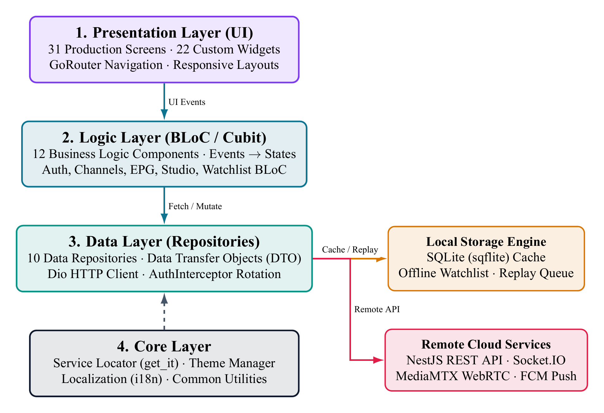
Figure 3.1: Flutter BLoC Layered Architecture for Mobile Client
The 4-tier layered architecture of OmniCast Mobile: Presentation routed by GoRouter (31 screens, 22 widgets), Logic driven by 12 BLoC/Cubits, and Data communicating concurrently with NestJS REST APIs, Socket.IO /live and local SQLite storage.
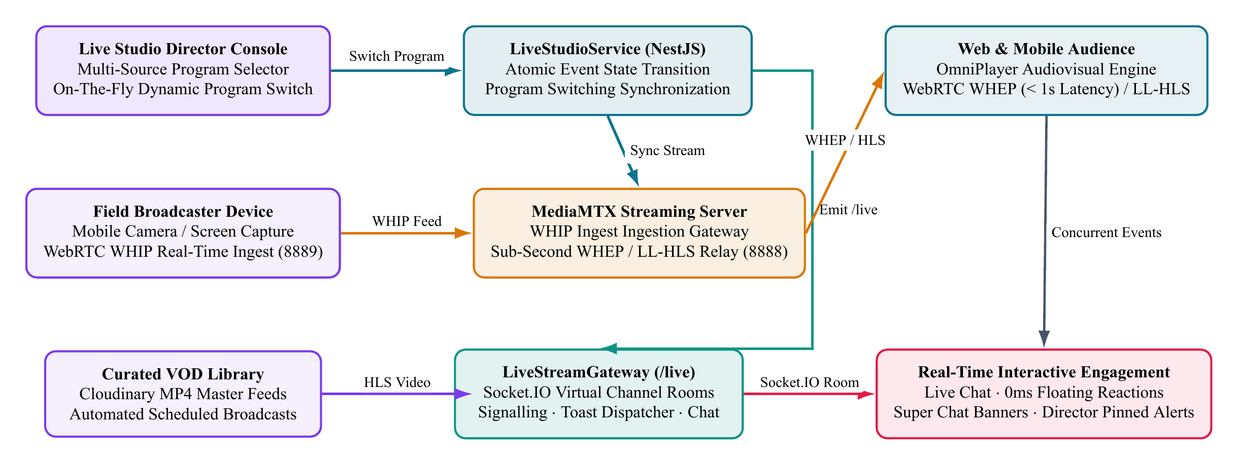
Figure 2.2: End-to-End LiveStream and Live Studio Real-Time Architecture
End-to-end LiveStream and Live Studio architecture bridging the Flutter mobile client, Next.js 15 web portal, MediaMTX (WHIP/WHEP/HLS) and the Socket.IO /live gateway.

Layered Organization
The four architectural tiers are defined as follows:
- Presentation Layer: Encompasses 31 screens and 22 reusable widgets. This tier is completely free of business computations, focusing solely on state rendering and event dispatching.
- Logic Layer (BLoC / Cubit): Hosts 12 state-management modules. BLoCs accept incoming events from UI widgets, invoke domain repositories, and emit reactive state streams.
- Data Layer: Encapsulates 10 Repositories, Data Sources, and 10 Data Transfer Objects (DTOs). It abstracts data origins, transparently querying SQLite or fetching remotely via Dio.
- Core Layer: Supplies cross-cutting concerns: GoRouter navigation definitions, get_it dependency injection, LanDiscoveryService Wi-Fi subnet scanner, WebRTCPublisherService WHIP streamer, UI theme styling, i18n localization, and secure token storage.

Dependency Injection with GetIt
All Repositories, Data Sources, Network Clients, and BLoC instances have their lifecycles managed via the get_it service locator. In injection_container.dart, registrations are strictly partitioned between Lazy Singletons (for stateless services, DB helpers, and repositories) and Factories (for transient BLoC instances tied to screen lifecycles):
final sl = GetIt.instance;
Future<void> init() async {
// BLoCs (Factory)
sl.registerFactory(() => AuthBloc(sl()));
sl.registerFactory(() => WatchlistBloc(sl()));
sl.registerFactory(() => EpgBloc(sl()));
// Repositories (Lazy Singleton)
sl.registerLazySingleton<WatchlistRepository>(
() => WatchlistRepositoryImpl(
remoteDataSource: sl(),
localDataSource: sl(),
),
);
// Core & Drivers
sl.registerLazySingleton(() => DioClient(sl()));
sl.registerLazySingleton(() => DatabaseHelper());
}

Networking and JWT Token Rotation
Remote HTTP communications are powered by Dio enriched with a custom AuthInterceptor. Upon intercepting an HTTP 401 Unauthorized response, the interceptor transparently initiates a background token refresh using the refresh token persisted in flutter_secure_storage:
- Locks the active request queue to prevent cascading 401 errors.
- Dispatches a refresh request to /api/v1/auth/refresh with the existing refresh token.
- Persists the refreshed token pair and replays pending requests with the new Bearer token.
- If the refresh token itself is invalid or revoked, safely clears the session and redirects the user to the Login screen.

State Management with BLoC
OmniCast Mobile adopts the Business Logic Component (BLoC) architectural pattern as its core state management strategy. BLoC leverages reactive Dart Streams to enforce strict unidirectional data flow: the UI dispatches an Event, the BLoC processes asynchronous business logic, and emits an immutable State reflecting the outcome.

Inventory of the 12 BLoC / Cubit Modules
The application’s business logic is modularized into 12 dedicated units situated under lib/logic/:
- AuthBloc: Manages user authentication lifecycle, login, registration, logout, and silent token rotation.
- WatchlistBloc: Coordinates personal watchlist items, offline SQLite cache syncing, and local notification scheduling.
- EpgBloc: Fetches and filters electronic programme guides per channel and date, consuming 24/7 seeded filler data.
- ChannelBloc: Maintains broadcast channel catalogue, channel subscriptions, and category filters.
- LiveBloc: Governs live broadcast playback, dynamic MediaMTX stream URL resolution, and player state.
- AiCuratorBloc: Interfaces with the AI curator service, validating broadcasting compliance and generating editorial suggestions.
- ProgramsBloc: Handles program catalogues, episode breakdowns, and production tags.
- RecordingsBloc: Queries published on-demand broadcast recordings (VOD).
- SearchBloc: Executes cross-entity searches across channels, events, and recordings with input debouncing.
- NotificationsBloc: Handles in-app alerts and synchronizes Firebase Cloud Messaging push payloads.
- NewsletterBloc: Manages channel newsletter subscriptions.
- StreamsBloc: Aggregates currently active broadcast transmissions across all channels.

Concurrency Transformers
To manage high-frequency user interactions, OmniCast Mobile incorporates the bloc_concurrency package, enforcing custom event transformers:
- droppable: Applied to mutations like watchlist toggling or live donation dispatch. If an operation is already in-flight, subsequent duplicate user taps are safely dropped to prevent idempotent violations.
- restartable: Applied to SearchBloc. When a new query is typed, previous pending network requests are immediately cancelled, giving precedence to the latest user input.

Eliminating Redundant Rebuilds via Equatable
All state representations extend the Equatable class. Whenever a BLoC emits a state instance, Flutter BLoC performs deep value-based equality checks instead of default object reference comparisons. Unchanged state emissions are discarded at the presentation boundary, completely avoiding redundant widget rebuilds and maintaining a fluid 60fps rendering budget.

Offline-First Architecture & Synchronization Engine
A hallmark technological achievement of OmniCast Mobile is its robust operational capability under complete network disconnection. Rather than halting execution with generic error dialogs, the client preserves an uninterrupted browsing experience using a dedicated local SQLite database (omnicast_local.db) managed by DatabaseHelper.
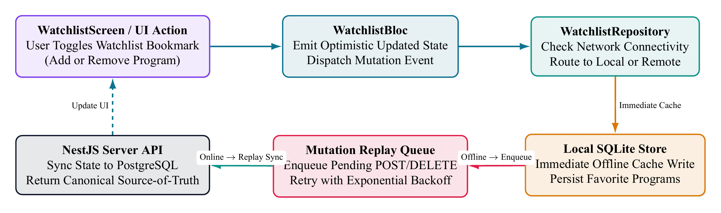
Figure 3.3: Offline-First SQLite Caching and Mutation Replay Queue Flow
The offline-first watchlist synchronization lifecycle: user actions immediately write to SQLite, schedule a local alert 15 minutes ahead, and enqueue into pending_ops for automated background replay upon network restoration.

Local SQLite Database Schema
The omnicast_local.db schema consists of five primary tables:
- watchlist: Stores user-bookmarked broadcast events. It includes cloud mirror markers such as cloudId, lastSyncedAt, and a dirty boolean flag signifying unsynchronized local alterations.
- cached_channels & cached_programs: Persists serialized JSON snapshots of channels and programs along with timestamps, powering zero-latency cold app launches.
- epg_cache: Caches EPG grids indexed by date string, allowing viewers to inspect programme schedules offline.
- pending_ops: An atomic mutation queue recording changes made offline (additions or deletions), preserving mutation types, payload identifiers, and UTC timestamps.

Pending Operations Replay Queue
When a viewer toggles a watchlist item without active connectivity, the repository executes an optimistic three-stage transaction:
- Optimistically reflects the change in the UI and writes to the local watchlist table with dirty = 1.
- Inserts an actionable mutation payload into the pending_ops queue.
- Listens for network reconnection events. Once online, the background WatchlistSyncService replays queued operations in FIFO sequence to the NestJS REST endpoints, clearing successfully committed entries.

Advance 15-Minute Local Notifications
To ensure viewers never miss broadcast premieres, OmniCast integrates flutter_local_notifications configured with the device’s local timezone. Adding an event to the watchlist automatically computes an exact reminder scheduled 15 minutes before airtime:
final scheduledTime = event.scheduledAt.subtract(
const Duration(minutes: 15),
);
if (scheduledTime.isAfter(DateTime.now())) {
await notificationsPlugin.zonedSchedule(
event.id.hashCode,
'Sắp phát sóng: ${event.title}',
'Chương trình sẽ bắt đầu sau 15 phút trên kênh ${event.channelName}',
tz.TZDateTime.from(scheduledTime, tz.local),
notificationDetails,
androidScheduleMode: AndroidScheduleMode.exactAllowWhileIdle,
uiLocalNotificationDateInterpretation:
UILocalNotificationDateInterpretation.absoluteTime,
);
}
Employing AndroidScheduleMode.exactAllowWhileIdle guarantees that reminders fire precisely on time even when the host operating system enters deep sleep (Doze mode), operating completely independent of external push gateways.

OmniPlayer, Interactive LiveStream Room & Mobile Live Studio
At the epicenter of the mobile broadcast experience are five tightly integrated components: (1) the multi-engine OmniPlayer (lib/presentation/widgets/omni_player.dart); (2) the automatic Wi-Fi subnet scanner LanDiscoveryService (lib/core/network/lan_discovery_service.dart); (3) the real-time broadcast hub LiveNowScreen (/live); (4) the interactive viewer lounge LiveWatchScreen (/live/:id); and (5) the 4-tab LiveStudioScreen (/studio/live) paired with the hardware field-reporter viewfinder MobileStudioRecorderScreen.

Multi-Engine OmniPlayer and Automatic LAN Host Discovery
For live channels and VOD assets, OmniPlayer inspects the incoming URL and routes playback across four specialised engines:
- Low-Latency MediaMTX HLS / WebRTC (:8888/<streamKey>/index.m3u8): Powered by native video_player and chewie with _isMediamtxLiveStream detection. When running on a physical smartphone over Wi-Fi where the backend returns localhost or Android emulator loopback 10.0.2.2, LanDiscoveryService automatically scans the local /24 subnet on port 8888, discovers the active MediaMTX host IP, and rewrites the stream URL transparently. Furthermore, to eliminate accumulated latency and maintain live synchronisation, OmniPlayer applies a two-stage adaptive speed catch-up algorithm: when playback drift from the live edge is between 1.8s and 4.0s, the speed is boosted to 1.25x; if drift exceeds 4.0s due to network congestion, the player executes an immediate hard-seek to the live head; and when drift normalises under 900ms, playback returns to 1.0x. A _lastBuffering hook triggers instant catch-up right after re-buffering ends.
- Zero-Cartoon-Fallback Live Camera Retry: For real-time camera streams (/live/webcam_*), while MediaMTX is muxing the initial HLS segments, OmniPlayer strictly disables sample VOD fallbacks and executes up to 10 exponential-backoff retries (triggering a fresh LAN subnet scan on retry #2) while displaying a studio signal synchronisation HUD.
- Direct Google Drive Stream Resolution: Standard drive.google.com/file/d/<id>/view links are rewritten to https://drive.usercontent.google.com/download?id=<id>&export=download&confirm=t, enabling native hardware decoding without Google login prompts.
- YouTube WebView Embed & VIP Paywall Enforcement: Partner YouTube streams mount an embedded webview_flutter player, while isPremium programmes verify the viewer’s subscription tier and present SubscriptionPaymentSheet when upgrading is required.
String resolveStreamUrl(String rawUrl, String? lanHostIp) {
if (lanHostIp != null &&
(rawUrl.contains('localhost') || rawUrl.contains('127.0.0.1') || rawUrl.contains('10.0.2.2'))) {
return rawUrl
.replaceAll('localhost', lanHostIp)
.replaceAll('127.0.0.1', lanHostIp)
.replaceAll('10.0.2.2', lanHostIp);
}
return rawUrl;
}

Live Broadcast Hub (LiveNowScreen) and Interactive Viewer Room (LiveWatchScreen)
The mobile viewer LiveStream journey spans two dedicated screens:
- Live Broadcast Hub (LiveNowScreen — /live): Auto-refreshes active LIVE broadcasts every 15 seconds (Timer.periodic), displays summary pills for active streams and total concurrent viewers (CCU), supports sorting by trending viewers or newest start time, and provides a quick-launch button to LiveStudioScreen for STAFF/ADMIN operators.
- Interactive Live Watch Room (LiveWatchScreen — /live/:id): Presents a LiveJoinPromptBanner lobby card and, upon joining, connects to the Socket.IO /live namespace (subscribe:event) to power six real-time interactive operations:
  - Real-Time Viewer Counter (live:viewerCount): Updates concurrent viewer badges live as audiences join or leave.
  - Threaded Live Chat & Moderation (live:chat): Supports real-time chat messages, nested replies (parentId), comment likes, and instant STAFF/ADMIN message deletion (chat:delete $→$ chat:deleted).
  - 0ms Haptic Floating Emoji Reactions (live:reaction): Tapping reaction buttons (HEART, FIRE, CLAP, WOW/PARTY) triggers immediate HapticFeedback.lightImpact(), increments optimistic local counters, and spawns rising particle animations via FloatingReactionOverlay.
  - Pinned Host Announcements (broadcaster:message): Renders live announcements from studio producers as a highlighted banner.
  - 6-Tier Super Chat & Live Donations with PayOS (LiveDonationModal): Enables viewers to send virtual gifts across 6 preset tiers (Bronze 10k, Silver 20k, Gold 50k, Diamond 100k, Crown 200k, Elite 500k) powered by the PayOS gateway with authentic MB Bank VietQR generation (Beneficiary: NGUYEN BINH AN, Account Number: 0935649095), updating creator wallets and triggering celebratory room overlays (live:donation:received).
  - Zero-Downtime Program Switching (live:program:changed): Automatically reloads OmniPlayer with the newly switched stream URL whenever the studio changes the active programme.

4-Tab LiveStudioScreen Console and MobileStudioRecorderScreen Field Viewfinder
A flagship engineering capability of OmniCast Mobile is transforming any authorised smartphone (STAFF/ADMIN) into a portable broadcast control centre via LiveStudioScreen (lib/presentation/screens/studio/live_studio_screen.dart) and MobileStudioRecorderScreen (lib/presentation/screens/studio/mobile_studio_recorder_screen.dart):
- The 4-Tab LiveStudioScreen Console:
  - Tab 1 — Curated Live: Pick target channel, enter stream metadata, and select one or more VOD recordings for immediate multi-item broadcast (POST /programs/studio/curate-live).
  - Tab 2 — Self-Record & Device Broadcast: Launch MobileStudioRecorderScreen or pick device media, upload directly to Cloudinary via signed parameters, and publish under IMMEDIATE, SCHEDULED or PRIVATE visibility.
  - Tab 3 — Verified Public Catalog: Browse verified public HLS/MP4 feeds with one-click channel import or custom URL probing.
  - Tab 4 — Host Announcement & Broadcast Control: Dispatch pinned room announcements (broadcaster:message) and stop active live events (keepAsVod).
- The MobileStudioRecorderScreen Field Reporter Viewfinder: Engineered after professional Electronic News Gathering (ENG) broadcast cameras with two operating modes:
  - Mode 1 — Push-to-Live Real-Time WebRTC WHIP: Streams live camera video and microphone audio directly to MediaMTX via WebRTCPublisherService with a flashing red ON-AIR tally border.
  - Mode 2 — 1080p Record-then-Live with Master QC: Captures 1080p MP4 video equipped with a real-time SMPTE Timecode Generator (HH:MM:SS:FF), dual-channel Stereo VU Audio Meter, Rule-of-Thirds & Safe Area framing guides, live Lower Third & Watermark overlays, hardware Torch toggle, front/rear lens flip, 1x--5x zoom presets, and an auto-scrolling Reporter Teleprompter HUD. Upon stopping, the studio transitions into a Master QC Review player to verify footage prior to signed cloud upload.

UI/UX Design, Navigation & 31-Screen Hierarchy
OmniCast Mobile embraces an elevated Cinema Dark Theme, anchoring its visual palette around midnight slate (#0F172A) and luminous cyan (#0E7490), complemented by dynamic Light Mode and bilingual Vietnamese/English switching (LanguageCubit). This aesthetic highlights video and graphical media while yielding significant power savings on modern OLED/AMOLED smartphone displays.
The OmniCast Mobile home view (HomeScreen): featured broadcast carousel, interactive LiveStream broadcast schedule with 4 filter chips (All, Live Now, Golden Hour, Today), category selector, and live/upcoming electronic programme guide.

Declarative Routing with GoRouter
The client’s comprehensive routing topology is orchestrated via go_router declared centrally in app_router.dart (Fig. 5). This architecture unlocks three critical capabilities:
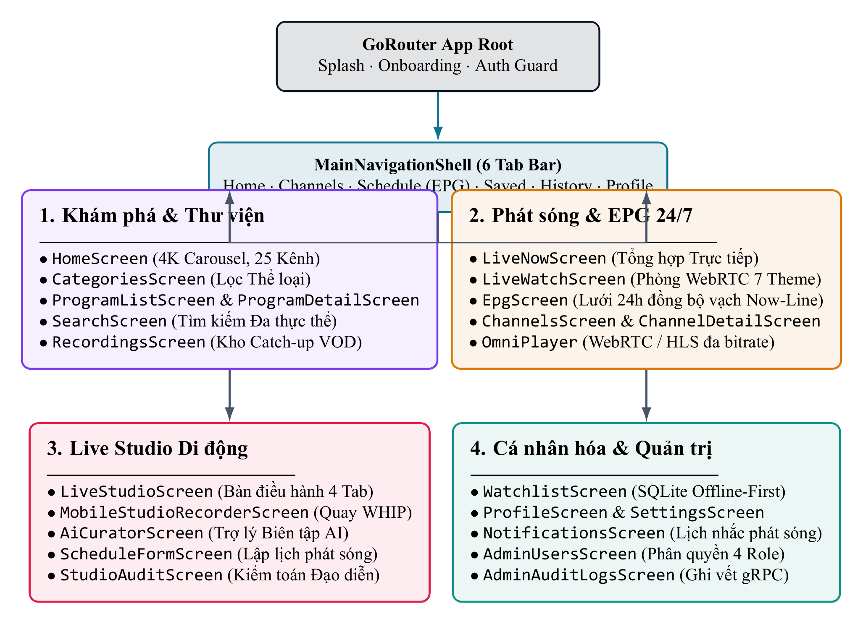
Figure 3.2: Mobile Navigation Hierarchy across 31 Dedicated Screens
Declarative GoRouter navigation topology and 31-screen hierarchy of OmniCast Mobile.
- Auth-Guarded & Role-Aware Routing:
Attempting to enter authenticated or role-restricted zones such as /studio/live, /admin/manage, or /admin/ai-curator triggers automatic checks against AuthBloc and role permissions (VIEWER, STAFF, ADMIN).
- Deep-Linking Support:
Natively maps routes such as /live/:id, /channels/:id, /programs/:id and /recordings/:id, routing users directly to destination views from FCM push alerts or shared links.
- 6-Tab MainNavigationShell:
A ShellRoute governing 6 primary destinations (/home, /channels, /schedule, /saved, /history, /profile) preserves navigation context across tab switches.

Complete Inventory of All 31 Mobile Application Screens
Table [tab:mob_screens] catalogues all 31 concrete screen implementations under mobile/lib/presentation/screens/ across 5 operational clusters:
Cluster | Screen Class & Route (31) | RBAC Role | Key Screen Features & Interactive Operations
1. Onboarding & Auth (6) | SplashScreen (/), OnboardingScreen (/onboarding) | Public | JWT session check via Secure Storage, interactive first-launch onboarding tour.
1. Onboarding & Auth (6) | LoginScreen (/login), RegisterScreen (/register) | Public | Email/Password + Google Sign-In, account registration with password strength validation.
1. Onboarding & Auth (6) | ForgotPasswordScreen, ResetPasswordScreen | Public | Request password reset token via email and set new password using a 6-digit code.
2. Discovery & EPG (8) | MainNavigationShell, HomeScreen (/home) | Public / Viewer | 6-tab navigation shell, LIVE spotlight carousel, featured channels, continue watching and curated picks.
2. Discovery & EPG (8) | ChannelsScreen (/channels), ChannelDetailScreen (/channels/:id) | Public / Viewer | Category-filtered channel directory, channel detail view with embedded OmniPlayer, follow toggle & EPG.
2. Discovery & EPG (8) | ScheduleScreen (/schedule), ProgramDetailScreen (/programs/:id) | Public / Viewer | Offline-capable 24/7 EPG timeline grid, programme detail view, production tags & 15-min local alarm reminder.
2. Discovery & EPG (8) | SearchScreen (/search), CategoryBrowseScreen (/categories) | Public / Viewer | Debounced cross-entity search (restartable BLoC transformer) and category browser.
2. Discovery & EPG (8) | LiveNowScreen (/live) | Public / Viewer | Live Broadcast Hub: 15s auto-refresh, total LIVE events & aggregate CCU pills, trending/newest sort.
 | LiveWatchScreen (/live/:id) | Public / Viewer | Interactive Live Watch Room: LiveJoinPromptBanner, LAN-aware & 1.25x low-latency OmniPlayer, threaded live chat, 0ms haptic floating reactions, 6-tier PayOS MB Bank Super Chat (LiveDonationModal), pinned host banner & on-the-fly program switch.
 | RecordingWatchScreen (/recordings/:id) | Public / Viewer | VOD recording playback screen, resume-position tracking, threaded comments and related recordings.
4. Studio & Admin (5) | LiveStudioScreen (/studio/live) | STAFF+ | 4-Tab Mobile Broadcast Console: (1) Curated VOD Live; (2) Self-Record / Signed Cloudinary Upload; (3) Public Catalog; (4) Host Announcement & Stop Live.
4. Studio & Admin (5) | MobileStudioRecorderScreen | STAFF+ | Field Reporter Viewfinder: real-time WebRTC WHIP (Push-to-Live) or 1080p MP4 (Record-then-Live), SMPTE timecode, Stereo VU meter, Teleprompter HUD, Rule-of-Thirds & Master QC review.
4. Studio & Admin (5) | AdminManageScreen (/admin/manage), ScheduleFormScreen, AiCuratorScreen | STAFF+ / ADMIN | 4-tab Admin Hub (Channels, Programmes, Schedules, Users), EPG conflict-checked schedule form and AI Curator workbench.
5. Personal, Offline & Legal (9) | WatchlistScreen (/saved), WatchHistoryScreen (/history) | VIEWER+ | Offline-first SQLite watchlist (pending_ops), status filter chips and watch history with progress bars.
5. Personal, Offline & Legal (9) | NotificationsScreen, ProfileScreen, EditProfileScreen, SubscriptionPlansScreen | VIEWER+ | FCM/Local notification centre, user profile, avatar editor and VIP subscription plan checkout.
5. Personal, Offline & Legal (9) | SettingsScreen, BroadcastStandardsScreen, LegalDocumentScreen | Public / Viewer | Dark/Light theme toggle, VI/EN language switch, server IP config, broadcast standards and legal documents.
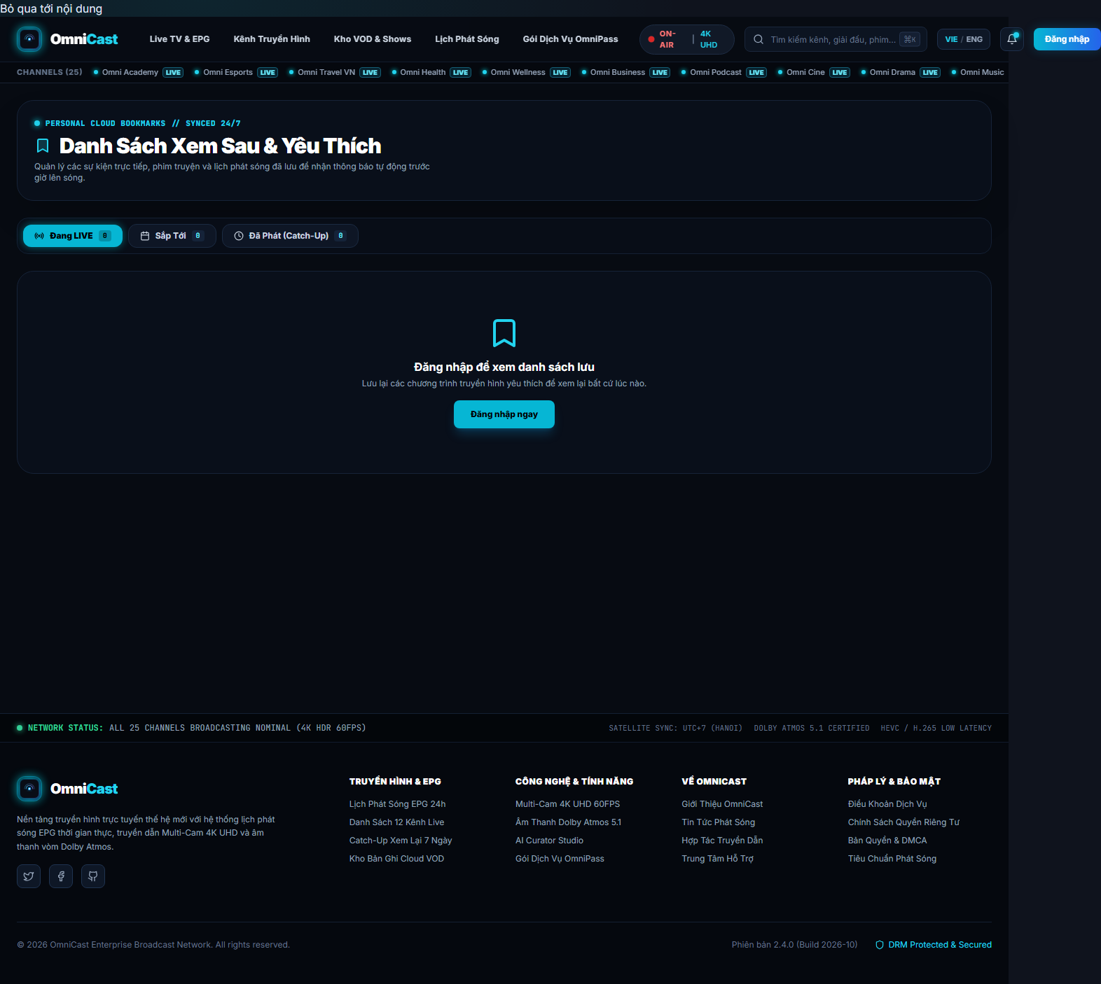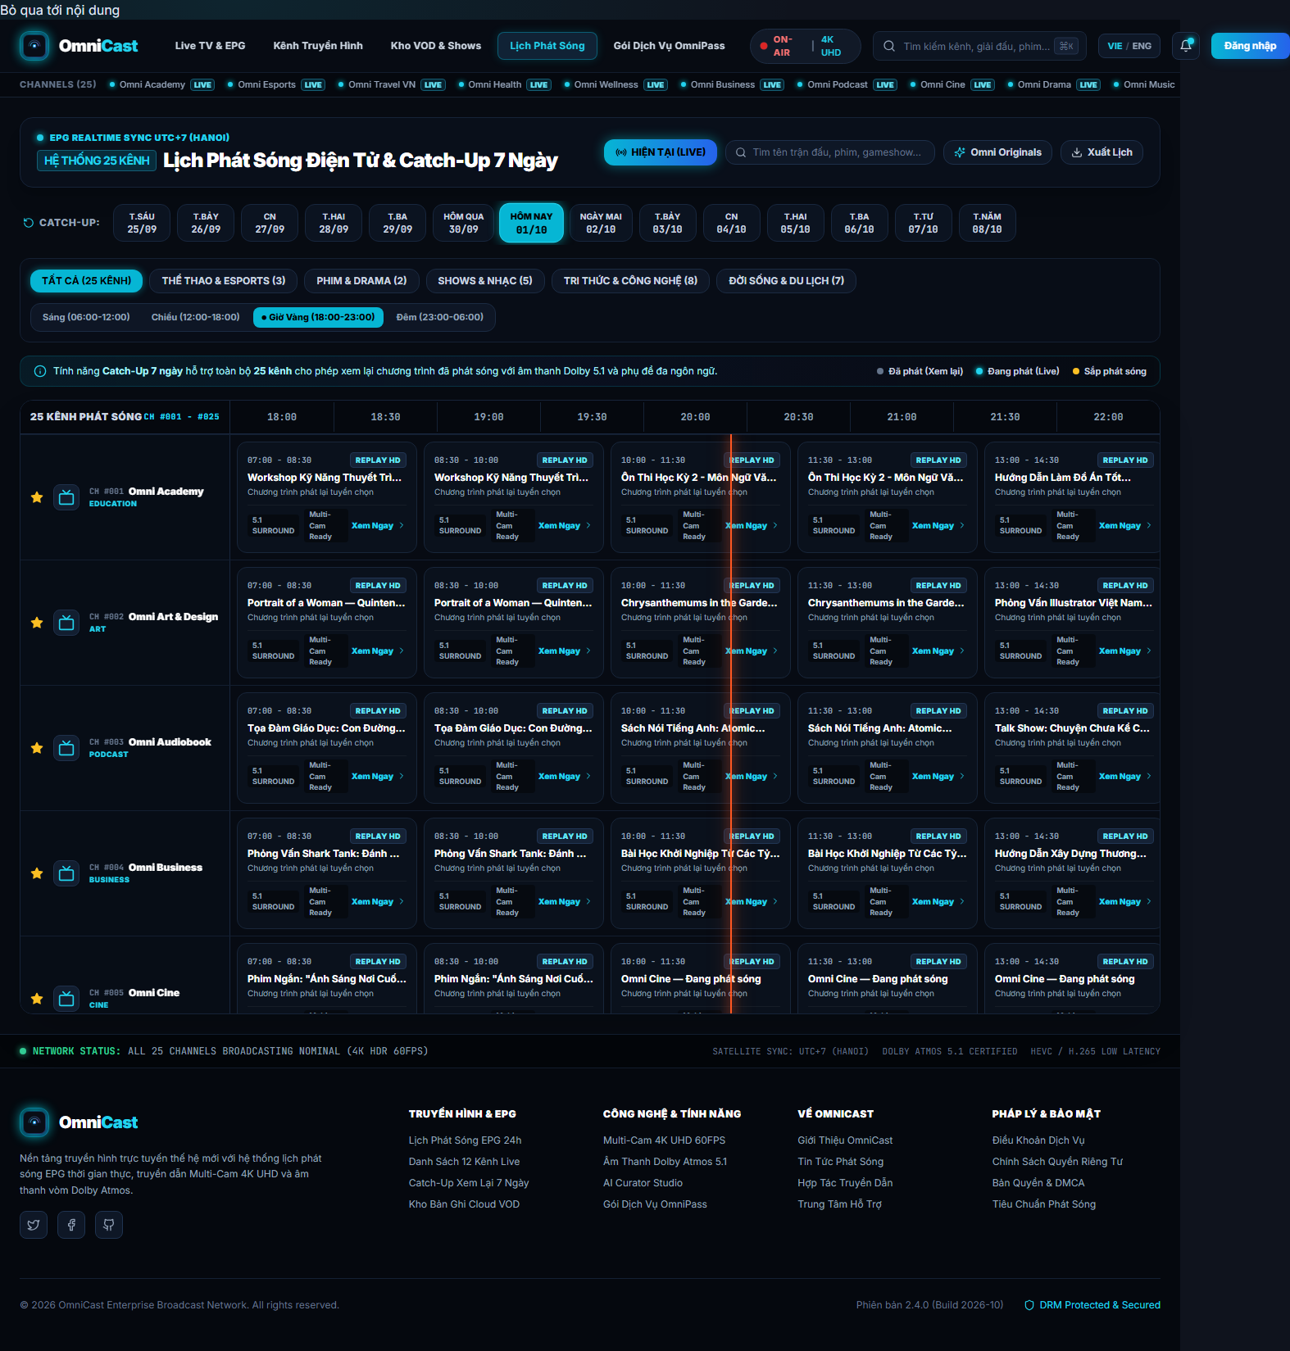
Personal Watchlist screen with offline status badges (left) and 24/7 EPG schedule grid with timeline filtering (right).

Automated Testing & Quality Assurance
The reliability and resilience of OmniCast Mobile are safeguarded through a multi-tiered automated testing regimen. The test tree contains 91 tests in 8 spec files; GitHub Actions run 40630318005 selected 77 tests from the data, logic and presentation directories, and all 77 passed. The remaining 14 tests were outside that CI command’s scope.

Testing Methodology and Layering
The test architecture spans three principal testing tiers:
- BLoC Unit Testing: Employs bloc_test to verify reactive event-to-state sequences. Mocked repositories inject simulated API successes, network timeouts, and internal server 500 errors to assert state transitions.
- Data Layer Integration: Validates DTO JSON serialization and verifies SQLite behaviors: inserting mutation records into pending_ops, computing CacheStats, and recovering cached records offline.
- Widget Component Testing: Uses testWidgets to exercise interactive widgets (such as SaveToWatchlistButton), verifying correct loading spinners and error snackbars upon failed operations.

Empirical Test Results Breakdown
Execution results of the 77 mobile tests in CI run 40630318005.
Test Suite | Scope | Tests | Rate
ai_curator_repository_test | Repository / Mock API | 25 | 100%
ai_curator_screen_test | Widget / Studio UI | 10 | 100%
auth_bloc_test | State / Session | 13 | 100%
watchlist_bloc_test | State / Offline | 10 | 100%
watchlist_item_model_test | Data model / JSON | 8 | 100%
save_to_watchlist_test | Interactive Widget | 4 | 100%
epg_bloc_test | State / Schedule | 5 | 100%
onboarding_screen_test | Presentation / Flow | 2 | 100%
In CI run 40630318005 | 8 spec files | 77 | 100%

Continuous Integration Pipeline
Within the project’s GitHub Actions workflow (ci.yml), the mobile job executes concurrently alongside backend and web runners:
- name: Setup Flutter
uses: subosito/flutter-action@v2
with:
flutter-version: '3.x'
channel: 'stable'
- name: Install dependencies
run: flutter pub get
- name: Run automated test suite
run: |
flutter test --coverage --machine \
test/data test/logic test/presentation > test-results-raw.json
node ../.github/scripts/parse-mobile-test.js \
test-results-raw.json test-results.json
- name: Build release APK
run: flutter build apk --split-per-abi

Conclusion & Future Work

Conclusion
This paper has presented the comprehensive software architecture and empirical findings of OmniCast Mobile developed by the four-member engineering team (Nguyễn Bình An, Trần Thanh Sơn, Nguyễn Vĩnh Phú, Đồng Hoàng Nguyên) at FPTU Quy Nhon AI Campus — FU Cahata for the PRM393 course under the mentorship of Mr. Huỳnh Vang. All five original engineering goals have been validated through concrete source code (53,922 Dart LOC across 31 screens) and rigorous benchmarks:
- A 4-tier Clean Architecture coupled with 12 decoupled BLoC/Cubit units, strictly segregating reactive UI rendering from domain calculations.
- An offline-first persistence engine driven by SQLite, mutation replay queuing (pending_ops), and exact 15-minute advance local alarms.
- The multi-engine OmniPlayer featuring automatic Wi-Fi LAN host discovery (LanDiscoveryService), ultra-low-latency WebRTC/HLS live streams, direct Google Drive streaming, and bi-directional Socket.IO /live rooms (LiveWatchScreen: threaded chat, 0ms haptic floating reactions, 6-tier Super Chat donations, pinned host banners and on-the-fly program switching).
- A portable broadcast studio comprising the 4-tab LiveStudioScreen and the MobileStudioRecorderScreen field viewfinder with real-time WebRTC WHIP publishing, SMPTE timecode, Stereo VU meter and auto-scrolling Teleprompter HUD.
- GitHub Actions run 40630318005 passed 77/77 mobile tests in workflow scope; the test tree contains 91 tests.

Performance Evaluation & Limitations
Field profiling across physical Android and iOS devices indicates steady rendering performance at 58–60 FPS during intensive EPG scrolling and floating reaction animations. Memory usage averages between 110MB and 145MB during continuous live stream decoding.
Nevertheless, two known technical limitations remain:
- Lack of native AV1 hardware decoding on older Android hardware profiles, necessitating automatic server-side fallback to HLS H.264 profiles.
- Offline synchronization employs a pragmatic Last-Write-Wins policy rather than Conflict-Free Replicated Data Types (CRDTs), which may yield minor discrepancies during simultaneous cross-device updates.

Future Work
Roadmap horizons for upcoming releases include:
- Integrating native Picture-in-Picture (PiP) and background audio services for broadcast news and podcast feeds.
- Expanding support for Android TV and Apple TV form factors with D-Pad remote control navigation focus states.
- Deploying lightweight on-device recommendation models via TensorFlow Lite to compute privacy-preserving suggestions locally.

Acknowledgements
The authors (Nguyễn Bình An, Trần Thanh Sơn, Nguyễn Vĩnh Phú, Đồng Hoàng Nguyên) wish to express their sincere appreciation to Mentor Mr. Huỳnh Vang and the faculty at FPTU Quy Nhon AI Campus — FU Cahata for their invaluable guidance throughout the development of OmniCast Mobile.
99 Google LLC, Flutter: Build apps for any screen, https://flutter.dev/, accessed Oct. 2026. Google LLC, The Dart Programming Language, https://dart.dev/, accessed Oct. 2026. S. Lapan and F. Harvy, “BLoC: (State Management) Library for Flutter,” in Proc. 1st Int. Workshop on Flutter, 2020, pp. 1–5. FlutterChina, Dio: A powerful HTTP client for Dart and Flutter, https://pub.dev/packages/dio, 2024. Tekartik, Sqflite: SQLite plugin for Flutter, https://pub.dev/packages/sqflite, 2024. Flutter Team, go_router: A declarative routing package for Flutter, https://pub.dev/packages/go_router, 2024. Bluenviron, MediaMTX: Live video server for WebRTC, HLS and RTMP, https://github.com/bluenviron/mediamtx, 2024. W3C / IETF, WebRTC 1.0: Real-Time Communication Between Browsers and Devices, https://www.w3.org/TR/webrtc/, 2021. Supabase Inc., Supabase Realtime: Broadcast, Presence, and Postgres CDC, https://supabase.com/docs/guides/realtime, 2024. Google LLC, Firebase Cloud Messaging, https://firebase.google.com/docs/cloud-messaging, 2024. M. Jones, J. Bradley, and N. Sakimura, “JSON Web Token (JWT),” RFC 7519, IETF, 2015. B. Thomas, get_it: Simple Service Locator for Dart and Flutter, https://pub.dev/packages/get_it, 2024. Flutter Team, An introduction to unit and widget testing in Flutter, https://docs.flutter.dev/testing/overview, 2024. N. Preguica, M. Shapiro, and C. Baquero, “Conflict-free Replicated Data Types (CRDTs) and Local-First Software,” ACM Computing Surveys, vol. 53, no. 3, pp. 1–37, 2020.

Appendix A: Detailed SQLite Schema
The local omnicast_local.db database is provisioned with five core tables and covering indices:
-- Bang luu danh sach theo doi va trang thai dong bo
CREATE TABLE watchlist (
id INTEGER PRIMARY KEY AUTOINCREMENT,
programId TEXT NOT NULL UNIQUE,
programTitle TEXT NOT NULL,
thumbnailUrl TEXT,
channelId TEXT,
channelName TEXT,
scheduledAt TEXT NOT NULL,
duration INTEGER,
reminderTime TEXT,
reminderEnabled INTEGER DEFAULT 0,
addedAt TEXT NOT NULL,
cloudId TEXT,
lastSyncedAt TEXT,
dirty INTEGER DEFAULT 0
);
CREATE INDEX idx_watchlist_scheduled ON watchlist(scheduledAt);
-- Bang hang doi phat lai dot bien ngoai tuyen
CREATE TABLE pending_ops (
id INTEGER PRIMARY KEY AUTOINCREMENT,
kind TEXT NOT NULL, -- 'add' hoac 'remove'
programId TEXT NOT NULL,
channelId TEXT,
note TEXT,
createdAt TEXT NOT NULL
);
CREATE INDEX idx_pending_ops_createdAt ON pending_ops(createdAt);
-- Bang cache bo nho dem EPG theo ngay
CREATE TABLE epg_cache (
date TEXT PRIMARY KEY,
payload TEXT NOT NULL,
fetchedAt TEXT NOT NULL
);

Appendix B: Screen to BLoC Coordination Matrix
The table below maps representative screens to their governing BLoC modules:
Mapping between Screens and governing BLoCs.
Screen | Primary BLoC | Data Source
LoginScreen | AuthBloc | Remote REST API / SecureStorage
HomeScreen | ChannelBloc, EpgBloc | Remote API + SQLite cache
ChannelsScreen | ChannelBloc | Remote API + SQLite cache
EpgScreen | EpgBloc | Remote API + epg_cache
LivePlayerScreen | LiveBloc | MediaMTX + Socket.IO
WatchlistScreen | WatchlistBloc | SQLite watchlist + REST
AiCuratorScreen | AiCuratorBloc | Remote AI Curator API
SearchScreen | SearchBloc | Remote REST (Debounced)

Appendix C: Mobile Source Scale
The OmniCast mobile project encompasses over 17,000 clean physical lines of Dart code (excluding generated assets), partitioned across more than 60 modular source files.
Mobile source-code breakdown.
Component | Lines of code | Unit
Backend NestJS (src/) | 27,826 | file .ts
Backend test (test/) | 4,512 | file .ts
gRPC proto | 83 | file .proto
Audit-logger microservice | 382 | file .ts
Prisma schema | 683 | file .prisma
Frontend Next.js (app/, components/, lib/) | 51,742 | file .ts/.tsx
Mobile Flutter (lib/) | 53,922 | file .dart
Mobile test (test/) | 2,529 | file .dart

