VIETNAM NATIONAL UNIVERSITY OF HOCHIMINH CITY

THE INTERNATIONAL UNIVERSITY

SCHOOL OF COMPUTER SCIENCE AND ENGINEERING



**TELEHEALTH**

By Team members:

Pham Hoang Minh ITITIU19031

Pham Cong Tuan ITITIU19060

Do Minh Hoang ITITIU17015

Nguyen Thien Bao ITITIU17035

Github: https://github.com/TomPham204/Telehealth

Ho Chi Minh City, Vietnam  
Year

**TELEHEALTH**

APPROVED BY:

**,   
LE DUY TAN**

REPORT COMMITTEE   
(Whichever applies)

# 

# ACKNOWLEGMENTS

It is with deep gratitude and appreciation that I acknowledge the professional guidance of teacher Le Duy Tan. His constant encouragement and support helped me to achieve my goal.

My gratitude goes to the all members of the team including me, Mr. Pham Cong Tuan and Mr. Pham Hoang Minh, Mr. Do Minh Hoang and Mr. Nguyen Thien Bao. Their technical help and good humor made thí project become a great learning experience. I am grateful to the faculty of the School of Computer Science of the International University for the support since the beginning of my studies. Gratitude is also expressed to the members of my reading and examination committee.

*Note: Paper A4, Top: 2.5cm; Bottom: 2cm; Left: 3cm; Right: 2cm*

# TABLE OF CONTENTS

ACKNOWLEGMENTS 3

TABLE OF CONTENTS 4

LIST OF FIGURES 6

LIST OF TABLES 7

ABSTRACT 8

CHAPTER 1 9

INTRODUCTION 9

1.1. Background 9

1.2. Problem Statement 9

1.3. Scope and Objectives 9

1.4. Assumption and Solution 9

1.5. Structure of thesis 9

CHAPTER 2 10

LITURATURE REVIEW/RELATED WORK 10

2.1. Review 1 10

2.1.1. Sub review 1 10

2.2. Review 2 10

2.2.1. Sub review 2 10

CHAPTER 3 11

METHODOLOGY 11

3.1. Overview 11

3.2. User requirement analysis 11

3.2.1. Sub 1 11

3.3. System Design 11

3.3.1. Datadase design 11

3.3.2. User Interface design 11

3.4. Abc 11

CHAPTER 4 12

IMPLEMENT AND RESULTS 12

4.1. Implement 12

4.1.1. Abc 12

4.2. Results 12

4.2.1. Result 1 12

4.2.2. Result 2 12

CHAPTER 5 13

DISCUSSION AND EVALUATION 13

5.1. Discussion 13

5.2. Comparison 13

5.3. Evaluation 13

CHAPTER 6 14

CONCLUSION AND FUTURE WORK 14

6.1. Conclusion 14

6.2. Future work 14

REFERENCES 15

APPENDIX 16

# LIST OF FIGURES

*Figure 1.1: Abc*

# LIST OF TABLES

*Table 3.1: Cde*

# ABSTRACT

This report examines a cutting-edge telehealth program aimed at transforming the provision of healthcare. Through online consultations, diagnostics, and monitoring, the program aims to improve patient outcomes, overcome geographical constraints, and increase accessibility. Emphasizing user-friendliness, secure communication, and EHR integration, the paper underlines the application's ability to expedite procedures, manage resources, and boost overall productivity. There is also discussion of privacy concerns, regulatory compliance, and obstacles to broad adoption. As a result, the telehealth application shows promise in meeting the changing needs of contemporary healthcare and adds insightful information to the continuing conversation about the evolution of digital healthcare.

# CHAPTER 1

# INTRODUCTION

## Background

The combination of patient-centered approaches and technology has become a game-changer in the rapidly changing healthcare industry. Traditional healthcare methods face difficulties such as resource constraints, extended wait times, and restricted accessibility. The emergence of telehealth applications represents a significant turning point in healthcare innovation by providing a convincing means of addressing these obstacles. With a growing dependence on digital connectivity, telehealth applications offer a practical way to deliver fast and effective medical care.

The widespread use of smartphones and the expansion of high-speed internet highlight the viability and potential benefits of telehealth solutions when applied globally. These days, people can easily access remote patient consultations, monitoring, and diagnostics from the comfort of their own homes rather than being restricted to physical healthcare locations. Acknowledging the transformational potential of telehealth, our project seeks to build a comprehensive telehealth application to add to this momentum. In order to maximize overall healthcare results, the objective is to not only improve healthcare accessibility but also promote smooth communication between healthcare providers and patients.

## Problem Statement

Although telehealth applications show great promise, there are many obstacles in the way of their successful acceptance and deployment. The challenge of achieving interoperability with current electronic health record (EHR) systems is significant and calls for cautious handling to guarantee a smooth integration that is advantageous to patients and healthcare providers alike. Patient data security and privacy is a major concern that necessitates strong solutions that follow strict legal standards.

Beyond the technical complexities, patients' and healthcare providers' adoption and usage of telehealth technologies present complex hurdles. It need a sophisticated knowledge and customized solutions to address the human elements involved, which range from patients' acceptance of this digital transformation to healthcare professionals' comfort level when using telehealth systems.

This project's main goal is to take on these complex difficulties head-on. We want to make a substantial contribution to the development of telehealth solutions by creating a telehealth application that not only complies with technical and legal standards but also puts user experience and security first. Our goal is to create a healthcare ecosystem that is not just technologically advanced but also firmly anchored in accessibility, effectiveness, and patient-centered care. Our vision goes beyond the simple application of technology. Our initiative aims to reinvent the way healthcare is delivered in the future by using a thorough and deliberate approach.

## Scope and Objectives

The report’s idea is about giving a thorough and overall views of technology, how technology takes part and adapt in the medical industry and what kind of achievement that it brings to the process.

This thesis will walk us through all the fundamental information of the system from the system requirements, system architecture and design, to the very last part where users can actually interact in the system through the implementation.

Specifically, the output of this project is the very first version of the Telehealth application including:

* Login function
* Making Appointment
* Doctor Video Call

## Assumption and Solution

The context of this report proposes that all the required documents of the property has been legally digitalized by the government and the usage of the system is approved.

## Structure of report

# CHAPTER 2

# LITURATURE REVIEW/RELATED WORK

## Review 1

Applications for telehealth have attracted a lot of interest because of their potential to completely change how chronic illness is managed. A survey of the literature indicates an increasing amount of data demonstrating telehealth's ability to enhance patient outcomes and lessen the strain on healthcare systems. These apps let patients participate more actively in their healthcare and enable prompt interventions, which improves treatment plan adherence.

Nonetheless, there are still issues, mainly with regard to how to incorporate telehealth into the current healthcare systems and the requirement for electronic health record (EHR) interoperability. Furthermore, problems with patient acceptability and usability highlight the need for user-centric design in telehealth apps.

### Sub review 1

A closer look at the literature provides a more complex picture of the usability issues related to telehealth apps. Healthcare practitioners voice worries about how integrating telehealth into their practice may affect workflow and present a learning curve. Patients, on the other side, frequently bring up concerns about perceived loss of individualized care, access, and technology literacy.

In order to overcome these obstacles, user interface design must be customized in order to make telehealth applications intuitive, user-friendly, and able to accommodate a wide range of user demographics. In order to increase overall usability, the sub study highlights the importance of user feedback loops, iterative testing, and continual improvement in the creation of telehealth interfaces.

## Review 2

Applications for telehealth have become a ray of hope for resolving the inequities in healthcare access that are common in rural areas. Promising results have been observed in improving early diagnosis, treatment adherence, and overall health outcomes in rural communities through the use of remote consultations, telemedicine clinics, and mobile health units equipped with telehealth equipment.

Notwithstanding these achievements, research indicates enduring problems such inadequate internet access, differences in technology, and the requirement for customized telehealth programs for a range of rural communities. The significance of community involvement and cooperative endeavors in the effective execution of telehealth in remote regions underscoring the necessity of culturally aware and situation-specific methodologies.

### Sub review 2

Focusing on the technical side of things, the sub review explores the obstacles related to the infrastructure needed for efficient telehealth delivery in rural areas. This subanalysis emphasizes how critical it is to solve infrastructure issues in order to guarantee the impact and fair implementation of telehealth apps in remote healthcare environments.

# CHAPTER 3

# METHODOLOGY

## Overview

## User requirement analysis

Add usecase diagrams here:

Doctor: remove appointment, join video call, chat with patient

Normal user: register user account, add appointment, chat with doctor, update profile info

Admin: add doctor account, approve/reject appointment

### Sub 1

Abc...

## System Design

Follow MVVC or something model-view-viewmodel

Class diagram:

Class FirestoreDB: singleton, method for return only 1 instance of dbmanager for CRUD

Kotlin is 100% OOP so any code must be in a class (because it’s java based)

Important classes:

1. Model classes for property of actors in the program (doctor, user, admin).

2.Fragment classes: contain logic code for features, listen for user interaction and update the UI

3. DAO classes: data transfer object, use for defining centralized operations CRUD and query sentence on database (aka only 1 query for adding doctor for example)

4.Repository class: methods separated for each user role for calling DAO. Can have duplicates (DoctorRepo have its own deleteAppointment(), UserRepo has its own deleteAppointment())

5. Class ViewModel: managing data received from the repository (live data, async calls to repo,…). In each feature’s fragment, I init instance of revelant viewmodels to get and manage the data.

6. Adapter class: Used for recycler view aka scrolling list and dropdown. It fits a list of data to the list of UI items in the dropdown/scrolling list

Data flow: fragment use viewmodel to call repo -> repo calls the query in DAO to firestore -> firestore returns data to repo -> repo returns data to viewmodel, viewmodel will update its livedata objects -> fragment calls getter to access the livedata in viewmodel

### Datadase design

Use firestore from firebase-google. Region asia/singapore. Free tier. Add ERD diagram here later

### User Interface design

4 activities: doctor, admin, normal user and login/logout

Login/logout not have menu bar because only navigate forth & back between 2 fragments login & signup

All other activities follow this UI design below

## Abc

# CHAPTER 4

# IMPLEMENT AND RESULTS

## Implement

Implementing a telehealth applicatioon involves several key steps:

### Admin Activity

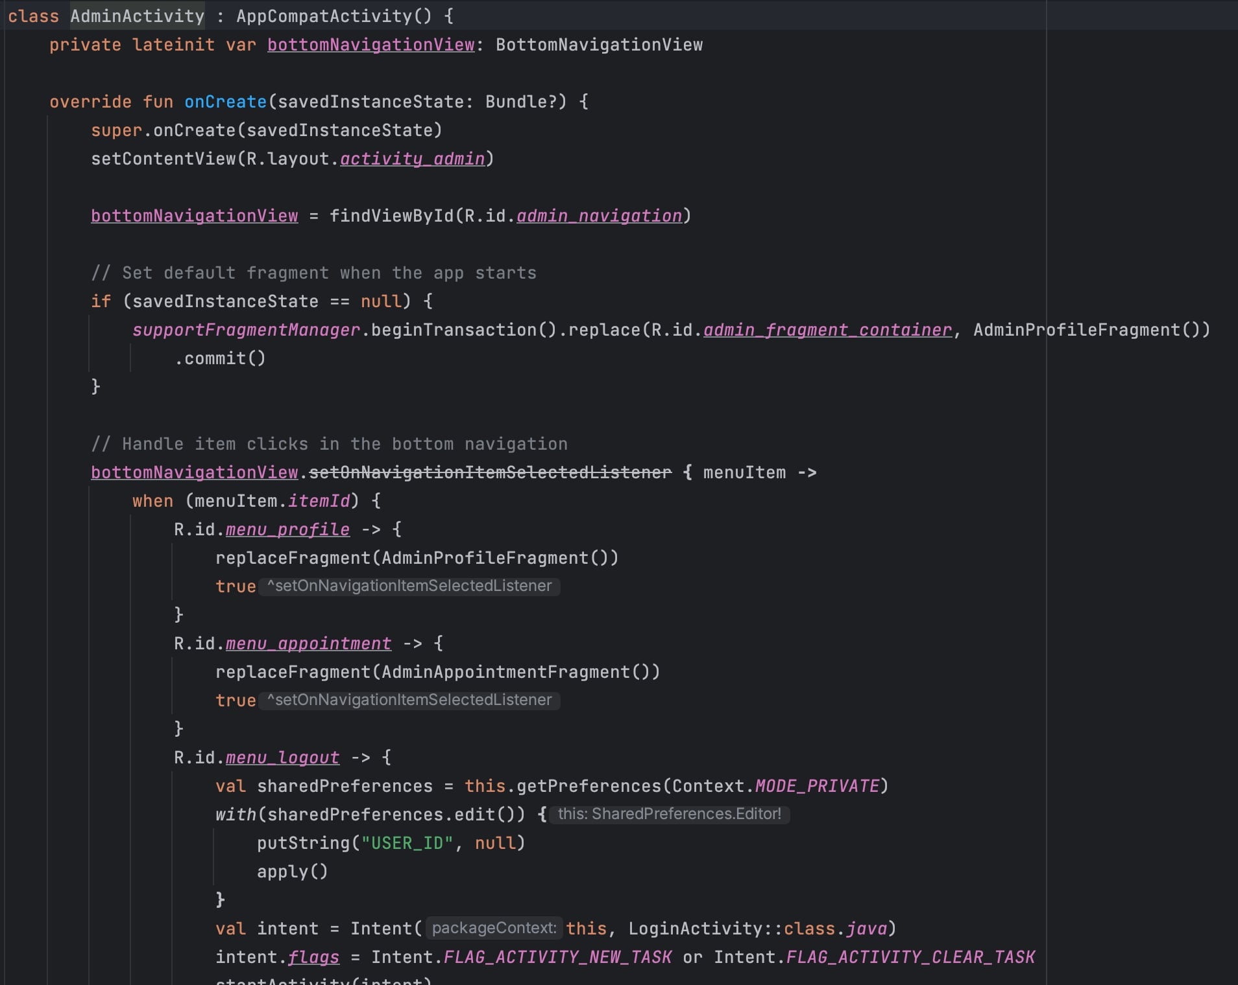

### Doctor Activity

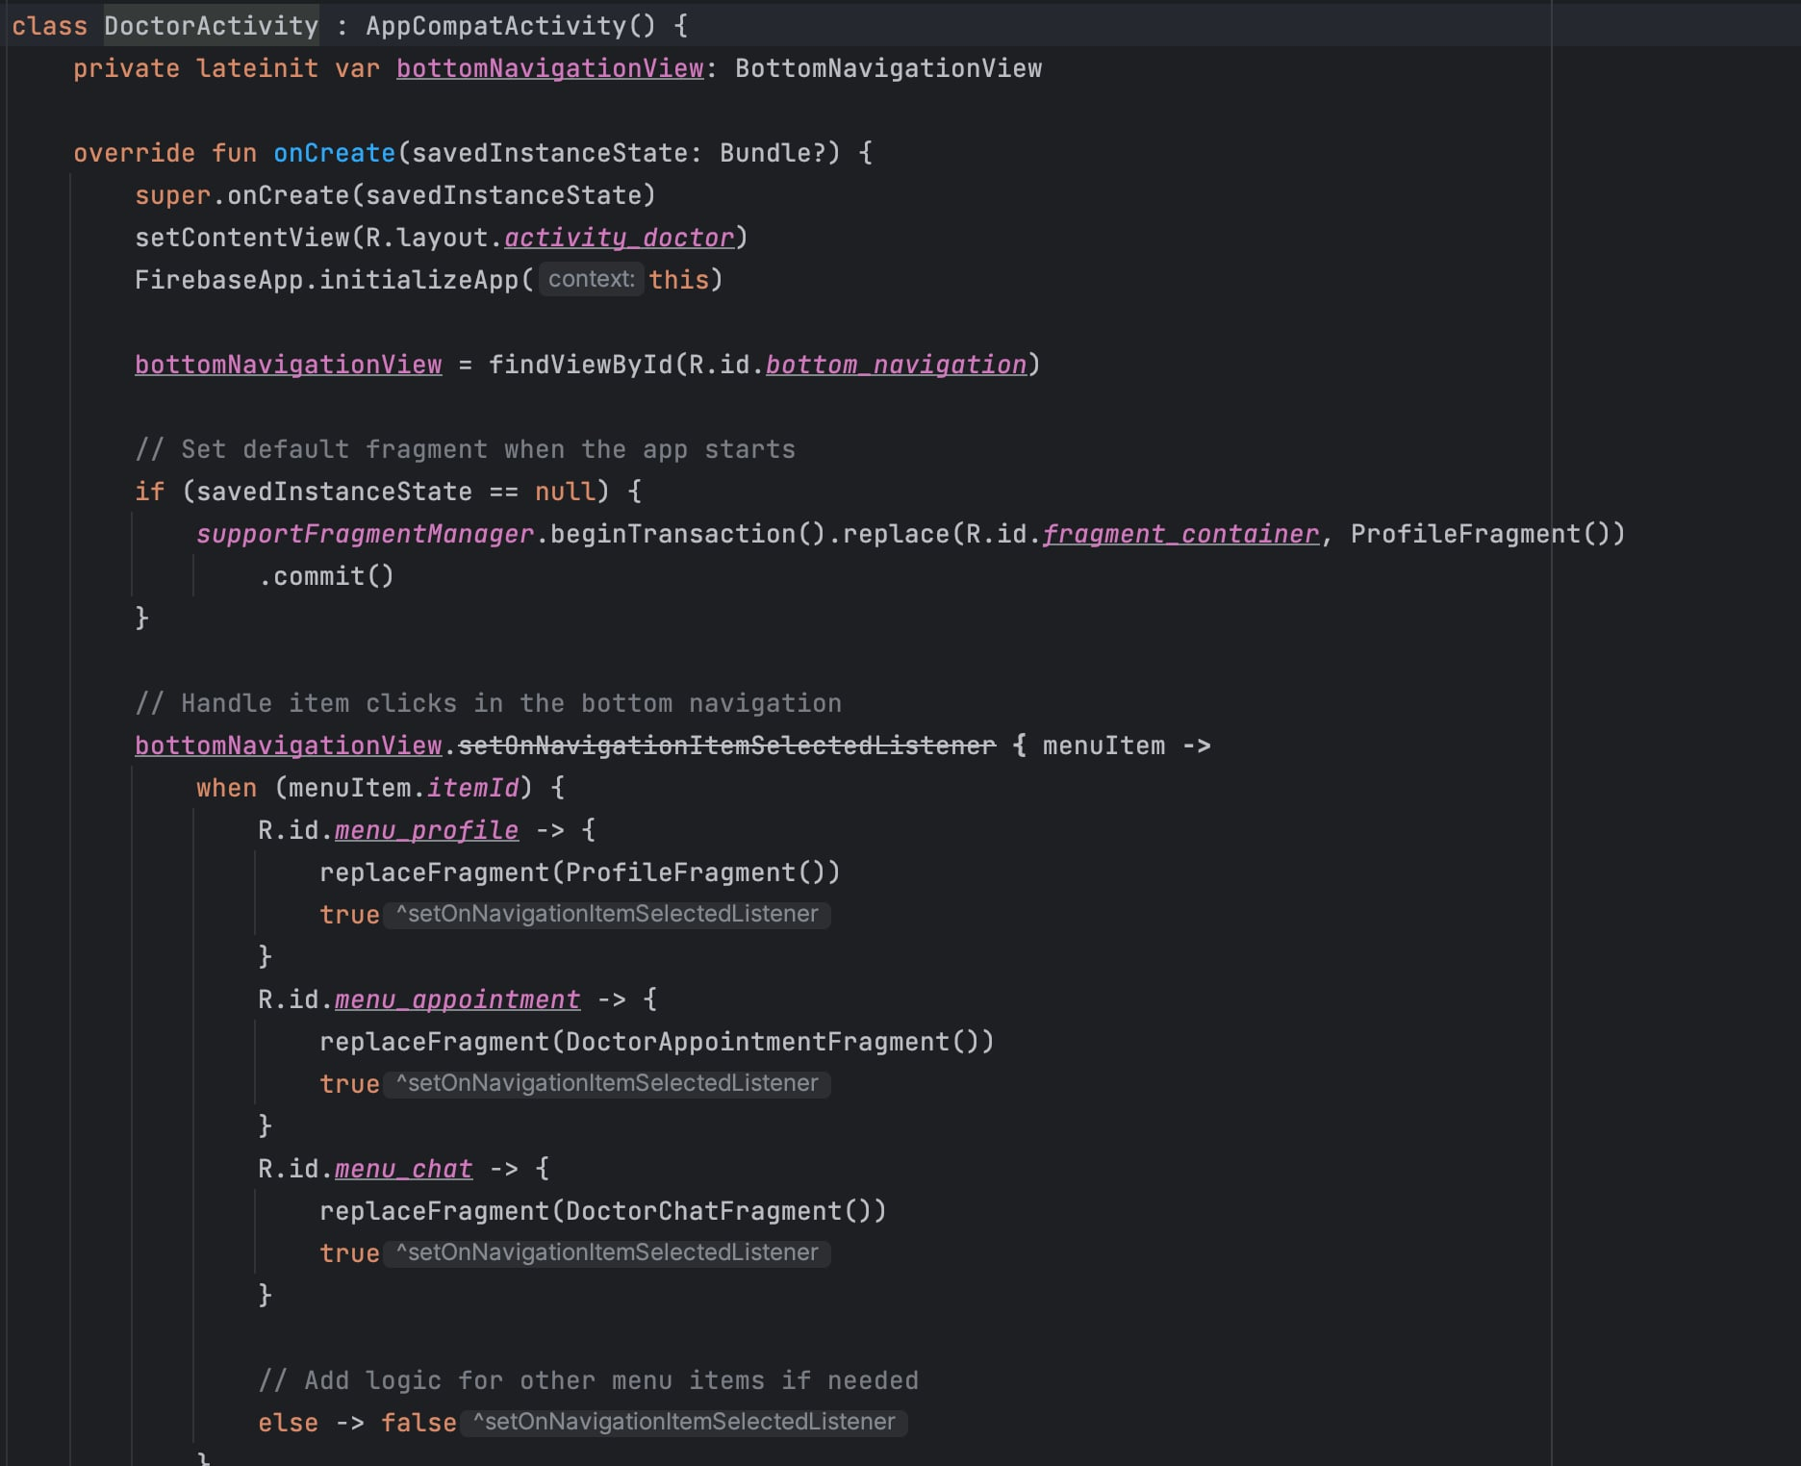

### 4.1.3 Login Activity

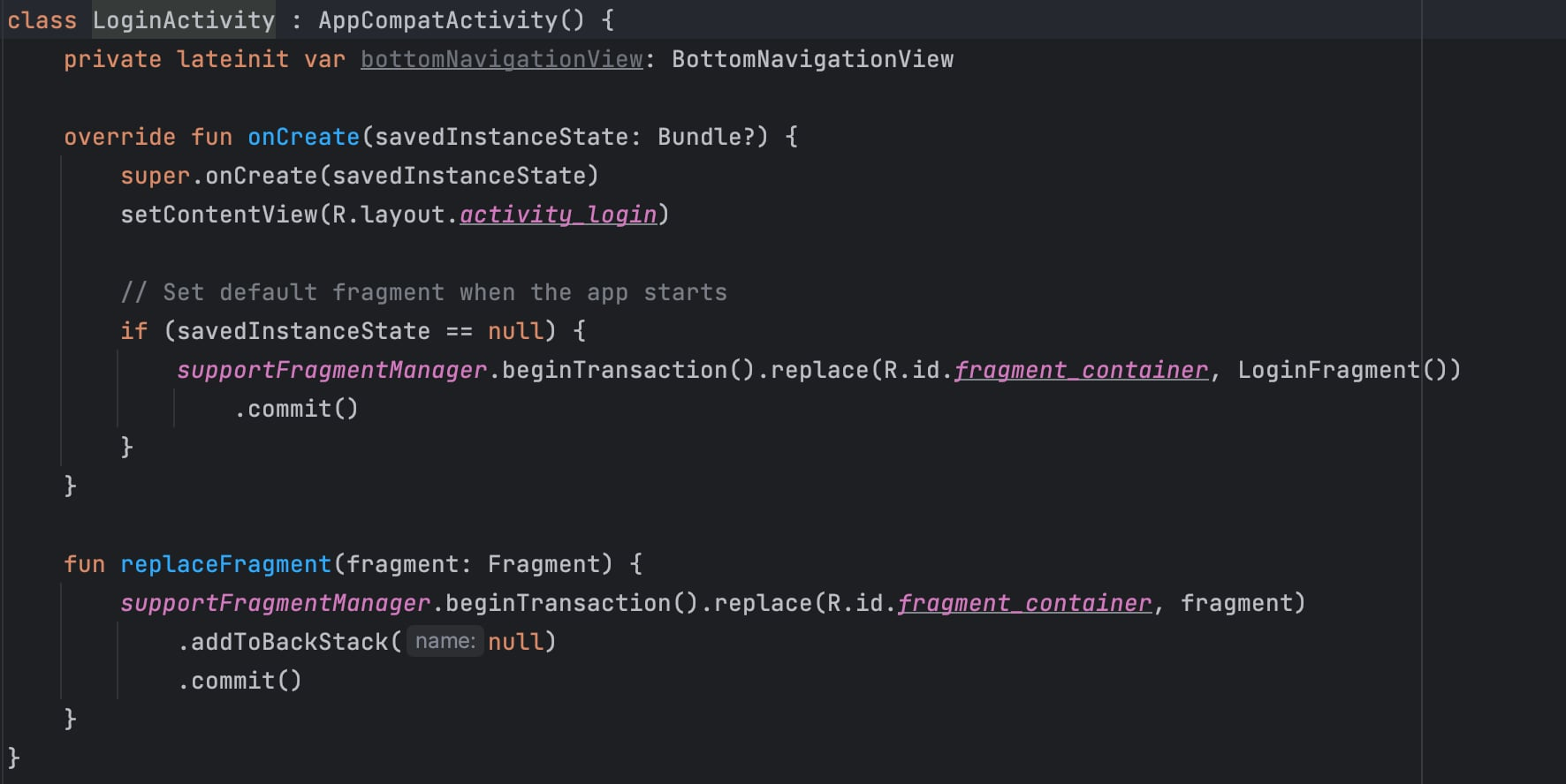

### 4.1.4 Video Activity

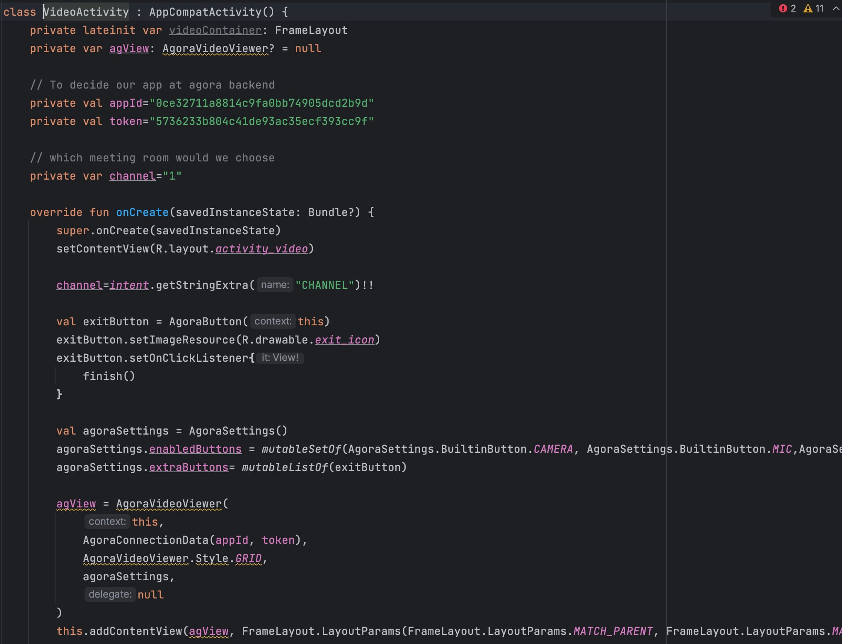

### 4.1.5 Main Activity

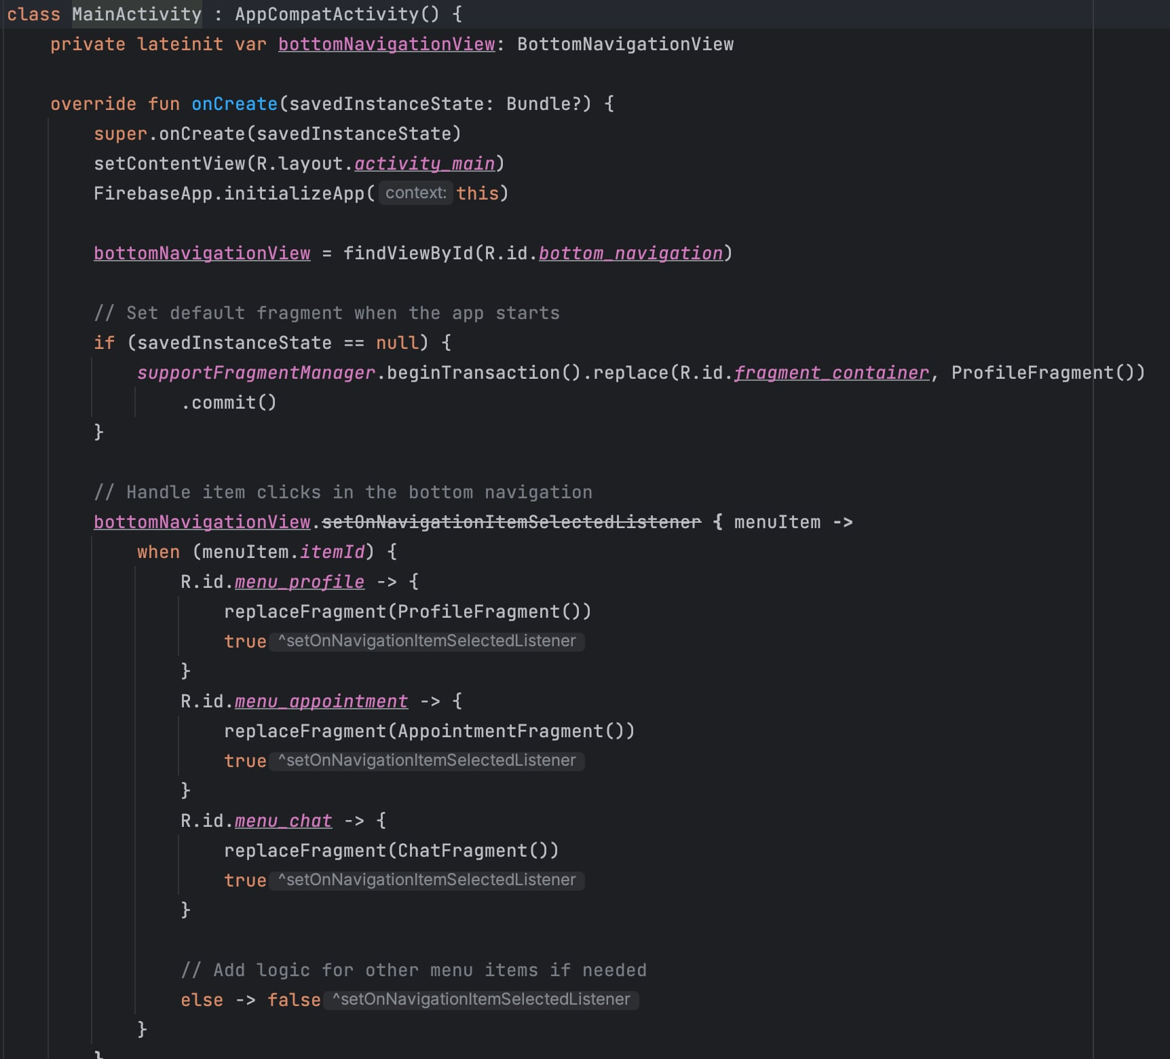

## Results

Abc…

### Login/Signup

### Profile details

### Appointment setup & video call

### Messaging with doctor

### Admin management

### Doctor messaging & appointment view

# CHAPTER 5

# DISCUSSION AND EVALUATION

## Discussion

The discussion section of the telehealth application report delves into the findings, implications, and broader context of the project. It provides a comprehensive analysis of the telehealth application's performance, addressing key aspects such as usability, effectiveness, and impact on healthcare outcomes. The discussion explores how the application aligns with the initial objectives outlined in the project, highlighting any deviations or unexpected outcomes.

Moreover, this section facilitates the interpretation of results in relation to existing literature, emphasizing the contributions of the telehealth application to the field. It delves into potential limitations, offering insights into areas that may require further refinement or investigation in future iterations. Engaging in a dialogue about the implications of the project's outcomes on the broader healthcare landscape, policy considerations, and potential scalability is also a crucial component of the discussion.

## Comparison

In the comparison section, the telehealth application report evaluates the performance and features of the developed application against existing telehealth solutions or industry standards. Comparative analysis provides valuable insights into the uniqueness and competitive edge of the developed application. It may involve benchmarking against similar applications in terms of user interface, functionality, security protocols, and overall user experience.

Furthermore, a comparative examination might extend to the contextual landscape, comparing the telehealth application's implementation in different healthcare settings or regions. This section aims to identify best practices, lessons learned from other telehealth initiatives, and areas where the developed application excels or requires enhancement in comparison to its counterparts.

## Evaluation

The evaluation section consolidates the overall assessment of the telehealth application, drawing on the discussion and comparison elements. It provides a summative analysis of the project's success in achieving its goals and objectives. The evaluation encompasses both quantitative and qualitative metrics, measuring the application's impact on healthcare accessibility, efficiency, and user satisfaction.

Critical evaluation involves addressing challenges encountered during the development and implementation phases, offering insights into the strategies employed to overcome these obstacles. It also considers the potential long-term sustainability and scalability of the telehealth application, taking into account evolving technologies, regulatory changes, and user needs. This section concludes with actionable recommendations for future enhancements or adaptations, ensuring that the telehealth application continues to evolve in response to the dynamic healthcare landscape.

# CHAPTER 6

# CONCLUSION AND FUTURE WORK

## Conclusion

In conclusion, the initial phase of developing the telehealth application, focusing on login and appointment scheduling functionalities, marks a significant stride towards fostering accessible and patient-centric healthcare delivery. The successful implementation of these foundational features lays the groundwork for a more comprehensive telehealth ecosystem. The user-friendly login interface and streamlined appointment scheduling process contribute to an efficient and convenient experience for both healthcare providers and patients.

However, it is crucial to acknowledge the limited scope of the current iteration and recognize that the full potential of telehealth is yet to be realized. While the implemented features form a robust foundation, the telehealth application is poised for expansion and augmentation to encompass a broader range of functionalities in subsequent phases.

## Future work

Moving forward, the telehealth application project must evolve to meet the escalating demands and expectations of modern healthcare. Future work will involve the integration of additional features, such as video consultations, secure messaging, and real-time health monitoring. These enhancements aim to facilitate more comprehensive and personalized healthcare interactions, transcending the limitations of traditional in-person consultations.

Furthermore, addressing interoperability challenges with existing electronic health record (EHR) systems and ensuring compliance with evolving healthcare regulations will be pivotal. Collaborations with healthcare professionals, user feedback sessions, and iterative testing will be essential in refining the application's usability and functionality.

The expansion of the telehealth application also necessitates considerations for scalability and adaptability to diverse healthcare settings. As the project progresses, exploring partnerships with healthcare institutions and incorporating telehealth into broader healthcare infrastructure will be imperative for widespread adoption.

# REFERENCES

1. MARTY HALL, LARRY BROWN “Core Servlets and JavaServer Pages™ - Volume 1 Core Technologies”, Second Edition, 2003.
2. MARTY HALL, LARRY BROWN “Core Web Programming”, Second Edition, 2001.
3. DAVE CRANE, ERIC PASCARILLO, DARREN JAMES, “Ajax in Action”, 2006.
4. JAMES L. WEAVER, KEVIN MUKHAR, AND JIM CRUME, “Beginning J2EE 1.4: From Novice to Professional”, 2004.
5. ?

# APPENDIX